PRIMO WatchDog User Manual

Version 1.10 (November 1, 2023)

Marcelino Hermida López

Servei de Física i Protecció Radiològica

Hospital Universitari Vall d’Hebron, Barcelona, Spain

[marcelino.hermida@vallhebron.cat](mailto:marcelino.hermida@vallhebron.cat)

**Purpose**

The PRIMO Monte Carlo software [1] allows the simulation of clinical IMRT and VMAT plans for Varian linacs. PRIMO relies on the general-purpose Monte Carlo code PENELOPE and the fast Monte Carlo code DPM [2,3]. The setup of a plan simulation in PRIMO (Figure 1) takes 5-10 min, as several manual steps are needed: project creation, selection of phase-space file (PSF), import of DICOM files, etc. After the simulation, a manual import of the DICOM dose file from the treatment planning system (TPS) is also needed to compare PRIMO and TPS dose distributions.

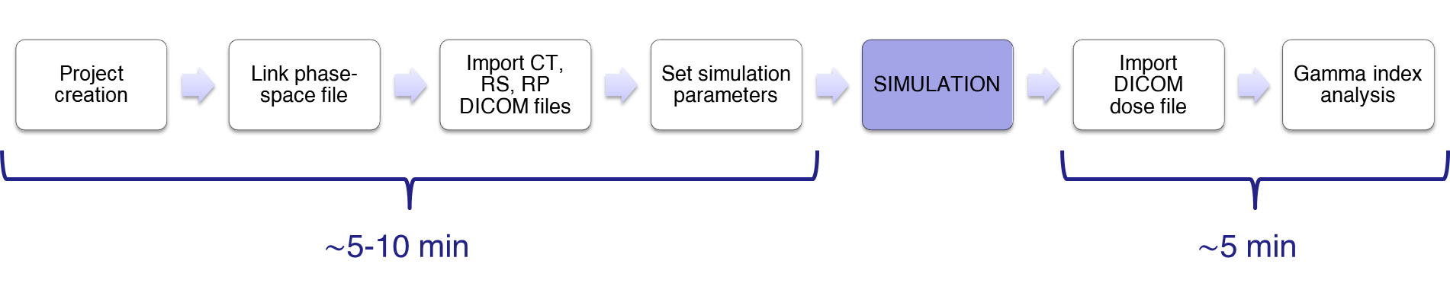

Figure 1. Steps for the setup of a plan simulation and gamma analysis in PRIMO.

PRIMO provides an advanced macro mode to speed up the process, but the macro file creation is also manual. Hence, the simulation of plans on a routine basis can be very time-consuming.

The purpose of the PRIMO WatchDog scripts is automating the simulation setup of clinical plans with PRIMO, including 3DCRT with no wedges, IMRT, dynamic conformal arc (DCA), and VMAT techniques.

**Components**

The distributed package includes the following files:

* PRIMO_WatchDog.exe: executable file.
* CONFIG.DOG: text configuration file.
* PRIMO_WatchDog_User_Manual.pdf: this manual.

The Python source code is also available at the GitHub repository https://github.com/marcelinohermida/PRIMO_watchdog

**Requirements**

To be able to use the executable file, the following requirements must be met:

* PRIMO software must be installed. The current version of PRIMO WatchDog needs PRIMO v. 1814 1816, which is freely available at <https://www.primoproject.net/primo/>.
* Current version of PRIMO WatchDog assumes that only 6 MV and 6 MV FFF photon beams from Clinac/TrueBeam linacs are used. This will be improved in further versions. So, PSF files are needed for both 6 MV and 6 MV FFF beams. We recommend using the PSF files provided by Varian at <https://www.myvarian.com>.

All other necessary Python packages are incorporated into the executable file.

If the user wants to use the optional feature of sending results to Telegram, a Telegram bot needs to be created. Details on how to create a Telegram bot are provided in the “Use” section.

If, instead of using the distributed executable file, the user wants to use the scripts directly from the Python console, or modifying the scripts, in addition to the aforementioned requirements, the following packages need to be installed in the Python environment:

|  |  |  |  |
| --- | --- | --- | --- |
| Package | Version | Purpose | Reference |
| colorama | 0.4.4 | Colored text under Windows terminals | https://pypi.org/project/colorama/ |
| pydicom | 2.0.0 | Management of DICOM files | https://pydicom.github.io/ |
| pyfiglet | 0.8.post1 | ASCII art | https://pypi.org/project/pyfiglet/ |
| PyInstaller | 4.7 | Compilation of Python scripts to Windows executable files | https://pyinstaller.org/en/stable/# |
| requests | 2.26.0 | Sending of HTTP requests (Telegram feature) | https://pypi.org/project/requests/ |
| watchdog | 2.1.6 | API and shell utilities to monitor file system events | https://pypi.org/project/watchdog/ |

The Python scripts were compiled into a Windows executable file with the Python package PyInstaller.

**Usage**

**Installation**

Download the distribution files into a folder of your choice. That’s it.

**Configuration**

Before using the scripts, some configuration needs to be done.

Open the CONFIG.DOG with any text editor. Modify the configuration parameters as desired:

# DICOM RT IMPORT FOLDER

Full path to the folder that will be monitored by the scripts in the search of DICOM files. Depending on the local network performance, better results may be obtained using a local folder, instead of a shared network folder.

Example: C:\DICOM_import_folder

# DICOM RT CASES

Full path to the folder that will be used by the scripts to store a copy of the DICOM files, in a subfolder for each case. The name of the folder will be composed by the DICOM Patient ID + DICOM Plan ID. Storing the DICOM files for each case may be useful to repeat the simulations and for record purposes. In other case, they can be safely deleted by the user.

Example: F:\CASOS

# PSF PATH 6 MV

Full path to the header file of the PSF for 6 MV photon energy. We recommend using the PSF provided by Varian.

Example: F:\SIMULATIONS\PSF_s1_TrueBeam_6MV_Varian\PSF_s1_TrueBeam_6MV_Varian.IAEAheader

# PSF PATH 6 MV FFF

Full path to the header file of the PSF for 6 MV FFF photon energy. We recommend using the PSF provided by Varian.

Example: F:\SIMULATIONS\PSF_s1_TB_6MV_FFF_v2\PSF_s1_TB_6MV_FFF_v2.IAEAheader

# SIMULATIONS FOLDERS

Full path to the folder used by the scripts to store the simulation folder of each plan. These folders contain the files necessary to perform the simulation, and the simulation results. Example: F:\SIMULATIONS\Simulations_patients

# PRIMO FOLDER

Full path to the folder in which the PRIMO software is installed. The default and recommended path is C:\PRIMO.

# ORIGINAL OR REDUCED CT RESOLUTION

If this parameter is set to REDUCED, PRIMO will reduce the CT slice size to 256×256 bins by linear interpolation. If the parameter is set to ORIGINAL, then the CT slices will be imported in their original size. See PRIMO manual for more details.

Recommendation: for clinical plans not including small targets, the REDUCED resolution is adequate. If small targets are involved, such as in radiosurgery plans, the ORIGINAL resolution may provide a greater dose resolution, at the expense of increasing the statistical uncertainty. In this case, the simulation folder may occupy as much as four times the disk space used with the REDUCED option (maybe 1 GB per case).

# HISTORIES (NUMBER OR FRACTION OF THE HISTORIES IN PSF)

Number of histories to be used in the simulations. If a value > 1 is stated, it is understood that we refer to the number of histories. This number should not be larger than the number of histories contained in the used PSF. If a value < 1 is used, it is understood that we refer to a fraction of the PSF available histories.

Examples: for using all the available histories in the PSF, use value 1. To use the 25% of the histories in the PSF, set this value to 0.25. This value allows reducing the simulation time by a factor of 4, with a statistical uncertainty increased by a factor of 2. Useful if quick results are needed. Typical statistical uncertainties attained for clinical plans when Varian PSFs are used (*k*=2): full PSF 1-2%, 25% of the PSF: 2-4%.

# SPLITTING FACTOR

Splitting factor to perform simple splitting in the CT. Based on our experience with clinical plans, we recommend using a value around 170 to optimize the ratio of simulation time and statistical uncertainty (efficiency of the simulation), although values between 100 and 300 may also offer good results.

# CALIBRATION FOR PSF 6 MV

# MEASURED DOSE IN Gy / MU / CALCULATED DOSE IN eV/(g history)

Calibration parameters needed by PRIMO to convert dose for each voxel from eV/g history to Gy. See PRIMO manual for more details. Example: 0.8 Gy in the calibration point for 100 MU correspond to 0.7167 eV/(g history), in this example for a 10x10 cm2 field at SSD=90 cm, for a 6 MV beam from a TrueBeam linac.

0.8

100

0.7167

# CALIBRATION FOR PSF 6 MV FFF

# MEASURED DOSE IN Gy / MU / CALCULATED DOSE IN eV/(g history)

Calibration parameters needed by PRIMO to convert dose for each voxel from eV/g history to Gy. See PRIMO manual for more details. Example: 0.8 Gy in the calibration point for 100 MU correspond to 1.4507 eV/(g history), in this example for a 10x10 cm2 field at SSD = 90 cm, for a 6 MV FFF beam from a TrueBeam linac.

0.8

100

1.4507

# GAMMA CRITERIA (ACTIVE/INACTIVE, dose_percent, DTA_mm, threshold_percent, uncertainty_percent, global/local)

Here you can specify the criteria for gamma index analysis between the simulated dose distribution, and the dose distribution of the plan calculated by the TPS. You may add as many lines of gamma criteria as you want. Parameters needed:

* ACTIVE/INACTIVE: activates the comparison with the specified gamma criteria. INACTIVE makes the software to ignore the comparison. In the CONFIG.DOG distributed, some gamma criteria are provided as suggestions, valid for standard plans, or for radiosurgery plans. Activate or inactivate as desired, or add new ones.
* dose_percent: dose criteria for the gamma analysis, in percentage.
* DTA_mm: dose-to-agreement value, stated in mm. Note that in the PRIMO GUI and in the PRIMO reports, the DTA is shown in cm.
* threshold_percent: threshold value, in percentage.
* uncertainty_percent: uncertainty threshold, in percentage.
* global/local: to choose between GLOBAL gamma analysis, or LOCAL gamma analysis.

For more details, check out the PRIMO manual.

# SEND TELEGRAM

To activate the optional feature of sending PDF reports of the results to a user-defined Telegram bot. For instructions on how to create a Telegram bot, see for instance: <https://medium.com/@ManHay_Hong/how-to-create-a-telegram-bot-and-send-messages-with-python-4cf314d9fa3e>.

Possible values: YES or NO.

# BOT TOKEN

Provide here your Telegram bot token.

# BOT CHATID

Provide here your Telegram chat id.

# SOUND

To activate/deactivate an audible warning (a barking dog!) once the simulation and data extraction of each simulation is finished. Possible values: YES or NO.

Configure in your TPS an export filter to export the plan, CT, structure and dose DICOM files to the DICOM folder specified in the CONFIG.DOG file. Name this filter, as an example, “Export to PRIMO WatchDog”.

**Routine use**

Execute the PRIMO_WatchDog.exe file, or execute the PRIMO_WatchDog.py file from the Windows command window: python PRIMO_WatchDog.py. A console window will open and in a few seconds the software will be ready, waiting for DICOM files to process (Figure 2). Note that if the executable file is used, a splash screen is shown until the unpacking of the necessary libraries is done. Depending on the computer, this may take some time, up to 1 min. Also, make sure that your antivirus software is not blocking the execution of the file.

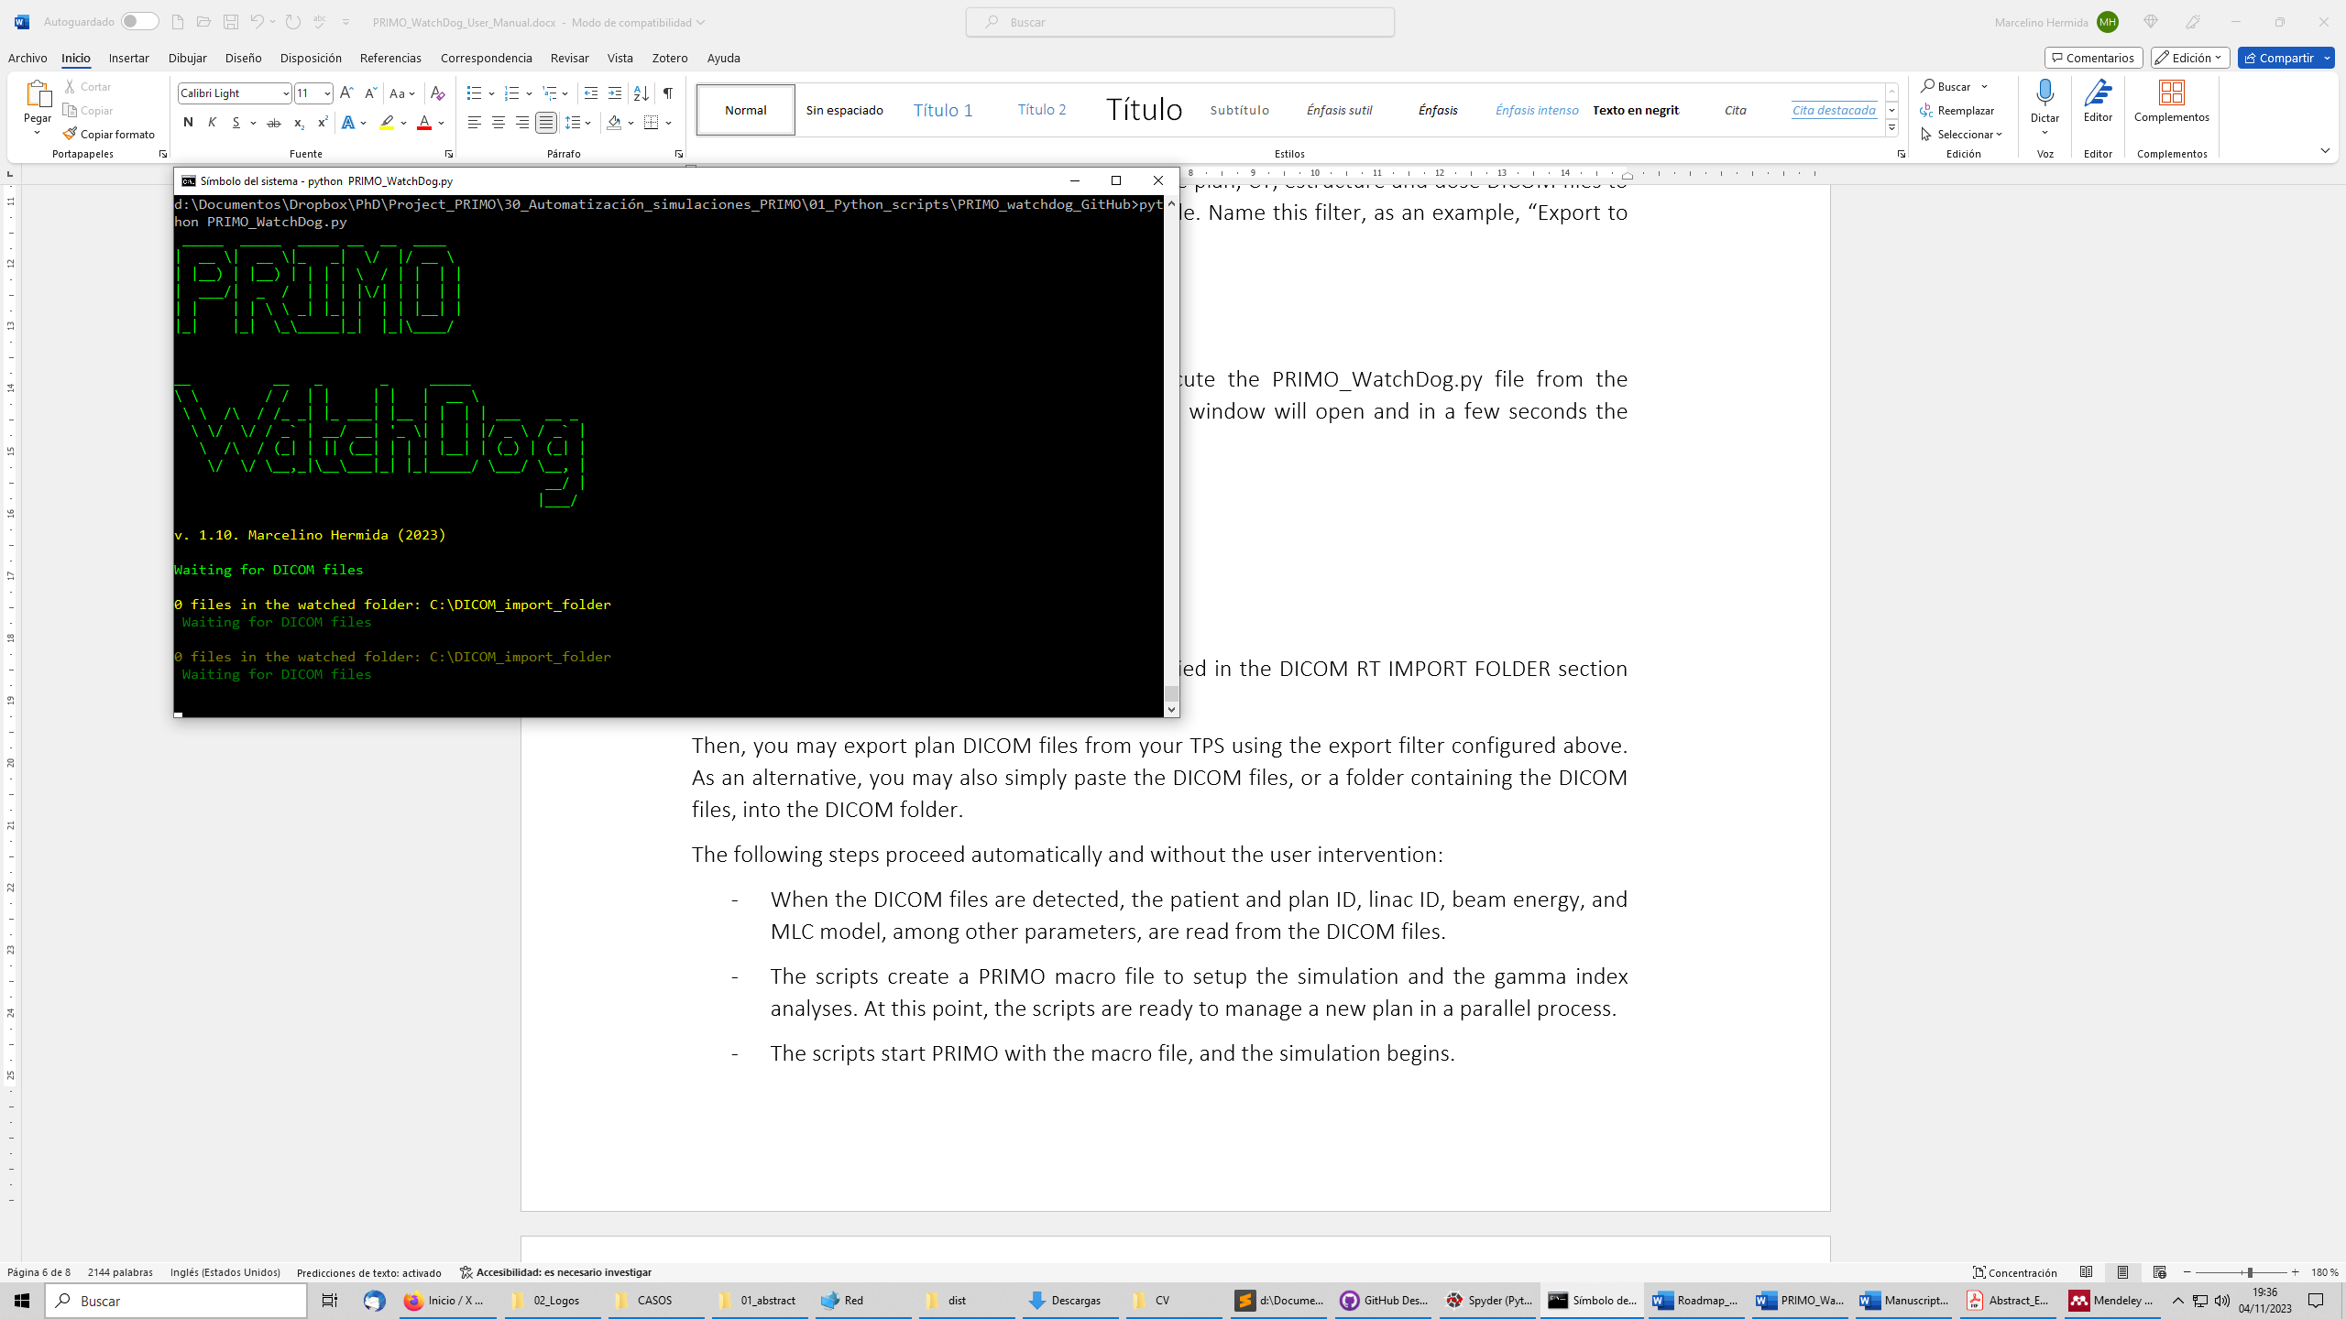

Figure 2. PRIMO WatchDog window.

The software will be monitoring the folder specified in the DICOM RT IMPORT FOLDER section of the configuration file.

Then, you may export plan DICOM files from your TPS using the export filter configured above. As an alternative, you may also simply paste the DICOM files, or a folder containing the DICOM files, into the DICOM folder.

When the DICOM files are detected, the following steps (Figure 3) proceed automatically and without the user intervention:

* Patient and plan ID, linac ID, beam energy, and MLC model, among other parameters, are read from the DICOM files.
* The scripts create a PRIMO macro file to setup the simulation and the gamma index analyses. At this point, the scripts are ready to manage a new plan in a parallel process!
* The scripts start a PRIMO instance in a parallel process with the created macro file, and the simulation begins.
* Once the simulation and the gamma index analyses are done, the scripts store the results in the PRIMO_simulation_results.csv file for further analysis, and the associated PRIMO instance is closed. If activated, an audible alarm warns the results are available. If activated, the results are also sent to the Telegram bot.



Figure 3. PRIMO WatchDog inner workings.

The scripts can manage performs adequately even if several plans are simulated simultaneously, although this is dependent on the computer resources, mainly RAM and disk speed. With a computer adequate to use the PRIMO software, sending 3-4 plans to be simulated simultaneously should work fine.

**Validation**

The distributed scripts were tested with:

* PRIMO v. 0.3.1.1816 installed in computers with Windows 7 and Windows 10 operating systems.
* Varian PSFs for 6 MV and 6 MV FFF photon beams from Varian TrueBeam linacs.
* IMRT and VMAT plans (including HyperArc plans) from Varian Eclipse v. 15.6 and v. 16.
* VMAT radiosurgery plans from Brainlab Elements Cranial SRS, and DCA plans from Elements Multiple Brain Metastases.
* Millennium 120 and HD120 MLCs.
* CT and phantoms created in Eclipse.

**Limitations**

If the DICOM file folder is located in a network folder, there can be some synchronization problems if the network speed is low. If this happens, as a workaround, use a local folder as DICOM folder. If that is not feasible, contact the author so the time delay can be increased. This will be fixed in coming versions.

In the current version, the plans managed by the scripts are simulated with the DPM simulation engine only. In future versions, the user will be able to choose DPM or PENELOPE using the configuration file.

Sometimes, the sending of results to the Telegram bot may not work, although it is well configured. The most likely reason is that a firewall is blocking the connection to the Telegram servers. This is likely to happen with computers in corporative networks, like in a hospital. In such situation, contact your IT department, or simply inactivate the feature in the CONFIG.DOG file, setting the tag “# SEND TELEGRAM” to NO.

**Recommended citation**

If you find this tool useful for your research, please cite this reference:

* M. Hermida-López and J. F. Calvo-Ortega, PRIMO WatchDog: a set of Python scripts to automate the simulations of IMRT and VMAT plans with the PRIMO Monte Carlo software, DIY Fair, 4th European Congress of Medical Physics, Dublin, 17-20 August 2022, Phys Med 104:S183 (2022).
* M. Hermida-López and J. F. Calvo-Ortega, PO-2062 Automating the simulations of IMRT, DCA and VMAT plans with the PRIMO Monte Carlo software. Radiother Oncol 182 Suppl. 1, S1838 - S1839 (2023).
* TECHNICAL NOTE

**Copyright notice**

Copyright 2023 Marcelino Hermida López.

Licensed under the Apache License, Version 2.0 (the "License"); you may not use this file except in compliance with the License. You may obtain a copy of the License at

http://www.apache.org/licenses/LICENSE-2.0

Unless required by applicable law or agreed to in writing, software distributed under the License is distributed on an "AS IS" BASIS, WITHOUT WARRANTIES OR CONDITIONS OF ANY KIND, either express or implied. See the License for the specific language governing permissions and limitations under the License.

**References**

[1] Rodriguez M, Sempau J, Brualla L. PRIMO: A graphical environment for the Monte Carlo simulation of Varian and Elekta linacs. Strahlenther Onkol 2013;189:881–6. doi:10.1007/s00066-013-0415-1.

[2] Sempau J, Wilderman SJ, Bielajew a F. DPM, a fast, accurate Monte Carlo code optimized for photon and electron radiotherapy treatment planning dose calculations. Phys Med Biol 2000;45:2263–91.

[3] Rodriguez M, Sempau J, Baumer C, Timmermann B, Brualla L. DPM as a radiation transport engine for PRIMO. Radiat Oncol 2018;13:256. doi:10.1186/s13014-018-1188-6.

**History**

2023-11-dd Version 1.10 released.