Ózdi SZC Bródy Imre Technikum

IPv6 - The next generation of Internet Protocol
Ózd, 2025. 10. 21. Made by: Peter Elias
Table of contents
The new language of the network: IPv6 3
Why was the introduction of IPv6 necessary? 3
Advantages of IPv6 3
Challenges of IPv6 deployment 4
IPv6 and the future 4
Summary 4

The new language of the network: IPv6
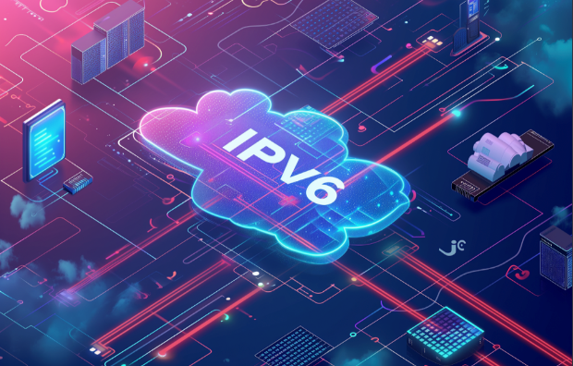
IPv6 (Internet Protocol version 6) is a new version of the network protocol that controls data traffic between devices connected to the Internet. IPv4, which has long been the basis of Internet communications, provided a limited number of addressing options, while IPv6 is designed to accommodate the rapid growth of global devices

Why was the introduction of IPv6 necessary?

The depletion of IPv4 addresses and the rapid increase in the number of devices available on the Internet led to IPv6. IPv4 addresses are 32-bit and allow for the creation of approximately 4.3 billion unique addresses. This number is no longer sufficient in today's Internet world. IPv6, on the other hand, uses 128-bit addresses, which provides an extremely large number of unique addresses, allowing a virtually unlimited number of devices to connect to the Internet.

Advantages of IPv6

- Almost Unlimited Addressing: IPv6's 128-bit addressing allows 340 undecillion addresses (340 x 10^36) to be available. This huge number means that every single person, device and sensor can have its own unique IP address.
- Better security: By default, IPv6 ensures the use of the IPsec (Internet Protocol Security) protocol, which encrypts and authenticates network traffic. This guarantees a higher level of security in Internet communication.
- More efficient address management: IPv6 has an automatic address allocation mechanism, which means that devices can automatically obtain their own IP address, reducing the need to manually configure IP addresses.
- Improved Network Performance: IPv6 has simplified headers that result in faster data packet handling and less network latency.

Challenges of IPv6 deployment
Although IPv6 has many advantages, its implementation is not without its challenges. In many regions of the world, the wide spread of the old IPv4-based requires time and resources. For service providers, companies and government institutions, the transition to IPv6 requires significant technical and financial efforts.

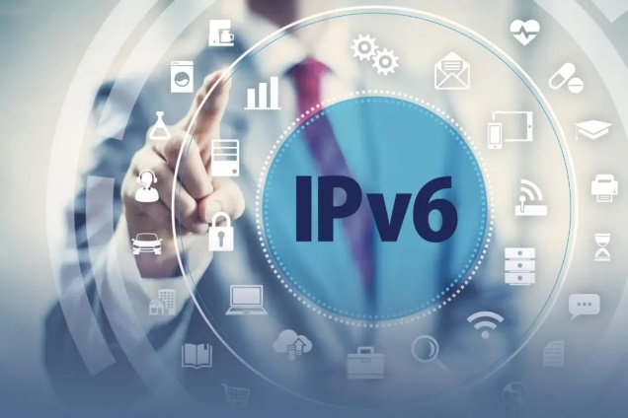
IPv6 and the future
Although IPv6 has been available for several years, it still works alongside IPv4 in many places. The transition is underway, and the adoption of IPv6 is key to future Internet applications and devices. With the growth of IoT (Internet of Things) devices, smart cities, vehicle-to-vehicle communication, and global data traffic, IPv6 is becoming essential in building a sustainable and scalable Internet infrastructure.

Summary
IPv6 is not just another Internet protocol; a technology offering completely new possibilities that allows more and more devices from all over the world to connect to the global network. The deployment of IPv6 will continue and contribute to the development of the Internet of the future.

