

San Francisco State University
Florida Atlantic University
Software Engineering
Csc 640/848, Cen 4010 - Fall 2008

Infinity Metrics
Automatic Collaboration
Metrics for java.net Projects

Requirements Specification
Milestone 3

Authors
Group 8
Marcello de Sales | (msales@sfsu.edu)
Andres Ardila | (aardila1@fau.edu)
Brett Fisher | (bfisher@sfsu.edu)
Marilyne Mendolla | (mmendoll@fau.edu)
Gurdeep Singh | (gurdeep@sfsu.edu)

Advisors
Dr. Dragutin Petkovic (SFSU), Gary Thompson (SFSU),
Dr. Shihong Huang (FAU)

San Francisco, CA
Boca Raton, FL
Document ID
Date | 10/31/2008
Responsible | Marcello de Sales
Document ID | INFINITYMETRICS_RS_20081023
Location | https://ppm-8.dev.java.net/source/browse/ppm-8/  trunk/www/milestones/1/INFINITYNET_M2.doc

Revision History
Date | Version | Authors | Description
2008-09-28 | 0.1 | Marcello de Sales | Template Creation
2008-09-28 | 0.2 | Marcello de Sales | Modifying template according to specification (See Requirements documentation under Milestone 1 folder at the Directories and Files PPM-8 java.net)
2008-10-04 | 0.3 | Andres Ardila & Marcello de Sales | Adding information on sections 2, 3, 4, 5, 6.
2008-10-16 | 1.0 | Marcello de Sales | Revision with the feedback from Gary Thomson and Prof. Petkovic
2008-10-07 | 1.1 | Andres Ardila | Final Revision for M1: Implemented feedback corrections (java.net capitalization, Use Case syntax), renaming project name (branding on images to be changed on next Milestone documentation).
2008-10-24 | 2.0 | Marcello de Sales | Final documentation for Milestone 2
2008-10-24 | 2.1 | Andres Ardila | Final Revision
2008-10-31 | 2.2 | Andres Ardila & Marilyne Mendolla | Sorted User Stories by Priority, moved Glossary section immediately after Executive Summary, moved Use Cases before Functional Requirements, renamed Dispute Tracker instances to Custom Event Tracker, updated TOC.
2008-10-31 | 2.3 | Marcello de Sales | Final Updates and adding subsections 2.2, 2.3, 3.1, 3.1.1, 3.1.2, 3.1.3, 3.2.2, 4.1, 4.3, 5, 5.1, 5.2, 5.2.1, 5.2.2, 5.2.3, 5.2.4, 5.3
2008-11-30 | 3.0 | Marcello de Sales, Marilyne Mendolla & Andres Ardila | General re-work for M3: Revision of User Stories & Use Cases with prioritization, updated UI designs for all components, updated Charting API information after Google Visualization API was chosen, updated DB schema, updated list of Components & their respective functionalities, updated Class Relationships & Diagrams. Removed Mateo Mejia from list of Authors at his request after he withdrew from the class/project.
2008-12-04 | 3.1 | Brett Fisher | Eliminated deprecated use of the term dispute in favor for custom event. Fixed Custom Event Metrics diagram. Updated user cases to the new more simplistic user friendly implementations. Updated the description of the Custom Event Tracker Storyboard.

Table of Contents
Executive Summary 5
Glossary ………………………………………………………………………………………….6
1. Business Process 7
2. Requirements Specifications 8
2.1. Use Case Diagrams 8
2.1.1. Actors 9
2.1.2. User Management 9
2.1.3. Metrics Workspace 12
2.1.4. Custom Event Tracker 15
2.1.5. Metrics Reports 17
2.1.6. Personal Agent API 19
2.2. Functional Requirements 21
2.3. Non-Functional Requirements 22
2.4. Domain Vocabulary 23
2.5. Metrics Data Collection 23
3. User Interfaces 26
3.1. Mock-ups 26
3.1.1. Users Registration 26
3.1.2. Metrics Workspace 27
3.1.3. Project Metrics report 28
3.1.4. Student Metrics Report 28
3.1.5. View Workspaces ………………………………………………… 29
3.1.5. View Custom Events …………………………………………… 29
3.1.6. Add Custom Event .…………………………………………… 30
3.1.8. Add Custom Event Entry ……………………………………… 30
3.1.9. Edit Custom Event .…………………………………………… 31
3.1.10. Delete Custom Event Entry ……………………………… 31
3.2. Storyboards 32
3.2.1. User Management Storyboard 32
3.2.2. Custom Event Tracker Storyboard 32
3.2.3. Metrics Workspace Storyboard 33
3.2.4. Metrics Reports Storyboard 33
4. High-level System Architecture 34
4.1. Web Server and Web technology 34
4.2. Database Server 34
4.3. Graphing Component 35
5. Architectural Design 36
5.1. Components diagram 36
5.2. MVC-D layers and Class Diagram 37
5.2.1. Model 37
5.2.2. View 37
5.2.3. Controller 37
5.2.4. Data 38
5.3. MVC, CMS and ORM Frameworks for evalution 39
6. Competitive Analysis 40
7. Risk management 41
7.1. Risk Analysis 41
7.2. Risk Monitoring 42
8. Resources Allocation 43

Executive Summary
Software Engineering is one of the fastest growing fields in today's global economy. This rapidly-evolving industry requires educational institutions to adopt innovative changes in their curriculums in order to provide students with the necessary competitive skills and experience required in today's job market. Precisely due to this globalization, an increasing number of companies are developing software in virtual, distributed environments that transcend national boundaries. As a consequence, educational institutions have redesigned their programs to simulate team software development in a controlled environment. This evolution in the pedagogy of Software Engineering, however, presents new challenges to instructors regarding student evaluation. It is therefore of paramount importance to provide instructors with the proper tools to assess individual and team progress, and to assess individual student participation within those teams in these new virtual classroom environments.

In light of these challenges, Infinity Metrics will provide cutting-edge and unique tools to instructors who choose the java.net development platform as part of a Software Engineering class curriculum. Infinity Metrics will allow instructors to monitor the participation of individual students in globally and/or locally distributed java.net group projects as well as the progress of the team as a whole in relation to other teams. Infinity Metrics will be an efficient, automated, and user-friendly web application that collects and reports on student participation metrics for such class settings. The application allows an instructor or set of instructors in different locations (i.e. concurrent Software Engineering courses taking place in different universities) to automatically collect participation data for a set of java.net projects and report on its members’ contribution to the project at all stages of development. Because Infinity Metrics understands the need for intuitive, easy-to-use software in academia, the initial set-up will automatically generate the metrics categories available for the given projects, whilst allowing instructors to retain full control to modify these settings at any point throughout the semester.

We believe that information is power. That’s why our system will provide instructors with the ability to collect and view a wide ranging variety of metrics from java.net projects. It will also provide instructors with insightful information about trends and common difficulties that may arise in the development and learning processes. Our tool’s seamless integration with the java.net platform, the valuable data it can extract and present (from granular to global), and its minimal maintenance overhead will allow instructors to focus their efforts in the most important aspect of their task: teaching. Infinity Metrics will thus enable and improve the quality of learning for students by providing instructors with the tools needed to be heavily involved in the progress of the class and its individuals.

Glossary

User | Derived from the Actors, a user has the username and password from java.net. It will be used by the specialized users Instructor and Student for identity verification.
Student | Students play a secondary role on Infinity Metrics where he/she just fills out the participation form with his/her personal information. Also, he can be identified as a team leader in any java.net project and is always tied to a given institution.
Instructor | Instructors are aggregated by their Metrics Workspaces for different terms on a given institution. They also can participate on the ownership of a given Workspace.
Personal Agent | The instructor’s personal agent is the internet crawler that uses the professor’s username and password to navigate through java.net on his/her behalf in order to get metrics information and find out more about the projects.
Metrics Workspace | The Metrics Workspace is composed by a set of java.net projects names and it can assume different states during the metrics workspace life-cycle.
java.net Project | The java.net project space name that will be tracked. It is composed of a set of java.net usernames in the form of the student names.
Event | Each item on a java.net project RSS feed is called an Event. Each event is part an event category such as the commit message, an issue, and a topic posted in a discussion forum or an email sent to a given mailing list. Finally, it contains a reference to the creator of the item, who can be a student or a professor. It can also refer to a given entry by the instructor. This information is associated with the java.net username used in the RSS ‘creator’ tag.
Event Category | This is an enumeration of the types of events, or from which category the RSS item originated. It will be associated with each event and will also include the customized values of events.
Workspace Status | It is associated with the Metrics Workspace. Active is defined by default when the instructor creates the workspace environment. In that way, the instructor can tell his Personal Agent to collect metrics online.
Custom Event | Any situation that may arise among members of the same team throughout the semester.
Custom Event Tracker | The Custom Event Tracker enables an instructor to track Custom Events within a team. It allows Instructors to add entries about Custom Events, and catalogues them for monitoring.
Custom Event  Entry | Custom Event Entries are entered by the Instructor to track significant events of a particular Custom Event in a team. An Instructor can add one or more entries for every instance of a Custom Event, which will be catalogued in the Custom Event Tracker.

Business Process
The business process defines the information about the overall project, gathering necessary information about the understanding of the problem that our system aims to solved. The business process is described as a high-level understanding of the system requested by Gary Thompson, and the domain vocabulary is described as the team captured both the high-level requirements and in-class information about the system.

As a matter of understanding the idea of the product, the business process model captures the main business activities, focusing on the inputs, outputs, goals and key events that drive the process. The goal of Infinity Metrics is to help instructors view participation metrics while students are learning software development on java.net.

We can describe Infinity Metrics as having two processes: one started by an instructor, and the other by students. Instructors create a configuration Workspace with the parent project in java.net from which its children projects are collected, while students provide their initial profile. As students start collaborating on java.net and, and as a result, generating RSS feeds and additional information, these metrics are collected and stored by Infinity Metrics. At this point, Infinity Metrics uses web pages to display these metrics in rich and meaningful ways to the instructor.

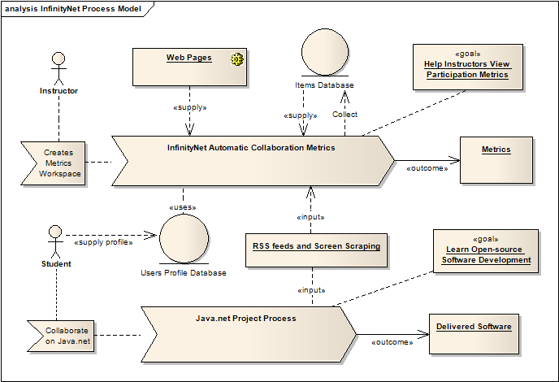

Requirements Specifications
This section describes the requirements gathered from the high-level specification documentation provided by Gary Thompson. Additionally, the wiki page for the PPM project was explored. The Formal Requirements catalogues the categorized specification for each component to be developed. On the other hand, the Non-Functional Requirements section lists generalized specifications. Finally, the Use Case Model groups these requirements and associates them the functionalities they fulfill.

As the reader will notice, the functional and non-functional requirements are specified by means of User Stories, following the formal conventions and best practices of the Agile Development community, where the stories remind us of a conversation with the client.

Use Case Diagrams
This section describes the use case diagrams for Infinity Metrics. It represents the fulfillment of each of the User Stories into the components as a given functionality. First, each actor is described and shown in the Actors UML diagram, and the following sections describe the use cases for each package listed in the Requirements section: Users Management is responsible for the management of users and their profiles; Metrics Workspace is the area used by the instructors to create the metrics configuration, and finally, the Personal Agent API is the set of functions that the instructor’s Personal Agent will perform on his/her behalf. Finally, the Custom Event Tracker is the package responsible for managing Custom Events in any project on a given workspace.

This next table summarizes the list of use cases that will be explained in the following sections.

Category | ID | Name
User Management | UC001 | Register Student
User Management | UC002 | Register Instructor
User Management | UC003 | Login
User Management | UC004 | View Account
User Management | UC005 | Update Instructor Account
User Management | UC006 | Update Student Account
Metrics Workspace | UC100 | Create Workspace
Metrics Workspace | UC101 | View Workspace Profile
Metrics Workspace | UC102 | View Workspace Collection
Metrics Workspace | UC103 | Update Workspace Configuration
Metrics Workspace | UC104 | Share Workspace
Custom Event Tracker | UC200 | Create Custom Event
Custom Event Tracker | UC201 | Update Custom Event
Custom Event Tracker | UC202 | Add Entry to Custom Event
Custom Event Tracker | UC203 | Remove Entry from Custom Event
Reports | UC300 | View User Metrics Report
Reports | UC301 | View Project Metrics Report
Reports | UC302 | View Top Performing Projects Report
Reports | UC303 | View Workspace Metrics Report
Reports | UC304 | View Workspace Metrics Report By Institution
Reports | UC305 | Export Report to Delimited Text File
Reports | UC306 | View Workspace Collection Metrics Report
Personal Agent | UC400 | Collect Events from RSS
Personal Agent | UC401 | Collect Children Projects
Personal Agent | UC402 | Verify user identity through java.net
Personal Agent | UC403 | Collect Event List from Project

Before explaining the use cases, it’s important to know which actors might be present on the use cases. The actors are the main entities in the system that starts the events of the system. It can be a human, or subsystem acting in favor of the system. After the Actors sub subsection, the following sections describe each of the packages of use cases.

Actors
 | 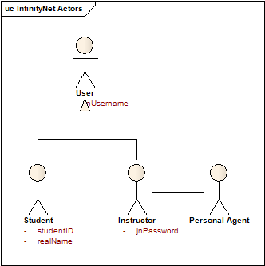
  User | This is the regular user of the website. It can make login using username and password.
  Instructor | Instructors are the java.net users who create the metrics. They will be providing java.net username and password to be able to navigate through the private projects.
  Student | Students will just fill out forms about their personal information, institution and group.
  Personal Agent | The instructor’s personal agent is in the form of a web crawler that represents the instructor and virtually navigates java.net to collect information.

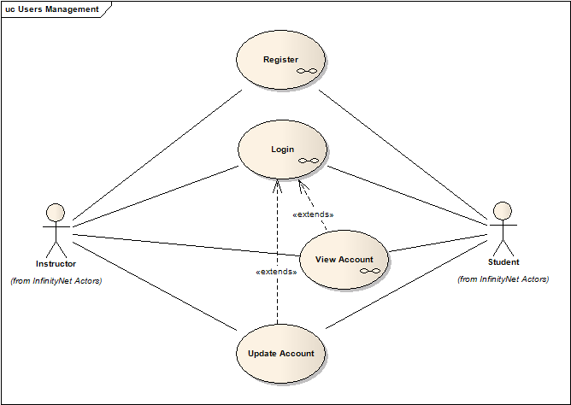
User Management
The User Management package expresses to how the main actors of Infinity Metrics will use the system to create an account, register into the system and modify their information. This package is the first section of Infinity Metrics available to the customers.

UC001 | Register Student
Description | A Student registers into the system.
Assumptions | The student must have a valid java.net account and email.
Precondition | The student has selected ‘Student’ as the user type on the registration page.
Postcondition | The student has an Infinity Metrics account.
Normal Flow | - The student enters his/her java.net username.  - The student enters his/her java.net password.  - The student enters his/her Real Name.  - The student enters his/her email address.  - The student selects his/her institution.  - The student enters his/her student ID.  - The student enters whether he/she is a team leader  - If so, he/she enters the java.net project name.  - The student submits the form.  - The system validates the input.  - The system verifies the student’s identity against java.net.  - The system sends a confirmation email to the student.  - The system logs student into Infinity Metrics.
Exceptional Flow :  java.net username field empty | Browser displays a message notifying student of empty field exception in java.net username field.
Exceptional Flow :  java.net username already exists | Browser displays a message notifying student of duplicate username in the system and prompts for new username or to abort registration.
Exceptional Flow :  java.net password field empty | Browser displays a message notifying student of empty field exception in java.net password field.
Exception Flow :  Real Name field empty | Browser displays a message notifying student of empty field exception in Real Name field.
Exception Flow :  Email address field empty | Browser displays a message notifying student of empty field exception in email address field.
Exceptional Flow :  Invalid email address format | Browser displays a message notifying student of invalid email format exception in email address field.
Exceptional Flow :  Institution empty | Browser displays a message notifying student of empty field exception in institution drop-down menu.
Exceptional Flow :  Student ID empty | Browser displays a message notifying student of empty field exception in student ID field.
Exceptional Flow :  Team leader selected AND project name empty | Browser displays a message notifying student of empty field exception in project name field.
Exceptional Flow :  java.net identity verification failure | Browser displays a message notifying student of java.net identity verification exception and requests new credentials to retry, or abort registration process.
Benefiting Actor | Student
Requirement Traceability | US060, US061, US062, US063

UC002 | Register Instructor
Description | An Instructor registers into the system.
Assumptions | The instructor must have a valid java.net account and email.
Precondition | The instructor has selected ‘Instructor’ as the user type on the registration page.
Postcondition | The instructor has an Infinity Metrics account.
Normal Flow | - The instructor enters his/her java.net user ID.  - The instructor enters his/her java.net password.  - The instructor enters the java.net project for which he/she is a project owner.  - The student enters his/her Real Name.  - The instructor enters his/her email address.  - The instructor selects his/her institution.  - The instructor clicks on the registration button.  - The system validates the input.  - The system verifies the instructor’s identity against java.net.  - The system sends a confirmation email to the instructor.  - The system logs instructor into Infinity Metrics.
Exception Flow :  java.net username field empty | Browser displays a message notifying instructor of empty field exception in java.net username field.
Exceptional Flow :  java.net username is already registered | Browser displays a message notifying instructor of duplicate username in the system and prompts for new username or to abort registration.
Exceptional Flow :  java.net password field empty | Browser displays a message notifying instructor of empty field exception in java.net password field.
Exceptional Flow :  java.net project field empty | Browser displays a message notifying instructor of empty field exception in java.net project field.
Exceptional Flow :  Real Name field empty | Browser displays a message notifying student of empty field exception in Real Name field.
Exception Flow :  Email address field empty | Browser displays a message notifying instructor of empty field exception in email address field.
Exceptional Flow :  Invalid email address format | Browser displays a message notifying instructor of invalid email format exception in email address field.
Exceptional Flow :  Institution empty | Browser displays a message notifying instructor of empty field exception in institution drop-down menu.
Exceptional Flow :  Institution not in list | Provide control in form for instructor to add an institution if it is not on the list
Exceptional Flow :  java.net identity verification failure | Browser displays a message notifying instructor of java.net identity verification exception and requests new credentials to retry, or abort registration process.
Exceptional Flow :  java.net project owners verification failure | Browser displays a message notifying instructor of java.net project ownership verification exception and requests new credentials to retry, or abort registration process.
Benefiting Actor | Instructor
Requirement Traceability | US060, US062

UC003 | Login
Description | An Instructor or Student logs in into the system.
Assumptions | - The user has already registered successfully with Infinity Metrics.
Preconditions | - The user visits Infinity Metrics login page.
Postconditions | - The user is logged into the system.
Normal Flow | - The user enters his/her java.net username.  - The user enters his/her java.net password.  - The system verifies credentials.  - The user is logged in.
Exceptional Flow :  Username empty | Browser displays a message notifying user of empty field exception in java.net username field.
Exceptional Flow :  Invalid username | Browser displays a message notifying user of invalid username.
Exceptional Flow :  password empty | Browser displays a message notifying instructor of empty field exception in java.net password field.
Exceptional Flow :  Invalid Password | Browser displays a message notifying user of invalid password exception.
Benefiting Actor | User
Requirement Traceability | US039

UC004 | View Account
Description | A User views his/her account information.
Assumptions | The user has logged into the Infinity Metrics system.
Preconditions | - The user has clicked the ‘View Account’ hyperlink.
Postconditions | - The user account information is displayed.
Normal Flow | - The user clicks on ‘View Account’ hyperlink.  - The system fetches user account information from database.  - The system displays user account information.
Benefiting Actor | User
Dependency | UC001, UC002, UC003
Requirement Traceability | US052

UC005 | Update Instructor Account
Description | An Instructor updates his/her account information.
Assumptions | The instructor has logged into the Infinity Metrics system.
Preconditions | The instructor has clicked the ‘Update Account’ hyperlink.
Postconditions | The instructor account information is updated.
Normal Flow | - The instructor clicks on ‘Update Account’ hyperlink.  - The instructor enters the updated information.  - The instructor submits the form.  - The system updates instructor account information in the database.  - The system displays a conformation.
Benefiting Actor | Instructor
Dependency | UC002, UC003
Requirement Traceability | US059

UC006 | Update Student Account
Description | A Student updates his/her account information.
Assumptions | - The user has logged into the Infinity Metrics system.
Preconditions | - The user has clicked the ‘View Account’ hyperlink.
Postconditions | - The user account information is updated.
Normal Flow | - The user clicks on ‘Update Account’ hyperlink.  - The user enters the updated information.  - The user submits the form by clicking the submit button.  - The system updates user account information in the database.  - The system displays a conformation.
Exceptional Flow :  Validation fails | Browser displays a message notifying student of validation exception.
Benefiting Actor | Student
Dependency | UC001, UC003
Requirement Traceability | US059

Metrics Workspace
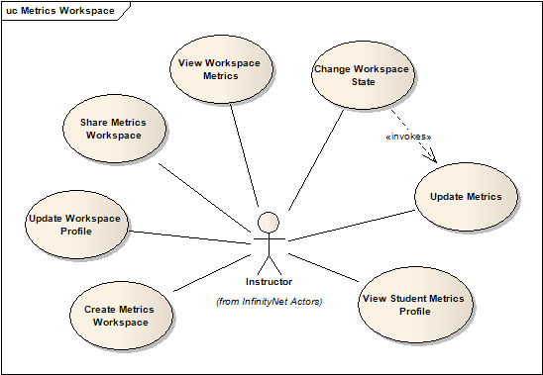
Metrics Workspace package is responsible for the metrics management by the instructors. It includes regular activities such as create new Metrics Workspace, view metrics for a given Workspace, view metrics for a given project in a Workspace, and export the metrics Workspace.

UC100 | Create Metrics Workspace
Description | The instructor creates a new metrics workspace for set of projects already created on java.net, identifying it by a name.
Assumptions | Instructor is logged in to Infinity Metrics system
Preconditions | The instructor has ownership of a java.net parent project.
Postconditions | The system has created a Metrics Workspace configuration linked to this instructor.
Normal Flow | - The instructor clicks on the ‘Create Workspace Configuration’ link.  - The instructor enters the java.net parent project name.  - The system verifies that the instructor is an owner of the given project.  - The system fetches and saves the list of child projects associated with the given parent project.  - The system invokes the Personal Agent to fetch and save the list of available mailing lists and discussion forums for each of the java.net children projects.  - The system will set the state of the project to ‘New’.  - The system displays a confirmation page for the successful workspace creation.
Exceptional Flow :  java.net project field empty | Browser displays a message notifying instructor of empty field exception in java.net username field.
Exceptional Flow :  java.net project name invalid | Browser displays a message notifying instructor of invalid java.net project name exception (i.e. project space does not exist) and prompts to re-enter or abort.
Exceptional Flow :  java.net project ownership verification failure | Browser displays a message notifying instructor of project ownership exception and prompts to re-enter or abort.
Benefiting Actor | Instructor
Dependency | UC002
Requirement Traceability | US015, US049

UC101 | View Workspace Profile
Description | The instructor views the profile of a given workspace (Title, Description, State and list of associated projects) by choosing the name of the workspace.
Assumptions | The instructor has created or has been linked to a Workspace configuration.
Preconditions | The instructor is logged into the Infinity Metrics system.
Postconditions | The system displays the profile for the Workspace.
Normal Flow | - The instructor clicks on the Workspace name hyperlink.  - The system fetches information from the database.  - The system displays the page with the workspace information: Title, Description, State, and list of projects.
Benefiting Actor | Instructor
Dependency | UC100, UC104
Requirement Traceability | US043

UC102 | View Workspace Collection
Description | The instructor views the all current Workspaces created by him/herself or those which have been shared with him/her.
Assumptions | The instructor has been linked to a Workspace configuration.
Precondition | The instructor is logged into the Infinity Metrics system.
Postcondition | The system displays the collection of Workspaces for that instructor.
Normal Flow | - The instructor clicks on the “Workspace” tab.  - The system fetches the information from the database.  - The system displays the list of Workspaces associated with the instructor.
Benefiting Actor | Instructor
Dependency | UC100, UC104
Requirement Traceability | US066

UC103 | Update Workspace Profile
Description | The instructor updates any information on a given Workspace such as adding and removing projects within a Workspace, and changing the name, description and/or state of the Workspace.
Assumptions | The instructor has been linked to a Workspace configuration.
Preconditions | The instructor is logged into the Infinity Metrics system.
Postconditions | The system has updated the Workspace Profile.
Normal Flow | - The instructor clicks on the ‘Update Workspace Information’ link.  - The instructor enters a new title/description/state for the given Workspace. The instructor may also choose to add or remove projects by adding a new project name or selecting a project from the list for deletion.  - The instructor submits the form.  - The system saves the updated information into the database.  - A confirmation page is displayed summarizing the changes made.
Exceptional Flow :  New project field empty  (on ‘rename’) | Browser displays a message notifying instructor of empty field exception for new project name, and prompts to re-select or abort.
Exceptional Flow :  Invalid new project | Browser displays a message notifying instructor of invalid java.net project (e.g. no project space in java.net) and prompts to re-select.
Exceptional Flow :  java.net project ownership verification failure | Browser displays a message notifying instructor of project ownership exception and prompts to re-enter or abort.
Benefiting Actor | Instructor
Dependency | UC100, UC104
Requirement Traceability | US024, US065

UC104 | Share Metrics Workspace
Description | The instructor shares the metrics workspace with another instructor by sending him/her an invitation.
Assumptions | - The instructor sharing the Workspace has created a Workspace.  - The instructor knows the java.net user id or email address of the instructor(s) with whom the Workspace is to be shared.  - The instructor sharing the Workspace must be the project owner for the parent java.net project.
Preconditions | The instructor is logged into the Infinity Metrics system.
Postconditions | The Workspace is shared among instructors.
Normal Flow | - The instructor clicks on the ‘Share Workspace’ link.  - The instructor enters the java.net username for the recipient.  - The system verifies that the user exists in the Infinity Metrics and java.net databases.  - The system saves the sharing configuration for the Workspace.  - The system sends a confirmation email to the recipient(s).  - The system displays a confirmation page to the instructor.
Exceptional Flow :  Invitee not found | Browser displays a message notifying instructor that java.net username was not found in the Infinity Metrics or in the java.net database, and prompts to re-enter or abort.
Benefiting Actor | Instructors
Dependency | UC100
Requirement Traceability | US017

Custom Event Tracker
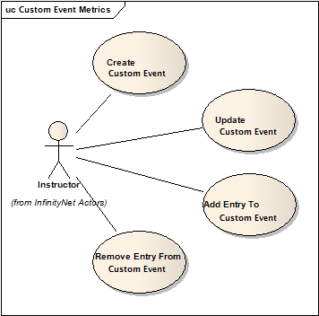
The Custom Event Tracker will help project owners to include additional information about each project they are managing in a given Metrics Workspace. This can be used to flag certain activities during the development of a project such as members that are misbehaving, etc.

UC200 | Create Custom Event
Description | Instructor creates a new Custom Event by entering a title for the Custom Event and notes for its first Entry.
Assumptions | - The Instructor has created a Workspace containing java.net projects.  - A Custom Event exists between team members of a project which the Instructor wishes to monitor.
Precondition | Instructor is logged in to the Infinity Metrics System
Postcondition | Custom Event is added to the Project.
Normal Flow | - Instructor clicks on the ‘Add To’ link next to the project.  - Instructor enters title for Custom Event (date defaults to current date).  - Instructor enters Custom Event Entry notes (date defaults to current date).  - Instructor submits information to be saved in database.  - System sets Custom Event status to ‘Open’ by default.  - System saves information.
Exception Flow :  Custom Event Title field empty | Browser displays a message notifying instructor of blank Custom Event Title field and is available for reentry.
Exception Flow :  Incorrect format for date | Browser displays a message notifying instructor of blank Custom Event Entry Notes field and is available for reentry.
Benefiting Actor | Instructor
Requirement Traceability | US007, US014

UC201 | Update Custom Event
Description | Instructor modifies the settings of a Custom Event.
Assumptions | Instructor has already created a Custom Event.
Precondition | The instructor is logged in to the Infinity Metrics system.
Postcondition | The Custom Event has been updated in the Custom Event Tracker.
Normal Flow | - Instructor clicks on the ‘Edit’ link next to the Custom Event.  - Instructor modifies title and/or status (toggle checkmark) of Custom Event.  - Instructor submits information to be saved in database.  - If Instructor selected ‘toggle’, the status of the Custom Event changes.  - System saves information in the database.
Benefiting Actor | Instructor
Dependency | UC200
Requirement Traceability | US007, US014
UC202 | Add Entry to Custom Event
Description | The instructor wishes to add an entry for a given Custom Event.
Assumptions | The instructor has already created a Custom Event.
Precondition | The instructor is logged in to the Infinity Metrics system.
Postcondition | The entry has been added to the Custom Event and is saved in the database.
Normal Flow | - Instructor clicks on the ‘Add To’ link next to the Custom Event.  - Instructor enters the notes for the entry.  - Instructor submits information to be saved in database.  - System saves information.
Exception Flow :  Blank entry submitted | Browser displays a message notifying instructor of blank Custom Event Entry Notes field and is available for reentry.
Benefiting Actor | Instructor
Dependency | UC200
Requirement Traceability | US007, US014

UC203 | Remove Entry from Custom Event
Description | The instructor deletes an Entry from a Custom Event.
Assumptions | The instructor has already created an entry in the Custom Event of interest.
Precondition | The instructor is logged in to the Infinity Metrics system.
Postcondition | The selected entry has been removed from the Custom Event.
Normal Flow | - Instructor clicks on the ‘Remove From’ link.  - Instructor selects the entry to be removed.  - Instructor submits his/her selection.  - System removes the entry from the database.
Benefiting Actor | Instructor
Dependency | UC200
Requirement Traceability | US007, US014

Metrics Reports

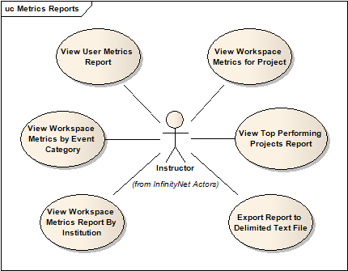
The reports package only includes Use Cases for the reporting capability. This package can be seen as part of the Metrics Workspace.

UC300 | View User Metrics Report
Description | The instructor wishes to view the participation metrics report for ONE student or ONE regular user for all event categories.
Assumptions | The instructor has created a Workspace.
Precondition | The instructor is logged in the Infinity Metrics system.
Postcondition | The system displays the student’s or user’s participation metrics report for every event category.
Normal Flow | - From the View Workspace Metrics by Report page, the instructor clicks on one of the student names associated with the project.  - System fetches information through queries.  - The system displays the report page for the individual student selected.
Benefiting Actor | Instructor
Dependency | UC100
Requirement Traceability | US010, US016, US022

UC301 | View Workspace Metrics Report By Project
Description | The instructor wishes to view the participation metrics report for one project for all the event categories.
Assumptions | The instructor has created a Workspace and has selected which event categories should be tracked.
Precondition | The instructor is logged in the Infinity Metrics system.
Postcondition | The system displays the project’s participation metrics report for all event categories.
Normal Flow | - From the View Workspace Collection page, the Instructor clicks on the project name hyperlink.  - System fetches information through queries.  - The system displays the report page for the individual project selected.
Benefiting Actor | Instructor
Dependency | UC100
Requirement Traceability | US010, US011, US016, US032, US034, US035

UC302 | View Top Performing Projects Report
Description | The instructor wishes to view the top performing projects report within a given Workspace for all event categories being tracked.
Assumptions | The instructor has created a Workspace.
Precondition | The instructor is logged in the Infinity Metrics system.
Postcondition | The system displays the top performing projects report for all event categories.
Normal Flow | - Instructor clicks on the ‘View Top Performing Projects Report’ link from the Workspace Collection homepage.  - Instructor chooses the number of total projects to be viewed from a menu (blank entry defaults to all projects in Workspace).  - Instructor submits information to the system.  - System fetches information through queries.  - The system displays the information.
Benefiting Actor | Instructor
Dependency | UC100
Requirement Traceability | US010, US016, US053

UC303 | View Workspace Metrics Report By Institution
Description | The instructor wishes to view the participation metrics report for all event categories in a Workspace for the selected institution.
Assumptions | The instructor has created a Workspace.
Precondition | The instructor is logged in the Infinity Metrics system.
Postcondition | The system displays the participation metrics in a Workspace for the given institution.
Normal Flow | - From the View Workspace Collection page, the instructor chooses an institution from the tracking list provided.  - System fetches information through queries.  - The system displays the report page for the given institution.
Benefiting Actor | Instructor
Dependency | UC100
Requirement Traceability | US010, US016, US018

UC304 | View Workspace Collection Metrics Report
Description | The instructor wishes to view the participation metrics report for all event categories in all Workspaces for all of the workspace projects.
Assumptions | The instructor has created a Workspace.
Precondition | The instructor is logged in the Infinity Metrics system.
Postcondition | The system displays the participation metrics for all Workspaces.
Normal Flow | - From the InfinityMetrics homepage, the instructor clicks on the Workspace tab.  - The system displays a list of all the workspaces associated with the instructor, along with a graph for the collection of workspaces metrics.
Benefiting Actor | Instructor
Dependency | UC100
Requirement Traceability | US010, US011, US016, US032, US034, US035

UC305 | Export Report to Delimited Text File
Description | The instructor wishes to export a given report to a delimited text file.
Assumptions | The instructor has created a Workspace and has selected which event categories should be tracked.
Precondition | The instructor is logged in the Infinity Metrics system and is currently viewing a report in a chosen format.
Postcondition | The system exports the report to a text file.
Normal Flow | - Instructor clicks on the ‘Export Report to Delimited Text File’ link.  - Instructor chooses name and location of output file.  - System writes information to file.  - The system displays the information.
Exception Flow :  Output file name already exists | Browser displays a message notifying instructor that the output file name already exists, prompts for either an overwrite, re-name or abort.
Benefiting Actor | Instructor
Dependency | UC100, UC300, UC301, UC302, UC303, UC304
Requirement Traceability | US027

Personal Agent API
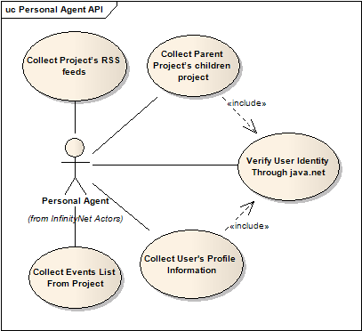
The personal agent API will be responsible for the collection of data from java.net. The personal agent will represent the Instructor on the web, and will be navigating java.net him/her, using his/her personal username and password.

For most of the functionalities that depends on java.net, personal agents can be used to ensure that the data is valid. For example, if different students can hack the system by registering their username as someone else. In order to prevent such malicious activities, the personal agent will always verify the java.net related information.

Finally, the personal agent can also collect the user’s personal information during the registration process. This information might include the real name and email address used on java.net.

UC400 | Collect Events From RSS
Description | The Instructor’s Personal Agent collects data from the list of RSS feeds for the given Workspace.
Assumptions | The instructor has created a Workspace configuration.
Precondition | The Personal Agent is prompted by the system to go collect events from the RSS feeds for all projects in the Workspace.
Postcondition | The events collected will be saved in the database.
Normal Flow | - The Personal Agent gets the total number of events for a given category and determines if new events have been posted.  - If so, the Instructor’s Personal Agent collects the events from the RSS feeds in all projects belonging to the Workspace.  - The events are saved to the database.
Benefiting Actor | Instructor
Dependency | UC100, UC103, UC401, UC403
Requirement Traceability | US002, US003, US004, US005, US006, US008, US009, US057

UC401 | Collect Children Projects
Description | While creating a new Workspace Profile, the instructor’s Personal Agent logs into the given java.net parent project and collects the names of all children projects.
Assumptions | The instructor has already created an account with Infinity Metrics.
Precondition | The Personal Agent is prompted by the system to go retrieve the list of children projects for the given parent project in the Workspace.
Postcondition | The list of children projects for a given java.net parent project will be saved in the database.
Normal Flow | - The Instructor’s Personal Agent logs into java.net using the credentials for the instructor.  - The Instructor’s Personal Agent retrieves the list of children projects for a given java.net parent project.  - The Instructor’s Personal Agent saves the list into the database.
Benefiting Actor | Instructor
Dependency | UC100, UC103
Requirement Traceability | US049

UC402 | Verify User Identity Through java.net
Description | While creating a new user on the system or getting updated available RSS feeds for a set of java.net projects, the Personal Agent determines whether the given java.net credentials are valid.
Assumptions | The User has provided java.net credentials to the system.
Precondition | The Personal Agent is prompted by the system to verify a user’s java.net credentials
Postcondition | The system has verified the identity of the user on java.net.
Normal Flow | - The system gets the java.net credentials from the prospective user or from the database.  - The system authenticates the user’s credentials against java.net.  - The system returns authentication results.
Benefiting Actor | User
Dependency | UC001, UC002, UC100, UC103, UC104
Requirement Traceability | US020, US061, US062

UC403 | Collect Events List From Project
Description | While creating or updating a Workspace, the Instructor’s Personal Agent logs into the given java.net projects and collects the event lists for all of its children projects.
Assumptions | The Instructor is creating or updating a given Workspace.
Precondition | The Instructor’s Personal Agent is prompted by the system to collect the event list from a given project.
Postcondition | The event list from a given project has been saved in the database.
Normal Flow | - The Instructor’s Personal Agent logs into java.net using his/her credentials.  - The Instructor’s Personal Agent retrieves the event list from all java.net projects for a given Workspace  - The Instructor’s Personal Agent constructs the RSS’ URL based on the syntax rules for the given event category (i.e. “https://[PName].dev.java.net/servlets/ProjectRSS?type=message&forumID=#” for Discussion Forums, where PName is the java.net project and # is an unsigned integer representing the GUID assigned by java.net; or  “https://[PName].dev.java.net/servlets/MailingListRSS?listName[MLName]”, where PName is the java.net project and MLName is the mailing list (dev, issues, announce, commits, or a custom mailing list).  - The Instructor’s Personal Agent saves the list into the database.
Benefiting Actor | Instructor
Dependency | UC100, UC103
Requirement Traceability | US047

UC404 | Collect User’s Profile Information
Description | During the registration process, the personal agent uses the user’s java.net username and password to collect his/her real name, email address and any other available personal information.
Assumptions | Any type of user is registering on the website.
Precondition | The user has an account at java.net.
Postcondition | The user’s username, real name and email address is shown to the user.
Normal Flow | - The Instructor’s Personal Agent logs into java.net using the credentials for the instructor  - Goes to the URL of User Profile. https://www.dev.java.net/servlets/UserEdit  - The agent collects the full name and email address, and verifies username.
Benefiting Actor | User
Dependency | UC100, UC103
Requirement Traceability | US067

Functional Requirements
User Management
ID | Description | Priority
US021 | Instructors shall be able to see the students’ real name on the reports. | P1
US039 | Instructors shall be able to login into the system with my username and password created in the registration. | P1
US052 | Instructors shall be able to view their account detail. | P1
US063 | Students, who are team leaders, shall be able to identify their team members by giving their java.net usernames. | P1
US020 | Users shall be able to identify themselves into the system by using their java.net username and password. | P2
US022 | Instructors shall be able to see each student's profile, with their Real Name, Student ID, Group Number, if he/she is a team leader, etc. | P2
US060 | Users shall be able to receive an email after registering on the website. | P2
US064 | The system shall send an email to the team’s dev mailing list with instructions (URL) | P2
US055 | Users shall be able to retrieve their lost/forgotten password by email or web browser. | P3
US059 | Users shall be able to change their profile information, but not their username. | P3

Metrics Workspace
ID | Description | Priority
US015 | Instructors shall be able to set up a Project Metrics Configuration Workspace. | P1
US024 | Instructors shall be able to add and modify a Configuration throughout the configuration life-cycle. | P1
US043 | Instructors shall be able browse for projects in a given Configuration. | P1
US017 | Instructors shall be able to share a Configuration with peer instructors. | P2
US018 | Instructors shall be able to filter the students by their institution on a given Configuration. | P2
US019 | Instructors shall be able to list the java.net username of each group member on a given Configuration. | P2
US044 | Instructors shall be able to browse for Event categories in a given Configuration. | P2
US053 | Instructors shall be able to see the top Projects based on participation by the sum on categories or each of them. | P2
US058 | Instructors shall be able to pause or make inactive the Metrics Workspace. | P2
US065 | Instructors shall be able to modify which event categories are tracked for a given project in a Workspace Configuration. | P2
US066 | Instructors shall be able to view the collection of Workspaces that he/she has created and those which have been shared with him/her | P2
US045 | Instructors shall be able to search for projects in a Configuration. | P3
US046 | Instructors shall be able to search for categories in a Configuration. | P3

Metrics Report
ID | Description | Priority
US002 | Instructors shall be able to track the Event of Code Repository. | P1
US003 | Instructors shall be able to track the Event of Tracking System. | P1
US004 | Instructors shall be able to track the Event of Emails sent to the available Mailing Lists. | P1
US005 | Instructors shall be able to track the Event of Posts sent to Discussion Forums. | P1
US006 | Instructors shall be able to track the Event of Documentation. | P1
US007 | Instructors shall be able to track the Event of Custom Events within teams. | P1
US010 | Instructors shall be able to monitor events. | P1
US011 | Instructors shall be able to view the Events by groups. | P1
US012 | Instructors shall be able to analyze Events from the groups by their event category. | P3
US016 | Instructors shall be able to create a Report for a Metrics Configuration. | P1
US025 | Instructors shall be able to view Reports in a tabular format. | P1
US026 | Instructors shall be able to view Reports in a graphical format. | P1
US027 | Instructors shall be able to export Reports to flat text files in delimited format. | P1
US032 | Instructors shall be able to read a Report for a single project in a tabular format for all the event categories. | P1
US035 | Instructors shall be able to read the Report for a single project in a graphical format. | P1
US031 | Instructors shall be able to read a Report comparing all the projects in a Configuration in a tabular way. | P2
US033 | Instructors shall be able to read a Report for a single Event category on a given Configuration Workspace. | P2
US034 | Instructors shall be able to read the Report comparing all the projects in a Configuration in a graphical format. | P2
US036 | Instructors shall be able to read the Report on a single event category in graphs for the groups on a Configuration. | P2

Personal Agent
ID | Description | Priority
US062 | Users shall not be able to use a different username and password from java.net. | P1
US047 | Instructors shall be able to have their Personal Agent use their java.net credentials to parse and extract the RSS feeds from each project mailing list. | P2
US049 | Instructors shall be able to have their personal agent to go to the parent project and load the project names for a new configuration. | P2
US057 | Instructors shall be able to have their personal agent to verify the summary of the RSS posts on a given project has been changed. | P2
US067 | Users shall be to collect to have their personal agent to collect his/her real name and email address from java.net | P2
US048 | Instructors shall be able to see the students' login activities such as number of visits to java.net and the last time he logged in. | P3

Custom Event Tracker
ID | Description | Priority
US014 | Instructors shall be able to manually add customized group interaction Events (i.e. custom events). | P1

Non-Functional Requirements
General Application
ID | Description | Priority
US001 | Instructors shall be able to access to the system using a web browser. | P1
US008 | The system shall be able to collect events' data automatically from java.net. | P1
US009 | The system shall be able to store relevant parts of the RSS feeds collected on a database. | P1
US013 | The system shall be targeted to java.net collaborative platform. | P1
US028 | Instructors shall be able to use the system without any additional training. | P1
US029 | The system shall not require users to have knowledge of web application development or database systems. | P1
US030 | The system shall be able to be accessed efficiently on high-speed Internet connections. | P1
US038 | The system shall be able to encrypt the user’s username and password. | P1
US040 | The system shall offer users online help. | P1
US041 | The system shall respond to queries in less than 3 seconds. | P1
US042 | The system shall offer users a secure connection through SSL. | P2
US061 | The system shall verify the students’ identity through java.net. | P2

Domain Vocabulary
The Domain Model defines a consistent, common vocabulary across a project. After analyzing the requirements and use cases, the entities and their relationships are defined below. The domain vocabulary can be thought of as the first abstraction of the high-level class diagram.

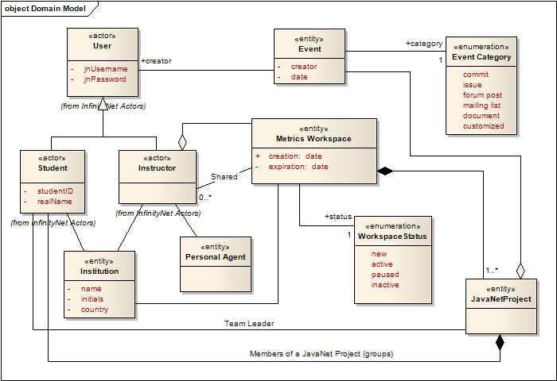

The glossary describes the domain module above.

Metrics Data Collection

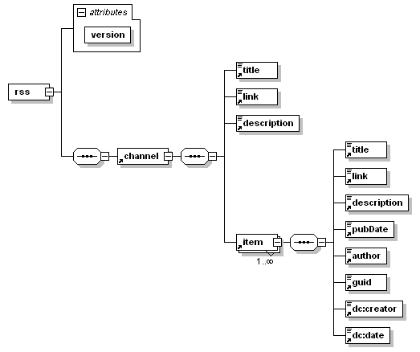
The most basic data to be used is the RSS feeds from the mailing lists and discussion forums. Those are the main source of data to generate the metrics. For this case, here is the XML Schema definition of the RSS feeds that are generated by java.net.

Note that an RSS feed is composed by an instance of channel, and each channel is composed by a collection of items. By the implementation of java.net RSS feeds, the channel element will always contain at least one item, showing that there are no items available.

In order to improve performance during data collection, the personal agent will be trained to collect just meaningful information from the RSS feeds. That includes unique identification of the event category, its description, location and the collection of items, in our case the collection of events generated on each of the categories. For this reason, it’s relevant to describe where each of the data will come from and map each of them into the Infinity Metrics. The next table describes the meaningful data extract from some of the xml elements from the RSS feeds.

The personal agent can extract the entire data or decide extracting only a subset of characters or the element value, depending on its values. There are possibly 2 different types of RSS feeds on java.net: One for mailing lists and another for discussion forums. For each of them, different URL structure is constructed to acquire the data to be collected. They can be described as follows:

- RSS feeds for Mailing Lists

https://{_PROJECT_NAME_}.dev.java.net/servlets/MailingListRSS?listName={_EVENT_CATEGORY_}

  - {_PROJECT_NAME_} is the name of the project;
  - {_EVENT_CATEGORY_} is the identification of the event category.
    - “announces”, “cvs”, “dev”, “users”, “issues”, “commits” are usually the default values for a new java.net project installation.

- RSS feeds for Discussion Forums:

https://{_PROJECT_NAME_}.dev.java.net/servlets/ProjectRSS?type=message&forumID={_FORUM_ID_}
  - {_PROJECT_NAME_} is the name of the project;
  - {_FORUM_ID_} is the positive integer value that identifies the forum.

Basically, the pairs {_PROJECT_NAME_}, {_EVENT_CATEGORY_} and {_PROJECT_NAME_}, {_FORUM_ID_} and will be used to uniquely identify each channel type of a project. As one can notice, both URLs differ on the name of the server-side component call and parameters name. There is NO need whatsoever in collecting those values, since they can be re-generated on the fly.

When it comes to the identification of each event, the Agent has to be capable of extracting the identifiers of each of them. As described below, they contain the same variables from the channel URL structure, plus their unique identification for each of them.

- Mailing Lists Event

https://{_PROJECT_NAME_}.dev.java.net/servlets/ReadMsg?list={_EVENT_CATEGORY_}&msgNo={_EVENT_ID_}

- RSS feeds for Discussion Forums:

https://{_PROJECT_NAME_}.dev.java.net/servlets/ProjectForumMessageView? forumID={_FORUM_ID_}&messageID={_EVENT_ID_}

  - {_EVENT_ID_} is the unique identification of the event.

In this way, the following table describes the parsing strategies and what meaningful data is being collected.

RSS Element (XPath) | Parsing Strategy | Infinity Metrics Data Binding
/rss/channel/title | Complete Data | The title for each event channel. This is used to visually identify each event category. It will be used just for the user interface.
/rss/channel/link | Partial Data | The agent extracts first the project name to make sure the data is valid from the URL being used. Depending from where the RSS was generated from, there are different channel identifiers to be captured:  - Mailing lists: must extract the value of the HTTP parameter “listName”;  - Discussion Forums: must extract the value of the HTTP parameter “forumId”.
/rss/channel/item[x]/link | Partial Data | Each event is identified by a unique identification.  - Mailing lists: must extract the value of the HTTP parameter “listName”;  - Discussion Forums: must extract the value of the HTTP parameter “messageID”
/rss/channel/item[x]/pubDate | Complete Data | This is the event’s publication date. It will be used for filtering events by its creation time.
/rss/channel/item[x]/author | Complete Data, with match | Different mailing lists can contain different values for the author of the event. Here is the list of the possible values, categorized by the types of RSS feeds:  - Issues, forums: the regular username;  - users, dev: the complete full name; Must match registered user’s full name.  - commits: the email address. Must match registered user’s java.net email address.

Some URLs from java.net gives the binding values the variables described above. The idea is to bind these variables with the values from the User’s Profile java.net URL, which contains the username, email address and possibly his/her full name, depending on the configuration of java.net. In this case, the system should collect this information directly from the user, asking to copy the same name as java.net.

User Interfaces
As user interfaces goes, Infinity Metrics will provide the regular registration forms and login forms as any other web application, containing their own set of required field for the type of user: instructor or students. However, the most important aspect of the application is the instructor’s metrics workspace.

Mock-ups

Users Registration and login

As soon as the user wants to register into Infinity Metrics, the user MUST use the same username and password from Java.net. The username, password and the project name on Java.net will be provided.

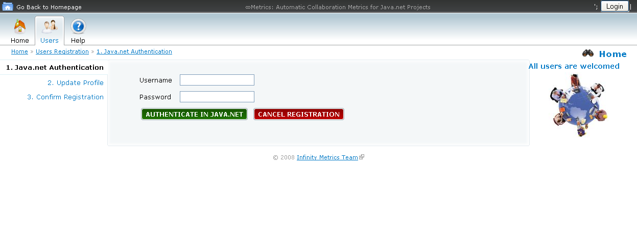

This information is the only necessary one for the internal agents to collect information of the user directly from Java.net . After this point, the Agent might have collected the user’s personal profile from Java.net. 2 special users are instructors and students or java.Net Users who do not come from any institution. Choose one or the other, will lead to the following screen.

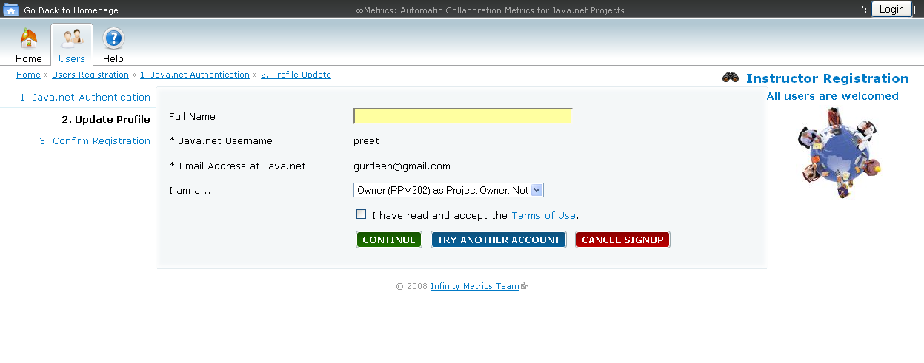
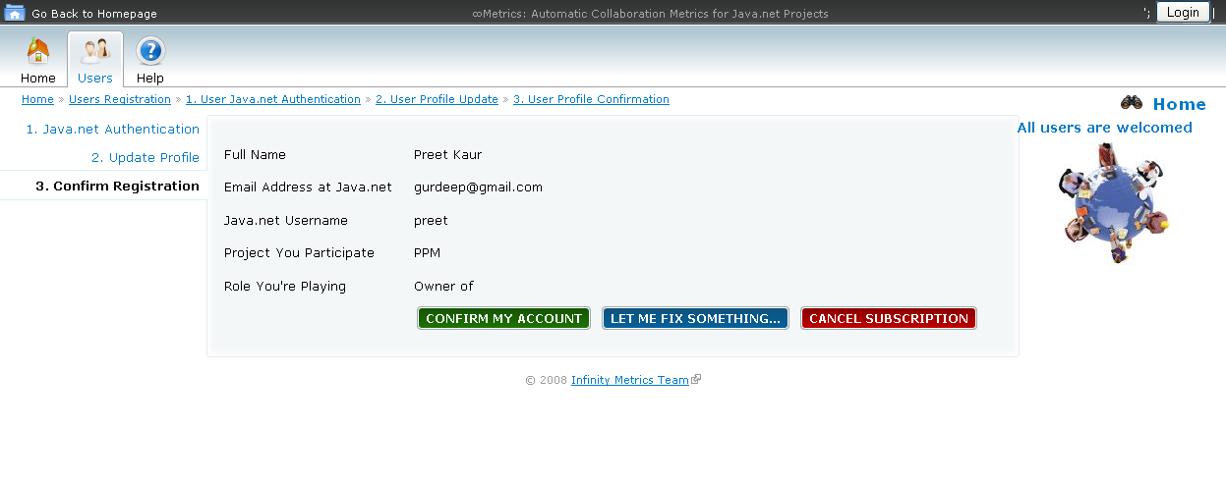

The second step of the registration steps brings the personal information from Java.net in regards the user. The user, instructor or student, can verify the form data collected from Java.net and modify it accordingly. The registration confirmation makes the system send an email to the dev mailing list of the user with instructions on how to proceed.

After Registering the user is automatically logged into the system. And if the user is already registered and wants to login then he can do so by entering his java.net username and password in the login page.

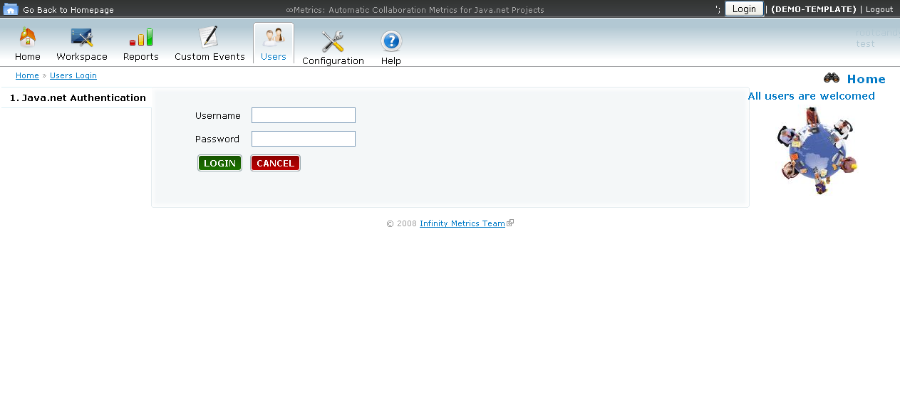.

Metrics Workspace

In order to view metrics for a given Workspace, the instructor clicks on the “Workspace” tab located in the top left corner of InfinityMetrics page. The Workspace homepage displays a collection of all the Workspaces associated with the instructor, both those created by the instructor and those shared by the instructor.

To view the Workspace metrics, the instructor needs to select one of the Workspace names listed on their Workspace homepage. This will link them to a page displaying the Workspace information, a graph of the Workspace metrics (with project and event information), and the list of all the projects associated with this Workspace.

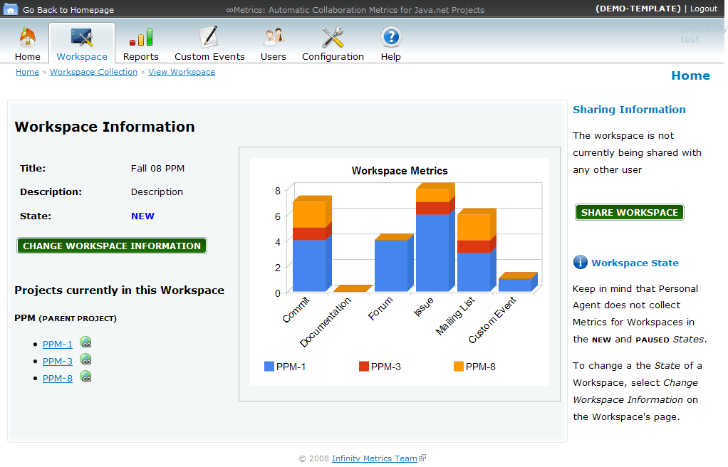

Project Metrics report

From the individual Workspace viewpage, the instructor may select to view a Project metrics by clicking on one of the project’s name listed. This will then display the Project information, along with a graph of the project metrics (comparing user (student) and event information) and a list of student (users) associated with the project.

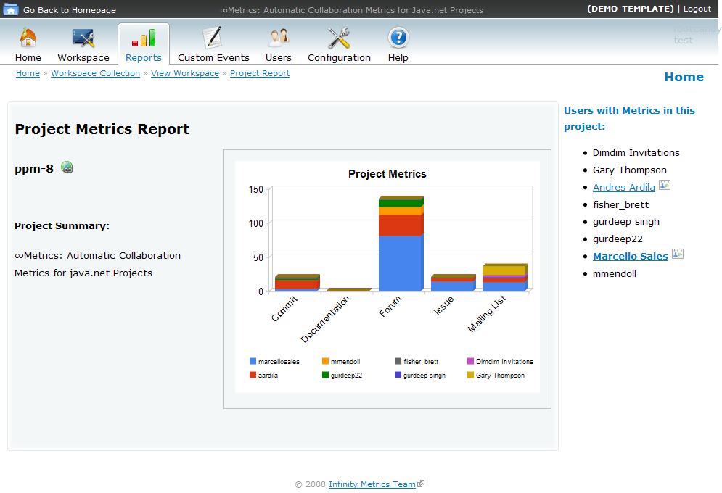

Student Metrics Report

From the Project metrics view, the instructor may elect to view metrics for one student (user) associated with that particular project. The instructor selects a name from the list of student (users) on the right side of the Project metrics viewpage. This links to the Student (User) metrics viewpage, which displays a graph of the student’s project participation in relation to the given monitored events.

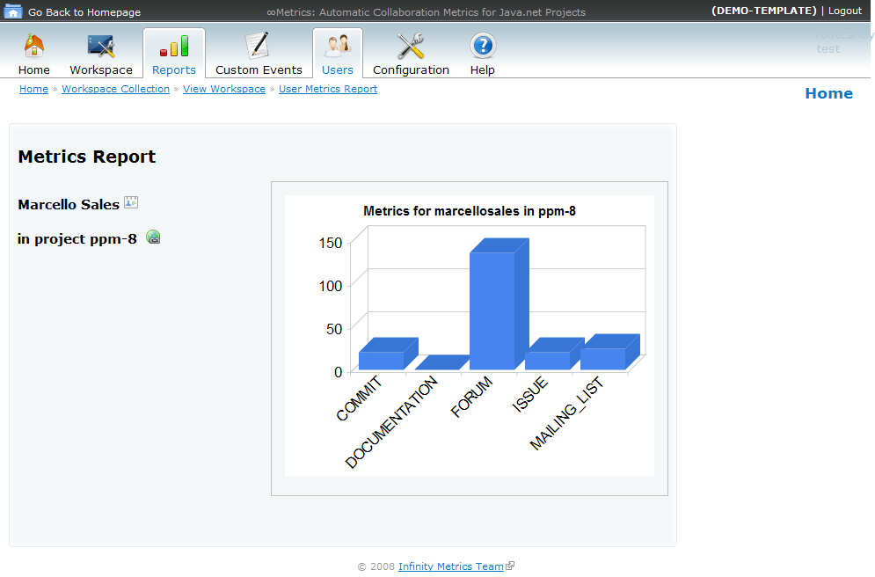

View Workspaces

The standard view from the Custom Events tab is shown below. From here an instructor can choose from the workspaces under his/her own control, or select from one shared with him/her.

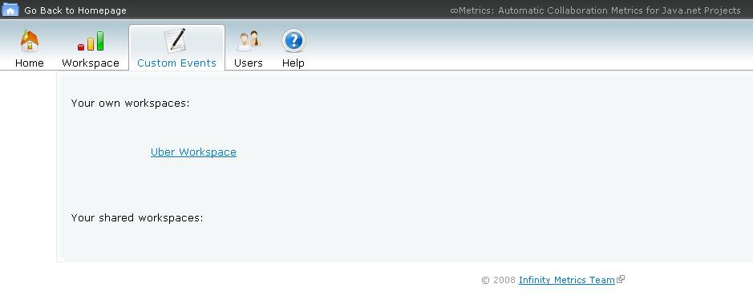

View Custom Events

Once the instructor chooses a workspace, each of the projects and custom events within the workspace are displayed. From here the instructor can choose to Add to a Project, an Event, edit an already existing Event, or delete an Entry.

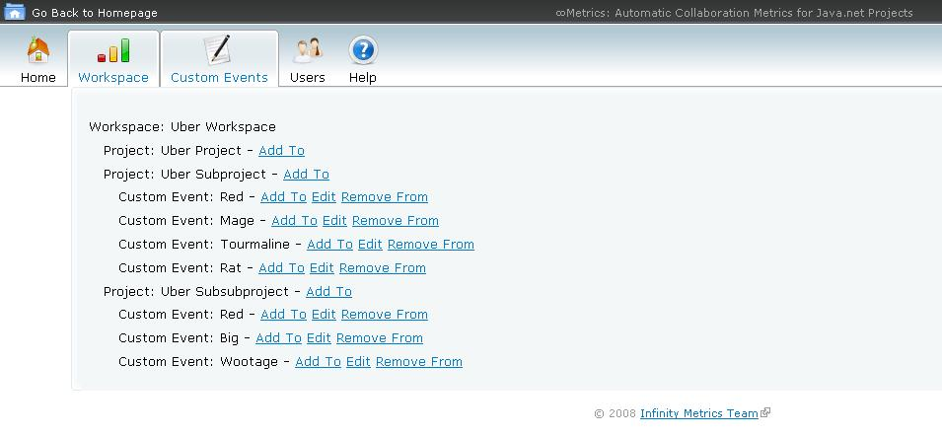

Add Custom Event

Once the instructor clicks on a project to add an Event to, this view is shown. The instructor must then enter both title and notes for the first Entry or an error will display. Upon valid entry, a confirmation notification is shown and the database is updated.

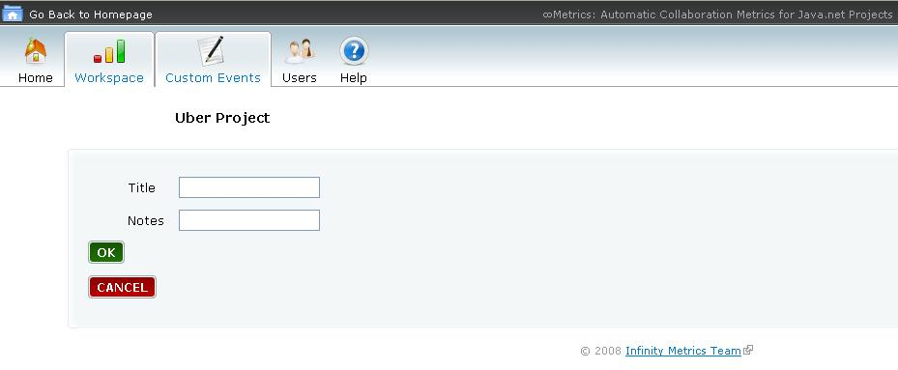

Add Custom Event Entry

When an instructor chooses to add an entry to an event, this view is shown. This simple text field simply needs the notes of the new entry to be entered. Failure to fill the text field results in an error.

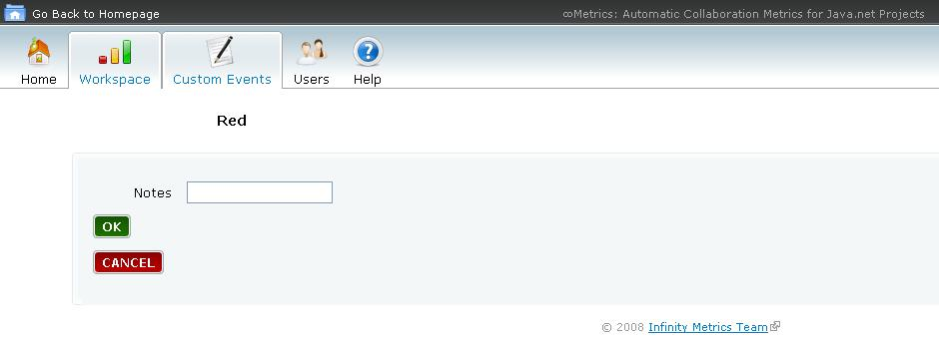

Edit Custom Event

When an instructor chooses to edit an event, this view is shown. Errors are not possible in this screen. The instructor can enter a new title, click the toggle checkmark to swap the status between Open and Resolved, or both. If both fields are left blank, the event is left unchanged upon submission.

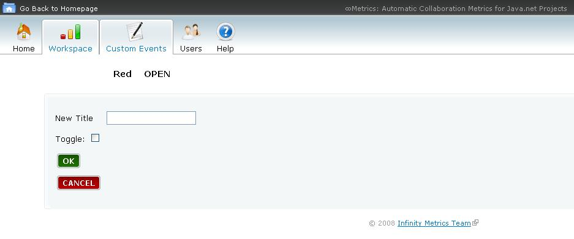

Delete Custom Event Entry

When an instructor chooses to delete an entry, this view is shown. Errors are not possible in this screen. The instructor simply clicks on an entry to delete and the screen is refreshed with the new shorter event.

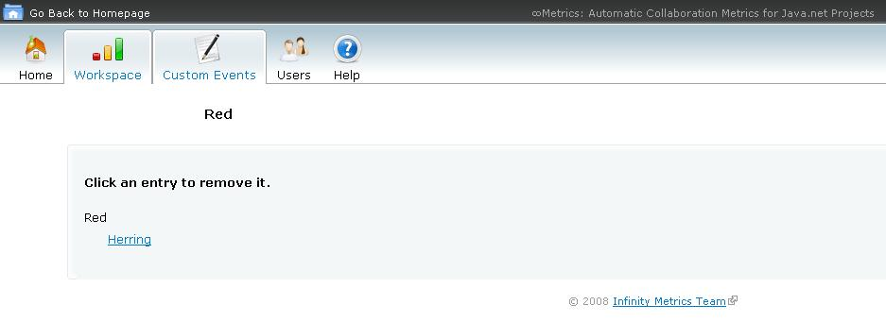

Storyboards

User Management Storyboard

Users will be taken to the User’s registration page. This page will be asking regular users for registering at the jnRegistration page. If they happen to be from an institution, then the instructors and students have a separate registration process. After a successful registration process, the user is automatically logged into the system. If user is already register he can do login from the login section, where they can use the username and password as like the one used on java.net. After a successful login into Infinity Metrics, then the user’s profile is shown for a team member or a project owner.

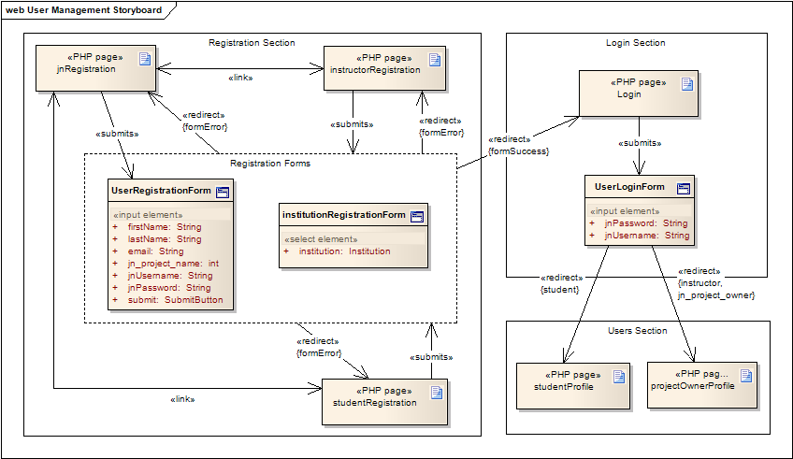

Custom Event Tracker Storyboard

The metrics for the Custom Event Tracker is used to control additional information about a project. The project owners can add and update Custom Events.  From a given Metrics Workspace, the project owner can select one of the existing functionalities: add Custom Events, edit Custom Events, add Custom Event Entry, and remove Custom Event Entry. The remove Custom Event Entry loads a new page where a specific entry is selectable. The edit Custom Events updates the information on the metrics, as well as it shows a notification of success for the given Custom Event. | 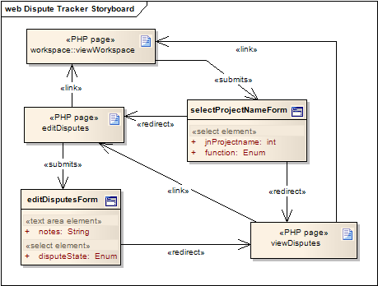

Metrics Workspace Storyboard

The metrics workspace is used by project owners to create, edit and update workspaces. It includes the boards of metrics reports. It will use the Personal Agent to verify the project’s ownership, and when the user wants to share the workspace metrics.

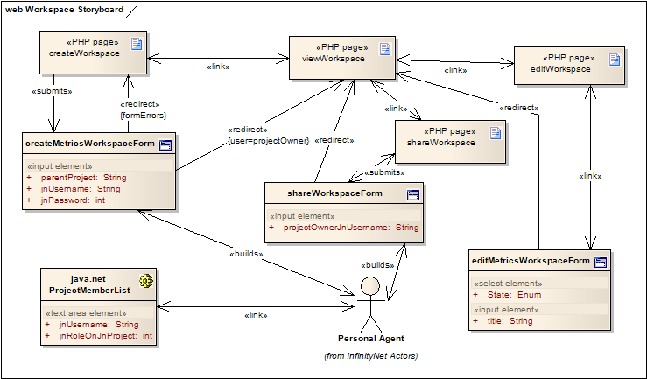

Metrics Reports Storyboard

The metrics will give options to the user to browse the projects list, and from each of them it will be possible to view more reports such as for a given project member. For institutions, that would be in the context of a project, its members and the events. For each of the metrics visualization pages, the project owner can go back to the first page to view his/her workspace.

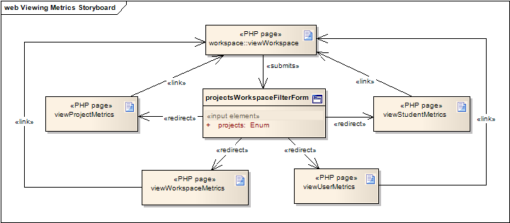

High-level System Architecture
The system is intended to be developed on the Internet. Therefore, main client to the application is a web browser and the server contains technologies to publish server-side web pages, integrated with a database system.

Web Server and Web technology

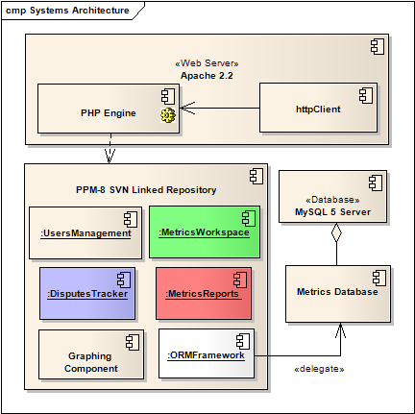
The font-end of the Infinity Metrics implementation consists of an extensive User Interface, constructed mainly in PHP and perhaps Ajax. Infinity Metrics will be redesigning and expanding on the core functionality of the StatsWidgets Project, and in doing so, will work to bring this functionality up-to-date with current technology by implementing a well-constructed, web-based user interface along with its back-end crawler. In order to offer most of the features planned, the server will feature an Apache Web Server, along with additional PHP modules. The most important additional module is called cURL, which can be used as an HTTP client.

As for the PHP source-code, it will be deployed to the SFSU T-2000 server using Subversion infrastructure during the development process. In this way, a given revision must be tested and selected to be deployed. This revision includes the core components for the Metrics Business logic, with the intent to make use of additional PHP frameworks. As you can see, the ORM Framework is the only one with the knowledge about the database system. Mode details for each component in section 5.

Database Server

In order to overcome the short-comings of RSS feeds where older data drops as new data is acquired, the back-bone of Infinity Metrics system will contain a MySQL database for information storage. In this way, the metrics data will be categorized in a meaningful way to be later retrieved. The MySQL server consists of the version 5, and will use advanced stored procedures and triggers during implementation.

At the end of a given semester, or upon project completion, the data that was collected and stored will not be discarded. This will allow instructors not only to maintain access over the project life-cycle and eventual project completion, but into the future, where analysis and comparisons can be made between different Workspace Configurations in order to infer trends or the effects of changes in the structure of the course by student participation and progress in the projects.

Graphing Component

The Google Visualization Framework (http://code.google.com/apis/visualization/) is a brand new tool from Google that provides visualization of structured data using AJAX. The framework includes capabilities to display different types of interactive charts, and dynamically modify or “fire” AJAX events that modify the chart’s appearance to create a rich user-experience even after the chart has been sent to the browser.

The Google Visualization API is a JavaScript library that exposes methods to create and manipulate the visualization. Data for the charts is provided to the API by instantiating a DataTable object, which is a two-dimensional table that is built by declaring the columns and data type they will hold, and then filling each individual cell in the table row by row.

The graphing API is integrated into the Metrics Reports component to insert the JavaScript into the source that will be rendered by the browser. All data manipulation is performed by methods in the Report Model, which are used by the Report Controller to generate the script to be inserted in the final HTML/PHP file that the browser renders. The Report Model exposes methods that return participation metrics for each of the views (i.e. Workspace Collection, Workspace, Project and User) by passing criteria, such as the user, project or workspace database identifiers. These metrics reports are formatted internally as multidimensional associative arrays, which are then passed to the Reports Controller to iterate through and construct the call to the API by building each portion of the JavaScript based from the metrics. An example of an array returned by the Report class for the hypothetical workspace for PPM would appear as follows:

Array (
[ppm-1] => Array (
[COMMITS] => 36
[ISSUES] => 24
[MAILING_LIST] => 124
[DOCUMENTATION] => 4
[FORUM] => 95
[CUSTOM_EVENT] => 3
)
[ppm-xx] = Array (
...
)
)

The controller builds the DataTable by iterating through the array and building each row, for example this code-snippet builds the table for the user report:

$script .= "function drawChart() {
var barData = new google.visualization.DataTable();
barData.addColumn('string', 'Event Category');
barData.addColumn('number', 'Number of Entries');
barData.addRows(".count($metrics).");";
$idx = 0;
foreach ($metrics as $category => $value) {
$script .= "barData.setValue($idx, 0, '".$key."');\n";
$script .= "barData.setValue($idx, 1, ".$value.");\n";
$idx++;
}

Finally, the chart is output by calling the draw method on the Google Visualization object and passing it the parameters, such as the position of the legend, title, dimension, etc.

For the final release, we anticipate to abstract the script generation by integrating an OO-PHP wrapper around the Visualization API. A simple wrapper can be implemented by the group, or off-the-shelf solution can be implemented. An open source option (BSD License) currently under consideration is QGoogleVisualization (http://www.phpclasses.org/browse/package/4665.html), which was recommended by the Google Code Blog to the APIs users. This wrapper provides all functionality that was implemented for Milestone 3 in addition to extra functionality that we can take advantage of for future releases/milestones.

Architectural Design
Infinity Metrics is modularized into components. Each component is designed using an extended version of the Model-View-Controller (MVC) architectural layers design-pattern. It includes the Data layer, among the traditional ones, responsible for the persistent space for the objects of the Model layer, being a mapping between the business classes from the Model to the relational database.

Components diagram

We will take the approach of separating the Use Cases packages into separate component, being responsible for the given functionality in as a well-contained collection of complete functionalities. Each component is then modeled using the DMVC layers introduced above and mixed together in the architectural diagram.

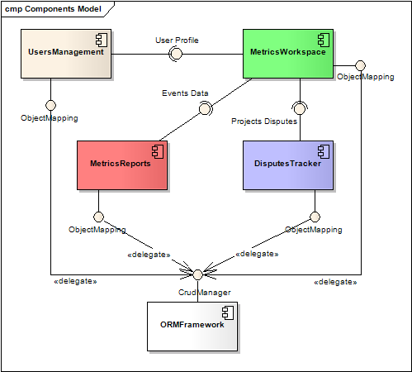

Component | Description
Users Management | It’s responsible for user management in general. It encapsulates the types of users, their profiles, and the personal agent for each type of users. It exposes the User Profile interface to the Metrics Workspace Profile.
Metrics Workspace | The main interface for project owners is placed into the Metrics Workspace. It will be responsible for managing the project owner’s metrics into groups of projects. In this way, it is composed by the Metrics Reports and Custom Events Tracker components, which has its own responsibilities.
Metrics Reports | Responsible for the generation of reports. It will be where the RSS data feeds are encapsulated.
Custom Events Tracker | Custom Events are generated for any project on a given workspace, whenever it is necessary.
ORM Framework | The Object-Relational Model framework is responsible for managing the mappings of objects of all components to the data layer, or the Database. This component is one to be selected from the available ones on the PHP Community.

MVC-D layers and Class Diagram

The next subsections describe each layer that is used on each of the components. After each of the subsections, the business classes that make part of the components were highlighted with the same color for better identification. The complete Architectural Diagram is located in the end of the subsections.

Model

The model describes the four main components, in PHP classes: Users, Metrics Workspace, Reports and Custom Event Tracker.

Instructor and Student are generalized into Users. They have profile information, including their java.net username & password, their real name and email address. Students and Instructors are associated with an Institution and also have an Institution Id.

Metrics Workspaces include a title and description as well as a state (e.g. 'Active', 'Paused', 'Inactive'). Workspaces contain a collection of java.net Projects, composed of a parent and children projects. Finally, the workspace can be shared with other Instructors.

The list of Event Channels that is available in each of the children projects is collected from java.net and allows the system to validate project ownership for Instructor registration and team leaders. Each Event Channel has an Event Category, which help record the metrics by Category (e.g. Commits, Issues, etc.) It is from each of these Channels and its respective mapping to a valid RSS resource that the Instructor's Personal Agent will collect the Participation Metrics for each Proect. Finally, the instructor may add Custom Events, which in turn contain Entries that will allow him/her to track individual events within a team pertaining to a Custom Event. These Custom events are considered Participation Metrics and are measured at the Project Level.

View

The presentation of model is based on the Participation Metrics collected by the Personal Agent, which can be viewed through the Workspace Collection in several PHP pages in graphical or tabular presentation. These views include Participation Metrics by project), by user by Event Category. Views are also provided for user accounts. In addition, a View is provided for the set of Workpspaces (Workspace Collection) that have been created and/or shared with an Instructor. Lastly, views are also available for the Custom Event Tracker on which the Instructor can create or read entries related to a given Custom Event.

Controller

The Controllers implements the functionality of the Use cases. Basically, for each package of the use cases, a controller is given the responsibility to implement each functionality. The controller MUST list all the methods, and those that are not implemented must through the exception to the client.

As it will be shown on the diagram, each component will have a mapping of 1-to-1 with the controllers. For example, the Use Cases package Users Management will have its UserController, implementing all the use cases mapped into method calls. They will extensively depend on the model and will select the appropriate view after its execution.

Data

The Data Persistence will consist of an ORM framework that will provide a transparent data storage mechanism for the state of the application. It will map the PHP persistent classes of the Model layer, and will implement the Create-Retrieve-Update-Date operations, also known as CRUD operations. Below is a table that summarizes the frameworks to be evaluated during the first iteration of the milestone 3.

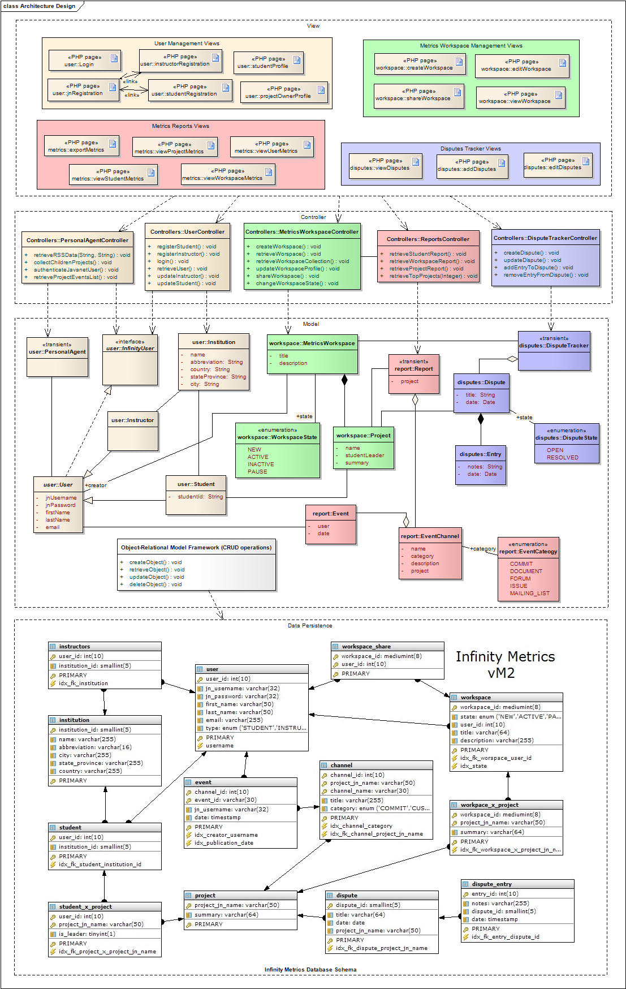

MVC, CMS and ORM Frameworks for evalution

For development, we will be evaluating a different number of frameworks that range from Model-View-Controler (MVC), Content-Management Systems (CMS) and Object-Relational Mapping (ORM) frameworks, in order to promote fast prototype. However, that also can lead to none of the frameworks to be chosen, given the development time frame. These frameworks are to be considered during Milestone 3.

Basically, such framework should be able to speed the development process, avoid having to develop the same configuration for the same usual code. Given the Data Mode, the code ORM framework should offer a simple code generation tool that can generate the Object Code and the CRUD Views. In this way, developers will just update and choose which of them are necessary. The image below depicts these ideas from the framework QCodo.
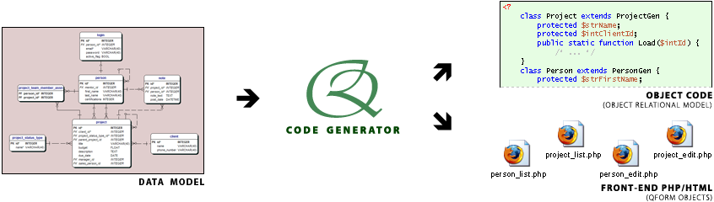
Image referenced from http://www.qcodo.com/images/codegen.png

Although the use of ORM helps development, it should give support to the execution of SQL in case of very complex objects graph. That should be one of the main features supported by the framework. For features like lazy loading and cascade, it should be provide performance and avoid multiple SQL requests. The maximum allowed should be not more than 4 SQL commands executed per batch.

- Doctrine: It uses descriptors to describe the tables and its columns in a very clean way. It supports CRUD, but might need integration with other frameworks such as PEAR: http://www.doctrine-project.org/documentation/cookbook/1_0/?one-page
- PHP Object Generator: It is the easiest way to generate the ORM in PHP, given that there’s no need for other installations, includes, etc. Online generation.
http://www.phpobjectgenerator.com/

- Propel: Maybe the most powerful ORM implementation in PHP, features all the properties of an ORM;
http://propel.phpdb.org
- QCodo: Generate classes and CRUD pages.
http://www.qcodo.com

- Xyster: From ZendFramework, and features ORM mapping and dependency injection.
http://xyster.devweblog.org/documentation/guide/xyster.orm.html

- SilverStripe: It has a content management system and the ORM framework.
http://www.silverstripe.com/showcase

- CakePHP, Synfony, Jelix, Phpontrax, ZoopFramework, Drupal CMS are the selections for Rapid Application development with a complete MVC stack.

Competitive Analysis
Despite its potential wide-ranging applications, research on the automation of collecting participation metrics of java.net projects by the community at large has yielded little significant results. In fact, GlassFish, one of the largest and most widely used projects on java.net^{[1]} has no automated participation metrics system^{[2]}. While StatsWidgets provides the limited functionality of outputting delimited text files of a given RSS feed (or a set of them) from public and/or private projects, this implementation provides little usability for the intended audience of our system because it would require instructors to set up, configure and maintain a database to handle the output files generated by StatsWidgets. Since the requirements explicitly state that users should have no such prior knowledge of database systems, StatsWidgets proves inadequate in this regard. In addition, not all metrics generated by a project are traceable using RSS, and so the need for a tool that will collect metrics on these non-RSS participation metrics is essential. We aim to automate not only the retrieval of the RSS feeds, but the storage in a database that will enable presentation in rich and meaningful ways to the instructor.

Notwithstanding StatsWidgets' differing intended audience, the similarity of its core functionality makes it a competitor to our system. Following is a side-by-side architectural and functional comparison of the two systems.

Competitive Analysis – Financial and Technical
Product | Open-Source | Cost | Platform | Persistence | Modules
∞Metrics | Yes | Free | PHP 5.2 | MySQL | PHP, cURL
Stats Widgets | Yes | Free | JDK 2 | Text Files | Kosuke Scraper
Project Metrics | No | Free | ~ | ~ | ~

Competitive Analysis – Functional Requirements

Functionality | ∞Metrics | Stats Widgets | Project Metrics
Provides Metrics for Public projects | ✓ | ✓ | ✓
Provides Metrics for Private Projects | ✓ | ✓
Store Metrics in a Database System | ✓ |  | ✓
Provides Web Interface for Users | ✓
Provides Tabular Data to Users | ✓ | ✓ | ✓
Provides Graphical Data to Users | ✓ |  | ✓
Export Delimited Data | ✓ | ✓ | ✓
Saves Configuration | ✓

[1] http://community.java.net/projects/top.csp
[2] http://wiki.glassfish.java.net/Wiki.jsp?page=CommunityStatistics

Risk management
The risk management is an important tool to identify possible problems and how to mitigate them. It is used by the entire team, especially by the project leaders. The Risk Analysis subsection describes each of the identified risks for this project, defining its scope and type. Along with that, the subsection Risk Monitoring describes probabilities of such risks to take place, indicators of that show when the risk has emerged the strategies on how to mitigate each of them.

Risk Analysis

Risk | Risk Type | Risk Scope | Description
Team Member Skill Set | People | Project/Product | Team members do not possess the programming skill set to adequately complete the project.
Scheduling Difficulties | Organizational | Project | Time zone differences, schedule overload and conflicting schedules among team members will occur
Legal Liabilities | Business Environment | Business | The Terms of Use in java.net do not permit automated or scripted access to the site.
Underestimating Project Size | Estimation | Project/Product | The team will underestimate the size of the project during the planning stage
Requirement Changes | Requirements Risk | Project/Product | The requirements will change after the requirement planning phase
Development IDE Underperformance | Tools | Project | The tools used to develop the software will not perform as expected (i.e. NetBeans 6.5 is a Beta release)
java.net updates its software platform | Technology | Project/Product | java.net updates the version of CEE to a new version that changes the layout of the HTML at the sections where the personal agent uses.
Team Member Drop-out | People | Project | Team members will withdraw from the class and thus out of the project
Team Semester Completion Conflict | People | Project/Product | FAU semester ends 2 weeks earlier than SFSU; FAU team members will end participation in project after Milestone 3.
Team Member Lack of Participation | People | Project | Team members will not participate sufficiently to fulfill the project's requirements.
Deployment Platform Malfunction | Technology | Project | The deployment environment (T2000) server will malfunction and render our system inoperable or inaccessible.
Support software underperformance | Tools | Project | The distributed virtual development environment will not perform as expected (i.e. Virtual Machine)
Underestimating Development Time of Requirements | Estimation | Project/Product | The time needed to develop and implement the requirement specifications will exceed the length of the semester.
Group Dynamics Conflicts or Failure | People | Project | The team will reach an impasse or a irreconcilable differences which will hinder the progress of the project.
CASE Tool Underperformance | Tools | Project | The code generated by CASE tools is insufficient or inaccurate

Risk Monitoring

Risk | Probability | Effects | Potential Indicators | Mitigation Strategy
Team Member Skill Set | High | Serious | - Constant build breaks, inability to meet;  - Implementation deadlines | - Have team members follow tutorials and training sessions to enhance skill set.
Scheduling Difficulties | High | Serious | - Missed meetings  - Poor communication,  - poor performance and missed deadlines in project & other activities | - Increase communication;  - Allow for flexibility in case of conflict;  - Provide time management tools for team members to fulfill all demands on time effectively and efficiently.
Legal Liabilities | Low | Armageddon | Legal suits are filed, cease & desist orders, etc. | - Research legal Terms of Use regarding use & access policies on java.net.
Underestimating Project Size | Moderate | Serious | Issues queue accumulate, and team seems unable to grasp scope of project design. | - Be realistic about time allowance for development;  - Use good planning strategies.
Requirement Changes | Moderate | Serious | - Multiple revisions to requirements due to customer requests;  - re-writing previously developed components to accommodate new requirements. | - Perform requirement validation;  - Verification techniques along with traceability.
Development IDE Underperformance | Moderate | Serious | Constant application crashes, loss of unsaved code. | - Have version control in case of file corruption;  - Stay up to date on NetBeans released/bug fixes and periodically download last build of IDE.
Technology Change | Low | Armageddon | Personal Agent unable to retrieve RSS feeds, project sets, or metrics | Stay up to date with java.net forums and news.
Team Member Drop-out | Moderate | Tolerable | Team members no longer in class | Build strong team cohesiveness.
Team Semester Completion Conflict | High | Tolerable | FAU Team will complete their semester two weeks prior to SFSU completion | - FAU team will complete their components to the best of their abilities  - Extensive documentation and communication of FAU work contributed so far on project  - FAU is to submit a document to SFSU with details about what components are complete, which are not, and what remains to be implemented.
Team Member Lack of Participation | Moderate | Tolerable | Lack of participation, missed meetings, lack of communication | Encourage team members to contribute to the best of their ability and allow flexibility in contribution levels.
Deployment Platform Malfunction | Low | Armageddon | System is inoperable or offline. | Have a set of policies & procedures with contact information for technical support team responsible for maintaining the T2000 server.
Support software underperformance | Moderate | Serious | Inability to use virtual environment. | Test environment thoroughly and stabilize environment before distributing to team.
Underestimating Development Time of Requirements | Moderate | Serious | End of semester with no complete implementation | Carefully plan execution time for each requirement.  Prioritize requirements.  Keep time constrains in mind.
Group Dynamics Conflicts or Failure | Low | Serious | Team Custom Events and communication ceases. | Provide a positive communication environment, morale-boosting techniques and conflict resolution.
CASE Tool Underperformance | Low | Insignificant | Code breaks and behaves unexpectedly. | Test thoroughly code generated by CASE tools and allow sufficient time for re-writes.

Open Risks:

Risk | Potential Indicators | Effects | Team Experience | Mitigation Strategy
Team Member Skill Set | - Constant build breaks, - Inability to meet  Implementation deadlines | Serious | - Team members have been submitting working code for their components | - No longer an open risk.
Scheduling Difficulties | - Missed meetings  - Poor communication,  - poor performance and missed deadlines in project & other activities | Serious | - Acceptable communication between team members  - Notification prior to missed meetings  - Weekly meeting scheduled to work with all team member’s schedule | - No longer an open risk
Legal Liabilities | Legal suits are filed, cease & desist orders, etc. | Armageddon | - Legal matters researched | - Still open risk pending deployment of InfinityMetrics
Underestimating Project Size | Issues queue accumulate, and team seems unable to grasp scope of project design. | Serious | -This risk has been largely experienced within the team  - Requests have been made to simplify project  - Decision has been made to move forward and implement as intended | - This is still an active issue within the team  - Adequate communication of implementation problems
Requirement Changes | - Multiple revisions to requirements due to customer requests;  - re-writing previously developed components to accommodate new requirements. | Serious | - The team has done some re-writes of requirements and use cases while implementing.  - Customer requirements have remained stable | - No longer an open risk.
Development IDE Underperformance | Constant application crashes, loss of unsaved code. | Moderate | - Several computer crashes experienced by one team member.  - Team does software updates and frequent SVN to alleviate this risk | - Still open risk  - Effect changed to moderate due to SVN tracking
Technology Change | Personal Agent unable to retrieve RSS feeds, project sets, or metrics | Armageddon | - Personal Agent has been successfully implemented | - No longer an open risk.
Team Member Drop-out | Team members no longer in class | Tolerable | - We have lost one team member from the FAU team. | - Still an open risk
Team Semester Completion Conflict | FAU Team will complete their semester two weeks prior to SFSU completion | Tolerable | - Team has implemented components ahead of schedule to counteract this risk. | - Still open risk.  - FAU team will complete their components to the best of their abilities  - Extensive documentation and communication of FAU work contributed so far on project  - FAU is to submit a document to SFSU with details about what components are complete, which are not, and what remains to be implemented.
Team Member Lack of Participation | Lack of participation, missed meetings, lack of communication | Tolerable | - This has been experienced within the team.  - Encouraged of team members to participate.  - Assign team members components to implement | - Still an open risk
Deployment Platform Malfunction | System is inoperable or offline. | Armageddon | - System has been launched on the T2000 server successfully. | - No longer an open risk.
Support software underperformance | Inability to use virtual environment. | Serious | - All team members have virtual box installed and operational. | - No longer an open risk.
Underestimating Development Time of Requirements | End of semester with no complete implementation | Serious | - Team leader has implementation schedule to keep team on track. | - Still an open risk.
Group Dynamics Conflicts or Failure | Team Custom Events and communication ceases. | Serious | - Team has developed a very professional working environment throughout this semester. | - No longer an open risk.
CASE Tool Underperformance | Code breaks and behaves unexpectedly. | Insignificant | - Team members have test cases for all their code.  - Minor issues have been experienced, but they have all been resolved. | - No longer an open risk

Resources Allocation
Since the team will be following an Agile/Scrum process, the team will be cross-functional, with all the members being developers, and the team leaders as product owner. More detail is presented in the following table, as well as the roles each of us will be playing in the team.

Team Member | Roles | Tasks & Responsibilities
Marcello de Sales | - Team Leader  - Scrum Master  - Product Owner  - Cross-functional Developer | - Design & implementation of MVC for Personal Agent Component  - Unit/Functional/System QA Testing for Personal Agent Component  - Template for User Interface  - Database Design  - Deployment and integration on T2000 server/environment.  - Monitoring component implementation from team members
Andres Ardila | - Product Owner  - Cross-functional Developer | - Design & implementation of MVC for Workspace Component  - Design & implementation of MVC for Reports Component  - Google Visualization API
Brett Fisher | - Cross-functional Developer | - Design & implementation of MVC for Custom Events Component  - Unit/Functional/System QA Testing for Custom Events Component
Marilyne Mendolla | - Cross-functional Developer | - Unit/Functional/System QA Testing for Workspace Component  - Unit/Functional/System QA Testing for Reports Component  - Google Visualization API
Gurdeep Singh | - Cross-functional Developer | - Design & implementation of MVC for User Component  - Unit/Functional/System QA Testing for User Component
Mateo Mejia | [Withdrew from Class] | Participated only in Milestones 1 and 2

