

San Francisco State University
Florida Atlantic University
SW Engineering Csc640/848 Fall 2008



InfinityNet:Automatic Collaboration Metrics

Requirements Specification
Milestone 1

Authors - Group 8
Marcello de Sales (msales@sfsu.edu)
Andres Ardilla (aardila1@fau.edu)
Brett Fisher (bfisher@sfsu.edu)
Gurdeep Singh (gsingh@sfsu.edu)
Marilyne Mendolla (mmendoll@fau.edu)
Advisors
Dr. Dragutin Petkovic (SFSU), Gary Thompson (SFSU),
Dr. Shihong Huang (FAU)

San Francisco, CA / Boca Raton, FL – USA.
Fall 2008

Document ID
Date | 09/27/2008
Responsible | Marcello de Sales
Documento ID | INFINITYNET_RS_20080927_02
Location | https://ppm-8.dev.java.net/source/browse/ppm-8/  trunk/www/milestones/1/INFINITYNET_M1_REQSPEC.doc

Revision History

Date | Version | Authors | Description
2008-09-28 | 0.1 | Marcello de Sales | Template Creation
2008-09-28 | 0.2 | Marcello de Sales | Modifying template accoring to specification (See Requirements documentation under Milestone 1 folder at the Dictories and Files PPM-8 Java.net)

Table of Contents

Introduction 4
1. Business Domain Definition 5
1.1. Business Process 5
1.2. Domain Vocabulary 6
1.3. Business Opportunity 7
2. Requirements Specifications 10
2.1. Formal Requirements 10
2.2. Non-Functional Requirements 12
2.3. Use Case Diagrams 14
2.3.1. Actors 14
2.3.2. User Management 15
2.3.3. Participation Metrics 15
3. User Interfaces – Mock-ups 17
3.1. User registration 17
3.2. User Login 17
3.3. Navigating and Viewing Metrics 18
4. High-level System Architecture 20
5. Competitive Analysis 21
6. Resources Allocation 23

Introduction

Software Engineering is one of the fastest growing fields today, not only in industrial America, but in the global economy. This rapidly-evolving environment requires Software Engineering educational institutions and educators to adopt innovative changes in their curriculums in order to provide future professionals with the necessary skills to be competitive and expose them to the most common issues facing Software Engineers in today’s global industry. Precisely because of this globalization, more and more companies are designing software in virtual distributed environments across national boundaries, and so educational institutions have felt the need to restructure their curriculums to reflect this change in the industry by encouraging and simulating team software development in such an environment. This evolution of the pedagogy of Software Engineering in our educational institutions, however, presents new challenges to instructors and traditional methodologies for student evaluation. Therefore, having the proper tools to thoroughly examine team and individual student progress and participation within team class projects in virtual development environments has become of paramount importance for instructors and institutions alike.

In view of these challenges and capitalizing on the opportunity it provides, InfinityNet will provide cutting-edge and unique tools to instructors who choose the Java.net development platform as part of a Software Engineering class curriculum by allowing them to monitor the participation of individual students in globally and/or locally distributed Java.net group projects as well as the progress of the team as a whole. InfiniftyNet will be an efficient, automated, and user-friendly web application that collects and reports student participation metrics for such class settings. The application allows an instructor or set of instructors in different locations (i.e. different concurrent SE courses taking place in different universities) to automatically collect participation data for a set of Java.net projects and report on its members’ contribution to the project at all stages of development. Because InfinityNet understands that the ease of use and low training, upkeep & maintenance requirements of any software tool are of vital importance to instructors, the system initial set-up will automatically generate the available metrics categories available for the given projects, whilst retaining full control by the instructor to modify these at any point throughout the semester.

We believe that information is power. That’s why our system will provide instructors with the ability to collect and view a wide ranging variety of metrics from Java.net projects as well as other capabilities outside of this environment that will give more depth to the data when evaluating a team and its members; and the it will provide instructors with insightful information about trends or blockages that may arise in the development and learning processes. Our tool’s seamless integration with the Java.net platform, the valuable data it can extract & present –from granular to global, and its insignificant maintenance overhead will allow instructors to focus their efforts in the most important aspect of their task: teaching. InfinityNet will thus enable and improve the quality of learning for students by having an instructor who is more aware and involved in the progress of the class and its individuals.

Business Domain Definition
Defines the information about the overall project, gethering necessary information about the understanding of the problem to be solved with our system. The domain model will include information about what the following concepts are:
- Java.net Project
- Java.net Users (Project Owner and Project User)
- Needed data to be gathered:
  - RSS feeds from Mailing List
  - Email from mailing list archieve submissions

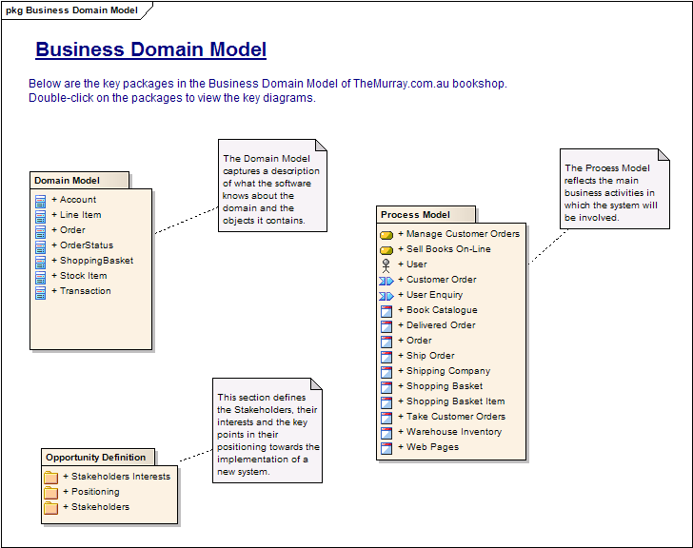

Business Process

The business process model lets you model the main business activities. A process may involve multiple departments or divisions of a larger entity. It describes something a business does as part of its normal activity; focusing mainly on the inputs, outputs, goals and key events that drive the process.

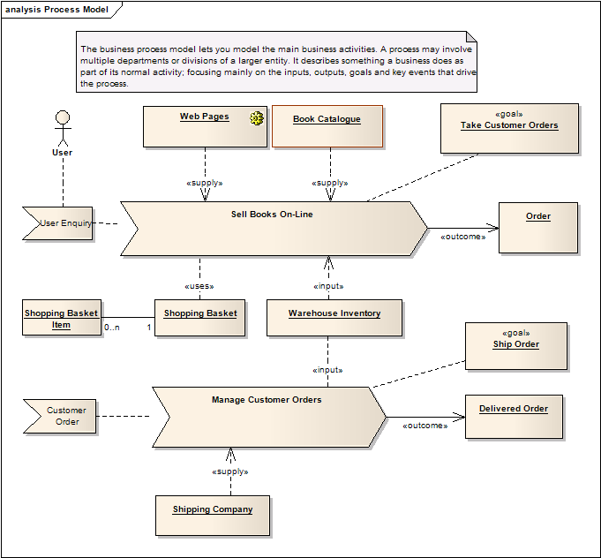

Domain Vocabulary

The Domain model defines a consistent, common vocabulary across a project. For example, this Domain model makes it clear that the project uses the term "Shopping Basket", not "Shopping Cart" and not "Shopping Trolley".
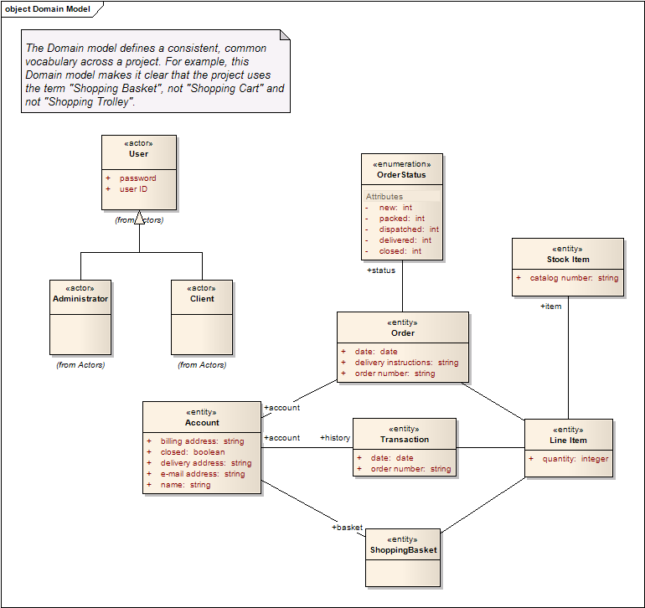

Business Opportunity

It’s about the project justifications, explaining why this project is necessary to be developed. The keys are: Positioning defines the current requirements seen by the stakeholders as background to the decision to implement the project; This package defines the stakeholders and their roles in making the decisions for implementing the project. The stakeholders interests documents any of the key interests expressed by the stakeholders in justifying their decision to implement the project.
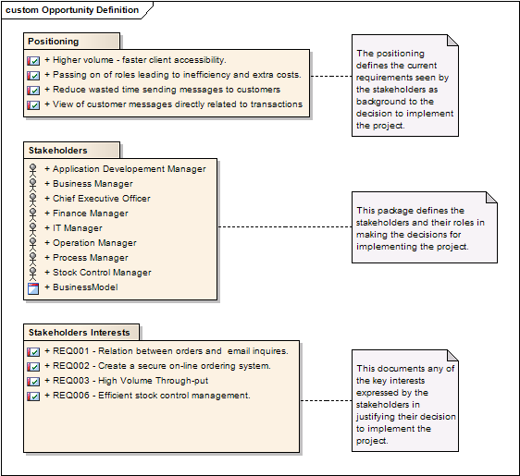

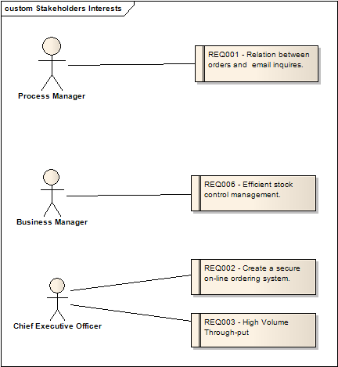

Stakeholders Interest
Requirement ID | Stakeholder
RQ002 | Professors, Java.Net project owners, BlaBlaBla
RQ003 | This this and that..

Although cell phones have become indispensable in daily life, some surveys shows that most of users are not satisfied with cell phone services, as well as with their features. On Error: Reference source not found was published an article that shows that most of Europeans do not use all the cell phone features, just to receive calls or send and receive short messages. On the other hand, Error: Reference source not found is a survey about what cell phone consumers want to see on cell phones, ranking.

Requirements Specifications
This section describes the requirements gathered from the High-Level specification documentation provided by Gary Thompson. Additionally, the wiki page for the PPM project was also explored.

The Formal requirements will list and categorize the specifications for each package (module, section) of the application. On the other hand, the non-functional requirements section will list the functionalities related to how the softwares shall execute. Finally, the Use Case model will group these requirements into modules and define the functionalities.

The forma and non-functional requirements are specified using User Stories from the Agile community formal definition.

Formal Requirements

Metrics Workspace
ID | Description
US002 | As an instructor, I would like to track the Event of Code Repository, so that I know how many commits each student or the group did;
US003 | As an instructor, I would like to track the Event of Tracking System, so that I know how many changes to the Isseue Tracker the group did;
US004 | As an Instructor, I would like to track the Event of Emails sent to the available mailing lists, so that I know how many emails the group has sent
US005 | As an Instructor, I would like to track the Event of Posts sent Dicussion Forum, so that I know how many posts the team did;
US006 | As an Instructor, I would like to track the Event of Documentation changes, so that I will be able to see how many documents were uploaded
US007 | As an Instructor, I would like to track the Event of Disputes or others on the teams, so that I will know what happened to have a given team changed
US010 | As an Instructor, I would like to be able to monitor events, so that I know the participation of each group
US011 | As an instructor, I would like to view the events of the groups, so that I know the participation of the groups
US012 | As an instructor, I would like to analyze a set of events from the groups, so that I know the participation of groups
US014 | As an instructor, I would like to manually adds group interaction events (i.e. team disputes), so that I can track different events
US015 | As an instructor, I would like to set up a project metrics configuration so that I can have a set of project or groups together
US016 | As an instructor, I would like to create a report for a metrics configuration so that I know the high-level details of the project participation.
US017 | As an instructor, I would like to share a metrics configuration so that my peer intructor can analyse the reports with me
US018 | As an instructor, I would like to filter the students from my institution on a given configuration, so that I know which ones are active or not when it comes to global teams
US019 | As an instructor, I would like to list Java.net username of each group members on a configuration, so that I can identify each of them
US023 | As an instructor, I would like to send emails to a given project alerting about students who haven't completed their profile information
US024 | As an instructor, I would like to add, remove and modify the configuration as they want throughout the configuration life-cycle, so that I can delete an old configuration data or I can edit information for example.
US025 | As an instructor, I would like to view reports in a tabular format, so that I can see each event category information.
US026 | As an instructor, I would like to view reports in a graphical format, so that I can the big picture of the data
US027 | As an instructor, I would like to export reports in flat text files in delimited format, so that I can use OpenOffice Spreadsheet, Microsoft Excel, Good Docs Spreesheets to visualize the data
US031 | As an instructor, I would like to be able to read the report comparing all the projects in a configuration in tabular way, so that I can compare each of them
US032 | As an instructor, I would like to read the report for a single project in a tabular format for all the categories, so that I know the participation numbers on each of them
US033 | As an instructor, I would like to read the report for a single event categoy for a given configuration, so that I can compare the groups on that category
US034 | As an instructor, I would like to read the report comparing all the projects in a configuration in a graphical format, so that I have the overall picture of the groups on each event category
US035 | As an instructor, I would like to read the report for a single project in a graphic format, so that I have an idea of the big picture of the project participation on each event category
US036 | As an instructor, I would like to read the report on a single event categoy in graphics for the groups on a configuration, so that I have the idea of the big picture of each for the event category
US043 | As an instructor, I would like to browse for projects in a given configuration, so I can easily see the list of the groups in a given configuration
US044 | As an instructor, I would like to browse for events categories in a given configuration, so that I know which events I am tracking in a given configuration
US045 | As an instructor, I would like to to search for projects in a configuration, so that I don't need to memorize names
US046 | As an instructor, I would like to search for categories in a configuration
US050 | As an instructor, I would like to add the list of team members to each of the projects on a workspace configuration, so that I will be able to know where each of them will be allocated.
US053 | As an instructor, I would like to see the top 5 projects based on the number of events by the sum on categories or each of them.

Users Management
ID | Description
US020 | As a student, I would like to identify myself into the system by using my java.net username and password, so that I don't need to create more user accounts
US021 | As an instructor, I would like to see the real name for each of the students on the reports, so that I don't have to memorize the Java.net username for them
US022 | As an instructor, I would like to see each student's profile, with their Real Name, Student ID, Group Number, if he/she is a team leader, etc , so that I know who he/she is and what his/her role is
US039 | As a User, I would like to login into the system with my username and password created in the registration.
US051 | As an instructor, I would like to import the list of team members from a delimited file into a configuration, so that I can easily setup a configuration
US052 | As an instructor, I would like to view my account detail.
US054 | As a student, I would like to view my account detail and update my information such as Real Name, StudentID, School I belong to, Group I belong to, so that Professors will know my information
US055 | As a user, I would like to retrieve my lost/forgotten password by email or web browser, so that I don't need to email the webmaster/support.

Crawler Activities
ID | Description
US047 | As an instructor, I would like the system to parse and extract the RSS feeds from the java.net so that I can view the consolidated data as metrics
US048 | As an instructor, I would like to see the students' login activities such as number of visits to Java.net and the last time he logged in, so that I know how his/her participation through the system
US049 | As an instructor, I would like to get the list of projects automatically from the parent project when I'm creating a new configuration, so that I don't need to enter the names of the groups for the term manually

Non-Functional Requirements

General
ID | Description
US001 | As an instructor, I would like to access to the system using the web browsers, so that I don't need to open any additional software)
US008 | As an Instructor, I would like the SYSTEM to browse each project's website to collect events' data automatically
US009 | As an Instructor, I would like the SYSTEM to store the RSS feeds collected on a database, so that I can search and browse the data on the web
US013 | As a Instructor, I would like to have the tool working on the Java.net collaborative platform, so that I can view the participation of the members on a set of projects
US028 | As an instructor, I would like to use the sytem without any additional training
US029 | As an instructor, I would like to use the system without any knowledge of web application development or Database systems, or writing SQLs
US030 | As a User, I would like to take advantage of high-speed Internet connection (DSL or cable), so that I can view meaninful information
US038 | As a User, I would like to know that my username and password are encrypted into the database, so that I'm sure there will be no data sent to anybody
US040 | As a User, I would like to view an online help section in the website, so that I just send email to the webmater whenever needed
US041 | As a User, I would like to have responses to the system in less than 3 seconds.
US042 | As a User, I would like to navigate through the system under a secure connection and see the lock on my browser, so that I can feel secure to provide personal information

Use Case Diagrams

This section describes the use case diagrams for InfinityNet. It represents the fullfilment of each of the User Stories into Modules. As a matter of organization, we will show the list of actors and then the use cases for each of the modules.

Actors

Actors are the entities that participate on each of the requirements, executing an action. In the user stories, they are either in the beginning or in the middle of the sentences.

User | This is the regular user of the website. It can make login using username and password.
Instructor | Instructors are the Java.net users who create the metrics. They will be providing Java.net username and password to be able to navigate through the private projects.
Student | Students will just fill out forms about their personal information, institution and group.
Personal Agent | The instructor’s personal agent is in the form of a web crawler that represents the instructor and virtually navigates Java.net to collect information.

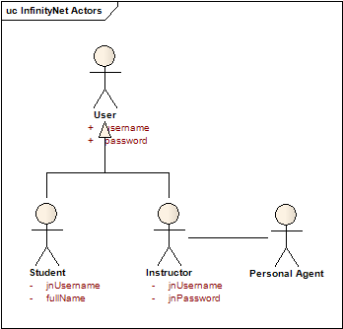

User Management

UC001 | Login for registered users
Description | Project Owner creates a new Metrics Profile.
Requirement Traceability

d categorize the specifications for each package (module, section) of the application. On the other hand, the non-functional requirements section will list the functionalities related to how the softwares shall execute. Finally, the Use Case model will determine.

Participation Metrics

UC001 | Browse for categories
Description | Project Owner creates a new Metrics Profile.
Requirement Traceability | RQ001, RQ003

UC001 | Search for projects
Description | Project Owner creates a new Metrics Profile.
Requirement Traceability

UC001 | Search for categories
Description | Project Owner creates a new Metrics Profile.
Requirement Traceability

UC001 | User view tabular data
Description | Project Owner creates a new Metrics Profile.
Requirement Traceability

UC001 | User view graphical data
Description | Project Owner creates a new Metrics Profile.
Requirement Traceability

d categorize the specifications for each package (module, section) of the application. On the other hand, the non-functional requirements section will list the functionalities related to how the softwares shall execute. Finally, the Use Case model will determine.

User Interfaces – Mock-ups
d categorize the specifications for each package (module, section) of the application. On the other hand, the non-functional requirements section will list the functionalities related to how the softwares shall execute. Finally, the Use Case model will determine.

User registration

d categorize the specifications for each package (module, section) of the application. On the other hand, the non-functional requirements section will list the functionalities related to how the softwares shall execute. Finally, the Use Case model will determine.

UI001 | Browse for categories
Description | Project Owner creates a new Metrics Profile.
Use Case Traceability | UC001

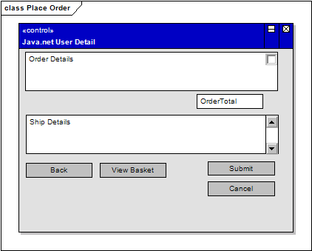

User Login

Categorize the specifications for each package (module, section) of the application. On the other hand, the non-functional requirements section will list the functionalities related to how the softwares shall execute. Finally, the Use Case model will determine.

UI001 | Browse for categories
Description | Project Owner creates a new Metrics Profile.
Use Case Traceability | UC001

Navigating and Viewing Metrics

d categorize the specifications for each package (module, section) of the application. On the other hand, the non-functional requirements section will list the functionalities related to how the softwares shall execute. Finally, the Use Case model will determine.

UI001 | Browse for categories
Description | Project Owner creates a new Metrics Profile.
Use Case Traceability | UC001

High-level System Architecture

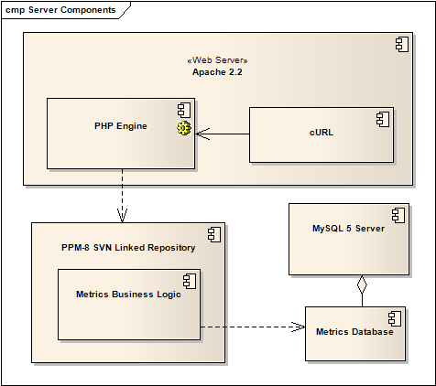

Competitive Analysis
d categorize the specifications for each package (module, section) of the application. On the other hand, the non-functional requirements section will list the functionalities related to how the softwares shall execute. Finally, the Use Case model will determine.

d categorize the specifications for each package (module, section) of the application. On the other hand, the non-functional requirements section will list the functionalities related to how the softwares shall execute. Finally, the Use Case model will determine.

Competitive Analysis – Financial and Technical
Product | Open-Source | Cost | Platform | Persistence | Modules
∞Net | YES | Free | PHP 5.2 | MySQL | PHP, cURL
Starwidgets | YES | Free | JDK 2 | Text Flat Files | Kosuke Scraper

Competitive Analysis – Functional
Function | ∞Net | Starwidgets
Provides Metrics for Public projects | YES | YES
Provides Metrics for Private Projects | YES | YES
Backed with Database System | YES | NO
Provides Web Interface for Users | YES | NO
Provides Tabular Data to Users | YES | YES
Provides Graphical Data to Users | YES | NO

Resources Allocation
d categorize the specifications for each package (module, section) of the application. On the other hand, the non-functional requirements section will list the functionalities related to how the softwares shall execute. Finally, the Use Case model will determine.

