graW: A Web Interactive Environment to Support Undergraduate Courses
Cidorvan dos Santos Silva¹, Evandro de Barros Costa²,
Marcello Alves de Sales Junior¹, Rodrigo de Barros Paes¹
Departamento de Tecnologia da Informação – Universidade Federal de Alagoas (UFAL)
Campus A. C. Simões, Tabuleiro dos Martins – Maceió – AL – Brasil
cidorvan@hotmail.com, ebc@fapeal.br,
masj@tci.ufal.br, r0drigopaes@yahoo.com
¹ CNPq Scholaship, ² Supervisor

Abstract. This paper presents a Web/Internet-based distance learning environment which is called graW (Undergraduate Course on the Web). The main idea is to provide an extension of the traditional classroom by using the Internet/Web through virtual communities which share the same space and are comprised of their own synchronous and asynchronous communication tools, pedagogical resources, in order to help the interaction among different users either from the same or different academic institutes, besides anyone connected on the Internet with the same interests. This paper focuses on graW environment, its architecture, and its development.
Keywords: Web-based Distance Learning Environment, Groupware, Higher Education
1. INTRODUCTION
The Internet/Web infrastructure may improve student possibilities to acquire knowledge and learning. The Internet provides new communication/interaction tools which support learning communities, specially the academic ones. The exchange of ideas and information is now faster with the help of these tools, such as email and chats. In this context, this paper presents a Web/Internet-based distance learning environment which is called graW (Undergraduate Course on the Web). Essentially, graW is composed of three categories of computational tools regarding an academic environment. The first one is concerned with pedagogical aspects, providing resources such as communication/interaction and content tools. The second one is related to learning management in terms of individual/group performance by means of statistical reports and other kind of management information reports. The last category is concerned with administrative/support aspects such as user and course register/support. The main idea is to provide an extension of the traditional classroom by using the Internet through virtual communities which may share the same information and are comprised of their own synchronous and asynchronous communication environments, pedagogical resources, in order to help the interaction among different users either from the same or different academic institutes, besides anyone connected on the Internet with the same interests. This paper focuses on graW environment, its architecture, and its development. It is structured as follows. In Section 2, we present graW architecture. In Section 3, we discuss the graW enviromment. The conclusions are presented in Section 4.
3. THE GRAW ARCHITECTURE
The environment was conceived to support the traditional learning space – in our case the academic one – using tools offered by the Internet and others developed at UFAL[01]. It’s based on groups of community which represent either each academic course presented physically at the academic institute, any extra course like tutorials or groups of research. Each community has also their own politics and rights applied to each user who chooses to be associated with it and share knowledge and information. These users may be teachers and students from any academic environment and external users that represent the guests of each community. The interactions among the users in each community is managed by an adaptive interface[02] which controls the presentation of the community for each kind of user. The community has two types of tools: the communication and the authorship one, which are responsible for providing the synchronous and asynchronous communication and the publication of new knowledge respectively. All information are mapped into a relational database as showed in the architecture (Figure 1).
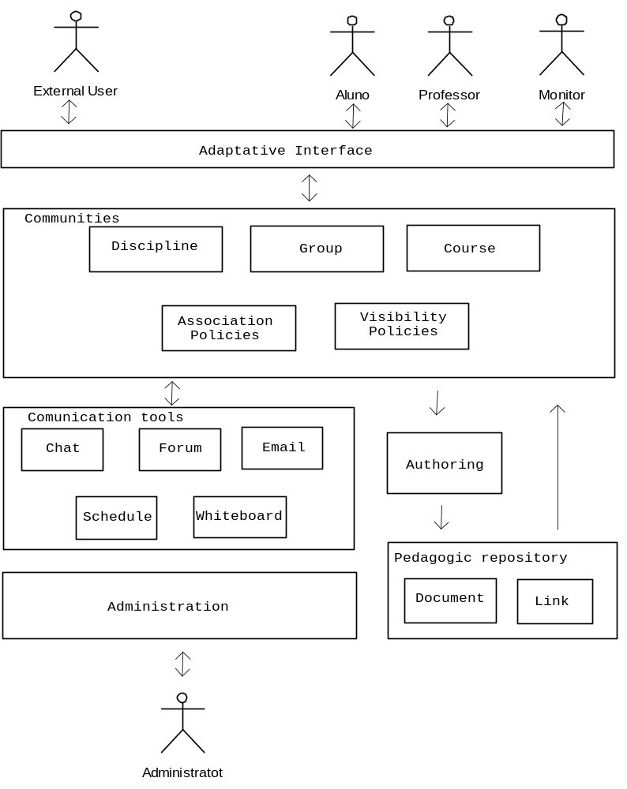
Figure 1

The ability of doing something by a user is defined in the adaptive interface, which stores information about the user and his preferences on the community he is associated with. Indeed, if a user is a teacher, he has the rights, for example, to post any document to the community or even date a chat session among the participants. However, a student could only have access to the generated knowledge of the community.
The communities have their own politics which define the association and visibility. They are also composed by tools to help the participant exchange information easily: the synchronous communication tool that is a chat room with a whiteboard for each community and the asynchronous communication ones which are the use of email, as a list of all participants, a discussion forum to discuss about any kind of categorized information and the integrated/personal schedule to apply a date to all community or for personal use.
3. THE GRAW ENVIRONMENT
As stated in the beginning, a community can have different users interacting in the environment sharing the same knowledge. At graW, these users can be from different academic institutes or not, like guests invited by a teacher who shares his knowledge with the community using the tools offered by it. Therefore, we can have an environment which has the exchange and dissemination of information as the main goal.
3.1. ACADEMIC, EXTERNAL AND ADMINISTRATOR USERS
There are basically three types of users: the academic, the external and the administrators one. Each of them has its own characteristics. The academic user is a Student, a Teacher or a Monitor which are interacting in the communities. The last one is the administrator of the graW which can delegate others to help on the configuration and give all permission to the environment. All of them are distributed in groups by academic courses.
- Teachers: They are responsible for proposing communities which are the ones taught by him in the institution. After the approval of the community by an administrator, the teacher can then populate the community by using tools like the host center in order to send email to users who can be interested on participating the virtual community. His community will also be seen by users like Students who can choose to join it. Besides, Teachers can “elect” monitors, among the students associated, to help him in the production of the community resources and the publication of academic resources like documents, links and so on.
- Students: Like in the real world, they are always in doubt about something they didn’t understand in a class and they can be shy to express it. So graW offers these users the chance to join their virtual classes in order to get their answers using the communication tools, besides exchanging ideas among the others.
- Monitors: They are students who were elected by teachers to assist them in the teach-learning process in a particular community and also answer the questions of them. Therefore, they will have the same ability the Teachers have.
- External User: If a teacher wants to have a guest to show something to his class, he invites another teacher, or even a business man to present them something new. The same we can have on graW. Teachers can invite someone to join the community and share his knowledge among the participants with interaction on a chat session or answer question on the discussion forum.
3.2. THE ADAPTIVE INTERFACE
The adaptive interface is responsible for storing and managing the users preferences for each community they are in. For this reason, graW can present the user the right format of the environment based on his preferences and let him know the users which have his same preferences, for instance.
In general, users have a tool that enable them to searching for communities distributed in categories of knowledge. So they can join any community depending on its politics. After joining a community, the adaptive interface knows the user has a new choices and then new preferences.
To organize the preferences of users in a given community, teachers build the knowledge preferences and then the users can mark their ones. It can be a good tool to provide a way of searching other users with the same preferences, whose knowledge can be shared.
3.3. COMMUNITIES
The graW environment enables each group of users to create different kind of communities, such as Academic subjects, Courses and Groups, each of them created by a different kind of user. Eg. A professor can create an Academic Subject or any other, whereas students can only create groups or courses. The figure 2 illustrates these communities and their hierarchy.
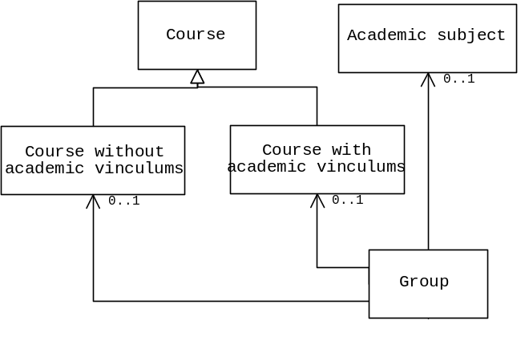

Figure 2. Communities: General view.
Every community has an association and a visibility policies. The association policy says how the system act when a user requests a association with. This policy was implemented with the following way:
- Opened association – Grant free association to new members;
- Semi-Opened association – New members only be accepted if the responsible of the community approve the request;
The visibility policies define which users can see a particular community. These policies are specified below:
- Intra-Course visibility – Visible only for a particular Academic Course (Ex: Computer Science, Architecture) members;
- Intra-Department visibility – Visible only for members of a particular department members. (Including all Academic Courses which are part of this department);
- Intra-Institute visibility – Visible for all members of a University;
- Inter-Institute visibility – Every Academic User from any University can see the community that has this visibility.
These visibilities only makes sense in an academic users context. Nevertheless, graW also offers a special visibility to enable not only the Academic Users, but also the External ones.
- Public visibility – Visible for all graW members.
3.3.1 ACADEMIC SUBJECT
The Academic Subject is intend to allows Academic Users discuss specifc insues related to it.
3.3.2 COURSE
- Course with a link to an Academic Subject: It allows the creation of extra curricular courses associated with an academic subject.
- Course without a link to an Academic Subject: It allows the creation of extra curricular courses without any association.
3.3.3 GROUP
- The main goal of group creation is allow users, who have a specific aim to be grouped and to make use of all tools presented at graW. In this context, the groups was designed to be associated with other communities. Furthermore, a group can be without any association policy which allows any kind of users to be grouped.
3.4 COMMUNICATION TOOLS
These tools are responsible for an easier end faster communication among the graW users. Then, this module has two synchronous tools and three asynchronous ones.
- Synchronous tools – graW offers a chat tool associated with each community, where users can have a real time chat session in order to debate anything with the others. Along with the chat tool, there is a whiteboard one to help users to explain what they are talking about just drawing on the board.
- Asynchronous tools – These are the most used tools of graW. It is offered a discussion forum for every community in order to enable users to expose your doubts and questions where teachers, monitors and even other users can answer, generating a new discussions. There is also a list of all users and their information, including email, associated with a particular community. Therefore any user can send an email to another or even to all participants of the community. Another tool in this category is a personal/shared schedule, where teachers and monitor can date an anything like a new class time or even the next chat session and it can be also used as a personal calendar.
3.5 AUTHORING TOOLS
In order to offer different pedagogical resources, graW has an authoring tool which enables teachers and monitors to publish resources on a particular community. These resources, which can be any kind of eletronic data like powerpoint presentation or links to another sites, are grouped into different subjects chosen by either teachers or monitors. Therefore, teachers can post your own documents, list of presentation and results of tests for your community, besides the links to other resources from other web sites presented on the Internet.
4. CONCLUSION
As we stated before, graW has been designed and developed to support learning communities with regarding to provide extra-class activities related to specific courses. Nowadays, graW has been experimented in a beta test in four different courses available at http://www.graw.tci.ufal.br. Preliminary results has pointed out positive aspects but at the same suggesting little adjusts concerning user interface. At the moment, there has been developed learning management tools as well as videoconference ones.
5. REFERENCES

DRAVES, William A.. Teaching Online. LERN Books. USA. 2000.
Simonson, Michael et all. Teaching and Learning at a Distance – Foundations of Distance Education. Prentice-Hall, Inc, 2000.
Pressman, Roger – Engenharia de Software. Editora Makron Books. 1ª Edição. 1995 ISBN 8534602379
J. AT. AL. Rumbaugh – Modelagem e projetos baseados em objetos. Editora Campus. 1ª Edição. 1997, ISBN 8570018410
Ramez A. Elmasri, Shamkant B. Navathe - Fundamentals of Database Systems. Editora Addison-Wesley. 3ª Edição. 1999

