Protean

Every vampire is one bad day away from giving in to the Beast. Some keep the creature leashed within, holding it back and only letting it out to prey on the weak. Others indulge their Beasts, reveling in the descent from an undead thing yearning
for its grave to a force of savage power. A vampire who attains the pinnacle of Protean becomes a formless creature, nothing more than smoke and hunger.

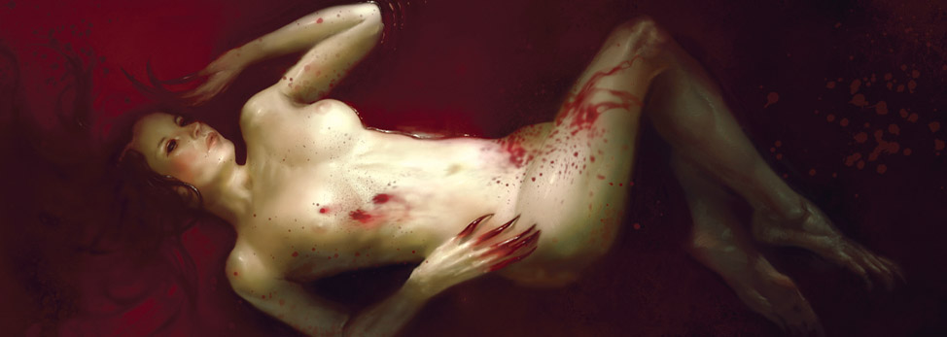

Unmarked Grave •
With a silent command, the earth itself yawns open to embrace the vampire. She merges with the ground, becoming immune to almost any harm. She can remain there indefinitely, waiting in a cocoon of soil until the time is right for her to emerge. She does not have to find stone or mud, she can just
as easily slip into concrete — as long as she has servants willing to feed her while she rests.
Cost: Varies; 0 for soil or earth, otherwise Vitae equal to the Durability of the material.
Requirement: The vampire’s hiding place must be at least
the same Size as her.
Dice Pool: None
Action: Instant
Duration: Indefinite
The vampire sinks bodily into the earth, for as long as she desires. Once interred, she’s mostly insensible to the outside world, though she can remain conscious if she so wishes.
She has a sense of the ground above her — she’s well aware if someone tries to concrete over her hiding place. Her Kindred senses continue to function, and she remains capable of sensing the predatory aura even though her safe haven means another vampire’s predatory aura can’t force her into a fight-or-flight reaction. Should someone spill blood or Vitae upon the ground, she can absorb it. The ground dilutes Vitae enough that it can’t
result in a blood bond, but to a Vitae-addicted vampire just the taste might be enough to drive her out of the ground, thirsty for more.
The only way to harm the vampire is to damage or destroy the ground she resides in; she takes one point of bashing damage for each point of Structure that her haven loses. When she takes her first point of lethal damage she emerges from the ground, unable to hold herself in.

Predatory Aspect ••
All the vampire has to do is give in just a little bit, and her Beast can slip out through her flesh, warping her body into a monstrous form. While every Gangrel’s Beast is different, its manifestation usually takes inspiration from a predatory or scavenging animal of some form. Some twist their bodies to run on all fours like a wolf, while others take on the rough skin and strange senses of a shark.
Cost: 1 Vitae
Dice Pool: None
Action: Reflexive
Duration: Scene
By spending a point of Vitae, the vampire can manifest a small host of bestial traits. When she first learns Predatory Aspect, she picks three adaptations from the list below. From then on, she can manifest any or all of these changes for the rest of the scene by spending a point of Vitae.
If none of these adaptations make sense for the character, the player and Storyteller should work together to create new ones, using these as guidelines.

• Aquatic: Growing webbed hands or slick scales, the vampire can swim at the same Speed she can run on land.
• Claws: Sharp claws grow from the vampire’s fingers. They are1L mundane weapons that use Brawl to attack.
• Extra Sense: The Kindred grows extra sensory organs, giving her tremor sense, echolocation, or some other sense that allows her to “see” without using her eyes. Using this sense, she has a 360-degree field of vision.
• Feral Senses: Taking on a hawk’s eyes or a dog’s sense of smell allows the vampire to hear heartbeats and see or smell blood as though her Blood Potency were two dots higher.
• Patagia: By growing a flap of leathery skin between her arms and torso, the vampire can glide — as long as she falls at least ten yards (ten meters), she can travel thirty yards (thirty meters) horizontally, and she takes no damage from the fall.
• Prehensile Tail: The vampire grows a long, prehensile tail .She can use it to grab things as though it were an extra arm, though it doesn’t have a hand and can’t be used for fine-motor tasks like unlocking a door or firing a gun.
• Quadripedal: Longer arms and shorter legs allow a vampire to run on all fours like a cheetah or wolf. When running on all fours, add +4 to her Speed and double all jump distances.
• Wall Crawling: The vampire grows hundreds of tiny insect legs, claws on his feet, or barbed hairs on his body that allow him to move freely across walls and ceilings without an Athletics roll.
A character can change her adaptations by spending a day in her Unmarked Grave and spending one point of Vitae for each adaptation she wants to replace. When she changes adaptation, the player should work to maintain the theme of a specific predatory creature — though she may pick a different predator to copy when the vampire’s adaptations change.

Beast’s Skin •••
The Beast can warp a vampire’s flesh, taking the form of an animal that she has consumed. Her body warps and shifts, growing extra muscle or folding in on itself until she fully resembles an animal she has consumed. The Beast will not give her the form of prey — her new skin must resonate with
her predatory nature in some way.
Cost: 2 Vitae
Dice Pool: None
Action: Instant
Duration: Indefinite
Her flesh ripples and warps as the vampire takes on the form of an animal. She must have consumed the beast — killing it by feeding from it. She can only take on the form of predatory animals, carrion-eaters, plague-carrying beasts, and parasites between Size 1 and 7. A vampire can keep a number of forms ready equal to her dots in Protean; to add or replace one she must consume the appropriate beast then slumber for a full day and night in her Unmarked Grave.
In animal form, she takes on the beast’s Physical Attributes and Skills, and its Size, Speed, and Health. She can move and sense and attack in any way that the animal can — a shark can swim and bite and sense blood, while a rat can scurry and bite, and a crow can fly. She may be unable to use some Physical Merits at the Storyteller’s discretion. She can remain in her animal form indefinitely, but she still feels the need for blood burning within her, and sunlight still harms her.
While in animal form, the vampire can use her Disciplines as normal.

Unnatural Aspect ••••
With her Beast boiling in her blood, the pathetic shell of the vampire’s human or animal form cannot contain it. Her flesh warps, twisting and cracking under the pressure. She manifests truly horrific changes — though they may be inspired by the animal kingdom, these features come from the Beast itself, rather than the pale shadows that walk the world.
Cost: 1 Vitae
Dice Pool: None
Action: None
Duration: Scene
When manifesting her Predatory Aspect, the vampire can spend an extra point of Vitae to produce a fourth feature, this one being her Beast made manifest. She can assume an adaptation from the following list; if none of these are suitable the player and Storyteller should work together to create an
appropriate feature.
• Barbed Hands: Pushing out tiny barbs on her hands and arms, the vampire can grab her opponents with incredible ferocity. Add her Protean dots to all grappling dice pools.
When choosing the Damage move in a grapple, the vampire deals lethal damage. These barbs enable very gory feeding in the middle of a fight, tearing the victim’s skin as she bites him.
• Hooked Hands: The vampire’s hands grow great hooked claws and other unnatural appendages that allow him to dig through soil and rock at up to half his Speed.
• Horrid Talons: By growing giant fangs or serrated talons, the vampire can deal horrific damage to anyone who gets in her way. These weapons give a +2 lethal weapon modifier on all Brawl attacks, and armor piercing 2. The damage is lethal even to vampires.
• Rubbery Flesh: Warping her flesh into a rubbery substance and her bones into flexible cartilage, the vampire can stretch, condense, and contort her body in impossible ways.
She can fit through almost any gap more than an inch (two centimeters) across. If the contortion requires a roll — such as squeezing through a drain cover while someone’s shooting at her — add the vampire’s Protean dots to her dice pool.
• Wings: The vampire grows great wings of sharp bone and pale leathery skin. The vampire can fly at up to her full running Speed.
The vampire can replace her chosen Unnatural Aspect by sleeping for a full day and night in her Unmarked Grave and spending two points of Vitae.

Primeval Miasma •••••
The Beast bursts out from the vampire’s body, dissolving it into a cloud of hungry smoke. Occasionally, her victims can flashes of yellow within the smoke, like the gleaming of eyes.
Nothing short of an airtight room can bar her passage, and nothing physical can harm her.
Cost: 3 Vitae
Dice Pool: None
Action: Instant
Taking on a smoke form gives the vampire a number of advantages. She can condense herself down to her human Size, or expand into a cloud of up to (Protean + Blood Potency)yards (meters) in diameter. She can move through pretty much anything that isn’t actively airtight, and floats at half her normal Speed. She can perceive inside the cloud of smoke as clearly as if she were looking with her human senses, but the world outside her form is blurred and muted. Her Kindred senses continue to function as normal.
In her smoke form, the vampire is immune to all harm that doesn’t come from fire, sunlight, or other banes that deal damage. If her smoke form is ever fully exposed to sunlight ,she returns to her human form. Nothing else can force her back into her human form — as long as she avoids sunlight she can slumber in her Miasma form. It has all the same benefits as her Unmarked Grave, allowing the vampire to shift her adaptations and animal forms.
Other beings pass right through the smoke. If a victim has any open wounds, the vampire can feed from them just by having them enter her Miasma — the blood boils out of his wounds, evaporating in a flash of grey and yellow smoke. If she needs to feed and can’t find someone who is already bleeding, the vampire can instead force herself into the victim’s lungs with strands of semi-tangible smoke, stealing her life-force along with her breath (grapple and “bite” using her normal Physical Attributes).

