C:\Users\Johnny\AppData\Local\Microsoft\Windows\Temporary Internet Files\Content.IE5\NTPQNKIN\MC900286462[1].wmf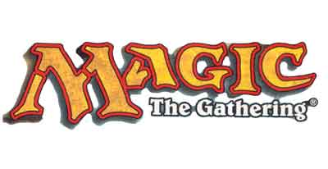C:\Users\Johnny\AppData\Local\Microsoft\Windows\Temporary Internet Files\Content.IE5\IIPF1684\MC900198164[1].wmf

Come play some games and enjoy pizza while we celebrate the end of the spring semester!

When: April 28th from 2:00 – 7:00

Where: Solarium

**Gaming club presents:**

**Game-a-thon 2014!**