**CS 1632 - DELIVERABLE 2: Unit Testing and Code Coverage**

Coffee Maker Quest – https://github.com/marcelo-dalmeida/CS-1632-DELIVERABLE-2-Unit-Testing-and-Code-Coverage

Marcelo d’Almeida

1. **Introduction**

All the code to reproduce the game was built and then the tests implementations were written. This caused the sensation of writing test cases to fit the code, since there were so much text being printed on the screen, though, in the end, the sensation was about changing the code to fit test minor particularities. The pros and cons of all this were to remove some get/set methods that were never being used and this made the code more or less cleaner, but I had to modify the code, not because it was wrong or inconsistent, but to make the assertEquals() work properly.

Here the problems faced and solved along the test implementations:

- How to capture the console output so it could be asserted with something;

- How to generate automated inputs so one didn’t need to enter the inputs by himself;

- The problem of having a System.exit() terminating the JUnit tests. (the fix breaks the code coverage analysis made by eclEMMA).

- The difference from the line break of a System.out.println() and a “\n” break line made the asserts fail even if the output looked the same. The code had to be deliberately changed to include “/n” and “print”s instead of “println”s so the tests could pass

1. **Unit Tests**

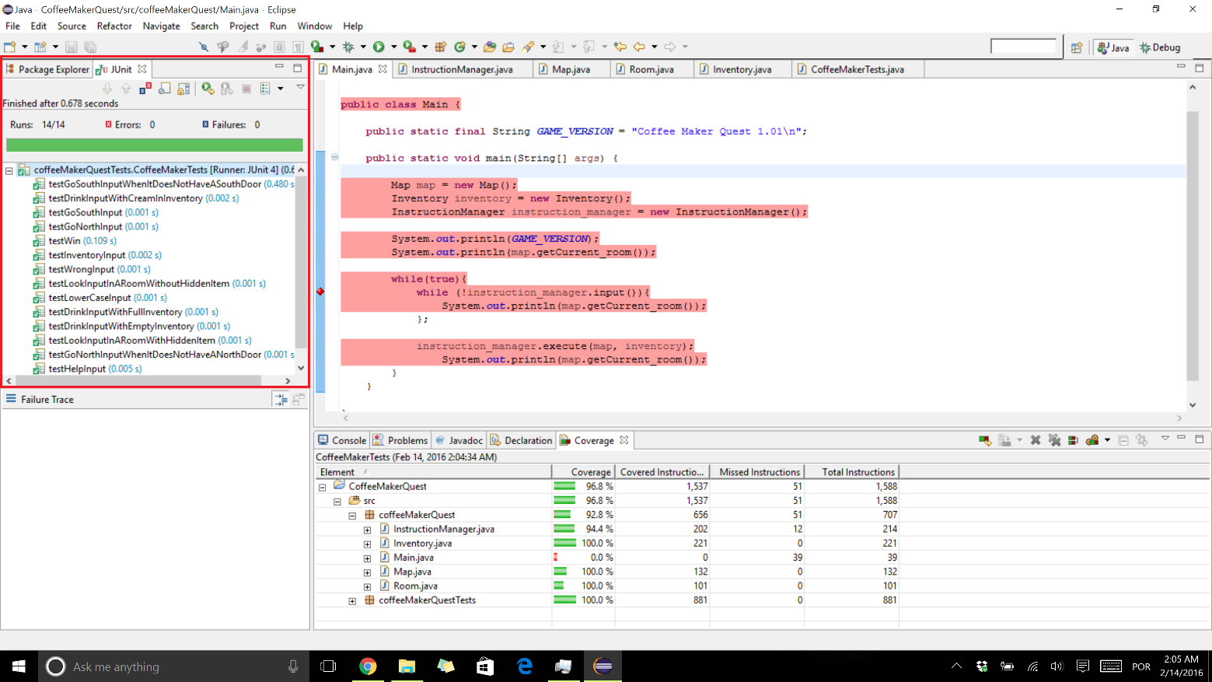

1. **Code Coverage**

