**CS 1632 - DELIVERABLE 3: Web Testing with BDD**

Wikipedia Web Test – https://github.com/marcelo-dalmeida/CS-1632-DELIVERABLE-3-Web-Testing-with-BDD

Marcelo d’Almeida

1. **Introduction**

The web page considered to be tested was Wikipedia due its importance and size, but mostly due its mostly static layout. It possess account/login section and other interesting features. It is a real web site with real applicability.

I decided to test login, account creation and reset password as they represent a group of complementary features. I decided to test donation due its number of different cases and because I could test in all of them in a similar way. And finally I tested some search with ambiguity to represent some use case.

The first problem was to check all the possible outcomes of a given feature. E.g the reset password would reject another sending in 24 hours and multiple attempts. Login also would multiple attempts restrictions.

Another minor problem was due the captcha in creating account, but I just let the captcha error be my success and all turned out to be fine.

A serious problem was due little CSS styling on page causing radio buttons to not be recognized as visible element, and therefore, not being able to use in test without receiving an error.

And also, the pages returned to the Selenium sometimes differs from Chrome web navigation and some debugging is necessary (e.g. checking the page source returned and search for id, class names, etc).

Failed tests:

testSearchApple  
testSearchAppleInc

Search tests were working at first, but the page now is being returned different and even with the possible outcome of being redirected automatically to disambiguation potentially solved, the page insist of not returning the expected result (the “Apple” page or the “disambiguation” page

testOneTime5DonationCreditCard  
testMontly5DonationCreditCard  
testOneTime100DonationCreditCard  
testMontly100DonationCreditCard  
testOneTimeOtherDonationCreditCard  
testMontlyOtherDonationCreditCard  
testOneTime5DonationPayPal  
testMontly5DonationPayPal

Donations tests gives the error “You may only interact with visible elements”, even the element being completely visible and usable. A lot of workarounds were tried, but without so much success. Away of that, the test simulates the clicking behavior to perform each one of the tasks

https://github.com/marcelo-dalmeida/CS-1632-DELIVERABLE-3-Web-Testing-with-BDD

1. **Test Run**

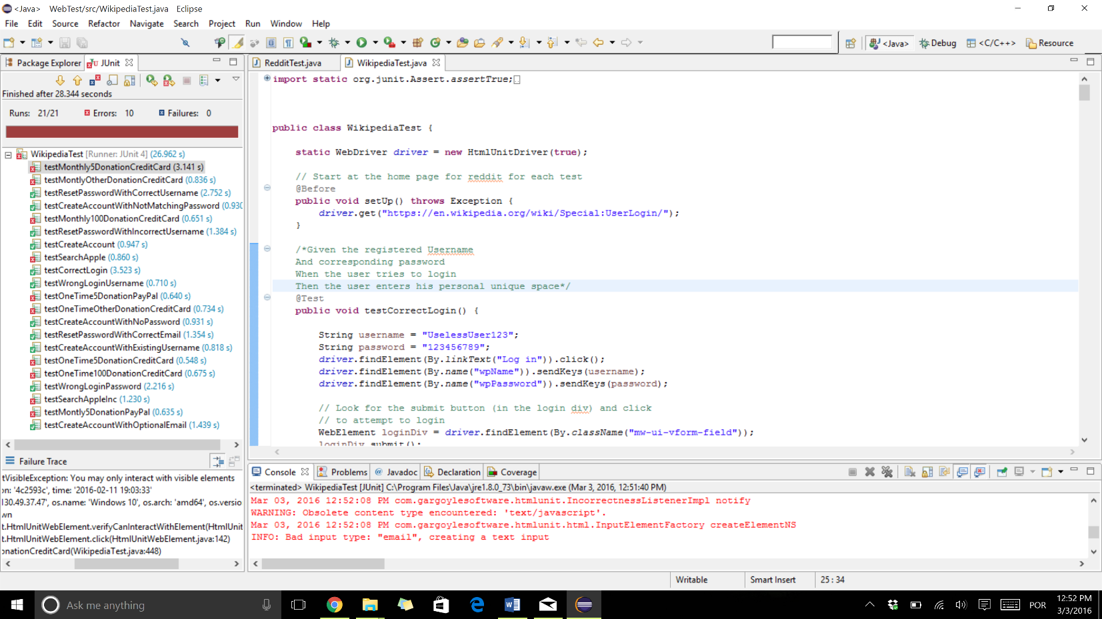

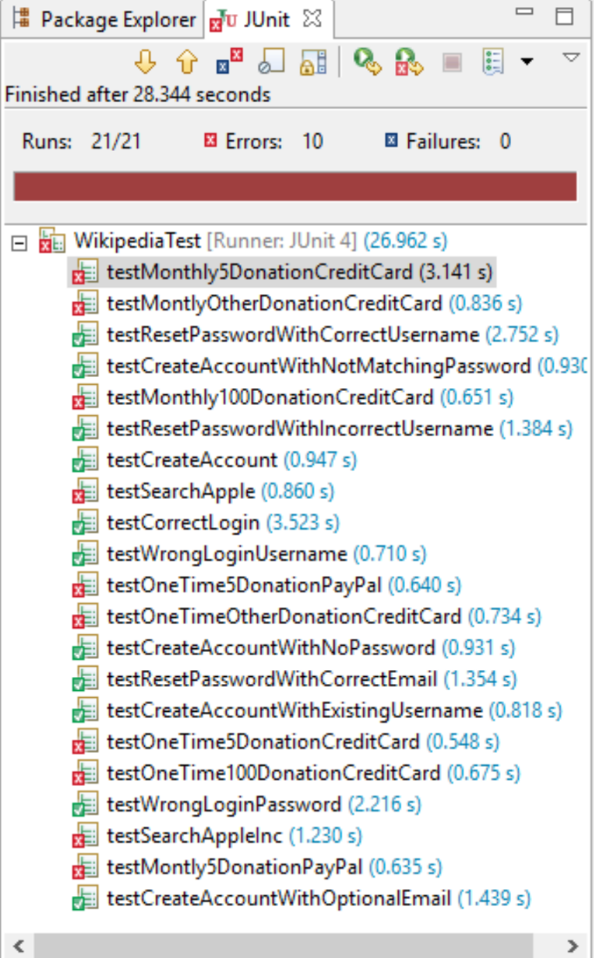

1. **User Stories and Scenarios**

**User Story A: Create account:**

As an editor

I want to be able to create an account

So I can store the text that I edit

**Scenario 1A – Create an account correctly:**

Given an unique Username

And matching password

When the user tries to create an account

Then the account is created and the user can use it

**Scenario 2A – Create an account with an optional E-mail:**

Given an unique Username

And matching password

And a valid e-mail address

When the user tries to create an account

Then the account is created and the user can use it

**Scenario 3A – Create an account with an existing Username:**

Given an existing Username

When ~automatically~

Then a message written “Username entered already in use”

**Scenario 4A – Create an account with not matching password:**

Given an unique Username

And a not matching password

When the user tries to create an account

Then a message written “The passwords you entered do not match”

**Scenario 5A – Create an account with no password:**

Given an unique Username

And no password

When the user tries to create an account

Then a message written "Passwords must be at least 1 character"

**User Story B: Login:**

As an editor

I want to be able to login

So I can manage the text that I edit

**Scenario 1B – Correct Login:**

Given the registered Username

And corresponding password

When the user tries to login

Then the user enters his personal unique space

**Scenario 2B – Wrong Login Username:**

Given a misspelled registered Username

And corresponding password

When the user tries to login

Then a message written “There is no user by the name *****” appears

**Scenario 3B – Wrong Login Password:**

Given a registered Username

And misspelled corresponding password

When the user tries to login

Then a message written “Incorrect password entered“ appears

**User Story C: Reset password:**

As an editor

I want to be able to reset my password

So I can recover if I forget it

**Scenario 1C – Reset Password with correct Username:**

Given the registered Username

When the user tries to reset the password

Then the user receives an email to his account associated with the Username

**Scenario 2C – Reset Password with correct E-mail:**

Given the registered e-mail

When the user tries to reset the password

Then the user receives an email to his account associated

**Scenario 3C – Reset Password with incorrect Username:**

Given a misspelled registered Username

When the user tries to reset the password

Then a message written “There is no user by the name *****” appears

**User Story D: Search:**

As a user

I want to search about Apple

So I can learn everything about it

**Scenario 1D – Search “Apple” (fruit):**

Given an user and a search field

When the user types “Apple” and search

Then the user is redirected to the page describing the Apple fruit

**Scenario 2D – Search “Apple” (company):**

Given an user and a search field

When the user types “Apple” and search

Then the user is redirected to the page describing the Apple fruit

And a link for disambiguation is offered to him

**User Story E: Donate:**

As a philanthropic user

I want to donate

So I can help the server to keep running

**Scenario 1E – Donate $5 one time with Credit Card:**

Given a user willing to donate

When the user selects the one time, $5 amount and credit card options

Then the user is redirected to the Credit card payment page

**Scenario 2E – Donate $5 monthly with Credit Card:**

Given a user willing to donate

When the user selects the monthly, $5 amount and credit card options

Then the user is redirected to the Credit card payment page

**Scenario 3E – Donate $100 one time with Credit Card:**

Given a user willing to donate

When the user selects the one time, $100 amount and credit card options

Then the user is redirected to the Credit card payment page

**Scenario 4E – Donate $100 monthly with Credit Card:**

Given a user willing to donate

When the user selects the monthly, $100 amount and credit card options

Then the user is redirected to the Credit card payment page

**Scenario 5E – Donate other amount one time with Credit Card:**

Given a user willing to donate

When the user selects the one time, other amount (e.g. $5000) and credit card options

Then the user is redirected to the Credit card payment page

**Scenario 6E – Donate other amount monthly with Credit Card:**

Given a user willing to donate

When the user selects the monthly, other amount (e.g. $5000) and credit card options

Then the user is redirected to the Credit card payment page

**Scenario 7E – Donate $5 one time with PayPal:**

Given a user willing to donate

When the user selects the one time, $5 amount and PayPal options

Then the user is redirected to the PayPal payment page

**Scenario 8E – Donate $5 one time with PayPal:**

Given a user willing to donate

When the user selects the one time, $5 amount and PayPal options

Then the user is redirected to the PayPal payment page