Paper Title* (use style: paper title)
*Note: Sub-titles are not captured in Xplore and should not be used

line 1: 1st Given Name Surname
line 2: dept. name of organization
(of Affiliation)
line 3: name of organization
(of Affiliation)
line 4: City, Country
line 5: email address or ORCID
line 1: 4th Given Name Surname
line 2: dept. name of organization
(of Affiliation)
line 3: name of organization
(of Affiliation)
line 4: City, Country
line 5: email address or ORCID
line 1: 2nd Given Name Surname
line 2: dept. name of organization
(of Affiliation)
line 3: name of organization
(of Affiliation)
line 4: City, Country
line 5: email address or ORCID
line 1: 5th Given Name Surname
line 2: dept. name of organization
(of Affiliation)
line 3: name of organization
(of Affiliation)
line 4: City, Country
line 5: email address or ORCID
line 1: 3rd Given Name Surname
line 2: dept. name of organization
(of Affiliation)
line 3: name of organization
(of Affiliation)
line 4: City, Country
line 5: email address or ORCID
line 1: 6th Given Name Surname
line 2: dept. name of organization
(of Affiliation)
line 3: name of organization
(of Affiliation)
line 4: City, Country
line 5: email address or ORCID

Abstract—This electronic document is a “live” template and already defines the components of your paper [title, text, heads, etc.] in its style sheet. *CRITICAL: Do Not Use Symbols, Special Characters, Footnotes, or Math in Paper Title or Abstract. (Abstract)
Keywords—component, formatting, style, styling, insert (key words)

Introduction (Heading 1)
This template, modified in MS Word 2007 and saved as a “Word 97-2003 Document” for the PC, provides authors with most of the formatting specifications needed for preparing electronic versions of their papers. All standard paper components have been specified for three reasons: (1) ease of use when formatting individual papers, (2) automatic compliance to electronic requirements that facilitate the concurrent or later production of electronic products, and (3) conformity of style throughout a conference proceedings. Margins, column widths, line spacing, and type styles are built-in; examples of the type styles are provided throughout this document and are identified in italic type, within parentheses, following the example. Some components, such as multi-leveled equations, graphics, and tables are not prescribed, although the various table text styles are provided. The formatter will need to create these components, incorporating the applicable criteria that follow.

Ease of Use

Selecting a Template (Heading 2)
First, confirm that you have the correct template for your paper size. This template has been tailored for output on the A4 paper size. If you are using US letter-sized paper, please close this file and download the Microsoft Word, Letter file.

Maintaining the Integrity of the Specifications
The template is used to format your paper and style the text. All margins, column widths, line spaces, and text fonts are prescribed; please do not alter them. You may note peculiarities. For example, the head margin in this template measures proportionately more than is customary. This measurement and others are deliberate, using specifications that anticipate your paper as one part of the entire proceedings, and not as an independent document. Please do not revise any of the current designations.

Prepare Your Paper Before Styling
Before you begin to format your paper, first write and save the content as a separate text file. Complete all content and organizational editing before formatting. Please note sections A-D below for more information on proofreading, spelling and grammar.
Keep your text and graphic files separate until after the text has been formatted and styled. Do not use hard tabs, and limit use of hard returns to only one return at the end of a paragraph. Do not add any kind of pagination anywhere in the paper. Do not number text heads-the template will do that for you.

Abbreviations and Acronyms
Define abbreviations and acronyms the first time they are used in the text, even after they have been defined in the abstract. Abbreviations such as IEEE, SI, MKS, CGS, sc, dc, and rms do not have to be defined. Do not use abbreviations in the title or heads unless they are unavoidable.

Units
- Use either SI (MKS) or CGS as primary units. (SI units are encouraged.) English units may be used as secondary units (in parentheses). An exception would be the use of English units as identifiers in trade, such as “3.5-inch disk drive”.
- Avoid combining SI and CGS units, such as current in amperes and magnetic field in oersteds. This often leads to confusion because equations do not balance dimensionally. If you must use mixed units, clearly state the units for each quantity that you use in an equation.
- Do not mix complete spellings and abbreviations of units: “Wb/m2” or “webers per square meter”, not “webers/m2”. Spell out units when they appear in text: “. . . a few henries”, not “. . . a few H”.
- Use a zero before decimal points: “0.25”, not “.25”. Use “cm3”, not “cc”. (bullet list)
Identify applicable funding agency here. If none, delete this text box.

Feature Selection
Feature selection method used to this experiment is variance threshold which can clear data with variance out of stablished limit, then removing outliers from dataset. Such feature selection filter has been implemented in Python to improve linear methods power to predict data using SkLearn™ library.

Results
After submitting benchmarks to experiment presented at section IV, four linear regression methods have been applied to each dataset: LASSO, Elastic Net, Ridge Regression and Linear Regression. Hence, two plots are expected per method appliance on dataset: residual error and real behavior versus prediction. Resulting in six graphs per dataset, then 24 graphs total (residuals graph will be shown only on LASSO sub-chapter) and one table to summarize Coefficient of Determination in train (R²_{train}), Coefficient of Determination in train (R²_{test}), Mean Squared Error (MSE) and Mean Absolute Error (MAE) per method results.

LASSO
LASSO method applied datasets (Airfoil, Water Toxicity and Fish Toxicity) resulted in R² _{train}, R² _{test}, MSE and MAE summarized by table I:
- Summarized Results For LASSO Method
Dataset | Evaluation Parameters
Dataset | R²_{train} | R²_{test} | MSE | MAE
Airfoil Noise | 0. 27229 | 0.26317 | 35.18097 | 4.76469
Aquatic Toxicity | 0.49686 | 0.43889 | 1.39699 | 0.91272
Fish Toxicity | 0.553 | 0.53339 | 0.99466 | 0.71215
Airfoil dataset presented R²_{train} near to R²_{test} variating less than 5% in total, however MSE is huge, as can be seen from figure 1:
- Airfoil Dataset Residual Plot for LASSO
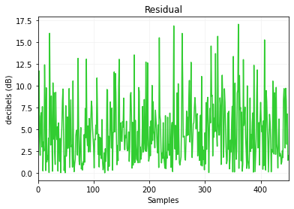
Figure 1 shows maximum residual in 17.2dB of residual difference between prediction and real test data, this plot is presented by figure 2:
- Airfoil Dataset Prediction x Real Plot for LASSO
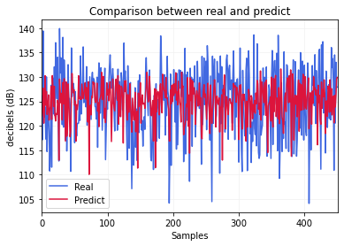
As expected, after analyzing residual graph, predictions are far from real dataset behavior. Furthermore, aquatic toxicity dataset performed better with LASSO, as figure 3 shows:
- Aquatic Toxicity Dataset Residual Plot for LASSO
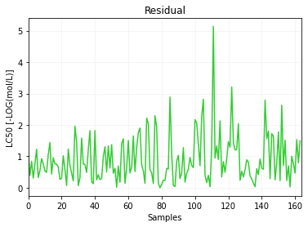
The maximum concentration LC50 residual is 5.2 {LC50}, and isolated point once others are minor than 3.2 {LC50}, so graph on figure 4 compares prediction and test data:
- Aquatic Toxicity Prediction x Real Plot for LASSO
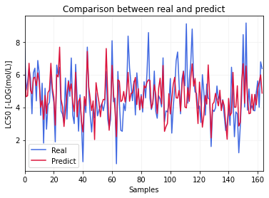
Water toxicity analysis used 162 samples to test dataset for LASSO predictions which are close to expected, total MSE is 1.39699. About fish toxicity benchmark, resulted total MSE near to 0.99, its residual graph can be seen at figure 5:
- Fish Toxicity Dataset Residual Plot for LASSO
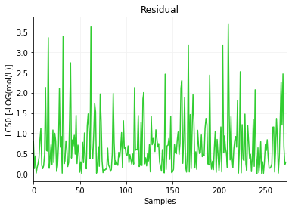
As can be seen, maximum residuals are near to 3.6 LC50 and comparison plot between prediction and real test data is presented by figure 6:
- Fish Toxicity Prediction x Real Plot for LASSO
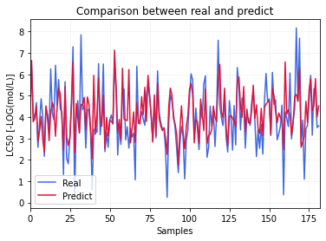
As fig. 6 shows, predictions are near to real test dataset behavior, as MSE and MAE indicators show, LASSO method predicted low variance points.

Elastic Net
For Elastic Net method, datasets performance is demonstrated by table 2:
- Summarized Results For Elasttic Net Method
Dataset | Evaluation Parameters
Dataset | R²_{train} | R²_{test} | MSE | MAE
Airfoil Noise | 0.26749 | 0.2642 | 31.94292 | 4.76469
Aquatic Toxicity | 0.48187 | 0.52057 | 1.13165 | 0.8478
Fish Toxicity | 0.54845 | 0.52315 | 0.96393 | 0.70377
Airfoil dataset presented low determinations coefficients, however MSE and MAE are relatively high, this can be shown by analyzing fig. 7 which compares real test data and prediction test:
- Airfoil Prediction x Real Plot for Elastic Net
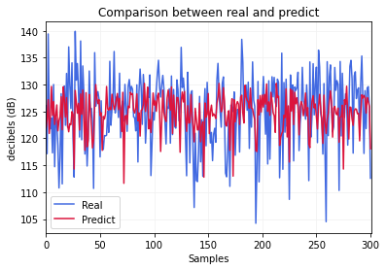
As seen, prediction is far from real behavior and residuals maximum value is approximately 17.6, resulting in MSE equals to 31.94 and MAE near to 4.76. For aquatic toxicity benchmark, maximum residual data is lower than LASSO, equals to 2.8 and happened twice, hence the MSE result is 1.13 and MAE approximately 0.85, the complete comparison is shown on fig. 8:
- Aquatic Toxicity Prediction x Real Plot for Elastic Net
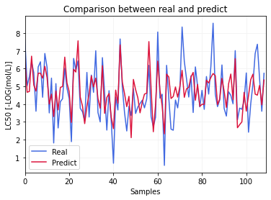
This plot shows that predictions are near to real test dataset behavior. Such as happened with fish toxicity for this method, the MSE is 0.96 and MAE near to 0.70, the prediction versus real test is shown on fig. 9:
- Fish Toxicity Prediction x Real Plot for Elastic Net
Fish toxicity benchmark with 182 test samples presented accurate prediction for Elastic Net method.

RIDGE REGRESSION
For RIDGE Regression method, results are presented by table 3:
- Summarized Results For Elasttic Net Method
Dataset | Evaluation Parameters
Dataset | R²_{train} | R²_{test} | MSE | MAE
Airfoil Noise | 0.27034 | 0.26191 | 32.04233 | 4.53891
Aquatic Toxicity | 0.485 | 0.52421 | 1.12306 | 0.83539
Fish Toxicity | 0.54868 | 0.52277 | 0.96471 | 0.70385
Its notable that Airfoil Noise benchmark had MSE like other methods, near to 32, then the prediction versus real data is presented by fig. 10:
- Airfoil Noise Prediction x Real Plot for RIDGE Regression
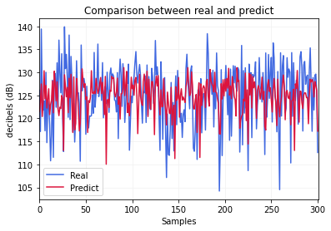
Prediction and real data are distinct as MSE shows, the maximum residual is 16.8dB of difference, then airfoil noise haven´t satisfactory performance on Elastic Net prediction method. By the other hand, aquatic toxicity benchmark presented MSE equals to 1.12 and low MAE, prediction behavior comparison between real test dataset and test prediction is presented by fig. 11:
- Aquatic Toxicity Prediction x Real Plot for RIDGE Regression
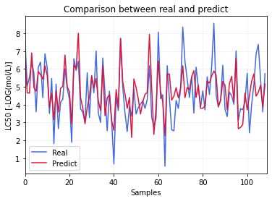
For aquatic dataset, as can be seen from fig. 11, predictions are near no real data, instead on peaks or valleys on graph, due variance threshold predictor focuses on low variance data. In addition to that, fish toxicity benchmark presented low MAE and MSE, maximum residual is 3.7 {LC50} and works as isolated peak. Such prediction can be seen on fig. 12:
- Fish Toxicity Prediction x Real Plot for RIDGE Regression
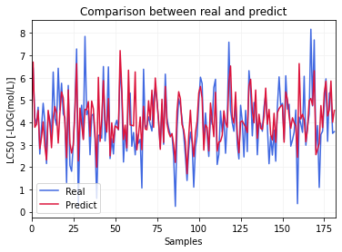

LINEAR REGRESSION
Linear regression Applied with SkLearn library in Python language resulted in table 4 data:
- Summarized Results For Linear Regression
Dataset | Evaluation Parameters
Dataset | R²_{train} | R²_{test} | MSE | MAE
Airfoil Noise | 0.27034 | 0.26191 | 32.04236 | 4.53892
Aquatic Toxicity | 0.48494 | 0.5238 | 1.12403 | 0.83607
Fish Toxicity | 0.54857 | 0.52214 | 0.96598 | 0.70442
For airfoil noise dataset, MSE continued to be higher, its due fact this dataset isn´t a linear benchmark, however it has been selected to evaluate linear methods performance on it. The graphical comparison between linear regression prediction and real test data can be seen on figure 13:
- Airfoil Noise Prediction x Real Plot for Linear Regression
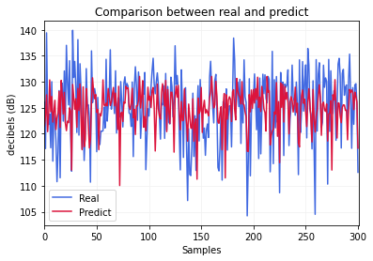
As shown on figure 13, Airfoil Noise dataset prediction had peak residuals over 15 decibels {dB} four times, resulting in MSE over 32 {dB²}. Afterwards, aquatic toxicity results are presented by fig. 14:
- Aquatic Toxicity Prediction x Real Plot for Linear Regression
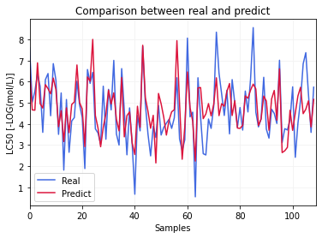
Finally, linear regression performance for fish toxicity dataset can be seen from fig. 15:
- Fish Toxicity Prediction x Real Plot for Linear Regression
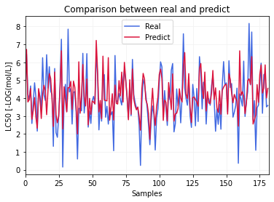

Acknowledgment (Heading 5)
The preferred spelling of the word “acknowledgment” in America is without an “e” after the “g”. Avoid the stilted expression “one of us (R. B. G.) thanks ...”. Instead, try “R. B. G. thanks...”. Put sponsor acknowledgments in the unnumbered footnote on the first page.

References
The template will number citations consecutively within brackets [1]. The sentence punctuation follows the bracket [2]. Refer simply to the reference number, as in [3]—do not use “Ref. [3]” or “reference [3]” except at the beginning of a sentence: “Reference [3] was the first ...”
Number footnotes separately in superscripts. Place the actual footnote at the bottom of the column in which it was cited. Do not put footnotes in the abstract or reference list. Use letters for table footnotes.
Unless there are six authors or more give all authors’ names; do not use “et al.”. Papers that have not been published, even if they have been submitted for publication, should be cited as “unpublished” [4]. Papers that have been accepted for publication should be cited as “in press” [5]. Capitalize only the first word in a paper title, except for proper nouns and element symbols.
For papers published in translation journals, please give the English citation first, followed by the original foreign-language citation [6].

- G. Eason, B. Noble, and I. N. Sneddon, “On certain integrals of Lipschitz-Hankel type involving products of Bessel functions,” Phil. Trans. Roy. Soc. London, vol. A247, pp. 529–551, April 1955. (references)
- J. Clerk Maxwell, A Treatise on Electricity and Magnetism, 3rd ed., vol. 2. Oxford: Clarendon, 1892, pp.68–73.
- I. S. Jacobs and C. P. Bean, “Fine particles, thin films and exchange anisotropy,” in Magnetism, vol. III, G. T. Rado and H. Suhl, Eds. New York: Academic, 1963, pp. 271–350.
- K. Elissa, “Title of paper if known,” unpublished.
- R. Nicole, “Title of paper with only first word capitalized,” J. Name Stand. Abbrev., in press.
- Y. Yorozu, M. Hirano, K. Oka, and Y. Tagawa, “Electron spectroscopy studies on magneto-optical media and plastic substrate interface,” IEEE Transl. J. Magn. Japan, vol. 2, pp. 740–741, August 1987 [Digests 9th Annual Conf. Magnetics Japan, p. 301, 1982].
- M. Young, The Technical Writer’s Handbook. Mill Valley, CA: University Science, 1989.

IEEE conference templates contain guidance text for composing and formatting conference papers. Please ensure that all template text is removed from your conference paper prior to submission to the conference. Failure to remove template text from your paper may result in your paper not being published.

We suggest that you use a text box to insert a graphic (which is ideally a 300 dpi TIFF or EPS file, with all fonts embedded) because, in an MSW document, this method is somewhat more stable than directly inserting a picture.
To have non-visible rules on your frame, use the MSWord “Format” pull-down menu, select Text Box > Colors and Lines to choose No Fill and No Line.

