MARCELO, Ira Levi D.

Part I.

Compare the value of pi inside and outside the “if” code block when using
varTest(true).

Both the values are the same even though the route it took to get the answer is somewhat different.
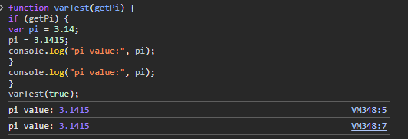

● Compare the value of pi inside and outside the “if” code block when usingletTest(true). What difference can you observe compared to the result of varTest(true)? If there is an error, why do you think the error occurred?
Inside the if it worked but the outside outputted an error. Let is block-scoped so if its accessed outside the black, the Javascript will say its not defined.

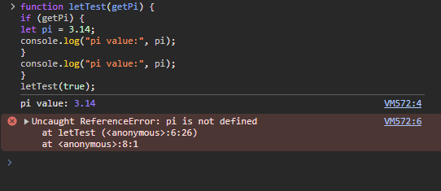

● Compare the result when using constTest(true) versus constTest(false). What
happened to the value of pi?
If true, the code assigns and logs pi = 3.14.
If false, the code never defines pi, so accessing it causes an error.
● Uncomment the single line comment, what do you think caused the error?
It’s because the const variables cannot be reassigned.
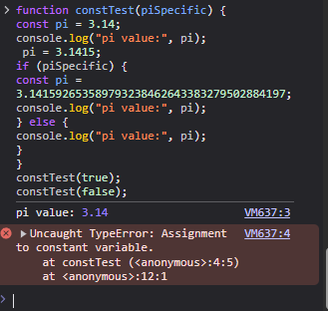

General Questions:
● Compare the value of pi inside and outside the “if” code block when usingletTest(true) and varTest(true)? What difference can you observe? If there is an error with either function, why do you think the error occurred?
In the ‘var’, allows access outside the block and no error
‘Let’ does not allow outside access and an error will occur. It was like the question before, when comparing the value of pi.

● What difference in behavior is the pi variable displaying regarding block scope and reassignment when declared using var, let, versus const?
Var is function-scoped, let and const are block-scoped. var has hoisting, let and const do not. let variables can be reassigned, const variables cannot be reassigned after initialization.

● Can you declare variables without using var, let, and const? When should you use
var, let, or const?
Yes, because when you define a variable without var , it becomes a global variable. Var, let, or const can be use if values that is going to be use will be change.
● Compare the process of declaring variables in JavaScript versus Java.
In java you must specify data type and in java script the datatype is dynamic meaning the value can later change because the datatype is decided during runtime, and not compile type.
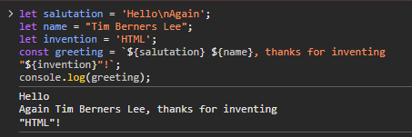

● Based on the simple greeting sentence being generated, what observations do you have with the usage of single quotes, double quotes, and backticks?
All
● Check the JS string methods and compare these with the equivalent methods used
in Java (e.g., how do you check the length of a string in each programming
language, concatenate, manipulate, etc.)
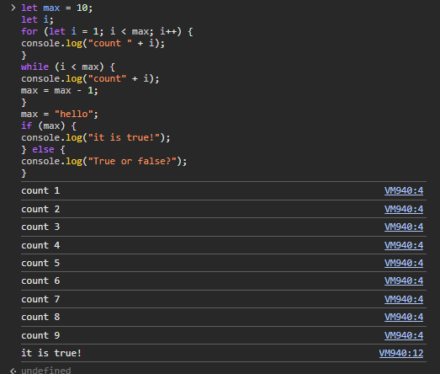
● What is the data type of the variable max? Why is this not allowed in Java?
● When does the while loop stop? What does this say about the number 0?
● Observe the output of the if statement. Then set max to null. Observe the result.
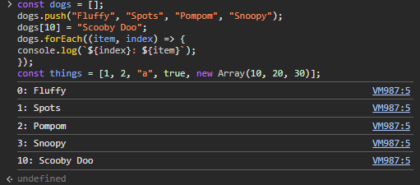

● The short code above shows a sample of creating an array. Compare the creation
of an array when using JS versus Java.
● The third line of the code shows adding “Scooby Doo” to the 10th index of the array.
What is the length of the array at this point? What does this behavior imply about
array size in JS. Is this allowed in Java?
● What does the last line imply about the contents of a JS array. Compare this with
Java.
● The snippet includes a sample of iterating through the array. Try to find and test other
code/methods of looping through the contents of an array using JS.
● Explore methods to perform array manipulation (e.g., sorting, splicing, filtering,
reversing contents, etc.)
● What methods simulate stack and queue operations using arrays?

Part II

● Java utilizes the Math class for mathematical operations such as round(), ceiling(),
pow(). Is there a similar object in JS?

● How do you declare a Date Object with the current date as its value?
● Declare a JS Object that is related to your hobby or area of interest.

● Declare a JSON object in JS that is related to your group’s assigned topic during the
Prelims. Have at least one level of nesting.

Part III

Create a JS program that will perform the addition and multiplication operations on two
matrices with at least or more than 3 rows and 3 columns. It is your choice if you will
hardcode the values of the matrix or have them randomized.

