Supplementary Materials

Regional comparison of Atlantic Forest physiognomies using GEDI-derived structural metrics

Marcelo C. S. Bandoria, Hugo T. Seixas, Marcos R. Rosa, Paulo G. Molin, Alfredo P. Queiroz
Correspondence: marcelo.bandoria@usp.br

Journal: Forests
Manuscript ID: forests-4346855

This supplementary material provides additional methodological details, quality-control information, statistical outputs, and supporting figures and tables associated with the manuscript.
Specifically, it documents (i) the polygon delineation workflow used to identify old-growth candidate forests, (ii) the visual QA/QC procedure adopted to verify polygon homogeneity, (iii) the quality-control (QC) and acquisition scenarios used to test the stability of GEDI-based inference, and (iv) expanded details on bootstrap resampling and spatial autocorrelation analysis. It also reports collinearity diagnostics among GEDI-derived structural metrics and summarizes the sensitivity of polygon-level separability to alternative QC and acquisition subsets. Complete scenario-wise outputs, including full correlation tables, sample-size logs, Dunn pairwise results, and effect-size deltas relative to the baseline scenario, are available in the public Zenodo repository listed in the Data Availability Statement. For clarity, IBGE and MapBiomas were used only in the polygon delineation workflow as ancillary classificatory and land-cover datasets, respectively, whereas all structural metrics analyzed in the study were derived directly from GEDI.
The complete repository, including the analytical dataset, spatial files, R scripts, metadata, reproducible outputs, and supplementary outputs, is archived on Zenodo at https://doi.org/10.5281/zenodo.20403257 and available through the public GitHub repository at https://github.com/marcelobandoria/GEDI_Atlantic_Forest_MDPI_repository.
The supplementary material is organized as follows: Supplementary Methods S1–S4, Supplementary Figures S1–S2, and Supplementary Tables S1a–S1b, S2a–S2b, S3a–S3b, and S4. Complete scenario-wise outputs and reproducible processing files are provided in the public Zenodo repository.
1. Supplementary Methods

S1. Visual interpretation key for polygon QA/QC
Figure 4 in the main manuscript presents the visual interpretation key used for polygon QA/QC based on CBERS-4A/WPM Level-4 pan-sharpened imagery (2 m). Representative scenes were selected for each Atlantic Forest phytophysiognomy and visually interpreted to support both polygon verification and the interpretation key: Dense Ombrophilous Forest (DOF), 08 May 2023; Mixed Ombrophilous Forest (MOF), 11 October 2023; Seasonal Semideciduous Forest (SSdF), 16 October 2023; and Seasonal Deciduous Forest (SDF), 16 September 2024.
All scenes were processed using the WPM multispectral bands (0–4) and displayed as natural-color RGB composites with pan-sharpening (PAN fusion) to enhance spatial detail. Visual interpretation was performed at a scale of 1:5,000 and considered canopy texture and roughness, crown-size distribution, shadow patterns, within-patch heterogeneity (including gaps and edge influence), and visible evidence of recent anthropogenic disturbance. These criteria were used to support the exclusion of polygons showing recent clearings, roads, or strong edge intrusion during QA/QC. Visual inspection was therefore used only to verify polygon integrity and recent disturbance signals, not to derive GEDI structural variables, validate GEDI-derived structural measurements, or serve as the primary basis for physiognomy attribution.

S2. Polygon delineation and filtering workflow
Old-growth candidate polygons were delineated through a GIS workflow combining the official IBGE phytophysiognomic framework and the corresponding 1:250,000 vegetation layer for physiognomy attribution, together with the MapBiomas annual land-cover and land-use series (Collection 9) for temporal stability screening. Temporal stability was assessed using the MapBiomas Forest formation class from 2009 to 2023. Polygons were assigned to a single phytophysiognomy using a majority-overlap rule (≥80%) and were required to show high internal homogeneity (≥90% Forest formation in 2023), no transition to anthropogenic classes during the screening period, a minimum area of 1.045 ha, and a non-empty core area after internal buffering.
The IBGE layer was used only for regional phytophysiognomic attribution, whereas MapBiomas was used for forest masking, temporal stability screening, and internal homogeneity assessment. IBGE and MapBiomas were therefore used only as ancillary classificatory and land-cover datasets in the sampling workflow, whereas all structural metrics analyzed in the study were derived directly from GEDI. Neither dataset was used to calibrate or validate GEDI structural measurements or footprint-level structural metrics. Forest age was not directly estimated in the field. Therefore, comparability among phytophysiognomies was based on the same temporal-stability and spatial-consistency criteria applied uniformly to all candidate polygons.
Polygon consistency was further controlled by visual quality assurance/quality control using CBERS-4A/WPM imagery and by the 60-m internal edge buffer applied in the main analysis. These procedures were used to reduce the influence of recent disturbance, boundary mixing, local edge effects, and potential geolocation uncertainty near polygon limits. GEDI footprints were treated as subsamples within polygons, and polygon-level summaries were used as the primary unit of inference in the main analyses. This design was adopted to reduce within-polygon dependence and to align the analytical unit with the ecological unit of comparison in a fragmented landscape.

S3. GEDI quality-control and acquisition scenarios
Polygon-level inference was evaluated under alternative QC and acquisition subsets, including baseline QC, sensitivity thresholds, strong beams only, night-only acquisitions, and low-uncertainty AGBD subsets. Redundant thresholds producing identical retained sample sizes were collapsed for compact reporting. These scenarios were designed to test the robustness of GEDI-derived polygon-level structural inference under plausible filtering choices. Complete scenario definitions, redundancy mapping, and processing outputs are available in the public Zenodo repository.

S4. Bootstrap and spatial autocorrelation details
Bootstrap resampling of polygons was used to balance sample sizes among physiognomies. Residual spatial autocorrelation was assessed using Moran’s I on polygon-level residuals with an adaptive k-nearest-neighbor weights matrix. These procedures were applied to polygon-level GEDI summaries used as the primary unit of inference.

2. Supplementary Figures

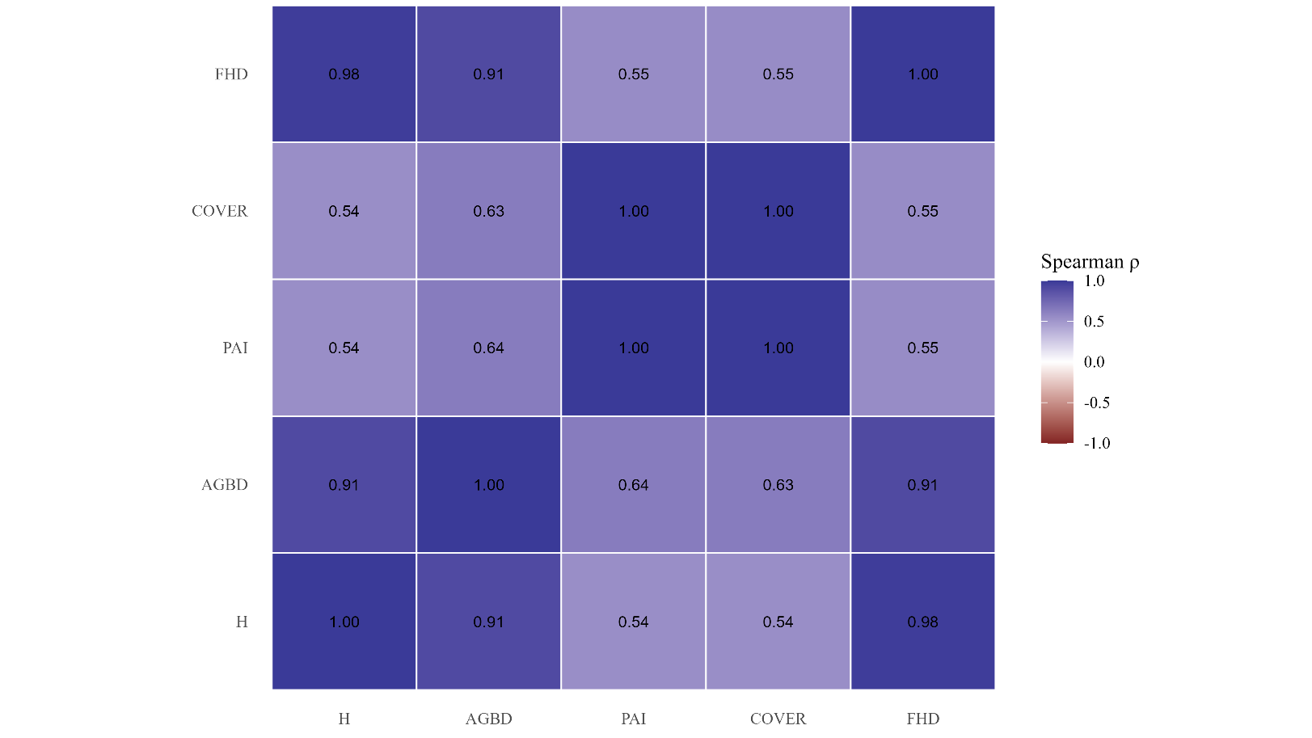
Figure S1. Spearman collinearity among GEDI-derived structural metrics (polygon level).

Note: Correlations were calculated from polygon-level summaries (median GEDI metric per polygon). Full correlation outputs are available in the public Zenodo repository.
Heatmap of pairwise Spearman’s ρ computed from polygon-level medians under the baseline QC scenario. Metrics include canopy height (H), aboveground biomass density (AGBD), plant area index (PAI), canopy cover (COVER), and foliage height diversity (FHD).

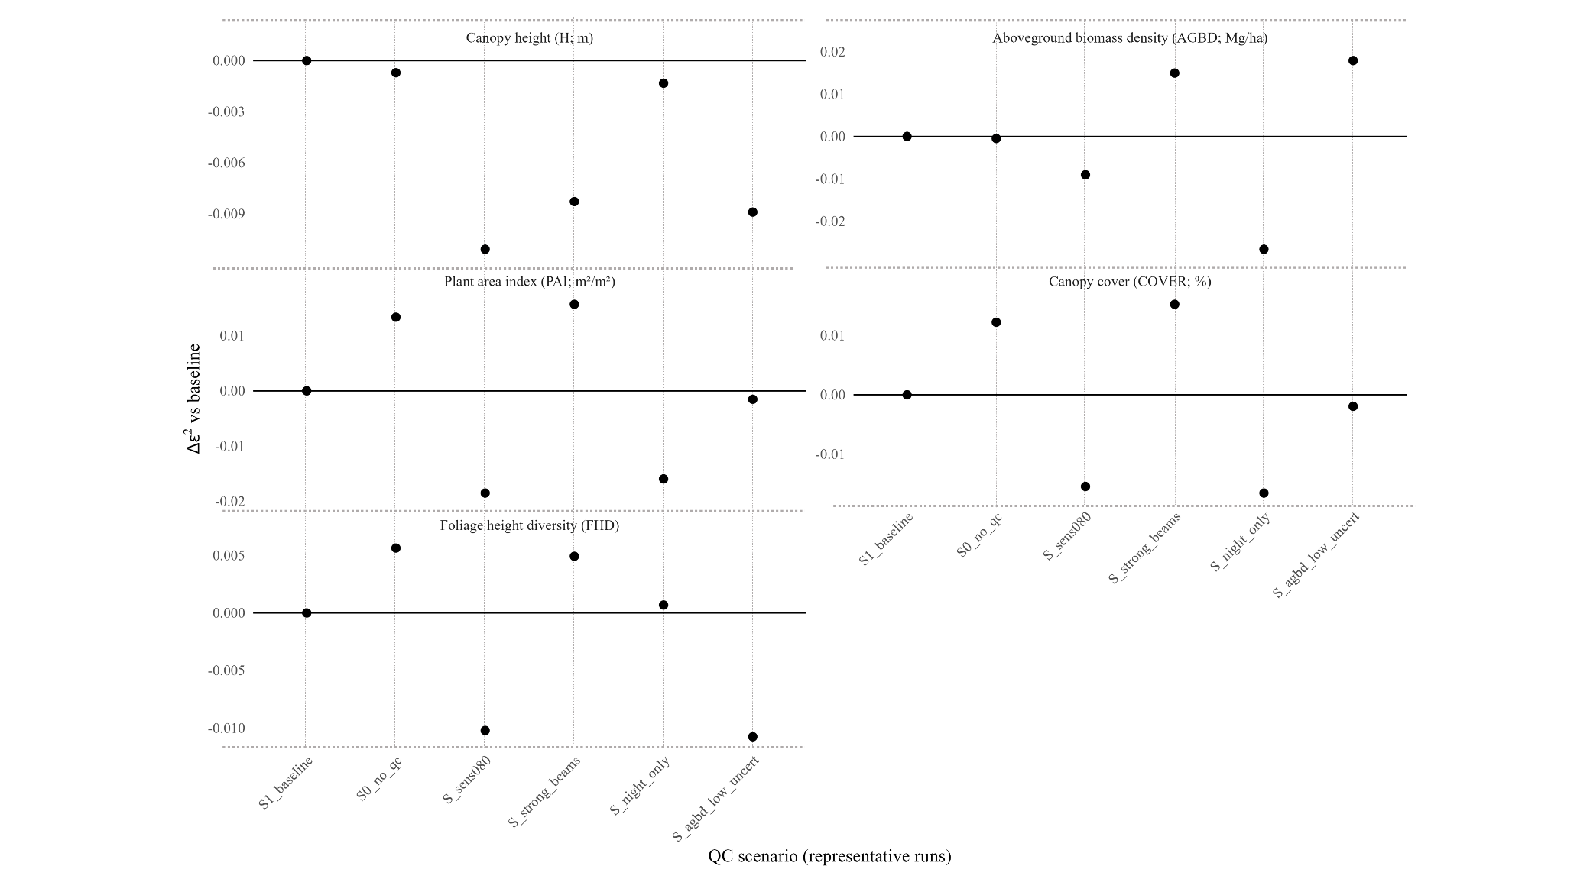
Fig. S2. Quality-control sensitivity based on Δε² relative to the baseline scenario.

Note: Effect sizes were computed using polygon-level summaries (median GEDI metric per polygon) with bootstrap resampling of polygons. Full scenario-wise outputs are available in the public Zenodo repository.
Change in polygon-level Kruskal–Wallis effect size relative to the baseline scenario (Δε² = ε²_scenario − ε²_baseline) across QC and acquisition subsets.

3. Supplementary Tables

Pairwise Spearman’s ρ among GEDI-derived structural metrics at the polygon level under the baseline QC scenario.

Table S1a. Polygon-level collinearity under baseline QC.
Note: Values were computed from polygon-level summaries (median GEDI metric per polygon). Pairs with |ρ| ≥ 0.70 are flagged as potentially collinear, and pairs with |ρ| ≥ 0.80 indicate high collinearity.

Summary of the stability of pairwise Spearman’s ρ across alternative QC and acquisition scenarios at the polygon level.

Table S1b. Stability of polygon-level collinearity across scenarios.

Note: For each metric pair, the table reports baseline ρ and the median, minimum, and maximum ρ across scenarios. Full correlation outputs are available in the public Zenodo repository.

QC and acquisition scenarios evaluated and their effects on retained sample size at the footprint and polygon levels, before and after application of the internal 60 m buffer.

Table S2a. QC/acquisition scenarios and sample-size impact.
Note: Sample-size counts are shown for compact comparison across scenarios. Full processing logs are available in the public Zenodo repository.

Definitions of the QC and acquisition scenarios used in the sensitivity analysis and identification of redundant scenarios collapsed for compact reporting.
All scenarios refer to alternative filtering subsets applied to GEDI footprints after polygon assignment.

Table S2b. Scenario definitions and redundancy handling.
Note: Redundant sensitivity thresholds producing identical retained sample sizes after QC and buffering were collapsed to a representative scenario. Full redundancy mapping is available in the public Zenodo repository.

Scenario definitions (QC/acquisition subsets):

- No QC (diagnostic): No per-shot QC screening; all footprints assigned to polygons by spatial join were retained (prior to the 60 m internal buffer).
- Baseline QC (quality = 1; degrade = 0): Retained only footprints meeting recommended per-shot QC for both GEDI products (L2B and L4A: quality_flag = 1 and degrade_flag = 0).
- Baseline + sensitivity ≥ 0.80 / 0.90 / 0.95 / 0.99: Baseline QC plus a minimum waveform sensitivity threshold in both products (sensitivity_2b ≥ threshold and sensitivity_4a ≥ threshold).
- Baseline + strong beams only: Baseline QC plus restriction to strong/high-energy beams (beam subset defined in a data-driven manner using per-beam sensitivity statistics; full details and beam lists are available in the public Zenodo repository).
- Baseline + night-only: Baseline QC plus restriction to nighttime acquisitions (solar_elevation ≤ 0 for both L2B and L4A).
- Baseline + low AGBD uncertainty (best 90%): Baseline QC plus restriction to the lowest-uncertainty AGBD shots, retaining the best 90% based on AGBD uncertainty metrics (AGBD_SE and/or AGBD prediction-interval width, when available).

Median polygon-level Kruskal–Wallis p-values and effect sizes (ε²) across QC and acquisition scenarios.

Table S3a. Polygon-level Kruskal-Wallis results by scenario.
Note: Results were computed using polygon-level summaries (median GEDI metric per polygon) with bootstrap resampling of polygons. Δε² is defined as ε²_scenario − ε²_baseline. Metrics include H, AGBD, PAI, COVER, and FHD.
Summary of changes in polygon-level separability (Δε²) across QC and acquisition scenarios, aggregated across the five structural metrics.

Table S3b. Scenario-level summary of Δε² across metrics.
Note: For each scenario, Δε² is summarized across H, AGBD, PAI, COVER, and FHD using the median, minimum, and maximum values relative to the baseline scenario. Positive Δε² indicates greater between-physiognomy separability than baseline, whereas negative Δε² indicates reduced separability.
Summary of the robustness of pairwise physiognomy contrasts across QC and acquisition scenarios based on polygon-level Dunn effect sizes (r) and the proportion of significant bootstrap replicates (prop_sig).
Table S4. Robustness of pairwise physiognomy separation across scenarios (polygon-level Dunn effect size, r).
Note: Results are based on polygon-level summaries (median GEDI metric per polygon) with bootstrap resampling of polygons (n_boot = 2,000). To keep the Supplementary Information concise, this table reports a compact subset of key contrasts and Bonferroni-adjusted results. Complete scenario-wise Dunn outputs and Δr relative to baseline are available in the public Zenodo repository.

