Supplementary Information for Regional comparison of Atlantic Forest physiognomies using GEDI-derived structural metrics.

Overview

This Supplementary Information provides additional methodological details and robustness analyses supporting the main manuscript. Specifically, it documents (i) the polygon delineation workflow used to identify old-growth candidate forests, (ii) the visual QA/QC procedure adopted to verify polygon homogeneity, (iii) the quality-control (QC) and acquisition scenarios used to test the stability of GEDI-based inference, and (iv) expanded details on bootstrap resampling and spatial autocorrelation analysis. It also reports collinearity diagnostics among GEDI-derived structural metrics and summarizes the sensitivity of polygon-level separability to alternative QC and acquisition subsets. Complete scenario-wise outputs, including full correlation tables, sample-size logs, Dunn pairwise results, and effect-size deltas relative to the baseline scenario, are provided in Supplementary Data 1 (Excel file). For clarity, IBGE and MapBiomas were used only in the polygon delineation workflow as ancillary classificatory and land-cover datasets, respectively, whereas all structural metrics analyzed in the study were derived directly from GEDI.

Supplementary Methods
S1. Visual QA/QC and interpretation key
Figure 2 presents the visual interpretation key used for polygon QA/QC based on CBERS-4A/WPM Level-4 pan-sharpened imagery (2 m). Representative scenes were selected for each Atlantic Forest phytophysiognomy and visually interpreted to support both polygon verification and the interpretation key: Dense Ombrophilous Forest (DOF), 08 May 2023; Mixed Ombrophilous Forest (MOF), 11 October 2023; Seasonal Semideciduous Forest (SSdF), 16 October 2023; and Seasonal Deciduous Forest (SDF), 16 September 2024.
All scenes were processed using the WPM multispectral bands (0–4) and displayed as natural-color RGB composites with pan-sharpening (PAN fusion) to enhance spatial detail. Visual interpretation was performed at a scale of 1:5,000 and considered canopy texture and roughness, crown-size distribution, shadow patterns, within-patch heterogeneity (including gaps and edge influence), and visible evidence of recent anthropogenic disturbance. These criteria were used to support the exclusion of polygons showing recent clearings, roads, or strong edge intrusion during QA/QC. Visual inspection was therefore used only to verify polygon integrity and recent disturbance signals, not to derive GEDI structural variables or to serve as the primary basis for physiognomy attribution.

S2. Polygon delineation workflow
Old-growth candidate polygons were delineated through a GIS workflow the official IBGE phytophysiognomic framework and the corresponding 1:250,000 vegetation layer for physiognomy attribution, together with the MapBiomas annual land-cover and land-use series (Collection 9) for temporal stability screening. Temporal stability was assessed using the MapBiomas Forest formation class from 2009 to 2023. Polygons were assigned to a single phytophysiognomy using a majority-overlap rule (≥ 80%) and were required to show high internal homogeneity (≥ 90% Forest formation in 2023). IBGE and MapBiomas were therefore used only as ancillary classificatory and land-cover datasets in the sampling workflow, whereas all structural variables analyzed in the study were derived directly from GEDI. Neither dataset was used to calibrate or validate GEDI structural measurements.
S3. GEDI QC and acquisition scenarios
Polygon-level inference was evaluated under alternative QC and acquisition subsets, including baseline QC, sensitivity thresholds, strong beams only, night-only acquisitions, and low-uncertainty AGBD subsets. Redundant thresholds producing identical retained sample sizes were collapsed for compact reporting. These scenarios were designed to test the robustness of GEDI-derived structural inference under plausible filtering choices.
S4. Bootstrap and spatial autocorrelation details
Bootstrap resampling of polygons was used to balance sample sizes among physiognomies. Residual spatial autocorrelation was assessed using Moran’s I on polygon-level residuals with an adaptive k-nearest-neighbor weights matrix. These procedures were applied to polygon-level GEDI summaries used as the primary unit of inference.

Supplementary Figures

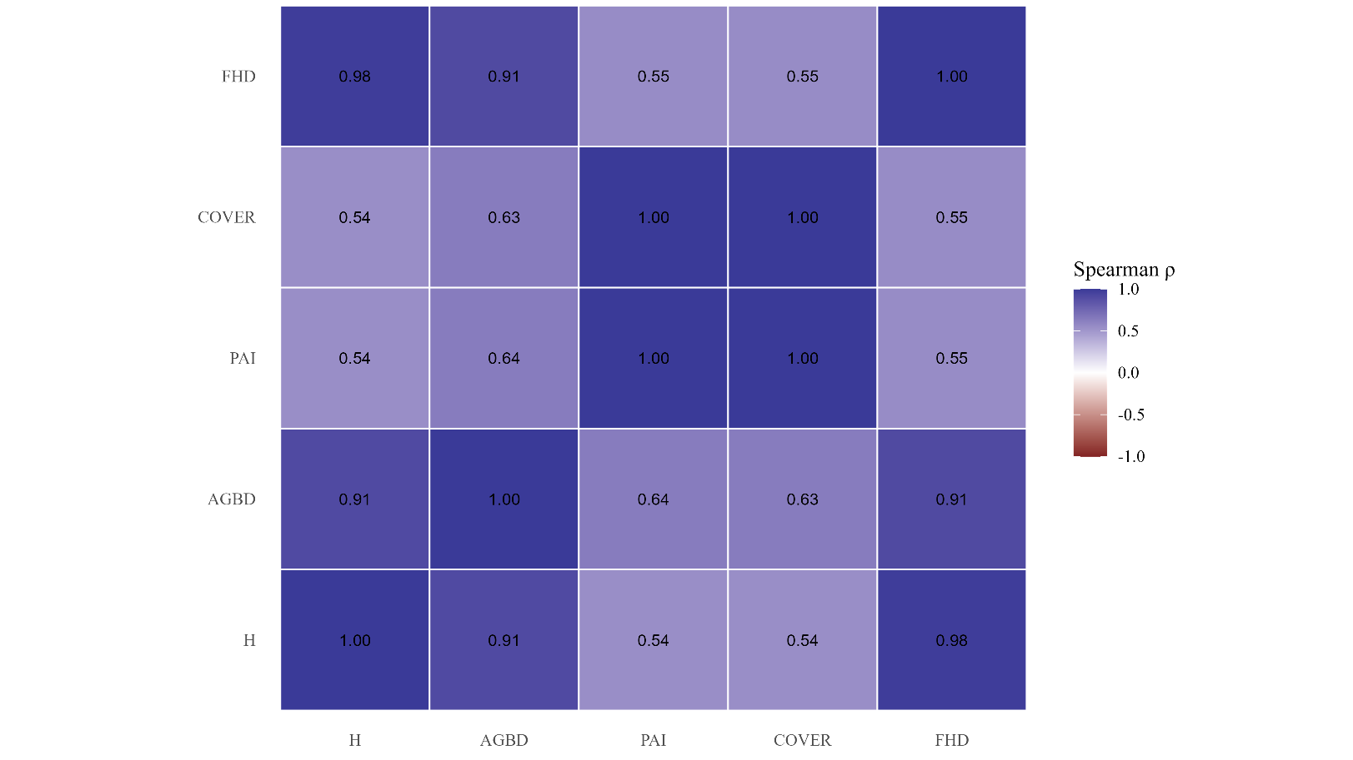

Fig. S1. Spearman collinearity among GEDI-derived structural metrics (polygon level).

Heatmap of pairwise Spearman’s ρ computed from polygon-level medians under the baseline QC scenario. Metrics include canopy height (H), aboveground biomass density (AGBD), plant area index (PAI), canopy cover (COVER), and foliage height diversity (FHD).

Note: Correlations were calculated from polygon-level summaries (median GEDI metric per polygon). Full correlation outputs are provided in Supplementary Data 1.

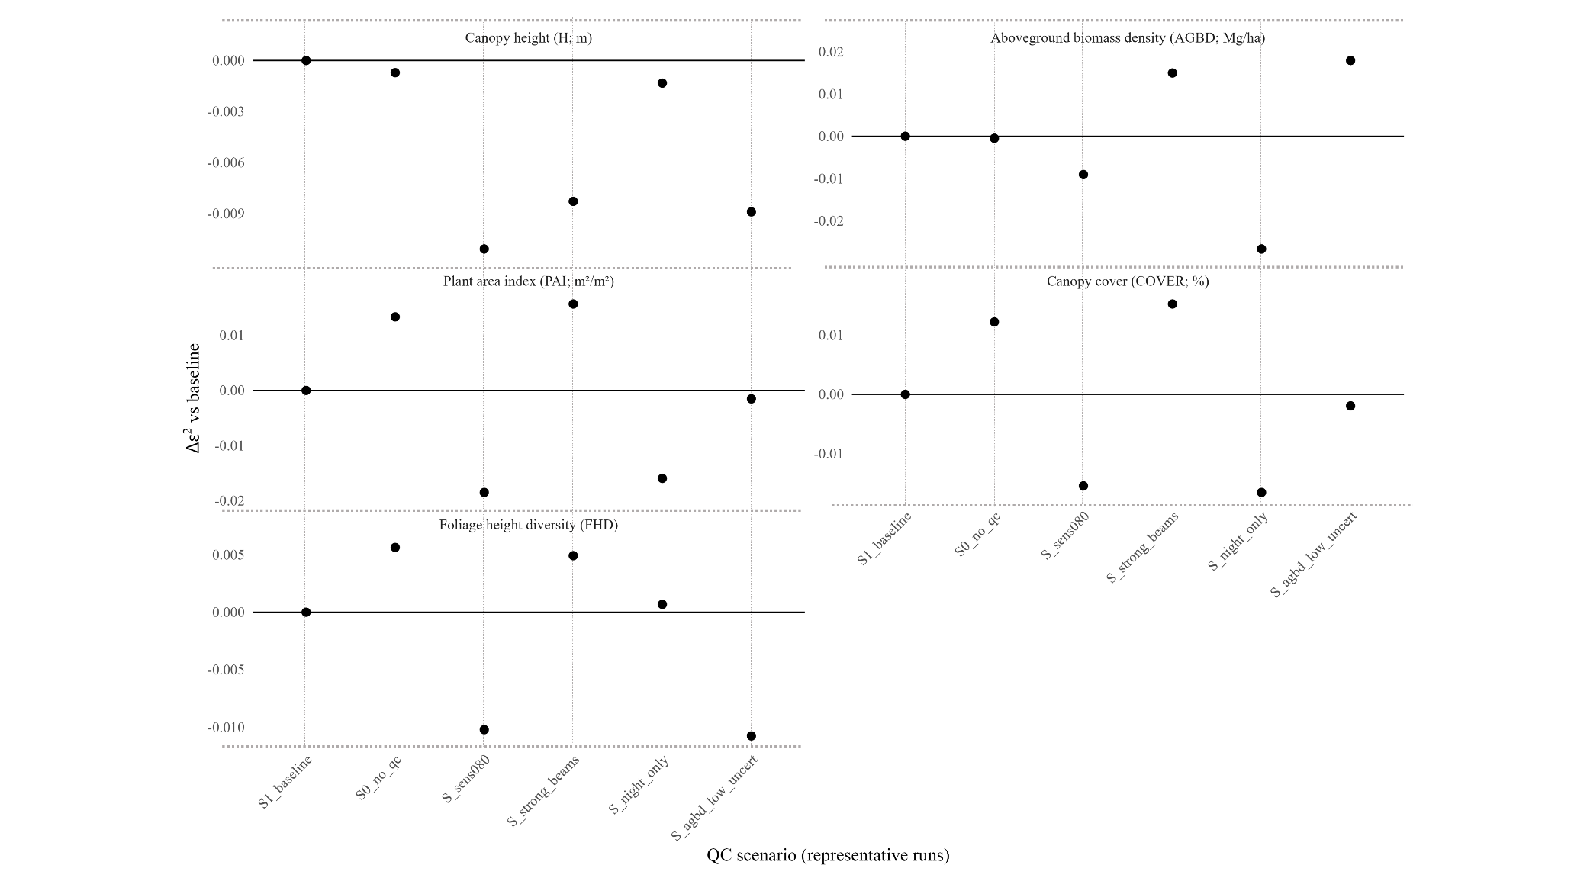
Fig. S2. QC/acquisition sensitivity of polygon-level Kruskal–Wallis effect sizes.

Change in polygon-level Kruskal–Wallis effect size relative to the baseline scenario (Δε² = ε²_scenario − ε²_baseline) across QC and acquisition subsets.

Note: Effect sizes were computed using polygon-level summaries (median GEDI metric per polygon) with bootstrap resampling of polygons. Full scenario-wise outputs are provided in Supplementary Data 1.

Supplementary Tables

Table S1a. Polygon-level collinearity under baseline QC.

Pairwise Spearman’s ρ among GEDI-derived structural metrics at the polygon level under the baseline QC scenario.

Note: Values were computed from polygon-level summaries (median GEDI metric per polygon). Pairs with |ρ| ≥ 0.70 are flagged as potentially collinear, and pairs with |ρ| ≥ 0.80 indicate high collinearity.

Table S1b. Stability of polygon-level collinearity across scenarios.

Summary of the stability of pairwise Spearman’s ρ across alternative QC and acquisition scenarios at the polygon level.

Note: For each metric pair, the table reports baseline ρ and the median, minimum, and maximum ρ across scenarios. Full correlation outputs are provided in Supplementary Data 1.
Table S2a. QC/acquisition scenarios and sample-size impact.

QC and acquisition scenarios evaluated and their effects on retained sample size at the footprint and polygon levels, before and after application of the internal 60 m buffer.

Note: Sample-size counts are shown for compact comparison across scenarios. Full processing logs are provided in Supplementary Data 1.

Table S2b. Scenario definitions and redundancy handling.
Definitions of the QC and acquisition scenarios used in the sensitivity analysis and identification of redundant scenarios collapsed for compact reporting.
All scenarios refer to alternative filtering subsets applied to GEDI footprints after polygon assignment.

Scenario definitions (QC/acquisition subsets):

- No QC (diagnostic): No per-shot QC screening; all footprints assigned to polygons by spatial join were retained (prior to the 60 m internal buffer).
- Baseline QC (quality = 1; degrade = 0): Retained only footprints meeting recommended per-shot QC for both GEDI products (L2B and L4A: quality_flag = 1 and degrade_flag = 0).
- Baseline + sensitivity ≥ 0.80 / 0.90 / 0.95 / 0.99: Baseline QC plus a minimum waveform sensitivity threshold in both products (sensitivity_2b ≥ threshold and sensitivity_4a ≥ threshold).
- Baseline + strong beams only: Baseline QC plus restriction to strong/high-energy beams (beam subset defined in a data-driven manner using per-beam sensitivity statistics; full details and beam lists are provided in Supplementary Data 1).
- Baseline + night-only: Baseline QC plus restriction to nighttime acquisitions (solar_elevation ≤ 0 for both L2B and L4A).
- Baseline + low AGBD uncertainty (best 90%): Baseline QC plus restriction to the lowest-uncertainty AGBD shots, retaining the best 90% based on AGBD uncertainty metrics (AGBD_SE and/or AGBD prediction-interval width, when available).

Note: Redundant sensitivity thresholds producing identical retained sample sizes after QC and buffering were collapsed to a representative scenario. Full redundancy mapping is available in Supplementary Data 1.

Table S3a. Polygon-level Kruskal-Wallis results by scenario.

Median polygon-level Kruskal–Wallis p-values and effect sizes (ε²) across QC and acquisition scenarios.

Note: Results were computed using polygon-level summaries (median GEDI metric per polygon) with bootstrap resampling of polygons. Δε² is defined as ε²_scenario − ε²_baseline. Metrics include H, AGBD, PAI, COVER, and FHD.

Table S3b. Scenario-level summary of Δε² across metrics.

Summary of changes in polygon-level separability (Δε²) across QC and acquisition scenarios, aggregated across the five structural metrics.

Note: For each scenario, Δε² is summarized across H, AGBD, PAI, COVER, and FHD using the median, minimum, and maximum values relative to the baseline scenario. Positive Δε² indicates greater between-physiognomy separability than baseline, whereas negative Δε² indicates reduced separability.

Table S4. Robustness of pairwise physiognomy separation across scenarios (polygon-level Dunn effect size, r).

Summary of the robustness of pairwise physiognomy contrasts across QC and acquisition scenarios based on polygon-level Dunn effect sizes (r) and the proportion of significant bootstrap replicates (prop_sig).

Note: Results are based on polygon-level summaries (median GEDI metric per polygon) with bootstrap resampling of polygons (n_boot = 2,000). To keep the Supplementary Information concise, this table reports a compact subset of key contrasts and Bonferroni-adjusted results. Complete scenario-wise Dunn outputs and Δr relative to baseline are provided in Supplementary Data 1.
Supplementary Data (Excel file).
Complete outputs for all GEDI QC and acquisition scenarios, including full correlation tables, scenario logs, retained sample sizes, full Dunn pairwise results, and scenario-wise deltas relative to the baseline scenario.

