1801 ctaggacaataaagccacttgttgggaaacagatgattcagggggtcccatgtccatagg
1861 tgatttgctctatcaacgatttccccccaaagggcgctttgccgaggctggttggggtgg
1921 agacttgggataccgcctggcgtggatggaggaggcgatgagggggccctggaagccagc
1981 ccctgagcctggcgtgtaaggcgattacacatcttcctggggtcatattttctgtgagcg
2041 tttatctttcatgcctgccgcgctaggattttccccctgccgtgcaagacatctttgctc
2101 ggtctggggagggcgcttagccatttgccccgggtgggggcgtcccgtgttctgcaaagt
2161 gctctgcacttgcccccgggttaggtcccggacggccgccctccagtgcccaccactaac
25 A Y S S V P V
2221 cccgccctccggggcttcttcactcgctgtctccactccagGCCTACTCCTCCGTCCCGG
32 S N M N S G L G S M N S M N T Y M T M N
2281 TCAGCAACATGAACTCAGGCCTGGGCTCCATGAACTCCATGAACACCTACATGACCATGA
52 T M T T S G N M T P A S F N M S Y A N P
2341 ACACCATGACTACGAGCGGCAACATGACCCCGGCGTCCTTCAACATGTCCTATGCCAACC
72 G L G A G L S P G A V A G M P G G S A G
2401 CGGGCCTAGGGGCCGGCCTGAGTCCCGGCGCAGTAGCCGGCATGCCGGGGGGCTCGGCGG
92 A M N S M T A A G V T A M G T A L S P S
2461 GCGCCATGAACAGCATGACTGCGGCCGGCGTGACGGCCATGGGTACGGCGCTGAGCCCGA
112 G M G A M G A Q Q A A S M N G L G P Y A
2521 GCGGCATGGGCGCCATGGGTGCGCAGCAGGCGGCCTCCATGAATGGCCTGGGCCCCTACG
132 A A M N P C M S P M A Y A P S N L G R S
2581 CGGCCGCCATGAACCCGTGCATGAGCCCCATGGCGTACGCGCCGTCCAACCTGGGCCGCA
152 R A G G G G D A K T F K R S Y P H A K P
2641 GCCGCGCGGGCGGCGGCGGCGACGCCAAGACGTTCAAGCGCAGCTACCCGCACGCCAAGC
172 P Y S Y I S L I T M A I Q Q A P S K M L
2701 CGCCCTACTCGTACATCTCGCTCATCACCATGGCCATCCAGCAGGCGCCCAGCAAGATGC
192 T L S E I Y Q W I M D L F P Y Y R Q N Q
2761 TCACGCTGAGCGAGATCTACCAGTGGATCATGGACCTCTTCCCCTATTACCGGCAGAACC
212 Q R W Q N S I R H S L S F N D C F V K V
2821 AGCAGCGCTGGCAGAACTCCATCCGCCACTCGCTGTCCTTCAATGACTGCTTCGTCAAGG
232 A R S P D K P G K G S Y W T L H P D S G
2881 TGGCACGCTCCCCGGACAAGCCGGGCAAGGGCTCCTACTGGACGCTGCACCCGGACTCCG
252 N M F E N G C Y L R R Q K R F K C E K Q
2941 GCAACATGTTCGAGAACGGCTGCTACTTGCGCCGCCAGAAGCGCTTCAAGTGCGAGAAGC
272 P G A G G G G G S G S G G S G A K G G P
3001 AGCCGGGGGCCGGCGGCGGGGGCGGGAGCGGAAGCGGGGGCAGCGGCGCCAAGGGCGGCC
292 E S R K D P S G A S N P S A D S P L H R
3061 CTGAGAGCCGCAAGGACCCCTCTGGCGCCTCTAACCCCAGCGCCGACTCGCCCCTCCATC
312 G V H G K T G Q L E G A P A P G P A A S
3121 GGGGTGTGCACGGGAAGACCGGCCAGCTAGAGGGCGCGCCGGCCCCCGGGCCCGCCGCCA
332 P Q T L D H S G A T A T G G A S E L K T
3181 GCCCCCAGACTCTGGACCACAGTGGGGCGACGGCGACAGGGGGCGCCTCGGAGTTGAAGA
352 P A S S T A P P I S S G P G A L A S V P
3241 CTCCAGCCTCCTCAACTGCGCCCCCCATAAGCTCCGGGCCCGGGGCGCTGGCCTCTGTGC
372 A S H P A H G L A P H E S Q L H L K G D
3301 CCGCCTCTCACCCGGCACACGGCTTGGCACCCCACGAGTCCCAGCTGCACCTGAAAGGGG
392 P H Y S F N H P F S I N N L M S S S E Q
3361 ACCCCCACTACTCCTTCAACCACCCGTTCTCCATCAACAACCTCATGTCCTCCTCGGAGC
412 Q H K L D F K A Y E Q A L Q Y S P Y G S
3421 AGCAGCATAAGCTGGACTTCAAGGCATACGAACAGGCACTGCAATACTCGCCTTACGGCT
432 T L P A S L P L G S A S V T T R S P I E
3481 CTACGTTGCCCGCCAGCCTGCCTCTAGGCAGCGCCTCGGTGACCACCAGGAGCCCCATCG
452 P S A L E P A Y Y Q G V Y S R P V L N T
3541 AGCCCTCAGCCCTGGAGCCGGCGTACTACCAAGGTGTGTATTCCAGACCCGTCCTAAACA
472 S *
3601 CTTCCTAG

Anotação Gênica de tecido tumoral e normal de próstata.

Gene: FOXA1

Dentre os genes de tecido tumoral, os genes FOXA1, SATB1, ZXDC estão envolvidos com fatores de transcrição e se mostraram mais relevantes para o estudo. Foi visto também que, a partir da função nos fatores de transcrição, os genes FOXA1 e ZXDC estão mais regulados em linhagens de celulas luminais no câncer de mama do que em celulas mesenquimais do câncer.

Seq. Escolhida: região intro-exon do Exon 2, e o Exon 2 inteiro, onde a mutação está localizada.

SNP missense – Pos. 497 do mRNA: GCG -> GTG / Pos. 62: Ala -> Val

Região escolhida para o Fprimer: 5’-aaagtgctctgcacttgcccc-3’
Seq. Fprimer: 5’-aaagtgctctgcacttgcccc-3’ – Tm = 64º

Região escolhida para o Rprimer: 5’-ATGAACCCGTGCATGAGCCC-3’
Seq. Rprimer: 3’-GGGCTCATGCACGGGTTCAT-5’ – Tm = 64º

Região Amplificada – aprox. 452pb visando que a SNP escolhida esteja aproximadamente no meio da sequencia a ser amplificada.

Mapa de Restrição feito pelo http://tools.neb.com/NEBcutter2/

Sequencia NORMAL:

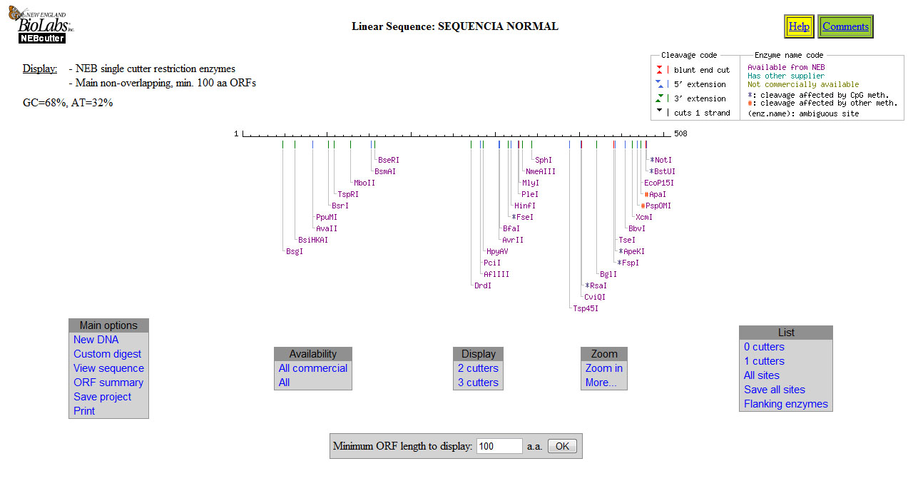

Sequencia MUTADA:

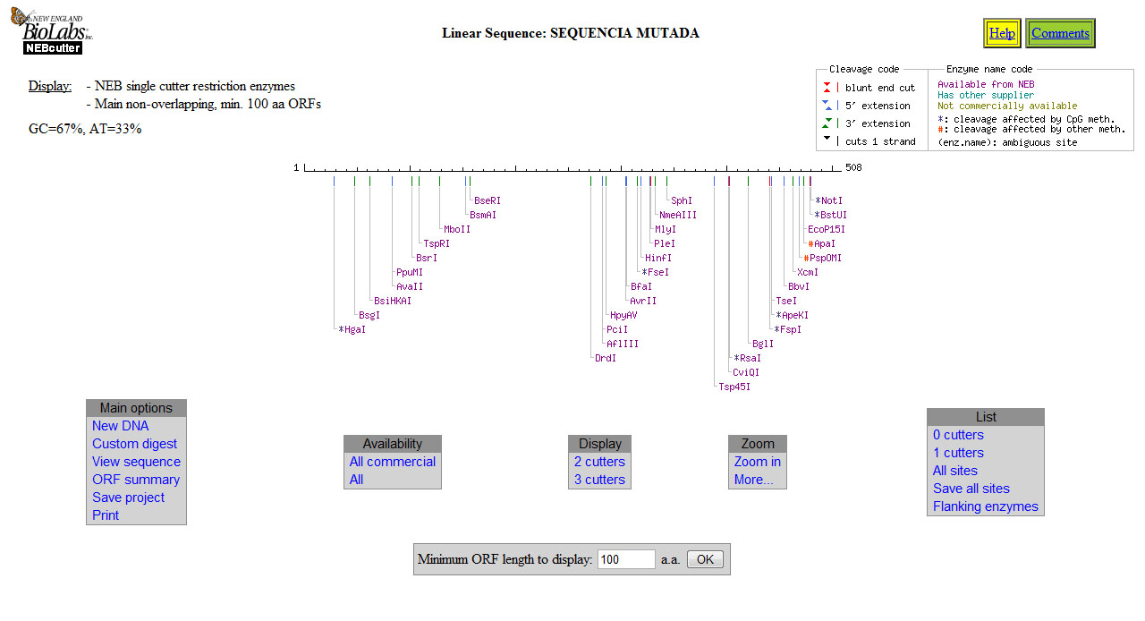

Após fazer o mapa de restrição da sequencia normal e da sequencia com mutação, foi observado que a sequencia mutada teve um sitio de restrição adicionado logo no inicio da sequencia, e manteve os demais sitios que a sequencia normal possui.

