A postagem da sequencia da região do gene PIGR para ser analisada no programa MethPrimer.

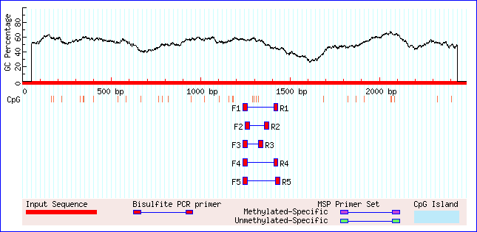

Não foram encontrados ilhas CpG, o que pode significar uma maior vunerabilidade a metilação.

No processo, foram obtidos Cinco primers:

Primer Start Size Tm GC% 'C's Sequence

1 Left primer 1249 25 59.48 56.00 4 TAAGGAGGTAGATTGTGTGATTGTG

Right primer 1379 25 58.76 52.00 4 AATCCCTTCCCACCTACTAATATTT

Product size: 131, Tm: 66.6, CpGs in product: 4

2 Left primer 1237 25 59.23 60.00 4 GGGTGATAAGGATAAGGAGGTAGAT

Right primer 1429 24 59.40 54.17 6 CCAAACACAAACCAAACTAAAAAA

Product size: 193, Tm: 71.0, CpGs in product: 4

3 Left primer 1237 25 59.23 60.00 4 GGGTGATAAGGATAAGGAGGTAGAT

Right primer 1349 25 57.10 56.00 8 AAAAAAATAAAAAACTTCCACACAC

Product size: 113, Tm: 65.1, CpGs in product: 4

4 Left primer 1237 25 59.23 60.00 4 GGGTGATAAGGATAAGGAGGTAGAT

Right primer 1432 24 58.92 50.00 5 AATCCAAACACAAACCAAACTAAA

Product size: 196, Tm: 71.3, CpGs in product: 4

5 Left primer 1237 25 59.23 60.00 4 GGGTGATAAGGATAAGGAGGTAGAT

Right primer 1441 25 58.78 52.00 7 AAATTAAAAAATCCAAACACAAACC

Product size: 205, Tm: 71.2, CpGs in product: 4