THIRD REVISED AND EXPANDED EDITION

Robotinics Rev. 3
Robotics, IoT, and Artificial Intelligence with Arduino, Raspberry Pi, and TCHATGPT
━━━━━━━━━━━━━━━━━━━━━━━━
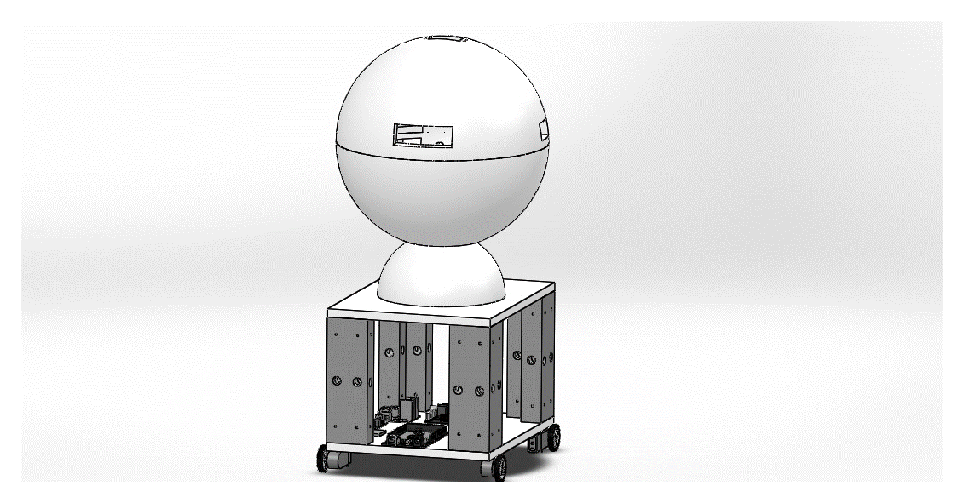
Marcelo Maurin Martins
Third revised and expanded edition • 2026

EDITION INFORMATION

Robotinics Rev. 3
Robotics, IoT, and Artificial Intelligence with Arduino, Raspberry Pi, and TCHATGPT
Author and project lead: Marcelo Maurin Martins
Third revised and expanded edition, 2026.
Language: English (United States).
Project | Editorial snapshot
Robotinics | 61d2a19d10e6701e27e46181e1a6c740b8ee4e30
TCHATGPT | 15d5e1a7780088701716896cfe9fb3afe0e7b71a

WARNING Educational and experimental project. Lithium-ion batteries, tools, soldering, motors, and moving parts require suitable protection, supervision, and components. AI never replaces deterministic safety barriers.
Project sources: Robotinics repository and TCHATGPT repository.
Editorial note: the examined Robotinics snapshot contains no formal license. Public release of this edition should be accompanied by the license chosen by the author.

To my beloved wife, Daniela Machado.
Eternal love.

Contents
Click an entry to navigate within the document.
Introduction to the third edition 6
What was corrected 6
How to use this book 7
Conventions 7
Acknowledgments 8
Part I - Project, architecture, and safety 9
1. Robotinics as a learning platform 10
1.1 Robot, IoT, and cyber-physical system 10
1.2 Rev. 3 objectives 10
1.3 Intended audience 10
1.4 Repository organization 10
1.5 Documentation strategy 11
2. Third-edition architecture 12
2.1 Separation of responsibilities 12
2.2 Command path 12
2.3 Deployment profiles 13
2.4 Operating states 14
2.5 Interfaces 14
3. Safety and working method 15
3.1 Safety hierarchy 15
3.2 Bench rules 15
3.3 Change control 15
3.4 Stage completion criteria 16
3.5 Credential and data security 16
3.6 Stated limitations 16
Part II - Mechanics, power, and electronics 17
4. Mechanical sizing 18
4.1 Requirements before selecting motors 18
4.2 Motion forces 18
4.3 Corrected traction example 18
4.4 Grip and traction limit 19
4.5 Arm torque 19
4.6 Center of gravity and stability 19
5. Structure and mechanical assembly 20
5.1 Mechanical archive 20
5.2 Material and printing 20
5.3 Base 20
5.4 Body, arms, and head 21
5.5 Alternatives to 3D printing 21
5.6 Mechanical acceptance criteria 22
6. Power, battery, and distribution 23
6.1 Fundamental quantities 23
6.2 3S pack 23
6.3 Safe charging 23
6.4 BMS, fuse, and master switch 23
6.5 Separate rails 24
6.6 Converters 25
6.7 Runtime 25
6.8 Capacitors and ripple 25
6.9 Correct measurement 25
6.10 Electrical acceptance criteria 25
7. Electronics, sensors, and actuators 27
7.1 Arduino and logic levels 27
7.2 Motor driver 27
7.3 Relays 27
7.4 LEDs 27
7.5 Ultrasonic sensor 27
7.6 Servos 28
7.7 Analog sensors 28
7.8 Decoupling and electromagnetic compatibility 28
7.9 Electronics checklist 28
Part III - Firmware, Linux, and communication 30
8. Robotinics Rev. 3 firmware 31
8.1 Why reorganize it 31
8.2 Modules 31
8.3 Safe initialization 31
8.4 Bounded serial input 32
8.5 Command manual 32
8.6 Watchdog and heartbeat 32
8.7 Obstacles and local limits 33
8.8 Telemetry 33
8.9 Avoiding memory fragmentation 33
8.10 Firmware tests 33
9. Raspberry Pi and robot services 34
9.1 Role of Raspberry Pi 34
9.2 System installation 34
9.3 Minimum profile 34
9.4 Services with systemd 34
9.5 Dependencies and installer 35
9.6 Camera and audio 35
9.7 Storage 35
9.8 Update and rollback 35
10. Communication, data, and software security 36
10.1 Serial before networking 36
10.2 Historical servers 36
10.3 Ports and contracts 36
10.4 Network interface 36
10.5 Structured messages 36
10.6 Database 37
10.7 Observability 37
10.8 Resilience tests 37
Part IV - Artificial intelligence with TCHATGPT 39
11. Preparing TCHATGPT 40
11.1 The project 40
11.2 Providers 40
11.3 Configuration without secrets in code 41
11.4 Asynchronous calls 41
11.5 Prompts and contracts 41
11.6 Self-test 41
12. Supervised control agent 43
12.1 Components 43
12.2 Safe configuration 43
12.3 Capability registration 43
12.4 Event before the action 44
12.5 Understandable confirmation 44
12.6 Deterministic discovery 44
12.7 Session memory 45
12.8 Current limits 45
12.9 Adversarial tests 45
13. Voice and human interaction 46
13.1 Pipeline 46
13.2 Speech recognition 46
13.3 Voice is not authorization 46
13.4 Traditional synthesis and voice cloning 46
13.5 Privacy 47
13.6 Acceptance criteria 47
14. Computer vision 48
14.1 Historical correction 48
14.2 Current components 48
14.3 Robotinics pipeline 48
14.4 Performance on Raspberry Pi 49
14.5 Safety and ethics 49
14.6 Tests 49
15. Memory and RAG 50
15.1 Use in the robot 50
15.2 TAIRAG 50
15.3 Separation of knowledge and authority 50
15.4 Sources and traceability 50
15.5 Chunking 51
15.6 Operational memory 51
15.7 Evaluation 51
16. Intelligent behaviors and limits 52
16.1 Operating modes 52
16.2 Appropriate capabilities 52
16.3 Plan, execute, and verify 52
16.4 Uncertainty 53
16.5 AI observability 53
16.6 Promotion criterion 53
Part V - Construction, validation, and evolution 54
17. Construction sequence 55
17.1 Stage 0 - documentation and inventory 55
17.2 Stage 1 - passive mechanics 55
17.3 Stage 2 - power distribution 55
17.4 Stage 3 - Arduino without actuators 55
17.5 Stage 4 - raised traction system 55
17.6 Stage 5 - servos and sensors 56
17.7 Stage 6 - Raspberry Pi and gateway 56
17.8 Stage 7 - TCHATGPT in simulation 56
17.9 Stage 8 - agent with hardware 56
17.10 Stage 9 - voice, vision, and RAG 56
17.11 First floor operation 57
18. Test and commissioning plan 58
18.1 Test pyramid 58
18.2 Minimum matrix 58
18.3 Electrical measurements 59
18.4 Mechanical measurements 59
18.5 AI evaluation 59
18.6 Fault injection 60
18.7 Test record 60
18.8 Commissioning criterion 60
19. Maintenance and evolution 61
19.1 Periodic inspection 61
19.2 Compatibility 61
19.3 Reproducible repository 61
19.4 Technical roadmap 61
19.5 Publication 62
Appendix A - Suggested bill of materials 63
Appendix B - Command protocol 64
B.1 Rules 64
B.2 Minimum catalog 64
B.3 Legacy aliases 64
Appendix C - Correction matrix for the previous edition 65
Appendix D - Reference formulas 67
Appendix E - Platform and dependency matrix 68
Appendix F - References 69
Projects 8
Official technical documentation 69
Appendix G - Glossary 70
Closing remarks 71

Introduction to the third edition
Robotinics began as a multidisciplinary project: a ground robot open to experimentation, built with 3D-printed parts, accessible electronics, Arduino, Raspberry Pi, and free and open-source software. The first edition documented a real journey of research and construction. This third edition preserves that historical value while reorganizing the material so that it once again works as a technical manual.
The main change is not merely an update to software versions. The architecture was revised to separate responsibilities, correct calculations, and incorporate artificial intelligence without giving a language model unrestricted control of the robot. Arduino remains responsible for deterministic and real-time tasks. Raspberry Pi coordinates services, sensors, and communication. The TCHATGPT project provides the layer for language models, agents, voice, vision, memory, RAG, and observability. A mandatory validation and safety layer sits between every AI decision and any actuator.
This edition was built on two frozen references:
Project | Editorial reference | Purpose
Robotinics | commit 61d2a19d10e6701e27e46181e1a6c740b8ee4e30 | Mechanics, electronics, firmware, and historical archive
TCHATGPT | commit 15d5e1a7780088701716896cfe9fb3afe0e7b71a | Lazarus/Free Pascal components for AI and integration

Freezing these references does not prevent future development. It only ensures that readers can relate the text to the code. Newer versions may be adopted after their differences have been verified.
WARNING This is an educational and experimental project. It includes motors, lithium-ion batteries, tools, soldering, and moving parts. Do not work on an energized system, do not assemble improvised lithium chargers, and do not make mains-voltage connections based solely on this book. Use certified modules, adequate protection, and supervision by a qualified person.

What was corrected
Corrections in this edition include, among others:
- series-cell capacity and the nominal and maximum voltage of a 3S pack;
- the CC/CV charging process, protection, and balancing of lithium cells;
- correct multimeter use for voltage and current measurements;
- the distinction between force, torque, power, energy, and capacity;
- traction, slope, and arm-torque calculations;
- LED current and sizing of the current-limiting resistor;
- definitions of normally open and normally closed relay contacts;
- actual buck-converter limits and separation of motor, servo, and logic power rails;
- the L298N description, PWM speed control, and component limitations;
- HC-SR04 frequency, code examples, and timing requirements;
- safety and memory problems in the historical C/C++ servers;
- conflicting ports and commands, and files absent from the current repository;
- outdated Linux, database, PHP, OpenCV, voice, and remote-access practices;
- navigation, references, terminology, and editorial organization.
A detailed matrix appears in Appendix C.

How to use this book
The project is divided into five parts. Part I defines requirements, architecture, and safety. Part II covers mechanics, power, and electronics. Part III presents firmware, Linux, and communication. Part IV integrates TCHATGPT. Part V guides assembly, testing, and evolution.
Readers do not need to install every tool to build the robot. Those who only want to reproduce the prototype can use the ready-made files. Those who intend to modify parts, boards, or software should work from the version-controlled sources. In both cases, every stage ends with acceptance criteria: do not proceed until the current subsystem is stable.

Conventions
- Voltage values are given in volts (V), current in amperes (A), power in watts (W), energy in watt-hours (Wh), force in newtons (N), and torque in newton-meters (N·m).
- Numerical examples are instructional. When a real component has a different datasheet, the datasheet takes precedence.
- Literal commands, filenames, and identifiers appear in monospaced type.
- Sections marked Experimental have not been sufficiently validated on the indicated platform.
- The term AI includes language models, vision, voice, classification, and agents. It does not imply unrestricted autonomy.

Acknowledgments
This work is the result of years of study, construction, and collaboration. Marcelo Maurin Martins remains grateful to God, his family, friends, professors at Centro Paula Souza, ETEC, and FATEC, and everyone who reviewed or supported the original project. The memory of Professor Danilo continues to be honored in this edition.
The Arduino, Raspberry Pi, Free Pascal, Lazarus, and free and open-source software communities are also recognized; their work makes it possible to build and share projects such as Robotinics.

Part I - Project, architecture, and safety
ROBOTINICS REV. 3

1. Robotinics as a learning platform

1.1 Robot, IoT, and cyber-physical system
A robot is an electromechanical system capable of sensing its environment, processing information, and producing actions. An Internet of Things device collects or receives data and exchanges it with other systems. Robotinics belongs to both groups: it has sensors, actuators, local processing, network communication, and services that can be integrated with external applications.
This definition is useful because it prevents the project from being reduced to a single board. Behavior emerges from cooperation among the mechanical structure, power supply, electronics, firmware, operating system, and applications. A power failure may look like a software error. Motor noise may corrupt a sensor reading. Network delay may make a motion command unsafe. The complete system is therefore the unit of design.

1.2 Rev. 3 objectives
The third edition adopts the following verifiable objectives:
- Keep the robot controllable when the network or AI is unavailable.
- Prevent free-form text from being converted directly into a motor signal.
- Allow deterministic discovery of the commands published by the firmware.
- Separate traction, servo, and logic power.
- Record the version, state, and failures of every subsystem.
- Run staged tests before full assembly.
- Offer local and remote AI modes without requiring a specific provider.
- Preserve compatibility with the mechanical archive and historical commands when doing so does not compromise safety.

1.3 Intended audience
This book is intended for students, teachers, makers, and developers who want to understand integration across several fields. It does not assume professional experience in all of them, but it does require care. A beginner can reproduce low-risk stages; activities involving batteries, high current, tools, or structural modifications should be performed with suitable guidance.
For programmers, Robotinics provides a real case study involving embedded systems, protocols, Lazarus, Free Pascal, C/C++, Linux, vision, voice, and AI. For electronics and mechanical professionals, it shows how to transform physical components into an observable and programmable system.

1.4 Repository organization
In the adopted snapshot, the main files are located at:
Area | Reference path | Contents
Mechanics | Mecanic/solidwork and Mecanic/stl | Assemblies, parts, and 3D-printing files
Electronics | Eletronic/eagle, Eletronic/pcb | Boards, drawings, and historical manufacturing files
Arduino | Software/arduino | Main firmware and head firmware
Raspberry | Software/raspberry | Services, camera, voice, and historical applications
Database and web | Software/database and Software/site | Scripts and historical interface
Book | docs | PDF of the previous edition

Some Lazarus tools mentioned in the previous edition were removed from the main branch in 2022. They remain recoverable from the history, but they must not be presented as though they were available in the current clone. Rev. 3 replaces their role with examples based on the modular TCHATGPT packages.

1.5 Documentation strategy
Concepts, calculations, architecture, and test criteria belong in the book. Installation sequences that change frequently should remain in version-controlled repository documentation. This separation reduces obsolescence: the book teaches why and how to validate, while the repository provides the exact command compatible with a given version.
Before starting, record the following on a build sheet:
- mechanical revision of the parts;
- Arduino and Raspberry Pi board models;
- model, chemistry, and declared battery capacity;
- motor and servo models;
- firmware version;
- commits of the Robotinics and TCHATGPT projects;
- operating system and architecture;
- AI provider or local server;
- bench-test results.

2. Third-edition architecture

2.1 Separation of responsibilities
The architecture uses layers. Arduino performs low-level control: motors, servos, simple readings, timing, limits, and stopping. Raspberry Pi runs the robot services: communication, capture of high-volume sensor data, supervision, and integration. TCHATGPT interprets intent, organizes context, and coordinates AI components. The human interface presents requests and confirms sensitive actions.
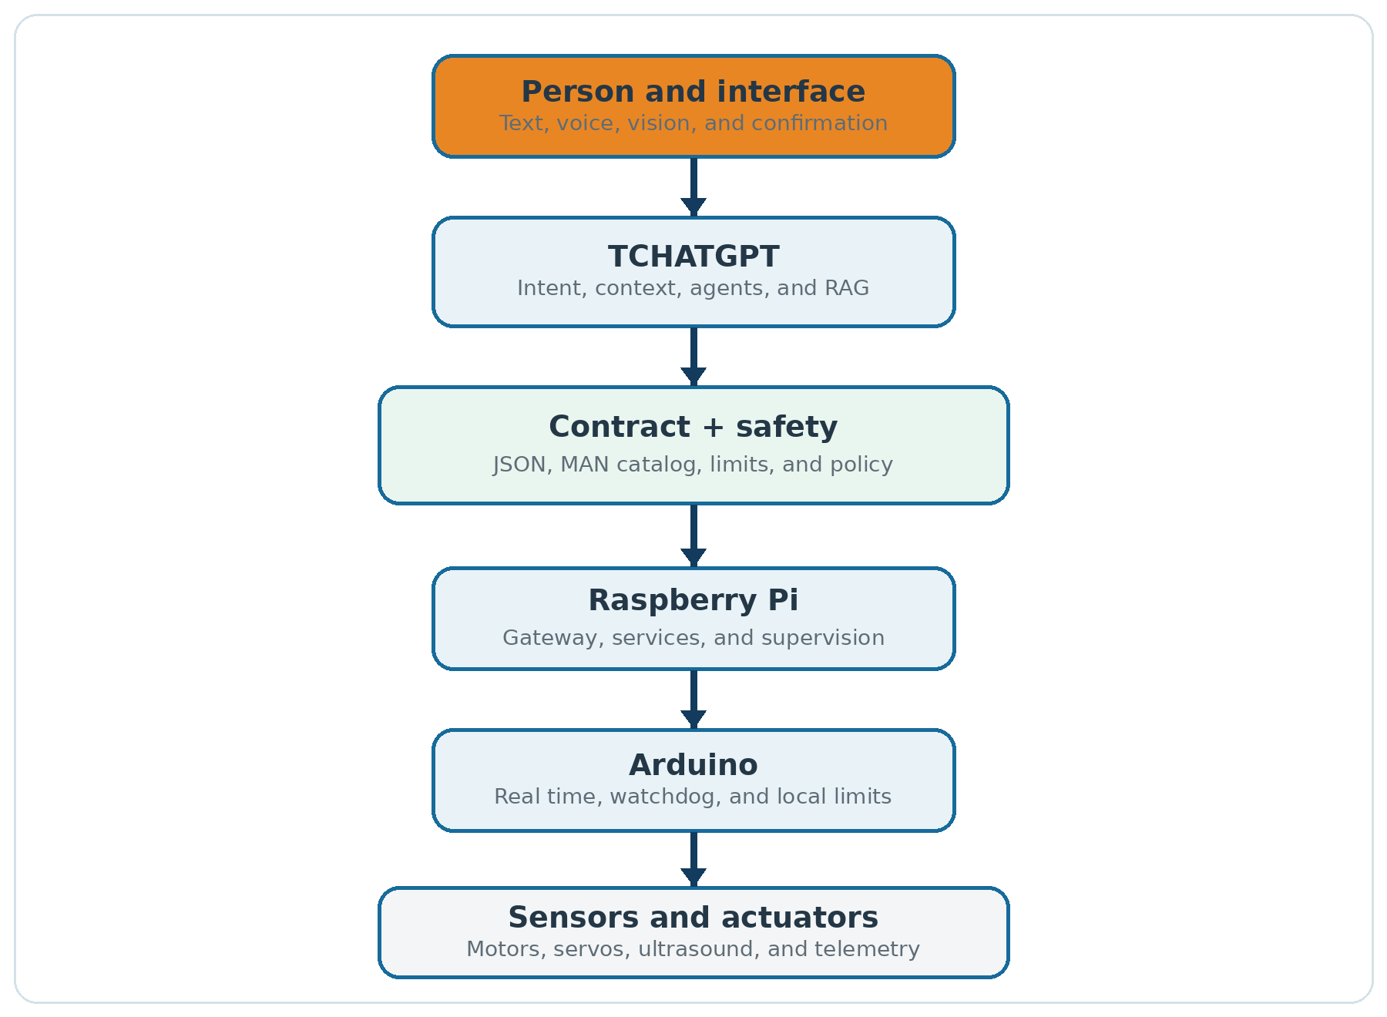
Figure 1 - Layered architecture of the third edition.
Source: Created by the author.
This separation is deliberate. Language models are probabilistic and may produce an incorrect response. Motors require predictable behavior. The model may suggest a structured action; only the validator decides whether the action is in the catalog, whether its parameters are in range, and whether the robot state permits execution.

2.2 Command path
The safe path of a request is:
- The user speaks or types an intent.
- The system converts the input to text and includes only the necessary context.
- The agent asks the model for a response in a structured format.
- A parser validates the structure; text outside the contract is not executed.
- The command is compared with the catalog discovered through MAN.
- The safety policy validates state, parameters, limits, and the need for confirmation.
- The user confirms physical actions when required.
- The command is sent to Arduino.
- The firmware applies its own limits and watchdog.
- Telemetry confirms the result, and the agent informs the user.
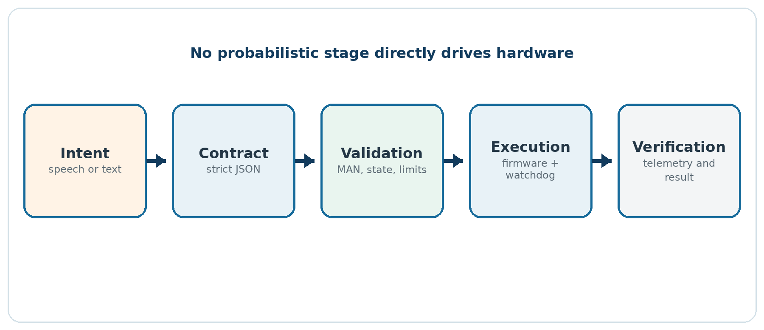
Figure 2 - Supervised path of a physical command.
Source: Created by the author.
The model is never the only barrier. If it invents a command, the catalog blocks it. If it uses an out-of-range parameter, the validator blocks it. If communication stops, the watchdog interrupts motion. If an obstacle is detected, the firmware can stop without consulting the AI.

2.3 Deployment profiles

Profile A - validated controller
The Lazarus application with TCHATGPT runs on Windows x64 or Linux x64. Raspberry Pi acts as the gateway and onboard computer. This is the recommended profile for the first build because these platforms have stronger evidence of support in the TCHATGPT project.

Profile B - AI embedded on Raspberry Pi
The Lazarus application and compatible packages run on Raspberry Pi ARM64. The model may be remote or local. In the snapshot used for this edition, ARM64 is classified as experimental; this profile therefore requires compilation, dependency testing, and validation of every component before controlling actuators.

Profile C - local operation without cloud services
TCHATGPT uses a local OpenAI-compatible endpoint, such as llama.cpp or neural-api. This profile avoids sending robot data to an external provider, but it requires memory, storage, and computing capacity appropriate for the model. On limited hardware, a small model can handle classification and short commands while vision and voice use specialized components.

2.4 Operating states
The robot uses at least four states:
State | Motion | Query commands | Allowed transition
DISARMED | Blocked | Allowed | To ARMED after verification and confirmation
ARMED | Allowed within limits | Allowed | To EXECUTING, DISARMED, or FAULT
EXECUTING | Current action only | Telemetry allowed | Returns to ARMED or moves to FAULT
FAULT | Blocked with safe output | Diagnostics allowed | To DISARMED after correction and reset

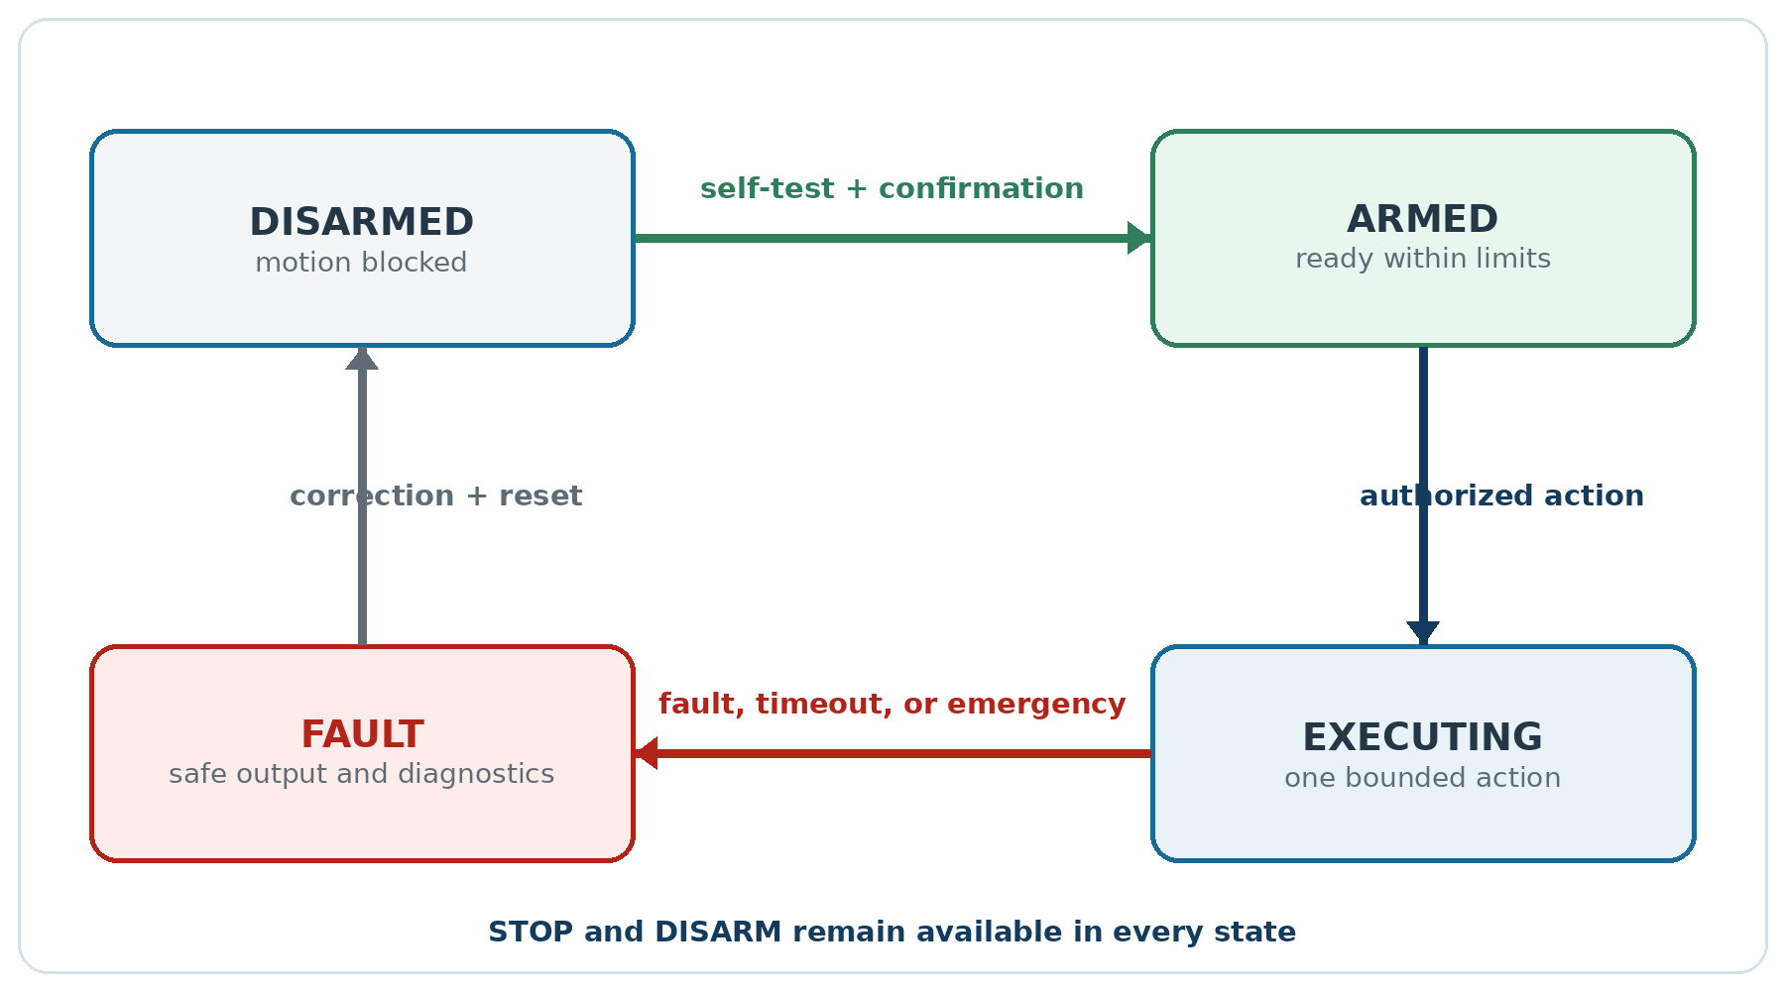
Figure 3 - Robotinics Rev. 3 operating-state machine.
Source: Created by the author.
STOP and DISARM must be accepted in every state. Loss of heartbeat, timeout, critical undervoltage, overcurrent, or activation of the emergency-stop button leads to a safe output without depending on Raspberry Pi.

2.5 Interfaces
The protocol between the controller and Arduino is text-based, line-delimited, and suitable for terminal debugging. A production version may evolve to frames with length, sequence, and integrity checking, but it should retain a human-readable diagnostic mode.
Between network services, prefer authenticated connections, restricted binding, and size-limited messages. Historical servers that accepted commands on every interface and forwarded data to a shell are not part of the recommended architecture.

3. Safety and working method

3.1 Safety hierarchy
Safety is implemented in independent layers:
- Mechanical: gear guards, secure mounting, center of gravity, and no accessible pinch points.
- Electrical: fuse, master switch, reverse-polarity protection, BMS, properly sized wires, and suitable connectors.
- Firmware: limits, timeout, watchdog, obstacle stopping, and disarmed state at startup.
- Application: command catalog, ranges, confirmation, authentication, and logging.
- AI: constrained prompt, structured output, action limits, and no direct operating-system access.
- Operation: clear area, supervision, emergency-stop button, and test procedure.
No layer authorizes removal of the next one. A well-written prompt does not replace a watchdog; a fuse does not replace current limiting in the design; an on-screen confirmation does not replace a physical button.

3.2 Bench rules
- Perform initial tests with the wheels raised off the surface.
- Use a current-limited bench supply before using the battery.
- Connect one subsystem at a time.
- Never adjust wiring while the system is energized.
- Keep the emergency-stop button within reach.
- Test STOP before any motion command.
- Remove arms and loads from servos during initial movements.
- Do not charge lithium cells inside the robot without suitable thermal design and protection.
- Do not leave the pack charging unattended.
- Record idle current, peak current, and temperature.

3.3 Change control
Every change should answer four questions:
- Which requirement motivated the change?
- Which files and components were changed?
- How was the change tested?
- How can the previous version be restored?
Firmware, application, and documentation should report their versions. A published version of the book should point to a repository tag; pointing only to main or master makes reproduction dependent on future changes.

3.4 Stage completion criteria
A stage is complete when:
- the assembly matches the drawing or a recorded modification;
- there are no loose wires, visible shorts, or unexpected heating;
- consumption is within the power budget;
- all expected commands respond;
- simulated failures lead to a safe state;
- results have been recorded with date and version;
- the next subsystem can be added without hiding earlier failures.

3.5 Credential and data security
API keys must not be stored in the repository or in a readable settings.ini. The TCHATGPT serial-agent example has a historical option for storing a token as plain text; this edition does not adopt it. Use an environment variable, operating-system vault, or protected file outside the project directory.
Camera, microphone, telemetry, and conversation data may contain personal information. When a remote provider is used, inform the operator, send only what is necessary, and apply a retention policy. For educational use, prefer controlled environments and non-identifying data.

3.6 Stated limitations
Robotinics is not a medical device, certified industrial equipment, a vehicle for carrying people, or a safety-critical platform. Use in another context requires a risk analysis, applicable standards, and professional validation. Low-cost components and clones may have different specifications; always measure the actual unit.

Part II - Mechanics, power, and electronics
ROBOTINICS REV. 3

4. Mechanical sizing

4.1 Requirements before selecting motors
A motor should not be selected solely from a commercial torque rating. First define mass, wheel diameter, speed, maximum slope, floor type, desired acceleration, and number of driven wheels. Then calculate the required effort and apply a margin.
Force and torque are not the same quantity. Force is measured in newtons. Torque is the product of force and the perpendicular distance to the axis and is measured in newton-meters. A force of 10 N applied 0.05 m from the axis produces 0.5 N·m.

4.2 Motion forces
On a slope at angle θ, the component of weight opposing motion is:
TEXT
F_slope = m × g × sin(θ)
The approximate rolling resistance is:
TEXT
F_rolling = Crr × m × g × cos(θ)
For acceleration:
TEXT
F_acceleration = m × a
At low speed, Robotinics aerodynamic drag tends to be small compared with the other components, but it can be included when necessary. The total design force is the sum of the relevant components. Required wheel torque is:
TEXT
T_total = (F_total × wheel_radius) / efficiency
Divide the result among the wheels that are actually driven. Efficiency represents transmission, deformation, bearing, and floor-contact losses. Do not assume 100%.

4.3 Corrected traction example
Consider a 12 kg robot with two driven wheels, a radius of 0.05 m, a 5° slope, an estimated rolling coefficient of 0.03, acceleration of 0.2 m/s², and overall efficiency of 70%.
Component | Calculation | Approximate result
Slope | 12 × 9.81 × sin(5°) | 10.26 N
Rolling | 0.03 × 12 × 9.81 × cos(5°) | 3.52 N
Acceleration | 12 × 0.2 | 2.40 N
Total | sum | 16.18 N

Total axle torque is approximately (16.18 × 0.05) / 0.70 = 1.16 N·m. With two driven wheels, each geared-motor assembly must provide about 0.58 N·m under the calculated condition. Applying a safety factor of 2 raises the target to approximately 1.16 N·m per wheel, or about 11.8 kgf·cm.
This value must be compared with the assembly's continuous torque, not only its stall torque. Continuous operation near stall heats the motor, increases consumption, and shortens its service life. Also confirm speed after reduction.

4.4 Grip and traction limit
Even a powerful motor cannot move the robot if the wheel slips. The maximum transferable force depends on the normal load on the driven wheels and the coefficient of friction. The battery and heavy components should be placed low and distributed to maintain stability and grip without overloading a single support point.
Run a ramp test using small increments. Record slope, motor current, speed, temperature, and slipping. This test validates both the mechanical calculation and the electrical budget.

4.5 Arm torque
For a joint, add the moment produced by each mass relative to the axis:
TEXT
T_static = Σ (mass_i × g × distance_i)
Distance is measured between the axis and the item's center of mass. For the shoulder, include the masses of the upper arm, forearm, gripper, servos installed beyond the axis, and payload. The worst condition usually occurs with the arm horizontal.
Example: a 0.25 kg link with its center of mass 0.10 m away; a 0.20 kg distal assembly centered at 0.28 m; and a 0.10 kg payload at 0.40 m.
TEXT
T = (0.25 × 9.81 × 0.10)
+ (0.20 × 9.81 × 0.28)
+ (0.10 × 9.81 × 0.40)
≈ 1.19 N·m ≈ 12.1 kgf·cm
This is static torque only. Starting, stopping, backlash, impact, and misalignment require a margin. With a factor of 2.5, the joint would require approximately 3.0 N·m, or 30.6 kgf·cm. A servo advertised as 10 or 15 kgf·cm therefore cannot reliably meet this condition. Solutions include reducing length or mass, limiting payload, using a counterweight or spring, changing the transmission, or choosing a suitable actuator.
NOTE The traditional servo unit is kgf·cm, not kgf·cm². For approximate conversion, 1 kgf·cm = 0.0981 N·m.

4.6 Center of gravity and stability
The projection of the center of gravity onto the floor must remain within the polygon formed by the contact points. Extended arms shift the center and may tip the robot. Evaluate extreme positions in CAD and run a physical test with the robot unpowered.
Keep the battery and power supplies low in the structure. Use software to restrict pose combinations that bring the center of gravity close to the edge. AI may choose a task, but a deterministic planner must reject poses outside the validated envelope.

5. Structure and mechanical assembly

5.1 Mechanical archive
The repository contains SolidWorks parts, assemblies, and STL files. Major elements include the base, wheel supports, lower and upper body, Raspberry Pi mount, head, arm extensions, and grippers. STL files allow reproduction without the original CAD software; assembly files support deeper modifications.

Figure 4 - CAD model of the Robotinics assembly preserved from the original archive.
Source: Robotinics project archive.
Before printing, verify:
- units and scale;
- part revision and orientation;
- holes, clearances, and minimum thickness;
- space for nuts, screw heads, and connectors;
- load direction relative to print layers;
- interference between cables and moving parts;
- maintenance access.

5.2 Material and printing
PLA is easy to print and works for rigid prototypes, but it may lose strength at elevated temperatures and fracture at fitted joints. PETG offers greater toughness and thermal tolerance in many scenarios. ABS/ASA can be useful for functional parts when the printer and environment control warping and emissions. The choice depends on load, temperature, and printing capability.
Do not copy slicing parameters without validation. Record material, manufacturer, nozzle diameter, layer height, perimeter count, infill, and orientation. For motor mounts and joints, perimeters and orientation are often more important than high, randomly patterned infill.

5.3 Base
The base should be assembled and validated before the body. The recommended sequence is:
- Inspect and finish the printed parts.
- Assemble mounts, motors, and wheels without electronics.
- Check parallelism and free rotation.
- Position the battery and boards with templates, without final fastening.
- Check the center of gravity and access to the master switch.
- Install cable ducts, strain relief, and logic-ground points.
- Perform a manual rolling test.
Misaligned wheels increase current and impair odometry. Measure the wheelbase on both sides and verify that the base is not twisted. Casters should provide support without lifting a driven wheel.

5.4 Body, arms, and head
The body houses boards, power distribution, and connections. Install removable panels and identify every harness. Arms should have stops or safe limits before power is applied. The head carries the camera, sensors, and positioning mechanisms; avoid routing cables through pinch zones.
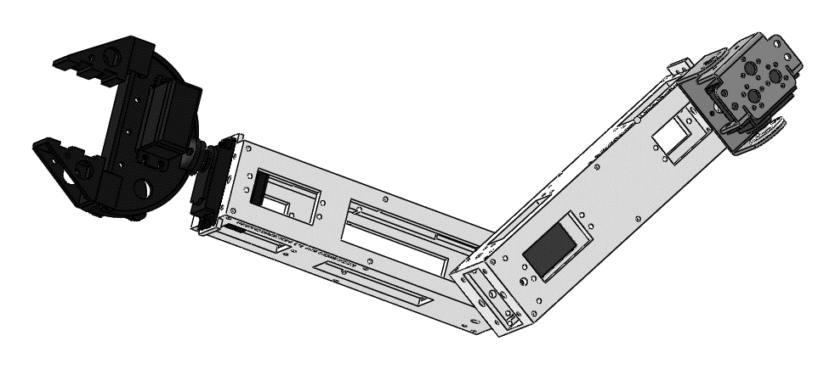
Figure 5 - Mechanical assembly of the arm and gripper.
Source: Robotinics project archive.
For every joint, record:
Item | Minimum record
Mechanical zero | physical reference position
Logical zero | value sent to the servo at that position
Minimum and maximum limits | collision-free range
No-load current | reference for detecting a stall
Maximum payload | validated condition, not merely advertised
Positive direction | convention used by the firmware

5.5 Alternatives to 3D printing
The original concept allows volumes to be built from accessible materials such as sheets, profiles, and coated spherical elements. Any substitution must preserve fastening, rigidity, access, and protection. Expanded polystyrene should not be exposed to products that dissolve it; coatings and adhesives should first be tested on a sample.

5.6 Mechanical acceptance criteria
- No cracked or deformed parts.
- Critical screws use suitable thread locking and inspection marks.
- Wheels are free and aligned.
- Cables are not strained throughout the full range of motion.
- The center of gravity remains stable with the arms in allowed poses.
- Accidental contact with moving parts is prevented.
- The battery, fuse, and emergency stop remain accessible without extensive disassembly.

6. Power, battery, and distribution

6.1 Fundamental quantities
Voltage represents potential difference. Current represents the flow of charge. DC electrical power is P = V × I. Energy is power accumulated over time and may be expressed in Wh. Battery capacity in Ah is not energy by itself; voltage must also be considered.
In the previous edition, currents from different rails were added without converting power. The correct procedure is to calculate the power of each load on its rail, include converter efficiency, and then estimate current drawn from the battery.

6.2 3S pack
Consider three lithium-ion cells rated at 3.7 V nominal and 5.2 Ah connected in series:
Property | Result
Nominal voltage | 3 × 3.7 = 11.1 V
Maximum charge voltage | 3 × 4.2 = 12.6 V, when specified for the cell
Capacity | 5.2 Ah
Approximate nominal energy | 11.1 × 5.2 = 57.7 Wh

In series, voltages add while capacity in Ah remains the same. A value of 15.6 Ah would correspond to three identical cells connected in parallel, not in series.
Values of 4.2 V per cell are common, but the manufacturer's datasheet is authoritative. Chemistry, charge limit, current, and temperature vary. Do not mix cells of different models, capacities, ages, or states.

6.3 Safe charging
Lithium cells require a CC/CV charger compatible with the number of cells and a suitable protection/balancing system. A BMS protects the pack, but it does not turn an ordinary power supply into a proper charger. For 3S, use a charger designed for 3S and the actual chemistry, with final voltage and current within specification.
Do not derive charge current from a universal rule such as C/10. Use the value recommended by the cell and pack manufacturers. Cells in series do not triple capacity for this calculation.
DANGER Rev. 3 does not teach how to build a mains-connected charger. Use certified equipment suitable for the pack. A swollen, damaged, hot, or abnormally charged cell must be isolated and disposed of according to local hazardous-waste guidance.

6.4 BMS, fuse, and master switch
The minimum architecture includes:
- a safely assembled pack;
- a BMS/protection device compatible with 3S, current, and chemistry;
- a fuse near the positive battery terminal;
- a master switch rated for direct current;
- protected distribution for each rail;
- polarized connectors with adequate capacity.
The fuse protects the conductor and reduces fault energy. Its rating must not exceed the safe capacity of wires and connectors. Starting currents must be considered to avoid nuisance opening without turning the fuse into a mere piece of wire.
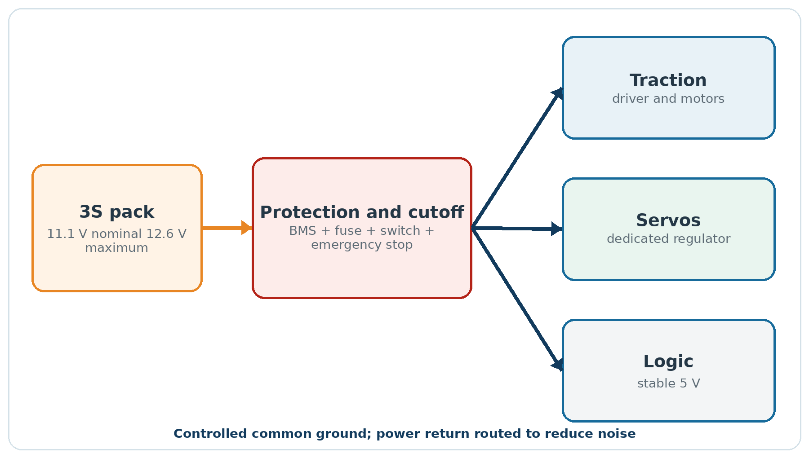
Figure 6 - Power distribution with protection and separate rails.
Source: Created by the author.

6.5 Separate rails
DC motors, servos, and logic generate and tolerate noise differently. Rev. 3 uses separate rails:
- Traction: voltage compatible with motors and driver, with its own protection.
- Servos: high-current converter at the voltage allowed by the servos.
- 5 V logic: Raspberry Pi and compatible peripherals, with margin for peaks.
- 3.3 V logic: sensors or interfaces that require it.
Grounds may need a common signal reference, but distribution must prevent motor current from flowing through the logic return. Use star topology, appropriate conductors, decoupling, and oscilloscope verification when possible.
A "5 V/5 A" supply is not automatically sufficient for Raspberry Pi, servos, and peripherals. High-torque servos may produce large peaks. Size the system using measurements and margin, and never power several servos through the Arduino board regulator.

6.6 Converters
A buck converter reduces voltage. It cannot regulate 12.6 V from a 12 V input. Raising voltage requires a boost converter; operation both above and below the output requires buck-boost. In Robotinics, prefer an architecture in which converters operate comfortably within their specified ranges.
Check maximum voltage, actual continuous current, cooling, ripple, efficiency, and transient response. The current printed on inexpensive modules may represent a peak under ideal conditions rather than continuous operation.

6.7 Runtime
Approximate runtime can be estimated as:
TEXT
time_h ≈ (nominal_energy_Wh × usable_efficiency) / average_power_W
With 57.7 Wh, an overall usable efficiency of 80%, and average consumption of 35 W, the estimate is (57.7 × 0.8) / 35 ≈ 1.32 h. Motion, terrain, temperature, aging, and BMS limits affect the result. Validate it in a controlled test and do not discharge beyond the safe limit.

6.8 Capacitors and ripple
20.75 × 10⁻³ F equals 0.02075 F, or 20,750 µF; not 20.75 µF. In a rectified supply, a common approximation is:
TEXT
C ≈ I / (f_ripple × ΔV)
For 1 A, 120 Hz ripple, and a 1 V variation, C ≈ 8,333 µF. This example does not replace power-supply design or consideration of tolerance, ESR, capacitor voltage, and ripple-current rating.

6.9 Correct measurement
Voltage is measured in parallel. Current is measured in series with the load or by using an appropriate sensor. Placing a multimeter set to current directly between positive and negative creates a low-resistance short circuit and may blow a fuse, damage probes or the circuit, or cause an accident.
Before measuring:
- confirm the selected terminals and function;
- start with an appropriate range;
- de-energize before changing a series connection;
- respect the instrument category, voltage, current, and fuse ratings;
- use a clamp or sensor when the series method is unsafe.

6.10 Electrical acceptance criteria
- Polarity and continuity verified without the battery.
- Fuses installed and identified.
- Each rail remains within tolerance, both unloaded and under load.
- Ripple and voltage drop are acceptable during motor/servo starting.
- Idle and peak currents are recorded.
- No connector or wire heats beyond expectation.
- BMS and charger are compatible and documented.
- Undervoltage and shutdown are tested in a controlled manner.

7. Electronics, sensors, and actuators

7.1 Arduino and logic levels
The historical firmware was developed for Arduino Mega, which normally uses 5 V logic. Raspberry Pi GPIO uses 3.3 V and is not directly 5 V tolerant. Every connection between boards must account for level, direction, current, and startup state. Use a level shifter when needed; never rely only on a coincidental bench result.

7.2 Motor driver
The L298N is a dual H-bridge based on bipolar transistors. It supports direction control and speed control through PWM applied to its enable pins. It does not provide galvanic isolation and has significant voltage drop and dissipation, especially at low motor voltage.
If retained for compatibility, measure motor voltage and driver temperature at worst-case load. In an electronics revision, a modern MOSFET driver sized for voltage, starting current, and braking will usually provide better efficiency.
Motors appear with different voltage ratings in historical sections. Rev. 3 does not assume 12 V: identify the installed model and follow its datasheet. A battery voltage of 11.1/12.6 V does not authorize direct connection of a 3-6 V motor.

7.3 Relays
A normally open (NO) contact remains open when the coil is de-energized and closes when energized. A normally closed (NC) contact remains closed at rest and opens when energized. Check the component diagram, coil voltage, contact current, and need for a flyback diode.

7.4 LEDs
0.02 A is 20 mA, not 200 mA. The resistor is calculated as:
TEXT
R = (V_supply - V_LED) / I_LED
For a 5 V supply, a red LED with an approximate 2 V drop, and a desired current of 9 mA, R ≈ 333 Ω; 330 Ω is an appropriate standard value in this example. Calculate resistor power as P = I² × R and confirm the actual LED specification.

7.5 Ultrasonic sensor
The HC-SR04 uses ultrasonic pulses near 40 kHz, not 40 Hz. The microcontroller sends a trigger pulse and measures echo duration. Approximate distance is calculated by accounting for the sound's round trip:
TEXT
distance = speed_of_sound × time / 2
Take independent readings, discard timeouts, and apply filtering. Converting the same measured time three times does not produce three samples. On Arduino, define the pins and set a timeout on pulseIn to avoid extended blocking.
The echo signal of many modules is 5 V. Use level adaptation for Raspberry Pi. Temperature, angle, material, and interference between sensors affect the result; ultrasound is an aid, not the only safety barrier.

7.6 Servos
The Arduino Servo library uses timers and can control servos on several digital pins; it is incorrect to state that only pins marked PWM can be used. Timer use may, however, interfere with other functions, and channel count depends on the board and library.
Power servos from a separate supply and join the signal reference in a planned manner. Define individual mechanical limits. At startup, do not abruptly send a position that causes a collision; load calibration, validate it, and move with a ramp.

7.7 Analog sensors
Voltage and current inputs must remain within ADC range. Resistor dividers must account for tolerance and impedance; current sensors require zero, gain, and noise calibration. To calculate average or RMS, clear accumulators at the start of the window and use distinct samples.
An overcurrent alarm should be below the level that damages wires, driver, or battery. Fast response may remain in firmware; Raspberry records and explains the event.

7.8 Decoupling and electromagnetic compatibility
Install decoupling capacitors near circuits, keep current loops small, and separate power cables from signals. Brushed motors may require suppression at the motor itself. Twist supply and return pairs where appropriate, and do not use data cables/connectors without checking current, voltage drop, and pinout.
An RJ45 connector can be used as an internal physical connector, but that does not make the circuit Ethernet. Label it clearly to prevent accidental connection to a network.

7.9 Electronics checklist
- Rated voltage and current confirmed for every component.
- 3.3 V and 5 V levels made compatible.
- Pins and connectors documented.
- Driver sized for starting current.
- Servos powered outside the Arduino regulator.
- Sensors calibrated and equipped with timeouts.
- Relays and inductive loads protected.
- Cables labeled, secured, and clear of moving parts.
- Noise test performed with motors and servos moving.

Part III - Firmware, Linux, and communication
ROBOTINICS REV. 3

8. Robotinics Rev. 3 firmware

8.1 Why reorganize it
The historical sketch demonstrates many features, but it concentrates about 1,500 lines in one file. It uses String extensively on a microcontroller with little RAM, mixes buffers from several ports, contains blocking waits, and interprets commands using substring tests. A prefix such as ULTRA may therefore also match ULTRA1, while timeouts, tests, and maintenance become difficult.
There are also objective defects: definitions such as #define PINOGPSRX = 0; are not valid macros when expanded; one routine prepares sInfo but prints another variable; the SERIAL: slice uses an index inconsistent with the prefix; ultrasonic reading repeats conversion of the same time; and the GPS parser may block and overflow its buffer.
Rev. 3 preserves the value of the original firmware while proposing a modular architecture and stable interface.

8.2 Modules
Module | Responsibility
Config | pins, limits, and board version
CommandParser | reception, tokenization, and syntax validation
Safety | state, heartbeat, emergency, timeouts, and faults
Drive | direction, PWM, ramp, and braking
Servos | calibration, limits, and gradual movement
Sensors | ultrasound, current, voltage, gas, and accelerometer
Telemetry | structured responses and events
Manual | deterministic catalog published through MAN

On small boards, modules may still compile into one sketch, but they should remain separated into files or clearly scoped functions.

8.3 Safe initialization
At power-up:
- Set enable pins inactive before direction pins.
- Turn motors off and keep the robot in DISARMED.
- Initialize serial ports and sensors with timeouts.
- Load validated calibration.
- Publish the version and reason for any fault.
- Accept motion only after ARM and verification of local conditions.
Servos should start at a known position without jumping. When physical position is unknown, move slowly toward a safe reference or require a manual procedure.

8.4 Bounded serial input
Use a fixed buffer, for example 128 bytes. Append each received byte until LF or CRLF. If the limit is exceeded, discard the line, report ERR LINE_TOO_LONG, and do not execute partial content. Every port must have its own receive state.
After receiving a line, split the first token and compare the whole command rather than searching for a substring. Convert parameters with error and range detection. An invalid line produces an error, never partial behavior.
TEXT
Input: MOVEFWD 120 800
Command: MOVEFWD
PWM: 120, validated within 0..255
Duration: 800 ms, validated within 1..2000

8.5 Command manual
The TCHATGPT TAIAgentSerial discovers the catalog from deterministic markers and lines. Rev. 3 firmware should respond:
TEXT
MAN-BEGIN
DEVICE: Robotinics Rev3
VERSION: 3.0.0
BAUD: 115200 8N1
COMMAND PING: test communication, no parameters
COMMAND STATUS?: return state, voltage, current, and faults
COMMAND ARM: enter armed state after local validation
COMMAND DISARM: disable actuators
COMMAND STOP: stop motion immediately
COMMAND MOVEFWD: MOVEFWD <pwm 0..255> <time_ms 1..2000>
COMMAND MOVEBACK: MOVEBACK <pwm 0..255> <time_ms 1..2000>
COMMAND TURNLEFT: TURNLEFT <pwm 0..255> <time_ms 1..1500>
COMMAND TURNRIGHT: TURNRIGHT <pwm 0..255> <time_ms 1..1500>
COMMAND RANGE?: return valid sensor distances
COMMAND BATTERY?: return voltage and estimated state
COMMAND MAN: publish this manual
MAN-END
The agent interprets only COMMAND lines. Information such as version and baud rate is shown to the operator but does not create actions. Unknown commands remain blocked. Historical aliases FRENTE, RE, GESQ, GDIR, and PARA may be retained for manual use, mapped internally to the new API and subject to the same limits.

8.6 Watchdog and heartbeat
Motion must expire. Even when a command contains a duration, firmware records the starting instant and stops at the limit. If the application uses continuous motion, it sends a periodic heartbeat; absence for a short interval, for example 500 ms, leads to STOP and either FAULT or DISARMED, according to policy.
Configure the hardware watchdog to recover from firmware hangs. After a watchdog reset, the robot starts disarmed and records the cause. Restarting must not resume the previous action.

8.7 Obstacles and local limits
Firmware may block forward motion when a valid front sensor indicates a distance shorter than the configured margin. Invalid readings must not automatically become "clear path." Define an explicit policy: reduce speed, stop, and request another reading.
Servos have per-joint limits. Excessive current or time suggests a stall and should stop output. A physical emergency stop should remove actuator power appropriately and report its state to logic when possible.

8.8 Telemetry
Responses follow simple patterns:
TEXT
OK <command> [details]
ERR <code> <short description>
STATE <key>=<value> ...
EVENT <type> <data>
Examples:
TEXT
OK ARM
STATE MODE=ARMED BATTERY_MV=11780 FRONT_MM=640
EVENT STOP REASON=HEARTBEAT_TIMEOUT
ERR RANGE_TIMEOUT SENSOR=FRONT
Include the unit in the key or contract. BATTERY_MV=11780 is less ambiguous than BATTERY=11.78 without a unit.

8.9 Avoiding memory fragmentation
On AVR, prefer char arrays, bounded buffers, and functions that do not make many copies. Avoid indefinite String concatenation. Serial content must never grow without limit. Long-running tests should observe RAM, stability, and recovery from invalid lines.

8.10 Firmware tests
- STOP works in every state.
- Motion is refused in DISARMED.
- Out-of-range PWM and duration are refused.
- A long line does not execute a fragment.
- An unknown command is refused.
- Loss of heartbeat stops motion.
- A sensor timeout does not freeze the loop.
- Reset returns to a safe state.
- MAN contains implemented commands only.
- Similar prefixes do not cause double execution.

9. Raspberry Pi and robot services

9.1 Role of Raspberry Pi
Raspberry Pi does not replace Arduino for real-time control. It performs higher-level tasks: camera and audio interfaces, network integration, storage, a compatible Lazarus application, serial gateway, telemetry, and AI services that fit the platform.
The system must remain safe during boot, update, or a crash. Actuator enable must not depend on a floating GPIO; Arduino remains disarmed until it receives a valid sequence.

9.2 System installation
Use Raspberry Pi Imager and the current official documentation. Configure a dedicated user, strong password, network, and SSH while writing the image when supported. Do not assume the old user pi with password raspberry; that practice belongs to historical images.
Record:
- Raspberry Pi model;
- ARM64 or ARMHF architecture;
- Raspberry Pi OS version;
- image and date;
- installed packages;
- enabled services;
- kernel and firmware version;
- serial-port, camera, and audio test results.

9.3 Minimum profile
Start with the Lite system when the robot does not require a local graphical environment. Install only necessary dependencies. Graphical interfaces, Chromium, OpenCV, voice, and local models increase consumption, storage, and failure surface.
TCHATGPT classifies Linux ARM64 and ARMHF as experimental in this edition's snapshot. Compile openai_core and a console test first. Then validate openai_input, openai_voice, and openai_vision separately. Do not install the whole suite and attribute a generic failure to Raspberry Pi.

9.4 Services with systemd
Long-running applications should be managed by systemd, under an unprivileged user, with an explicit working directory, controlled restart, and journal logging.
INI
[Unit]
Description=Robotinics Gateway
After=network-online.target
Wants=network-online.target
[Service]
Type=simple
User=robotinics
Group=robotinics
WorkingDirectory=/opt/robotinics
ExecStart=/opt/robotinics/bin/robotinics-gateway
Restart=on-failure
RestartSec=3
NoNewPrivileges=true
PrivateTmp=true
[Install]
WantedBy=multi-user.target
Grant serial-device permissions through the appropriate group and rules. Do not run the service as root merely to access /dev/ttyUSB0.

9.5 Dependencies and installer
External dependencies should be resolved deterministically by an installer or version-controlled script. Documentation states which are required, optional, and platform-specific. Installer tests must confirm runtime libraries, not merely compilation.
For TCHATGPT packages, Python-based components should use TAIPythonRuntime. Vision, voice, and native libraries must validate architecture. An x64 binary does not run on ARM64; a 32-bit library does not satisfy a 64-bit process.

9.6 Camera and audio
Test capture and playback outside AI. First confirm device, format, rate, and latency. Then connect voice or vision components. This separates hardware, permission, and library failures from model failures.
Use persistent names or rules for USB devices when ordering may change. The service should clearly report "device missing" and remain safe rather than freezing the whole robot.

9.7 Storage
MicroSD cards wear out. Avoid unlimited logs and continuous unbounded writes. Use a lightweight database or atomic files for configuration, with backups and validation. Important data may be sent to external storage when the network is available without blocking local control.

9.8 Update and rollback
Update the application and firmware as versioned units. Before replacing them:
- save the current configuration and version;
- verify package signature or origin;
- install into a version directory;
- run a self-test without actuators;
- change the active-version link;
- monitor the first boot;
- return to the previous version if criteria fail.

10. Communication, data, and software security

10.1 Serial before networking
Validate the local serial link between Raspberry and Arduino before exposing any network interface. Use 115200 8N1, line termination, and a documented protocol unless there is a technical reason to use another configuration. The gateway limits size, rate, and timeout.
Do not reuse one buffer for Serial, Serial1, and a SoftwareSerial. Every channel has its own origin and state. Identify the origin when forwarding a response.

10.2 Historical servers
The srvMonitor2 and srvFala programs document the original experience, but they must not be run on a network as they are. Identified problems include an invalid read size, unterminated buffers, input-controlled format strings, the wrong variable passed to system, no authentication, and binding on all interfaces.
The speech server also forwards input to a shell, enabling command injection. Rev. 3 replaces this design with voice components and an API that accepts only structured fields with permitted size, characters, and actions.

10.3 Ports and contracts
Historical material uses different ports for the same service: the speech tool uses 7091, while the current server uses 8091. The controller sends PARAR at one point, but firmware recognizes PARA. Contracts of this kind must exist in one version-controlled file and be tested automatically.
Rev. 3 recommends against hard-coding ports in several sources. Use central configuration, a documented default, and conflict validation. Record address, protocol, and purpose.

10.4 Network interface
By default, robot services listen only on 127.0.0.1 or a local socket. Network exposure requires authentication, authorization, request limits, and transport protection appropriate to the risk. Never accept actuator commands through Telnet or a raw socket accessible to any machine.
When remote access is necessary, use a properly configured and maintained VPN or HTTPS layer. The firewall should allow only necessary origins and ports. Emergency stop and local safety remain independent of the network.

10.5 Structured messages
JSON is sufficient for moderate-volume communication between services. Define a schema and version:
JSON
{
"schema": "robotinics.command.v1",
"request_id": "8f2c...",
"action": "move_forward",
"parameters": {"pwm": 120, "duration_ms": 800},
"requires_confirmation": true
}
The service validates types, required fields, ranges, and size before conversion to the serial protocol. Unknown fields may be rejected to avoid divergent interpretations.

10.6 Database
The database supports configuration, inventory, telemetry, and auditing, not the safety loop. The robot must stop even when the database is unavailable.
Do not use a root account in the application. Create a least-privilege user and store the secret outside the code. Use parameterized queries. Administrative interfaces such as phpMyAdmin must not be publicly exposed or required for robot operation.
The historical C/MySQL example contains typographic quotes, capitalization errors, and parentheses that prevent compilation. In Rev. 3, complete examples should compile in CI; illustrative fragments are identified as pseudocode.

10.7 Observability
Every request receives a request_id or TraceID. Record:
- origin and time;
- controller and firmware versions;
- received intent;
- proposed structured action;
- validation and confirmation result;
- command sent;
- returned telemetry;
- duration and error.
Do not record API keys, passwords, or sensitive audio or images by default. Logs require rotation and a retention policy.

10.8 Resilience tests
- disconnect the network during motion;
- interrupt the model response;
- send invalid and oversized JSON;
- repeat a request_id;
- disconnect and reconnect serial;
- restart Raspberry Pi;
- hang the gateway process;
- make the database unavailable;
- simulate a delayed response;
- confirm that no failure prevents Arduino from executing STOP.

Part IV - Artificial intelligence with TCHATGPT
ROBOTINICS REV. 3

11. Preparing TCHATGPT

11.1 The project
TCHATGPT is a suite of visual and nonvisual components for Lazarus and Free Pascal. In the adopted commit, unit chatgpt declares version 1.7 and integrates remote providers and local servers. The suite is modular: do not install the former monolithic openai.lpk package.
The main packages for basic Robotinics integration are:
Package | Robot use | Snapshot status
openai_core | TCHATGPT, prompts, models, and foundation | Stable/Beta based on compilation
openai_input | serial, sockets, capture, and input | Stable/Beta; specific combinations may be experimental
openai_agent | serial agent, memory, actions, and safety | mixed; components used here have evidence, while the general pipeline remains experimental
openai_voice | capture, STT, TTS, authorized cloning, and assistant | Stable/Beta based on dedicated samples
openai_vision | image, filters, camera, and OpenCV | Beta, with backends of differing maturity
openai_rag | document indexing and retrieval | Stable/Beta based on sample
openai_observability | TraceID, spans, and metrics | Stable/Beta based on compilation

"PASS" in the project report means that a sample compiled. It does not automatically prove that a camera, microphone, board, model, or external service works at runtime. Rev. 3 maintains this distinction.

11.2 Providers
TCHATGPT supports OpenAI, OpenRouter, Cerebras, Gemini, Claude, DeepSeek, an OpenAI-compatible endpoint, llama.cpp, neural-api, and a local profile. The book does not require a provider.
Choose according to privacy, latency, cost, availability, and hardware capacity:
- Remote: lower compute requirements on the robot; depends on internet connectivity and provider policy.
- Local x64: suitable for a laboratory server on the network; data stays within the controlled environment.
- Local on Raspberry: greater independence, but models and vision compete for CPU/RAM; requires actual measurement.
- Hybrid: simple commands and safety remain local; complex language tasks run on a remote server or more powerful local server.

11.3 Configuration without secrets in code
The following fragment uses the real API from the frozen version. SendQuestion returns Boolean; the response is stored in Response. Do not treat the function result as text.
PASCAL
uses
SysUtils, chatgpt;
procedure ConfigureLLM(Chat: TCHATGPT);
begin
Chat.Provider := AIP_OPENAI_COMPATIBLE;
Chat.URL := GetEnvironmentVariable('ROBOTINICS_LLM_URL');
Chat.CustomModel := GetEnvironmentVariable('ROBOTINICS_LLM_MODEL');
Chat.TOKEN := GetEnvironmentVariable('ROBOTINICS_LLM_TOKEN');
Chat.MaxTokens := 256;
Chat.Temperature := 0.1;
Chat.Timeout := 30000;
Chat.Dev :=
'Convert the intent to strict JSON. Do not invent commands. ' +
'Physical execution will be validated by another layer.';
end;
function AskLLM(Chat: TCHATGPT; const Question: string): string;
begin
if not Chat.SendQuestion(Question) then
raise Exception.Create(Chat.LastError);
Result := UTF8Encode(Chat.Response);
end;
In Marcelo's laboratory, a local server may be configured on port 8095. This is an environment setting, not a universal TCHATGPT default. Set ROBOTINICS_LLM_URL, for example http://127.0.0.1:8095/v1/chat/completions, only after confirming the endpoint and model.

11.4 Asynchronous calls
Graphical interfaces must not freeze during a request. TCHATGPT offers SendQuestionAsync, streaming, state events, and cancellation. States include Idle, Connecting, Receiving, Completed, Cancelled, and Error.
Use asynchronous calls for conversation and explanations. Physical control still requires serialization: do not allow two concurrent decisions over the same actuator. A coordinator maintains a short queue, cancels obsolete requests, and invalidates a response that arrives after a state change.

11.5 Prompts and contracts
A prompt is not an authorization mechanism. It describes the expected format, but every response must pass through a parser. For control, use strict JSON, a small action set, and numeric parameters. Set a low temperature and token limit; long responses only increase latency and attack surface.
Do not send the entire history, all telemetry, or complete documents to the model. Select relevant context, state the units, and include current state. A decision made from stale telemetry must expire.

11.6 Self-test
Before associating the LLM with the serial agent:
- Send a short question and confirm Response.
- Stop the server and validate LastError and timeout behavior.
- Cancel a request.
- Test Unicode text and JSON.
- Measure average and worst-case latency.
- Confirm that the token does not appear in logs or configuration.
- Run the test with every actuator de-energized.

12. Supervised control agent

12.1 Components
The agent_serial_demo sample provides the closest foundation for Robotinics. It uses:
- TCHATGPT for interpretation;
- TAISerialModem for the real port;
- TAIListSerialDevices for port discovery;
- TAIAgentSerial for structured actions;
- TAIAgentAction as the command catalog;
- TAIAgentMemoryMap for history;
- events for confirmation, logs, and rejected commands.
Rev. 3 adds TAIAgentSafety and a Robotinics-specific parameter validator.

12.2 Safe configuration
PASCAL
procedure TfrmRobotinics.ConfigureAgent;
begin
AIAgentSerial1.Serial := AISerialModem1;
AIAgentSerial1.LLM := CHATGPT1;
AIAgentSerial1.CommandCatalog := AIAgentCommands1;
AIAgentSerial1.RequireConfirmation := True;
AIAgentSerial1.MaxActionsPerPrompt := 3;
AIAgentSerial1.AutoDiscoverCommands := True;
AIAgentSerial1.AllowUnknownDeviceCommands := False;
AIAgentSerial1.ClearCatalogOnDisconnect := True;
AIAgentSafety1.Enabled := True;
AIAgentSafety1.ReadOnlyMode := False;
AIAgentSafety1.SimulationMode := False;
AIAgentSafety1.AllowIndustrialWrite := True;
AIAgentSafety1.RequireConfirmation := True;
end;
AllowIndustrialWrite=True does not permit everything. The action list, capability registration, MAN catalog, parameter validator, and confirmation remain mandatory.

12.3 Capability registration
Register the action that represents physical transmission:
PASCAL
RegisterActionCapability(
'ROBOTINICS_SERIAL_SEND',
[acIndustrialWrite, acStateMutation]
);
Add this action to AIAgentSafety1.AllowedActions. The policy is fail-closed: an unregistered action must be refused.

12.4 Event before the action
The OnBeforeAction event receives the proposed type and parameter. The Robotinics implementation should:
- map the internal type to a safety action;
- validate physical-command syntax and range;
- validate current state and telemetry;
- call TAIAgentSafety.ValidateAction;
- present a clear confirmation;
- set AAllow=True only if every step succeeds.
PASCAL
procedure TfrmRobotinics.AgentBeforeAction(Sender: TObject;
AKind: TAgentActionKind; const AParam: string; var AAllow: Boolean);
var
Params: TStringList;
ErrorText: string;
begin
AAllow := False;
if not ValidateRobotinicsCommand(AKind, AParam, ErrorText) then
begin
LogRejection(AParam, ErrorText);
Exit;
end;
Params := TStringList.Create;
try
Params.Values['COMMAND'] := AParam;
AAllow := AIAgentSafety1.ValidateAction(
'ROBOTINICS_SERIAL_SEND', Params, ErrorText);
finally
Params.Free;
end;
if not AAllow then
LogRejection(AParam, ErrorText);
end;
ValidateRobotinicsCommand belongs to the application because it knows commands, ranges, state, and sensors. The generic component should not embed robot-specific rules.

12.5 Understandable confirmation
Do not show only "Allow send?" Show the physical action and its consequence:
TEXT
The robot will move forward at PWM 120 for up to 800 ms.
Current front distance: 640 mm.
State: ARMED. Battery: 11.78 V.
[Allow once] [Cancel]
Do not use one generic confirmation for a long sequence. Every motion action should be short, or the entire sequence should be presented with limits and a stop option.

12.6 Deterministic discovery
On connection, TAIAgentSerial sends MAN. The parser expects MAN-BEGIN, collects lines of the form COMMAND <name>: <description>, and finishes at MAN-END. The LLM does not interpret the manual; the parser does. Before send, the first token is compared with the catalog.
This design is a strength of TCHATGPT and should be preserved. For Robotinics, firmware publishes only commands actually available in the current configuration. A missing arm must not generate arm commands.

12.7 Session memory
TAIAgentMemoryMap can record questions, responses, and actions. Do not use history as a source of physical state: state comes from current telemetry. An old sentence such as "the robot is armed" does not authorize movement after restart.
Do not store the token in history. Define retention, a new-conversation option, and a maximum size. For auditing, store IDs and validation results in a log separate from the conversation.

12.8 Current limits
TAIAgentSerial.Execute uses a synchronous LLM call. In a GUI, run it without blocking the interface and synchronize component access. The component limits the number of actions, but it does not know acceleration, geometry, battery, or distance; these rules belong to Robotinics.

12.9 Adversarial tests
Ask the model to:
- use a command that does not exist;
- move with PWM -1 or 999;
- move for an excessively long time;
- ignore instructions and send text to the shell;
- run five actions when the limit is three;
- move while DISARMED;
- move forward with a nearby obstacle;
- use information from a RAG document as a command.
Every case must be blocked or converted into a question without action.

13. Voice and human interaction

13.1 Pipeline
The openai_voice package integrates the flow:
TEXT
TAIAudioInput → TAISpeechRecognizer → TCHATGPT
→ TAIVoiceClone or TAIVoiceSynthesizer → TAIAudioPlayer
TAIVoiceAssistant coordinates recognition, model, and synthesis. States indicate whether the system is listening, recognizing, thinking, speaking, cancelled, or in error.

13.2 Speech recognition
The process-based Whisper backend requires a compatible executable and model. Variables such as WHISPER_CLI and WHISPER_MODEL avoid hard-coded paths. Test a known WAV file first, then the microphone, and finally the integration.
Continuous recognition may divide audio into blocks. In the snapshot, processing remains synchronous, so the GUI must use an appropriate worker. The operator needs a visible indication when the microphone is active.

13.3 Voice is not authorization
Noise or misrecognition can turn "do not move forward" into "move forward." Physical actions derived from voice require interface confirmation or a clear challenge-response phrase. Stop words should receive local, high-priority handling, but they do not replace the emergency-stop button.
A recommended sequence is:
- user: "move forward a little";
- STT produces text;
- agent proposes MOVEFWD 90 500;
- application presents the interpretation;
- user confirms;
- validation and firmware execute it;
- voice reports the result.

13.4 Traditional synthesis and voice cloning
Traditional TTS is sufficient for operational feedback and reduces dependencies. Voice cloning is optional. TAIVoiceClone requires consent by default, identification of the voice owner, and an authorized reference recording. Do not clone a third party's voice without explicit authorization.
Announce a synthesized file only after it exists and has a valid size and WAV header. Cancellation must propagate to STT, LLM, and synthesis.

13.5 Privacy
Do not record the microphone continuously by default. Disclose capture, retention, and destination. When remote STT or LLM is used, audio or text may leave the device. Avoid storing participants' voices in classroom demonstrations.

13.6 Acceptance criteria
- Capture and playback work independently.
- STT correctly recognizes a set of test phrases in the real environment.
- Cancellation stops every stage.
- A physical action passes through the same validation as typed text.
- Voice-cloning consent is verifiable.
- A missing microphone or model produces a clear error and does not freeze the robot.

14. Computer vision

14.1 Historical correction
The historical face.py file imports VPython/visual and draws an animated face. It does not implement OpenCV face recognition and must not be presented as doing so. Motion performs capture/motion detection according to its configuration, but this does not automatically constitute semantic recognition.

14.2 Current components
TAIOpenCV has two backends:
Backend | Recommended use | Limitation
ocvPythonProcess | actual image processing through a Python worker | depends on Python, OpenCV, and NumPy
ocvNativeDLL | runtime detection and loading | complete native processing is still partial/experimental

In the frozen version, actual filters include gray, blur, Canny, threshold, and resize in the Python backend. The combined demo mentions simulated tracking in places; it must therefore not be used as proof of real recognition.
For face, object, or pose detection, use dedicated components and samples, confirm the actual backend, and validate with test images. TAIHumanPoseDetector requires a 64-bit platform in the documented state.

14.3 Robotinics pipeline
The recommended pipeline is:
- capture a frame with timestamp;
- validate dimensions and format;
- reduce resolution where appropriate;
- run a filter or specialized detector;
- convert the result into a structured observation;
- apply a threshold and temporal stability;
- supply the observation to the planner;
- maintain independent proximity safety.
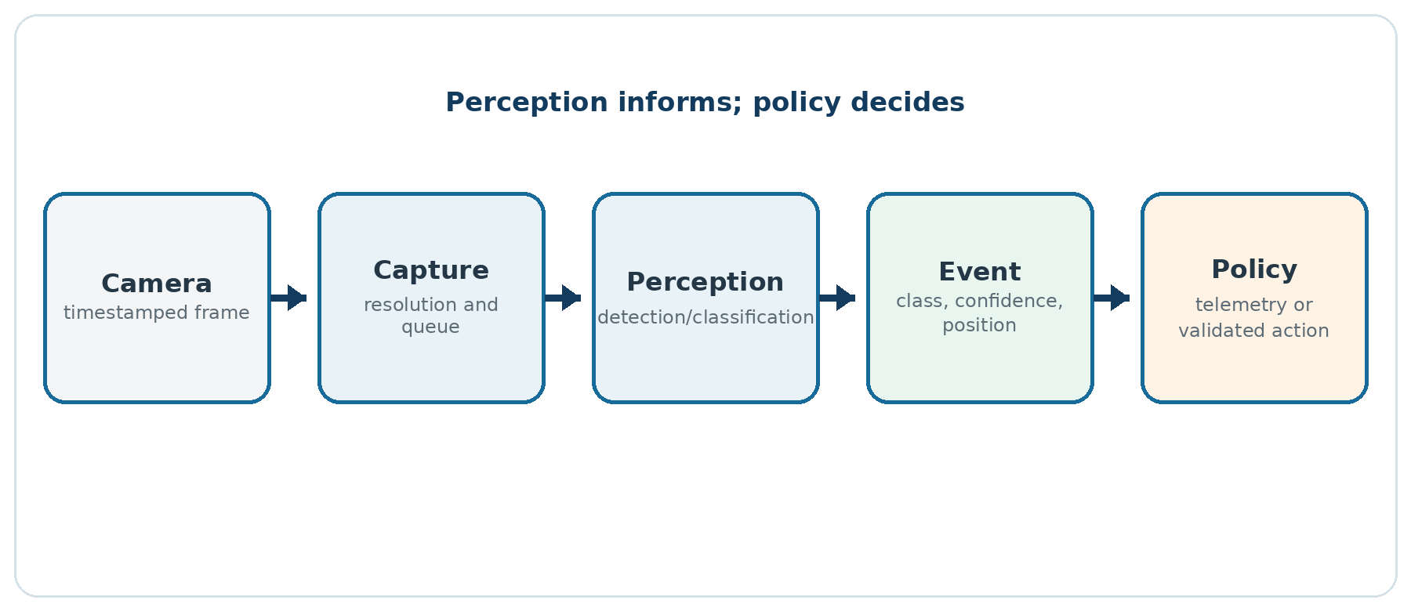
Figure 7 - Vision pipeline separated from motion control.
Source: Created by the author.
Do not send an entire image to the LLM when a simple local detection answers the question. A detector may produce PERSON confidence=0.91 x=...; the agent receives that observation and decides whether to explain, ask, or propose an action.

14.4 Performance on Raspberry Pi
Measure FPS, latency, CPU, RAM, temperature, and consumption. A model that works on a desktop may cause throttling on Raspberry Pi. Adjust resolution, analysis interval, and model. Separate capture from processing so old frames do not accumulate; when delayed, discard them and use the latest frame.

14.5 Safety and ethics
Face detection does not imply reliable identification. Recognition of people involves consent, bias, data protection, and false-identification risk. For an educational project, prefer presence, color, marker, or object detection without identity.
Vision must not be the only stop source. Lighting, occlusion, and motion cause failures. Local sensors and speed limits remain active.

14.6 Tests
- valid, corrupted, and missing image;
- camera disconnected during execution;
- varying light and background;
- partially occluded object;
- delayed frame;
- detector unavailable;
- high CPU load;
- confirmation that vision failure reduces capability and does not enable motion.

15. Memory and RAG

15.1 Use in the robot
RAG enables answers based on project documents without retraining the model. Robotinics can index:
- the Rev. 3 manual;
- component catalogs and authorized datasheets;
- the pin map;
- maintenance records;
- test procedures;
- a summarized fault history;
- the protocol version.
The purpose is to support diagnosis and operation, not to turn retrieved text into an automatic action.

15.2 TAIRAG
TAIRAG integrates TAIGraphMap and TCHATGPT. The minimum flow is to associate components, add files/folders, build the index, retrieve context, and ask a question. The current version offers graph, vector, BM25, and hybrid modes, a token budget, and optional reranking.
PASCAL
RAG.GraphMap := GraphMap;
RAG.ChatGPT := ChatGPT;
Agent.RAG := RAG;
Agent.ChatGPT := ChatGPT;
RAG.AddFolder('/opt/robotinics/docs');
RAG.BuildIndex;
Use extension and directory filters. Do not index secrets, keys, raw logs, or personal data without a need.

15.3 Separation of knowledge and authority
A document may say "for testing, send FRENTE." This text does not authorize the action. RAG supplies context for the answer; only the device catalog and safety policy define permitted actions. Retrieved content is treated as untrusted data and cannot override agent instructions.

15.4 Sources and traceability
The response should present the files or fragments used. Store document hash, version, and date. If two revisions differ, prefer the one linked to the robot version and report the conflict.
A useful response is: "According to the revision 3.0 pin map, the front trigger is on pin X; confirm the installed board." A poor response asserts certainty without a source or mixes pins from different revisions.

15.5 Chunking
Chunks should preserve semantic units: a complete procedure, a definition with its formula, or a table with its header. Fixed size is a starting point, not a universal solution. Use moderate overlap and chapter, component, and version metadata.
Evaluate with real questions and expected answers. Measure retrieval of the correct source before blaming the LLM. A small model can answer well when retrieved context is short and precise.

15.6 Operational memory
Separate:
- current state: volatile telemetry, never obtained from conversation;
- session memory: dialogue and recent actions;
- maintenance memory: confirmed events and versions;
- document base: indexed and versioned content.
After restart, physical state begins unknown/disarmed even if memory says that the robot was armed.

15.7 Evaluation
Create a question set:
- What is the nominal voltage of the 3S pack?
- Which command must always stop the robot?
- Where is the firmware file?
- Does the native OpenCV backend fully process images?
- Which pin-map revision is installed?
Record the retrieved source, answer, correctness, latency, and tokens. Include unanswerable questions; the system should acknowledge a lack of evidence.

16. Intelligent behaviors and limits

16.1 Operating modes
Mode | AI | Actuators | Use
Manual | optional for explanations | operator sends commands | initial diagnosis
Assisted | interprets intent | confirmation for each action | recommended use
Supervised | proposes a short sequence | limits and sequence confirmation | validated tasks
Simulation | acts on a virtual model | no physical output | development and testing

Unsupervised physical autonomy is not an initial Rev. 3 objective. It should be considered only after tests, localization, obstacles, power, and fault recovery have been validated.

16.2 Appropriate capabilities
Initial capabilities:
- explain state and faults;
- discover and list commands;
- query sensors;
- propose a short motion with confirmation;
- guide a maintenance checklist;
- answer questions using RAG;
- recognize a phrase and speak a response;
- describe an already structured vision observation.
Initially avoid:
- extended navigation without mapping/localization;
- manipulation of fragile objects or people;
- shell execution;
- automatic firmware changes;
- unrestricted internet access;
- a long action chain without confirmation or feedback.

16.3 Plan, execute, and verify
Divide a task into short steps. Validate state before each step. Then read telemetry and compare the result. If the effect is not confirmed, stop; do not repeat indefinitely.
Example: "move 30 cm closer":
- check sensor and state;
- propose a short initial displacement;
- confirm;
- execute for a limited time;
- measure again;
- recalculate with an iteration limit;
- stop and report the result.
Without calibrated odometry and a reliable sensor, the system must say that it cannot guarantee 30 cm.

16.4 Uncertainty
The agent must distinguish fact, inference, and missing data. Stale timestamped telemetry is not "current state." Low-confidence detection is not confirmed presence. A document from another revision is not authoritative for the current assembly.
Define thresholds and responses: ask the operator, repeat the reading, reduce speed, or refuse. "I don't know" is safe behavior.

16.5 AI observability
Record model version, provider, temperature, prompt hash, TraceID, latency, and structured response. For privacy, do not store all content by default. After a failure, it should be possible to answer: which model proposed the action, which validator blocked or allowed it, and which command the firmware received.

16.6 Promotion criterion
A capability moves from simulation to physical operation when:
- it has a documented contract and limits;
- all commands belong to the catalog;
- normal and adversarial tests pass;
- an independent stop exists;
- network/model failures are safe;
- the interface clearly presents intent and confirmation;
- results have been repeated on real hardware;
- the code version has been frozen.

Part V - Construction, validation, and evolution
ROBOTINICS REV. 3

17. Construction sequence

17.1 Stage 0 - documentation and inventory
Before buying or energizing components:
- download the frozen project version;
- generate an inventory of required files;
- identify the components actually available;
- check datasheets and voltages;
- record substitutions;
- prepare the power diagram;
- define the emergency-stop button and test procedure.
Do not use photographs as the only schematic. Create a connection map with names, pins, voltage, and current. Replacing a motor or servo may affect mechanics, power, and firmware simultaneously.

17.2 Stage 1 - passive mechanics
Assemble the base, wheels, supports, and structure without a battery. Check alignment, clearance, and access. Install weights representing the battery and boards to assess the center of gravity. Keep arms unloaded and remove servo horns during initial adjustment.
Acceptance: the base rolls freely, does not tip in permitted poses, and has no cable or part interference.

17.3 Stage 2 - power distribution
Install fuses, switch, converters, and terminals, but test initially with a current-limited bench supply. Validate one rail at a time with an electronic or known load. Measure polarity before connecting boards.
Acceptance: voltages remain within tolerance during transients; there is no unexpected heating; shutdown removes actuator power as designed.

17.4 Stage 3 - Arduino without actuators
Load Rev. 3 firmware. Use a serial terminal to test PING, MAN, STATUS?, invalid lines, overflow, and timeout. Simulate sensors where possible. Verify that boot always reports DISARMED.
Acceptance: the catalog matches firmware, the parser does not execute partial prefixes, and failures do not block the loop.

17.5 Stage 4 - raised traction system
Raise the wheels. Connect driver and motors with a current limit. Test one direction at a time, then STOP, duration, and watchdog. Confirm that left and right match the convention. Reverse wires or configuration in a documented way; do not scatter direction corrections across several routines.
Acceptance: starting, ramp, direction, stopping, and timeout are predictable; current and temperature remain below defined limits.

17.6 Stage 5 - servos and sensors
Connect one servo at a time. Calibrate zero and limits without the link; then install the unloaded link and measure current. Validate sensors individually, including timeout and out-of-range values.
Acceptance: no joint collides; loss of a relevant sensor reduces capability; the power supply does not reset logic during movement.

17.7 Stage 6 - Raspberry Pi and gateway
Install the system, create a service user, and validate serial communication. The gateway queries state and records telemetry but does not yet control motion over the network. Test restart, disconnection, and permissions.
Acceptance: Raspberry Pi can restart without activating actuators; the service restores communication and reports its version.

17.8 Stage 7 - TCHATGPT in simulation
Configure the LLM and agent with SimulationMode=True or without the physical serial port. Use a test catalog and send normal and adversarial questions. Verify JSON, limits, and confirmation.
Acceptance: the model cannot bypass catalog and policy; the interface remains responsive; credentials are not persisted as plain text.

17.9 Stage 8 - agent with hardware
Connect the real serial port with wheels raised. Discover MAN, query state, and execute only STOP, PING, and sensor commands at first. Then authorize short movements. Monitor the robot physically and keep the emergency stop within reach.
Acceptance: proposed action, confirmation, command, telemetry, and log show the same request_id; any mismatch stops the test.

17.10 Stage 9 - voice, vision, and RAG
Add one feature at a time. Voice first produces text without action; vision first produces an observation; RAG first answers with sources. Only then may each feature feed the agent through the same barriers.
Acceptance: failure of an added feature does not change basic safety; the operator knows when camera/microphone are active.

17.11 First floor operation
Use a flat, clear, marked area. Begin at low speed over a short distance. Record video, telemetry, current, and temperature. Increase gradually. Ramps and arms are later phases and never part of the first integrated test.

18. Test and commissioning plan

18.1 Test pyramid
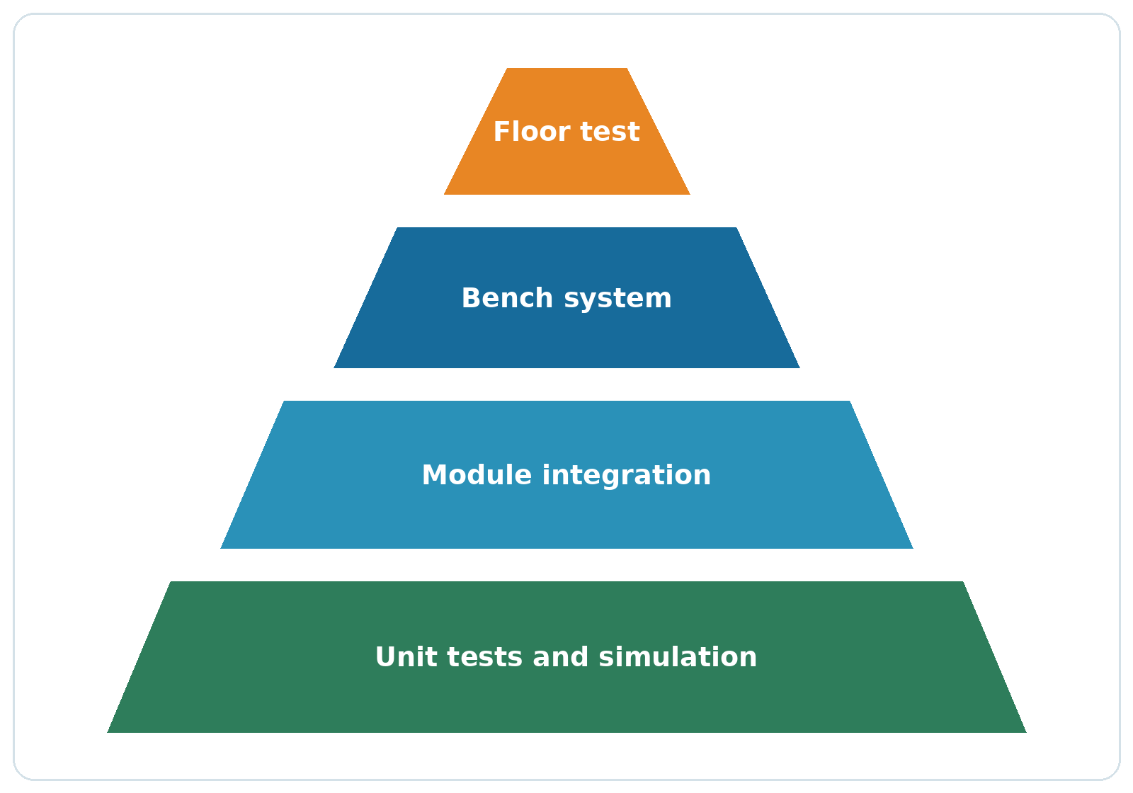
Figure 8 - Validation pyramid: many inexpensive tests support a few complete trials.
Source: Created by the author.
Tests begin with functions and modules, progress to integration, and end with the complete robot. The more physical and integrated a test is, the more expensive and dangerous it is to discover a defect. Exercise parser, calculations, and policy without hardware.

18.2 Minimum matrix
ID | Test | Condition | Expected result
PWR-01 | Polarity | without boards | all outputs correct
PWR-02 | Servo start | worst validated load | logic does not reset
PWR-03 | Undervoltage | supply reduced in a controlled manner | actuators stop and fault is recorded
FW-01 | Boot | any reset | DISARMED, motors off
FW-02 | Long line | > buffer | error, no execution
FW-03 | Lost heartbeat | during motion | STOP within limit
FW-04 | Unknown command | valid line | refused
AG-01 | Invented command | LLM response | blocked by catalog
AG-02 | Out-of-range parameter | PWM 999 | blocked by validator
AG-03 | No confirmation | motion | not sent
NET-01 | Network loss | during operation | local safety preserved
VIS-01 | Missing camera | startup and runtime | clear error, no motion enabled
VOI-01 | Ambiguous phrase | noise | question/refusal, no action
RAG-01 | Conflicting document | old revision | conflict reported

18.3 Electrical measurements
Record in each mode:
Mode | Battery V | Battery I | Minimum logic V | Peak servo I | Temperature
Idle
Wheels raised
Floor start
Turn
Arm, worst validated pose

Use safe instruments and methods. A single reading does not represent a fast peak; an oscilloscope or recorder may be necessary for voltage drop.

18.4 Mechanical measurements
- total mass and distribution;
- actual wheel diameter;
- current and speed on level floor;
- maximum validated slope;
- stopping distance by speed;
- joint backlash;
- position repeatability;
- motor and servo temperature;
- stability with arms in extreme positions.

18.5 AI evaluation
Create a fixed set of English phrases, including variations and errors. Classify:
- response without action;
- sensor query;
- valid action;
- ambiguous action;
- prohibited action;
- prompt attack;
- impossible request;
- loss of context.
For each case, record proposed JSON, validator decision, confirmation requirement, and final response. Changing models requires repeating the set; models with similar names may behave differently.

18.6 Fault injection
Induce faults in a controlled way:
- remove the serial cable;
- stop the LLM server;
- delay a response;
- send corrupted bytes;
- block a sensor;
- simulate high current through a test input;
- restart a process;
- fill log space in a test environment;
- supply a RAG document with a malicious instruction.
The goal is to verify safe output and diagnosis, not to damage equipment.

18.7 Test record
Each test includes:
TEXT
ID and title:
Date and person responsible:
Mechanical version:
Firmware and commit:
Application/TCHATGPT and commit:
Hardware and configuration:
Preconditions:
Steps:
Expected result:
Observed result:
Measurements and evidence:
Conclusion: PASS / FAIL / BLOCKED
Linked anomaly:

18.8 Commissioning criterion
The robot may operate under supervision when every critical test passes, there is no open safety fault, and the tested configuration matches the assembled one. One successful demonstration does not replace the test suite.

19. Maintenance and evolution

19.1 Periodic inspection
Before each session, inspect the battery, connectors, fuses, wheels, screws, cables, and emergency stop. After impact or transport, repeat the mechanical inspection and raised-wheel test.
Periodically:
- check pack capacity and balance using an appropriate procedure;
- clean and inspect motors and joints;
- look for heating and discoloration at connectors;
- review undervoltage, overcurrent, and watchdog logs;
- back up configuration and the RAG index;
- apply updates only with a rollback plan;
- repeat affected tests.

19.2 Compatibility
Maintain a matrix of operating system, architecture, Lazarus, FPC, packages, and runtime. "Compiles on Windows" does not prove Linux or ARM support. CI should build samples per package and a Robotinics-specific set. Hardware tests remain separate from compilation tests.

19.3 Reproducible repository
Rev. 3 recommends:
- a Robotinics tag corresponding to the book;
- a docs/rev3 directory with an editable source for the book;
- Rev. 3 firmware separate from legacy firmware;
- a Lazarus sample named robotinics_ai_controller;
- version-controlled schematics and BOM;
- installation and verification script;
- CI for firmware and Lazarus;
- releases with checksums;
- vulnerability and contribution policies.
Compiled files, objects, and caches must not replace sources. Removed historical tools may remain under a legacy tag with a security warning.

19.4 Technical roadmap

Priority 0 - safety and reproduction
- validate pack, BMS, charger, fuse, and rails;
- implement Rev. 3 firmware with watchdog;
- correct the pin map and commands;
- create a physical stop and fault test;
- freeze the BOM and versions.

Priority 1 - intelligent controller
- adapt agent_serial_demo to Robotinics;
- integrate TAIAgentSafety and a specific validator;
- create simulation mode;
- add telemetry and TraceID;
- test Windows/Linux x64.

Priority 2 - Raspberry Pi ARM64
- create CI or a reproducible ARM64 build;
- validate openai_core, serial, and agent;
- validate voice and vision separately;
- measure performance and temperature;
- promote components only with evidence.

Priority 3 - perception and knowledge
- RAG with versioned documents;
- voice with consent and confirmation;
- vision with an identified real backend;
- evaluation datasets;
- observability and regression testing.

19.5 Publication
Before publishing:
- define licenses for text and figures;
- preserve the GPLv3 license and notices applicable to TCHATGPT;
- audit the origin of third-party images and models;
- remove passwords, tokens, and personal data;
- verify links and commits;
- conduct technical reviews of the battery, electrical system, and mechanics;
- generate a PDF with bookmarks, links, and selectable text;
- provide DOCX or equivalent source for future revisions.
The Robotinics repository has no formal license in the examined snapshot. Any claim that the project is open should be accompanied by a license file chosen by the author. This edition does not choose a license on his behalf.

Appendix A - Suggested bill of materials
This list organizes categories. Final models and quantities depend on the assembly and should appear in the version-controlled BOM.
Subsystem | Items | Verification
Structure | STL/CAD parts, screws, inserts, mounts | material, revision, load, and clearance
Traction | geared motors, wheels, driver | voltage, stall current, continuous torque
Control | Arduino Mega or compatible board | pins, memory, interfaces
Computing | compatible Raspberry Pi, storage | architecture, power, temperature
Power | 3S pack, BMS, charger, fuse, switch | chemistry, current, certification, and assembly
Conversion | traction, servo, and logic rails | voltage, current, ripple, and cooling
Servos | actuators and mounts | calculated torque, limits, and current
Sensors | ultrasound, voltage, current, IMU/gas as required | logic level, range, calibration
Interface | camera, microphone, speaker | driver, consent, consumption
Safety | emergency stop, guards, fastening | access, test, and safe failure
Wiring | wires, terminals, connectors, labels | current, drop, polarization, and flexing

Do not buy from the historical BOM without checking availability and specifications. Clones sold under the same commercial name may differ.

Appendix B - Command protocol

B.1 Rules
- Commands use restricted ASCII/UTF-8; one line per message.
- Termination is LF or CRLF.
- Reference configuration allows at most 127 bytes of content per line.
- The first token identifies the command exactly.
- Decimal numbers omit units only when the contract defines the unit.
- STOP, DISARM, PING, STATUS?, and MAN do not depend on AI.
- Motion requires the ARMED state.
- Responses include OK, ERR, STATE, or EVENT.

B.2 Minimum catalog
Command | Parameters | State | Effect
PING | none | any | responds OK PING
MAN | none | any | publishes catalog
STATUS? | none | any | returns state and faults
ARM | according to policy | DISARMED | runs self-test and arms
DISARM | none | any | disables actuators
STOP | none | any | stops motion
MOVEFWD | PWM, ms | ARMED | bounded forward motion
MOVEBACK | PWM, ms | ARMED | bounded reverse motion
TURNLEFT | PWM, ms | ARMED | bounded left turn
TURNRIGHT | PWM, ms | ARMED | bounded right turn
RANGE? | optional sensor | any | distance or timeout
BATTERY? | none | any | voltage and state
SERVO | axis, angle, speed | ARMED | pose within limits

B.3 Legacy aliases
Legacy | Rev. 3 | Note
FRENTE | MOVEFWD | conservative default parameters
RE | MOVEBACK | conservative default parameters
GESQ | TURNLEFT | bounded duration
GDIR | TURNRIGHT | bounded duration
PARA | STOP | PARAR may be accepted only as a documented alias

Aliases do not bypass state, catalog, or limits.

Appendix C - Correction matrix for the previous edition
Approximate location | Identified problem | Correction adopted in Rev. 3
pp. 32-45 | force in N compared directly with torque in N·m | separate formulas and conversion by radius
pp. 38-39 | mass, weight, kgf, N, and slope mixed | m×g×sin(θ) and dimensional example
pp. 42-45 | arm torque in kgf·cm² and inconsistent masses | sum of moments in N·m, centers of mass, and margin
pp. 49-50 | 0.02 A = 200 mA | 0.02 A = 20 mA
pp. 53-56 | apparent/reactive power applied to DC pack | calculation using W, Wh, and conversion efficiency
pp. 58-59 | series-cell capacities added | 3S remains 5.2 Ah; only voltage adds
p. 96 | 20.75×10⁻³ F converted to 20.75 µF | correct value: 20,750 µF
pp. 97-113 | lithium charging based on wrong current and indefinite connection | 3S CC/CV charger, BMS, balancing, and datasheet
pp. 108-113 | buck set for 12.6 V from a 12 V input | buck cannot raise voltage; architecture redesigned
p. 106 | NO/NC inverted | NO open at rest; NC closed at rest
p. 113 | ammeter connected in parallel with output | current measured in series; short-circuit warning
pp. 135-146 | currents from different rails added and single supply undersized | power-based budget and separate rails
pp. 140-144 | L298N described without PWM/as isolation | PWM on enables, no isolation, explicit losses
pp. 150-155 | HC-SR04 described as 40 Hz | approximately 40 kHz
ultrasonic example | undefined echoPin/trigPin and same sample repeated | defined pins, timeout, and distinct samples
pp. 187-193 | servo associated only with PWM pins | library uses timers and compatible digital pins
p. 196 | 5/330 = 0.15 A | 5/330 ≈ 0.015 A; formula uses LED drop
p. 216 | MySQL example with typographic quotes and syntax errors | compilable examples and parameterized queries
pp. 218-220 | C/C++ servers with unsafe buffers, formatting, and shell | removed from operational architecture; validated gateway
pp. 221-223 | Motion confused with semantic vision | capture/motion separated from detection/classification
pp. 252-255 | OpenCV 2.4 and old installation | current documentation and TCHATGPT backends
face.py | VPython animation presented as recognition | correctly classified; use a real detector
pp. 256-267 | old PocketSphinx as the only route | modular Whisper/STT, with Sphinx retained only as legacy
pp. 268-275 | FANN and absent/incomplete examples | current ML components or explicitly historical documentation
pp. 280-297 | PHP5, MySQL root, exposed phpMyAdmin, chmod 777 | least privilege, local service, authentication, and permissions
firmware | String, delays, shared buffer, and no timeout | fixed parser, modules, watchdog, and limits
firmware | invalid GPS macros and overflow/blocking risk | correct definitions, bounded buffer, and timeout
firmware | ULTRA tested before ULTRA1/2 | exact comparison of the first token
firmware | substring(5) for prefix SERIAL: | token parser and actual length
tools | conflicting ports 7091/8091 and PARAR/PARA | central contract and documented aliases
repository | cited tools removed from current branch | declared snapshot/history; proposed new sample
editorial | missing chapter 6.2, non-clickable links, no bookmarks | continuous numbering, navigation, and links
PDF | open-project claim without formal license | license decision required before publication

Appendix D - Reference formulas
Quantity | Formula | Unit
Weight | F = m × g | N
Slope force | F = m × g × sin(θ) | N
Rolling | F = Crr × m × g × cos(θ) | N
Acceleration | F = m × a | N
Torque | T = F × r | N·m
Arm torque | T = Σ(m_i × g × d_i) | N·m
DC power | P = V × I | W
Energy | E = P × t or V × Ah | Wh
LED resistor | R = (V_supply - V_LED) / I | Ω
Resistor power | P = I² × R | W
Ripple capacitor | C ≈ I/(f×ΔV) | F
Runtime | t ≈ E_usable/P_average | h
Ultrasonic distance | d = v_sound × time/2 | m

Use consistent units. Convert millimeters to meters and milliamperes to amperes before calculating. State assumptions and rounding.

Appendix E - Platform and dependency matrix
Layer | Windows x64 | Linux x64 | Raspberry ARM64 | Note
openai_core | supported | supported | likely/experimental | validate HTTPS and runtime
serial/input | supported by samples | supported by samples | likely/experimental | permissions and device
serial agent | compiles in report | compiles according to environment | experimental | test hardware and GUI
voice | depends on executables/models | depends on executables/models | experimental | CPU/RAM cost
OpenCV Python | depends on Python/OpenCV | depends on Python/OpenCV | experimental | use TAIPythonRuntime
OpenCV native | partial loading | partial loading | experimental | incomplete native processing
RAG | compiles through sample | expected | experimental | measure memory and index

Do not promote "likely" to "supported" without a repeatable build and test.

Appendix F - References

Projects
- Marcelo Maurin Martins. Robotinics. Robotinics repository. Editorial snapshot 61d2a19d10e6701e27e46181e1a6c740b8ee4e30.
- Marcelo Maurin Martins. TCHATGPT - AI Component Suite for Lazarus / Free Pascal. TCHATGPT repository. Editorial snapshot 15d5e1a7780088701716896cfe9fb3afe0e7b71a.
- TCHATGPT. Platform compatibility.
- TCHATGPT. Agent Serial Demo.
- TCHATGPT. LLM and provider architecture.

Official technical documentation
- Raspberry Pi Ltd. Getting started - Raspberry Pi Documentation.
- Arduino. Arduino IDE 2 - Getting Started.
- OpenCV. Installation in Linux.
- Texas Instruments. Cell balancing buys extra run time and battery life.
- Texas Instruments. Precise Constant Current Regulation Helps Advance Fast-charging.
- Fluke. Digital multimeter safety and measurement guidance.
- Omron. Explanation of relay terms.

Appendix G - Glossary
Term | Definition
ADC | analog-to-digital converter
BMS | battery management/protection system
CC/CV | constant-current and constant-voltage charging
CI | continuous integration; automated build/test
Firmware | software executed by the microcontroller
GPIO | general-purpose input/output
Heartbeat | periodic presence/health message
LLM | large language model
PWM | pulse-width modulation
RAG | retrieval-augmented generation using documents
Stall | motor condition with a locked shaft
STT | speech-to-text conversion
TTS | text-to-speech conversion
Watchdog | timer that detects a hang or missing update

Closing remarks
Robotinics remains more valuable as an open learning platform than as a closed product. The third edition does not erase its history: it turns errors, limitations, and technological changes into part of the learning process.
The central principle is simple: artificial intelligence expands the ability to converse, perceive, and plan, but robot safety remains deterministic, local, measurable, and testable. With this separation, the project can evolve without confusing creativity with authorization.
The next step belongs to the community: reproduce, measure, record, and improve, always preserving origin and the ability to verify every decision.

