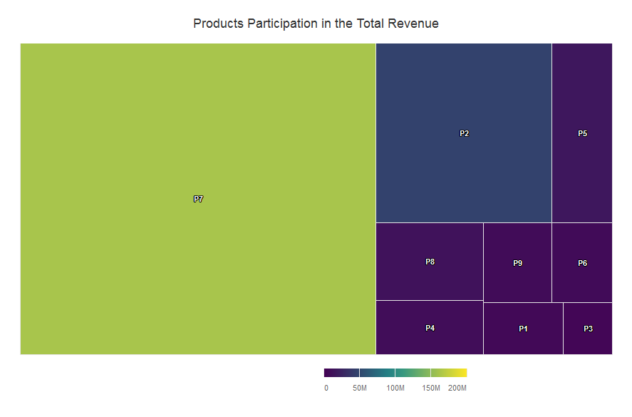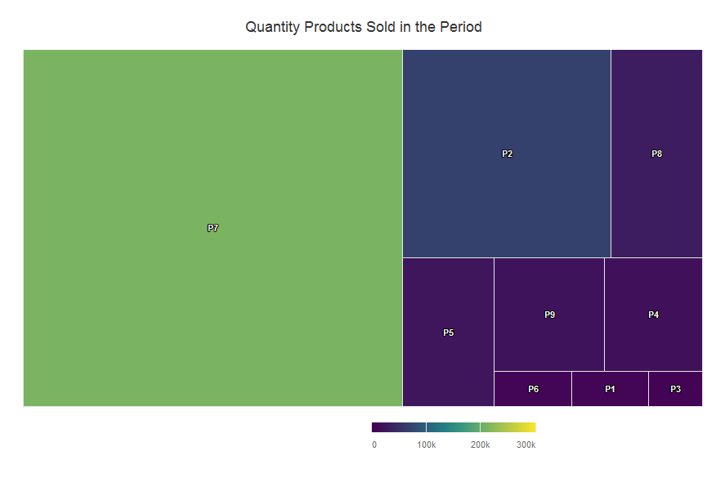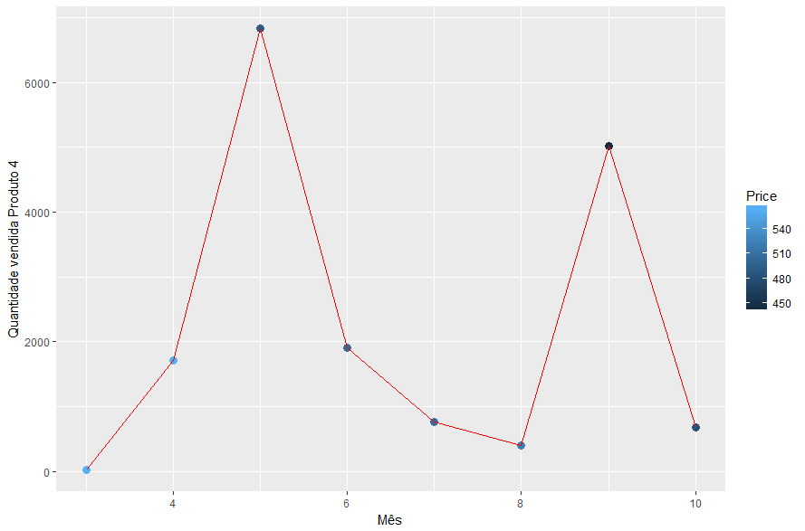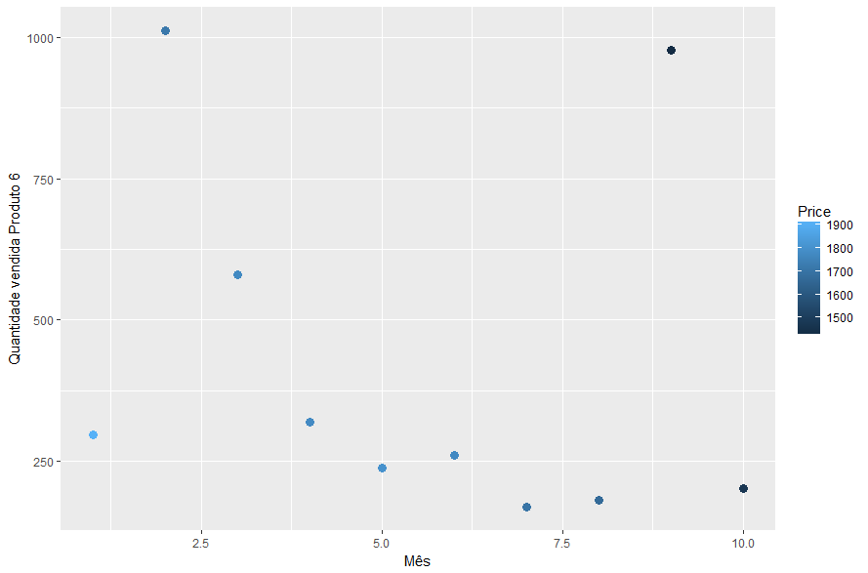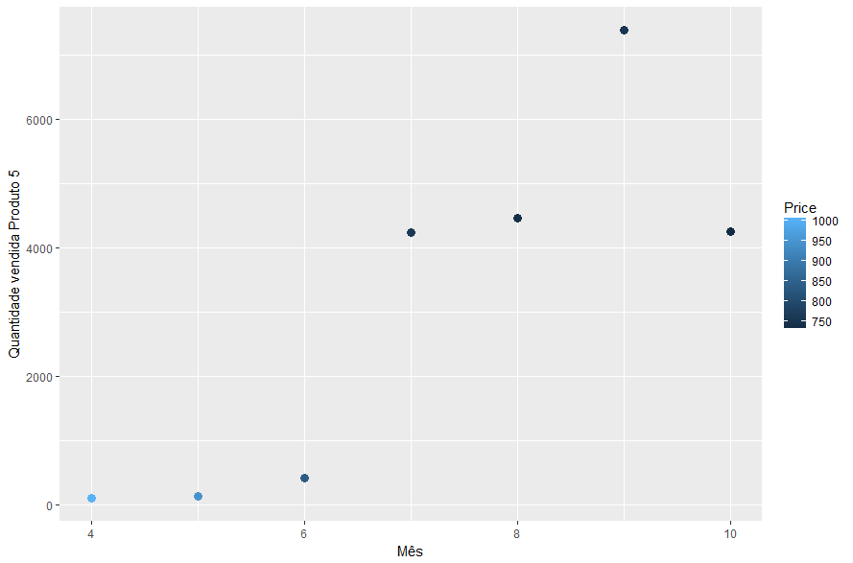

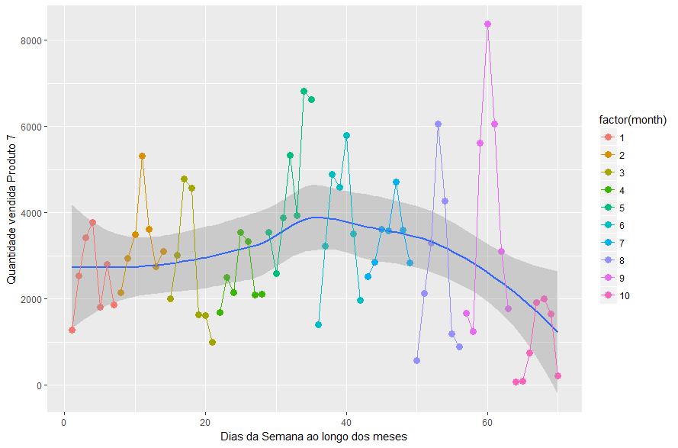

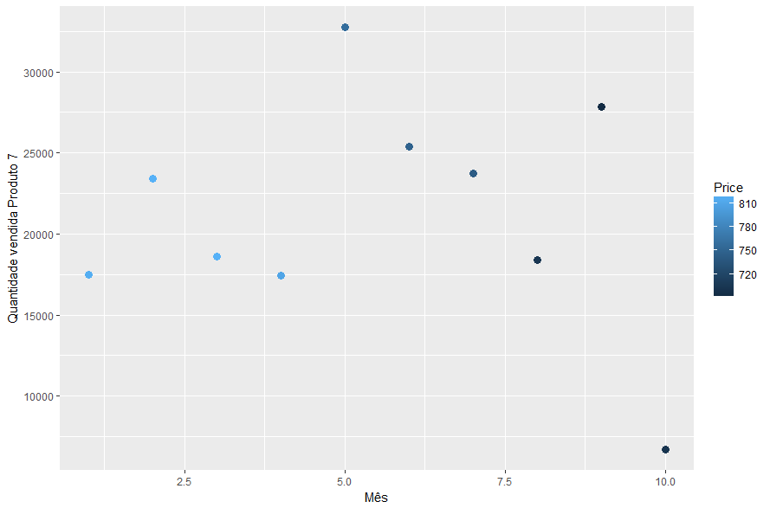

|  |  |  |  |  |  |  |  |  |  |  |  |  |
| --- | --- | --- | --- | --- | --- | --- | --- | --- | --- | --- | --- | --- |
| PROD | COMP 1 | | COMP 2 | | COMP 3 | | COMP 4 | | COMP 5 | | COMP 6 | |
| 1 | 2 | 1 | 2 | 1 | 2 | 1 | 2 | 1 | 2 | 1 | 2 |
| 1 | 0.2 | 0.2 | 0.2 | 0.2 |  |  |  |  |  |  |  |  |
| 2 |  |  |  |  | 0.68 | 0.68 |  |  |  |  |  |  |
| 3 | 0.81 | 0.81 | 0.81 | 0.81 | 0.78 | 0.78 |  |  |  |  |  |  |
| 4 |  |  |  |  |  |  |  |  |  |  |  |  |
| 5 | 0.71 |  | 0.73 |  | 0.72 |  |  |  |  |  |  |  |
| 6 | 0.69 |  |  |  | 0.67 |  |  |  |  |  |  |  |
| 7 | 0.77 |  | 0.77 |  | 0.72 |  | 0.82 |  |  |  |  |  |
| 8 | 0.73 |  |  |  |  |  |  |  |  |  | 0.74 |  |
| 9 | 0.77 |  | 0.77 |  |  |  |  |  |  |  |  |  |

Models

P1 – MLP

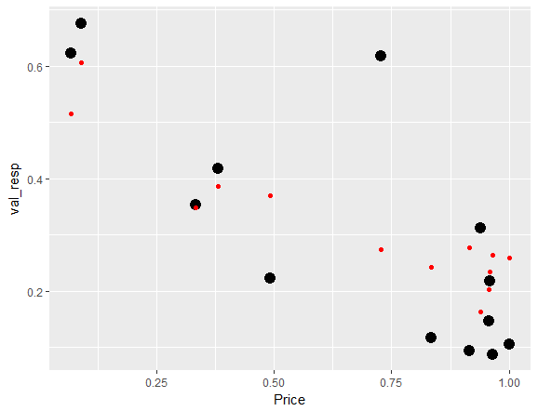

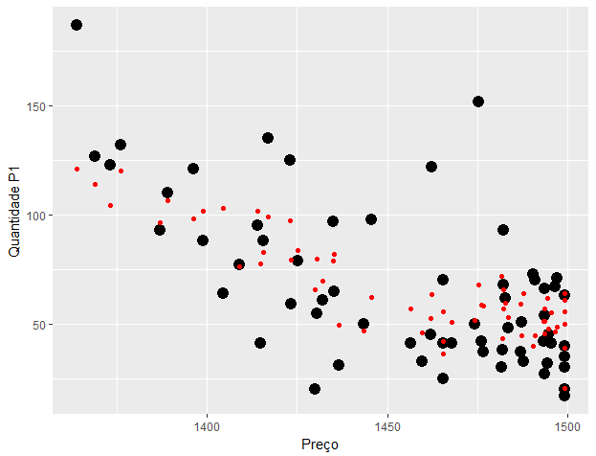

P1 – SVM

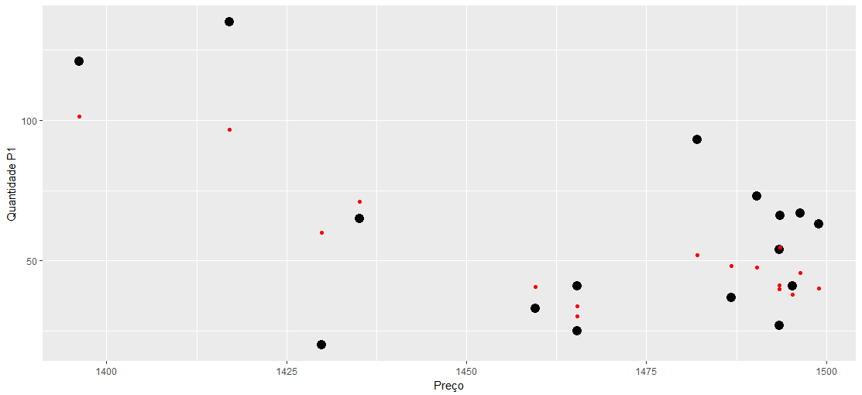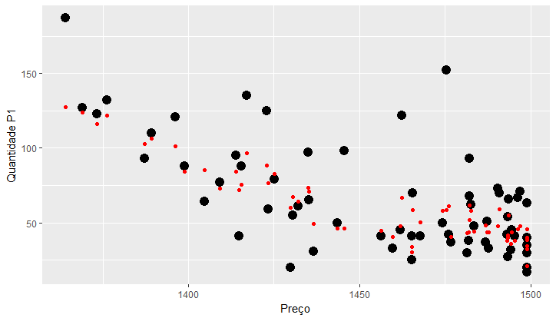

P2 – SVM

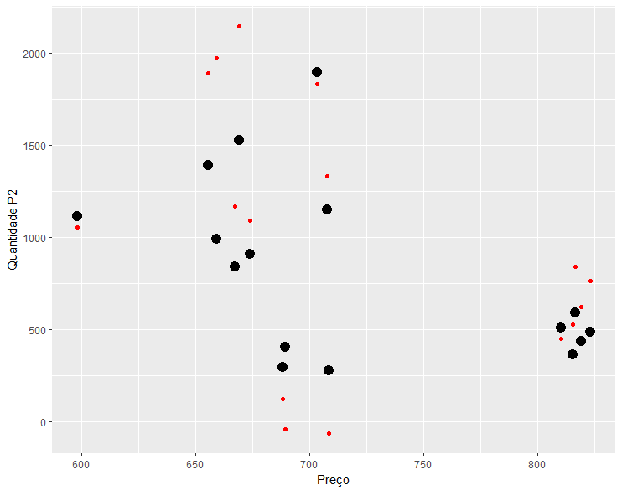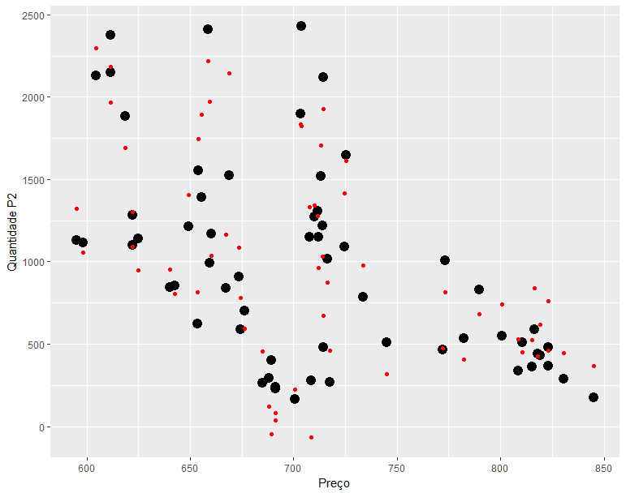

P3 –

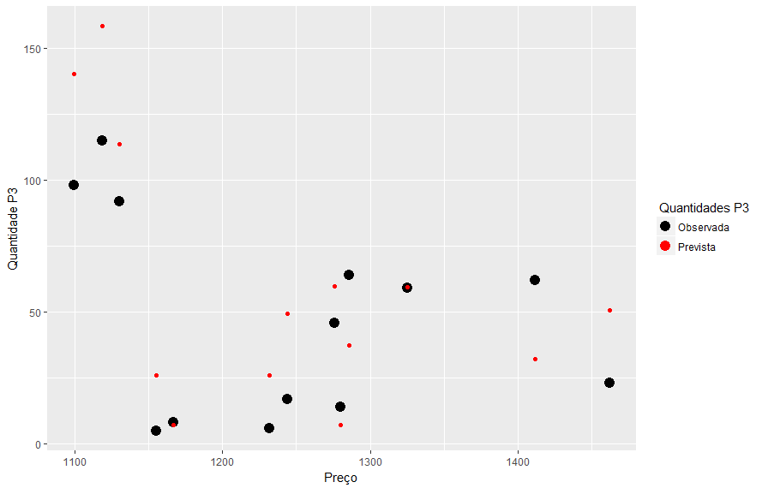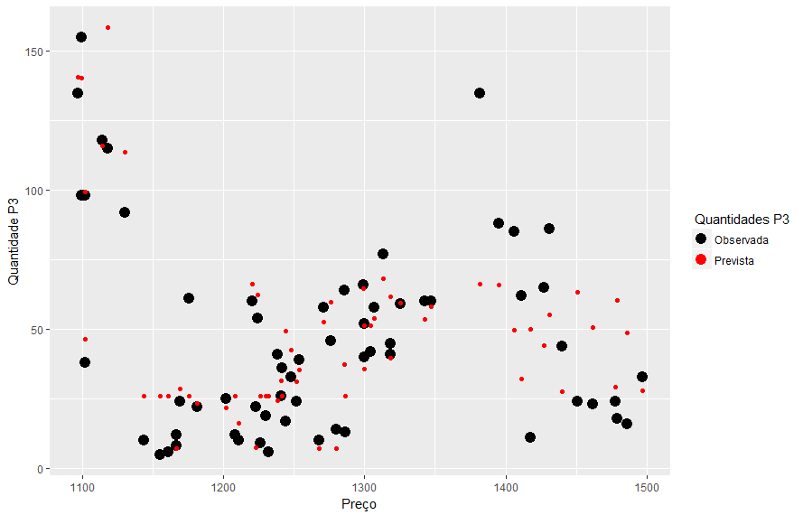

P4 –

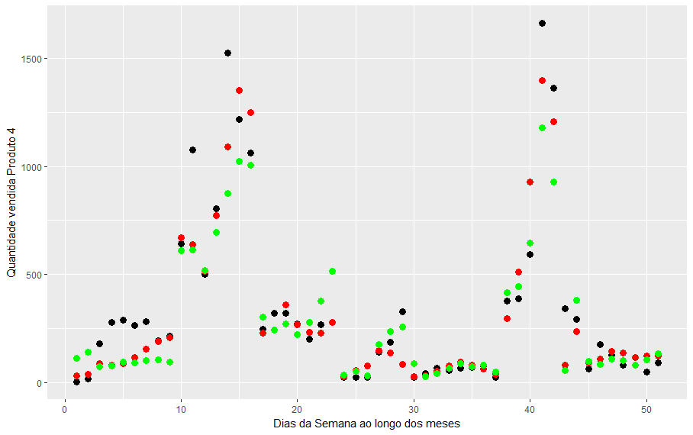

Preto – Valores Observados, Verde = GLM(log(QTY_ORDER) ~ Price + month + day), Vermelho = MLP(4, decay – 0.1)

P5 -

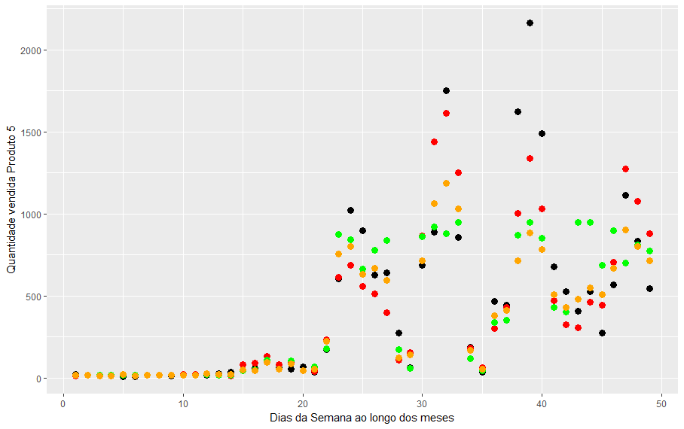

Preto – Valores Observados, Verde = polinomial 4th order, Laranja = MLP(4, decay – 0.1) e Vermelho = SVM.

P6 – 