CIS 302

A JavaScript Calculator

Add the GitHub Page Link

Add a screenshot of the Calculator using the given codes

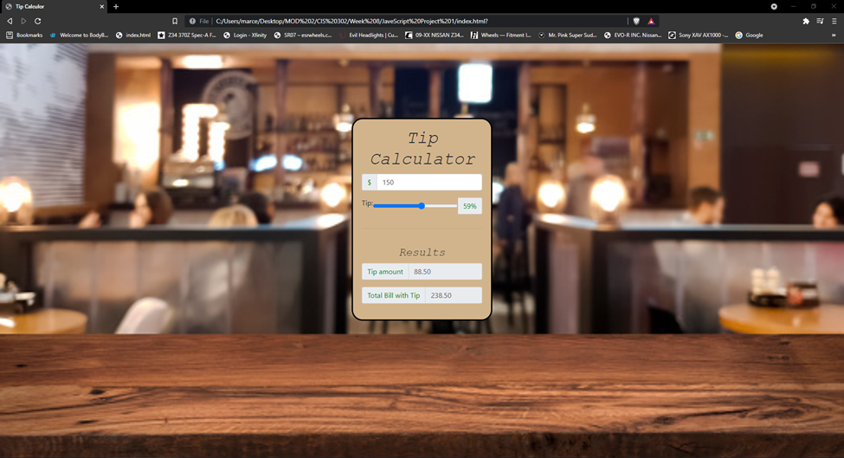Add a screenshot of your version of the Calculator