
EspnowMqttPeer2Peer
Beta version 1.1.8
ESP-NOW/MQTT Hybrid Communication Protocol
*Technical Documentation – v2.1.0*
Author: Eng. Marcelo Pimentel
marcelo-pimentel@hotmail.com
https://github.com/sponsors/marcelopi

Table of Contents
- Introduction
- API Reference
- Code Examples
- Project Structure
- Platform Compatibility
- Key Event Sequence
- Troubleshooting
- Revision History

1. Introduction
1.1 Protocol Overview

Inspiration and Core Concept
This system was designed to unify MQTT and ESP-NOW paradigms, creating a transparent communication layer where:
ESP-NOW acts as "Wireless MQTT": Messages are routed using topic patterns (source/destination/action), simulating MQTT's publish/subscribe model without requiring a central broker.
Thislibrary includes implemented methods to update using OTA protocol (over the air) using ESP-NOW.

Full Abstraction: Developers interact with a single API while the library automatically chooses between:
ESP-NOW: For local peer-to-peer communication (ESP32/ESP8266)
MQTT: For cloud/remote connectivity (ESP32 Router only)
A hybrid communication system combining:
- ESP-NOW for direct device-to-device messaging
- MQTT for cloud/remote communication
- Unified API for seamless protocol switching
- Hierarchical Tree:
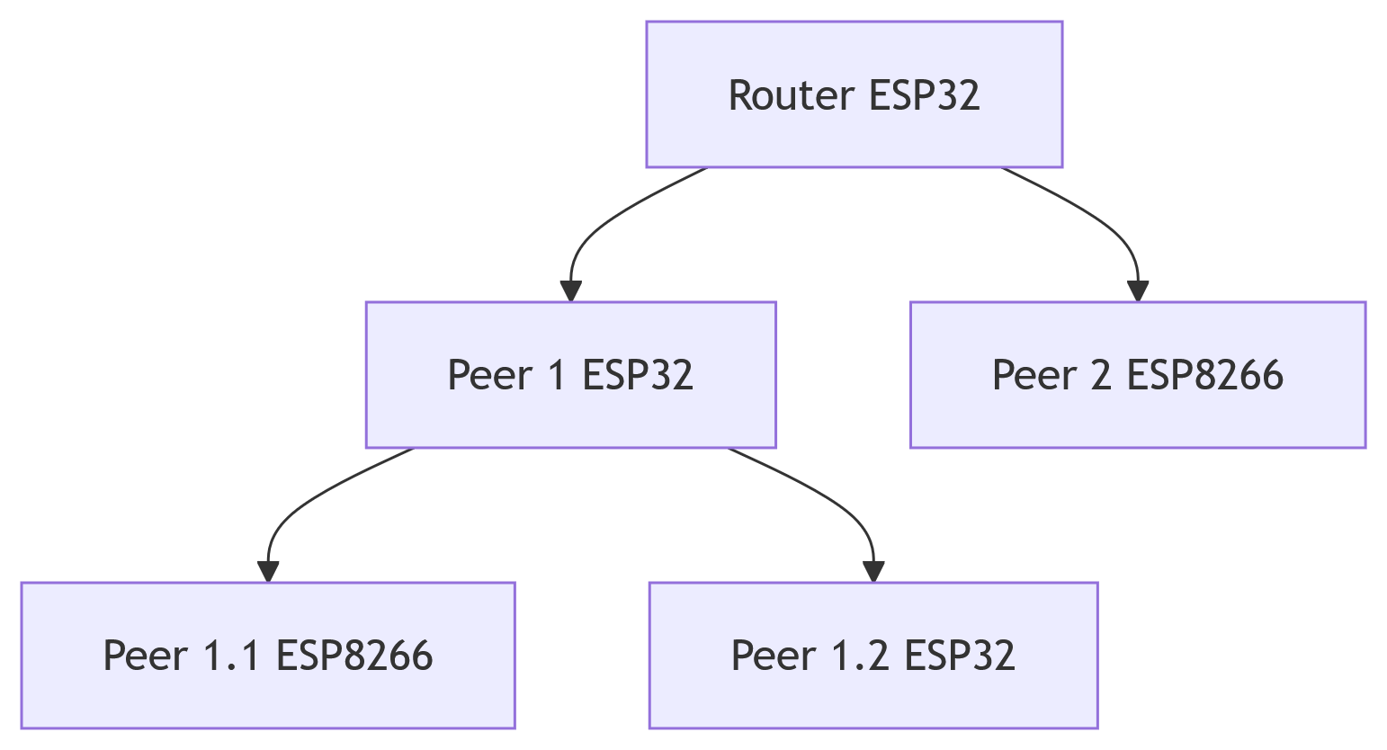
- Linear Chain:
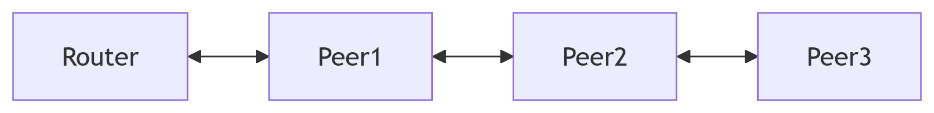
1.2 Key Features
Feature | Description
Dual-Mode Operation | Automatic ESP-NOW/MQTT selection
Event-Driven Architecture | Critical network event callbacks
Multi-Hop Routing | Message forwarding through peers
Cross-Platform Support | ESP32 (Router/Peer), ESP8266 (Peer)
1.3 Use Cases
- Industrial sensor networks
- Smart home automation
- Agricultural monitoring systems

2. API Reference
2.1 Core Classes

MqttEspNowRouter (ESP32 Only)
cpp
class MqttEspNowRouter {
public:
void begin(uint8_t wifiChan, uint8_t espnowChan, const char* name,
const uint8_t* mac, const char* mqttName,
std::vector<DeviceInfo>& peers, const char* mqttSrv,
uint16_t port, const char* user = "", const char* pwd = "");

void subscribe(const String& src, const String& dest,
const String& action, LocalHandler h, RouteType t);

void publishMqtt(const String& src, const String& dest,
const String& action, const String& msg);
};

EspNowPeer
cpp
class EspNowPeer {
public:
void begin(uint8_t channel, const char* name,
std::vector<DeviceInfo>& routers,
std::vector<DeviceInfo>& peers);

void subscribe(const String& src, const String& dest,
const String& action, LocalHandler h);
};
2.2 Data Structures
cpp
struct DeviceInfo {
String name;
uint8_t mac[6]; // MAC address in byte array format
bool online = false;
unsigned long lastPing = 0;
};

3. Code Examples
3.1 Router Initialization
cpp
/* File: examples/Router/RouterBasic.ino */

#include <MqttEspNowRouter.h>

// Network configuration
const uint8_t routerMac[] = {0x12,0x34,0x56,0x78,0x9A,0xBC};
std::vector<DeviceInfo> peers = {{"Sensor1", {0xAA,0xBB,0xCC,0xDD,0xEE,0xFF}};

MqttEspNowRouter router;
wifiConnManager wifi;

void setup() {
wifi.onWifiReady([]() {
wifi.onEspNowReady([]() {
router.begin(6, 6, "MainRouter", routerMac,
"CloudBroker", peers, "mqtt.server.com", 1883);

router.subscribe("CloudBroker", "Sensor1", "LED",
[](String msg) { /* Handler */ }, ROUTE_MQTT);
});
});
wifi.begin(/* ... parameters ... */);
}

3.2 Peer Implementation
cpp
/* File: examples/Peer/PeerBasic.ino */

#include <EspNowPeer.h>

EspNowPeer peer;
std::vector<DeviceInfo> routers = {{"MainRouter", {0x12,0x34,0x56,0x78,0x9A,0xBC}};

void setup() {
peer.begin(6, "TempSensor1", routers, {});

peer.subscribe("MainRouter", "TempSensor1", "REPORT",
[](String msg) { /* Handle command */ });
}

void loop() {
peer.publishENow("TempSensor1", "MainRouter", "TEMP", readTemp());
delay(10000);
}

4. Project Structure
Directory Layout
ESPNow-MQTT-Hybrid/
├── src/ # Core library
│ ├── EspNowPeer.cpp # Peer implementation
│ └── MqttEspNowRouter.h # Router class
│
├── examples/ # Sample implementations
│ ├── Router/ # ESP32 router examples
│ └── Peer/ # ESP32/ESP8266 peer examples
│
├── docs/ # Documentation
│ ├── ESPNowMqttProtocol.pdf
│ └── wiring_diagrams/ # Hardware schematics
│
└── library.json # PlatformIO metadata

5. Platform Compatibility
Hardware Support
Feature | ESP32 Router | ESP32 Peer | ESP8266 Peer
MQTT Client | ✅ | ❌ | ❌
ESP-NOW Transmitter | ✅ | ✅ | ✅
Dual Protocol Routing | ✅ | ✅ | Limited
Software Requirements
- PlatformIO Core 6.1+
- Arduino Framework 3.0+
- ESP32 Arduino Core 2.0.9+

6. Key Event Sequence
Initialization Flow
- WiFi Connection Establishment
- ESP-NOW Protocol Initialization
- MQTT Broker Connection (Router Only)
- Peer/Router Registration
- Message Handler Setup
Event Timeline
[0ms] WiFi.begin()
[1200ms] onWifiReady()
[1500ms] esp_now_init()
[1600ms] onEspNowReady()
[1700ms] MQTT.connect()
[2000ms] Ready for Operation

7. Troubleshooting
Common Issues
Error Code | Description | Solution
0x3001 | ESP-NOW Not Initialized | Check WiFi channel
0x102 | MQTT Connection Failed | Verify broker credentials
N/A | Message Loss | Verify MAC addresses
Debugging Tips
cpp
// Enable verbose logging
#define COMM_DEBUG 1 // 0-Disable, 1-Basic, 2-Verbose

// In setup():
Serial.setDebugOutput(true);

8. Revision History
Version | Date | Changes
2.1.0 | 2024-03-15 | Added event API
2.0.2 | 2024-02-28 | ESP8266 fixes
1.4.1 | 2023-12-10 | Initial release

*Documentation generated on 2024-03-20 - MIT License*

