**Assignment 1**

**Part 1: Creating Contacts**

This assignment will take place in parts and will span the course. It will require you to contain components of various lessons throughout the course. Each part will be graded like the exercises in the course. Each part must be done within 1 week of being posted for full marks. Parts that are presented after 1 week will only be awarded half marks. Exceptions will only be considered around holidays and examinations.

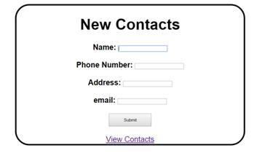

Step 1: Create the New Contacts page.

Examine the page example above. This is an html page. It should load with your root directory. Recreate the page in your Assignment 1. The submit button should have an action that sends all 4 text fields to a controller method. The "View Contacts" at the bottom is a hyperlink that will be discussed in part 5.

Step 2: Contact Object

Since we are dealing with a name, address, phone number, and email, it makes sense to group this data together. This will be done inside of a bean. Create a class Contact that stores all 4 pieces of data as Strings. This class should have constructors, getters and setters, and a toString method. Have this class be in the ca.sheridancollege.beans package.

Step 3: Contact List

Create a public static arraylist of type Contact in your controller.

Step 4: Create a Contact

In your controller method from part 1, use the parameters that were read to create an instance of the Contact object. Store this Contact object in your list from part 3. Have your method from part 1 return to the add contact page.

Step 5: View Contacts

Create a new method in your controller that prints all of the Contacts from the arraylist to System.out. Each Contact should be printed one per line. The View Contacts hyperlink from your HTML page should call this method. This method will also return to the above HTML page.

Things to remember:

* You only need 1 HTML page for this part.
* Your controller will have 1 static arraylist and 3 mapped methods.
* You should only have System.out in your view contacts method from part 5. Anywhere else is considered wrong.
* Your packages should be defined appropriately as discussed above and in class.