**Assignment 1**

**Part 1: Creating Contacts**

**Part 2: Form Binding and View Contacts**

This assignment will take place in parts and will span the course. It will require you to contain components of various lessons throughout the course. Each part will be graded like the exercises in the course. Each part must be done within 1 week of being posted for full marks. Parts that are presented after 1 week will only be awarded half marks. Exceptions will only be considered around holidays and examinations.

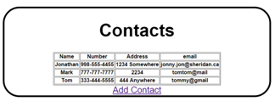

Step 1: Form Binding

Modify your add contact page so that it uses form binding to collect information.

Step 2: View Contacts

Modify your program so that it displays all of the contacts in a table where each row represents 1 record.

Step 3: Hyperlinks

Include hyperlinks that will allow you to navigate between the add and view pages.

Step 4: CSS

Include CSS into your program to make both pages attractive.