Patient-Reported Outcomes, Disability, and Substance Use Risk in Young Patients With Inflammatory Bowel Disease in a Low- and Middle-Income Country
[Authors and Affiliations]

ABSTRACT
Background and Aims: Patient-reported outcomes (PROs) in young patients with inflammatory bowel disease (IBD) remain poorly characterised in low- and middle-income countries (LMICs). We aimed to describe quality of life (QoL), disability, and substance use risk in young patients with IBD at a tertiary public hospital in Brazil, and to compare PROs between Crohn's disease (CD) and ulcerative colitis (UC).
Methods: This cross-sectional study enrolled 148 patients with IBD (105 CD, 38 UC, 5 IBD-U) at the Hospital das Clinicas, University of Sao Paulo. Four PRO instruments were administered: CRAFFT 2.1 (substance use screening), IBD-Disk (disability), IBDQ (QoL, patients >= 18 years), and IMPACT-III (QoL, patients < 18 years). Groups were compared using Mann-Whitney U and Kruskal-Wallis tests; correlations were assessed with Spearman's coefficient.
Results: Patients with UC reported significantly worse QoL than those with CD across all IBDQ domains: total score 135 vs 175 (p = 0.02), bowel symptoms (p = 0.04), systemic symptoms (p = 0.02), emotional well-being (p = 0.02), and social function (p = 0.01). IBD-Disk disability scores were strongly inversely correlated with IBDQ scores (rho = -0.71, p < 0.001). One in five patients (22.2%) screened positive for substance use risk, with no significant difference between disease types.
Conclusions: Young UC patients at a LMIC tertiary centre report significantly worse QoL than CD patients across all domains. Substance use risk is prevalent regardless of disease type. Systematic PRO assessment should be integrated into IBD care in LMICs.
Keywords: inflammatory bowel disease | patient-reported outcomes | quality of life | disability | substance use | low- and middle-income country

Plain Language Summary
Inflammatory bowel disease (IBD) is a chronic gut condition increasingly diagnosed in young people worldwide, yet little is known about how it affects daily life in developing countries. We studied 148 young patients with IBD at a large public hospital in Brazil using validated questionnaires measuring quality of life, disability, and substance use risk. We found that patients with ulcerative colitis reported significantly worse quality of life than those with Crohn's disease in all areas measured — bowel symptoms, energy, emotions, and social life. Higher disability was strongly linked to lower quality of life. Additionally, about one in five patients showed signs of risky substance use, regardless of their type of IBD. These findings suggest that routine quality of life assessment and substance use screening should be part of standard care for young IBD patients, particularly in countries with limited healthcare resources.

1 | Introduction
[TO DO]

2 | Materials and Methods

2.1 | Study Design and Setting
This was a cross-sectional, single-centre study conducted at the Inflammatory Bowel Disease outpatient clinic of the Hospital das Clinicas, Faculty of Medicine, University of Sao Paulo (HC-FMUSP), Sao Paulo, Brazil. HC-FMUSP is a tertiary referral hospital within the Brazilian Unified Health System (Sistema Unico de Saude, SUS), serving a predominantly low- and middle-income population. Data were collected between June 2021 and February 2026. Reporting adheres to the STROBE guidelines for observational studies.

2.2 | Study Population
Patients diagnosed with IBD (Crohn's disease [CD], ulcerative colitis [UC], or IBD-unclassified [IBD-U]) according to established clinical, endoscopic, and histopathological criteria were consecutively enrolled during routine outpatient visits. Patients were eligible if they had been diagnosed with IBD during childhood or adolescence (age at diagnosis 7-27 years) and were followed at the HC-FMUSP IBD clinic. Patients who refused participation or lacked a confirmed diagnostic classification were excluded. Disease phenotype was classified according to the Paris classification.

2.3 | Patient-Reported Outcome Instruments
PROs were assessed using four validated instruments during routine outpatient visits. The choice of QoL instrument was determined by the patient's age at evaluation:
CRAFFT 2.1 (all patients). A six-item screening tool for substance-related risks in adolescents and young adults. Total score 0-6; a score >= 2 indicates a positive screen.
IBD-Disk (all patients). A visual analogue disc measuring disability across 10 domains (abdominal pain, defecation, interpersonal interactions, education/work, sleep, energy, emotions, body image, sexual function, joint pain). Total score 0-100; higher scores indicate greater disability.
IBDQ (patients >= 18 years). A 32-item questionnaire assessing QoL across four domains: bowel symptoms, systemic symptoms, emotional well-being, and social function. Total score 32-224; higher scores indicate better QoL.
IMPACT-III (patients < 18 years). A 35-item disease-specific QoL questionnaire for paediatric IBD across five domains: symptoms, emotional functioning, social functioning, well-being, and treatment.

2.4 | Study Definitions
Age at diagnosis was defined as the age at initial IBD diagnosis as recorded in the medical chart, and categorised per the Paris classification: A1a (< 10 years), A1b (10-16 years), A2 (17-40 years). For patients with multiple evaluations, the first assessment was used. Positive CRAFFT screen was defined as a total score >= 2.

2.5 | Statistical Analysis
Continuous variables were described as median (IQR). Categorical variables were presented as n (%). Comparisons across three disease groups used the Kruskal-Wallis test; pairwise comparisons between CD and UC, and between sexes, used the Mann-Whitney U test. Categorical variables were compared using chi-squared or Fisher's exact test when expected counts were below 5. Correlations between PRO instruments and with age at diagnosis were assessed using Spearman's rank correlation coefficient. A composite extraintestinal burden score was calculated as the sum of IBD-Disk items for joint pain, energy, and sleep (range 0-30), and patients were dichotomised at the median. Bootstrap 95% confidence intervals (10,000 iterations) were calculated for medians; Wilson score intervals for proportions. A two-sided p < 0.05 was considered significant. Analyses were performed using Python 3.12 (SciPy 1.14, pandas 2.2). All analysis scripts are publicly available at https://github.com/marcelosilva2604/gastro-pediatria. The underlying clinical datasets contain protected health information (patient names and hospital registration numbers) and therefore could not be deposited in a public repository.

2.6 | Ethical Considerations
This study was approved by the Ethics Committee of HC-FMUSP (CAAE: 82679518.2.0000). Informed consent was obtained from all participants. For patients under 18 years, legal guardians signed consent with adolescent assent. For patients over 18 years diagnosed in childhood, consent was obtained directly.

3 | Results

3.1 | Study Sample
A total of 148 patients were included (Table 1): 105 (70.9%) with CD, 38 (25.7%) with UC, and 5 (3.4%) with IBD-U. The majority were male (88/148, 59.5%). The median age at diagnosis was 21 years (IQR 19-23; range 7-27). Most patients (132, 89.2%) were classified as Paris A2 (17-40 years). The distribution of Paris age categories differed significantly across disease types (p = 0.006), with IBD-U patients more frequently diagnosed before age 10. Sex and age at diagnosis did not differ significantly between CD and UC.

3.2 | Quality of Life: UC Worse Than CD
Among 68 patients aged >= 18 years who completed the IBDQ, patients with UC reported significantly worse QoL than those with CD across all four domains (Figure 1, Table 1). The median IBDQ total score was 135 (IQR 97-169; 95% CI for median: 96-162) in UC versus 175 (IQR 130-195; 95% CI: 155-180) in CD (p = 0.02). Domain-specific findings were consistent: bowel symptoms (33 vs 43, p = 0.04), systemic symptoms (15 vs 23, p = 0.02), emotional well-being (43 vs 50, p = 0.02), and social function (45 vs 53, p = 0.01).
Among 22 patients aged < 18 years who completed the IMPACT-III, the median total score was 70 (IQR 49-93). Female patients reported significantly worse outcomes than males: total score 88 vs 66 (p = 0.042), symptoms domain 24 vs 15 (p = 0.022), and social domain 30 vs 16 (p = 0.029).

3.3 | Disability, Extraintestinal Burden, and Quality of Life
The median IBD-Disk total score was 34 (IQR 15-56) out of 100. Female patients reported significantly higher disability than males (44 vs 31, p = 0.035), with pronounced differences in emotions (8 vs 4, p < 0.001), energy (6 vs 4, p = 0.012), body image (5 vs 3, p = 0.030), sexual function (3 vs 1, p = 0.017), and joint pain (5 vs 1, p = 0.018). This sex difference persisted within the CD subgroup (47 vs 30, p = 0.022).

3.4 | Substance Use Risk and Age at Diagnosis
Among 144 patients who completed the CRAFFT, 32 (22.2%) screened positive (score >= 2). The prevalence did not differ between disease types (CD 19.6%, UC 27.0%, IBD-U 40.0%; p = 0.40) or between sexes (males 25.3% vs females 18.3%; p = 0.42). However, age at diagnosis correlated positively with CRAFFT score (Spearman rho = 0.21, p = 0.013), and patients diagnosed at age >= 17 had higher CRAFFT scores than those diagnosed younger (p = 0.027). Age at diagnosis was also correlated with greater emotional impact (IBD-Disk emotions: rho = 0.23, p = 0.010) and worse sexual function (rho = 0.21, p = 0.018). The composite extraintestinal burden score showed a weak but significant positive correlation with CRAFFT score (rho = 0.18, p = 0.037), suggesting that patients with higher extraintestinal burden may be at slightly greater risk of substance use.

TABLE 1 | Demographic characteristics and patient-reported outcome scores by disease type.
 | All | CD | UC | IBD-U | p
Demographics | (n=148) | (n=105) | (n=38) | (n=5)
Sex, n (%) |  |  |  |  | 0.22 (a)
Male | 88 (59.5) | 67 (63.8) | 19 (50.0) | 2 (40.0)
Female | 60 (40.5) | 38 (36.2) | 19 (50.0) | 3 (60.0)
Age at dx (y), median (IQR) | 21 (19-23) | 20 (18-22) | 22 (19-23) | 21 (18-22) | 0.22 (b)
95% CI for median | 20-21 | 20-21 | 20-23 | 7-22
Range | 7-27 | 9-27 | 13-25 | 7-22
Paris age, n (%) |  |  |  |  | 0.006 (a)
A1a (<10 y) | 2 (1.4) | 1 (1.0) | 0 (0) | 1 (20.0)
A1b (10-16 y) | 14 (9.5) | 11 (10.5) | 3 (7.9) | 0 (0)
A2 (17-40 y) | 132 (89.2) | 93 (88.6) | 35 (92.1) | 4 (80.0)
CRAFFT (n=144) |  | (n=102) | (n=37) | (n=5)
Total score, median (IQR) | 0 (0-1) | 0 (0-1) | 0 (0-2) | 1 (0-3) | 0.44 (b)
Positive (>=2), n (%) | 32 (22.2) | 20 (19.6) | 10 (27.0) | 2 (40.0) | 0.40 (a)
IBD-Disk (n=144) |  | (n=103) | (n=36) | (n=5)
Total score, median (IQR) | 34 (15-56) | 33 (14-54) | 42 (17-62) | 44 (0-52) | 0.58 (b)
 |  |  |  |  | CD vs UC (c)
IBDQ >= 18 y (n=68) |  | (n=50) | (n=15) | (n=3)
Total score, median (IQR) | 160 (120-184) | 175 (130-195) | 135 (97-169) | 121 (102-134) | 0.02
95% CI for median | 141-176 | 155-180 | 96-162 | -
Bowel symptoms | 42 (31-48) | 43 (34-48) | 33 (26-45) | 25 (22-36) | 0.04
Systemic symptoms | 22 (14-26) | 23 (16-26) | 15 (10-24) | 13 (10-14) | 0.02
Emotional well-being | 48 (33-58) | 50 (40-60) | 43 (28-50) | 37 (30-38) | 0.02
Social function | 50 (38-61) | 53 (41-64) | 45 (30-53) | 45 (38-46) | 0.01
IMPACT-III < 18 y (n=22) |  | (n=18) | (n=4) | -
Total score, median (IQR) | 70 (49-93) | 68 (46-93) | 76 (68-85) | - | 0.43 (c)
Median (IQR) unless otherwise specified. First evaluation per patient.
95% CI: bootstrap (10,000 iterations). Bold p-values: p < 0.05.
(a) Chi-squared / Fisher's exact. (b) Kruskal-Wallis. (c) Mann-Whitney U (CD vs UC).
CRAFFT/IBD-Disk: all patients. IBDQ: >= 18 y. IMPACT-III: < 18 y.

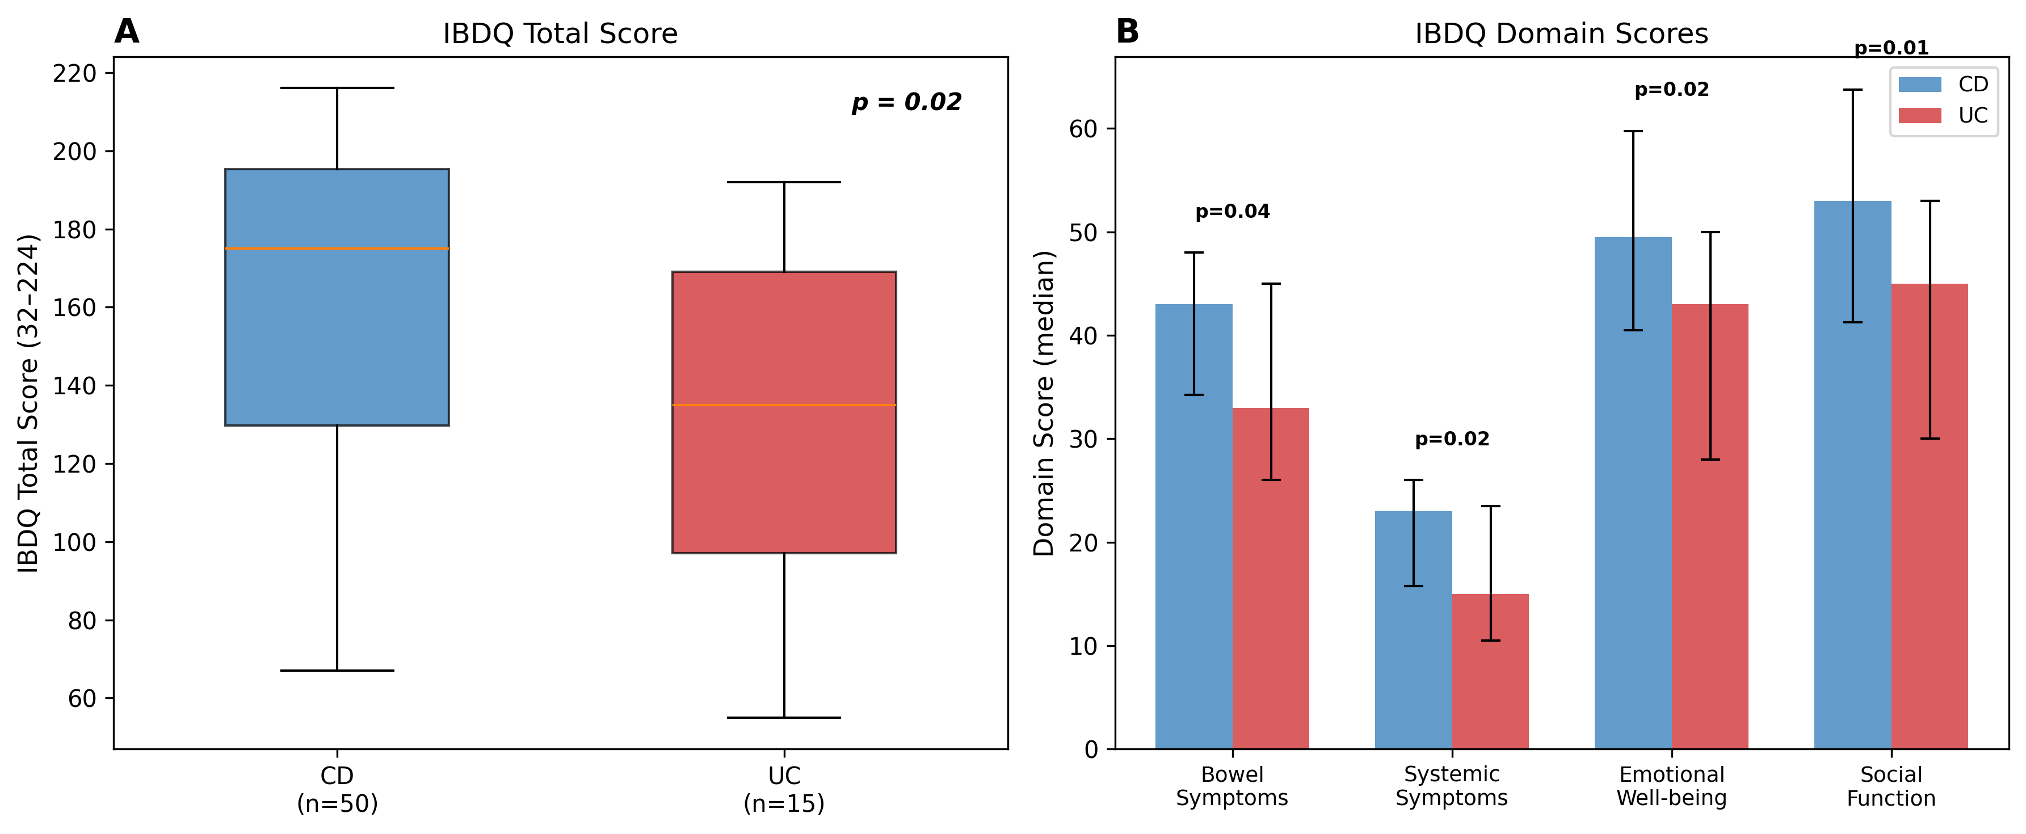
FIGURE 1 | IBDQ scores by disease type (CD vs UC). (A) Total score (p = 0.02). (B) Domain scores; all domains p < 0.05. Bars show median; error bars show IQR.

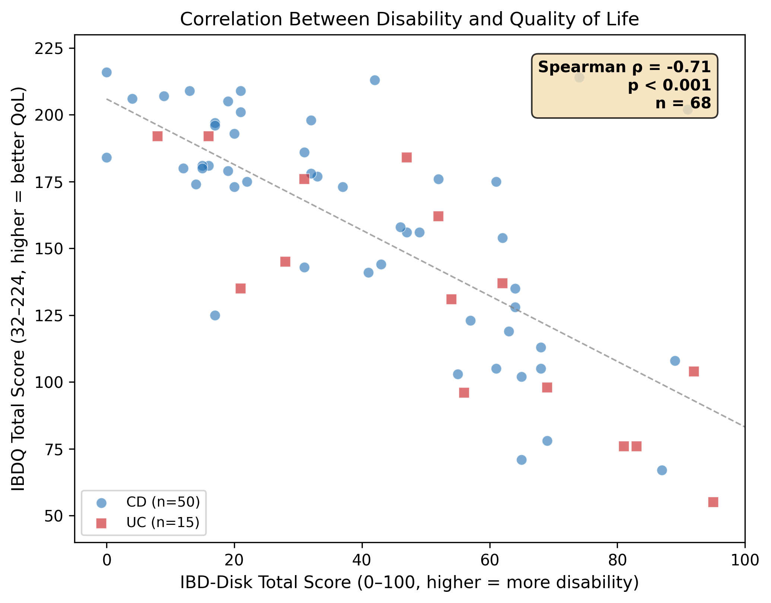
FIGURE 2 | Correlation between IBD-Disk (disability) and IBDQ (QoL). Spearman rho = -0.71, p < 0.001, n = 68. CD: blue circles; UC: red squares.

4 | Discussion
[TO DO]

4.1 | Limitations
[TO DO]

5 | Conclusion
[TO DO]

Author Contributions
[TO DO]

Acknowledgments
[TO DO]

Artificial Intelligence Statement
[TO DO]

Funding
[TO DO]

Ethics Statement
This study was approved by the Ethics Committee of HC-FMUSP (CAAE: 82679518.2.0000).

Consent
Informed consent was obtained from all participants. For patients under 18, legal guardians signed consent with adolescent assent. For patients over 18 diagnosed in childhood, consent was obtained directly.

Conflicts of Interest
The authors declare no conflicts of interest.

Data Availability Statement
All analysis code and scripts used in this study are publicly available at https://github.com/marcelosilva2604/gastro-pediatria. The underlying clinical datasets contain protected health information (patient names and hospital registration numbers) and are not publicly available in compliance with Brazilian data protection legislation (Lei Geral de Protecao de Dados, LGPD). De-identified data may be made available upon reasonable request to the corresponding author, subject to ethical review and institutional approval.

References
[TO DO]

