**Tecnologias utilizadas**Java versão 1.8

Servidor Glasfish 4.1 com Java EE 7

Padrão de arquitetura: JSF 2.2

Persistência no banco: JPA Eclipselink

Front-end: Bootstrap 3.3.6, Primefaces 6.1, Font-awesome 4.7.0

Log: log4j => local do log: /var/log/backend-test/log.out

API Rest: Jersey 2.17

Building: Maven 3.5

Banco de dados: Postgresql 10.6  
Sistema operacional: Ubuntu 18.04

**API’s Rest**

Lista todas as moedas cadastradas - Method **GET**:

[http://192.168.1.222:8080/backend-test/api/ws/coin/all](http://192.168.1.222:8080/backend-test/api/ws/coin/all" \t "/home/marcelo.silva/Documents\\x/_blank)  
  
Obtém os dados de uma moeda específica através do código (USD, EUR, ARS, GBP, BTC) - Method **GET**:  
[http://192.168.1.222:8080/backend-test/api/ws/coin/code/](http://192.168.1.222:8080/backend-test/api/ws/coin/code/USD" \t "/home/marcelo.silva/Documents\\x/_blank)**[USD](http://192.168.1.222:8080/backend-test/api/ws/coin/code/USD" \t "/home/marcelo.silva/Documents\\x/_blank)**

Lista todas as empresas cadastradas - Method **GET**:  
[http://192.168.1.222:8080/backend-test/api/ws/company/all](http://192.168.1.222:8080/backend-test/api/ws/company/all" \t "/home/marcelo.silva/Documents\\x/_blank)

Obtém dos dados de uma empresa específica através do cnpj - Method **GET** :  
[http://192.168.1.222:8080/backend-test/api/ws/company/cnpj/](http://192.168.1.222:8080/backend-test/api/ws/company/cnpj/04025700000191" \t "/home/marcelo.silva/Documents\\x/_blank)**[04025700000191](http://192.168.1.222:8080/backend-test/api/ws/company/cnpj/04025700000191" \t "/home/marcelo.silva/Documents\\x/_blank)**

Remove uma empresa específica através do cnpj - Method **DELETE**:  
[http://192.168.1.222:8080/backend-test/api/ws/company/remove/cnpj/](http://192.168.1.222:8080/backend-test/api/ws/company/remove/cnpj/04025700000191" \t "/home/marcelo.silva/Documents\\x/_blank)**[0402570000019](http://192.168.1.222:8080/backend-test/api/ws/company/remove/cnpj/04025700000191" \t "/home/marcelo.silva/Documents\\x/_blank)**[1](http://192.168.1.222:8080/backend-test/api/ws/company/remove/cnpj/04025700000191" \t "/home/marcelo.silva/Documents\\x/_blank)

Adiciona uma empresa passando o cnpj, nome, e-mail, logradouro, número, bairro, complemento, cep, cidade e código da moeda (USD, EUR, ARS, GBP, BTC) - Method **PUT**:  
[http://192.168.1.222:8080/backend-test/api/ws/company/insert/cnpj/](http://192.168.1.222:8080/backend-test/api/ws/company/insert/cnpj/55299069000150/name/TESTE/email/ /street/Rua X/number/100/neighborhood/ /complement/ /cep/13.687-320/city/ARARAQUARA/coinCode/USD" \t "/home/marcelo.silva/Documents\\x/_blank)**[55299069000150](http://192.168.1.222:8080/backend-test/api/ws/company/insert/cnpj/55299069000150/name/TESTE/email/ /street/Rua X/number/100/neighborhood/ /complement/ /cep/13.687-320/city/ARARAQUARA/coinCode/USD" \t "/home/marcelo.silva/Documents\\x/_blank)**[/name/](http://192.168.1.222:8080/backend-test/api/ws/company/insert/cnpj/55299069000150/name/TESTE/email/ /street/Rua X/number/100/neighborhood/ /complement/ /cep/13.687-320/city/ARARAQUARA/coinCode/USD" \t "/home/marcelo.silva/Documents\\x/_blank)**[TESTE](http://192.168.1.222:8080/backend-test/api/ws/company/insert/cnpj/55299069000150/name/TESTE/email/ /street/Rua X/number/100/neighborhood/ /complement/ /cep/13.687-320/city/ARARAQUARA/coinCode/USD" \t "/home/marcelo.silva/Documents\\x/_blank)**[/email/](http://192.168.1.222:8080/backend-test/api/ws/company/insert/cnpj/55299069000150/name/TESTE/email/ /street/Rua X/number/100/neighborhood/ /complement/ /cep/13.687-320/city/ARARAQUARA/coinCode/USD" \t "/home/marcelo.silva/Documents\\x/_blank)**[%20](http://192.168.1.222:8080/backend-test/api/ws/company/insert/cnpj/55299069000150/name/TESTE/email/ /street/Rua X/number/100/neighborhood/ /complement/ /cep/13.687-320/city/ARARAQUARA/coinCode/USD" \t "/home/marcelo.silva/Documents\\x/_blank)**[/street/](http://192.168.1.222:8080/backend-test/api/ws/company/insert/cnpj/55299069000150/name/TESTE/email/ /street/Rua X/number/100/neighborhood/ /complement/ /cep/13.687-320/city/ARARAQUARA/coinCode/USD" \t "/home/marcelo.silva/Documents\\x/_blank)**[Rua%20X](http://192.168.1.222:8080/backend-test/api/ws/company/insert/cnpj/55299069000150/name/TESTE/email/ /street/Rua X/number/100/neighborhood/ /complement/ /cep/13.687-320/city/ARARAQUARA/coinCode/USD" \t "/home/marcelo.silva/Documents\\x/_blank)**[/number/](http://192.168.1.222:8080/backend-test/api/ws/company/insert/cnpj/55299069000150/name/TESTE/email/ /street/Rua X/number/100/neighborhood/ /complement/ /cep/13.687-320/city/ARARAQUARA/coinCode/USD" \t "/home/marcelo.silva/Documents\\x/_blank)**[100](http://192.168.1.222:8080/backend-test/api/ws/company/insert/cnpj/55299069000150/name/TESTE/email/ /street/Rua X/number/100/neighborhood/ /complement/ /cep/13.687-320/city/ARARAQUARA/coinCode/USD" \t "/home/marcelo.silva/Documents\\x/_blank)**[/neighborhood/](http://192.168.1.222:8080/backend-test/api/ws/company/insert/cnpj/55299069000150/name/TESTE/email/ /street/Rua X/number/100/neighborhood/ /complement/ /cep/13.687-320/city/ARARAQUARA/coinCode/USD" \t "/home/marcelo.silva/Documents\\x/_blank)**[%20](http://192.168.1.222:8080/backend-test/api/ws/company/insert/cnpj/55299069000150/name/TESTE/email/ /street/Rua X/number/100/neighborhood/ /complement/ /cep/13.687-320/city/ARARAQUARA/coinCode/USD" \t "/home/marcelo.silva/Documents\\x/_blank)**[/complement/](http://192.168.1.222:8080/backend-test/api/ws/company/insert/cnpj/55299069000150/name/TESTE/email/ /street/Rua X/number/100/neighborhood/ /complement/ /cep/13.687-320/city/ARARAQUARA/coinCode/USD" \t "/home/marcelo.silva/Documents\\x/_blank)**[%20](http://192.168.1.222:8080/backend-test/api/ws/company/insert/cnpj/55299069000150/name/TESTE/email/ /street/Rua X/number/100/neighborhood/ /complement/ /cep/13.687-320/city/ARARAQUARA/coinCode/USD" \t "/home/marcelo.silva/Documents\\x/_blank)**[/cep/](http://192.168.1.222:8080/backend-test/api/ws/company/insert/cnpj/55299069000150/name/TESTE/email/ /street/Rua X/number/100/neighborhood/ /complement/ /cep/13.687-320/city/ARARAQUARA/coinCode/USD" \t "/home/marcelo.silva/Documents\\x/_blank)**[13.687-320](http://192.168.1.222:8080/backend-test/api/ws/company/insert/cnpj/55299069000150/name/TESTE/email/ /street/Rua X/number/100/neighborhood/ /complement/ /cep/13.687-320/city/ARARAQUARA/coinCode/USD" \t "/home/marcelo.silva/Documents\\x/_blank)**[/city/](http://192.168.1.222:8080/backend-test/api/ws/company/insert/cnpj/55299069000150/name/TESTE/email/ /street/Rua X/number/100/neighborhood/ /complement/ /cep/13.687-320/city/ARARAQUARA/coinCode/USD" \t "/home/marcelo.silva/Documents\\x/_blank)**[ARARAQUARA](http://192.168.1.222:8080/backend-test/api/ws/company/insert/cnpj/55299069000150/name/TESTE/email/ /street/Rua X/number/100/neighborhood/ /complement/ /cep/13.687-320/city/ARARAQUARA/coinCode/USD" \t "/home/marcelo.silva/Documents\\x/_blank)**[/coinCode/](http://192.168.1.222:8080/backend-test/api/ws/company/insert/cnpj/55299069000150/name/TESTE/email/ /street/Rua X/number/100/neighborhood/ /complement/ /cep/13.687-320/city/ARARAQUARA/coinCode/USD" \t "/home/marcelo.silva/Documents\\x/_blank)**[USD](http://192.168.1.222:8080/backend-test/api/ws/company/insert/cnpj/55299069000150/name/TESTE/email/ /street/Rua X/number/100/neighborhood/ /complement/ /cep/13.687-320/city/ARARAQUARA/coinCode/USD" \t "/home/marcelo.silva/Documents\\x/_blank)**

**Telas**

Listagem das empresas. A página é atualiza de 1 em 1 minuto.

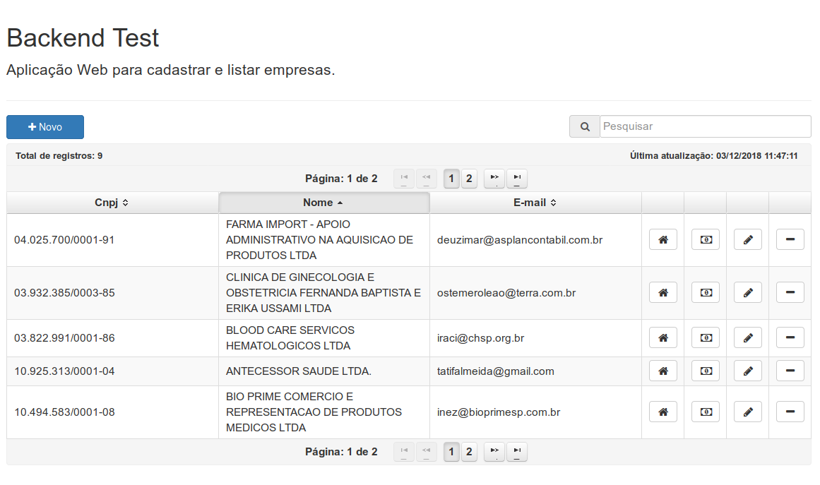  
  
Dialog para mostrar as informações do endereço:  
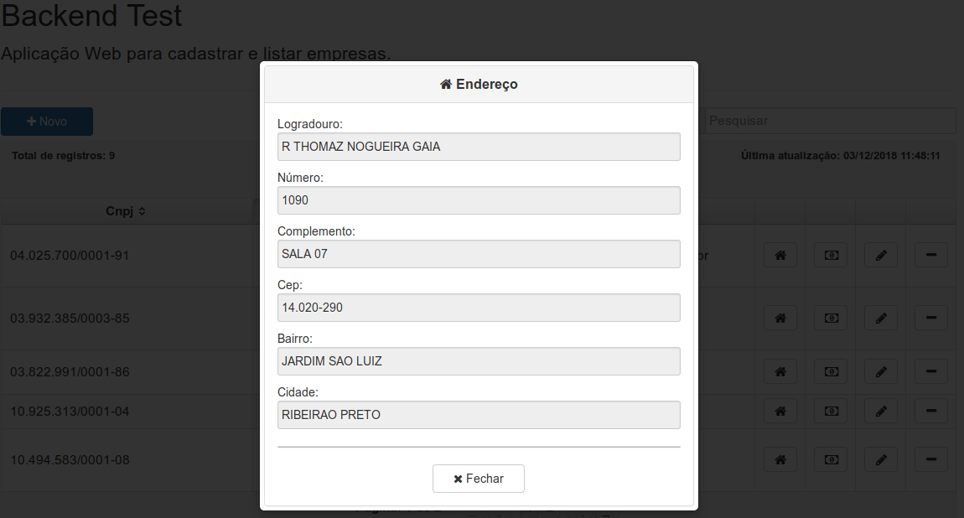

Dialog para mostrar as informações da moeda de trabalho:

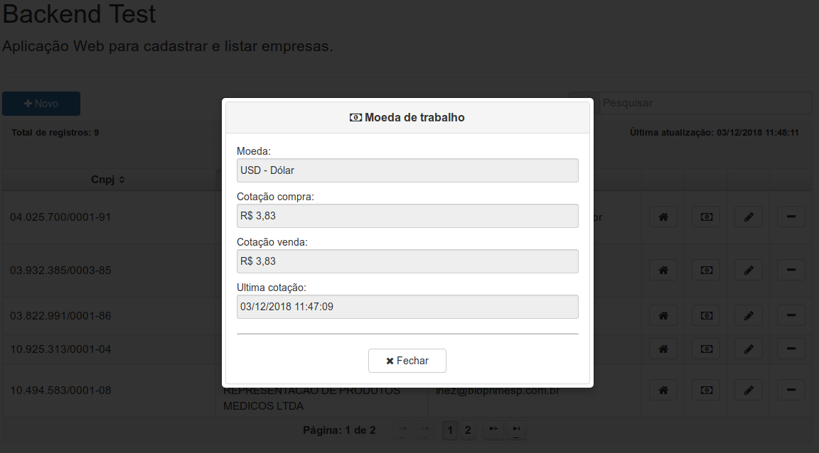

Caso a cotação esteja desatualizada a mais de 20 minutos por algum problema ao obter os dados da API é apresentado o alerta:

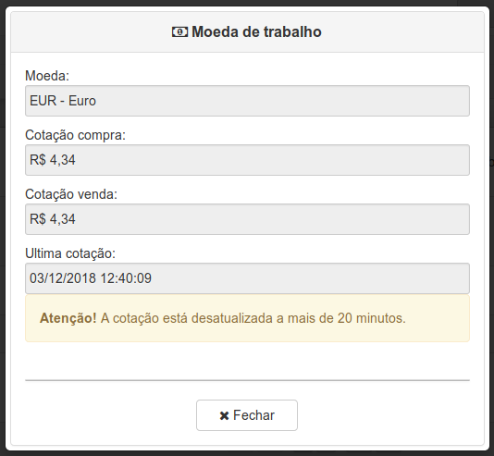

Dialog para confirmação de remoção de uma empresa:

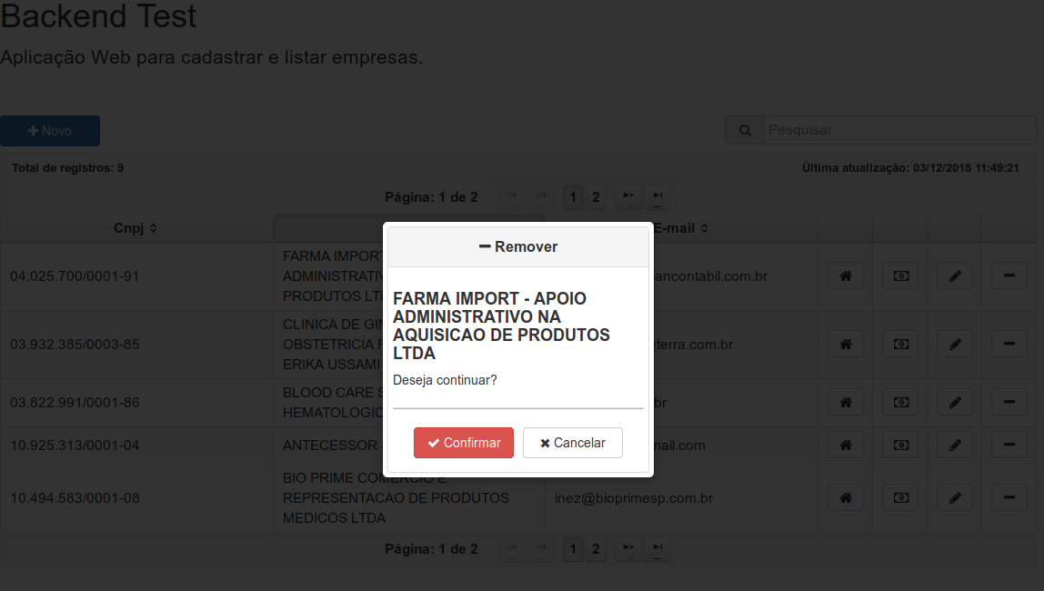

Para cadastrar uma nova empresa entrar com o CNPJ e ‘Confirmar’, o sistema verifica se já está cadastrado na base de dados, tenta obter os dados via API ou caso não encontre o usuário entra com os dados manualmente na tela de cadastro da empresa:

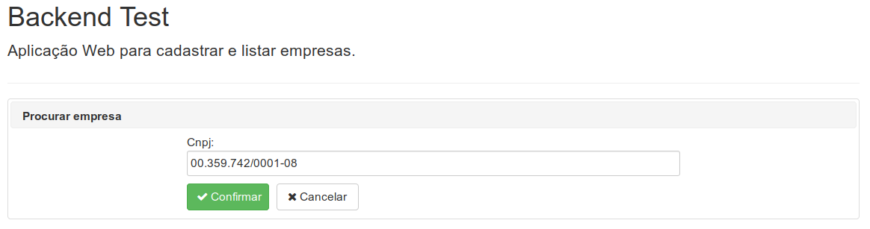

Tela de um novo cadastro ou edição da empresa:

