# Informace pro sdílení na iOS

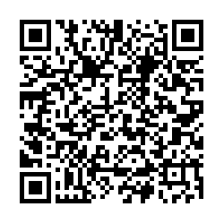

URL:

<https://itunes.apple.com/us/app/%C4%8Desk%C3%A1-kanada-%C5%BEiv%C4%9B-turistick%C3%A9-informace/id1215416600?mt=8>

HTML:

<a href="https://itunes.apple.com/us/app/%C4%8Desk%C3%A1-kanada-%C5%BEiv%C4%9B-turistick%C3%A9-informace/id1215416600?mt=8"><img height="25" src='http://resources.rozumny.cz/appstore.png' /></a>

# Informace pro sdílení na Google Play

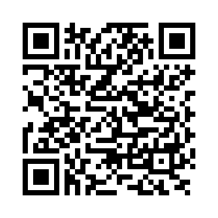

URL:

<https://play.google.com/store/apps/details?id=cz.jaros.ceskakanada>

HTML:

<a href='https://play.google.com/store/apps/details?id=cz.jaros.ceskakanada'><img height="25" src='http://resources.rozumny.cz/googleplay.png' /></a>