**Assignment 4**

CLINIC

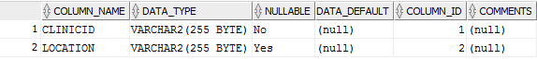

DENTIST



EMPLOYEE



PATIENT

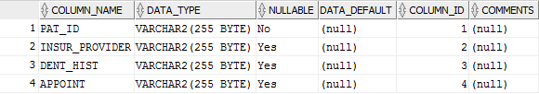

PERSON



PRODUCT

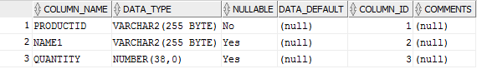

SUPPLIER

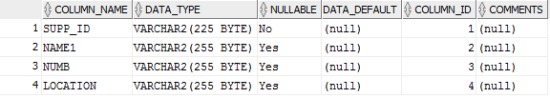

RECEPTIONIST

