Dental Clinic DBMS

CPS510_Group 3_Section 1

Assignment 4

**Team members:**

Shawn Fernandes

Marcel-Pierre Douglas Samuels

Manzor Sarahi

SELECT location FROM CLINIC;

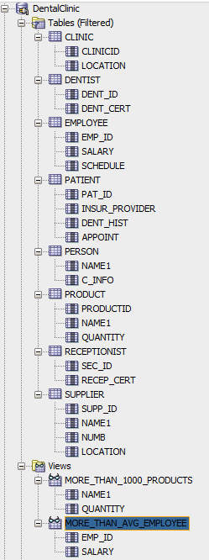

SELECT DISTINCT dent_cert FROM DENTIST;



SELECT salary FROM EMPLOYEE;

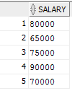

SELECT insur_provider, dent_hist, appoint FROM PATIENT

WHERE insur_provider = 'InsurancePlace';



SELECT name1 from PERSON;

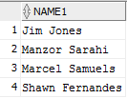

SELECT productid, name1, quantity from PRODUCT

ORDER BY quantity;

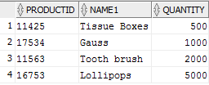

SELECT recep_cert from RECEPTIONIST;

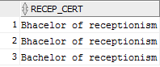

SELECT name1, location from SUPPLIER;

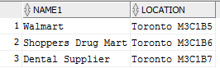

CREATE VIEW more_than_avg_employee AS

SELECT EMP_ID, SALARY

FROM EMPLOYEE

WHERE SALARY > (SELECT AVG (SALARY) FROM EMPLOYEE);



CREATE VIEW more_than_1000_products AS

SELECT NAME1, QUANTITY

FROM PRODUCT

WHERE QUANTITY>1000;

