**DENTAL CLINIC: DBMS**

CPS510_Group3_Section2

Assignment 8

Team:

Shawn Fernandes

Manzor Sarahi

Marcel-Pierre Douglas Samuels



None of the attributes are functionally dependent on the primary key so thus it is in BCNF



Employee_ID is dependent on the Dentist_ID and since Employee_ID is a candidate key for this table it is in BCNF



Person_ID is dependent on Employee_ID and since Person_ID is a candidate key for this table it is in BCNF

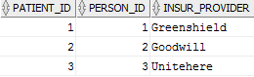

Person_ID is dependent on Patient_ID and since Person_ID is a candidate key for this table it is in BCNF

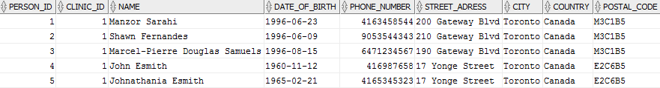

Clinic_ID is dependent on Person_ID and since Clinic_ID is a candidate key for this table it is in BCNF

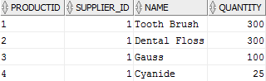

Supplier_ID and NAME are dependent on Product_ID and since Supplier_ID and NAME are candidate keys for this table it is in BCNF



Employee_ID is dependent on the Reception_ID and since Employee_ID is a candidate key for this table it is in BCNF



Company_Name is dependent on the Suppler_ID and since Company_Name is a candidate key for this table it is in BCNF

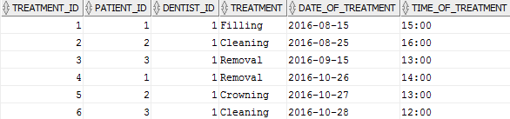

None of the attributes are functionally dependent on the primary key so thus it is in BCNF