Dental Clinic DBMS

CPS510_Group 3_Section 1

Assignment 10

**Team members:**

Shawn Fernandes

Marcel-Pierre Douglas Samuels

Manzor Sarahi

**Application Data: Dental Clinic DBMS**

A Dental Clinic database was chosen as the topic of focus for our design. The direction of this database is to organize and simplify the information of the employees, patients and supply orders. This will also allow the clinic to access the information of the patient, update patient data and schedule as well as cancel appointments. Product orders will also be implemented to enable the tracking and sending of outgoing and incoming orders to supply the clinic with dental products.

**Functions:**

CreateAppointment()

cancelAppointment()

rescheduleAppointment()

orderSupplies()

createNewPatient()

updatePatientData()

createNewEmployee()

updateEmployeeData()

Treats()

Pays()

**Operational Data:**

Person

|  |  |  |  |  |  |  |  |
| --- | --- | --- | --- | --- | --- | --- | --- |
| *Person_ID | **Name** | **Date_Of_**  **Birth** | **Phone_**  **Number** | **Street_Address** | **City** | **Postal_Code** | **Country** |

Employee

|  |  |  |  |  |
| --- | --- | --- | --- | --- |
| *Employee_ ID | **Person_ID** | **Salary** | **Date_Hired** | **Schedule** |

Receptionist

|  |  |  |
| --- | --- | --- |
| *Recpetionist_ID | **Employee_ID** | **Receptionist_Certification** |

Patient

|  |  |  |
| --- | --- | --- |
| *Patient_ID | **Person_ID** | **Insurance_Provider** |

Dentist

|  |  |  |
| --- | --- | --- |
| *Dentist_ID | **Employee_ID** | **Dental_Certification** |

Clinic

|  |  |  |  |  |
| --- | --- | --- | --- | --- |
| *Clinic_ID | **Street_Address** | **City** | **Country** | **Postal_Code** |

Treatment

|  |  |  |  |  |  |
| --- | --- | --- | --- | --- | --- |
| *Treatment  _ID | **Patient**  **_ID** | **Dentist**  **_ID** | **Treatment** | **Date_Of_Treatment** | **Time_Of_Treatment** |

Supplier

|  |  |  |  |  |  |
| --- | --- | --- | --- | --- | --- |
| *Supplier_ID | **Company_Name** | **Street_Address** | **City** | **Country** | **Postal_Code** |

Product

|  |  |  |  |
| --- | --- | --- | --- |
| *Product ID | **Supplier_ID** | **Quantity** | **Name** |

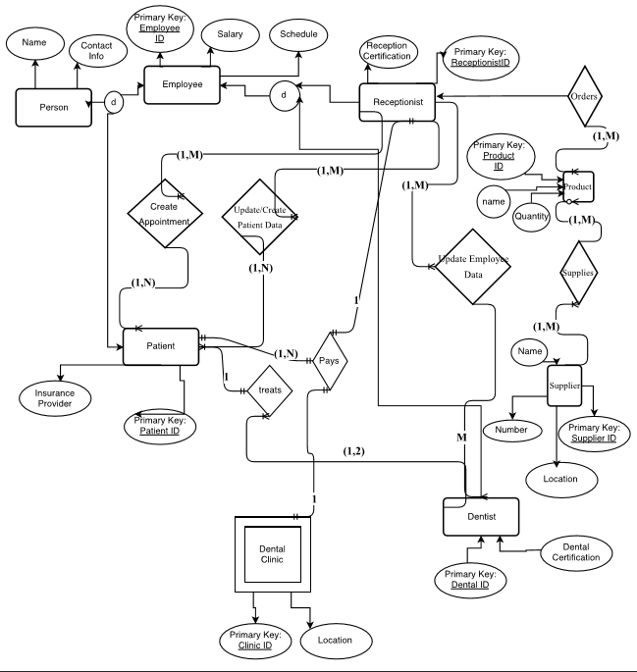

CLINIC

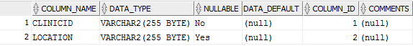

DENTIST



EMPLOYEE

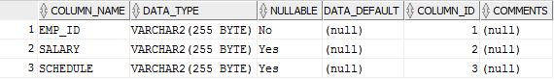

PATIENT

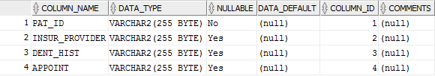

PERSON



PRODUCT

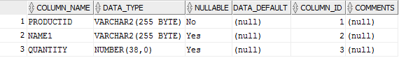

SUPPLIER

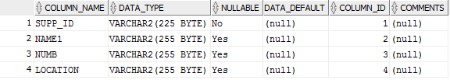

RECEPTIONIST

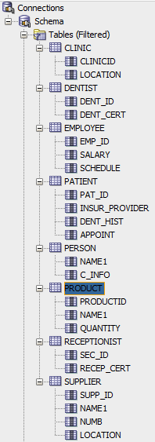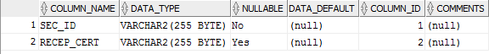

create table clinic

(

clinic_ID integer,

street_adress varchar(255),

city varchar(255),

country varchar(255),

postal_code varchar(255),

PRIMARY KEY (clinic_ID)

);

create table person

(

person_ID integer,

clinic_ID integer,

name varchar(255),

date_of_birth varchar(255),

phone_number integer,

street_adress varchar(255),

city varchar(255),

country varchar(255),

postal_code varchar(255),

PRIMARY KEY (person_ID),

FOREIGN KEY (clinic_ID) REFERENCES clinic(clinic_ID)

);

create table patient

(

patient_ID integer,

person_ID integer,

insur_provider varchar(255),

PRIMARY KEY (patient_ID),

FOREIGN KEY (person_ID) REFERENCES person(person_ID)

);

create table employee

(

employee_ID integer,

person_ID integer,

salary decimal(20,2),

date_hired varchar(255),

schedule varchar(255),

PRIMARY KEY (employee_ID),

FOREIGN KEY (person_ID) REFERENCES person(person_ID)

);

create table dentist

(

dentist_ID integer,

employee_ID integer,

dental_certification varchar(255),

PRIMARY KEY (dentist_ID),

FOREIGN KEY (employee_ID) REFERENCES employee(employee_ID)

);

create table receptionist

(

receptionist_ID integer,

employee_ID integer,

receptionist_certification varchar(255),

PRIMARY KEY (receptionist_ID),

FOREIGN KEY (employee_ID) REFERENCES employee(employee_ID)

);

create table treatment

(

treatment_ID integer,

patient_ID integer,

dentist_ID integer,

treatment varchar(255),

date_of_treatment varchar(255),

time_of_treatment varchar(255),

PRIMARY KEY (treatment_ID),

FOREIGN KEY (patient_ID) REFERENCES patient(patient_ID),

FOREIGN KEY (dentist_ID) REFERENCES dentist(dentist_ID)

);

create table supplier

(

supplier_ID integer,

clinic_ID integer,

company_name varchar(255),

street_adress varchar(255),

city varchar(255),

country varchar(255),

postal_code varchar(255),

PRIMARY KEY (supplier_ID),

FOREIGN KEY (clinic_ID) REFERENCES clinic(clinic_ID)

);

create table product

(

productID varchar(255),

supplier_ID integer,

name varchar(255),

quantity INTEGER,

PRIMARY KEY (productID),

FOREIGN KEY (supplier_ID) REFERENCES supplier(supplier_ID)

);

SELECT location FROM CLINIC;

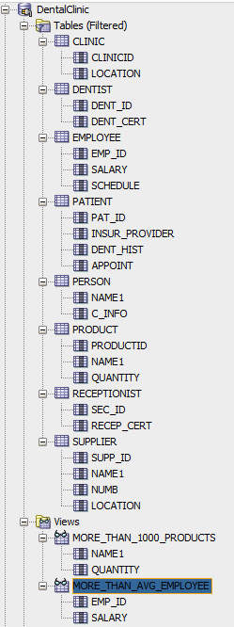

SELECT DISTINCT dent_cert FROM DENTIST;



SELECT salary FROM EMPLOYEE;

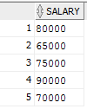

SELECT insur_provider, dent_hist, appoint FROM PATIENT

WHERE insur_provider = 'InsurancePlace';



SELECT name1 from PERSON;

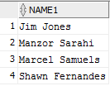

SELECT productid, name1, quantity from PRODUCT

ORDER BY quantity;

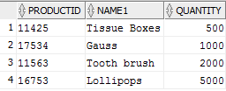

SELECT recep_cert from RECEPTIONIST;

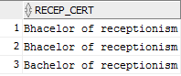

SELECT name1, location from SUPPLIER;

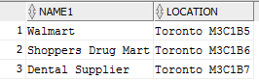

CREATE VIEW more_than_avg_employee AS

SELECT EMP_ID, SALARY

FROM EMPLOYEE

WHERE SALARY > (SELECT AVG (SALARY) FROM EMPLOYEE);



CREATE VIEW more_than_1000_products AS

SELECT NAME1, QUANTITY

FROM PRODUCT

WHERE QUANTITY>1000;



/*Select all patients in the clinic*/

select person.name

from person, patient, clinic

where person.clinic_id = clinic.clinic_id

and patient.person_id = person.person_id;

/*Select future appoinment/treatments*/

select person.name, treatment.treatment, treatment.date_of_treatment

from person, patient, treatment

where treatment.PATIENT_ID = patient.PATIENT_ID

AND patient.PERSON_ID = person.PERSON_ID

AND treatment.DATE_OF_TREATMENT > '2016-10-24';

/*Select name of dentist working on upcoming treatments*/

select person.name, treatment.treatment, treatment.date_of_treatment

from person, employee, dentist, treatment

where treatment.DATE_OF_TREATMENT > '2016-10-24'

AND treatment.dentist_id = dentist.dentist_id

AND dentist.employee_ID = employee.employee_ID

AND employee.person_ID = person.person_id;

/*Select salaries over 65000*/

SELECT person.name, employee.salary

FROM person, employee

WHERE salary > 65000

AND employee.person_id = person.person_id;

/*Select everyone that has had a cleaning*/

select person.name, treatment.date_of_treatment

from person, patient, treatment

where treatment.PATIENT_ID = patient.PATIENT_ID

AND patient.PERSON_ID = person.PERSON_ID

AND treatment.treatment = 'Cleaning'

AND treatment.DATE_OF_TREATMENT < '2016-10-24';

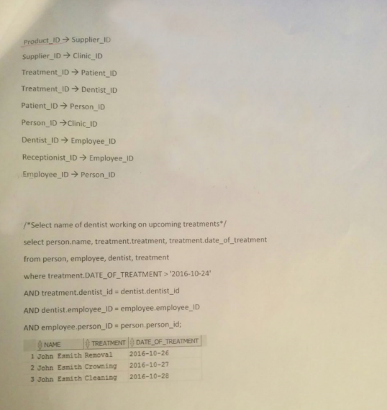

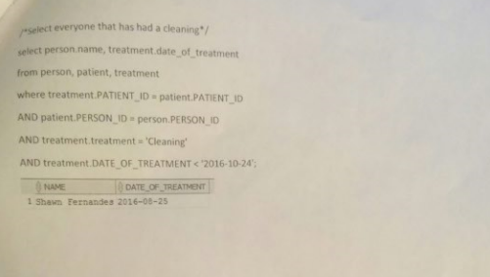



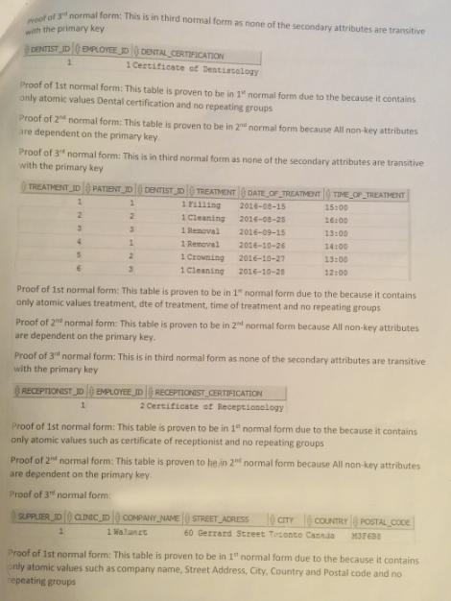





None of the attributes are functionally dependent on the primary key so thus it is in BCNF



Employee_ID is dependent on the Dentist_ID and since Employee_ID is a candidate key for this table it is in BCNF



Person_ID is dependent on Employee_ID and since Person_ID is a candidate key for this table it is in BCNF

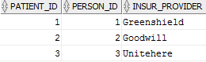

Person_ID is dependent on Patient_ID and since Person_ID is a candidate key for this table it is in BCNF

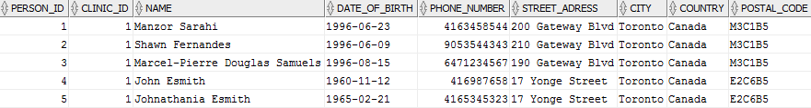

Clinic_ID is dependent on Person_ID and since Clinic_ID is a candidate key for this table it is in BCNF

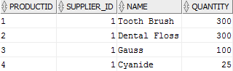

Supplier_ID and NAME are dependent on Product_ID and since Supplier_ID and NAME are candidate keys for this table it is in BCNF



Employee_ID is dependent on the Reception_ID and since Employee_ID is a candidate key for this table it is in BCNF



Company_Name is dependent on the Suppler_ID and since Company_Name is a candidate key for this table it is in BCNF

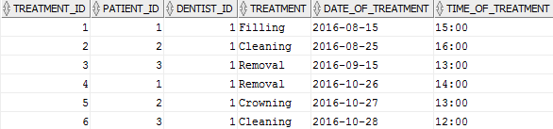

None of the attributes are functionally dependent on the primary key so thus it is in BCNF

SELECT location FROM CLINIC; σsubject = “location”^(CLINIC)

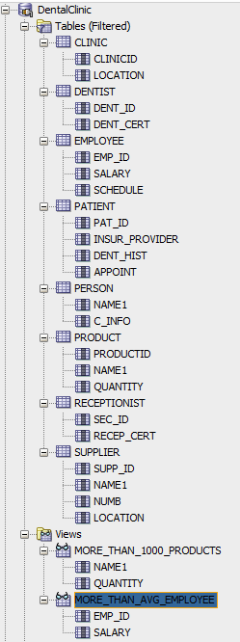

SELECT DISTINCT dent_cert FROM DENTIST;

σsubject = “dent_cert”^(DENTIST)



SELECT salary FROM EMPLOYEE;

σsubject = “salary”^(EMPLOYEE)

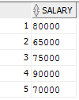

SELECT insur_provider, dent_hist, appoint FROM PATIENT

WHERE insur_provider = 'InsurancePlace';

σsubject = “insur_provider” = “InsurancePlace” and “dent_hist” and “appoint”^(PATIENT)



SELECT name1 from PERSON;

σsubject = “name1”^(PERSON)

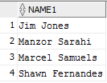

SELECT productid, name1, quantity from PRODUCT

ORDER BY quantity;

σsubject = “productid” and “name1” and “quantity”^(PRODUCT)

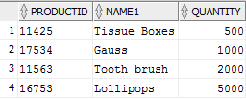

SELECT recep_cert from RECEPTIONIST;

σsubject = “recep_cert”^(RECEPTIONIST)

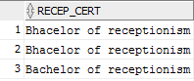

SELECT name1, location from SUPPLIER;

σsubject = “name1” and “location” ^(SUPPLIER)

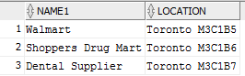

CREATE VIEW more_than_avg_employee AS

SELECT EMP_ID, SALARY

FROM EMPLOYEE

WHERE SALARY > (SELECT AVG (SALARY) FROM EMPLOYEE);

σsubject = “emp_id” and “salary” > AVG(“salary”)^(EMPLOYEE)



CREATE VIEW more_than_1000_products AS

SELECT NAME1, QUANTITY

FROM PRODUCT

WHERE QUANTITY>1000;

σsubject = “name1” and “quantity” > 1000 ^(PRODUCT)

