**Project Proposal: A quantitative evaluation of Optical vs. SAR-based Wave Kinematic Bathymetry (WKB) for deriving ocean depth in the surf-zone**

by Marcel Rodriguez-Riccelli

**Motivation**

Since the earliest record of coastal human settlement on the African coast over 100,000 years ago, the coastal zone has been a cradle for human development, to the extent that adapting to coastal environments are theorized to have influenced human evolutionary traits. [1] Coasts provide for civilization in several ways---as an abundant source of food and energy resources and as a gateway for travel, commerce, exploration, and recreation. The coastal zone is inhabited by 40% of the global population, and is host to many of the world’s megacities and much of our critical infrastructure. [2] The majority of natural disasters occur either as a direct cause of marine processes, by meteorological events that occur over the ocean, or by geological events that happen at plate boundaries located at continental edges and mid-ocean ridge. [3] Settlements and ecosystems in the coastal zone are particularly exposed to the damaging effects of natural disasters, which are becoming increasingly exacerbated by warming global climates, and so there is a growing need for informed solutions that can mitigate their impact. [4] The goal of coastal science is to characterize and predict coastal processes in order to inform civil engineering projects and other applied use cases. [5]

Coastal science is often referred to as being data-poor — the coastal zone is a highly dynamic environment where turbulent marine processes and unstable morphology make sampling environmental parameters difficult. [5] [6] Scientific research vessels (R/Vs) that deploy scientific instrumentation for quantifying marine phenomena are unable to operate in the turbulent and shallow depths of the surf-zone. Traditionally in-situ point sensors have been the method of choice for measuring nearshore phenomena, but are limited in several ways:

* High cost associated with equipment, maintenance, and deployment. [5]
* Highly localized, small area of coverage. [5]
* Nearshore phenomena are highly inhomogeneous in the along-shore direction, and would require a large array of sensors to sample at resolution needed for adequate characterization. [6]
* Rapid erosion and accretion in the nearshore can dislodge or cover up moored instruments. [6]
* Large tidal sea-level changes can put in-situ sensors out of range for gathering meaningful data. [6]

In recent years, advances in computing and remote sensing technology have enabled the usefulness of satellite based remote sensing in monitoring and measuring coastal processes. [5] [6] Satellite based remote sensing offers a promising alternative to overcoming the challenges with measuring coastal phenomena:

* Data available at little to no cost to the user. [5]
* Provides global coverage. [5]
* Able to simultaneously sample a wide spatial array of points. [6]
* Removed from damaging and destabilizing hydrodynamic and morphological processes. [6]

Bathymetry is the variable that currently limits numerical modeling of nearshore phenomena. [6] Currently, less than ~15% of the ocean floor, representing ~70% of the area of Earth’s crust, has been mapped at a spatial resolution of under 5 kilometers. [7] Hydrodynamic processes in the nearshore such as currents and wave dissipation are highly subject to even small changes in bathymetric morphology, and so models predicting nearshore dynamics improve markedly when accurate and detailed bathymetric data is provided. [8] While both active and passive satellite remote sensors are unable to penetrate the surface of the ocean in all but the most shallow and non-turbid areas, characteristics of the seafloor can be derived from images of surface phenomena by retrieval algorithms. [2]

**Problem Statement**

There are several frameworks for resolving ocean depth using remotely sensed imagery, one of the most prominent being Wave Kinematics Bathymetry (WKB). WKB can be applied to both optical and Synthetic Aperture RADAR (SAR) imagery to derive ocean depth from the observed behavior of wave dissipation as they shoal in break in the surf-zone. SAR is a form of active microwave remote sensing used to obtain high-resolution imagery of the Earth’s surface. SAR is of particular interest to this application for its ability to overcome certain limitations associated with passive optical imagery—especially effects of turbidity on radiation transmission, and the lack of ability to sense the surface in adverse weather and low-light conditions. [2] [9] However, optical imagery is available at higher resolutions, and enables a more streamlined and intuitive approach to performing WKB inversion. [2] [9]

Our goal is to select four diverse coastal areas with existing high-resolution bathymetric maps gathered by multibeam echosounder for ground-truthing, derive bathymetry by WKB for both optical and SAR based imagery from those areas, then compute the Root Mean Square Error (RMSE) of both maps against the ground-truth maps to analyze the strengths and weaknesses of each method.

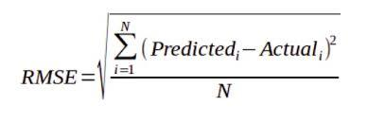

Our hypothesis is based on studies that have evaluated the effectiveness of WKB applied to both types of imagery. WKB performed on SAR imagery will be better suited to the highly energetic and turbid coasts of high latitude areas, while WKB performed on optical imagery will be better suited to the low-energy clear waters of low-latitude areas. [2] [9]

**Datasets / Area Selection**

Studies that have successfully applied WKB to derive bathymetry from satellite imagery have centered around data from each of the Sentinel Earth observation missions conducted by the European Space Agency’s (ESA) Copernicus Programme. [2] [9] [10] The Sentinel-1 constellation of satellites deploy SAR instruments operating solely in the C-Band, while the Sentinel-2 constellation of satellites carry Multispectral Imager (MSI) instruments, that measure reflectance in 13 bands in the visible, near-infrared, and short-wave infrared portions of the electromagnetic spectrum. [11] [12] We will similarly use datasets from the Sentinel-1 and Sentinel-2 missions to compare the abilities of WKB when applied to both SAR and optical imagery from each mission respectively. For our ground-truth data, we will be using bathymetric digital elevation models (DEMs) derived from multibeam echosounding (MBES), a type of active-sonar sensing that is the traditional method of obtaining high-resolution maps of the ocean floor.

The National Centers for Environmental Information (NCEI) operated by the National Oceanic and Atmospheric Administration (NOAA) maintains a large database of coastal DEMS, generated from data gathered by various MBES missions, that are freely available to the public. Our areas of interest then must satisfy the criteria of having been covered by Sentinel-1, Sentinel-2, and one of the missions included in the NCEI database. A Python script will be written that, for a given location, queries the Sentinel-1, Sentinel-2, and NCEI databases, to return a summary table for coverage of a given area, in order to ensure a selected area meets the requirements of being included in each database, within a timespan short enough to be usable for comparing bathymetry considering the effects of erosion and accretion. There must also be a minimal cloud coverage image from Sentinel-2 within the acceptable time window. The selected Sentinel-1 and 2 imagery must meet the minimum requirements for performing WKB, outlined in the following Anticipated Analysis Methods section. Finally, selected areas should represent a diverse range of environmental conditions considering those environmental parameters that influence the effectiveness of bathymetry derivation from both optical and SAR-based imagery using WKB.

The following figures are from a test exercise to successfully load Sentinel 1, Sentinel 2, and NCEI datasets for the same area via Python script: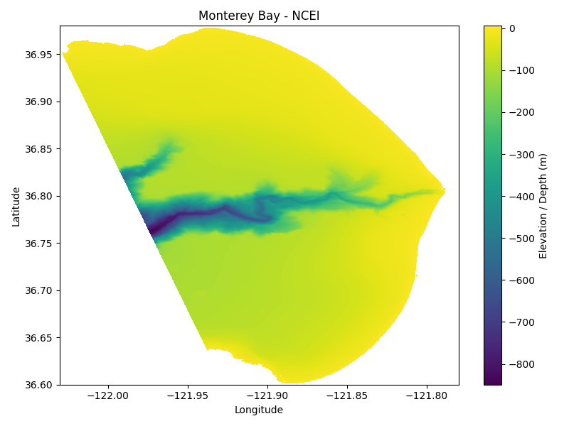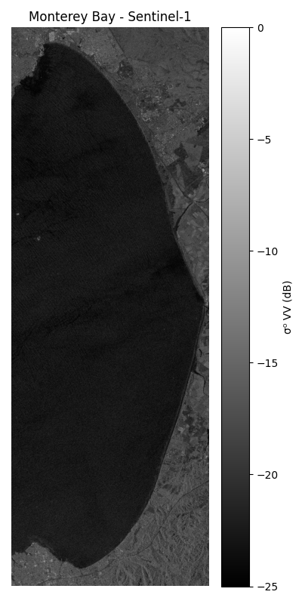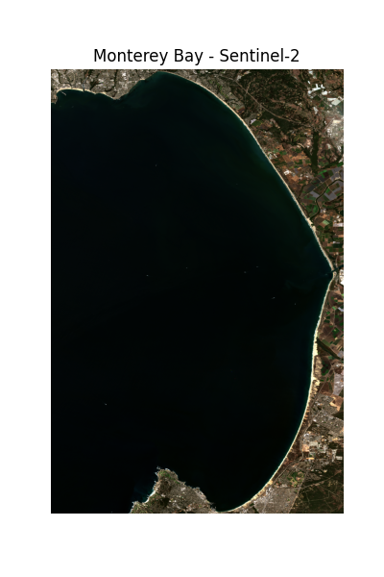

**Anticipated Analysis Methods**

SAR is able to sense backscatter from actively transmitted microwave packets that reflect off of the surface of the water given the presence of Bragg Waves. [2] [9] A certain amount of ocean surface roughness caused by wind-induced capillary waves must be present to induce a phenomenon known as Bragg Scattering, that causes the surface of the water to constructively reflect enough radiation to be detectable by SAR. [2] [9] Bragg Scattering is a resonance condition, meaning that the wavelength of the capillary waves needed to induce Bragg Scattering is a function of the wavelength of the SAR by the following formula:

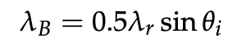[9]

Additionally, the ability for SAR to be able to detect swell patterns of traveling waves relies on a variety of other modulation mechanisms. [9] In short, due to the orbital motion of ocean waves, points that move toward the satellite in the along-track direction produce a phase shift in the radar return that is recognizable by the SAR, causing the crests of waves to have higher intensity values than the troughs. [9] Based on this phenomenon, another threshold for minimum wavelength to achieve bathymetric inversion by WKB is given by the following equation:

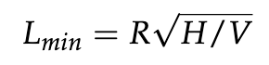[9]

where R is the slant range of the observed wave, V is the SAR platform velocity, and H is the significant wave height. [9] Short wavelength ocean waves dissipate at shallow depths, so for the WKB method to be effective for deriving bathymetry for shallow coastal environments, Lmin must be as low as possible. [9]

A two-dimensional Fast Fourier Transform (FFT) is then performed to give a 2D image spectrum that is analyzed for sharp peaks. [9] Then, the wavelength (λ) may be estimated from the inverse of the distance separating the two peaks, while the wave direction (θ) is estimated from the orientation of the line connecting the two peaks:

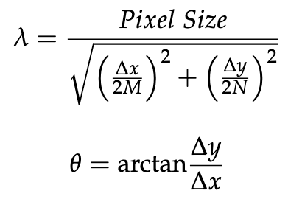[9]

where N is the number of rows of pixels, M is the number of columns (for a square pixel N = M), ∆x is the number of columns between the two identified sharp peaks, and ∆y is the respective difference in the number of rows. [9]

Waves break as depths equal one-half wave height, so linear dispersion can be used to calculate the bathymetry, which describes the swell-wave propagation. The shallow water depth (h) can be retrieved given wavelength (λ) and peak wave period (Tp):

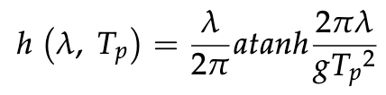[9]

The application of optical imagery for WKB is dependent on sunlight reflected from the sea surface, known as sun glitter. [10] The visibility of waves to Satellite-based optical imagers are dependent on several factors, such as atmospheric conditions, the angle of the satellite in relation to waves, and height, period, and direction of travel. [10] Time-lag between bands is used to estimate the direction of traveling swell waves. [10] In a method described by Bergsma et. al, a Radon transform is applied to the satellite imagery to accentuate linear features by integrating image intensity (𝐼(𝑥,𝑦)) along lines defined by angle 𝜃 and offset 𝜌. [10] Then, a discrete fourier transform (DFT) is used to obtain the phase per band. At each x, y location the spectral phase-shift (∆Φ in rad) is calculated between multiple detector bands at different times (t). [10] Similarly to the SAR-method, since the wave number (k) is kept fixed, a shift in spectral phase-shift represents ω(t) and the celerity can be calculated, and the derived wave celerity c and wave number k (or wavelength λ) depth found solving:

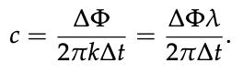

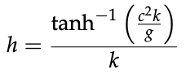[10]

**Works Cited**

[1] M. Will, A. W. Kandel, K. Kyriacou, and N. J. Conard, “An evolutionary perspective on coastal adaptations by modern humans during the Middle Stone Age of Africa,” *Quaternary International*, vol. 404, pp. 68–86, June 2016, doi: [10.1016/j.quaint.2015.10.021](https://doi.org/10.1016/j.quaint.2015.10.021).

[2] M. Reithmeier, I. Laut, M. Gawehn, C. Kleih, J. Schneider von Deimling, and K. Hartmann, “Improving global coastal bathymetry from waves – Introducing scalable processing and post-processing workflows for 100 m resolution grids,” *Int. Hydrogr. Rev.*, vol. 30, no. 2, pp. [online], Apr. 2025. DOI: 10.58440/ihr-30-2-a18.

[3] W. Kron, “Coasts: the high-risk areas of the world,” *Nat Hazards*, vol. 66, no. 3, pp. 1363–1382, Apr. 2013, doi: [10.1007/s11069-012-0215-4](https://doi.org/10.1007/s11069-012-0215-4).

[4] B. Neumann, A. T. Vafeidis, J. Zimmermann, and R. J. Nicholls, “Future Coastal Population Growth and Exposure to Sea-Level Rise and Coastal Flooding - A Global Assessment,” PLOS ONE, vol. 10, no. 3, p. e0118571, Mar. 2015, doi: 10.1371/journal.pone.0118571.

[5] S. Vitousek, D. Buscombe, K. Vos, P. L. Barnard, A. C. Ritchie, and J. A. Warrick, “The future of coastal monitoring through satellite remote sensing,” *Cambridge Prisms: Coastal Futures*, vol. 1, 2023, Art. no. e10, doi: 10.1017/cft.2022.4.

[1]

[6] R. Holman and M. C. Haller, “Remote Sensing of the Nearshore,” Annu. Rev. Mar. Sci., vol. 5, no. 1, pp. 95–113, Jan. 2013, doi: [10.1146/annurev-marine-121211-172408](https://doi.org/10.1146/annurev-marine-121211-172408).

[7] J. Baumann, “The Race to Make a High-Resolution Map of the World’s Oceans,” *ArcUser*, Esri, Feb. 6, 2019. [Online]. Available:<https://www.esri.com/about/newsroom/arcuser/xprize>.

[8] B. G. Ruessink, J. R. Miles, F. Feddersen, R. T. Guza, and S. Elgar, “Modeling the alongshore current on barred beaches,” J. Geophys. Res., vol. 106, no. C10, pp. 22,451-22,463, 2001.

[9] S. D. Mudiyanselage, B. Wilkinson, and A. Abd-Elrahman, “Automated High-Resolution Bathymetry from Sentinel-1 SAR Images in Deeper Nearshore Coastal Waters in Eastern Florida,” *Remote Sensing*, vol. 16, no. 1, p. 1, Jan. 2024, doi: [10.3390/rs16010001](https://doi.org/10.3390/rs16010001).

[10] E. W. J. Bergsma, R. Almar, and P. Maisongrande, “Radon-Augmented Sentinel-2 Satellite Imagery to Derive Wave-Patterns and Regional Bathymetry,” *Remote Sensing*, vol. 11, no. 16, p. 1918, Jan. 2019, doi: [10.3390/rs11161918](https://doi.org/10.3390/rs11161918).

[11] N. Earth Science Data Systems, “Sentinel-1 C-band Synthetic Aperture Radar | NASA Earthdata.” Accessed: Oct. 19, 2025. [Online]. Available:<https://www.earthdata.nasa.gov/data/instruments/sentinel-1-c-sar>

[12] N. Earth Science Data Systems, “Sentinel-2 Multispectral Imager | NASA Earthdata.” Accessed: Oct. 19, 2025. [Online]. Available:<https://www.earthdata.nasa.gov/data/instruments/sentinel-2-msi>

[13] “Bathymetric Data Viewer.” Accessed: Oct. 19, 2025. [Online]. Available:<https://www.ncei.noaa.gov/maps/bathymetry/>