13)

a) methA = 12

methB = 25

methC = 4

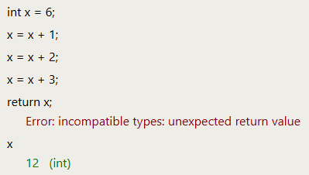

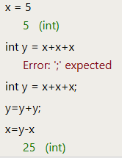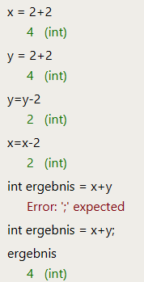

|  |  |  |  |  |  |
| --- | --- | --- | --- | --- | --- |
| Zeile | Deklaration | Zuweisung? | Ausdruck? | Fehler? | Ausgabe |
| Bsp b; | x |  |  |  |  |
| b = new Bsp(); |  | x |  |  |  |
| Int a:a; |  |  |  | x |  |
| Int b; |  |  |  | x |  |
| Int c = b.methB(2); | x | x |  |  |  |
| methA(c); |  | x |  |  |  |
| Bsp d = new Bsp(); | x | x |  |  |  |
| Int e = d.methC(c,c); | x | x |  |  |  |
| e |  |  |  |  | x |
| d.methA(c) = 42; |  | x |  |  |  |
| d.methA(c); |  |  | x |  |  |
| d.methA(c) |  |  |  |  | x |
| c+c |  |  |  |  | x |
| c+c; |  |  | x |  |  |
| d+d |  |  |  |  | x |
| c+d; |  |  | x |  |  |
| d.methC(c,c) + c |  |  |  |  | x |

15.)

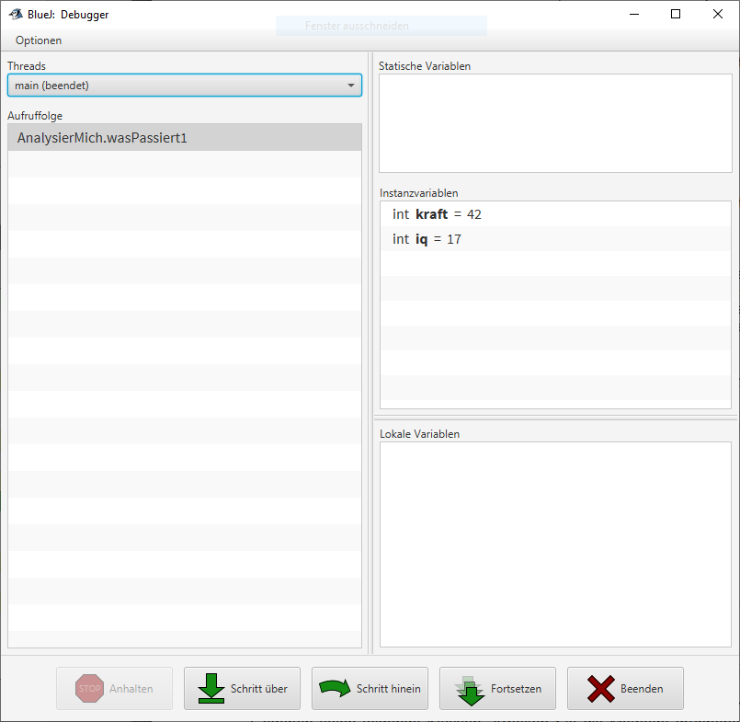

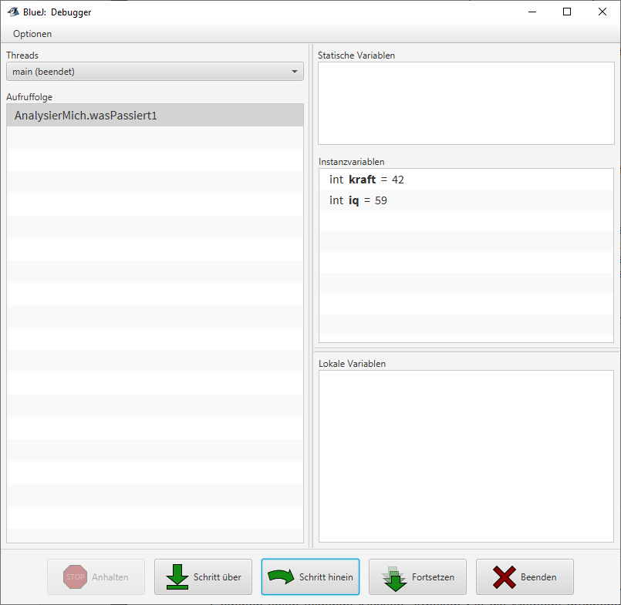

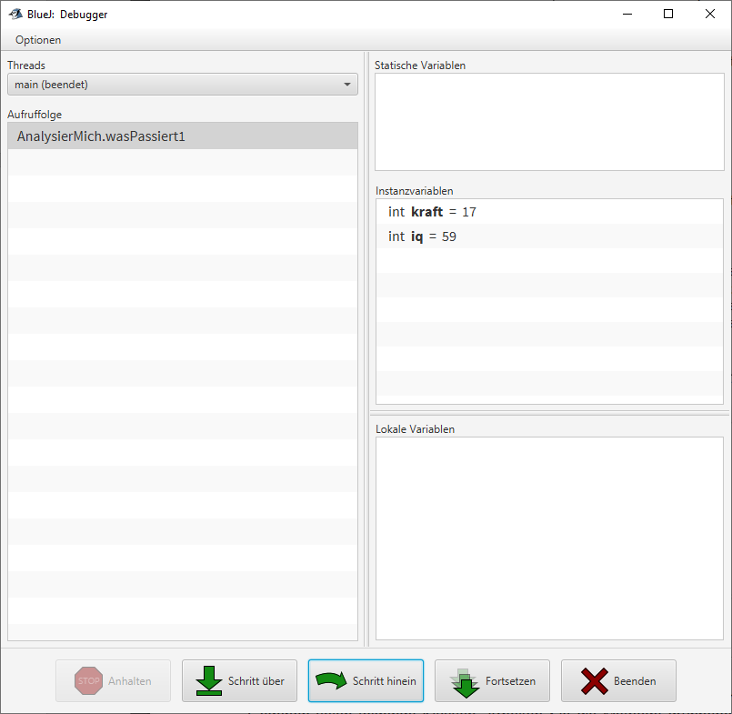

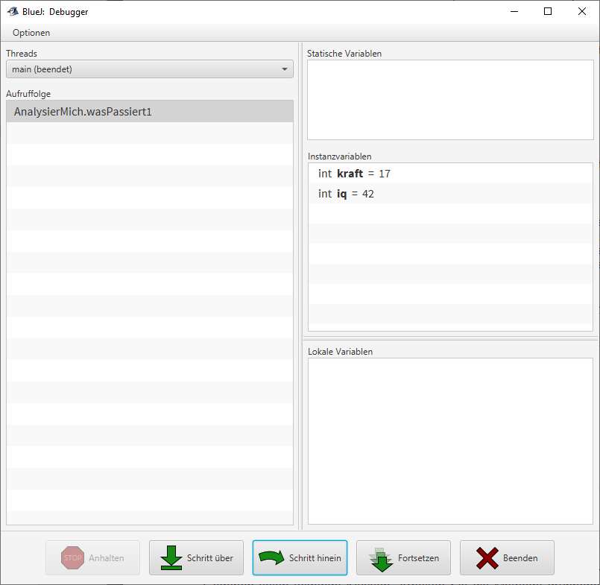

Methode 2