A Neutral First Finite Completion of the Balance Field Framework
  - A proposed source law, exact tangent reduction, and conditional successor
Marcel Theodor Wende
BalanceFeld Gleichung (BFG) · Independent Researcher
E-mail: marcel-wende@gmx.net | ORCID: 0009-0007-4028-2208
Preprint · 30 September 2026 · proposed mathematical extension
Abstract
The Balance-Field Framework (BFG) places neutral admissibility before or alongside formed distinctions, but its existing Level-0 formation functional and its exact neutral completion do not identify a unique channel between them. We state a neutral-capacity source rule in a finite-dimensional formed-branch tangent sector. The rule identifies the mixed source–neutral Hessian with the already named neutral-capacity operator and gives the completed neutral cost the formed-branch Hessian metric. These are new constitutive identifications, expressed in BFG quantities, rather than consequences of the earlier formation equation. They uniquely determine the tangent channel, its Gram load, and the exact neutral resolvent. A general Schur-complement characterization proves that both identifications are necessary for this particular completion. Scalar countermodels establish non-uniqueness under the older data; a two-dimensional example retains a noncommuting neutral load. Three separately declared finite successor rules give a conditional, rank-aware self-map with exact terminal gates. This paper neither asserts a derivation of its new source rule from the older Level-0 text nor identifies a natural physical mediator or proves universal irreducible emergence.
Keywords: Balance-Field Framework; Level 0; neutral admissibility; Hessian; Schur complement; resolvent; finite reclosure.
Claim status: new source law proposed; algebraic consequences proved conditionally; natural realization open.

1 Source order and mathematical scope
The earlier constructive BFG formulation describes primitive units, admissibility, signed transitions, recurrence, and identity retention [1]. A neutral appearance proposal places an appearance-supporting neutral condition before admissible distinction, schematically $N_{pre}→ΔN_{0}→\left(+,−\right)$ [2]. This is a precedence claim. It does not, by itself, specify a differentiable cross-energy or a normalization in the later finite Hilbert carrier. In particular, the precursor $N_{pre}$ and the finite operator $ℵ_{0}$ have different mathematical types; a map between them must be specified rather than inferred from their names.
The later BFG source [3] declares the triple $\left(D_{0},c_{0},ℵ_{0}\right)$ and a formation equation in its Section 3.1, then a quadratic neutral completion with a supplied channel $A$ in Section 3.2. This paper completes a selected finite tangent sector by an explicit rule connecting these stages. Its logical direction is
$$N_{pre}→ΔN_{0}→\left(D_{0},c_{0},ℵ_{0};F_{0}\right)→\left(A,Y,C_{N},B_{N}\right)→Ξ_{+}.$$ (1)
The three later arrows denote representation, a new tangent rule, and finite successor rules respectively. They are specifications, not theorems from the preceding noun alone. Every theorem below records its premises. Established matrix analysis supplies the spectral and positivity methods used here [8,9]; these references do not independently verify the proposed BFG source law.

2 The formed Level-0 metric
Let $V_{0}$ be a nonzero finite-dimensional real Hilbert space. For this extension, assume the operator representatives $D_{0},c_{0},ℵ_{0}$ are self-adjoint in its fixed inner product; the examples below use positive semidefinite capacities. Put
$$K_{0}=c_{0}+ℵ_{0}−D_{0}, F_{0}\left(δ\right)=\frac{1}{2}⟨δ,K_{0}δ⟩+\frac{1}{4}∥δ∥^{4}.$$ (2)
Assume the least eigenvalue $λ_{0}<0$ of $K_{0}$ is simple, with unit eigenvector $e_{0}$ and a positive gap above it. Lemma 2.1 (Formation and tangent metric). The two global minima are $δ_{±}=±\sqrt{−λ_{0}}e_{0}$. At either minimum,
$$H_{*}=D^{2}F_{0}\left(δ_{±}\right)=K_{0}−λ_{0}I−2λ_{0}e_{0}e_{0}^{​*}>0.$$ (3)
Proof. For $r=∥δ∥$, the Rayleigh bound gives $F_{0}\left(δ\right)≥λ_{0}r^{2}/2+r^{4}/4$, with equality for $δ$ in the ground eigenspace. The radial minimum has $r^{2}=−λ_{0}$. Differentiating yields $D^{2}F_{0}\left(δ\right)=K_{0}+∥δ∥^{2}I+2δδ^{​*}$. On $e_{0}$ the eigenvalue of (3) is $−2λ_{0}>0$; on each orthogonal eigenmode $e_{j}$ it is $λ_{j}−λ_{0}>0$. $▫$
Equation (3) supplies a canonical local metric from the declared formation rule. The finite-displacement energy retains third- and fourth-order terms; its exact global value is not replaced by its Hessian.

3 A source law with two explicit identifications
Write $D∈V_{0}$ for a formed-branch tangent source and $η∈V_{0}$ for a formal copy used as a neutral tangent. The same-carrier-copy restriction is a domain choice. An independently measured neutral carrier requires a separate correspondence map. Proposed source rule 3.1 (L0–NC: neutral-capacity tangent rule). In this finite same-carrier tangent sector: (NC1) the mixed source–neutral Hessian in original $V_{0}$ coordinates equals $−ℵ_{0}$; (NC2) the intrinsic neutral metric after completion of the source square equals the formed metric $H_{*}$. There is no independently fitted scalar in either identification.
These statements fix the exact quadratic tangent functional
$$\boxed{J_{NC}\left(D,η\right)=\frac{1}{2}∥D−H_{*}^{−1}ℵ_{0}η∥_{H_{*}}^{2}+\frac{1}{2}∥η∥_{H_{*}}^{2}, ∥x∥_{H_{*}}^{2}=⟨x,H_{*}x⟩.}$$ (4)
The rule uses the existing neutral capacity as a specified representation of neutral-first difference production. This is scientifically substantive: the older source calls $ℵ_{0}$ a neutral admissibility role but does not identify it as this mixed derivative [3]. Thus “BFG-only” here means no external physical law or fitted channel is inserted; it does not mean that the historical text already proved Axiom 3.1.

3.1 Why exactly two identifications are required
Consider any symmetric quadratic joint tangent energy with source Hessian $H_{*}$:
$$J\left(D,η\right)=1/2⟨D,H_{*}D⟩−⟨D,Bη⟩+1/2⟨η,Qη⟩, M:=Q−B^{​*}H_{*}^{−1}B>0.$$ (5)
Here $B$ is the mixed coupling, $Q$ the raw neutral Hessian, and $M$ its Schur complement. This standard block-matrix device is documented in the matrix literature [10,8]. Completion of the square gives, identically,
$$J\left(D,η\right)=1/2∥D−H_{*}^{−1}Bη∥_{H_{*}}^{2}+1/2∥η∥_{M}^{2}.$$ (6)
For $d=H_{*}^{1/2}D$ and $ν=M^{1/2}η$, the old BFG quadratic form is $\frac{1}{2}∥d−A^{​*}ν∥^{2}+\frac{1}{2}∥ν∥^{2}$ with
$$A^{​*}=H_{*}^{−1/2}BM^{−1/2}, Y=A^{​*}A=H_{*}^{−1/2}BM^{−1}B^{​*}H_{*}^{−1/2}.$$ (7)
L0–NC is the particular choice
$$B=ℵ_{0}, M=H_{*}, Q=H_{*}+ℵ_{0}H_{*}^{−1}ℵ_{0}.$$ (8)
Conversely, equality of the full joint Hessians in (5) and (4) forces both equalities $B=ℵ_{0}$ and $M=H_{*}$. This is an if-and-only-if characterization, not a derivation of (8) from (2).

4 Exact neutral resolution
Theorem 4.1 (Unique tangent channel and response). Under the formed-branch assumptions and L0–NC, set
$$d=H_{*}^{1/2}D, ν=H_{*}^{1/2}η, A=A^{​*}=H_{*}^{−1/2}ℵ_{0}H_{*}^{−1/2}, Y=A^{2}≽0.$$ (9)
The block Hessian of $J_{NC}$ is strictly positive. The minimizer is unique and obeys
$$η_{*}={\left(H_{*}+ℵ_{0}H_{*}^{−1}ℵ_{0}\right)}^{−1}ℵ_{0}D,$$ (10)
$$\min_{η}J_{NC}\left(D,η\right)=\frac{1}{2}⟨D,H_{*}^{1/2}{\left(I+Y\right)}^{−1}H_{*}^{1/2}D⟩.$$ (11)
The retained and complementary responses $C_{N}={\left(I+Y\right)}^{−1}$ and $B_{N}=Y{\left(I+Y\right)}^{−1}$ satisfy $C_{N}+B_{N}=I$, $0<C_{N}≤I$ and $0≤B_{N}<I$. All statements are covariant under orthogonal changes of the declared carrier coordinates.
Proof. Expansion of (4) yields the block Hessian
$$\left(\begin{matrix}H_{*} & −ℵ_{0} \\ −ℵ_{0} & H_{*}+ℵ_{0}H_{*}^{−1}ℵ_{0}\end{matrix}\right).$$ (12)
Its Schur complement relative to $H_{*}>0$ is $H_{*}>0$, so the block is strictly positive. The neutral stationarity equation is $\left(H_{*}+ℵ_{0}H_{*}^{−1}ℵ_{0}\right)η=ℵ_{0}D$, proving (10). Whitening gives $J_{NC}=\frac{1}{2}∥d−Aν∥^{2}+\frac{1}{2}∥ν∥^{2}$. Its unique stationary point is ${\left(I+A^{2}\right)}^{−1}Ad$; substitution or the resolvent identity proves (11). The response inequalities follow from spectral calculus for $Y≽0$. Functional calculus also commutes with orthogonal conjugation. $▫$
There is no assertion that an arbitrary channel $A$ of the older BFG Section 3.2 equals (9). The new source rule restricts that older model class to a selected sector.

5 Countermodels and a nontrivial example
Proposition 5.1 (The old source does not select L0–NC). The formation data (2), even together with the general quadratic completion of BFG Section 3.2, do not uniquely determine $A$ or $M$.
Proof. Take $V_{0}=R$, $K_{0}=−1$, $c_{0}=0$, $ℵ_{0}=2$, $D_{0}=3$. Then $δ_{*}=1$ and $H_{*}=2$. With the same complete formation data, choose $M=2$ and a neutral map $L=1$ or $L=2$ in $J_{L}\left(D,η\right)=\frac{1}{2}∥D−Lη∥_{H_{*}}^{2}+\frac{1}{2}∥η∥_{M}^{2}$. Their reduced energies are respectively $D^{2}/2$ and $D^{2}/5$. Both have a positive joint Hessian and the general old neutral-completion form after whitening. L0–NC chooses $L=H_{*}^{−1}ℵ_{0}=1$ by its new mixed-Hessian clause. Even fixing $L=1$ does not fix the response without NC2: $M=4$ gives $2D^{2}/3$. $▫$
The exact parent displacement energy in this scalar example is
$$F_{0}\left(1+z\right)−F_{0}\left(1\right)=z^{2}+z^{3}+1/4z^{4}.$$ (13)
Thus (11) is an exact quadratic tangent-sector identity, not an equality with the global quartic parent for finite displacement.
For a matrix example with genuine cross-mode neutral geometry, take
$$K_{0}=\left(\begin{matrix}−1 & 0 \\ 0 & 2\end{matrix}\right), ℵ_{0}=\left(\begin{matrix}1 & 1/4 \\ 1/4 & 1\end{matrix}\right), c_{0}=\left(\begin{matrix}0 & 0 \\ 0 & 3\end{matrix}\right), D_{0}=\left(\begin{matrix}2 & 1/4 \\ 1/4 & 2\end{matrix}\right).$$ (14)
These capacities are positive semidefinite and satisfy (2). At $δ_{*}=e_{1}$, $H_{*}=diag\left(2,3\right)$ and
$$A=\left(\begin{matrix}\frac{1}{2} & \frac{1}{4\sqrt{6}} \\ \frac{1}{4\sqrt{6}} & \frac{1}{3}\end{matrix}\right), 0<A<I, Y_{12}=\frac{5}{24\sqrt{6}}, {\left[K_{0},Y\right]}_{12}=−\frac{5}{8\sqrt{6}}≠0.$$ (15)
The source law consequently need not erase neutral structure or force $Y$ to commute with formation. Noncommutation permits, but does not guarantee on every persistent support, the strict finite novelty analyzed in [5]. Figure 1 displays only analytic scalar evaluations of (11); no measurements or synthetic validation are inferred from that surface.
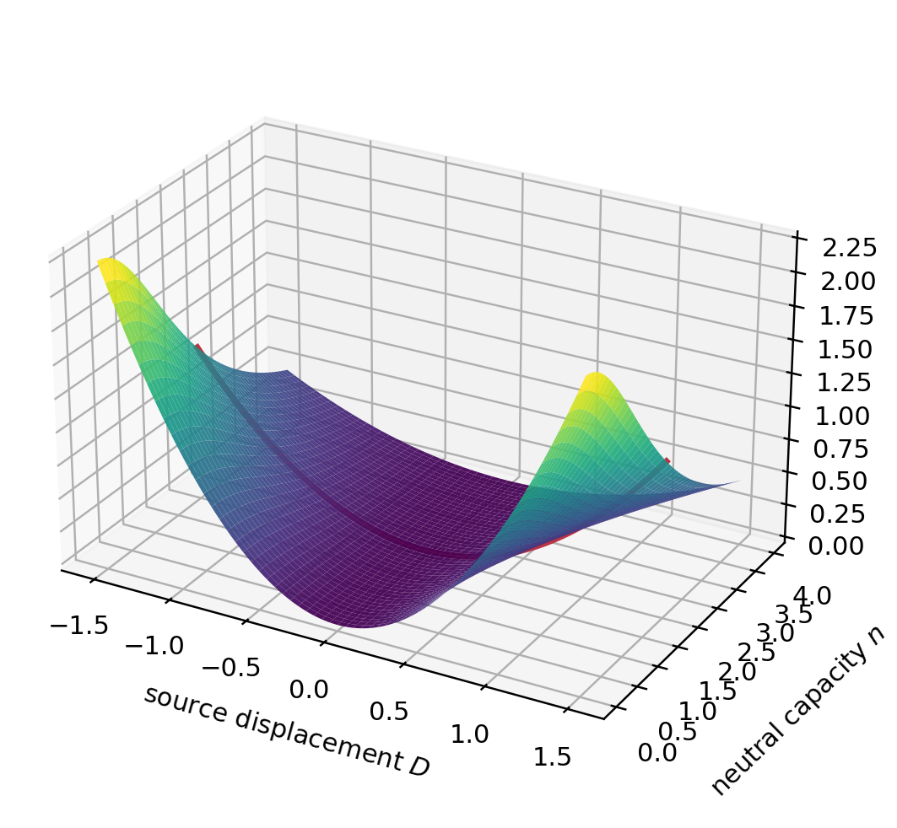
Figure 1. Analytic reduced tangent energy E(D,n)=D²/[1+(n/2)²] for H*=2 and neutral capacity n. The marked n=2 slice is the scalar example in Proposition 5.1. The surface shows dependence on n; it does not select n from the earlier Level-0 formation rule.

6 Declared finite successor and a conditional closure theorem
The source rule supplies an initial neutral channel on its domain. To iterate a finite BFG state, three additional already declared role identifications remain necessary [4,6]. We collect them as a proposed coherent contract, rather than pretend they follow from (2). Definition 6.1 (Finite reclosure contract). Let a finite typed state $Ξ$ carry Hermitian capacities, a nonzero positive formation density, a unit-trace positive witness density, a positive neutral load, and a power-bounded recursion. At each source step, apply the exact existing admission and persistence gates. On a nonterminal step let $A:H→K$ be the specified cross-fed analysis map, $S={\left(kerA\right)}^{⊥}$, $T=RanA$, and $A=J\left|A\right|$ its reduced polar decomposition. Declare:
$$\text{(G) }Y_{+}=J\left(A^{​*}A\right)J^{​*}=\left(AA^{​*}\right)|_{T}.$$ (16)
$$\text{(S) }Z=\left(I−Y\right){\left(I+Y\right)}^{−1}, P_{sel}=1_{\left(0,∞\right)}\left(Z\right)=1_{[0,1)}\left(Y\right).$$ (17)
$$\text{(R) }R_{+}=P_{+}+Q_{+}{\left(I+Y_{+}\right)}^{−1}Q_{+}, Q_{+}=I−P_{+}.$$ (18)
Here $P_{+}$ is the nonzero orthogonal target persistence projector assembled from the selected inherited support and, when required, the exact formation seed. Failure of an exact gate returns an absorbing terminal state. Selection precedes target reclosure; the response is computed before transverse output projection. The target transport, witness-survival mass, and seed are the independently specified finite BFG rules of [4,6].
The law (G) is stronger than positivity, (S) adopts neutral contrast as the sign of gain, and (R) chooses one contraction among several admissible ones. Each is visible as a declared rule. The equality $P_{sel}=1_{[0,1)}\left(Y\right)$ follows from the scalar sign of $\left(1−y\right)/\left(1+y\right)$, including the strict exclusion of $y=1$.
Theorem 6.2 (Conditional finite successor). Suppose all input types and exact gates in the finite reclosure contract hold, $r=rankA>0$, the transferred witness mass is positive, and the target formation density has positive trace. Then the nonterminal target is uniquely defined up to simultaneous orthogonal/unitary active frames. It has $dimT=r≤dimH$, $Y_{+}>0$ on $T$, positive normalized witness, nonzero positive formation density, Hermitian transported capacities, and power-bounded $R_{+}$ with peripheral space exactly $RanP_{+}$. Every finite iterate is consequently either typed or terminal.
Proof. On $T$, the reduced singular values of $A$ are strictly positive; hence (G) is positive definite and frame-independent. Positive congruence transports the two densities; division by the strictly positive witness survival mass gives unit trace. The positive seed, if required and admitted by its simple-ground gate, is supported orthogonally to inherited formation. The stated formation gate preserves nonzero trace. Hermitian capacity transport preserves the adjoint type. Since $Y_{+}>0$ on finite-dimensional $T$, $C_{+}={\left(I+Y_{+}\right)}^{−1}$ satisfies $0<C_{+}≤qI$ for $q={\left(1+λ_{min}\left(Y_{+}\right)\right)}^{−1}<1$. Relative to $RanP_{+}⊕RanQ_{+}$, (R) has blocks $I$ and $Q_{+}C_{+}Q_{+}|_{RanQ_{+}}$, the latter of norm at most $q$. Thus $R_{+}$ is power bounded and its only unit-modulus eigenspace is $RanP_{+}$. Rank and frame claims follow from the standard polar factorization [11,8]. Reapplying the same gates and rules gives the finite-iterate claim by induction; no nonterminality at every step is asserted. $▫$
This theorem consolidates the finite source audit [6]; it does not reconstruct every factor role from Level 0. Positivity and covariance alone would also admit $Y_{+}′=Y_{+}+Y_{+}^{2}$; stability would admit $R_{+}′=P_{+}+Q_{+}C_{+}^{2}Q_{+}$. The contract selects (16) and (18) explicitly.
If the data used to construct an isolated persistent spectral subspace are perturbed, the gap conditions become essential to a stability analysis. Standard spectral perturbation results describe that separate sensitivity question [12,9]; the finite self-map theorem above establishes type preservation for the specified exact data and does not supply a uniform noise bound.

7 Interpretation, tests, and unresolved implications
The neutral-first statement explains why BFG treats neutral admissibility as a condition for distinction. Axiom 3.1 is the new quantitative representation of that idea on a formed-branch tangent copy. Theorems 4.1 and 6.2 establish conditional finite mathematics, not a causal identification of a physical neutral object. An empirically adequate realization needs a prespecified map from measured neutral states to $η$, measurements of the mixed Hessian and both metrics, selective removal and restoration, and comparison with a matched-memory direct model [7].
The source rule also has a sharp mathematical falsifier within its declared domain: if the measured or independently derived mixed Hessian is not $−ℵ_{0}$, or if the neutral Schur metric differs from $H_{*}$, the L0–NC specialization fails while the more general quadratic form (5) may remain valid. A vanishing $ℵ_{0}$ gives $A=Y=0$ and no active neutral successor; the finite rank gate then terminates instead of inventing a channel.

8 Conclusion
We have fixed a coherent finite BFG extension using existing BFG objects and a neutral-first interpretation. Two newly stated source identifications determine the tangent channel and make its Gram and resolvent exact. Three separately declared successor rules yield a typed finite self-map under explicit gates. The historical Level-0 formation equation alone does not imply any of these choices; the scalar countermodel proves this limitation for the neutral channel. A complete account of natural universal emergence, continuum dynamics, or a unique physical intermediary requires additional evidence beyond this finite mathematical completion.

References
- M. T. Wende and T. W. Loker, A Constructive Level-0 Foundation of the Balance-Field Framework (BFG): A Pre-Mathematical Balance Substrate for Emergent Order, Information, Process Time and Physics, 11 March 2026. Author manuscript, https://www.academia.edu/167365210/.
- M. T. Wende, The Neutral Appearance Substrate of the Balance-Field Framework: A Level-Minus-One Continuation of the Constructive Level-0 BFG, 2026. Author description on https://independent.academia.edu/MarcelWende; full manuscript was not accessible for this version.
- M. T. Wende, BFG Strong Universal Reclosure Whitepaper, 8 September 2026, Sections 3.1–3.2, https://github.com/marceltheodorwende-ops/BalanceFieldResearch/blob/main/papers/BFG_Strong_Universal_Reclosure_Whitepaper_2026-09-08.pdf.
- M. T. Wende, BFG Canonical Universal Reclosure Architecture Preprint, 22 September 2026, https://github.com/marceltheodorwende-ops/BalanceFieldResearch/tree/main/papers/canonical-2026-09-22.
- M. T. Wende, BFG Canonical Reclosure and Structural Novelty Preprint, 22 September 2026, same repository and directory as [4].
- BFG Unified Finite Neutral Spine and Explicit Proof-Chain Audit, 26–29 September 2026, https://github.com/marceltheodorwende-ops/BalanceFieldResearch/tree/main/research/completion-boundary-2026-09-29.
- M. T. Wende, BFG Universal Reclosure and Emergence Preprint, 29 September 2026, https://github.com/marceltheodorwende-ops/BalanceFieldResearch/tree/main/papers/universal-reclosure-emergence-2026-09-29.
- R. A. Horn and C. R. Johnson, Matrix Analysis, 2nd ed., Cambridge University Press, 2012, https://www.cambridge.org/highereducation/books/matrix-analysis/FDA3627DC2B9F5C3DF2FD8C3CC136B48.
- T. Kato, Perturbation Theory for Linear Operators, Springer, 1966, https://doi.org/10.1007/978-3-662-12678-3.
- E. V. Haynsworth, “Determination of the inertia of a partitioned Hermitian matrix,” Linear Algebra and Its Applications 1 (1968), 73–81, https://doi.org/10.1016/0024-3795(68)90050-5.
- N. J. Higham, “Computing the polar decomposition—with applications,” SIAM Journal on Scientific and Statistical Computing 7 (1986), 1160–1174, https://doi.org/10.1137/0907079.
- C. Davis and W. M. Kahan, “The rotation of eigenvectors by a perturbation. III,” SIAM Journal on Numerical Analysis 7 (1970), 1–46, https://doi.org/10.1137/0707001.
Declarations. Theoretical proposal; no natural-system experiment. Draft prepared with AI assistance. Author review is required before public attribution or adoption of the rules.

