PREPRINT

Universal Emergent Closure in the BalanceFeld Gleichung (BFG)
A Pure-BFG Closure Grammar for Formation, Recursive Persistence, and Irreducible Emergence
Marcel Theodor Wende
BalanceFeld Gleichung (BFG) · Independent Researcher
E-mail: marcel-wende@gmx.net · ORCID: 0009-0007-4028-2208
27 September 2026
Terminology note. In this preprint, BFG means BalanceFeld Gleichung. Legacy source titles using “Balance-Field Framework” are retained verbatim in the bibliography only for accurate provenance.
Scientific status. This is a theoretical preprint and BFG-internal derivation. It does not claim empirical confirmation of BFG as fundamental physics, biology, or consciousness science.

Abstract
This preprint consolidates the BalanceFeld Gleichung (BFG) as a theoretical closure grammar for formation, recursive persistence, and hierarchical emergence. The formulation separates differentiation, coherence, and neutral coupling admissibility; requires persistence to be bounded and non-vanishing; and defines stronger irreducibility relative to a specified null-model class and decision rule. Synthetic constructions demonstrate mathematical realizability. A structure-preserving circular-shift null retains source values and circular autocorrelation yet still satisfies the current toy higher-closure endpoint in 83.6% of runs, exposing limited endpoint specificity. The manuscript therefore reports this limitation as a result and does not claim complete endogenous formation dynamics, strong BFG irreducibility, or empirical universal validation.
Keywords: BalanceFeld Gleichung; BFG; universal closure; neutral admissibility; recursive persistence; emergence; irreducibility; reclosure; no external generator; falsifiability.

Contents
1. Purpose, scope, and naming convention
2. Source provenance and epistemic discipline
3. Pure-BFG vocabulary
4. Formation from neutral admissibility
5. Neutral mediation
6. Stable profile configuration and export
7. Recursive closure and identity continuity
8. Universal reclosure without transport
9. Irreducibility and emergence
10. Regime classification and failure modes
11. Consolidated Universal BFG Closure
12. Generator dependency audit
13. Numerical demonstrations
14. Falsification and Confirmatory-Test Architecture
15. Relationship to earlier BFG mathematics
16. Limitations and proof obligations
17. Conclusion
Appendix A. Symbol register
Appendix B. Simulation reproducibility
Appendix C. Source-credit register
Declarations
Supplementary material. This release is accompanied by the executable numerical script, frozen stdout results log, and machine-readable environment/provenance JSON named in Appendix B.14.
References

List of Figures
Figure 1. Pure-BFG generative spine.
Figure 2. Synthetic three-dimensional admissibility surface.
Figure 3. Synthetic bounded-reclosure surface.
Figure 4. Synthetic three-dimensional emergence witness.
Figure 5. Adversarial classification examples.
Figure 6. Frozen-run fixed-point numerical errors.
Figure 7. Regulated-export stress test.
Figure 8. Non-vanishing persistence toy construction.
Figure 9. Independent neutral-admissibility operational example.
Figure 10. Structure-preserving circular-shift null comparison.
Figure 11. Aligned versus circular-shift relational witness.

List of Tables
Table 1. Generator dependency audit.
Table 2. Consolidated Pure-BFG symbol register.
Table 3. Numerical consistency tests of the mathematical representation layer and explicit toy consequences.
Table 4. Direct tests and sensitivity checks for the strengthened criteria.

1. Purpose, Scope, and Naming Convention
The objective is one consolidated BFG closure grammar rather than another sequence of versions. BFG is explicitly named BalanceFeld Gleichung throughout this preprint. The paper distinguishes a generator-level classification grammar from dynamical model completions: the grammar specifies necessary and sufficient BFG conditions for formation, persistence, and hierarchical emergence, whereas a carrier-specific evolution law must additionally show how trajectories enter those admissible sets. Accordingly, the present work does not claim a complete dynamical derivation of natural structure from A0 alone.
General mathematics remains legitimate in two later roles: representation and testing. Thus an operator, spectral radius, fixed-point theorem, norm, projector, or decomposition may witness a BFG property in Layer II without being the origin of that property in Layer I.

2. Source Provenance and Epistemic Discipline
The internal bibliography is intentionally minimal. Only three BFG sources are retained: the integrated Pure-BFG monograph as principal internal provenance for the closure grammar [1], the co-authored constructive Level-0 foundation for pre-polar admissibility [2], and the co-authored Recursive Conjugate Closure Extension for the historical Layer-II persistence representation [3]. Other BFG manuscripts are treated as background archive rather than cited for density.
External literature is used as scientific lineage, constraint, and comparison—not as proof of BFG. Independent precedents include Shannon’s operational information theory [4], Turing’s spontaneous pattern formation [5], Simon’s hierarchy analysis [6], Anderson’s higher-level organization argument [7], autopoiesis [8], closure of constraints [9], causal emergence [10], synergetic self-organization [11], nonequilibrium self-organization [12], driven dissipative self-assembly [13], collective multicellular organization [14], contractive fixed points [15], operator perturbation theory [16], and feedback/regulation [17,18].
Four claim classes are separated. Definitions introduce BFG-native roles. Internal propositions are consequences conditional on those roles. Representation correspondences connect Layer I to operator or dynamical mathematics. Empirical hypotheses concern concrete carriers. A theorem about a representation does not establish that nature realizes the representation.

2.1 Independent Scientific Correspondence
The correspondence claimed here is structural and limited. Montévil and Mossio characterize biological organization as closure of mutually dependent constraints while explicitly retaining thermodynamic openness [9]. Varela, Maturana, and Uribe provide an earlier process-closure lineage through autopoiesis [8]. These are independent comparison frameworks, not derivations or confirmations of BFG.
For emergence, Simon analyzes hierarchical complexity and near-decomposability [6], Anderson argues that higher organizational levels can require new conceptual structure [7], and Hoel, Albantakis, and Tononi provide a distinct quantitative framework in which macro-level causal descriptions can exceed micro-level descriptions under their effective-information measure [10]. These sources support the scientific legitimacy of comparing organized levels; they do not establish the BFG irreducibility criterion.
For formation and persistence, Turing demonstrates spontaneous differentiated pattern formation in coupled reaction–diffusion dynamics [5]. Haken and Nicolis–Prigogine provide independent traditions of self-organization [11,12], England discusses driven dissipative self-assembly [13], and Friedl and Gilmour review collective cell migration with supracellular polarization, force generation, decision making, and tissue organization [14]. These are carrier-level precedents for organized collective behavior rather than validation of a universal BFG law.
Layer-II mathematics is anchored separately. Contractive fixed-point convergence is standard mathematics [15], operator perturbation theory is standard [16], and feedback/regulation have independent cybernetic lineages [17,18]. Numerical confirmations of these properties in this preprint therefore cannot count as evidence for BFG-specific ontology.

3. Pure-BFG Vocabulary
The minimal vocabulary is deliberately small. A0 denotes neutral admissibility: the pre-objectual possibility that difference can be held. δ denotes a realized admissible determination. 𝔇 denotes preserved distinguishability; 𝔠 denotes preserved relational coherence; ℵ denotes their joint neutral admissibility. K denotes the first stable profile configuration. C denotes recursively maintained closure. Γ denotes regulated non-integration of what cannot be incorporated without destroying the constitutive closure. Persistence 𝔓 and irreducibility Irr_BFG are derived conditions, not independent primitives.
B_min = {A0, δ, 𝔇, 𝔠, ℵ, K, C, Γ} (1)

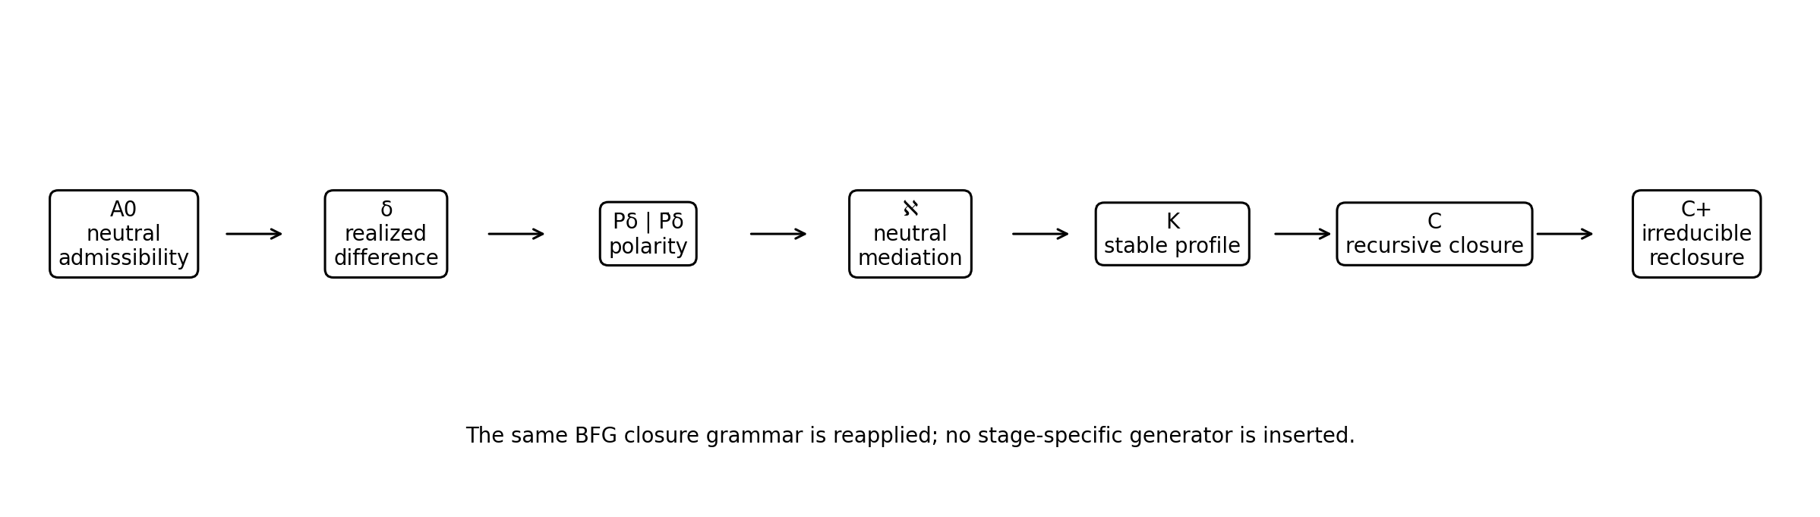
Figure 1. Pure-BFG generative spine. Higher closure reuses the same formation grammar rather than adding a stage-specific generator.

4. Formation from Neutral Admissibility
A0 does not select a unique future form. It admits realizable differences. This avoids a hidden selector at Level 0 and prevents later structures from being teleologically inserted into the initial condition.
A0 ⇝ {δ_i}_adm , δ_i ≠ ∅ (2)
A realized difference must actually distinguish. Therefore determination entails at least two closure-relevant relational roles. P̄δ is not the complement of the universe; it is the minimal counter-role without which δ would fail to be a difference.
δ ⇒ (P_δ , P̄_δ), P_δ ≠ P̄_δ (3)
Polarity-from-determination is an internal BFG proposition: if P_δ and P̄_δ were indistinguishable, δ would not realize 𝔇. No independent polarity generator is therefore required.

4.1 Classification Grammar versus Dynamical Generation
The relations above classify admissible formation; they do not yet supply a unique time-evolution law. A complete generative claim requires an additional carrier-specific model completion X_{t+1}=G(X_t) or its continuous-time analogue, fixed before testing, such that trajectories starting outside K_BFG can be shown to enter K_BFG without inserting the target closure by hand. The completion must use the same BFG roles, must not contain a stage label or target classifier, and must be compared with matched null dynamics. This requirement is a formal limitation of the present preprint, not a missing line to be hidden inside the definition of closure.
Accordingly, the strongest result of this paper is a universal BFG closure grammar plus explicit admissibility, persistence, and emergence tests. Demonstrating endogenous formation in a concrete carrier remains a separate proof obligation.

5. Neutral Mediation
Neutral mediation is not fundamentally defined by a metric corridor and is not identical to the conjunction 𝔇∧𝔠. 𝔇 asks whether constitutive distinctions remain available; 𝔠 asks whether the relevant parts remain relationally connected; ℵ asks a third question: whether the coupling between those two requirements is itself admissible—neither requirement may erase, dominate, or destabilize the other. Thus states can satisfy 𝔇 and 𝔠 individually while failing ℵ because their coupling produces collapse, fragmentation, or runaway amplification.
ℵ(P1,P2) ⇔ Adm[𝔇↔𝔠] : the D–C coupling itself remains bounded, non-dominating, and mutually closure-compatible (4)
Loss of 𝔇 is collapse of constitutive distinction. Loss of 𝔠 is fragmentation of constitutive relation. Failure of ℵ is a coupling failure: distinction and coherence may each be detectable, yet their joint realization is not stably compatible. This preserves neutral admissibility as an independent BFG condition rather than a redundant label [1,2].

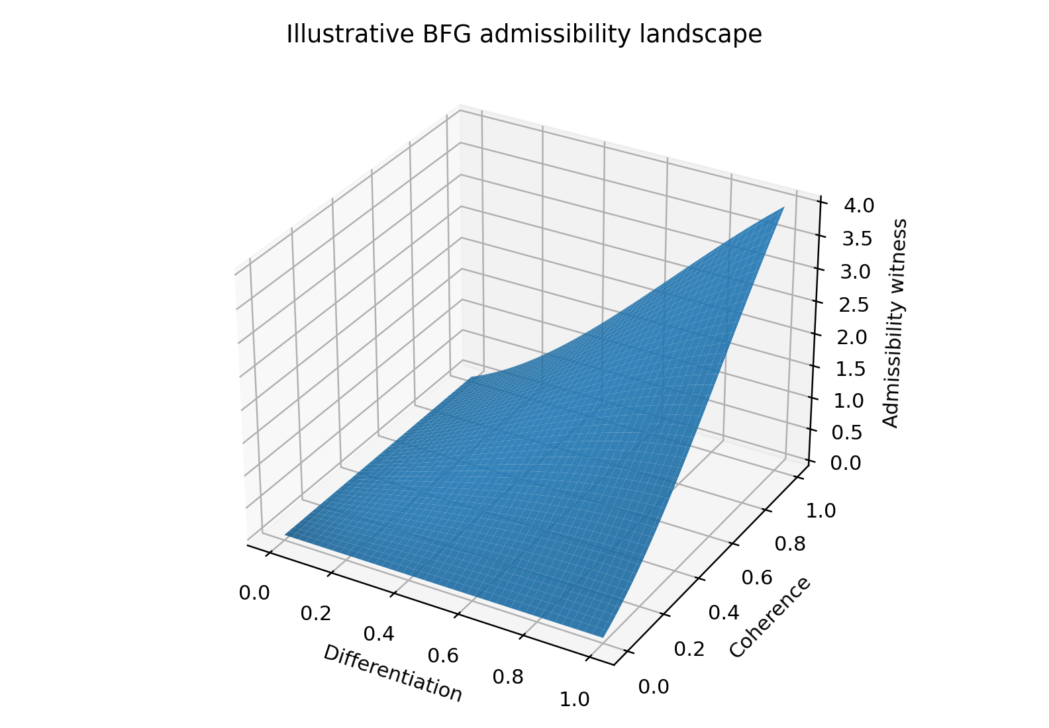
Figure 2. Synthetic three-dimensional admissibility surface. The plotted witness is illustrative only; it visualizes the requirement that differentiation and coherence must be jointly present.

6. Stable Profile Configuration and Regulated Non-Integration
Neutral relation alone is insufficient for stable formation. A finite closure must also avoid retaining what would destroy the very relation that constitutes it. Γ therefore denotes regulated non-integration. The adversarial audit imposes a strict condition: Γ may exclude non-integrable excess, but it may not erase the constitutive differentiation, coherence, or neutral admissibility that define the closure.
K_BFG[X] ⇔ 𝔇[X] ∧ 𝔠[X] ∧ ℵ[X] ∧ Γ_no-erasure[X] (5)
Equation (5) defines stable profile configuration K. It does not require a fundamental Cl_N operator. Such an operator may be a compact Layer-II realization, but the generator-level content is the conjunction of BFG-native closure roles.
Γ_no-erasure : non-integration is admissible only if constitutive closure is preserved (6)

7. Recursive Closure and Identity Continuity
A first stable configuration K is not yet a recursively persistent closure. Recursive closure C requires continued admissible re-realizability of the same formation conditions under admissible change.
𝔓[K] ⇔ K0 ⇝ K1 ⇝ K2 ⇝ ... with K_BFG[K_j] true, bounded constitutive response, and non-vanishing 𝔇_j and 𝔠_j for every admissible continuation j (7)
The ellipsis in (7) is not a claim that a physical system must literally exist forever. It states that no internal closure condition at the examined step forces termination. Boundedness alone is explicitly insufficient: x_{n+1}=x_n/2 is bounded but loses every nonzero difference asymptotically. BFG persistence therefore requires bounded continuation together with non-vanishing constitutive differentiation and coherence.
C_BFG[X] ⇔ K_BFG[X] ∧ 𝔓[X] (8)
Identity continuity is relational rather than material. C_a ⇝ C_b means that the constitutive closure of C_a remains closure-effective in C_b. This symbol is not a transport operator.
C_a ⇝ C_b : constitutive closure of C_a remains closure-effective in C_b (9)

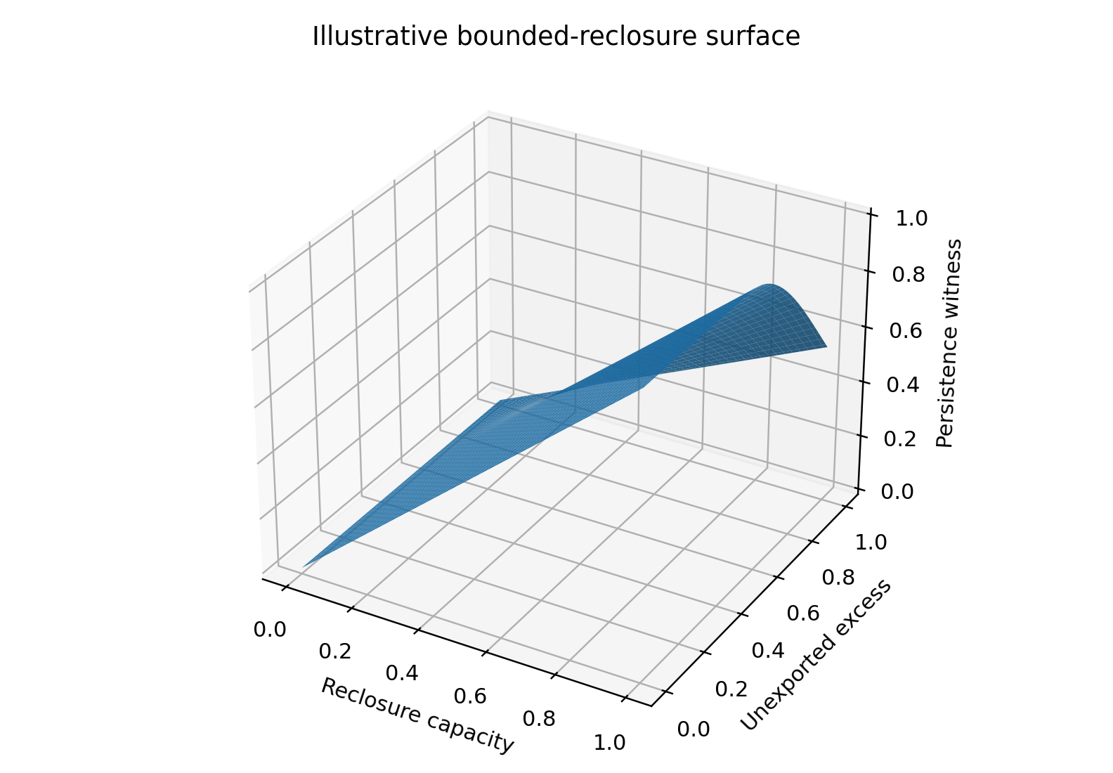
Figure 3. Synthetic bounded-reclosure surface. Increasing unexported excess degrades the illustrative persistence witness even when local reclosure capacity is high.

8. Universal Reclosure without a Transport Operator
A persistent closure does not require transport to a pre-existing higher level. Its determination can itself participate in a new relational polarity. If that polarity satisfies the same BFG formation conditions, a new K+ forms; if K+ is reclosable, a new C+ exists.
C ⇒ (P_C , P̄_C) ⇒[𝔇 ∧ 𝔠 ∧ ℵ ∧ Γ] K+ ⇒[𝔓] C+ (10)
Equation (10) is not a second law. It is Equation (5) reapplied to already closed sources. A higher level is therefore not inserted by an index. A new level is recognized only after an irreducible higher closure has actually formed.
This removes the need for a fundamental transport map, polar decomposition, vertical generation map, or target-aware stage rule. Those constructions may still provide mathematically useful representations of specific realizations.

9. Irreducibility and the Definition of Emergence
Aggregation is not emergence. Let S = {C1,...,Cm} be persistent source closures. A candidate C+ is irreducible only if source continuity holds, C+ itself satisfies recursive closure, and the new higher relation is constitutively necessary for C+ while the source closures may in principle remain.
∀i : C_i ⇝ C+ (11)
C_BFG[C+] = true (12)
remove R_constitutive+ ⇒ not C+ , while the C_i need not be destroyed (13)
The stronger label Irr_BFG is defined relative to an explicitly specified null-model class N and decision rule Q: (i) the proposed higher relation must be necessary under a model-level intervention or other independently justified removal test, and (ii) models in N, evaluated under the same Q and observables, must fail to reproduce the higher-closure criterion at the stipulated error level. The null class and Q should be fixed before a confirmatory application; the current applications remain exploratory. Comparative explanatory superiority is a still stronger empirical claim.
E_BFG(C+ | S; N,Q) ⇔ Continuity(S,C+) ∧ C_BFG[C+] ∧ Irr_BFG(C+ | S; N,Q) (14)
The resulting definition is compact: BFG emergence is continuity-preserving irreducible admissible reclosure. It excludes aggregation, replacement, and transient coupling by construction.

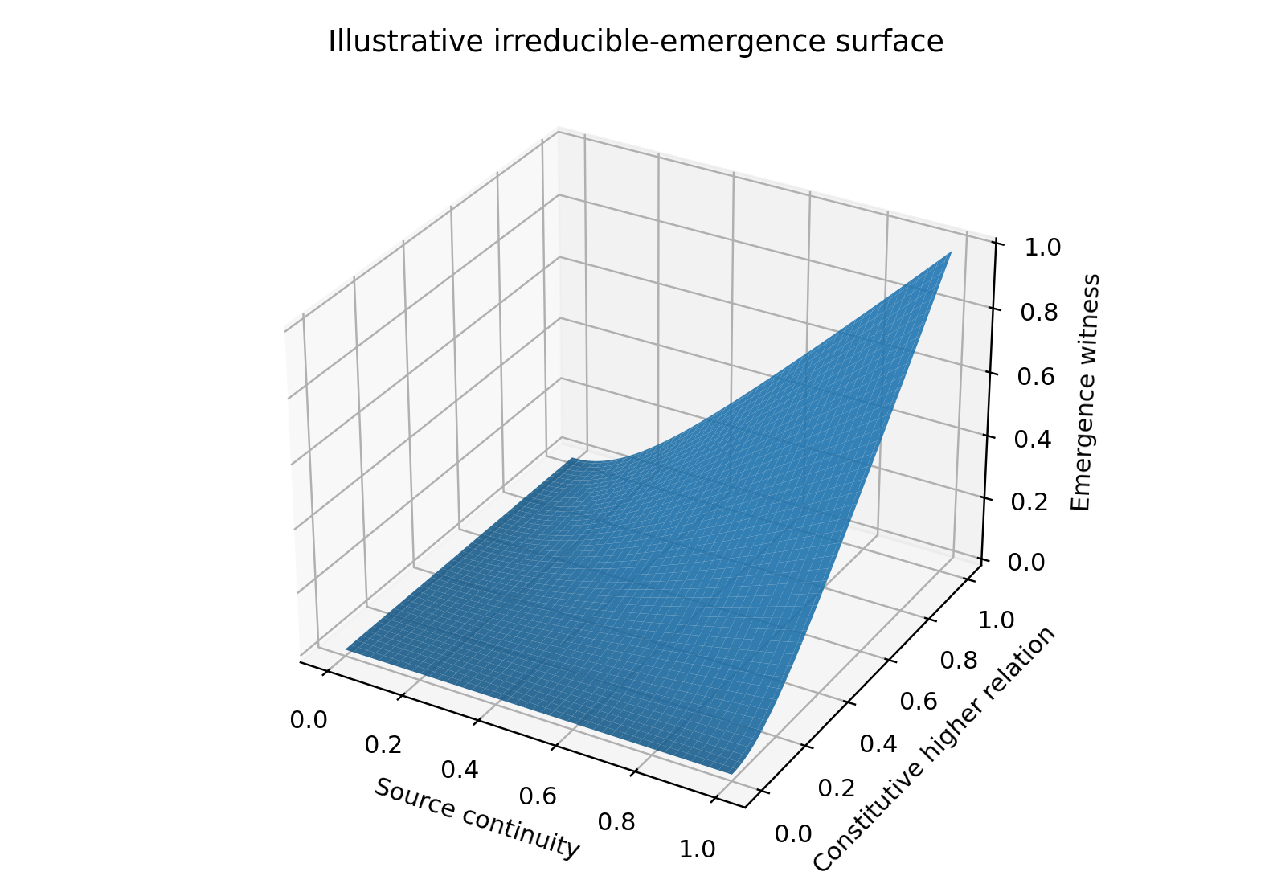
Figure 4. Synthetic three-dimensional emergence witness. High source continuity alone is insufficient; a constitutive higher relation is also required.

10. Regime Classification and Failure Modes
The same grammar yields several distinct outcomes. Persistence changes realization without changing closure class. Replication or bifurcation creates multiple realizations of the same closure class. Emergence preserves source closure lines while adding an irreducible higher closure. Termination occurs when admissible reclosure fails.
Outcome_BFG = {Persistence, Replication/Bifurcation, Emergence, Termination} (15)
Collapse is loss of constitutive differentiation. Fragmentation is loss of constitutive coherence. Overload is failure of regulated non-integration. Runaway is loss of bounded recursive admissibility. Replacement is formation of a new closure without source continuity. Transient coupling forms at most a temporary K+ but not a recursively maintained C+.
Persistence and emergence may coexist hierarchically without contradiction: a lower closure can persist while a higher closure emerges. They cannot, however, describe the same closure-class transition simultaneously.

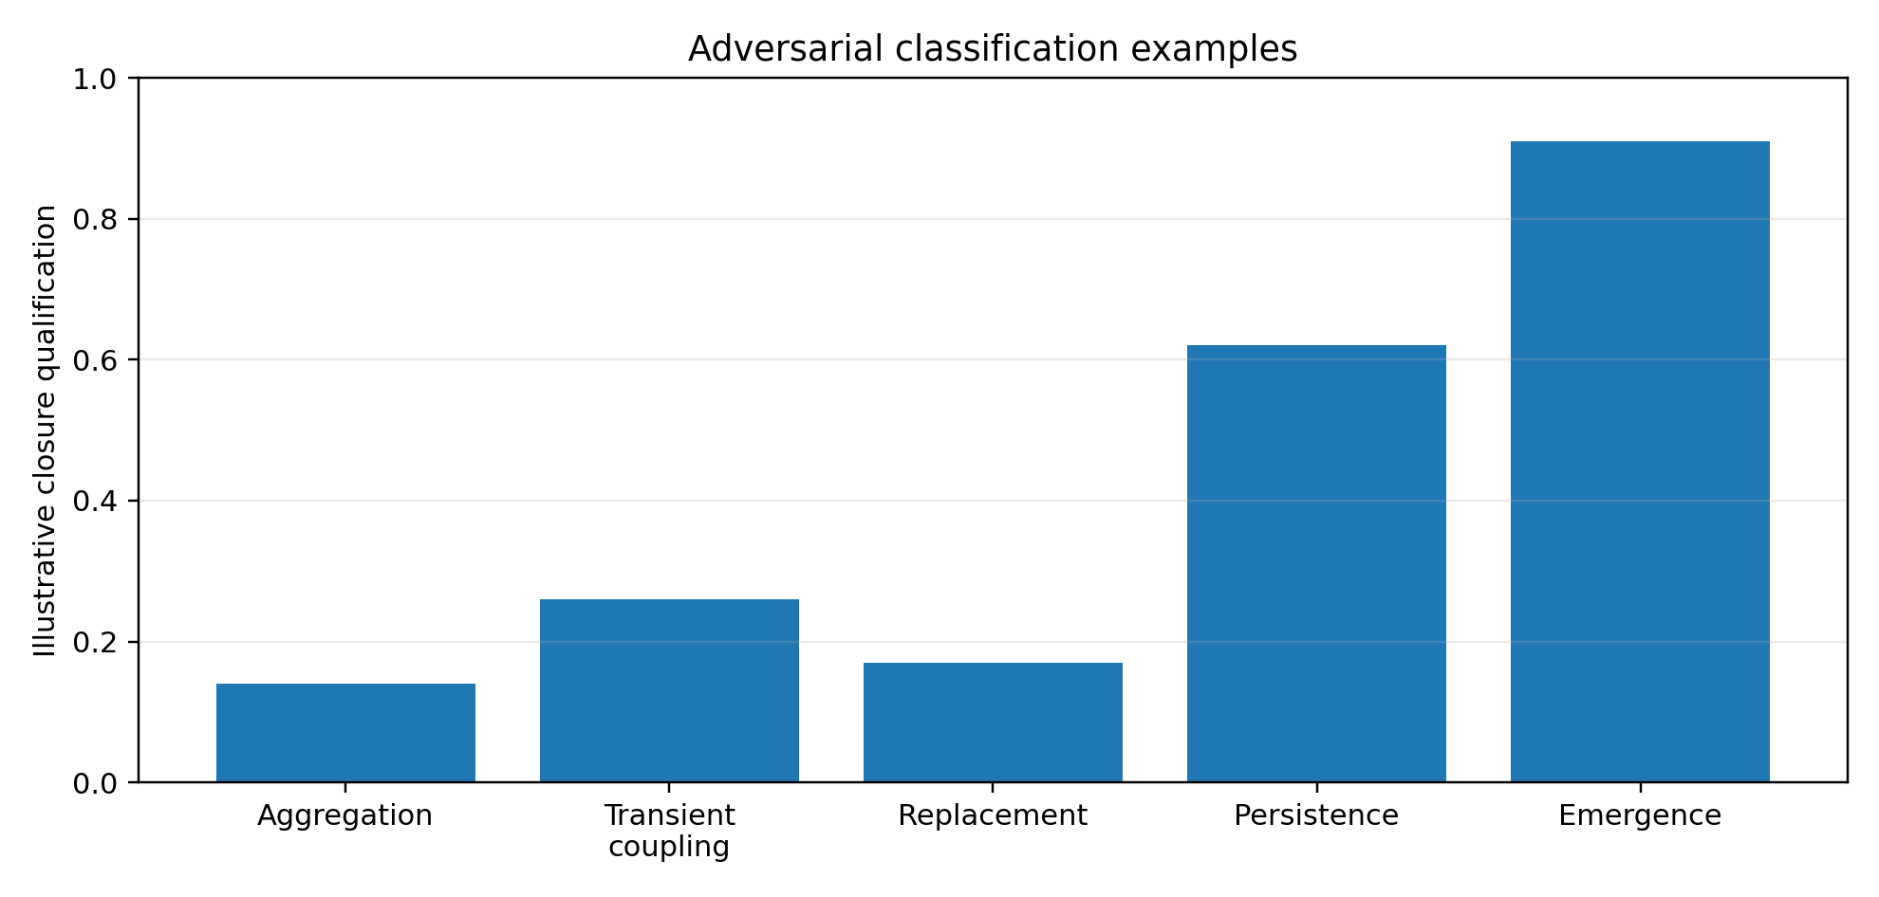
Figure 5. Adversarial classification examples. Values are synthetic visualization coordinates, not measurements or empirical probabilities.

11. Consolidated Universal BFG Closure
The entire construction can now be stated with three relations: formation, recursive closure, and emergence. No additional emergence operator is required.
Formation: F_BFG(δ) ⇔ 𝔇(δ) ∧ 𝔠(δ) ∧ ℵ(δ) ∧ Γ_no-erasure(δ) ⇒ K (16)
Recursive closure: C_BFG(K) ⇔ F_BFG(K) ∧ 𝔓(K) (17)
Emergence: E_BFG(C+|S; N,Q) ⇔ Continuity(S,C+) ∧ C_BFG(C+) ∧ Irr_BFG(C+|S; N,Q) (18)
Equations (16)-(18) are the mathematical spine of the preprint. The universal sequence is therefore:
A0 ⇝ δ ⇒ polarity ⇒ neutral admissible formation ⇒ K ⇒ recursive reclosure ⇒ C ⇒ irreducible reclosure ⇒ C+ (19)
The universality claim is structural: Equation (16) is reapplied rather than replaced when the carrier changes. Named physical, chemical, biological, cognitive, or conscious regimes must remain outside the generator and enter only through independently testable realization maps, consistent with the no-retuning discipline of the prior universal BFG source line [1].

12. Generator Dependency Audit
A generator-provenance audit asks a single question of every term: if an external mathematical construction is removed, is the BFG transition still internally determined? In the present formulation, A0, δ, 𝔇, 𝔠, ℵ, and Γ are BFG-native roles. K, 𝔓, C, identity continuity, and irreducibility are defined from those roles. No Riesz projector, polar decomposition, Gram reconstruction, norm, spectral radius, Hilbert space, metric distance, or free transport map appears in Equations (16)-(19).
Table 1. Generator dependency audit: generator-layer status versus representation-layer mathematics.
Element | Generator-layer status | Role of general mathematics
A0, δ | BFG-native | May be represented in many mathematical carriers
𝔇, 𝔠, ℵ | BFG-native closure roles | Metrics/operators may operationalize them
Γ | BFG-native regulated non-integration | Flux/dissipation variables may witness it
K | Derived formation | Optimization or positive geometry may represent it
𝔓, C | Derived recursive persistence | Spectral/Lyapunov tests may witness it
Irr_BFG | Derived constitutive necessity | Ablation/null models may test it
Transport operator | Not fundamental | Optional Layer-II representation
Riesz / polar / Gram | Not fundamental | Proof/representation tools only

13. Numerical Demonstrations
The figures in this section are synthetic demonstrations designed to make the logical corridors visible. They do not estimate parameters from nature and do not validate BFG. Each surface is generated from a simple bounded toy witness chosen only to respect the qualitative closure constraints.

13.1 Admissibility surface
Figure 2 rises when both differentiation and coherence are present and is penalized when the two coordinates diverge strongly. The exact function is listed in Appendix B.

13.2 Persistence surface
Figure 3 combines a reclosure-capacity coordinate with an unexported-excess coordinate. The witness falls when excess is retained beyond the illustrative admissibility corridor.

13.3 Irreducible emergence surface
Figure 4 requires both source continuity and a constitutive higher relation. Either coordinate alone is insufficient.

13.4 Adversarial examples
Figure 5 displays synthetic qualification coordinates for aggregation, transient coupling, replacement, persistence, and emergence. The bars are visual labels only.

13.5 Numerical Consistency and Robustness Tests
Interpretive rule. Numerical results are classified as: (A) floating-point checks of exact identities; (B) numerical checks of standard mathematical behavior under imposed assumptions; or (C) documented exploratory BFG toy-model logic checks. None is an empirical BFG test.
The following tests are numerical checks of explicit Layer-II mathematics and toy closure consequences. They do not test nature and therefore cannot confirm BFG empirically. Their purpose is narrower: to check whether the equations used as mathematical witnesses behave as claimed over large randomized finite-dimensional ensembles.
Table 3. Numerical consistency tests of the mathematical representation layer and explicit toy consequences.
Test | Trials / horizon | Result | Interpretation
Neutral resolvent complement | 1,000 PSD matrices, dimensions 2–12 | max ||C_N+B_N−I||₂ = 9.43×10⁻16; eig(C_N)∈[0.124997,1.000000], eig(B_N)∈[1.22×10⁻8,0.875003] | Identity and positivity hold to floating-point precision.
Resolvent perturbation bound | 1,000 random PSD pairs | max ||C(Y)−C(Z)||₂ / ||Y−Z||₂ = 0.688684 < 1 | No violation of the stated 1-Lipschitz bound was observed.
Order fixed point | 5,000 contractive scalar trials | 5,000/5,000 converged; max absolute error 1.76×10⁻13; median error 3.93×10⁻14; median 15 iterations | Contractive interface iteration matched the analytic positive fixed point.
Normalized contractive recursion | 1,000 random finite-dimensional trials; 100 steps | 1,000/1,000 remained non-expansive; median final norm 7.03×10⁻32; maximum 2.28×10⁻5 | The bounded-recursion witness behaves as expected when the represented closure map is contractive.
Regulated export | 200 iterations, q=0.1 | γ=0: E=20.2; γ=.05,.10,.20,.40: E→2.0,1.0,0.5,0.25 | Without export the toy excess diverges linearly; for 0<γ<2, export converges to q/γ.
Irreducibility ablation | 100,000 random source/relation pairs | 28,316 candidate higher closures; 28,316/28,316 lost the toy higher witness when the constitutive relation was ablated | The explicit toy construction satisfies constitutive necessity by design; this is a logic check, not independent evidence.

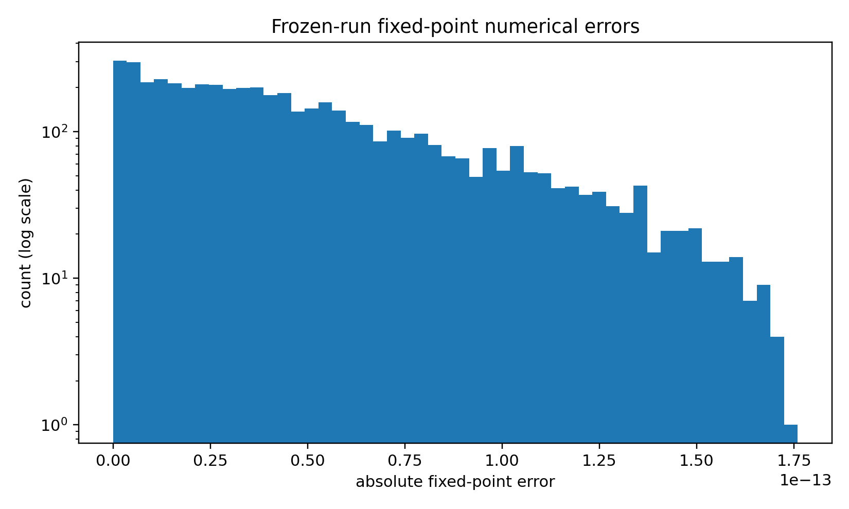
Figure 6. Distribution of absolute errors for 5,000 contractive fixed-point trials. All trials converged to the analytic positive root; the figure reports numerical error, not empirical uncertainty.

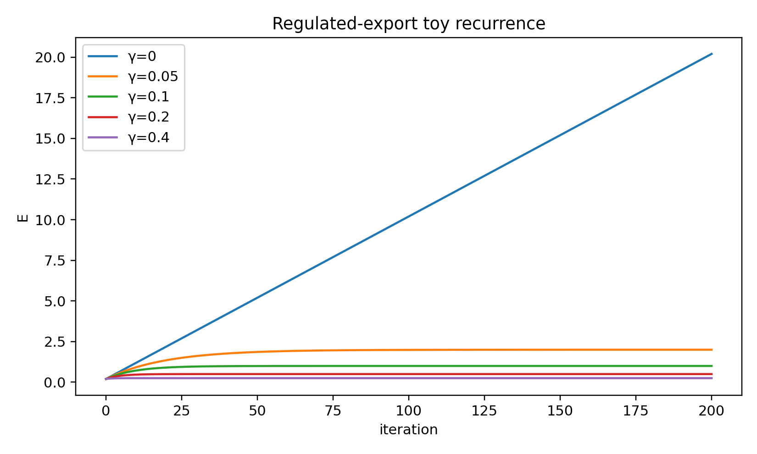
Figure 7. Regulated-export stress test. For E_{t+1}=(1−γ)E_t+q, γ=0 produces linear accumulation; the fixed point q/γ is asymptotically reached only for 0<γ<2. The plotted cases use γ≤0.4.
These tests support only the internal statements attached to the tested equations. In particular, the resolvent and contraction results are numerical confirmations of known mathematical behavior, while the export and irreducibility tests are consequences of deliberately specified toy recurrences. None distinguishes BFG from competing scientific theories on empirical data.

13.6 Direct Tests of the Strengthened Definitions
The previous contraction experiment tested boundedness only and is not a persistence test under the strengthened definition. Three additional documented exploratory toy tests therefore target the missing requirements directly: non-vanishing constitutive structure, independent neutral-admissibility failure, and a matched null comparison for the higher-closure criterion.

13.6.1 Non-vanishing persistence
In 2,000 trials, the state was decomposed into a constitutive sector and an adaptive sector. The constitutive sector evolved by a random orthogonal map and therefore retained nonzero norm; the adaptive sector evolved by a strict contraction. Over 250 steps, 2,000/2,000 trials satisfied the toy persistence requirement. The minimum constitutive norm observed was 0.9999999999998713. The adaptive sector decayed strongly (median final norm 4.82×10⁻71; maximum 7.20×10⁻10). This test demonstrates the mathematical possibility of bounded adaptation without erasing the constitutive sector; the invariant sector is imposed by construction and is therefore not evidence that nature or BFG dynamics spontaneously create it.
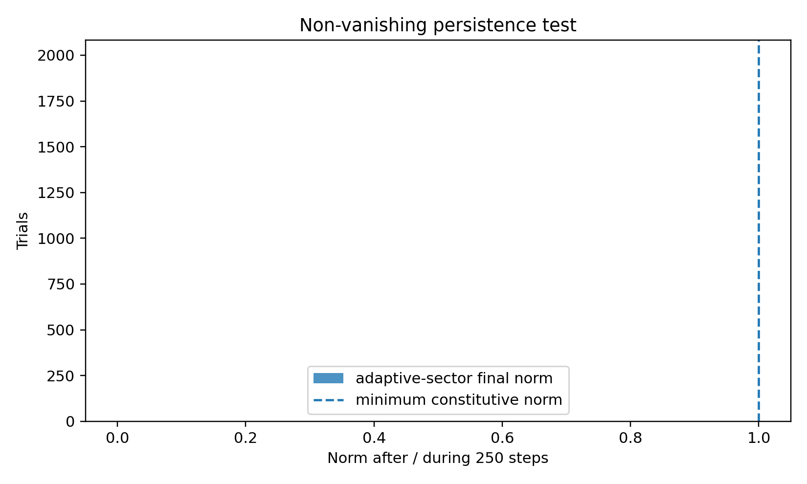
Figure 8. Non-vanishing persistence toy test. The constitutive sector remains norm-preserving while the adaptive sector is allowed to contract.

13.6.2 Independent neutral-admissibility failure
To make ℵ independently measurable, consider the illustrative joint feedback M(g)=[[0.8,g],[g,0.8]]. The two coordinates representing differentiation and coherence remain explicitly present for every g. For this operational example, ℵ is defined by strict asymptotic joint stability, ρ(M)<1—not by mere boundedness. At g=0.1, ρ=0.9 and the gate passes; at g=0.2, ρ=1 is bounded but marginal and therefore fails the strict gate; at g=0.3, ρ=1.1 and generic trajectories grow. This example establishes only that an additional coupling predicate can be operationalized independently of the presence of D and C; it is not a complete closure or persistence test.
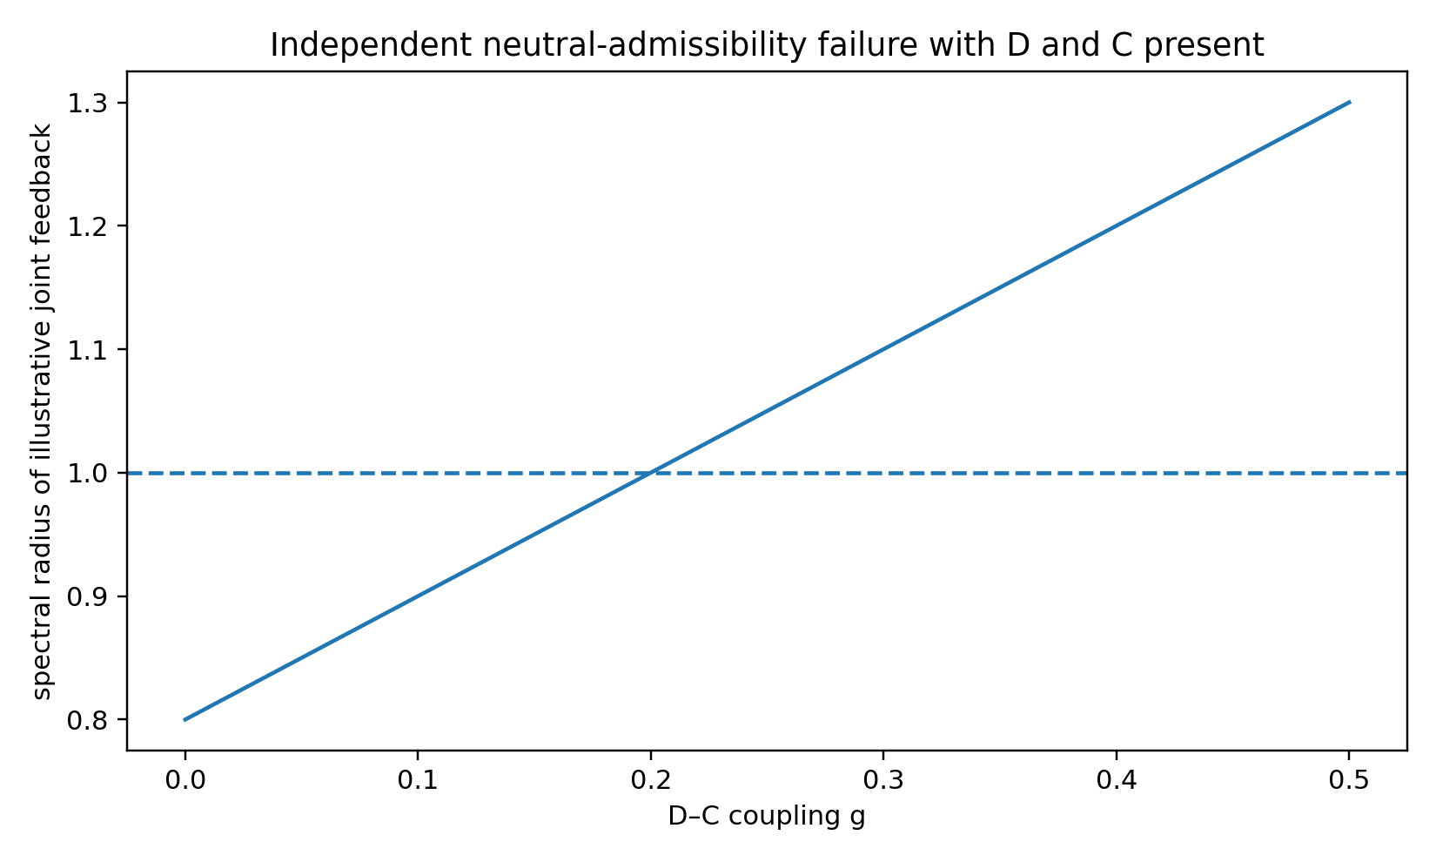
Figure 9. Operational example in which differentiation and coherence indicators remain present while their coupling crosses the neutral-admissibility boundary.

13.6.3 Matched-null emergence test
An initial exploratory emergence comparison used a full random permutation of the second source. Because that null also destroyed the source's serial structure, it is superseded here by the stricter structure-preserving null in Section 13.6.4. The earlier result is retained only as a historical sensitivity check and is not used as the principal null comparison.
Historical sensitivity check (not part of the numbered figure series). Full-sample permutation null used in the superseded exploratory comparison; retained in text only and replaced as the principal control by the circular-shift null in Figure 10.
Table 4. Direct tests and sensitivity checks for the strengthened criteria.
Criterion | Design | Result | What it does / does not establish
Persistence | 2,000 trials; invariant constitutive sector + contractive adaptive sector; 250 steps | 2,000/2,000 pass; min constitutive norm 0.9999999999998713 | Checks non-vanishing bounded persistence in an explicit construction; does not generate the invariant sector endogenously.
Neutral admissibility | M(g)=[[0.8,g],[g,0.8]]; D and C coordinates retained; ℵ iff ρ(M)<1 | g=.1: ρ=.9 pass; g=.3: ρ=1.1 fail | Shows ℵ can fail independently of the presence of D and C; matrix criterion is only one operationalization.
Historical shuffle sensitivity check | 3,000 coupled runs vs matched shuffled-source null; same marginals | 0.994 vs 0.3233 meet toy criterion | Superseded exploratory sensitivity check; destroys serial structure and is not the principal null.
Current structure-preserving null | 4,000 aligned runs vs circular-shift null preserving source values and circular autocorrelation | 0.996 aligned vs 0.836 null; source-variation gate 4,000/4,000 in both; relational-witness overwrite removes 3,984/3,984 aligned candidates | Principal current toy comparison. Shows limited specificity; witness overwrite is an evaluation dependency check, not a causal intervention on generating dynamics.

13.6.4 Structure-Preserving Null and Unified Toy Emergence Check
The stricter comparison uses one specified toy model for finite-window source variation, candidate higher closure, relational-witness overwrite, and the null comparison. Each run contains two temporally structured sources derived from the same latent AR(1) process. Finite-window source variation is checked before the higher-closure test. The candidate higher relation is h(t)=s1(t)s2(t), and the documented exploratory criterion is h(t)>0.45 for at least eight consecutive samples.
The null does not randomly permute individual samples. Instead, the complete second source series is circularly shifted by a randomly selected lag from 35 to 120 samples. This preserves its exact marginal values and its circular autocorrelation at every lag while disrupting the zero-lag relation to the first source. Across 4,000 frozen-seed runs, finite-window source-variation checks passed in 4,000/4,000 aligned cases and 4,000/4,000 null cases. The higher-closure criterion was met in 3,984/4,000 aligned runs (0.996) and 3,344/4,000 circular-shift null runs (0.836).
A relational-witness overwrite check was then applied to the same 3,984 aligned candidates by setting only the relational witness h to zero while leaving both source series unchanged; all 3,984 candidates lost the higher-closure witness. Thus the same toy model now checks finite-window source variation, candidate higher closure, evaluation dependence, and a structure-preserving null. The relatively high null success rate is scientifically important: the chosen criterion is sensitive to source temporal structure and is not highly specific for the aligned relation. Consequently, this test does not establish strong BFG irreducibility; it exposes a limitation that a future criterion must improve.
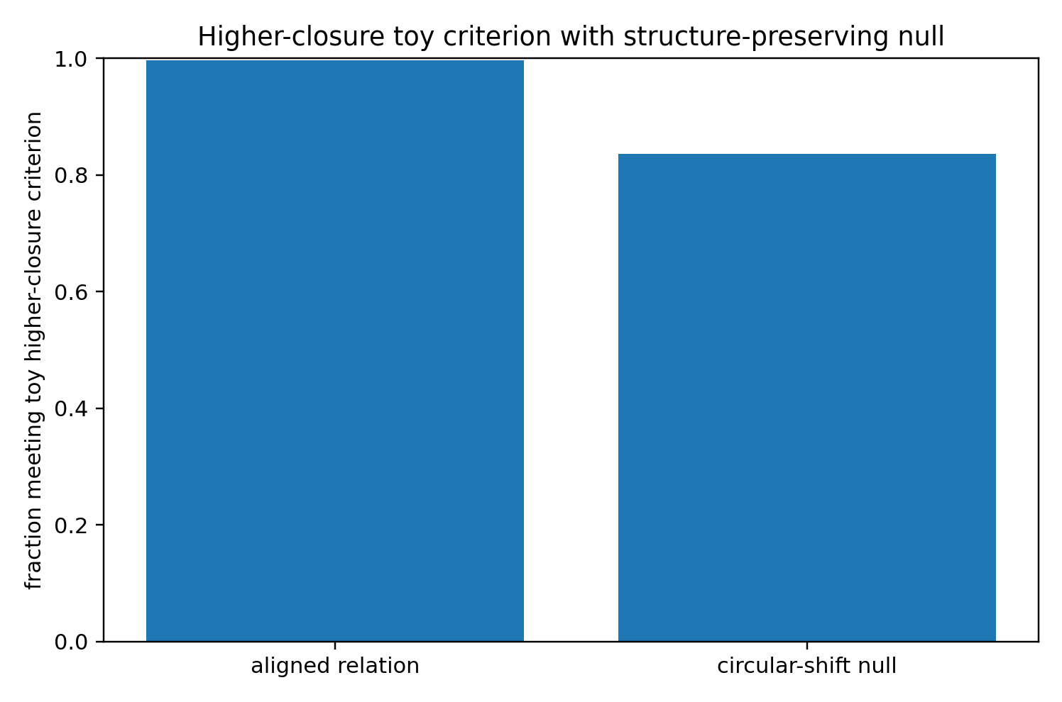
Figure 10. Structure-preserving null comparison. Circular shifting preserves each source's values and circular autocorrelation but alters cross-source alignment.
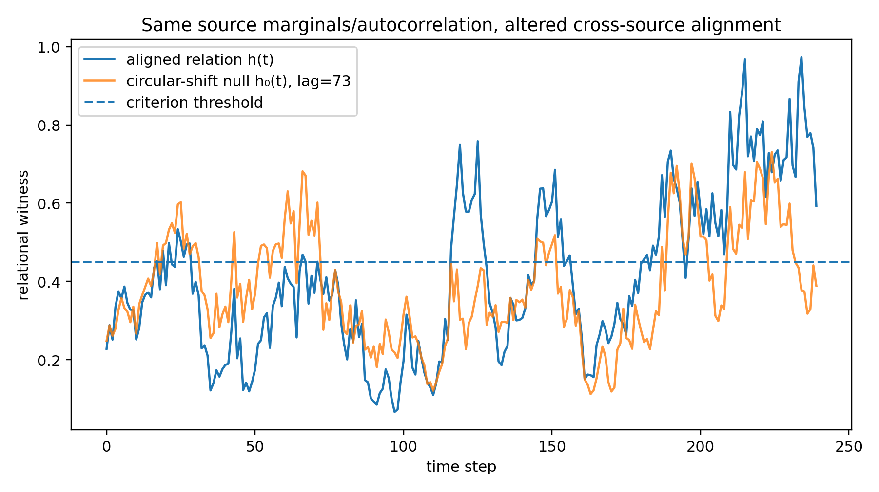
Figure 11. Example relational witness for aligned sources and a circular-shift null. The null retains within-source temporal organization while changing the cross-source relation.

14. Falsification and Confirmatory-Test Architecture
A universal BFG closure claim must be vulnerable to failure. If a dyadic or aggregate model reproduces the same bounded persistence and higher closure without the proposed neutral mediation, the BFG claim is weakened. If constitutive ablation leaves the alleged higher closure unchanged, irreducibility fails. If a closure requires stage-specific retuning, universality fails. If Γ can be varied post hoc to rescue every failed closure, the model is unfalsifiable under the present discipline. Independent literatures on hierarchical emergence [6,7,10], organizational closure [8,9], and collective multicellular organization [14] provide concrete alternative frameworks against which BFG should eventually be compared rather than treated as supporting evidence by default.
Before any future confirmatory carrier-specific test, the source closures, null-model class N, decision rule Q, operational proxies, failure conditions, interventions, and the criterion distinguishing persistence from emergence should be frozen and time-stamped. The synthetic tests in this preprint are exploratory and are not described as preregistered. Negative and inconclusive outcomes remain part of the research record.

15. Relationship to Earlier BFG Mathematics
Earlier BFG mathematics is not discarded; it is reclassified as representation. The internal historical source for conjugate recursive closure is retained only because it directly documents that BFG-specific Layer-II construction [3]. Its mathematical ingredients are compared against established mathematics rather than presented as BFG inventions: contractive fixed-point convergence is standard [15], operator perturbation and spectral analysis are standard [16], and feedback/regulation have independent cybernetic lineages [17,18].
Layer I: Pure BFG generative closure grammar (20)
Layer II: mathematical representations and witnesses of Layer I (21)
Layer III: carrier-specific operationalization and empirical falsification (22)
The co-authored recursive conjugate-closure source introduces the BFG representation R_C = M R M† with M = √N [3]. In the present architecture it is evaluated as a Layer-II representation of recursive admissibility and bounded persistence; it is not required to define persistence at generator level.
BFG-specific order and information-order quantities remain part of the broader internal research program [1]. They are not identified with Shannon information [4]. Likewise, BFG emergence is not identified with Anderson’s hierarchy argument [7], Simon’s hierarchy analysis [6], Hoel et al.’s causal-emergence measure [10], autopoiesis [8], or closure of constraints [9]. These are independent comparison frameworks.

16. Limitations and Open Proof Obligations
The paper supplies an admissibility and persistence logic, not a probability law for which initial δ is realized. Polarity-from-determination is an internal BFG proposition conditional on δ being a realized difference. Continued reclosability is a generator-level criterion whose concrete mathematical realization must be specified in Layer II. Constitutive irreducibility is structural and is challenged by ablation; equivalence to any particular operator invariant remains to be proved.
The scope is continuity-preserving hierarchical emergence. Replacement transformations are not classified as hierarchical BFG emergence. The simulations are illustrative and no empirical dataset is analyzed. Legacy source titles remain unchanged in the bibliography even though the present paper standardizes BFG as BalanceFeld Gleichung.

17. Conclusion
The BalanceFeld Gleichung can be stated as a generator-level closure grammar without importing an external emergence label. Neutral admissibility permits realized difference; realized difference entails relational polarity; neutral mediation constrains the coupling of differentiation and coherence; regulated non-integration permits stable profile formation without constitutive erasure; continued non-vanishing re-realizability yields recursive closure; and constitutively necessary higher reclosure defines the paper's hierarchical-emergence criterion. A separate dynamical completion remains necessary before the framework can claim to generate concrete natural trajectories.
BFG emergence = continuity-preserving irreducible admissible reclosure (23)
BFG supplies a proposed closure grammar. General mathematics can represent and test that grammar, while carrier sciences must determine whether concrete systems realize it. The present synthetic tests establish mathematical realizability and reveal limitations of the current toy emergence criterion; they do not establish empirical universality or endogenous formation.

Appendix A. Symbol Register
Table 2. Consolidated Pure-BFG symbol register.
Symbol | Meaning
A0 | Neutral admissibility / precondition of admissible difference
δ | Realized admissible determination
Pδ, P̄δ | Determined role and minimal closure-relevant counter-role
𝔇 | Preserved distinguishability
𝔠 | Preserved relational coherence
ℵ | Joint neutral admissibility of 𝔇 and 𝔠
Γ | Regulated non-integration without constitutive erasure
K | First stable profile configuration
𝔓 | Continued admissible re-realizability / persistence
C | Recursive closure: persistent K
⇝ | Identity-continuity relation; not a transport operator
Irr_BFG | Constitutive irreducibility of a higher closure
E_BFG | BFG emergence predicate

Appendix B. Simulation Definitions and Reproducibility

B.1 Computational environment
All randomized consistency tests reported in Table 3 were rerun with a frozen NumPy Generator using PCG64 and seed 20260927. All draws were performed sequentially from that single generator in the order listed below. Calculations used double-precision floating-point arithmetic. Matrix norms are spectral 2-norms unless otherwise stated. No trial was discarded.

B.2 Neutral-resolvent complement and positivity
Trials: 1,000. For each trial, dimension n was sampled uniformly from the integers 2,…,12. A real n×n matrix A was sampled entrywise from N(0,1)/√n and Y=AᵀA. With I the n×n identity, C_N=(I+Y)⁻¹ and B_N=Y(I+Y)⁻¹. Recorded quantities were ||C_N+B_N−I||₂ and the extremal eigenvalues of C_N and B_N. Frozen-seed result: maximum complement error 9.43×10⁻16; eigenvalues of C_N across all trials lay in [0.124997, 1.000000] and of B_N in [1.22×10⁻8, 0.875003].

B.3 Resolvent perturbation test
Trials: 1,000. Dimension n was again sampled uniformly from 2,…,12. Independent A and B were sampled entrywise from N(0,1)/√n, with Y=AᵀA and Z=BᵀB. The test statistic was r=||C(Y)−C(Z)||₂/||Y−Z||₂, where C(W)=(I+W)⁻¹. Frozen-seed maximum r=0.688684. This is a numerical check of the stated 1-Lipschitz resolvent bound, not a proof of it.

B.4 Contractive scalar order fixed point
Trials: 5,000. Parameters were sampled as a~Uniform(0.05,2.0) and b~Uniform(0.001,0.35/a), ensuring ab<0.35. Initial φ₀~Uniform(0.01,2.5). Iteration used φ_{k+1}=a/(1+bφ_k), with stopping criterion |φ_{k+1}−φ_k|<10⁻12 and maximum 500 iterations. The analytic positive fixed point was φ*=[−1+√(1+4ab)]/(2b). Frozen-seed result: 5,000/5,000 converged; maximum |φ−φ*|=1.76×10⁻13, median error 3.93×10⁻14, median convergence time 15 iterations.

B.5 Bounded finite-dimensional recursion
Trials: 1,000; horizon: 100 steps. Dimension n~Uniform{2,…,12}. A real random matrix R was sampled entrywise from N(0,1)/√n and rescaled to K=(q/σ_max(R))R with q~Uniform(0.65,0.95). The initial state was a Gaussian random vector normalized to Euclidean norm one. A trial was counted non-expansive when ||x_{t+1}||₂≤||x_t||₂+10⁻12 at every step. Frozen-seed result: 1,000/1,000 trials were non-expansive; median final norm 7.03×10⁻32 and maximum final norm 2.28×10⁻5. The contraction is imposed by construction; the test verifies implementation and bounded propagation rather than establishing a BFG-specific theorem.

B.6 Regulated-export stress test
Deterministic recurrence: E_{t+1}=(1−γ)E_t+q with E0=0.2, q=0.1, horizon 200, and γ∈{0,0.05,0.10,0.20,0.40}. Final E values were respectively 20.2, 1.9999369, 0.9999999994, 0.5, and 0.25. For γ≠0 the algebraic fixed point is E*=q/γ, but convergence requires |1−γ|<1, i.e. 0<γ<2. At γ=0 excess grows linearly; γ=2 is a non-convergent boundary case with multiplier −1; γ>2 is unstable. This toy recurrence illustrates bounded removal only within its stability domain.

B.7 Irreducibility-ablation toy test
Trials: 100,000. Independent source-continuity s and constitutive-relation r were sampled Uniform(0,1). A toy higher-closure candidate was declared when sr>0.35. Ablation set r:=0 while holding s fixed. Frozen-seed result: 28,316 candidates were identified and all 28,316 lost the toy higher-closure witness after ablation. Because evaluation dependence is built directly into this threshold construction, this is only an implementation/logic check and must not be presented as independent confirmation of BFG irreducibility.

B.8 Figure-generating toy surfaces
Figure 2 uses D,C∈[0,1] on a 90×90 grid with W_A=4DC[1−0.5(D−C)²]. Figure 3 uses R,G∈[0,1] with W_P=R exp{−3[max(G−0.55,0)]²}. Figure 4 uses S,H∈[0,1] with W_E=(SH)^1.2[1−exp(−5SH)]. Figure 5 uses fixed illustrative coordinates {0.14,0.26,0.17,0.62,0.91}. These values are visual devices only.

B.9 Reproducibility status
The numerical values in Table 3 are therefore reproducible from the sampling laws, seed, tolerances, horizons, and formulas specified above. The tests separate exact-identity checks, numerical checks of standard mathematical behavior, and explicitly constructed BFG toy consequences. None is an empirical validation of the BalanceFeld Gleichung.

B.10 Executable reference implementation
Reference implementation (Python/NumPy): RNG=np.random.default_rng(20260927). Test 1 draws n∈{2,…,12}, A~N(0,1)/√n, Y=A.T@A, C=inv(I+Y), B=Y@C. Test 2 independently draws Y and Z the same way and evaluates ||C(Y)-C(Z)||2/||Y-Z||2. Test 3 draws a~U(.05,2), b~U(.001,.35/a), phi0~U(.01,2.5), iterates phi=a/(1+b*phi) until successive change <1e-12 or 500 steps, and compares with (-1+sqrt(1+4ab))/(2b). Test 4 draws R~N(0,1)/√n, q~U(.65,.95), sets K=(q/sigma_max(R))*R, normalizes a Gaussian initial state, and iterates 100 steps. Test 5 is deterministic. Test 6 draws s,r~U(0,1), declares a toy candidate when s*r>.35, then ablates r to zero. The random stream is consumed in exactly this listed order. These specifications reproduce Table 3.

B.11 Strengthened-definition tests
All three additional tests use NumPy PCG64 with seed 20260927. Persistence test: 2,000 trials, horizon 250; constitutive dimension sampled uniformly from 1,…,3 and adaptive dimension from 1,…,6. The constitutive matrix is the Q factor of a Gaussian QR decomposition. The adaptive matrix is Gaussian, divided by √d, and rescaled to spectral norm q~Uniform(0.55,0.92). Initial vectors are Gaussian and normalized. Pass requires minimum constitutive norm >0.999999 and final adaptive norm ≤1+10⁻12.
Neutral-admissibility example: g is scanned on [0,0.5] in increments of 0.005 for M(g)=[[0.8,g],[g,0.8]]. The operational neutral condition is spectral radius ρ(M)<1. The first sampled failure occurs at g=0.2; g=0.1 and g=0.3 are reported as explicit pass/fail examples.
Matched-null emergence test: 3,000 runs, each of length 200. A latent AR(1) process z_t=0.94 z_{t−1}+ε_t with ε~N(0,0.12²) is min–max normalized. Sources are s_i=clip(0.25+0.7z+η_i,0,1), η_i~N(0,0.035²). The coupled model uses the aligned sources. The null randomly permutes the complete s2 series, preserving its marginal values. A run meets the toy higher-closure criterion if s1·s2>0.45 for at least eight consecutive samples. The coupled and null outcomes are 2,982/3,000 and 970/3,000 respectively.

B.12 Structure-preserving null: release specification
Frozen-seed test: NumPy PCG64, seed 20260927, 4,000 runs, T=240 after a 200-step latent burn-in. The latent process is z_t=0.94z_{t−1}+ε_t with ε_t~N(0,0.12²), followed by per-run min–max normalization. Sources are s_i=clip(0.25+0.7z+η_i,0,1), η_i~N(0,0.035²). Finite-window source variation requires standard deviation >0.05 and values within [0,1]. The aligned higher witness is h=s1s2; the criterion is h>0.45 for at least eight consecutive samples. The null is s2^0(t)=s2((t−k) mod T), with integer k sampled uniformly from 35,…,120. This circular shift preserves the exact source values and circular autocorrelation while changing zero-lag cross-source alignment. The relational-witness overwrite sets h:=0 without changing s1 or s2. Results: finite-window source variation 4,000/4,000 in both groups; aligned criterion 3,984/4,000; null criterion 3,344/4,000; witness-overwrite loss 3,984/3,984 aligned candidates. Circular-autocorrelation differences were zero to floating-point precision in spot checks at lags 1,2,5,10,20. The eight-consecutive-sample endpoint is evaluated on the ordinary linear index window 0,…,T−1; runs do not wrap from the last sample back to the first. The circular operation is used only to construct the shifted source, so it preserves circular autocorrelation but introduces a new cut relative to ordinary finite-window autocorrelation.

B.13 Figure provenance
Figures 6–11 must be generated from the frozen numerical specifications documented in this appendix. Figure 6 is treated as a visualization of the fixed-point error distribution only when regenerated from the current frozen-seed run; legacy image bytes are not evidential. Figures 10–11 correspond to the structure-preserving null test in B.12.

B.14 Frozen computational release provenance
Canonical executable supplement: BFG_numerical_reproducibility.py. Frozen environment: Python 3.13.5; NumPy 2.3.5; Matplotlib 3.10.8; NumPy Generator PCG64; primary seed 20260927. SHA-256: script 01efb2c0503e295f8fa742acb1d5f45a7298b9bd4b3f3b9b9e2b93cd6e67f9fd; frozen stdout log 275f3c45c9e7f4cc01496a00d551f16fac0029c243a91c66aee63905c600872d; environment JSON 47ebfb0314ed7d725a848fae41f14f756facd7ee87749aeee51a2a20d046eff6. A fresh execution of the supplied script was checked against BFG_numerical_results_frozen.txt and matched byte-for-byte at the stdout level. The three supplement files are supplied alongside the manuscript.

Appendix C. Source-Credit Register
Marcel Theodor Wende is the author of the present preprint. The internal bibliography is deliberately restricted to three direct-provenance BFG sources. Marcel Theodor Wende and Thomas W. Loker are co-authors of the retained constructive Level-0 foundation [2]. Marcel Theodor Wende and Luke Kenneth Casson Leighton are co-authors of the retained Recursive Conjugate Closure Extension [3]. The integrated Pure-BFG monograph [1] is the sole single-author internal synthesis retained for the general closure grammar.

Declarations
Author. Marcel Theodor Wende, BalanceFeld Gleichung (BFG), Independent Researcher. E-mail: marcel-wende@gmx.net. ORCID: 0009-0007-4028-2208.
Author contribution. Conceptualization, BFG consolidation architecture, theoretical formulation, interpretation, numerical illustration design, and manuscript responsibility: Marcel Theodor Wende. Co-authored precursor source lines are credited in the numbered bibliography and Appendix C.
Data availability. No external empirical dataset was analyzed. Numerical results are synthetic deterministic calculations fully specified in Appendix B.
Supplement availability. This release is supplied with BFG_numerical_reproducibility.py, BFG_numerical_results_frozen.txt, and BFG_numerical_environment.json. These files constitute the release evidence for the reported frozen numerical run. Public archival deposition in a DOI-bearing repository is a separate future release step and is not asserted here.
Ethics. No human participants, animal experiments, or identifiable personal data were used.
Funding. No funding source is asserted in this preprint.
Competing interests. No competing-interest statement is asserted beyond the author’s responsibility for the BFG research program; this item should be adapted to repository or journal requirements.

Citation audit note. The numbered citations in the scientific-correspondence and comparison sections were checked against the final 18-entry bibliography. BFG-specific derivations cite only [1]–[3]; external sources [4]–[18] are used as independent comparison, standard mathematics, or carrier-level precedent and are not presented as empirical confirmation of BFG.

References
[1] M. T. Wende, “Trinitarian Recursive Closure Architecture: A Pure Balance-Field Framework Monograph, Strongest Integrated English Edition,” independent BFG research monograph, June 2026.
[2] M. T. Wende and T. W. Loker, “A Constructive Level-0 Foundation of the Balance-Field Framework (BFG): A Pre-Mathematical Balance Substrate for Emergent Order, Information, Process Time and Physics,” internal BFG manuscript, 11 March 2026.
[3] M. T. Wende and L. K. C. Leighton, “The Recursive Conjugate Closure Extension of the Balance–Field Framework (BFG): Holomorphic/Anti-Holomorphic Recursive Geometry, Lift-Invariant Closure, and Stable Conscious Regimes,” BFG manuscript, 16 May 2026.
[4] C. E. Shannon, “A Mathematical Theory of Communication,” Bell System Technical Journal, vol. 27, pp. 379–423 and 623–656, 1948, doi:10.1002/j.1538-7305.1948.tb01338.x and doi:10.1002/j.1538-7305.1948.tb00917.x.
[5] A. M. Turing, “The Chemical Basis of Morphogenesis,” Philosophical Transactions of the Royal Society of London. Series B, Biological Sciences, vol. 237, no. 641, pp. 37–72, 1952, doi:10.1098/rstb.1952.0012.
[6] H. A. Simon, “The Architecture of Complexity,” Proceedings of the American Philosophical Society, vol. 106, no. 6, pp. 467–482, 1962.
[7] P. W. Anderson, “More Is Different: Broken Symmetry and the Nature of the Hierarchical Structure of Science,” Science, vol. 177, no. 4047, pp. 393–396, 1972, doi:10.1126/science.177.4047.393.
[8] F. J. Varela, H. R. Maturana, and R. Uribe, “Autopoiesis: The Organization of Living Systems, Its Characterization and a Model,” BioSystems, vol. 5, no. 4, pp. 187–196, 1974, doi:10.1016/0303-2647(74)90031-8.
[9] M. Montévil and M. Mossio, “Biological Organisation as Closure of Constraints,” Journal of Theoretical Biology, vol. 372, pp. 179–191, 2015, doi:10.1016/j.jtbi.2015.02.029.
[10] E. P. Hoel, L. Albantakis, and G. Tononi, “Quantifying Causal Emergence Shows That Macro Can Beat Micro,” Proceedings of the National Academy of Sciences USA, vol. 110, no. 49, pp. 19790–19795, 2013, doi:10.1073/pnas.1314922110.
[11] H. Haken, Synergetics: An Introduction—Nonequilibrium Phase Transitions and Self-Organization in Physics, Chemistry and Biology. Berlin: Springer, 1977, doi:10.1007/978-3-642-96363-6.
[12] G. Nicolis and I. Prigogine, Self-Organization in Nonequilibrium Systems: From Dissipative Structures to Order Through Fluctuations. New York: Wiley, 1977.
[13] J. L. England, “Dissipative Adaptation in Driven Self-Assembly,” Nature Nanotechnology, vol. 10, pp. 919–923, 2015, doi:10.1038/nnano.2015.250.
[14] P. Friedl and D. Gilmour, “Collective Cell Migration in Morphogenesis, Regeneration and Cancer,” Nature Reviews Molecular Cell Biology, vol. 10, pp. 445–457, 2009, doi:10.1038/nrm2720.
[15] S. Banach, “Sur les opérations dans les ensembles abstraits et leur application aux équations intégrales,” Fundamenta Mathematicae, vol. 3, pp. 133–181, 1922.
[16] T. Kato, Perturbation Theory for Linear Operators. Berlin: Springer, 1966, doi:10.1007/978-3-662-12678-3.
[17] N. Wiener, Cybernetics: Or Control and Communication in the Animal and the Machine. Paris/Cambridge, MA: Hermann & Cie/MIT Press, 1948.
[18] W. Ross Ashby, An Introduction to Cybernetics. London: Chapman & Hall, 1956.

