BALANCE–FIELD FRAMEWORK (BFG)

Canonical Minimal Finite Closure and Universal Reclosure
  - A Preprint on Typed-Operational Minimality, Neutral Selection, Intrinsic-Gram Reconstruction, Identity Continuity, and Structural Emergence

Marcel Theodor Wende
Balance–Field Framework (BFG) · Independent Researcher
E-mail: marcel-wende@gmx.net | ORCID: 0009-0007-4028-2208
Preprint · 26 September 2026

Scientific status.
Independent mathematical preprint and falsifiable research program. The finite operator identities and theorem statements are mathematical consequences only under their stated assumptions. The present work does not establish the Balance–Field Framework as empirically confirmed fundamental physics or as a completed Theory of Everything. It isolates the current minimal finite BFG closure core and the exact or source-synthesized operations used by the living reclosure candidate.

Source discipline.
No external physical theory is used as a constitutive premise of the finite construction. BFG source documents determine the architecture. External mathematical literature is cited only for standard mathematical tools and established background results; external physical literature appears only in comparison and recovery discussions.

Abstract
This preprint consolidates the current finite Balance–Field Framework (BFG) closure program into a single minimal and auditable formulation. The operative state is the five-object quotient Ξ=(K,ρ_F,ρ_W,Y,P), comprising Hermitian formation geometry, a nonzero positive formation/load density, a normalized positive identity witness, a positive neutral load, and an orthogonal persistent projector. Within the present finite candidate this state is typed-operationally minimal: deleting any one role can make the successor indeterminate. The universal neutral pair C_N=(I+Y)^{-1} and B_N=Y(I+Y)^{-1} is exact and complementary. A source-synthesized Neutral-Contrast Selection identifies closure-positive modes through Q_N=1_(0,∞)[(I−Y)(I+Y)^{-1}], without a fitted threshold. Selection precedes generation of the next packet. The surviving source determines reciprocal closure loads and a parameter-free dual weight pair; these define a cross-fed analysis operator whose reduced singular values generate the successor positive geometry Y_+=Σ². The same active frame transports the formation operator, while a distinct R4 polar overlap carries inherited identity and formation into the successor without relabelling emergent formation as prior identity. A simple negative ground mode in the non-inherited target complement supplies the only admissible endogenous formation seed. The resulting map is a level-independent finite self-reclosure law with no free numerical or constitutive completion function in the current minimal kernel, subject to the explicitly stated source-synthesis boundary. An exact BFG inheritance–emergence theorem further shows, on the neutral-compatible persistent stratum, that [Y_P,K_P]=0 is equivalent to formation inheritance, whereas noncommutation forces a change in the formation spectrum. Numerical audits reported in the BFG source line test the finite identities and novelty mechanism to floating-point precision but are not empirical evidence for natural realization. The preprint closes by locating continuum phase, memory, minimal polar carrier geometry, gravity, quantum structure, and cosmology as downstream derivation obligations rather than new fundamental inputs.
Keywords: Balance–Field Framework; recursive closure; neutral mediation; operator theory; polar decomposition; singular value decomposition; persistence; identity witness; structural emergence; no-retuning; minimal state.

Contents
1. Purpose, scope, and claim discipline
2. Source discipline and mathematical background
3. The minimal finite BFG state
4. Exact neutral resolution
5. Selection-first neutral admissibility
6. Reciprocal dual balance and the cross-fed analysis map
7. Intrinsic-Gram successor geometry
8. Formation transport, identity continuity, and emergent seeding
9. The canonical finite master reclosure law
10. Typed-operational minimality
11. Inheritance, reproduction, and structural emergence
12. Dimension monotonicity, terminality, and boundary discipline
13. Computational and numerical audit status
14. Continuum, memory, and phase
15. Minimal polar carrier and the geometric branch
16. Relation to the rich BFG semantic state
17. Falsification surfaces and open proof obligations
18. Conclusion
Appendix A. Symbol register
Appendix B. Reproducibility and figure-generation note
References

1. Purpose, scope, and claim discipline
The purpose of this preprint is to place the present finite BFG research program in one internally ordered mathematical document. The target is not to add another layer of mechanisms. The target is to identify the smallest currently sufficient finite state, derive the successor from already present BFG roles, and mark every remaining assumption or branch condition explicitly. This consolidates the natural-derivation methodology of the living BFG package [3–8].
Existence = stable admissible recursive persistence | (1)
The finite mathematical content is therefore organized around a single level-independent state transformation rather than around separate domain laws. Physical, biological, cognitive, or phenomenological realizations are downstream interpretation problems.
Ξₙ₊₁ = 𝒰_BFG(Ξₙ), 𝒰_BFG(⊥) = ⊥ | (2)
Table 1. Epistemic discipline used throughout the preprint.
Claim class | Meaning in this preprint
Definition | Introduces a state object, operator, equivalence, or terminal state.
Theorem | Exact consequence of the stated assumptions.
Source-synthesized construction | Combines BFG-explicit roles by a standard mathematical operation without adding a free parameter.
Conditional theorem | Exact consequence after an explicitly stated branch assumption.
Numerical audit | Finite-precision stress test of mathematics or implementation; not empirical validation.
Empirical realization | A future claim that measured natural systems instantiate the frozen BFG law.

2. Source discipline and mathematical background
The constitutive source line is BFG-internal. In particular, the minimal finite state, the neutral pair, the two-density separation, Selection-first ordering, reciprocal dual balance, intrinsic-Gram successor load, formation transport, and R4 identity continuation are taken from or synthesized within the BFG research corpus [1–8].
Standard matrix and operator theory is used only as mathematical language: spectral functional calculus, orthogonal and metric projections, SVD, polar decomposition, Moore–Penrose inversion, positive Gram operators, and perturbation estimates are established tools [16–30]. Their use does not make the BFG law a patchwork of external physical theories.
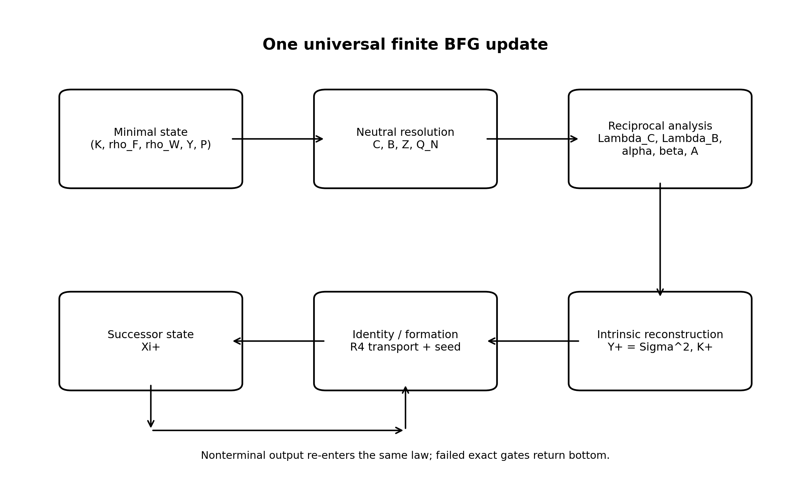
Figure 1. Canonical organization of the finite BFG update. The boxes are not separate fundamental laws; they are deterministic stages of a single state map 𝒰_BFG. Failed exact gates return the absorbing terminal state ⊥.

3. The minimal finite BFG state
The current finite closure dynamics factors through a five-object quotient. The common finite carrier is implicit in matrix dimension and is therefore not an additional dynamic coordinate [3,4].
Ξ_min = (K, ρ_F, ρ_W, Y, P) | (3)
K = K† | (4)
ρ_F ⪰ 0, tr ρ_F > 0 | (5)
ρ_W ⪰ 0, tr ρ_W = 1 | (6)
Y > 0 | (7)
P = P† = P² | (8)
The five roles are typed rather than merely stored: K carries formation/balance; ρ_F carries present formation/load distribution; ρ_W carries inherited identity continuity; Y carries neutral mediation; P carries persistent support. The BFG minimality audit provides counterexamples showing that no one role is universally recoverable from the remaining four [4].
Table 2. Typed-operational roles of the minimal finite state [4].
Object | Role | Why it cannot be deleted in the current finite candidate
K | Formation / balance geometry | Changing K alone can switch an emergent block between a valid simple negative seed and terminal nonformation.
ρ_F | Formation / load density | Changing ρ_F changes reciprocal loads, weights, singular values, and therefore Y₊.
ρ_W | Identity witness | Different witnesses on the same K,ρ_F,Y,P can survive or be annihilated by the same Selection event.
Y | Neutral geometry | Changing Y changes C_N,B_N,Z, Selection, graph metric, reciprocal loads, and the successor Gram.
P | Persistent support | States with identical K,ρ_F,ρ_W,Y but different persistent rank can have different successors.

4. Exact neutral resolution
Let Y be a positive neutral load. The exact BFG neutral resolution is the complementary operator pair already present in the Universal Structural and Canonical Reclosure lines [1,11].
C_N(Y) = (I + Y)⁻¹ | (9)
B_N(Y) = Y(I + Y)⁻¹ = I − C_N(Y) | (10)
C_N(Y) + B_N(Y) = I | (11)
G(Y) = I + Y | (12)
Z(Y) = C_N(Y) − B_N(Y) = (I − Y)(I + Y)⁻¹ | (13)
Because C_N and B_N are complementary functions of the same positive operator, the neutral split introduces no independent response law. The exact contrast Z is a lossless encoding of the pair.
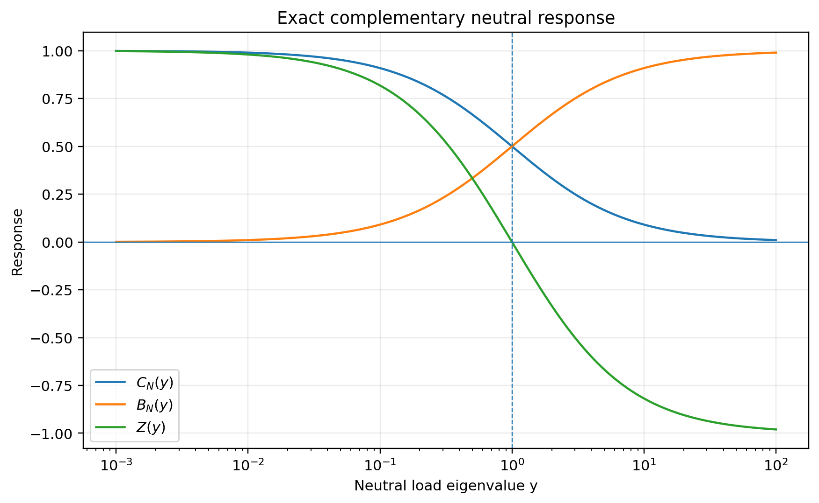
Figure 2. Exact neutral response on a scalar spectral mode. The crossing y=1 is the intrinsic role-balance point C_N=B_N, not an externally fitted threshold.
Theorem 1 (Exact neutral complementarity). For Y⪰0, C_N is positive with 0<C_N≤I, B_N is positive with 0≤B_N<I, and C_N+B_N=I. The contrast Z has spectrum in (−1,1].
Proof sketch. Apply scalar functional calculus to y≥0 and lift the resulting inequalities spectrally [16–19].

5. Selection-first neutral admissibility
The current finite ordering applies Selection to the present closure before generating the next packet. This follows the BFG source ordering A→S_A→T_A and avoids a built-in bias toward preserving every previously persistent direction [8].
Q_N = 𝟙_(0,∞)(Z) | (14)
Q_N = 𝟙_[0,1)(Y) | (15)
The second equality follows because z(y)=(1−y)/(1+y). Exact equality y=1 is assigned to export; floating arithmetic near y=1 is reported as numerical ambiguity rather than converted into a physical tolerance.
T_sel = polar(Q_N P) | (16)
T_sel is the canonical partial-isometric survival transport from the old persistent support into the currently closure-positive source sector. Formation is transported without normalization, while the identity witness remains normalized after retained-mass accounting.
Theorem 2 (Parameter-free neutral Selection). Under the source-synthesized identification of closure-positive neutral mode with retained response exceeding complementary response, the universal selector is Q_N=𝟙_(0,∞)(Z), with no fitted threshold, gain magnitude, or extra response channel [6,8].
Epistemic boundary. The retained/complementary neutral roles and their exact balance surface are source-explicit; their use as the universal finite Selection boundary is a cross-source BFG synthesis rather than a single historical equation [6].

6. Reciprocal dual balance and the cross-fed analysis map
Let P^(G) denote the G-orthogonal projector onto the selected persistent source. The selected formation density determines two complementary closure loads [3,7].
Λ_C = tr(G P^(G) C_N ρ_F C_N P^(G)†) | (17)
Λ_B = tr(G P^(G) B_N ρ_F B_N P^(G)†) | (18)
α = Λ_B / (Λ_C + Λ_B), β = Λ_C / (Λ_C + Λ_B) | (19)
α + β = 1, αΛ_C = βΛ_B | (20)
Thus reciprocal order is not an externally fitted pair. For strictly positive dual loads it is uniquely fixed by the state.
𝒜 = [ √α P^(G) C_N ; √β P^(G) B_N ] | (21)
The two neutral channels therefore produce a single selected cross-fed analysis map. The arithmetic-geometric-mean estimate in the Canonical Universal Reclosure architecture shows that this construction is non-amplifying in the structural graph metric [1].

7. Intrinsic-Gram successor geometry
The successor neutral load is generated by the transformation that actually occurred. Let the reduced singular value decomposition of the selected analysis map be
𝒜 = U Σ V† | (22)
𝒜†𝒜 = V Σ² V† | (23)
The positive quadratic form q(x)=‖𝒜x‖² has the unique positive representing operator 𝒜†𝒜 on the active source support. In reduced active coordinates the successor load is therefore
Y₊ = Σ² | (24)
Theorem 3 (Intrinsic-Gram successor load). Once the selected analysis map 𝒜 is fixed, its induced positive quadratic geometry is unique. In the reduced singular-vector coordinates this geometry is Σ²; hence no independent next-load coefficient or response function is required [3,5].
This theorem is a BFG derivation using standard matrix representation theory. It should be distinguished from the historical question of whether every earlier BFG paper had already written Y₊=Σ² explicitly.
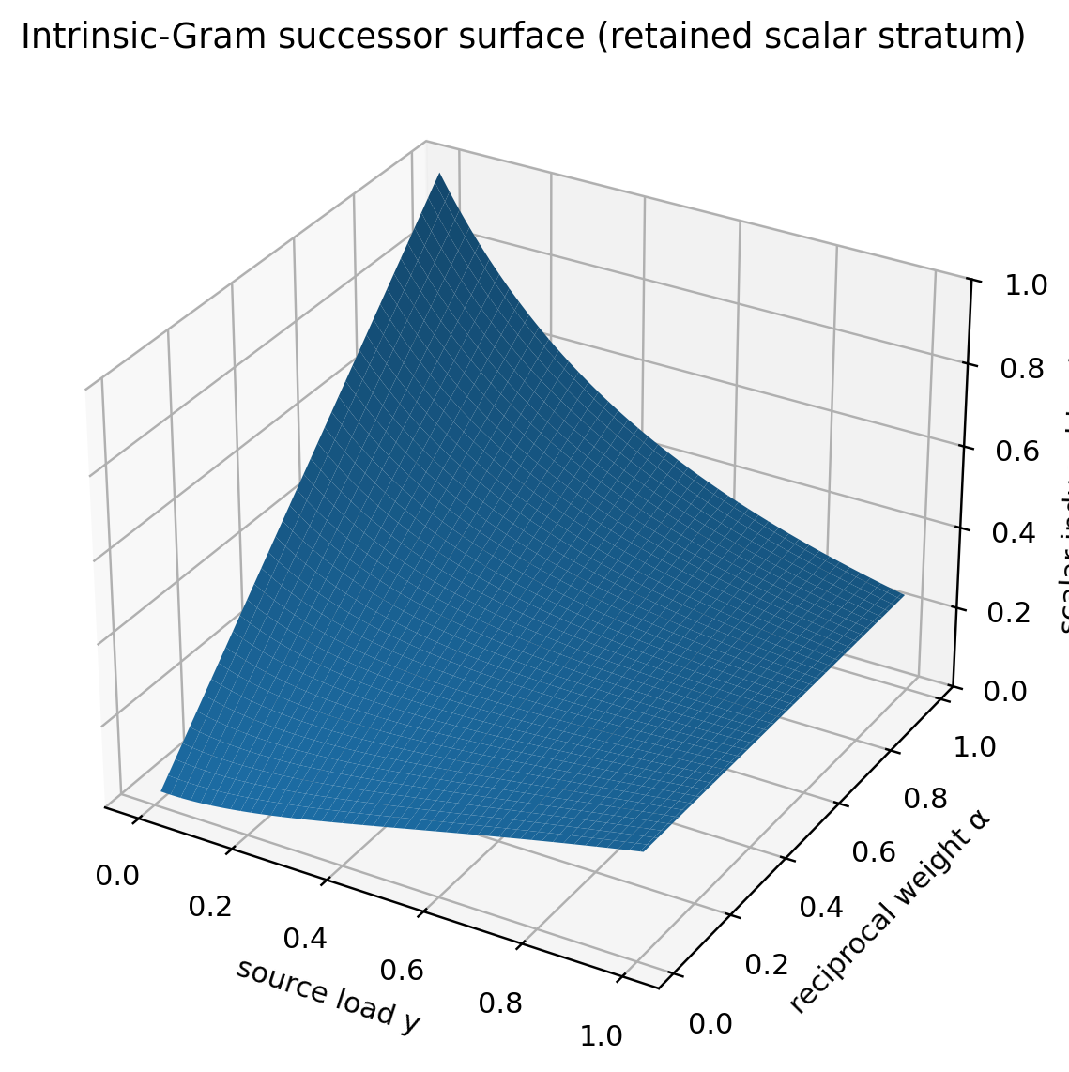
Figure 3. Scalar visualization of the induced successor load y₊=[α+(1−α)y²]/(1+y)² on a retained one-mode stratum. The surface is a mathematical visualization, not empirical data.

8. Formation transport, identity continuity, and emergent seeding
Because the rich BFG capacity operators share one linear transport, their dynamically visible finite combination factors exactly through the Hermitian formation operator K [3,4].
K = 𝔠 + ℵ − 𝔇 | (25)
K₊ = U†(K ⊕ K)U | (26)
The two positive state densities must remain distinct. ρ_F carries current formation/load magnitude; ρ_W is a normalized witness of inherited identity. A single untagged positive operator cannot satisfy both roles across a seeded rank increase [7].
S₋ = T_R4† T_R4, S₊ = T_R4 T_R4† | (27)
m_keep = tr(S₋ ρ_W) | (28)
ρ_W,₊ = T_R4 ρ_W T_R4† / m_keep (m_keep > 0) | (29)
ρ_F^inh = T_R4 ρ_F T_R4† | (30)
Let E=I−S₊ be the active target complement not inherited from the predecessor. If E≠0, a new formation seed is admitted only when the compressed operator K_E has a simple negative lowest eigenvalue.
K_E = E K₊ E |_(Ran E) | (31)
ρ_E = (−λ₀^E) Π_E | (32)
ρ_F,₊ = ρ_F^inh + ρ_E | (33)
P₊ = S₊ + Π_E | (34)
No emergent formation is relabelled as inherited identity: Eρ_W,₊=0 by construction. This is the central reason for the explicit two-density state.

9. The canonical finite master reclosure law
The complete finite update can now be stated as one map. Its internal stages are deterministic consequences of the current state, standard matrix operations, and exact no-choice gates.
𝒰_BFG : (K, ρ_F, ρ_W, Y, P) ↦ (K₊, ρ_F,₊, ρ_W,₊, Y₊, P₊) | (35)
Ξₙ₊₁ = 𝒰_BFG(Ξₙ) | (36)
For the richer semantic/source representation, a canonical transverse recursion representative may be reconstructed after the minimal update:
R_C,₊ = P₊ + (I − P₊) C_N(Y₊) (I − P₊) | (37)
This representative is not an additional finite constitutive law. Once P₊ and Y₊ are known, it is a derived rich-state lift [3,4].
Table 3. Canonical finite BFG update pipeline.
Stage | Input role | Canonical operation | Output
1 | Y | Exact neutral functional calculus | C_N, B_N, G, Z
2 | Y,P | Neutral-Contrast Selection + polar survival | Q_N, T_sel
3 | ρ_F,Y,P | Reciprocal load traces | Λ_C, Λ_B, α, β
4 | Selected source | Cross-fed analysis | 𝒜
5 | 𝒜 | Reduced SVD / positive Gram | U,Σ,V and Y₊
6 | K,U | Common linear transport | K₊
7 | ρ_W,ρ_F | R4 polar overlap | Inherited witness and formation
8 | K₊ on emergent complement | Simple-negative-ground no-choice seed | ρ_E, Π_E
9 | Inherited + emergent sectors | State commit | Ξ₊ or ⊥

Theorem 4 (Finite BFG master reclosure, current candidate). For an admissible minimal state Ξ, the Selection-first finite construction determines either a unique nonterminal successor Ξ₊ of the same five-object type or the absorbing terminal state ⊥, without a free numerical or constitutive completion function in the minimal kernel. Under a conservative single-document audit, one cross-source role identification remains visible: the Neutral-Contrast operationalization of closure-positive Selection [3,6].

10. Typed-operational minimality
Minimality is asserted here in a typed operational sense, not in the set-theoretic sense that several matrices cannot be encoded into a single symbol. The current finite update requires five independent information roles [4].
Theorem 5 (Typed-operational minimality). Within the current finite candidate and declared state types, deleting any one coordinate from (K,ρ_F,ρ_W,Y,P) destroys deterministic successor evolution on some admissible state family. Therefore the five-object quotient is typed-operationally minimal [4].
The theorem does not declare the richer capacity triple, recursive operator, or semantic BFG variables meaningless. It states only that they are not required to compute the present finite successor once their dynamically visible quotient information is known.

11. Inheritance, reproduction, and structural emergence
A nontrivial state transition is not automatically emergence. Canonical equivalence to the inherited active-support reference is persistence or reproduction; inequivalence is structural novelty. On the neutral-compatible persistent stratum the BFG reclosure admits an exact closed form [2].
χ_ij = (α + β y_i y_j) / √[(α + β y_i²)(α + β y_j²)] | (38)
(K₊)_ij = χ_ij (K_P)_ij | (39)
tr(K_P²) − tr(K₊²) = αβ Σ_ij [(y_i−y_j)² |(K_P)_ij|²] / [(α+βy_i²)(α+βy_j²)] | (40)
Theorem 6 (Inheritance–emergence dichotomy on the neutral-compatible stratum). [Y_P,K_P]=0 if and only if K₊=K_P. If [Y_P,K_P]≠0, then tr(K_P²)>tr(K₊²), hence the formation spectra differ. The relevant noncommutativity is therefore internal mismatch between inherited formation and neutral geometry, not merely [K,P] [2].
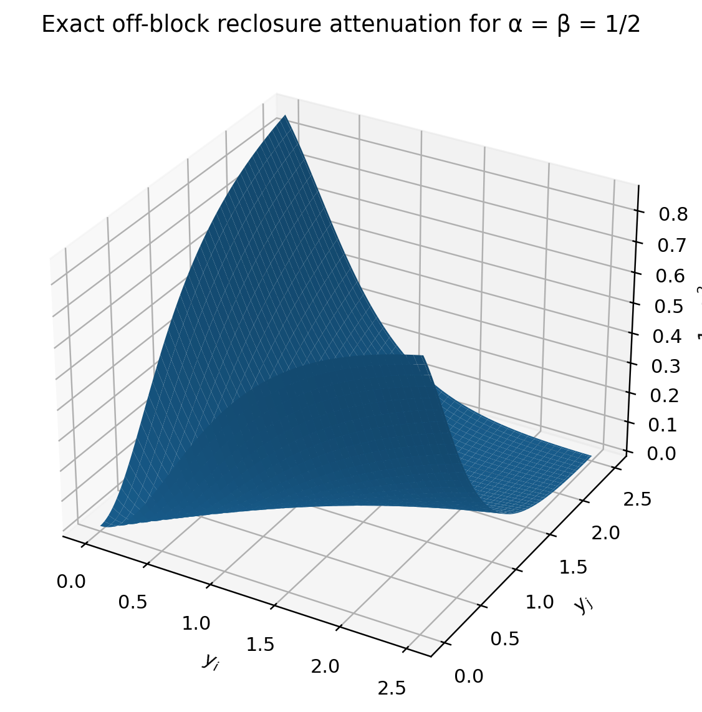
Figure 4. Exact reclosure attenuation 1−χ² for a pair of neutral eigenvalues at α=β=1/2. The attenuation vanishes on y_i=y_j and is strictly positive across distinct neutral eigenspaces.
For fixed neutral geometry, repeated Schur reclosure suppresses cross-eigenspace couplings and converges to spectral pinching onto the commutant of Y. Accordingly, long-run universal emergence cannot be identified with endless repetition of a frozen geometry; the full BFG orbit must be allowed to reconstruct its own state data [2].
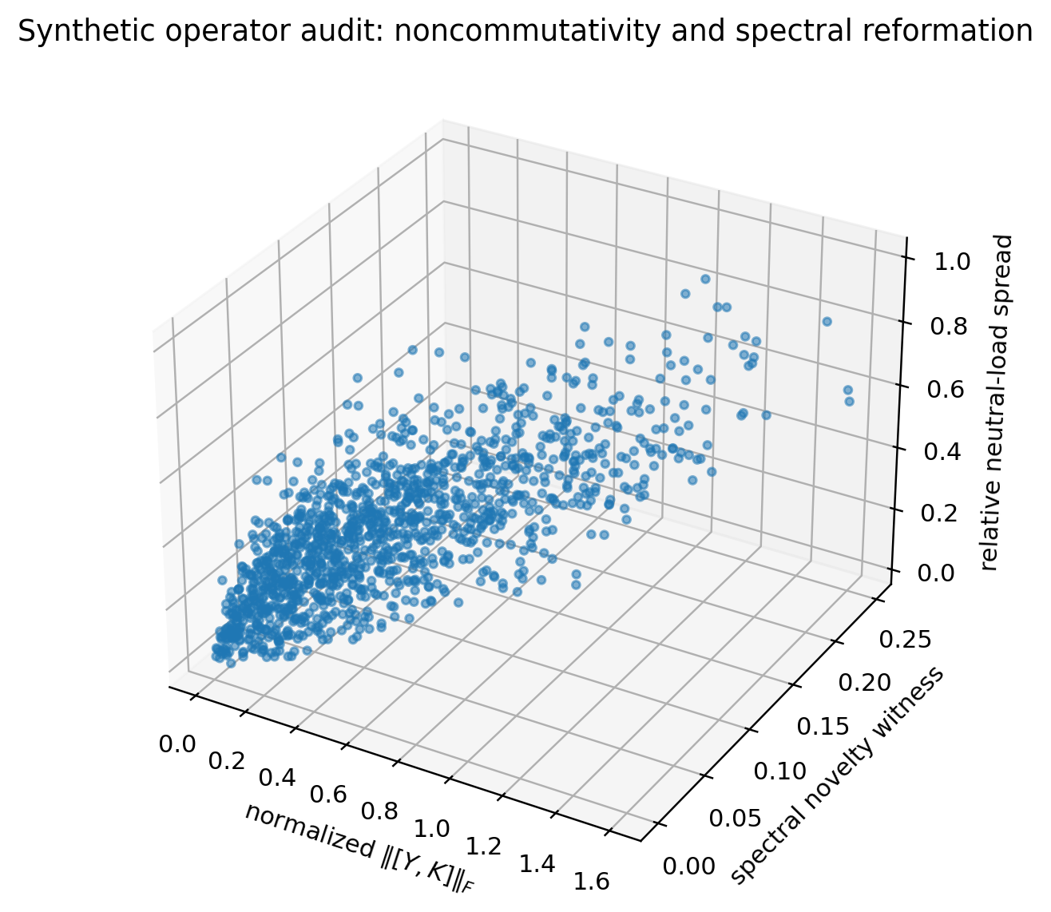
Figure 5. Synthetic 3×3 operator audit (1,300 random trials; seed 20260926) illustrating the relationship among normalized commutator magnitude, spectral novelty, and neutral-load differentiation. This figure is a new mathematical visualization for this preprint and is not empirical evidence.

12. Dimension monotonicity, terminality, and boundary discipline
The active target carrier is the reduced range of the selected analysis map. Therefore finite reclosure cannot create unbounded carrier dimension from a finite-dimensional start.
dim ℋₙ₊₁ = rank 𝒜ₙ ≤ dim ℋₙ | (41)
dim ℋₙ ≤ dim ℋ₀ | (42)
Emergence is therefore structural reorganization within, or compression of, an available carrier; it is not purchased by arbitrarily appending new basis directions. Persistent rank can nevertheless decrease or increase inside the active carrier through exact loss of inherited support and the canonical emergent seed mechanism.

12.1 Exact terminal conditions
- No persistent source or no closure-positive selected source sector.
- Exact identity-witness annihilation.
- Exact formation annihilation after Selection.
- Exact vanishing of a required dual branch load.
- Exactly zero analysis rank.
- An emergent complement that lacks the required unique simple negative ground seed.

12.2 Numerical ambiguity is not terminality
Floating-point uncertainty near a rank boundary, y=1 Selection boundary, or very small positive dual load is reported as numerical ambiguity. No implementation tolerance is promoted to a physical constant. This distinction is explicit in the living package audit [3].

13. Computational and numerical audit status
The BFG source line contains several distinct audits. They test mathematical identities, implementation consistency, and discrimination of synthetic operator cases. They do not establish natural realization.
Table 4. Mathematical and implementation audit ledger.
Audit | Reported sample | Result / diagnostic | Interpretation boundary
Canonical universal reclosure consistency audit | 10,000 complex random instances | Neutral partition, reciprocal balance, compact/expanded equivalence, polar support, positivity, non-expansion checked to floating precision. | Internal mathematical consistency only [1].
Canonical emergence audit | 10,000 trials | 9,993 formation-gate passes; all 9,993 successful trials had a nonzero spectral novelty witness; 1,000 commuting controls stayed at roundoff. | Synthetic discrimination test, not physical probability [1].
Analytic novelty falsification audit | 20,000 random + 5,000 commuting + 5,000 ambient-support tests | Closed Schur formula and moment identity reproduced to floating precision. | The theorem is analytical; simulation is implementation stress [2].
Archived fundamental-closure regression audit | 174 tests | PASS, Python compile PASS, package consistency PASS (25 Sep 2026). | Archived package status [3].
Working status supplied for this preprint | 198 regression tests | Author-supplied 26 Sep 2026 working count. | Use the repository-certified count when this preprint is formally archived.

The differing regression counts in the final two rows are intentionally shown rather than silently reconciled: the retrievable 25 September package audit documents 174 passes, whereas the author’s 26 September development-status note supplied for this preprint records 198. This is a provenance difference, not a mathematical result.

14. Continuum, memory, and phase
The committed finite state does not include continuum phase or full historical memory. Continuum research introduces closure-depth or recursive phase charts only after the finite event law is fixed [3]. On locally invertible charts, a previous anchor can be reconstructed from the current state; an explicit memory coordinate is required only when several mathematically distinct continuations share the same instantaneous readout.
Memory = minimal branch information required for unique continuation | (43)
This makes memory a continuation structure rather than a second copy of the entire historical state. The normalized finite witness ρ_W still carries current identity continuity across discrete reclosure events.

14.1 Phase and persistent transport
The canonical finite recursion representative places eigenvalue 1 on the persistent block and is sufficient for finite stability bookkeeping. A richer continuous physical branch may retain nontrivial unit-modulus phase/holonomy. Such phase is not inserted into the finite minimal state merely because it may be needed later; it must arise from the continuum extension or a derived physical quotient [9,11–13].

15. Minimal polar carrier and the geometric branch
The BFG minimal-carrier program is downstream of the finite closure law. Under explicit branch conditions—two independent noncollapsed polarity roles, a nonzero relation, retained conjugate phase, and freedom-closed minimality—the minimal complex role carrier is C² [9]. The real Hermitian readout then has four dimensions.
ℋ_pol ≅ ℂ² | (44)
span_ℝ{P₊, P₋, Q₁, Q₂} = Herm(2,ℂ) | (45)
X = x⁰I + x¹σ₁ + x²σ₂ + x³σ₃ | (46)
det X = (x⁰)² − (x¹)² − (x²)² − (x³)² | (47)
The determinant identity is standard two-spinor/Hermitian-matrix mathematics [31]. In BFG it is relevant only after the polar-conjugate branch conditions have been obtained internally; it is not used as a constitutive premise of the finite closure law.
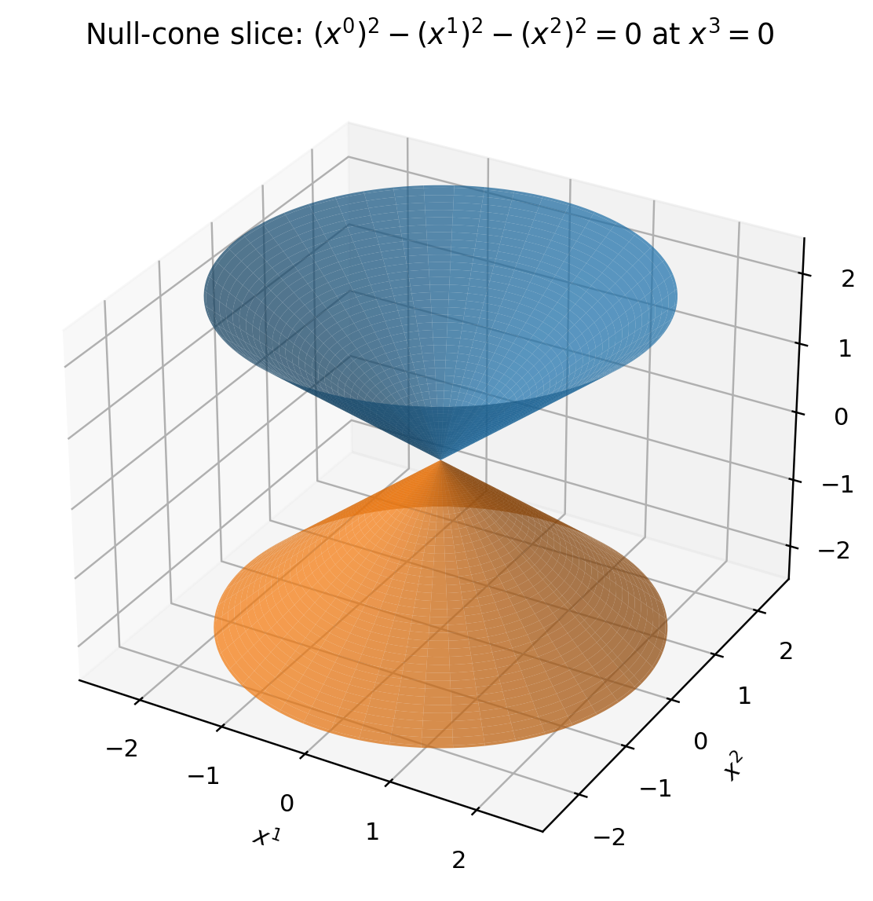
Figure 6. Three-dimensional x³=0 slice of the null set det X=0 for X∈Herm(2,C). The double cone is a downstream geometric representation of the minimal polar-conjugate branch, not a primitive BFG spacetime assumption.

15.1 Universal action-scale branch
For a continuous persistent phase representation U(τ) with additive phase frequency ω, the BFG action-scale closure imposes continuity, additivity, positive orientation, and no-retuning on the phase-to-energy readout. Under these assumptions the readout is linear [9].
E(ω) = S₀ ω | (48)
An isolated first positive persistent phase rate Ω₀ then defines internal temporal and energetic scales. This is a branch theorem, not part of the five-object finite state.

16. Relation to the rich BFG semantic state
The reduction to five finite roles does not erase the older BFG state language. It organizes it. A richer source-facing state may retain the carrier, the difference/coherence/neutral-admissibility capacity triple, and the detailed recursion operator:
Ξ_rich = (ℋ, 𝔇, 𝔠, ℵ, ρ_F, ρ_W, Y, R_C) | (49)
K = 𝔠 + ℵ − 𝔇, P = P_per(R_C) | (50)
The rich state is therefore a semantic/source lift when separate capacity meanings, recursive phase, or domain-level readouts are required. The finite quotient asserts only that these details are unnecessary for computing the current finite successor after K and P are known [3,4].
Likewise, earlier coarse-grained BFG variables such as order, information, attractor organization, temporal continuity, self-consistency, memory, and closure stability may be retained as downstream observables or semantic coordinates. They should not be reintroduced as independent finite generator variables unless an explicit counterexample shows that the five-object state loses necessary information.

17. Falsification surfaces and open proof obligations
Table 5. Principal open proof and realization obligations.
Obligation | Current status | Failure meaning
Neutral Selection source synthesis | Parameter-free and adopted in the living finite law; cross-source rather than one historical equation. | If a deeper BFG derivation gives a different universal retain/export boundary, the present finite selector must be revised.
Noncommuting same-rank continuum | Open. | Finite event law would not yet determine a unique local continuous interpolation.
Persistent phase / memory reduction | Partly closed on local invertible charts; globally branch-dependent. | Additional continuation data may remain necessary.
Minimal polar carrier | Closed only on the declared noncollapse/nonfragmentation/conjugate-phase minimal branch. | Failure of a branch gate terminates that geometric derivation.
Gravity / Einstein branch | BFG-internal conditional reduction exists, but universality from the frozen master law remains a proof obligation [10]. | GR-like recovery would remain branch-specific or incomplete.
Gauge and matter structure | Open at absolute-master level. | Would require imported structure or leave sector freedom.
Quantum statistics / measurement | Open. | A universal quantum recovery cannot yet be claimed.
Cosmology and dimensionless predictions | Open. | No completed ToE-level empirical closure.
Independent empirical realization | Open. | Mathematical closure would not imply natural truth.

These obligations are deliberately not filled by importing external physical theories. External references [32–38] provide standards against which later BFG recovery claims must be compared; they do not define the finite BFG generator.

18. Conclusion
The current finite BFG program can be expressed more compactly than its historical source architecture without weakening its finite predictive closure. The central result is not a single giant formula, but a disciplined separation between one minimal typed state and one universal reclosure law.
Ξ_min = (K, ρ_F, ρ_W, Y, P) | (51)
Ξₙ₊₁ = 𝒰_BFG(Ξₙ) | (52)
Inside 𝒰_BFG, exact neutral resolution determines the complementary responses; Neutral-Contrast Selection removes the need for a fitted retain/export threshold; the selected formation density fixes reciprocal dual order; the resulting analysis map induces its own positive successor load; one common active frame transports formation; a separate polar overlap transports inherited identity; and a simple negative ground mode is the only source of genuinely new formation in the non-inherited target complement. Emergence is therefore a possible result of the same reclosure, not an additional fundamental force.
The finite architecture is now simple enough to state in one line yet rich enough to distinguish formation, identity, neutral mediation, persistence, reproduction, export, and structural emergence. The next development stage is consequently derivational rather than additive: extend the frozen master law into a local noncommuting continuum, derive phase and geometry without retuning, and test whether the same law recovers physical sectors and independent observations.
Minimal state → neutral reclosure → induced geometry → inheritance or emergence → reclosure

Appendix A. Symbol register
Table 6. Core symbol register.
Symbol | Meaning
Ξ_min | Minimal finite BFG state (K,ρ_F,ρ_W,Y,P).
K | Hermitian formation/balance operator.
ρ_F | Positive nonzero formation/load density.
ρ_W | Normalized positive identity witness.
Y | Positive neutral/master load.
P | Orthogonal persistent projector.
C_N | Retained neutral response (I+Y)⁻¹.
B_N | Complementary mediated/export response Y(I+Y)⁻¹.
G | Graph metric I+Y.
Z | Neutral contrast C_N−B_N.
Q_N | Closure-positive Neutral-Contrast selector.
T_sel | Polar survival transport from old persistence to selected source.
Λ_C, Λ_B | Selected persistent neutral closure loads.
α, β | Reciprocal dual weights.
𝒜 | Selected cross-fed analysis map.
U,Σ,V | Reduced SVD factors of 𝒜.
T_R4 | Polar inherited-support overlap transport into active target.
Π_E | Projector of the unique simple negative emergent ground mode.
⊥ | Absorbing terminal/non-generation state.

Appendix B. Reproducibility and figure-generation note
Figures 2–4 and 6 are direct visualizations of equations displayed in this preprint. Figure 5 is a synthetic complex-Hermitian operator audit generated with NumPy using seed 20260926. Each trial draws a 3×3 Hermitian formation operator, a positive diagonal neutral load, and α∈(0.05,0.95), then applies the exact Schur multiplier of Equation (45). The figure is included only to visualize the analytical theorem; the theorem does not depend on the simulation.
All numerical counts imported from BFG source documents are labelled as source-reported audits. No figure in this preprint uses observational data.

References
References [1]–[15] are BFG-internal constitutive/source works. References [16]–[31] are standard mathematical background only. References [32]–[38] are external physical comparison literature and are not premises of the finite BFG construction.
[1] M. T. Wende, “The BFG Canonical Universal Reclosure Architecture: A Self-Contained Mathematical Whitepaper on Determinate Formation, Exact Neutral Resolution, Persistent Recursive Closure, Endogenous Reciprocal Order, and the Canonical Emergence of New Structure,” BFG preprint, 22 September 2026.
[2] M. T. Wende, “Balance–Field Framework (BFG): Canonical Reclosure and Structural Novelty—An Operator-Theoretic Inheritance–Emergence Theorem Derived from the Balance–Field Reclosure Equation,” mathematical preprint, 22 September 2026.
[3] M. T. Wende, “Fundamental Closure Law,” living BFG research package, 26 September 2026. https://github.com/marceltheodorwende-ops/BalanceFieldResearch/tree/main/research/fundamental-closure-2026-09-25
[4] M. T. Wende, “Minimal Fundamental Closure Core,” BFG research note, 26 September 2026. https://github.com/marceltheodorwende-ops/BalanceFieldResearch
[5] M. T. Wende, “Natural Derivation Protocol,” BFG research note, 26 September 2026. https://github.com/marceltheodorwende-ops/BalanceFieldResearch
[6] M. T. Wende, “Source-Synthesized Neutral Selection,” BFG research note, 26 September 2026. https://github.com/marceltheodorwende-ops/BalanceFieldResearch
[7] M. T. Wende, “Two-Density Universal State and Rank-Aware Reclosure,” BFG research note, 25 September 2026. https://github.com/marceltheodorwende-ops/BalanceFieldResearch
[8] M. T. Wende, “Selection-First Ordering Theorem,” BFG research note, 25 September 2026. https://github.com/marceltheodorwende-ops/BalanceFieldResearch
[9] M. T. Wende, “BFG Minimal Carrier and Action-Scale Closure,” foundations preprint, 22 September 2026.
[10] M. T. Wende, “BFG Level-0 to Einstein Closed Reduction,” mathematical preprint, 22 September 2026.
[11] M. T. Wende, “Balance–Field Theory: Universal Structural Whitepaper—Reviewed, Corrected, Equation-Numbered, and Literature-Referenced Edition,” September 2026.
[12] M. T. Wende, “BFG: The Neutral Interface,” BFG preprint, 2026.
[13] M. T. Wende and L. K. C. Leighton, “The Recursive Conjugate Closure Extension of the BFG,” BFG co-authored preprint, 2026.
[14] M. T. Wende, “Trinitarian Recursive Closure Architecture,” BFG whitepaper, 2026.
[15] M. T. Wende, BalanceFieldResearch repository, GitHub, accessed 26 September 2026. https://github.com/marceltheodorwende-ops/BalanceFieldResearch
[16] R. A. Horn and C. R. Johnson, Matrix Analysis, 2nd ed. Cambridge University Press, 2012. DOI: 10.1017/CBO9781139020411. https://doi.org/10.1017/CBO9781139020411
[17] R. Bhatia, Matrix Analysis. Graduate Texts in Mathematics 169. Springer, 1997. DOI: 10.1007/978-1-4612-0653-8. https://doi.org/10.1007/978-1-4612-0653-8
[18] T. Kato, Perturbation Theory for Linear Operators, 2nd ed. Springer, 1995. DOI: 10.1007/978-3-642-66282-9. https://doi.org/10.1007/978-3-642-66282-9
[19] N. J. Higham, Functions of Matrices: Theory and Computation. SIAM, 2008. DOI: 10.1137/1.9780898717778. https://doi.org/10.1137/1.9780898717778
[20] G. H. Golub and C. F. Van Loan, Matrix Computations, 4th ed. Johns Hopkins University Press, 2013. DOI: 10.56021/9781421407944. https://doi.org/10.56021/9781421407944
[21] G. W. Stewart and J.-G. Sun, Matrix Perturbation Theory. Academic Press, 1990.
[22] R. Penrose, “A Generalized Inverse for Matrices,” Mathematical Proceedings of the Cambridge Philosophical Society 51(3), 406–413 (1955). DOI: 10.1017/S0305004100030401. https://doi.org/10.1017/S0305004100030401
[23] A. Ben-Israel and T. N. E. Greville, Generalized Inverses: Theory and Applications, 2nd ed. Springer, 2003. DOI: 10.1007/b97366. https://doi.org/10.1007/b97366
[24] B. Sz.-Nagy and C. Foiaş, Harmonic Analysis of Operators on Hilbert Space. North-Holland, 1970.
[25] K.-J. Engel and R. Nagel, One-Parameter Semigroups for Linear Evolution Equations. Graduate Texts in Mathematics 194. Springer, 2000. DOI: 10.1007/b97696. https://doi.org/10.1007/b97696
[26] A. Böttcher and D. Wenzel, “The Frobenius Norm and the Commutator,” Linear Algebra and its Applications 429, 1864–1885 (2008). DOI: 10.1016/j.laa.2008.05.020. https://doi.org/10.1016/j.laa.2008.05.020
[27] M.-D. Choi, “Completely Positive Linear Maps on Complex Matrices,” Linear Algebra and its Applications 10(3), 285–290 (1975). DOI: 10.1016/0024-3795(75)90075-0. https://doi.org/10.1016/0024-3795(75)90075-0
[28] W. F. Stinespring, “Positive Functions on C*-Algebras,” Proceedings of the American Mathematical Society 6(2), 211–216 (1955). DOI: 10.1090/S0002-9939-1955-0069403-4. https://doi.org/10.1090/S0002-9939-1955-0069403-4
[29] G. J. Murphy, C*-Algebras and Operator Theory. Academic Press, 1990. DOI: 10.1016/C2009-0-22289-6. https://doi.org/10.1016/C2009-0-22289-6
[30] M. Takesaki, Theory of Operator Algebras I. Springer, 1979. DOI: 10.1007/978-1-4612-6188-9. https://doi.org/10.1007/978-1-4612-6188-9
[31] R. Penrose and W. Rindler, Spinors and Space-Time, Vol. 1: Two-Spinor Calculus and Relativistic Fields. Cambridge University Press, 1984. DOI: 10.1017/CBO9780511564048. https://doi.org/10.1017/CBO9780511564048
[32] M. Fierz and W. Pauli, “On Relativistic Wave Equations for Particles of Arbitrary Spin in an Electromagnetic Field,” Proceedings of the Royal Society A 173(953), 211–232 (1939). DOI: 10.1098/rspa.1939.0140. https://doi.org/10.1098/rspa.1939.0140
[33] S. Deser, “Self-Interaction and Gauge Invariance,” General Relativity and Gravitation 1, 9–18 (1970). DOI: 10.1007/BF00759198. https://doi.org/10.1007/BF00759198
[34] D. Lovelock, “The Einstein Tensor and Its Generalizations,” Journal of Mathematical Physics 12(3), 498–501 (1971). DOI: 10.1063/1.1665613. https://doi.org/10.1063/1.1665613
[35] R. M. Wald, General Relativity. University of Chicago Press, 1984. DOI: 10.7208/chicago/9780226870373.001.0001. https://doi.org/10.7208/chicago/9780226870373.001.0001
[36] J. F. Donoghue, “General Relativity as an Effective Field Theory: The Leading Quantum Corrections,” Physical Review D 50, 3874–3888 (1994). DOI: 10.1103/PhysRevD.50.3874. https://doi.org/10.1103/PhysRevD.50.3874
[37] B. P. Abbott et al., “Gravitational Waves and Gamma-Rays from a Binary Neutron Star Merger: GW170817 and GRB 170817A,” Astrophysical Journal Letters 848, L13 (2017). DOI: 10.3847/2041-8213/aa920c. https://doi.org/10.3847/2041-8213/aa920c
[38] N. Aghanim et al. (Planck Collaboration), “Planck 2018 Results. VI. Cosmological Parameters,” Astronomy & Astrophysics 641, A6 (2020). DOI: 10.1051/0004-6361/201833910. https://doi.org/10.1051/0004-6361/201833910

Declarations
Author. Marcel Theodor Wende, Independent Researcher, Balance–Field Framework (BFG). E-mail: marcel-wende@gmx.net. ORCID: 0009-0007-4028-2208.
Author contribution. Conceptualization, BFG source development, mathematical formulation, interpretation, and manuscript responsibility: Marcel Theodor Wende.
Data availability. No empirical dataset is analyzed in this preprint. Numerical figures are synthetic mathematical visualizations. BFG source materials are identified in the references and source package.
Competing interests and funding. No external funding or competing-interest claim is made in this preprint; journal-specific declarations should be updated at submission.
AI-assisted preparation disclosure. The manuscript was assembled with AI assistance for source consolidation, mathematical cross-checking, literature retrieval, figure generation, and document production. The BFG claims, source hierarchy, and final scientific responsibility remain with the author.

