Face Detection

Technical overview

Overview
The Microsoft Face Detection system provides a solution that can automatically detect faces in still images and real time video feeds. The system can detect an arbitrary number of faces at any scale and location.

The system takes photographic images or a video stream as input. The output consists of an array of rectangles which corresponds to the location and scale of faces detected. If it detects no faces, it will return an empty array.

The following graphic illustrates the Face Detection system:

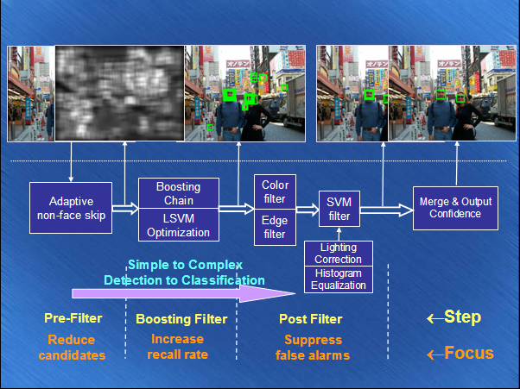

In the first step the system uses an adaptive pre-filter to eliminate candidate rectangles in the input that it can confidently determine do not contain faces.

In the second step the system feeds the remaining rectangles to an improved implementation of an algorithm called “Boosting Chain.” Boosting Chain is a framework for rapid object detection developed by Microsoft Research (please see the ‘Documentation’ section below for a paper detailing Boosting Chain).

Finally, in the third step the system attempts to eliminate false positives. It applies a color filter and an edge filter to improve the precision of the detection. It uses a support vector machine (SVM) filter, plus lighting correction and histogram equalization, to further eliminate false positives. The system then outputs each rectangle, which contains a detected face, along with its confidence in each detection.

Components
The Face Detection algorithm can be divided into three parts:
- Pre-filtering stage: This stage includes pre-color filters and non-face skipping algorithm.
- Boosting filtering stage
- Post-filtering stage: This part includes SVM classifier, Edge boosting filter, post-color filter and eye component filter.

Face Detection algorithm structural overview:

In order to simplify the face detection problem, the system divides the target faces to be detected into four categories: upright frontal face, extend frontal face set with difficulty illumination/lighting and expression, profiled face (left profile and right profile), and in-plane rotated face (clockwise and anti-clockwise). Three sets of filters are applied to each kind of face. After the filtering stage, regions detected are merged to generate final result.

Core Scenarios
- In a video-conference scenario, a passive camera with a wide angle lens provides a global view of the persons seated around a conference table. An active camera provides a close-up of whichever person is speaking. Face detection, operating on the wide-angle images, can be used to estimate the location of conference participants around the table. When a participant speaks, the high resolution camera can zoom onto the face of the speaker and hold the face in the center of the image.
- In the real-world usage of video surveillance, multiple cameras are utilized in a wide spectrum of applications for the purpose of monitoring. As a result, multiple monitors are used to display the various output video streams. Manual monitoring of multiple screens is tedious and operators are prone to fatigue. Face detection can help to reduce the data from multiple screens into one main screen for monitoring.
- Better surveillance systems: Face Detection is the first step for face recognition.

Documentation
Microsoft Research has published several papers on the face detection algorithms:
- Rong Xiao, Mingjing Li, Hongjiang Zhang. Robust Multipose Face Detection in Images . IEEE Transactions on Circuits and Systems for Video Technology (CSVT), Volume 14, PART1, 2004.
- Longbin Chen, Lei Zhang, Hongjiang Zhang, and Mohamed Abdel-Mottaleb. 3D Shape Constraint Facial Feature Localization Using Probabilistic-like Output. Accepted by 6th IEEE International Conference on Automatic Face and Gesture Recognition (FG), Seoul, Korea, 2004.
- Longbin Chen, Lei Zhang, Long Zhu, Mingjing Li and Hongjiang Zhang, A Novel Facial Feature Point Localization algorithm using Probabilistic-like output , in Proc. of Asian Conference on Computer Vision (ACCV), Jeju Island, Korea, 2004.
- Rong Xiao, Long Zhu, and Hongjiang Zhang. Boosting Chain Learning for Object Detection , in Proc. of International Conference on Computer Vision (ICCV), Nice, France, 2003.
- Stan.Z. Li, Long Zhu, Zhengqiu Zhang, Andrew Blake, Hongjiang Zhang, Harry Shum, Statistical Learning of Multi-View Face Detection , In Proceedings of The 7th European Conference on Computer Vision (ECCV), Copenhagen, Denmark, May, 2002.
In addition, Microsoft Research has created an internal document describing the details of the Face Detection prototype implementation, as well as a PowerPoint presentation summarizing the highlights of the Face Detection solution. Basic, API-level documentation for the SDK exists as well.

Caveats
- This algorithm will achieve its best recall rate when the face is upright frontal with non- exaggerated expression, simple lighting and illumination condition. The more a face varies from the above conditions, the worse the recall rate will be.

Related Work
Please refer to the ‘Documentation’ section above for published papers detailing related work.

Differentiating Features
The three-step detection algorithm achieves both high detection rate and high precision with unprecedented speed performance. It can successfully detect faces with significant lateral and polar rotation.

Demo/Prototype

Development Status
The Face Detection technique is mature and well tested on a large scale dataset.
Still image detection prototype screenshot:

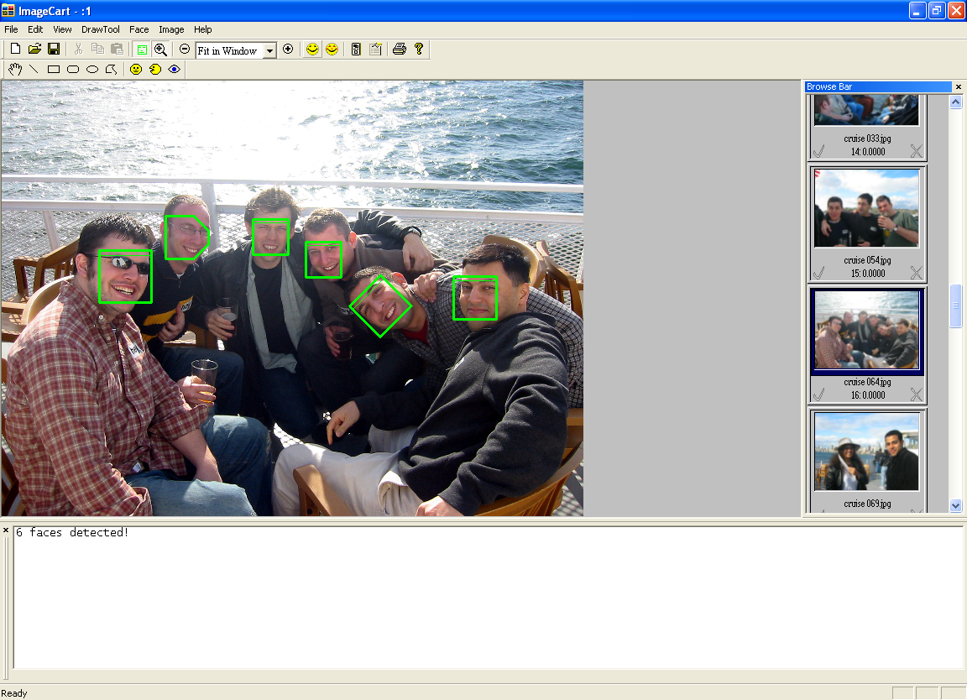

The real time face detection prototype indicates the detection of a face by overlaying diving goggles.

Here is a screenshot of the prototype in action:


Internal Projects
The system has been used in a research project regarding video conferencing.

Technical Specifications
- Implemented in C++
- Currently optimized for 1024x768 video streams.

