Conquest DICOM Server version release 1.5.0g

September 20, 2026

Contact, Conquest DICOM server and many MicroPACS extensions
Marcel van Herk; The Netherlands University of Manchester; Manchester; vanherkmarcel@gmail.com

Original MicroPACS developer (not active anymore)
Mark Oskin; UC Davis Medical Center; PACS Research and Development Lab.
(916)734-0308 / FAX (916)734-0316 / Email: mhoskin@ucdavis.edu

Administrative / Licensing Contact, original MicroPACS components
Richard L. Kennedy; UC Davis Medical Center
(916)734-7267 / FAX (916)734-0316 / Email: rlkennedy@ucdavis.edu

Copyright (c) 2026 University of Manchester, The Netherlands Cancer Institute.
Developed by Marcel van Herk and Lambert Zijp at the Netherlands Cancer Institute; RT Department; now maintained by Marcel van Herk and further developed at the University of Manchester

Server core based upon:

Copyright (c) 1995 Regents of the University of California. All rights reserved.
Developed by: Mark Oskin, mhoskin@ucdavis.edu; University of California, Davis Medical Center; Department of Radiology with a Solaris port done and maintained by: Terry Rosenbaum; Michigan State University; Department of Radiology.

Redistribution and use in source and binary forms are permitted provided that the above copyright notice and this paragraph are duplicated in all such forms and that any documentation, advertising materials, and other materials related to such distribution and use acknowledge that the software was developed by the University of California, Davis and The Netherlands Cancer Institute, Amsterdam. The name of the University may not be used to endorse or promote products derived from this software without specific prior written permission. THIS SOFTWARE IS PROVIDED “AS IS” AND WITHOUT ANY EXPRESS OR IMPLIED WARRANTIES, INCLUDING, WITHOUT LIMITATION, THE IMPLIED WARRANTIES OF MERCHANTIBILITY AND FITNESS FOR A PARTICULAR PURPOSE.

We would like to thank all individuals that help with testing, maintaining and documenting the Conquest DICOM server. Please keep up the good work!

I thank all users that have made contributions to this manual, reported bugs and made feature requests.

For release 1.5.0g I would like to thank Marcin Makalowski (DivNet/MakeIT divinus) who has provided IP matching code and has helped with a streaming DICOMWeb extension for Ladle.
TABLE OF CONTENTS
SECTION 1 INTRODUCTION 3
SECTION 2 Windows INSTALLATION GUIDE 6
2.0 INTRODUCTION 6
2.1 FIRST TIME INSTALLATION 7
Database Selection. 7
DICOM Server Configuration 8
Installing as an NT Service 9
2.1.1 VERIFY INSTALLATION 10
Verify TCP/IP Connectivity .........12
Verify Database .........12
Test Server .........12
Browse Database Options .........12
Query/Move page 16
2.1.2 MULTIPLE SERVERS ON ONE PC 18
2.1.3 Updating to Newer Versions .........18

APPENDIX 1: Database setup and benchmarks ....................................................19

APPENDIX 2: Using Conquest as DICOM router and gateway...........................24

APPENDIX 3: How to set up a Redundant Conquest Server in a Windows........28

APPENDIX 4: Using Conquest web server..............................................................30

APPENDIX 5: Dgate Command Line.......................................................................41

APPENDIX 6. Configuration Files and Discussion.................................................44
Import/ExportConverters Syntax 58
Lua scripts 64
Debugging Lua scripts 75

SECTION 1. INTRODUCTION

Conquest is a Windows, Linux or Unix based PACS system that has, at it’s core, the UCDMC DICOM Network Transport libraries. This system has been combined with a complete Windows user interface , which also acts as installation program (written in Borland Delphi) to form the Conquest DICOM server. A web interface and extensive scripting options are also available. The Information Definition is designed to be field/run-time programmable. Below the DICOM interface is a database connectivity class that uses a stable built-in SqLite driver or DBASEIII driver, talks to ODBC compatible data sources (Windows only), MySql or PostGres. This combination permits a PACS system with the following features:

- Complete DICOM Interface. Including SCP’s for run-time programmable storage IOD’s, and SCP for DICOM Queries, Retrieves and Gets. Any behavior can be modified by scripts.
- Programmable SQL Database tables. This user-programmable feature allows the MicroPACS to be custom tailored to a particular Clinical/Research area. For instance, in a CR setting, the PACS system can be programmed to allow users to query on kvp and ma or in a CT setting, the PACS can be programmed to allow queries on slice-distance.
- The communication to the database is done via a built-in SqLite (default and advised for small archives of up to 1,000,000 images), a built-in dbaseIII driver, ODBC (Windows only), MySQL or Postgres. This allows a de-coupling of PACS and SQL technology. ODBC has been tested with (Windows only):
- Microsoft Access
- SQL server
- Some users have reported successful operation using Interbase and Oracle. Oracle requires simple manual editing of the DICOM.SQL file, where the names of fields ‘rows’ and ‘columns’ are changed to, e.g., ‘qrows’ and ‘qcolumns’.
See appendix 1 for tests of the various database options.

- (Conquest addition) Easy installation of many servers on a single PC. Servers may run as service(s).
- (Conquest addition) A database browser and slice viewer (Windows only) integrated in the PACS system with options for: viewing the DICOM information in a slice, creating BMP files (ideal for slides), sending selected images, printing, and database fix tools such as changing patient IDs, and deleting, anonymizing or modifying patients, studies, series or selected images. Also tools to merge or split series. Drag and drop to load DICOM or HL7 files or directories.
- (Conquest addition) A simple query/move user interface (Windows only) for diagnostic purposes, to improve your knowledge of DICOM, and to grab missing data from another server.
- (Conquest addition) Fully integrated functionality in one user interface.
- (Conquest addition) Simple print server (Windows) - to default printer.
- (Conquest addition) Log files, which are daily zipped (Windows only). 7Zip is used.
- (Conquest addition) Correct display of JPEG, JPEG2000, JPEGLs and RLE compressed images in browser (Windows only).
- (Conquest addition) Flexible configuration of JPEG, JPEG2000, JPEGLs and NKI private compression with optional (de)compression of incoming, dropped, transmitted and archived files. The actual JPEG (de)compression is done using a modified version of the International JPEG group code, OpenJPEG and CharLS.
- (More Conquest additions) High performance (e.g., using a read-ahead thread) access, and simple image forwarding/action capability.
- Runs and compiles on Linux and has a simple WEB interface.
- DICOM Worklist query functionality with HL7 import and translation to DICOM worklist.
- Virtual server functionality: queries and retrieves can be forwarded to up to 10 other servers. (see appendix 7).
- Includes a simple series viewer based on EZDicom / K-Pacs (many thanks to Chris Rorden and Andreas Knopke).
- Version 1.4.12 improves database performance, has some important bug fixes (rare crashes, incomplete deletion and grabbing, and rare database corruption on dbaseIII). Further it has the possibility to forward multiple images on a single association, and improved documentation (appendix 5-7).
- Version 1.4.12b and c add importconverters and bug fixes in dbaseIII driver and web access and does not allow .dcm with nki compression
- Version 1.4.13 has a web viewer based on K-PACS, SQLite is now included, and more import and export converter options were added such as delayed forwarding and preretrieval. More automatic setup of the databases has been added to simplify installation.
- Version 1.4.14 extends and the web interface; adds computed fields like 'Number of Patient Related Instances' extends the exportconverters.
- Version 1.4.15: 64 bit supported (to support very large dicom objects), postgres supported, improved virtual server performance, jpg images possible in web interface, multiframe support in serverside viewer, sequence access in scripting, anonymize_script.cq, better handling of corrupt DICOM files and a few more scripting options
- Version1.4.16: Internal JPEG (IJG) and JPEG2000 (Jasper) support added by Bruce Barton, more scripting options; WADO server and client, more converters; improved serversideviewer, caching of repetitive queries, enabled MAG0\incoming folder, upload from web server, optional overlap of get and send in virtualservers, animated GIF and preliminary MPEG support.
- Version 1.4.16rc2 adds exporting zip files, log file zipping and cleanup at night also for a service and linux, more commands and fixes
- Version 1.4.16rc4 adds lua as very fast and flexible scripting language for converters (with access to configuration, connection, dicom objects, pixel data, database, queries) and web page design
- Version 1.4.16 fixes several bugs
- Version 1.4.17 extends the lua scripting system extensively for tasks such as: web page generation, anonymization (including image masking), forwarding, preprocessing and modifying queries, postprocessing query results and outgoing images, debugging, modification and logging of incoming images, image processing, capturing failed stores, or to much to list! Of course this version also fixes all bugs encountered in 1.4.16. This version may also be used as pure bridge between any DICOM PACS system and WADO.
- A connection to the ZeroBraneStudio IDE allowing easy development, testing and debugging Lua scipts. This makes Conquest even more a general purpose DICOM workhorse.
- In 1.4.17b the scripting options have been extended and some bugs have been fixed.
- In 1.4.17c some more bugs have been fixed, such a thread safety of 'forward to AE' import converters, and allow channel * in these functions, allow dgate –dolua:filename
- In 1.4.17d the scripting options have been extended and bugs have been fixed.
- In 1.4.17e the network library has been fixed to work with Aria.
- 1.4.18 is maintained by Bruce Barton for Mac and Linux.
- 1.4.19beta sees a complete recoding of the browser in the GUI for speed and lots of new options such as flexible DICOM modification, server speedup, JpegLS and better Jpeg2000 compression (thanks Bruce Barton), a completely scripted web interface with a new interactive viewer, and options for a new flexible anonymisation server.
- 1.4.19beta3 is mainly a bugfix release with mostly minor fixes. It is intended to be the final 1.4.19 release after a a few users have played with it.
- Version 1.4.19 fixed one major bug: anonymisation failure for old databases and a few small bugs; scripting adds Rclient; fix overflow crashes jpegLS and jpeg2000 compressors
- Version 1.4.19a fixes lossless jpeg decompression on color images and a merge issue. It adds a web based installer and revamps the newweb web interface.
- Version 1.4.19b adds printer header/footer/background; gamma clause in bitmap converters; fix cancel C-move crash; and several other fixes.
- Version 1.4.19c adds C-GET, optional case-insensitive searches (configured through dicom.sql), a small built-in web server (using Ladle), uses bigger file buffer sizes and has several bug fixes.
- Version 1.4.19c1 adds a weasis viewer connector, fixes the ZerobraneStudio connection install, and fixes a more serious DICOM communication bug, found against carestream
- Version 1.4.19d make the PDU size reactive to the requester; It also fixes some of the deletexxx server commands
- Version 1.5.0; Open source release on Github; Implements C-GET, a small built-in web server, web page and server command attachfile; multi-threaded move and forwards, more scripting features and servercommands, a Lua console using IUP, better Linux options, scriptable dicom echo, etc.
- Version 1.5.0a Includes some fixes; Up to date Python3 bridge; new web utility commands; Bug to stopped incoming data being compressed; Faster incoming processing; Fix anypage-exceptions truncation; Rare data corruption on Linux servers due to incorrect error handling of send().
- Version 1.5.0b Optimises the anonymizer, retries loads in incoming, fixes lossless RGB decompression; adds basic authentication to the web interface; fixes index errors on SQL server; fixes the HL7 parser; fixes 'find missing patients' and 'nightly move'.
- Version 1.5.0b Optimises the anonymizer, retries loads in incoming, fixes lossless RGB decompression; adds basic authentication to the web interface; fixes index errors on SQL server; fixes the HL7 parser; fixes 'find missing patients' and 'nightly move'.
- Version 1.5.0c Adds joint indices on study..images tables; Allow regen of selected folders; RenameOnRewrite flag; json interfaces; md5 lua call; optional anonymise using md5 hash; -$ sets binary output; Web api for DICOMWeb, demo viewers by Luiz Oliveira and OHIF. Newweb is now in html.
- Version 1.5.0d Fixes some bugs in CGET and Association.ConnectedIP; and extends the web interface.
- Version 1.5.0e Fixes some bugs, fix built-in webserver Ladle; support MONOCHROME1, DICOM updates, fix lua\; filenamesyntax, some json fixes
- Version 1.5.0f Fixes some bugs, unsafe link in ohiftop.7z, enables association with lossy lpeg-ls, fixed pixelrepresentation, anonymisation code, Mis-encoded pixel data is now a warning, Some web api fixes, database open retry to monitorthread; made e.g. 'forward series' on multiple export converter lines asynchroneous, Added [lua]poststart and [lua]timer events, GUI error on query, fix DICOM api with SQL server.
- Version 1.5.0g adds date shift in anonymisation, sqlite backup, compilation with lua built-in, support for streaming web-services, provide access control on IP, several security enhancements, several bug fixes, update methods for Windows and Linux.
SECTION 2. WINDOWS INSTALLATION GUIDE

This section details how to setup the Conquest DICOM server, as well as how the various components work together. More information and discussion may be found at the forum: https://forum.image-systems.biz/forum/index.php?board/33-conquest-users/

2.0 INTRODUCTION

For clarity/brevity, this section makes the following assumptions:

The server is located in "c:\dicomserver"
Your Image Storage drive is "c:\dicomserver\data"
You have only one image drive
All Conquest DICOM server files are in "c:\dicomserver", i.e., after unzipping ‘dicomserver150g.zip’.

Minimum System Requirements:

* Windows XP/Vista/7/8/10/11/Server2012-2025
(for Linux see separate manual).
* 32 or 64 bit OS
* 96 megabytes of memory
* 1024x768x256 display.
* 1 GB free hard disk space (for some images).

Recommended System Configuration:

* Windows 10 or higher (for Linux or Unix see separate manual).
* 64 bit OS if very large DICOM objects (e.g., >1 GB) occur.
* Pentium 4 or faster
* 4 GB of memory or more (memory limitations affect the largest DICOM object that can be transferred).
* 1920x1440 true color display.
* As much disk space as you can get.

It is recommended that the user familiarize themselves with the Appendices, Discussions and examples before starting to use the newly installed Conquest PACS.

Note: changing database or configuration files may require extremely long regeneration for large image archives.

Note: always backup image and database files. Database corruption is rare but has been reported, likely related to hardware faults.

2.1 First time installation.

There is a Windows GUI based installation which is detailed below.

Any part of the installation can be repeated at any time without loss of data, since the database may be (re-) generated from the images stored on disk. However, database regeneration may take a long time and active connections may be terminated during some of the installation steps. Note that the modality worklist cannot be regenerated; it therefore has its own clear button.

Then, you must enter the following commands from the command prompt (or perform similar functions using the explorer):

md c:\dicomserver
cd \dicomserver
unzip DICOMSERVER150g.ZIP here, using folder names
conquestdicomserver

It is preferred to install the server in a directory without spaces in its name (a warning will be given if you try otherwise). If everything went correctly, the server should display a message that this is a first time installation (this window can be recalled at any time by deleting dicom.ini and starting the server):

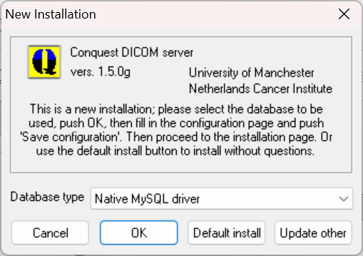
In version 1.5.0g the [Update other] button is new. To update and existing installation for Windows: Download 150g zip file and unzip to temporary location. Start ConquestDicomServer.exe. Use [Update other] button to copy binary files to existing server. Note that this NOT UPDATE webserver files OUTSIDE the Conquest folder. It is imperative to copy these manually e.g. from c:\dicomserver\webserver\htdocs to c:\xampp\htdocs.

For a new install the database type for automatic setup should be selected here. You can choose: Built-in SqLite driver (the default), Built-in Dbase III without ODBC, Microsoft Access (ODBC), Microsoft SQL server (ODBC), Native MySQL driver or Native PostGres driver. Microsoft Access should not be used for any new installations. The MySQL driver works with MariaDB.

Built-in SqLite is used as default, since this driver does not require pre-installed software or ODBC configuration. This default is advised for small archives of up to 1,000,000 images and can also be used for huge archives (10 M images) with some restrictions on query speed. It can be used fine for small production systems such as DICOM cache systems.

The built-in DbaseIII driver is quite OK, but startup is slow for large archives, and uncommon queries may not be supported or may be slow. It is no longer recommended but still works fine, e.g., if you want to upgrade an existing archive with new software.

Note: The built-in dBaseIII driver (Conquest addition) is not a full SQL server and poses limitations on query keys: only queries like ‘key’ = exact match; ‘key*’ = value starts with key; and ‘*key*’ = value contains key, are supported, as well as date-range queries and multiple UID matching queries. Only common hierarchical queries are supported with fields that are listed in the single de-normalized table for the selected query level (see file DICOM.SQL). Regular queries passing PatientID, StudyUID, and/or SeriesUID will be (very) fast, even for huge archives. Other (image) queries in large archives (>1000.000 images) may be very slow. Server startup time for huge archives may be long due to in-memory index creation (about 1 minute per 1000.000 images). During indexing the server is read-only and only shows indexed images. Due to these limitations, DBASEIII is no longer advised for production servers. Use SQLITE for 'small' installations.

Native MySQL support and Postgres support are available. Under windows these options need client DLLs, and neither 32 and 64 bits are provided in 1.5.0g. After pressing OK, the installer will ask for the location e.g., libpq.dll in C:\Program Files\PostgreSQL\xx\bin or libmysql.dll or libmariadb.dll in C:\Program Files\Mysql\x.x\lib. Please make sure you selected the correct DLL file.

To use ODBC access to SQL servers or database drivers not listed here (e.g., Interbase or Oracle), an ODBC data source must be selected here. Then, ODBC configuration must be made by hand instead of using the "Make ODBC data source" button that will be explained later.

The SQL server option requires a running Microsoft SQL server running on this or another PC. The server will attempt to configure a database (default called "conquest", set through ODBC), login name ("conquest", set in dicom.ini) and password ("conquest1415", set in dicom.ini). To be able to do this the user interface will ask for the SA password as described later. The 'conquest' login should have full permissions for the ‘conquest’ database. SQL server is suitable for large-scale and multi-user archives, just as MySQL (MariaDB) and PostGres, which are free and perform better in my view.

After pushing "OK", the server window should open. If this does not happen the following problem may exist:

ODBC not installed (if required, which is not for most databases).

Ask your system administrator for help in installing/updating.

The following steps are not required when choosing "Default install".
Fill all entries in the "Configuration page" of the Conquest DICOM server.

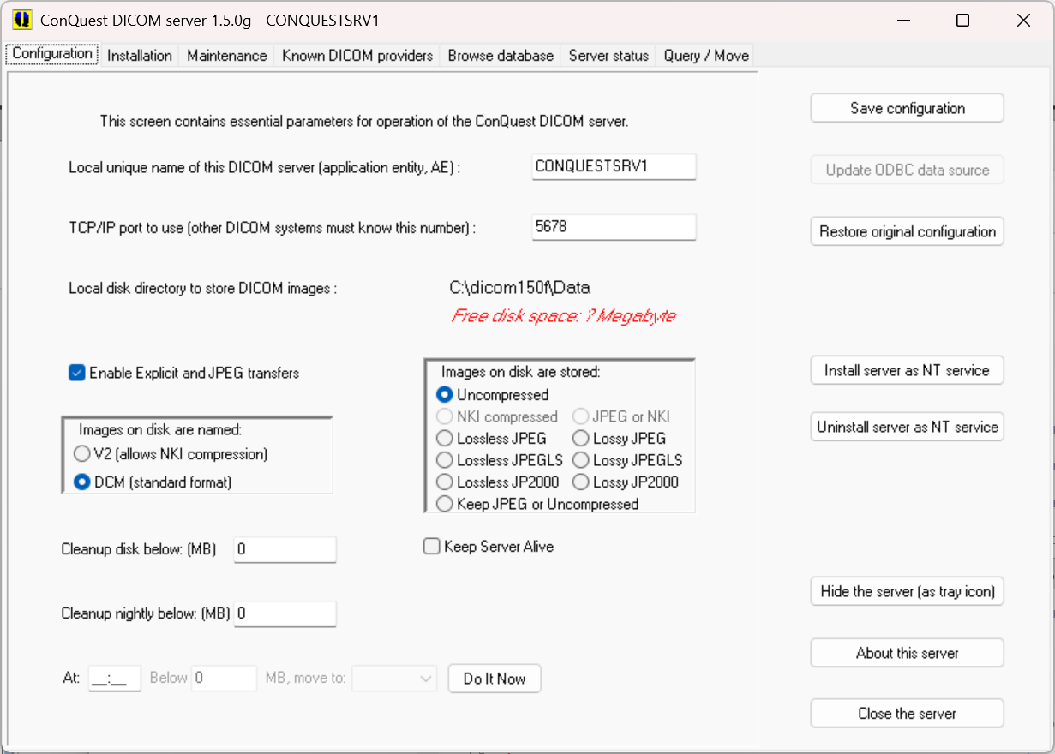

These settings can be changed later at any time if required. The following entries may be configured (the defaults are OK as a first test):

* Local unique name of this DICOM server (default "CONQUESTSRV1")
(AE name of this server, maximum 16 characters). To use special characters in the name, close the server, edit the name in dicom.ini and restart the server).
* TCP/IP port to use (default 5678)
(use another value if there are multiple DICOM AE's on one machine). Port 5678 may be occupied in Vista or Windows7. If the server has trouble starting, please try another port number. Running multiple DICOM servers on one machine require them to have different ports.
* Local disk directory to store data (default c:\dicomserver\data)
Click this string to select a directory. Patient directories will be made under the selected directory to store the DICOM images.
* Enable Explicit and JPEG transfers.
When set (default), the server accepts incoming Explicit coded and JPEG, JPEG2000 and JPEGLs compressed images over the network, and will compress and decompress such images if enabled by the following option.
* Images on disk are stored: (default uncompressed)
Storing images compressed may limit your ability to read the images directly from disk using third party software. JPEG2000 compression is slow and lossy compression affects the fidelity of the images. The options presented in the user interface correspond with the parameters in dicom.ini named IncomingCompression and DroppedFileCompression set to ‘un’, ‘n4’, 'nj', ‘j2’, ‘j6’, js, j7, 'jk', 'jl', and ‘uj’, respectively. Double click the label to edit the string directly e.g. to set the compression quality, see further section 7.7.
* Images on disk are named: (default DCM)
Storing images as V2 may limit your ability to read the images directly from disk using third party software. DCM precludes using fast but now obsolete NKI compression. The options presented in the user interface correspond with the parameter in dicom.ini named FileNameSyntax. Double click the label to edit the string directly.
* Cleanup disk below … megabyte (default 0= do not delete even if disk full) (Cleaning the disk involves deleting least recently loaded patients, may be configured as the oldest latest study using the LRUSort option in dicom.ini).
* Cleanup nightly below … MB (default 0= do not delete even if disk full) (This cleaning of the disk occurs each night at 01:00).
* At … Below … MB move to … (default 0= do not move even if disk full) (Moves … MB data from MAG0 to e.g., MAG1 at 02:00). This option requires the GUI to be running to function, it is enabled if multiple MAG devices are defined – which needs to be manually done in dicom.ini. The button “Do It Now” forces an instant move.
* Keep server alive: if set, the server self tests once per minute and is automatically restarted in the rare event of a software crash. This option requires the GUI to be running to function and is generally not needed nor recommended.

Push "Save Configuration". When JPEG support is changed the user will be prompted about overwriting dgatesop.lst, which specifies the accepted transfer syntaxes. When the file dicom.sql existed, a backup will be made of it, and it is overwritten. The user will be warned that full db regeneration is required when its layout has changed. On a first install, the installation page is then automatically displayed (you can go back for the next item later).

Optional (Win2000 and up): Use "Install server as NT service" to run the actual DICOM server (dgate.exe) independent of this user interface (it will then also re-start automatically when the computer is booted). This option will install the service such that it logins with a system account. On most windows systems only system administrators can use this option (run 'ConquestDicomServer' as administrator to make it work). Important order of events: 1) Start conquestsdicomserver as regular user to install it; 2) When done start it as administrator to install or uninstall it as service. 3) Close it and use it as regular user.

For the NT service to work by default, the databases and images should reside on the local system with sufficient access rights. Otherwise an error message is generated (push ‘Uninstall server as NT service’ to restore the previous situation). ODBC is installed with a system datasource and should work without modifying the service. However, if a network share is used, make sure the service has access to the network resource, by opening its properties and changing the logon. Do not use drive mapping, since services do not receive these.

‘Kill and restart the server’ from the server status page can be used at any time to restart the service. The name of the server is used as service name, and cannot be changed while using this option. Use "Uninstall server as NT service" to restore that the DICOM server functions only if conquestdicomserver.exe is running and to allow a change of server name.

NOTE: this version (v1.5.0g) will not run as service if the directory path where the server executables reside includes space characters.

The following hidden option exists: when the service buttons are alt-right clicked, the service is installed four times (e.g., with ports 5678…5681). Each server runs independently against the same data(base). Use for testing purposes.

Next go to the "Installation" page of the Conquest DICOM server.

2.1.1 Verify Installation

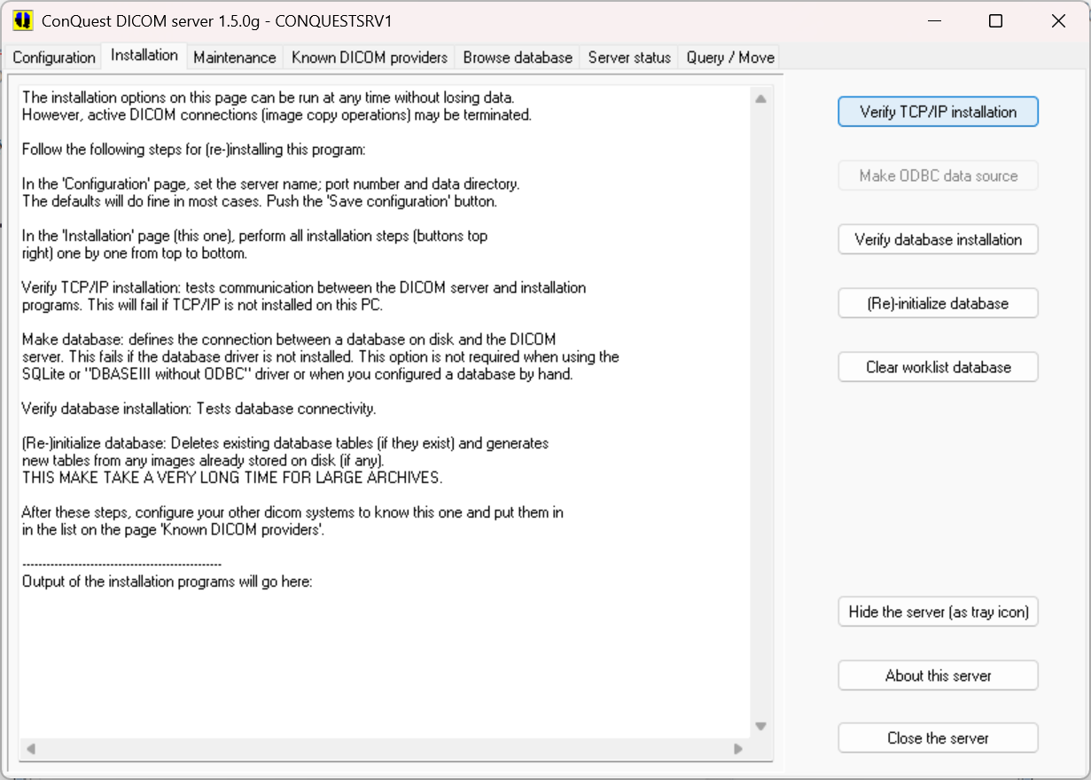
Push button "Verify TCP/IP installation". It should respond with the following messages:

------------------- Start TCP/IP test --------------------
[CONQUESTSRV1] This output is generated by the dicom server application
[CONQUESTSRV1] If you can read this, the console communication is OK
[CONQUESTSRV1] This is systemdebug output; can you read this ?
[CONQUESTSRV1] This is a very long text output for testing -- This is a very long text output for testing -- This is a very long text output for testing -- This is a very long text output for testing -- This is a very long text output for testing -- This is a very long text output for testing --
[CONQUESTSRV1] ---------- Succesful end of test -----------

If the response is different, TCP/IP may not be functioning on your computer. Ask your system administrator for help.

When not using Dbase III without ODBC or native MySQL (MariaDB), push button "Make ODBC/MySql/Postgres database", unless you want to configure the ODBC data source by hand. After a confirm, it should respond with similar messages:

----------- Start ODBC data source update or creation -------------
[CONQUESTSRV1] Creating data source
[CONQUESTSRV1] Driver = Microsoft Access Driver (*.mdb)
[CONQUESTSRV1] Options = DSN=conquestpacs_s;Description=Conquest DICOM server… [CONQUESTSRV1] Datasource configuration succesful
[CONQUESTSRV1] ----------------------------------
[CONQUESTSRV1] Creating data source
[CONQUESTSRV1] Driver = Microsoft Access Driver (*.mdb)
[CONQUESTSRV1] Options = DSN=conquestpacs_s;Description=Conquest DICOM server… [CONQUESTSRV1] Datasource configuration succesful
[CONQUESTSRV1] ----------------------------------

If the response is different, ODBC may not be installed on your computer or the selected driver has not been installed. Ask your system administrator for help. For MsSQL server, the same button will read: "Make ODBC and database". In that case it will also as for the SA password. If this is correctly given, the application will attempt to create the conquest database. This will fail harmlessly when the database already exists. In this way it is possible to use free MsSQL products that do not come with a user interface to create databases. For native mysql and or Postgres, the button will read "Make mysql/postgres database", and will ask for the database name and the root password (that defaults is empty). If this is correctly given, the application will attempt to create the conquest database. This will fail harmlessly when the database already exists. In this way it is possible to configure mysql/postgres very easily.

Note that it is perfectly possible to create or edit an ODBC/Mysql or Postgres database connection by hand.

Push button "Verify database installation". It should respond with the following messages:

------------------- Start ODBC test --------------------
[CONQUESTSRV1] Attempting to open database; test #1 of 10
[CONQUESTSRV1] Creating test table
[CONQUESTSRV1] Adding a record
[CONQUESTSRV1] Dropping test table
[CONQUESTSRV1] Closing database
[CONQUESTSRV1] Attempting to open database; test #2 of 10
[CONQUESTSRV1] Creating test table
[CONQUESTSRV1] Adding a record
[CONQUESTSRV1] Dropping test table
[CONQUESTSRV1] Closing database
.
.
[CONQUESTSRV1] Attempting to open database; test #10 of 10
[CONQUESTSRV1] Creating test table
[CONQUESTSRV1] Adding a record
[CONQUESTSRV1] Dropping test table
[CONQUESTSRV1] Closing database
[CONQUESTSRV1] ---------- Succesful end of test -----------

If the response is different, the database or drivers may be buggy. Ask your system administrator for help. When using native MySql or PostGres and the response is different, database conquest may not exist (or password and username may be wrong) or mysql/postgres may not be running. Attempt to create the database again using mysqladmin (with ‘mysqladmin –u root create conquest’) and make sure mysql runs. The verify database button also executes some sql scripts to update (1.4.19) and optimise (1.5.0b) the UIDMODS anonymisation database. No changes occur if not needed.

Push button "(Re)-initialize database". After confirmation, it respond with the following or similar messages:

------------------- Start database init and regeneration --------------------
[CONQUESTSRV1] Regen Database
[CONQUESTSRV1] Step 1: Re-initialize SQL Tables
[CONQUESTSRV1] ***SQLITEExec error: no such table: DICOMWorkList
[CONQUESTSRV1] ***SQLITEExec error: no such table: DICOMWorkList
[CONQUESTSRV1] ***Failed SQLITEExec : DROP TABLE DICOMWorkList
[CONQUESTSRV1] ***SQLITEExec error: no such table: DICOMPatients
[CONQUESTSRV1] ***Failed SQLITEExec : DROP TABLE DICOMPatients
[CONQUESTSRV1] ***SQLITEExec error: no such table: DICOMStudies
[CONQUESTSRV1] ***Failed SQLITEExec : DROP TABLE DICOMStudies
[CONQUESTSRV1] ***SQLITEExec error: no such table: DICOMSeries
[CONQUESTSRV1] ***Failed SQLITEExec : DROP TABLE DICOMSeries
[CONQUESTSRV1] ***SQLITEExec error: no such table: DICOMImages
[CONQUESTSRV1] ***Failed SQLITEExec : DROP TABLE DICOMImages
[CONQUESTSRV1] ***SQLITEExec error: no such table: UIDMODS
[CONQUESTSRV1] ***Failed SQLITEExec : DROP TABLE UIDMODS
[CONQUESTSRV1] Step 2: Load / Add DICOM Object files
[CONQUESTSRV1] [Regen] F:\dicomserver\Data\HEAD_EXP_00097038\0001_002000_892665661.v2 -SUCCESS
[CONQUESTSRV1] [Regen] F:\dicomserver\Data\HEAD_EXP_00097038\0001_003000_892665662.v2 -SUCCESS
[CONQUESTSRV1] Regeneration Complete

These or similar "failed" messages occur normally, when the server attempts to delete tables that dot not exist yet. The [regen] messages show that each image file is entered into the database. They will be missing if the image folder is empty. If the response is otherwise different, you may have not performed the full installation correctly. Best is to retry from the start or get help. IT IS NOT NEEDED TO USE THIS INSTALLATION PROCEDURE. REGENERATE THE DATABASE WHEN UPDATING A LARGE ACRHIVE. See instructions for updating versions below.

The button "Clear worklist" will create and/or re-initialize the worklist table: During install it it will not be re-created automatically if it already contained data. Use this button after changing the database format; it will erase all worklist data.

Go to the "Known DICOM providers" page and enter information about the systems that you want to communicate with. A similar step is required at those systems to make the Conquest DICOM server known to them. Push the "Save this list" button. The server will load the changed list at this point, without a restart. Note that only a single server reloads the list. If multiple servers run (using the hidden four-service option), they have be to restarted in another way to reload the list. Notes: 1) Items will * should be listed below because they otherwise take priority, e.g. WORKSERVER should be above W*. 2) There is no check for duplicates, the top matching item is used.

After installation is complete: you can test the server as follows.

TESTING THE SERVER FUNCTIONS

- Try buttons on the "Maintenance" page (with the exception of "(Re)-initialize database" since this action can take quite some time).
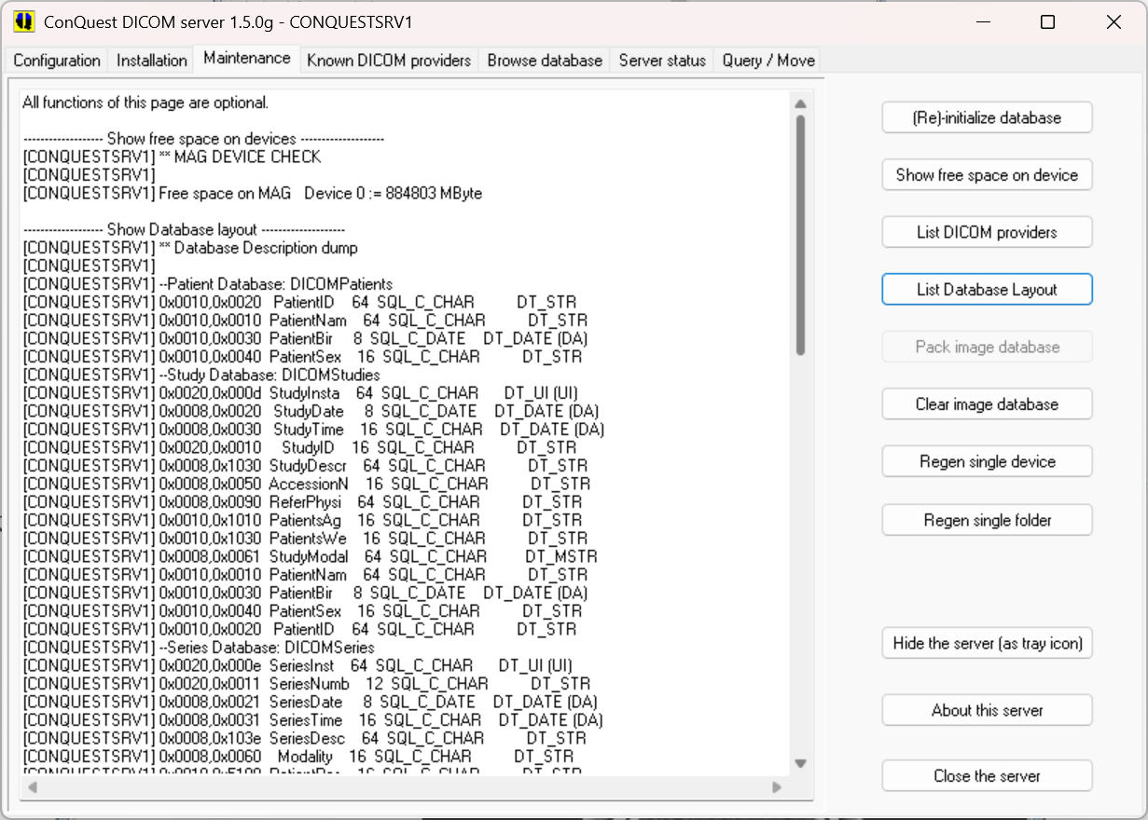

- Browse through the database and look at some pictures in the "Browse database" page. Click the image to show it and then right-click with the mouse for several extra options:

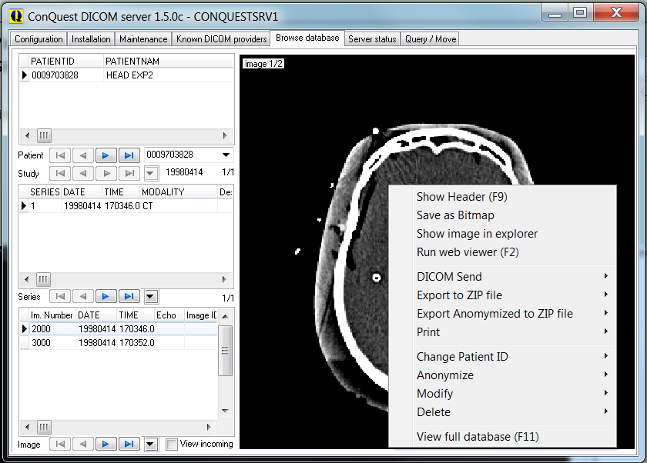
- "Show header (F9)" lists the DICOM header of the currently selected image. Use keys CTRL-A = select all, CTRL-C = copy to clipboard, CTRL-F = find text, CTRL-S = save as text file, F3 = search again, F9 = close.
- "Save as Bitmap" saves the currently visible file as windows BMP, JPG or GIF file. Multiframe images will be exported as animated GIF if GIF is selected.
- “Show image in explorer”. Opens a file explorer at the selected image.
- "Run web viewer (F2)" shows a bit more advanced viewer in a web browser, using the built-in (limited) web server.
Web viewer as opened from the browser.

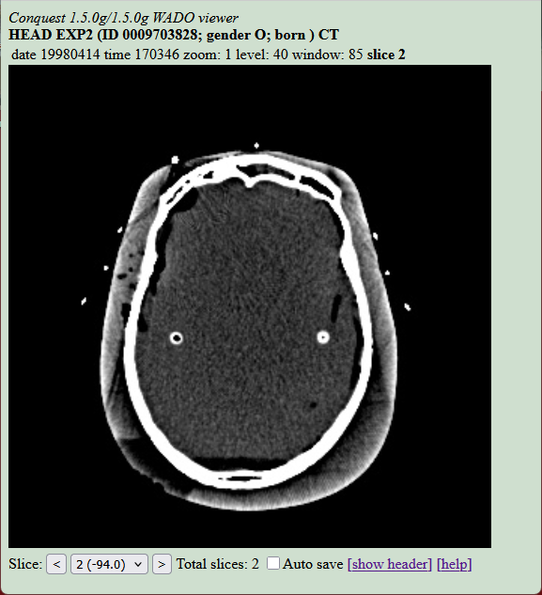
- Optional "Run external viewer" (if configured in dicom.ini) starts an external viewer program with the selected DICOM image as argument.
- The "DICOM Send" options allow sending the current image, selected images of the current series, the current series, the current study, or the current patient to another DICOM station.
- The "Export to ZIP file" options allow storing the current image, the current series, the current study, or the current patient in a ZIP file.
- The "Export Anonymized to ZIP file" options allow storing the current image, the current series, the current study, or the current patient in a ZIP file while removing any identifying information.
- The “Print” menu has options for: "Print Image on local DICOM printer" prints a full page printout of the selected image using the built-in DICOM print server on the default Windows printer. The "Print Selected Images on local ..." option prints a selection of images of the current series using a selectable page layout (default 4x6 images on a portrait page) on the default Windows printer. The "DICOM print selected images to ..." option prints a selection of images of the current series using a selectable page layout (default 4x6 images on a portrait page) on a selected DICOM printer (configured on “known DICOM providers” page).
- The “Change Patient ID” options changes patientID to a given value. Because of the changed UIDs, the changed slices will belong to new studies and series even if the patient ID is changed back to its original value. I.e., images with a new patient ID are considered as completely new images.
- The “Anonymize” options de-identifies the images according to a stand algorithm, which is provide in script lua/anonymize_script.lua. It can be modified if needed.
- The “Modify” options provide entry of a Lua script modifying the images. See below for more explanation. The "Merge selected series" sub-option will give a list of all series in this study and will next merge selected series (generating new UIDs for consistency). The "Merge selected studies" sub-option will give a list of all studies in a patient and will next merge selected studies (generating new UIDs for consistency).The "Split series" sub-option will give a list of all images in this series and will next split selected images from this series (generating a new series UID and new SOP UIDs for the selected images).
- The “Delete” options delete the selection from the archive; use with care. Sub-menu "Remove image from database" option effectively hides an image from queries (until the database is re-generated or the image is re-entered, e.g., by dropping it onto the server from an explorer window).
- The “View full database (F11)” option allows in-depth exploration of the database.

When the ‘View incoming’ check box on the browser page is set, each newly stored slice is displayed, with a red overlay of the calling AE. This options also displays incoming images to be printed. While this option is ON, the built-in elementary DICOM printer is disabled.
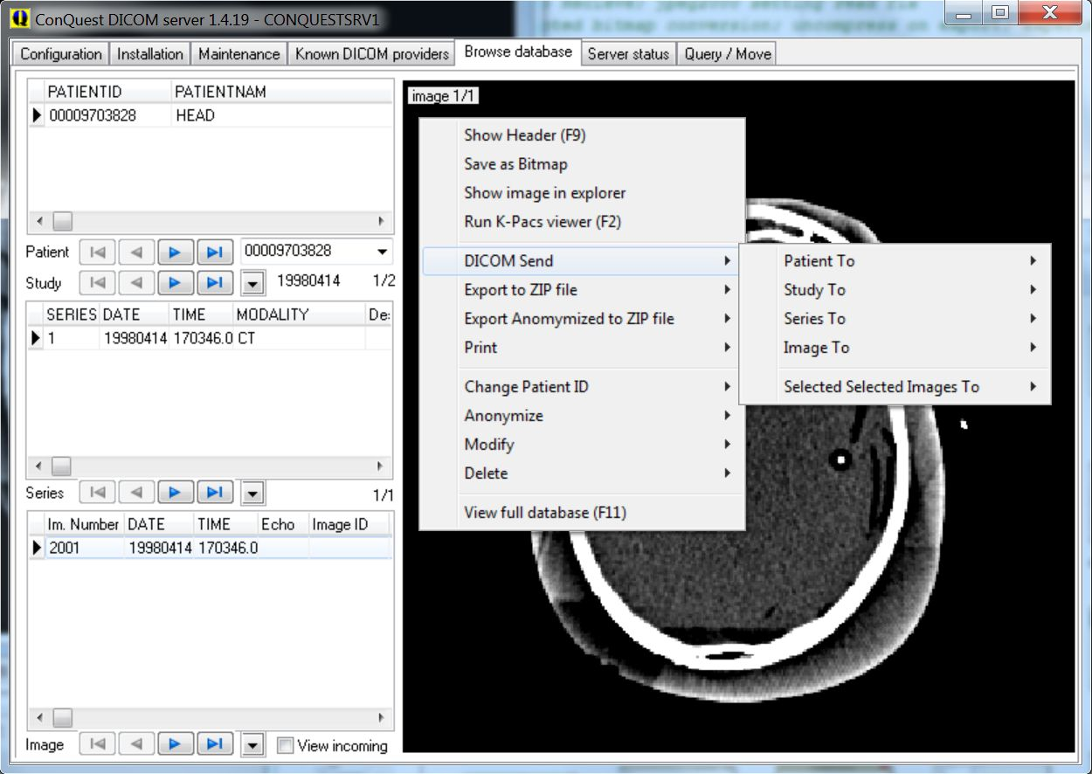
Database browser and its pop-up menu. The menu options typically have sub-menu for selecting this patient, this study, this series, or this image. In 1.5.0g the browser can sort; and there are several keyboard shortcuts to quickly look through the images

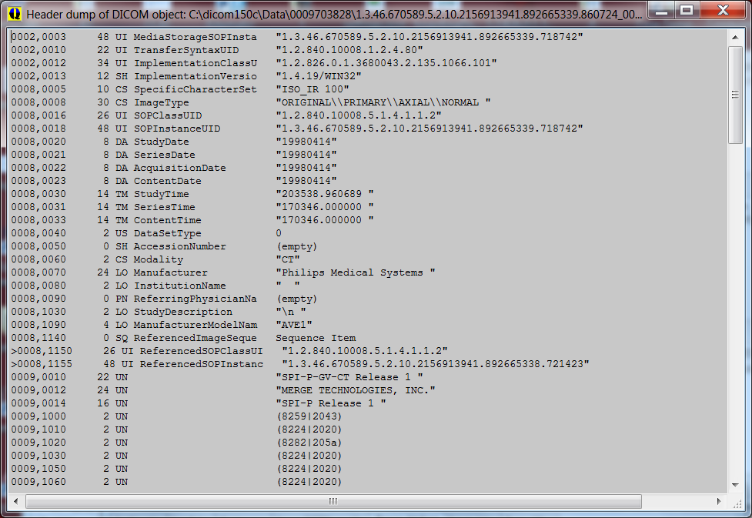
The header lister (F9) can be used for detailed exploration of the images. You can use standard keys CTRL-C for copy and CTRL-F and F3 to find (again).
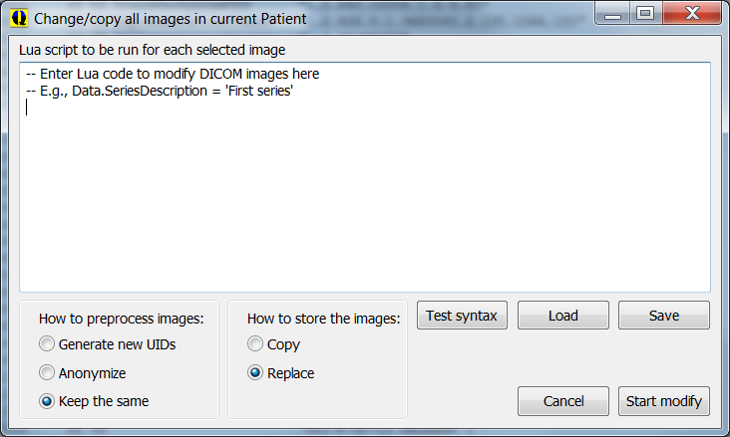
The modify window allows scripted modification of almost any property of one or more DICOM objects. The “Test Syntax” button runs the script on the selected image without storing the result and is therefore harmless. Its output is shown in a pop-up window. “Load” and “Save” load and save the script to file. “Start Modify” or alt-“Start Modify” is used to run the script on all selected images, press alt while clinkcing keeps this window open. Preprocessing includes generating all new UIDs, full anonymization, or keep the same. The Copy option many not be used with “keep the same”. For the Lua language see the manual below.

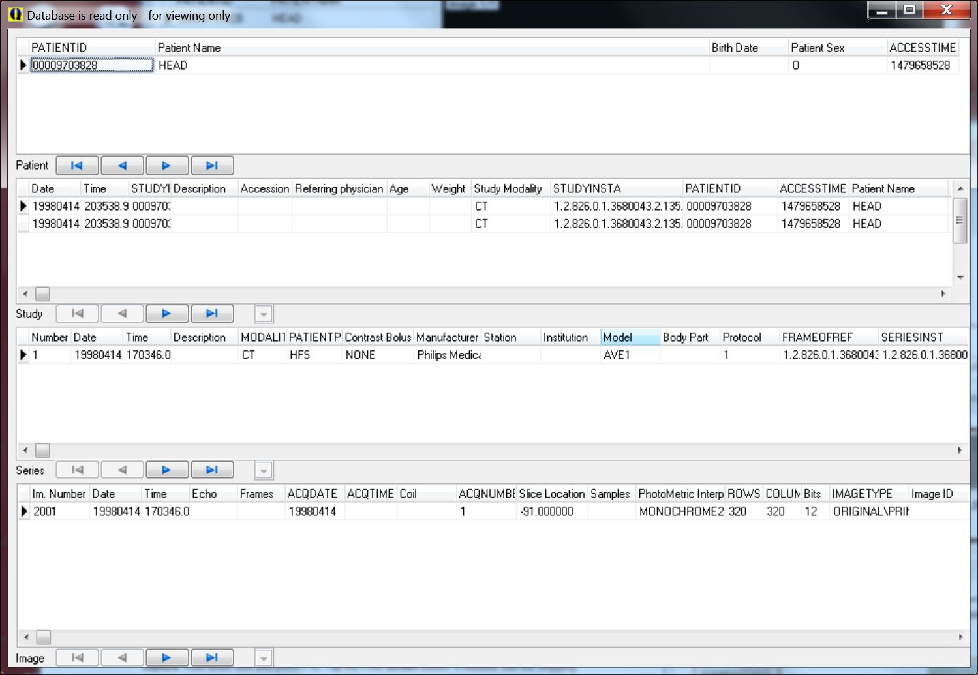
The view full database (F11) window.

Note that in some cases, the database browser may not correctly update changes made through the menu. In those cases, select a different page of the server and go back to the browser page to fully refresh the database browser, or enter a value in the filter box for patients.

3) Try to query or copy some images using the "Query / Move" page. You may query your own database or copy from your database to your database as a first test. Hint: try different "Query levels" and observe the results.

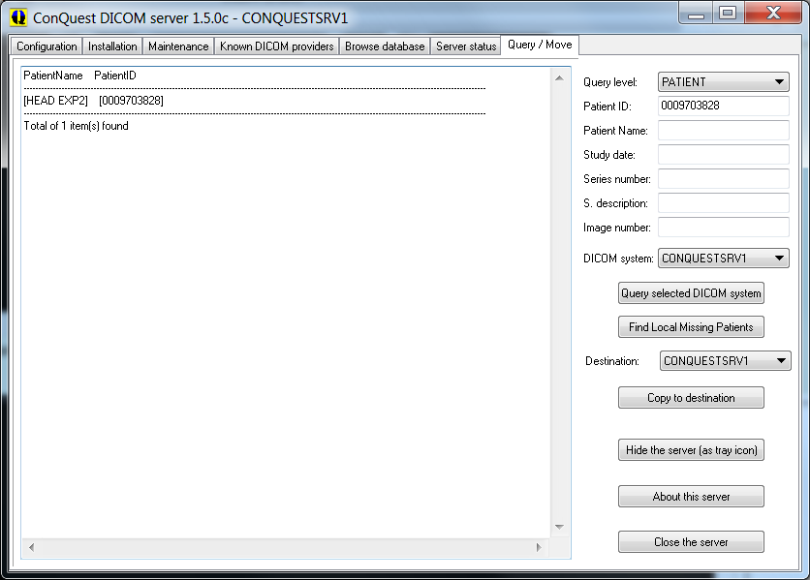
Query/Move page

To quickly fill in information such as the patient ID, double click on the result window where the patient ID is shown. Double clicking a patient ID with the control button pressed will add that ID to a comma separated patient ID list to copy several patients at once. This feature is only available for the patient ID. The "Query level" button also allows you to select three query methods.

The default method is a PatientRoot query, but lower in the list you will find query levels which use the StudyRoot and PatientStudyOnly query methods. These query levels are provided because many DICOM servers do not support the default PatientRoot query method. Default the queries are on human-readable entries. By double-clicking on the label next to the Series number edit box, the query mechanism switches over to using UIDs. This is less readable but supported by more servers. To read the long responses, it is possible to resize the GUI.

Finally, it is possible to query a modality worklist.

The "Find Local Missing Patients" button finds all patient data on the selected DICOM system that is not present on the LOCAL server for copying to a DESTINATION server. For example, to grab all new data from a CT scanner, enter today’s date into "Study date", select the CT scanner as DICOM system, and select the local server as DESTINATION. Push "Find Local Missing Patients", which may take a while. The missing patients (if any) are listed. Then push "Copy to destination" to copy the missing patients into the local server.

4) Entering DICOM or HL7 files into the server is provided through a drag and drop interface. Just drag and drop files or directories from the explorer to add them. The dropped files are copied into the data directory of the server and the database is updated to include the new files. Images of a single patient may be entered with a changed patient ID by pressing the ALT key while dropping the files or the directory. This latter option will generate new study, series and SOP instance UIDs for consistency. HL7 files update the worklist database only and patient ID changing is not available. A variety of compressed archives can be dropped as well, that will be decompressed by 7za.exe. Note that there is a limit of about 4000 files that can be dropped at once. If you have more, drop the folder instead.

5) Look at the "Server status" page to see connection activity and print server progress. To read long lines, it is possible to resize the GUI. This page also contains the "Kill and restart the server" button which is needed when the DICOM server has crashed (please report any crashes on the forum). Also from this page, a fully lua scripted built-in version of the webserver based on ladle can be run; this is not dependent on e.g. Apache, but is not suitable for production use. Right click the enable button to show the browser on the start page.

The "Hide this server (as tray icon)" and other buttons do what you expect of them. The small up/down arrows set the amount of debug information displayed when debug log is switched on (up=more, down=less). At high debug levels also internal communication from the server is logged.

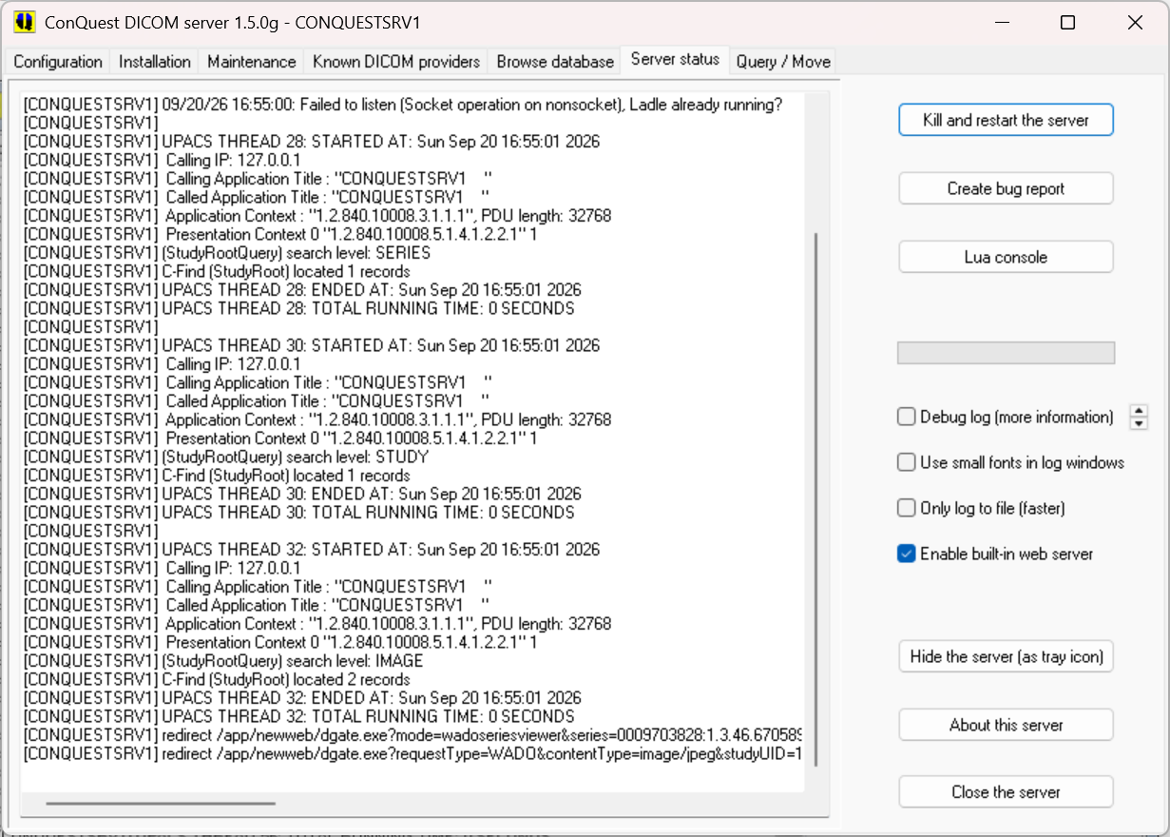
Server status page
2.1.2 Installing multiple servers on the same PC.

Installing two or more servers on one PC is a nice way to test DICOM since it allows copying and querying in a simple way. Many servers can be running simultaneously. However, it is essentially helpful to leave the first server(s) running while attempting to install new ones (otherwise the same TCP/IP ports will be used and the servers will fail to operate simultaneously). The installation must be done in different directories. So replace "c:\dicomserver\" by, e.g., "c:\dicomserver2\" and perform all installation steps again. The servers must be made known to each other using the "Known DICOM providers" page. If SQL server, MySQL or PostGres are used as database, each DICOM server should have its own SQL server database and login.

2.1.3 Updating to newer versions.

Typically, a new version can be installed by just replacing the exe and dll files with newer versions (it is a good idea to keep backups of the older ones). Note that in 1.5.0g, the executables stored in install32 and install64 folders must be copied manually when updating (normally the installer would do this automatically). Version 1.5.0g has a button on the New Installation window to copy all executable and script files from a new version to an older version. Download the zip, unpack it into a temporary folder and run ConquestDicomServer.exe to update an existing installation automatically. Note that this NOT UPDATE webserver files OUTSIDE the Conquest folder. It is imperative to copy these manually e.g. from c:\dicomserver\webserver\htdocs to c:\xampp\htdocs.

Naturally, the server must be stopped before files can be replaced. In case the server runs as a service it must be stopped using the control panel or by un-installing it as a service. To enable use of a new database layout (requires a full regen!) and/or new modalities and JPEG communication, the files dicom.sql and/or dgatesop.lst can be manually deleted prior to installation; new versions of these files are created when conquestdicomserver.exe is restarted.

To choose a new database driver delete dicom.ini, which also causes dicom.sql to be overwritten. Be careful, since installing a modified version of dicom.sql requires re-initialization of the image and/or worklist database using the buttons on the installation or maintenance page. Regeneration may take a very long time (several days to weeks) for large databases.

If you do not want to regenerate the database, keep a copy of your previous dicom.sql and restore it after upgrading.

Note: From 1.4.19a, the internal UIDMODs (anonymization key) table has changed. To update it after installing1.4.19 executables in older databases, push the 'verify database installation' button on the install page. If needed this will add the Stage and Annotation columns (see server status output).

This is equivalent to these command lines, which fail if not needed:

dgate --dolua:"sql('ALTER TABLE UIDMODS ADD COLUMN Stage varchar(32)')"
dgate --dolua:"sql('ALTER TABLE UIDMODS ADD COLUMN Annotation varchar(64)')"

Note2: From 1.5.0b; the same button adds an index to UIDMODS to optimise its performance. This is equivalent to this command line, which fails if not needed::

dgate --dolua:"sql('CREATE INDEX mods_joint ON UIDMODS (OldUID, Stage)')"

APPENDIX 1. Database setup and benchmarks

The conquest DICOM server can use any ODBC database and includes quite a few native drivers. Since there have been a number of issues with database performance, I decided to stress test a few database solutions a few years ago. The latest tests where done with postgresql-18.6-3-windows-x64 and mariadb-12.3.3-winx64. Note that since version1.5.0g the windows server will ask for the location of the driver DLL files during a first installation.

The benchmark is a set of queries that will duplicate a snapshot of our hospital’s Conquest research PACS (Built-in DbaseIII driver) from 2004 with 4.375 million images into a test server. The records are transferred through command "dgate –clonedb:conquestsrv1" on conquestsrv2 from conquestsrv1 to conquestsrv2. This is equivalent of a regeneration of a big server (14700 patients, 36000 studies, 195000 series and 4.375 million images), but EXCLUDING the read time of the objects. Hence we purely test database write speed – which is the most demanding database operation. The operation that is performed is that, for each patient, study, series and image, it must be found out if it already exists on the server. If not, the item is added else it is updated. The queries are special in the sense that the primary keys are DICOM UIDs, which are quite long strings. Next, a query test is performed where of 2000 patients all images are listed, on average 300 images per patient.

The recent tests were run a Intel I5 machine from 2015 with 4 Gbyte of RAM, without hyper-threading, running Windows 10 home, and using an SSD disk. Both source and destination servers run on the same machine, but in practice the source server is barely loaded.

MICROSOFT SQL SERVER (SQLEXPRESS 2014)

NOT RECENTLY TESTED. I downloaded sqlserver express SQL server 2014. As it required an ms account I downloaded it elsewhere. Download takes 10 minutes; it is a whopping 853 MB. sql server - start install. I disabled management tools; used named instance SQLExpress; enabled mixed mode; set SA password <pw>.
services - sqlbrowser - start (maybe needed because I disabled it at setup, needed at all if you guess the name?).

Then install a conquest server using SQL server for database. The server will first ask for the SQL server name. This is (local) for the default SQL server instance. If using SQL server express 2014 with a named instance, select COMPUTERNAME\SQLEXPRESS or similar as SQL server. The server then asks for a database name, login and password for the database to be used with the DICOM server. The database and login will automatically be created if they did not yet exists (harmless error messages appear if they did exist). Finally, the server asks the SA password to be able to perform the installation automatically.

Alternatively create database conquest, with login conquest (important: use SQL server authentication) with password conquest1415 by hand. Initialize the database. I then ran the clonedb task to load 4.3 million images into the system.

Write speed. With conquest 1.4.19, the clonedb operation took 1 h 57 minutes, over 600 images per second. There is no noticeable speed difference for large or small studies or early and late in the process. The database size is 3.13 GB. CPU Activity is 50% with 1.6 - 2 GB memory used for the SQL server and it is the most resource hungry of all servers.

Read speed. Quite fast: a fit shows 28 ms + 0.084 ms per record.

SQL server cannot be used from Linux and automatic ODBC configuration is doubtful on 64 bits OS's.

MARIADB

Installed xampp-windows-x64-8.0.10-0-VS16-installer (164 MB)- includes 10.1.10-MariaDB - with all defaults, and gave it a root password. Run xampp control panel as admin; made apache service and made mysql a service. Started xampp and then started mysql. Then I installed the conquest server using the Native MySQL driver option. The server asks for the root password to be able to install the conquest database, and it will then actually run as root database user by default: i.e., the database username is set to root. MariaDB works fairly slow without manual configuration, it works fine both in MYISAM or INNODB mode. The new test is with MYISAM.

Note that the server will also set the following registry entries to avoid that mysql chokes during extensive activity such as dropping thousands of files into the server:
HKLM\SYSTEM\CurrentControlSet\Services\Tcpip\Parameters\MaxUserPort = 65534
HKLM\SYSTEM\CurrentControlSet\Services\Tcpip\Parameters\TcpTimedWaitDelay = 30

Write speed. This clonedb operation took 5 hours and 6 minutes or 238 images per second, the slowest one tested. There is no noticeable speed difference for large or small studies or early and late in the clonedb process. The database size is 3.7 GB. Memory and CPU use are very small, I assume the default setup is optimized for memory and cpu use, but not for speed. Previously MySQL tests were much faster.

Read speed. Is still extremely fast: a fit shows 8 ms + 0.067 ms per record.

For MariaDB >= 10.2.4, the name of fields ‘Rows’ and ‘Colums’ can no longer be used. In 1.5.0 up these names are now initialized as ‘QRows’ and ‘QColumns".

BUILT-IN DBASE III Driver

The built-in dBaseIII driver runs out of the box. The parameter IndexDBF in dicom.ini should, however, be initially set to about 10 times the expected number of million images to be loaded in one session (the default allows loading 100.000 images before needing a restart). This allocates enough data to store the index buffer. Spare space is allocated when the server is restarted.

In contrast to the "real" sql servers, the DbaseIII only includes indexes on Patient ID. This index is kept in memory and generated each time the server is started. So, starting a large server takes several minutes (the source test server takes 8 minutes to start). This also means that any (image) query that spans multiple patients will be veryyyyyy slow – this should, however, not be a problem in routine use, as these queries are almost never used.

Write speed. The dbclone operation took 1 hour and 48 minutes or 675 images per second. There is some speed difference between large or small studies – small patient studies load a lot faster/ The database size is 6.1 GB, which is almost completely taken up by the denormalized dicomimages table.

Read speed. Even querying large patients (with 2000 images) takes about 1 second for a full image query from the test database of 4.374 million images. Queries that are not supported by the index (e.g., search individual images on patient name) take very long (minutes). Because the index is kept into memory, the server is very responsive once the index is done during server starting. Quite fast: a fit shows 12 ms + 0.1 ms per record.

This driver is no longer advised for production systems but is OK for upgrades. Use SQLite for small production systems.

Built-in SqLite driver

The setup runs out of the box. Just select the sqlite driver and install the server. Then I ran the clonedb task to load 4.3 million images into the system.

Write speed. The clonedb operation took 1 hours and 16 minutes, 961 images per second. There is no noticeable speed difference for large or small studies, however, write speed does goes down late in the process – when the database gets large. The database size is 2.9 GB.

Read speed. Queries to the server are reasonably responsive. SqLite can also be used in Linux. The query test fit shows a slow response time of 68ms + 0.33 ms/record.

PostgreSQL
I installed postgres 15.4 for windows x64 (353 MB), installed with all defaults, password <pw>.
The performance depends on the SYNC setting. If OFF, the clonedb operation takes 2 hours and 42 minutes (449 records per second). If SYNC is ON, it takes almost 6 hours (203 records per second).

NULL Driver
If no SQLServer name is entered in dicom.ini, a NULL driver is used for the database. This drivers accepts all writes and updates, and responds with 0 records for any query. This driver is useful for speed testing, to run database-less image receivers, and for DICOM routers. With the NULL driver, the server clone operation took 0 hour and 49 minutes (over 1400 images per second). This is the overhead of the server.

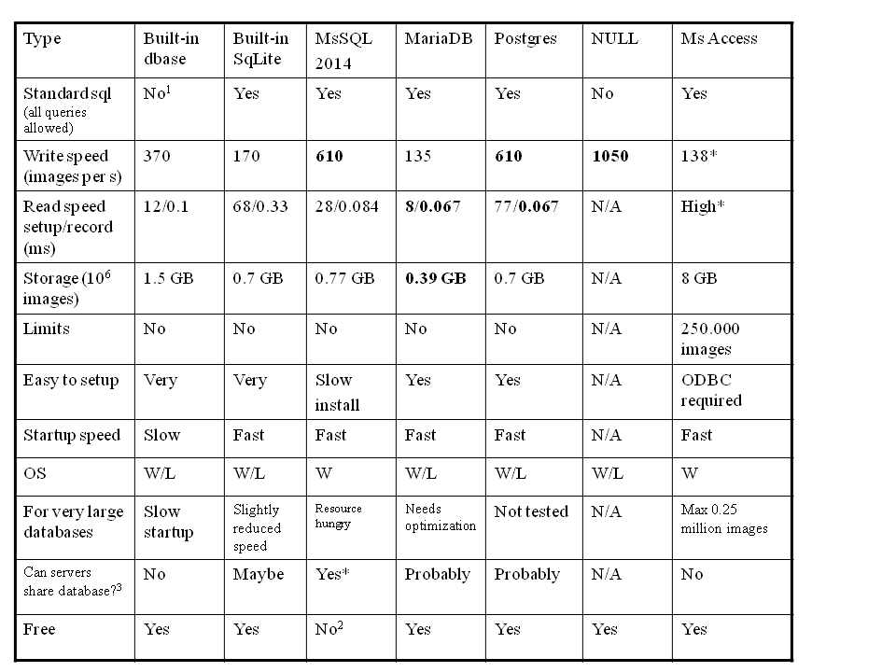
Table. Summary of older database tests: tested writing 4.375 million images and then performing queries listing all (average 300) images per patient. Notes: 1) Queries into the image that do not pass a patient ID are very slow, and not all fields can be queried at all levels. 2) Free For personal use. 3) Useful for multi-headed archive: multiple conquest servers running against the same database and data storage: they all show the same images, and can use mirroring to allow fast access to images for e.g., different hospital departments. *) Not recently tested.

Conclusions

See the table above. For beginner users the built-in Sqlite drivers is perfect: it is built-in and therefore easy to install and also extremely fast for common queries. DbaseIII works OK but should be avoided for large production systems. Best performance is found with Postgres. More experienced users may benefit from SQL server although performance problems occur under certain situations. Using Microsoft Access should be avoided.

Since database speeds are similar, familiarity with a database may be the best reason to select one!

APPENDIX 2. Using Conquest as a DICOM router and gateway.

The Conquest DICOM server has functionality to route incoming DICOM images to other servers (DICOM router) and to forward incoming query/move requests to other servers (DICOM gateway or virtual server). The first option is often used to distribute images over multiple servers based on filters. The second option makes Conquest a perfect image cache and/or central point of access for your hospital’s PACS.

Configuration of both options is through DICOM.INI. It is advised to only change DICOM.INI when the server is closed, as "save settings" in the GUI will overwrite your fresh changes. However, for making things work: most items can be changed while the server is running except ExportConverters.

Import and export converters allow automation of many DICOM related tasks. They run as follows:
As an image comes in these are run one by one in order:
ImportConverter0
...
ImportConverter99
Then the image is stored in the database and stored on disk.
Afterwards ExportConverter0 .. ExportConverter19 occur, which are all running in parallel in random order.

DICOM Routing

The following shows some examples of DICOM routing. There are 6 export converters installed (out of maximal 20: ExportConverter0..19), with different filter options:

ForwardAssociationLevel = SERIES
ForwardAssociationCloseDelay = 5
ForwardAssociationRefreshDelay = 3600
ExportConverters = 6
DelayedForwarderThreads = 1

ExportModality0 = CT
ExportStationName0 = CT_SCANNER
ExportCalledAE0 = CONQUESTSRV1
ExportCallingAE0 = CONQUESTSRV2
ExportFilter0 = Rows = 512 and Columns = 512
ExportConverter0 = forward to SERVER1

ExportModality1 = MR
ExportConverter1 = forward compressed as j2 to SERVER2

ExportModality2 = RT*
ExportConverter2 = forward to RTSERVER; forward to RTSERVER2 org MYSERVER

ExportConverter3 = forward patient to VIEWERAE after 60
ExportConverter4 = forward study to SERVER3
Exportconverter5 = ifequal "%u","SERVER2"; stop; between "9", "17"; defer; forward to SERVER2
ExportConverter6 = forward study to PACS after 60 script lua:Data.PatientName=''

The item ExportConverters determines the number of converters in use. An export converter is an external or internal program that is run for each incoming image slice of prescribed Modality, StationName, CalledAE and CallingAE (* matches anything, this is the default value). Note that an empty string is not the same as ‘*’, empty string will only match, e.g., empty Modality.

Files that match all items above are tested against an optional SQL statement in ExportFilterN, e.g., ImageNumber LIKE '1%' matches all images with an image number starting on 1. All fields in the database can be used in the SQL statement with the exception of PatientID (ImagePat may be used instead), StudyInstanceUID and SeriesInstanceUID. Since the SQL filtering is relatively slow it is advised to also/only use the hard coded filter options.

Note: When the built-in dBaseIII driver is used, filter queries are limited to fields in the de-normalized image table, and only queries like: ImageNumber LIKE '1%' and Modality = ‘MR’ are supported. Supported fields are listed in the DICOMImages definition in dicom.sql, and only the and keyword is supported. Spaces should be used exactly as in the example.

The ‘forward compressed as .. to’ option may use any style of NKI or JPEG compression using the same values as defined for DroppedFileCompression. In the example, MR is forwarded using loss-less JPEG compression to SERVER2. The 'org' option for “forward to' and 'forward compressed as xx to' allows setting the name of the originating server. This may be used to allow a DICOM router mimic the original sender.

When an export fails, exports on that converter are blocked for 60 s (=FailHoldOff); while 100 s (=RetryDelay) after the last failure they will be automatically retried based on data stored in files like ‘ExportFailures5678_0’ (where 5678=port number, 0=converter number). These files may sometimes need to be deleted (the GUI asks so at startup) to stop endless retries or limit the number of retries by setting MaximumExportRetries other than 0.

The flag ForwardAssociationLevel may have values [GLOBAL, SOPCLASS, PATIENT, STUDY, SERIES, IMAGE]. Forwarders keep the association open as long as the UID at ForwardAssociationLevel does not change. The default is SERIES, creating a new association for each series. By changing to more global settings more images are sent per association, improving performance.

However, associations are always closed when a new image type [SOPCLASS] is sent that was not sent before by this converter. After ForwardAssociationCloseDelay seconds of inactivity (default 5), the association is closed. After ForwardAssociationRefreshDelay seconds of inactivity (default 3600) the list of known sop classes is deleted. This latter option avoids having to restart conquest when other servers change their capability.

The ‘forward patient to ’ option is a 10 minutes (configurable though ForwardCollectDelay, or using the 'after' clause) delayed forward of the entire patient study (entire study or series can be handled in the same way) to another server. I.e., even if a single image is received, the entire patient is forwarded. This is useful to ensure that all data at a given patient level is available when forwarding i.e., a new image to a viewer like k-PACS (needed for the typical situation where a physician would like to compare a new scan with older scans, giving fast access). It is also useful to ensure that all data is transmitted on a single association. Other new delayed export and import options are "prefetch" (read data from disk to put it in cache, useful when data is stored on hierarchical storage) and "preretrieve SERVER" (collect all data on incoming patient from server, useful when conquest is used as cache for a big PACS). Each line is executed on its own Delayed Forwarder Threads in order of reception. Data that is collected by a "preretrieve" statement is not processed by import- or export-converters. The maximum number of retries for these delayed options is set through MaximumDelayedFetchForwardRetries.

Export converters lines are executed asynchronously (they are queued in memory in a queue of QueueSize length) but will somewhat slow down operation of the server. If one line contains multiple commands (separated by ;) these are executed one by one in sequence. In- and exportconverters now have a small scripting language and/or lua; allowing even more flexibility in routing, see A5.2.1, page 31.

Exportconverter5 is a real-life example of this scripting language. This script uses the commands 'ifequal "%u","SERVER2"; stop;' to ignore all data with calling AE of 'SERVER2'. This will avoid any data from SERVER2 to be sent back to SERVER2 causing a potential loop. The commands 'between "9" and "17"; defer' cause the converter to wait until after 17:00 before subsequent commands are processed using the retrying mechanism. The last command forwards the data to SERVER2. Having a similar line in SERVER2 forwarding to SERVER1 will cause both servers to synchronize after 17:00 without a loop.

Exportconverter6 show how image data can be changed during transmission. This particular example removes the patient name for privacy reasons.

Note that in version 1.5.0b up, moves may be made multi-threaded using scripting as follows:

[lua]
association=require('association') – contains several utility functions

RetrieveConverter0=mtmove(2) – this forces all moves to be 2-threaded

or

RetrieveConverter0=mtmove(2, function() find_amap(Command.MoveDestination)[5] end)
– this adds a 5th column to ACRNEMA.MAP where the number of threads is set for each AE

DICOM Routing without database

The following demonstrates database-less DICOM routing using ImportConverters:
SQLHost =
SQLServer =
Username =
Password =
ForwardAssociationLevel = SERIES
ImportConverter0 = ifequal "%m", "CT"; { forward to AE1 channel *; destroy; }
ImportConverter1 = ifequal "%m", "MRI"; { forward to AE2 channel *; destroy; }

The empty database entries makes that the system uses a NULL database driver. The “destroy” command in the ImportConverters stops the data from being stored on disk. Setting the ForwardAssociationLevel limits the number of associations used to connect to AE1 and AE2. Note: ExportConverters or delayed forward statements (such as “forward study to AE”) cannot be used in this setup since the images are not stored and therefore cannot be transmitted later. The clause “channel *” is an option of version 1.4.17b or higher, it splits simultaneous incoming connections over multiple outgoing connections. Best is to use only one forward statement per ImportConverter line.
Note that also Lua scripting may be used to program forwarding in several ways.

DICOM Gateway or virtual server

DICOM gateway operation is simpler. Just add lines like these to your DICOM.INI:
VirtualServerFor0 = SERVER1
VirtualServerFor1 = SERVER2,CACHESTUDIES
VirtualServerFor2 = SERVER3,CACHESTUDIES,NONVIRTUAL

Queries and move requests sent to the local server are forwarded to the given AE titles in VirtualServerFor0..9. The AE titles must be known in ACRNEMA.MAP. The client will effectively see all data of the listed servers and this one merged – at the cost of query speed. The merging occurs during each query in memory. When moves are performed, images retrieved from the listed servers are stored locally (i.e., the server functions as a DICOM cache). This option makes Conquest a perfect image cache and/or central point of access for your hospital’s PACS.
With version1.4.15, a flag VirtualServerPerSeries0..9 has been added. It defaults to 0, meaning that a virtual server collects images on an image per image basis. In some cases this may not work, setting this value to N means that if there are more than N images to be collected this will be done on a series per series basis. Set the flag to 1 to collect all data per series. For Kodak, N should be set to about 800.
Since 1.4.16, server names may also be appended with ',CACHESERIES' or ',CACHESTUDIES'. In this case, repetitive queries in the IMAGE table are cached locally at SERIE or STUDY level, under the following filenames: MAG0\printer_files\querycache\YYYY\MMDD\xxxxxxxx.query and MAG0\printer_files\querycache\YYYY\MMDD\xxxxxxxx.result. This option typically makes access to slow DICOM servers much quicker. Also option OverlapVirtualGet has been added, if set other than 0, data coming in for other (virtual) servers is transmitted directly through to clients. The value determines how many objects are kept in memory. Add flag ',NONVIRTUAL' to instruct the virtual server (this works only when connecting to Conquest DICOM systems of a recent version) to not forward requests to its own virtual servers (to avoid loops and double entries).
APPENDIX 3. How to set up a Redundant Conquest DICOM Server in a Two-Node Windows Cluster Environment

Alternate Titles I couldn't decide :)
Conquest Redundancy in Eight Easy Steps
Conquest Freedom in Eight Easy Steps
Conquest Cluster in Eight Easy Steps

To set up Conquest in a failover, redundant environment that will be virtually seamless to end-users who need a highly reliable system, we installed Conquest in a Windows Clustered environment. This environment is Active/Passive meaning that only one node has control at any time of the shared drive where all the images are received. The second node sits passively waiting to be manually or automatically failed-over.

This how-to will not explain how to install and configure Windows Clustered Services. There are many documents online detailing how to set up a 2+ node Windows Cluster, and Windows Cluster fundamentals. Setup will require the expertise of a Windows server administrator.

In our case, the cluster environment already existed and we installed Conquest as a DICOM server/listener on these existing servers. If the cluster is in place, you can set up and test all of the following in a couple hours especially if you are already familiar with Conquest

SET-UP

OS: Windows 2003 Server, Clustered Environment
FileSystem: Veritas Volume MGR installed to manage SAN shares - you can use whatever you want as long as there is a shared drive available.
Nodes: Server A (192.168.1.6), Server B (192.168.1.7)
Virtual IP Address created for cluster: 192.168.1.5
Local drive letter: C:\
Clustered drive letter: G:\ drive for example represents a SAN share that is available to the active node in the cluster
DICOM SCU Device: any CT scanner, DICOM workstation, or other hospital
PACS, in our environment we use TeraMedica Evercore since we require storage of DICOM-RT and DICOM-RT-ION.

INSTRUCTIONS

(1) Set-up two Windows 2003 servers if not already in place. Configure clustered services and a shared drive if not already in place.

(2) Once the cluster is configured, you should have a drive letter typically mounted from a SAN that is shared to only one server node at a time. In this case, we call it G:\ drive.
(3) Once the cluster is configured and tested for fail-over, you will have a Virtual IP address (e.g., 192.168.1.5) and two physical servers: Server A (192.168.1.6) and Server B (192.168.1.7). When you ping the Virtual IP, you are actually pinging whatever is the active node in the cluster. Once you complete all steps, when ever you send DICOM data to the Virtual IP, you are actually sending it to whichever node is active as the primary node.
(4) Install Conquest on the active node local hard drive C:\

(5) The active node is connected to the shared, clustered drive, G:\ drive in our case. Configure Conquest to use some G:\ path instead of C:\ path for all DICOM files. Configure Conquest to use the same exact AE Title and port number on both nodes. You can use the default AET/port# provided by Conquest
(6) Install Conquest as an NT Server Service so that it will run 24/7 listening for incoming data. Follow the rest of the Conquest instructions for customization, setup, etc..

(7) Failover or ask your Windows Server Admin to failover to second node, Server B. Now that Server B is the active node. repeat steps #4, #5, #6 on Server B.

(8) IMPORTANT: now configure your CT scanners, PACS, other DICOM SCU device to send ONLY to the "VIRTUAL IP" address for the Windows Cluster (e.g., 192.168.1.5). This means that no matter which node is currently active, all the files will go to the G:\ drive. Both nodes have the same port# and AET, but it won't matter since only one node is actually receiving data at a time, because only one node receives data through the virtual IP.

Conquest is technically listening actively on both nodes but it doesn't matter. All DICOM data is being sent to the virtual IP address so only the active node that is actively connected to the G:\ drive will actually receive the data. As soon as cluster is failed-over to second, passive node, then that server becomes active and starts receiving the DICOM files.

We tested this many times causing the nodes to fail-over while actively sending files before and during a fail-over. It works pretty well and usually our DICOM SCU's just attempted to resend if it failed while the nodes were in the middle of a fail-over. Your mileage may vary, but it makes your system a lot more redundant and you don't have to worry about any single server point of failure. Although this was done in a Windows Cluster, I'm sure you could create the same situation in a Linux Cluster.

Happy ConQuesting!
Kim L. Dang
APPENDIX 4. Using CONQUEST WEB server

Since version 1.4.8, a small WEB interface has been built in into the Conquest DICOM server. From 1.5.0e conquest web always uses PHP (or pure Lua scripting). To enable it, you need a webserver with PhP enabled that allows rewriting with .htaccess. XAMPP works fine as test web server with little or no configuration. After installation, copy the contents of folder c:\dicomserver\webserver\htdocs to e.g. c:\xampp\htdocs. The pure Lua web server is built-in and can be enabled from the the GUI.

Security. From version1.5.0g, many webserver functions are by default restricted to a client running from the same server, opening http://127.0.0.1/app/newweb. To enable other users add a similar section to dicom.ini:

# Configure IP based access control (first processes DeniedIPs than AllowedIPs)
# default 127.0.0.1 only: Archive,Change,Move,Remote,Script,Status,Store,Wado,Zip,Stow,Delete
# default all allowed: Cverification,Cfind,Cmove,Cget,Cstore,Cmovedest
AllowedIPsStore = 192.168.0.*
AllowedIPsMove = 192.168.0.*
AllowedIPsZip = 192.168.0.*
AllowedIPsChange = 192.168.0.*

Each DeniedIPs OR AllowedIPs line can contain a comma separated list of IPv4 addresses or ranges and Ipv6 addresses or ranges (the latter only USED for the web interface). List entry forms accepted:

1.2.3.4 exact Ipv4
192.168.1.* legacy IPv4 wildcard
192.168.1.0/24 IPv4 CIDR
::1 exact IPv6, any notation, any case, any leading zeros
2001:db8::/32 IPv6 CIDR
2001:db8:* iPv6 wildcard, cut on a group boundary
* everything
none nothing (kept for compatibility with the old default)

Note that webservers depend on REMOTE_ADDR for filtering these requests. If you use a forwarder or proxy service, REMOTE_ADDR will show the address of that service. Install Apache module mod_remoteip, with RemoteIPHeader X-Forwarded-For and RemoteIPTrustedProxy set correctly to make sure the client address is used to filter requests.

In the HTDOCS folder you will find a DICOMWeb api (api/dicom), and three applications: app/newweb, the classic conquest interface; app/luiz, a simple Cornerstone based viewer by Luiz Oliviera, and app/ohif, a demo version of OHIF1.03.

In the classic Conquest web interface the dgate executable is called from PhP to emulate the CGI interface used before that connects to the dicom server (another dgate executable) that runs elsewhere (most likely on the same computer, but may be on another computer, if allowed by IP list above). Its address and port are set in config.php (a quite similar file is provided for api/dicom):

<?php
$folder = '.'; // where are the newweb files
$exe = 'dgate -p5678 -q127.0.0.1'; // communication with DICOM server
$quote = '""'; // quotes in command line

if (PHP_OS_FAMILY != 'Windows') { // On Linux:
$exe = './' . $exe; // start as ./servertask
$quote = '\"'; // quotes in command line
}

$userlogin = false; // uses single file login system
$wplogin = false; // uses wordpress login system
$cors = false; // allow cross site use

It also uses it own DICOM.INI to set various things like the selected viewers and readonly mode, but no longer the port and address. The communication goes through a private DICOM interface.

About dicom.ini: The settings under [sscscp] configures Tempdir which should be set to a folder that cgi applications have right to read and write. The webdefaults entry defines the size of the viewers, downsize of image before display (0 is none), compression for DICOM based viewers, size of icons in the thumbnail view, mode of display for graphical images, and viewers used for displaying the images. The block of settings including DefaultPage and AnyPage make that only the listed web pages are available. It effectively blocks the CGI web interface used in 1.4.17. Note that AnyPage and DefaultPage must both be defined to block pages of the built-in webserver such as “top”.

This setup has been tested with Apache servers. For Linux or Unix, the file dgate.exe is replaced by the file dgate. Since 1.4.16, the web interface also accepts WADO requests. Since 1.4.17, the web server may be used as a WADO bridge for any DICOM PACS. Web pages can be scripted by the user in the Lua programming language, or in any other language if the DICOMWeb api is used.

Normally the app runs form a full-feature web server. Alternatively, in 1.5.0 the web interface may be accessed for testing from the windows GUI on the server status page, where a checkbox “Enable built-in web server” has been added. This starts a pure Lua mini-web-server based on ladle (https://github.com/stpettersens/ladle). After checking the box, right click it to open the newweb interface. This interface is quite limited but is good to test or demonstrate the web-server code prior to installing and configuring it on a full web server.

To open the normal web interface browse to:

http://127.0.0.1/app/newweb/

or (for Ladle built-in server):

http://127.0.0.1:8086/app/newweb/

If $userlogin (PHP only) is enabled, it will first show a simple login page:

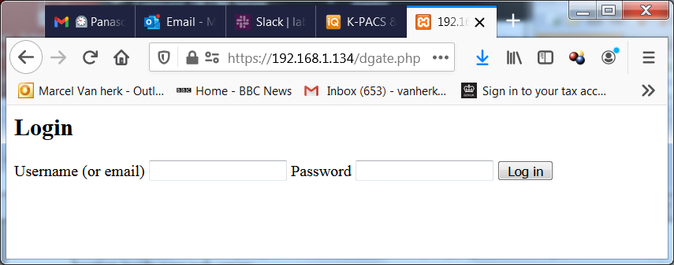

In dicom.ini you define the admin password as follows:

admin_password = password

After entering 'admin', 'password' it opens the main page. The admin (logout) button top right and the link to register new accounts are only shown if $login = true.

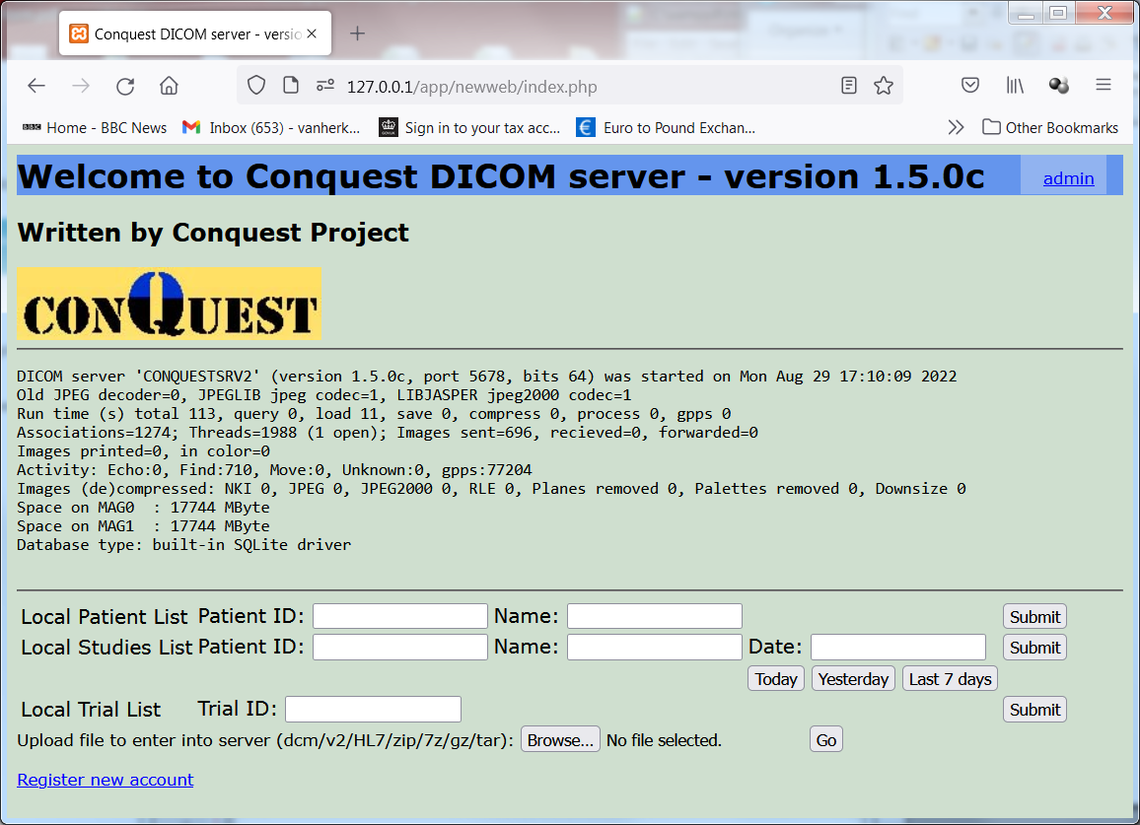
If the upload section is not shown store access has not been enabled for the remote IP address in dicom.ini (see security section above)

From this window you go to the patient or study list:

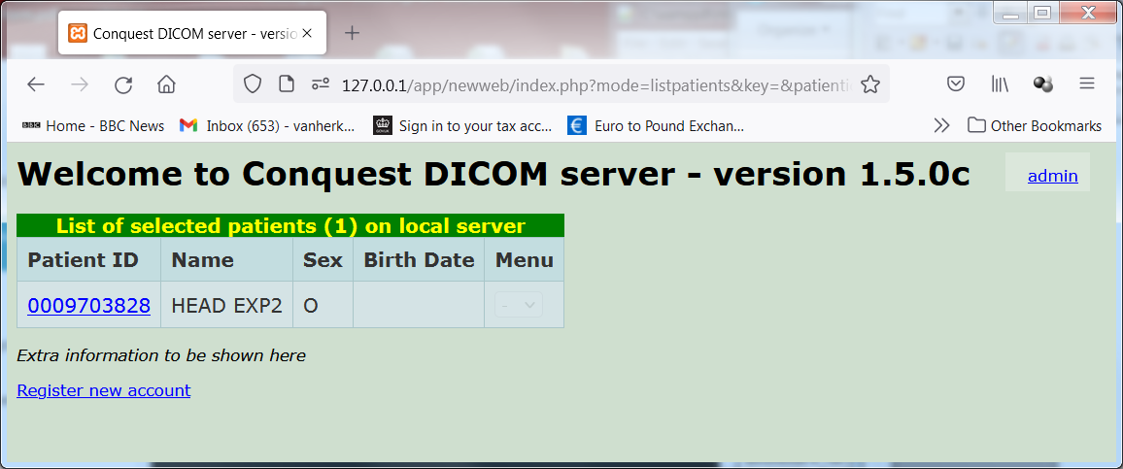
Then to a study list, series list and image list. In the series list there is a 'thumbs' link that shows thumbnails of a sub-selection of all images if there are many:

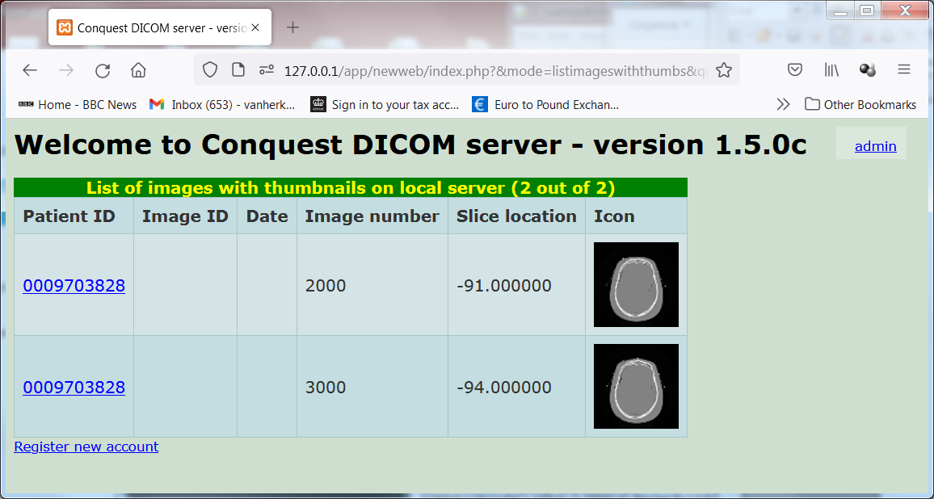
The menu icon at most levels shows these options, depending on the access configuration for the remote IP address in the security section above:

-
- Send A list with servers to send to is shown
- Change Patient ID A box to enter the new ID is shown
- Anonymize A box with the new Patient ID is shown
- Delete The deletion asks for confirmation
- Zip Zipping asks for confirmation
- Zip anonymized A box with the new Patient ID is shown
- View A link is shown or viewer opens in window
- Cancel Does nothing

A study and series level viewer are included: On the study viewer, the left size of the page shows a list of all series in the selected study. Clicking the arrow next to a series brings it up in the image viewer on the right side of the page. In the series level viewer, the series list is absent but other viewer functions are identical.
By hovering the mouse over various elements around the viewer pane a hint line is displayed below the viewer pane providing hints for use of the mouse and the keyboard.
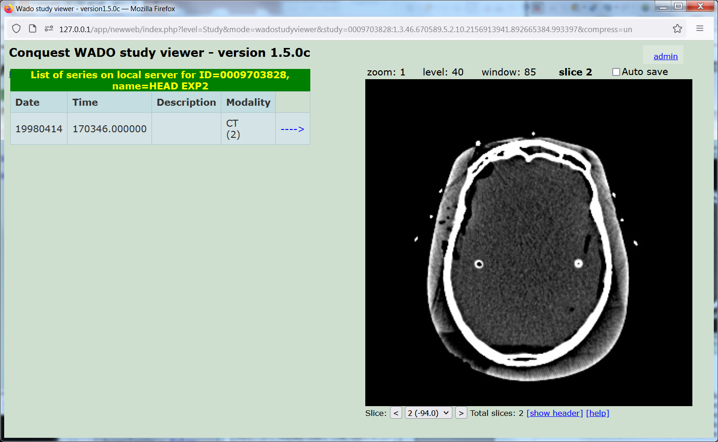
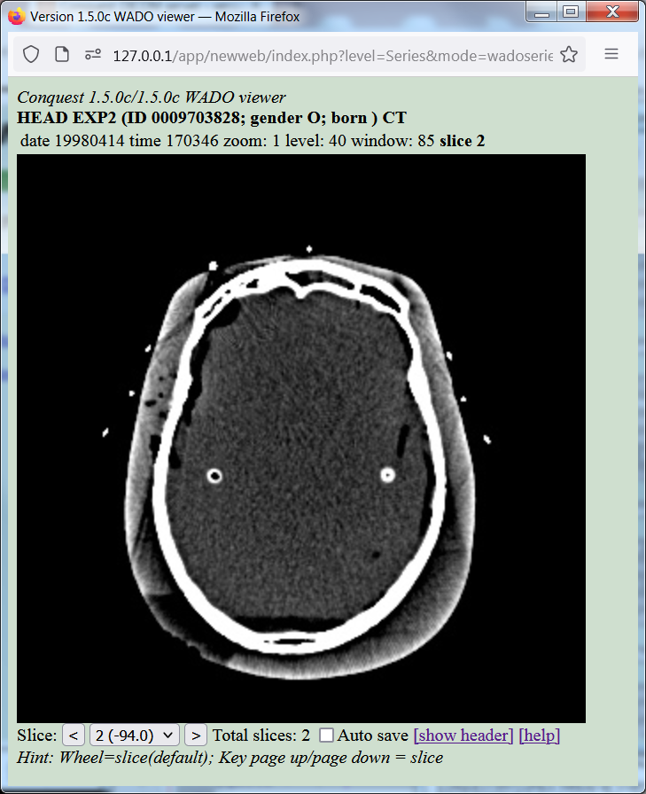
Built-in web viewers at study and series level. They can zoom/pan/slice/level/window and frame the images using the mouse wheel.

Slice
To page through the slices of a series you can hover the mouse over the slice text above the viewer or the viewer area itself and rotate the mouse wheel. Alternatively you can use the page up/down keyboard keys. If you click on the slice text you can enter the requested slice number. Below the viewer area you can use the < and > buttons to slice down or up, or select a slice from the dropdown list between these buttons, that shows the slice number and coordinate of all slices.

Zoom and pan
To zoom the slices of a series you can hover the mouse over the zoom text above the viewer and rotate the mouse wheel. Alternatively you can use the I and O keyboard keys for zoom in and out respectively. Keyboard keys F resets the zoom. If you click on the zoom text you can enter the requested zoom factor numerically. After zooming you can use the arrow keys to pan the image.

Level and window
To change the contrast of the slices of a series you can hover the mouse over the level or window text above the viewer and rotate the mouse wheel. Alternatively you can use the B and D keyboard keys for brighter and darker respectively and H and L keyboard keys for higher and lower contrast. Keyboard keys P load the preset level and window, and A disables windowing at all. Key N makes the display negative. If you click on the level or window text you can enter the requested level and window values numerically.

Frame
For a multiframe object only. To page through the frames in an object you can hover the mouse over the frame text above the viewer and rotate the mouse wheel. Alternatively you can use the U/V keyboard keys. If you click on the frame text you can enter the requested frame number. If this is the only image in the series you can also use the wheel over the viewer pane itself or the < and > buttons below the viewer, or the page up/down keys.

Other functions
If you check Auto save changes to level, window, slice, zoom and pan are saved and restored for each series. Link [show header] or keyboard key Q lists the textual image header. Link [help] displays this text.

The web interface can be changed to open a range of viewers. However, due to external dependencies these may not always work. Look at the xxx_starter.lua files for weasis, papaya and dwv. For instance, modify this entry in the dicom.ini of app/newweb to apply Weasis as study level viewer (not recently tested):

studyviewer = weasis_starter

Then install Java; and download weasis-portable.zip (14.2 MB) and unzip it into e.g. folder c:\xampp\htdocs\weasis. Folder htdocs/weasis should exist and contain files such as weasis-launcher.jar, and folders such as conf.

If you open a study viewer, a jnlp file is created which should launch Weasis (not supported in all browsers, this is from Firefox):

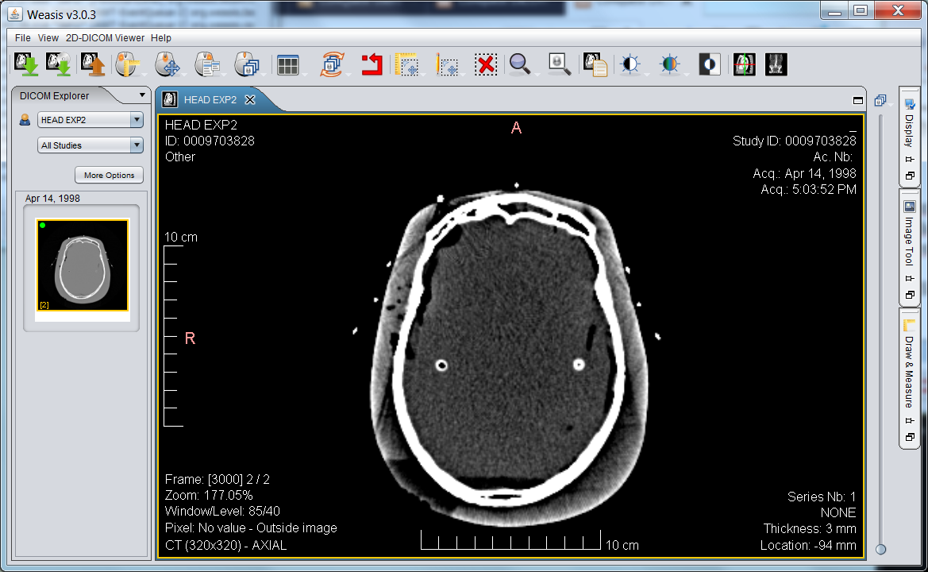
Since version 1.5.0d, also DICOMWEB has been enabled and OHIF can be run. An embedded demo version of OHIF 1.0.3 is included, without extensions.

It can be called as http://localhost/app/ohif, or http://localhost:8086/app/ohif. The latter is for the built-in server.

OHIF with extensions has been tested including submission of measurements. A 7zipped version of OHIF including extensions is in the install file. Unzip it to ohiftop to try it out.

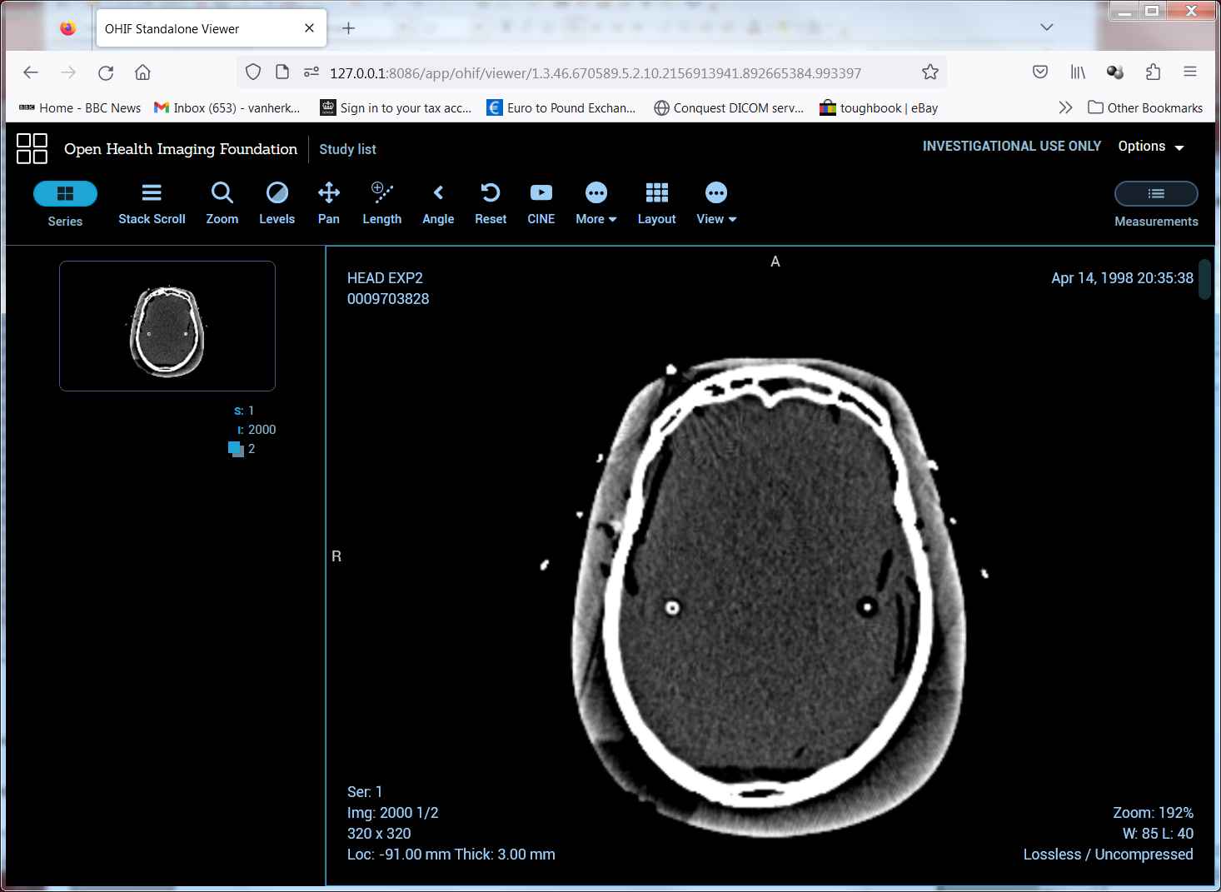
WEBSERVER DETAILS

A dicom api is provided by running scripts in a PhP enabled webserver with url rewriting enabled, with extended memory limit and upload limits recommended. Luiz Oliveira has provided a Node.js based api as well which is in principle compatible but not maintained by me.

Features required for DICOMWeb are enabled by (Linux command-line example):

sudo a2enmod rewrite
sudo sed -i 's/AllowOverride None/AllowOverride All/g' /etc/apache2/apache2.conf
sudo sed -i 's/memory_limit = 128M/memory_limit = 512M/g' /etc/php/*/apache2/php.ini
sudo sed -i 's/upload_max_filesize = 2M/upload_max_filesize = 250M/g' /etc/php/*/apache2/php.ini
sudo sed -i 's/post_max_size = 8M/post_max_size = 250M/g' /etc/php/*/apache2/php.ini

Note again that Conquest webservers depend on REMOTE_ADDR for filtering http requests. If you use a forwarder or proxy service, REMOTE_ADDR will show the address of that service. Install Apache module mod_remoteip, with RemoteIPHeader X-Forwarded-For and RemoteIPTrustedProxy set correctly to make sure the client address is used to filter requests.

Followed by copying the webserver/api and webserver/app folders to the root of the webserver for an Apache server (on Linux this is done by installer software).

In api/dicom/config.php one can set the target server (default port 5678 on localhost) and optionally enable user authentication:

$exe = 'servertask -p5678 -q127.0.0.1' // sets port and IP of Conquest
$userlogin = false; // uses sample single file login system
$wplogin = false; // uses Wordpress login system

The built-in server based on Lua Ladle also serves the API and should be ready to go without any installation. The internal webserver is started by the button on the Windows GUI, or by the following command line (Linux example):

./dgate "--luastart:require([[ladle]])({port='8086'})"
The internal webserver is stopped by the button on the Windows GUI or by (Linux example):

./dgate "--luastart:package.path=Global.basedir..[[lua/?.lua]];dofile(Global.basedir..[[lua/quitladle.lua]])"

The provided http endpoints in the DICOM API are:

http://localhost/api/dicom Root of extended DICOMweb API in Apache
http://localhost:8086/api/dicom Root of extended API built-in webserver

GET / About the API
GET /wadouri WADO provider

requires script access:
POST /rs/startscript Start a script, returns UID
GET³ /rs/startscript/{UID} Script progress 0..100 (done)
POST /rs/script Run immediate script

requires store access:
POST /rs/attach Attach zip or object
POST /rs/attachdicom Attach single object

GET /rs/modalities List modality AE's
GET /rs/modalities/{AE} Echo given modality

GET⁴ /rs/studies? Query on studies
GET /rs/studies/{uid} Get study
GET /rs/studies/{uid}/metadata Get study metadata
GET¹ /rs/studies/{uid}/zip Get zip with study (requires zip access)
GET^{1,2} /rs/studies/{uid}/move Move a study (requires move access)
GET /rs/studies/{uid}/thumbnail Picture of middle image

GET⁴ /rs/studies/{uid}/series? Query on series
GET /rs/studies/{uid}/series/{uid} Get Series
GET /rs/studies/{uid}/series/{uid}/metadata Get series metadata
GET¹ /rs/studies/{uid}/series/{uid}/zip Get zip with series (requires zip access)
GET^{1,2} /rs/studies/{uid}/series/{uid}/move Move series (requires move access)
GET /rs/studies/{uid}/series/{uid}/thumbnail Picture of middle image

GET⁴ /rs/studies/{uid}/series/{uid}/instances? Query on instances
GET /rs/studies/{uid}/series/{uid}/instances/{uid} Get instance
GET /rs/studies/{uid}/series/{uid}/instances/{uid}/metadata ' metadata
GET¹ /rs/studies/{uid}/series/{uid}/instances/{uid}/zip ' zip (requires zip access)
GET^{1,2} /rs/studies/{uid}/series/{uid}/instances/{uid}/move ' move (move access)
GET /rs/studies/{uid}/series/{uid}/instances/{uid}/thumbnail ' picture

GET /rs/studies/{uid}/series/{uid}/instances/{uid}/thumbnail/frames/{N} 'pict
GET /rs/studies/{uid}/series/{uid}/instances/{uid}/frames/{N} ' pixel data
GET¹ /rs/studies/{uid}/series/{uid}/instances/{uid}/zip ' zip (requires zip access)

Items in italics are non-standard.

Notes:
¹Can pass script parameter, Conquest-style script to be applied to each image. (requires script access)
²Must pass target parameter, AE to send to.
³Can pass setvalue parameter to set value of progress indicator.
⁴Queries support limit and offset parameters as well as {attributes}

The DICOMWeb api is used by these applications (code provided):

http://localhost/api/dicom/test.html Limited test script for the API
http://localhost:8086/api/dicom/test.html Same built-in

http://localhost/app/ohif OHIF embedded viewer 1.03
http://localhost:8086/app/ohif OHIF embedded viewer 1.03
http://localhost/app/ohiftop OHIF viewer, more recent
http://localhost:8086/app/ohiftop OHIF viewer, more recent

OHIF can be configured to link to an API on another server by changing, in index.html for app/ohif or app-config.js for app/ohiftop:

wadoUriRoot: '/api/dicom/wadouri',
qidoRoot: '/api/dicom/rs',
wadoRoot: '/api/dicom/rs',

http://localhost/app/luiz Demo Cornerstone viewer By Luiz

The original Conquest lua newweb scripted is available through:

http://localhost/app/newweb Lua based Conquest web interface
http://localhost:8086/app/newweb Lua based Conquest web interface

app/newweb if configured through config.php and dicom.ini in the web folder:

$exe = 'servertask -p5678 -q127.0.0.1' // sets port and IP of Conquest
$userlogin = false; // uses single file login system
$wplogin = false; // uses Wordpress login system

and

admin_password = password
readOnly = 0
viewOnly = 0
viewer = wadoseriesviewer
studyviewer = wadostudyviewer
Access per IP are configured in dicom.ini in the DICOM server.
APPENDIX 5

The following listing shows the output of dgate -? (always in progress) , some examples of their use is shown below.

E:\software\dicomserver\dgate\src>..\dgate64 -?

DGATE: UCDMC/NKI DICOM server thread and PACS utility application 1.5.0g

Usage:
(1) DGATE <-!#|-v|-u#> Report as in dicom.ini|stdout|UDP(#=port)
[-^|-l|-Lfile|-$] GUI/Normal/Debug log to file, binary output
[-p#|-hAE|-qIP|-b] Set port|AE|Target IP|Single thread debug mode
[-wDIR] Set the working directory for dgate(ini,dic,...)
[-i|-r|-arDEV[,dir]]Init|Init/regenerate DB|Regen dirs single device
[-d|-m|-k] List (-d) devices (-m) AE map (-k) DICOM.SQL
[-t|-o] Test console|Test database
[-sOpt|-esap d u p] Create ODBC source (WIN32), database with SApw
[-nd|-nc#,FILE] NKI de-/compress# FILE
[-nu IN OUT] Generic decompress NKI file
[-jd|-jc#,FILE] JPEG de-/compress# FILE
[-js|-jjFILE] DICOM to json summary;complete with pixel data
[-j*##|-j-##,FILE] Recompress FILE to ##
[-as#,N|-amFROM,TO] Select#KB to archive of MAGN|move device data
[-au|-aeFROM,TO] Undo select for archiving|rename device
[-av|-atDEVICE] Verify mirror disk|Test read files for DEVICE
[-abJUKEBOX1.2,N] Make cacheset to burn JUKEBOX1,CD2 from MAGN
[-acJUKEBOX1.2] Verify JUKEBOX1,CD2 against cacheset
[-adJUKEBOX1.2] Verify and delete cacheset for JUKEBOX1, CD2
[-f<p|t|s|i>ID] Delete DB for Patient, sTudy, Series, Image
[-f<e|d|z>file] Enter/Delete DB of file, Zap server file
[-faFILE<,ID>] Add file to server<optionally change PATID>
[-zID] Delete (zap) patient
[-frDEVICE,DIR] Regen single directory DIR on DEVICE
[-f<c|k>PATID,file] Change/Kopy PATID of file (irreversible/once)
[-f?file|-fu|-c#] get UID of file|Make new UID|UID helper(0..99)
[-ff#] Delete old patients until #MB free
[-gSERVER,DATE] grab images from SERVER of date not on here
Otherwise: run as threaded server, port=1111

(2) DGATE FileMapping Run server child; shared memory has socket#

(3) DGATE <-pPORT> <-qIP> --command:arguments
Send command to (this or other) running server
(works directly - use with care)
Delete options:
--deleteimagefile:file Delete given image file from server
--deletepatient:patid Delete given patient from server
--deletestudy:patid:studyuid Delete given study from server
--deletestudies:date(range) Delete studies from server on date
--deleteseries:patid:seriesuid Delete given series from server
--deleteimage:patid:sop Delete given image from server
--deleteimagefromdb:file Delete given file from db only
--deletesopfromdb:pat,study,series,sop Delete specified image from db only

DICOM move options:
--movepatient:source,dest,patid Move patient, source e.g. (local)
--movestudy:source,dest,patid:studyuid Move study, patid: optional
--moveaccession:source,dest,patid:acc Move by Accession#, patid: optional
--movestudies:source,dest,date(range) Move studies on date
--moveseries:src,dst,patid:seruid,stuid Move series patid: optional
--move:src,dst,p,st,ser,sop Move patient..image

Modification of dicom objects:
--modifypatid:patid,file Change patid of given file
--anonymize:patid,file Anonymize given file
--modifystudy:p,st,script Change patient or study
--modifyseries:p,se,scrip Change series
--modifier:p,st,se,so,ch,s Change(ch=1)/copy pat/st/ser/sop
--modifyimage:file,script Change single image (filename passed)
--mergestudy:uid,uid,.. Start merging studies with given studyuids
--mergestudyfile:file Use to process all files to merge
--mergeseries:uid,uid,.. Start merging series with given seriesuids
--mergeseriesfile:file Use to process all files to merge
--attachanytopatient:any,sample Modify uids to attach any object to
--attachanytostudy:any,sample patient|study|series in sample file
--attachanytoseries:any,sample Do not attach same at different levels
--attachrtplantortstruct:plan,struc Attach rtplan to rtstruct

Maintenance options:
--initializetables: Clear and create database
--initializetables:1 Clear and create database without indices
--initializetables:2 Clear and create worklist database
--regen: Re-generate entire database
--regendevice:device Re-generate database for single device
--regendir:device,dir Re-generate database for single directory
--regenfile:file Re-enter given file in database
--makespace:# Delete old patients to make #MB space
--quit: Stop the server
--safequit: Stop the server when not active

Logging options:
--debuglog_on:file/port Start debug logging
--log_on:file/port/pipe Start normal logging
--debuglevel:# Set debug logging level
--display_status:file Display server status
--status_string:file Display status string of submit operation
--checklargestmalloc: Estimates DICOM object size limit
--get_freestore:dev,fmt Report free #Mb on device
--testmode:# Append # to dicom filenames
--echo:AE,file Echo server; show response

Configuration options:
--get_param:name,fmt Read any parameter from DICOM.INI
--get_ini_param:name,fmt Read any parameter from DICOM.INI
--get_ini_num:index,fmt List any entry from DICOM.INI
--get_ini:fmt List all entries from DICOM.INI
--put_param:name,value Write any parameter to DICOM.INI
--delete_param:name Delete any parameter from DICOM.INI
--read_ini: Re-read all parameters from DICOM.INI
--get_amap:index,fmt List any entry from ACRNEMA.MAP
--get_amaps:fmt List all entries from ACRNEMA.MAP
--put_amap:i,AE,ip,p#,cmp Write entry in memory for ACRNEMA.MAP
--delete_amap:index Delete entry in memory for ACRNEMA.MAP
--write_amap: Write ACRNEMA.MAP from memory to disk
--read_amap: Re-read ACRNEMA.MAP from disk to memory
--get_sop:index,fmt List any accepted service class UID
--put_sop:index,UID,name Write/add accepted service class UID
--delete_sop:index Delete accepted service class UID
--get_transfer:index,fmt List any accepted transfer syntax
--put_transfer:in,UID,nam Write/add accepted transfer syntax
--delete_transfer:index Delete accepted transfer syntax
--get_application:idx,fmt List any accepted application UID
--put_application:i,U,n Write/add accepted application UID
--delete_application:inde Delete accepted application UID
--get_localae:index,fmt List any accepted local AE title
--put_localae:in,AE,name Write/add accepted local AE title
--delete_localae:index Delete accepted local AE title
--get_remoteae:index,fmt List any accepted remote AE title
--put_remoteae:in,AE,name Write/add accepted remote AE title
--delete_remoteae:index Delete accepted remote AE title
--get_dic:index,fmt List any dicom dictionary item
--mk_binary_dic:filename Save dictionary in faster binary form
--get_sqldef:level,in,fmt List any database field definition

Communication options:
--addimagefile:file,patid Copy file into server, optionally new patid
--addlocalfile:file,patid Copy local file into server, opt. new patid
--attachfile:file,script Copy local file into server, process with script
--loadanddeletedir:dir,patid Load folder and delete its contents
--loadhl7:file Load HL7 data into worklist
--dump_header:filein,fileout Create header dump of file
--forward:file,mode,server Send file with compr. mode to server
--grabimagesfromserver:AE,date Update this server from other
--prefetch:patientid Prefetch all images for improved speed
--browsepatient:searchstring Select patient in windows GUI
--submit:p,s,s,s,target,pw,scr Immediate sftp submit of data
--submit2:p,s,s,s,target,c,scr Immediate submit with command line c
--export:p,st,ser,sop,file,scr Immediate process and zip/7z data
--concat:p,st,se,so,b,sz,bd,cp,f concat/ComPress batch b with sz objects
--scheduletransfer:options Background sftp transfer as above

Test options:
--genuid: Generate an UID
--changeuid:UID Give new UID as generated now or before
--changeuidback:UID Give old UID from one generated above
--checksum:string Give checksum of string
--testcompress:file Enter file in server with many compressions
--clonedb:AE Clone db from server for testing

Conversion options:
--convert_to_gif:file,size,out,l/w/f Downsize and convert to mono GIF
--convert_to_bmp:file,size,out,l/w/f Downsize and convert to color BMP
--convert_to_jpg:file,size,out,l/w/f Downsize and convert to color JPG
--convert_to_dicom:file,size,comp,f Downsize/compress/frame DICOM
--extract_frames:file,out,first,last Select frames of DICOM file
--count_frames:file report # frames in DICOM file
--uncompress:file,out Uncompress DICOM
--compress:file,mode,out Compress DICOM to mode e.g. J2
--wadorequest:parameters Internal WADO server (old)
--wadoparse:query_string Internal WADO server

Database options:
--query:table|fields|where|fmt|file Arbitrary query output to file
--query2:tab|fld|whe|fmt|max|file Same but limit output rows to max
--patientfinder:srv|str|fmt|file List patients on server
--studyfinder:srv|str|fmt|file List studies on server
--seriesfinder:srv|str|fmt|file List series on server
--imagefinder:srv|str|fmt|file List images on server
--serieslister:srv|pat|stu|fmt|file List series in a study
--imagelister:srv|pat|ser|fmt|file List (local) files in a series
--imagefilelister:pat|stu|ser|sop|f List (local) files at any level
--extract:PatientID = 'id' Extract all tables to Xtable.dbf
--extract: Extract patient dbase table to XA..
--todbf:folder|table|query|sort|max Convert query result all fields to dbf
--addrecord:table|flds|values Append record, values must be in ''
--deleterecord:table,where Delete record from table
For DbaseIII without ODBC:
--packdbf: Pack database, recreate memory index
--indexdbf: Re-create memory index

Archival options:
--renamedevice:from,to Rename device in database
--verifymirrordisk:device Verify mirror disk for selected device
--testimages:device Test read all images on device
--movedatatodevice:to,from Move patients from one device to another
--moveseriestodevice:to,from Move series from one device to another
--selectlruforarchival:kb,device Step 1 for archival: to device.Archival
--selectseriestomove:device,age,kb Step 1 for archival: to device.Archival
--preparebunchforburning:to,from Step 2 for archival: moves to cache
--deletebunchafterburning:deviceto Step 3 for archival: deletes from cache
--comparebunchafterburning:deviceto Part step 3 - compare jukebox to cache
--restoremagflags: Undo archival sofar

Scripting options:
--lua:chunk Run lua chunk in server, wait to finish
--globallua:chunk Run lua chunk in main thread in server
--luastart:chunk Run lua chunk in server, retn immediate
--dolua:chunk Run lua chunk in this dgate instance
--dolua:filename Run lua file in this dgate instance
--checkaccess:item,IP Check ip against dicom.ini options

The - - commands can also be send using the servertask binary that has a much faster startup but limited Lua functions. It is used instead of dgate binary in api/dicom. Its -? output:

Conquest server control client: runs lua chunk, has servercommand function
Usage: servertask -hAE -pPort -qIP --dolua:chunk
servertask -hAE -pPort -qIP chunk
servertask chunk (with default parameters)
E.g. servertask "servercommand([[lua:print('hi')]])"
dgate -- commands executed by server also allowed. e.g. servertask –echo:AE

Note that in many cases special characters or spaces are needed in the parameters, e.g. when passing a lua or conquest script. In that case best quote the entire – command.

For example:

dgate "--lua:dofile('test.lua')"

Which passes a Lua script that calls another Lua script.

or

dgate "--modifier:0009703728,,,,1,lua:Data.PatientID = Data.StudyDate"

Which calls the lua: command to run a Lua script to modify all images of patient 0009703728.

In case quotes are needed in the command, pass "" in windows, and \" in Linux, e.g.:

dgate "--lua:dofile(""test.lua"")" or dgate "--lua:dofile(\"test.lua\")"

Many - - commands accept multiple parameters. These are separated as shown in the help file, typically with a single comma. No spaces are allowed except in the last parameter, which in many cases can be a script.

Most dgate - - commands are sent to a running server and if the command runs for a long time the connection will time out. Therefore do not expect these commands to finish before the next one starts when multiple are started in a batch file.

dgate –dolua: runs in the sending program, and has no direct access to server resources except those from the folder it started in. The program servertask has the same function, but is has no need for nor access to server resources such as dicom.ini and dgate.dic. It therefore starts faster, but can only run straight Lua scripts, -- commands to be sent to the server, and the Conquest servercommand() function described in the Lua section that sends --commands from Lua.

Dgate --commands are used for the server's Windows GUI and the web interface. Binary servertask is used in the DICOMWeb api.

Access to – commands in restricted by IP address as set in dicom.ini, by default only allowed by 127.0.0.1.
APPENDIX 6. Configuration Files and Discussion

7.1 AE Title/Presentation Address Mapping

The Local AE Title is configurable by the user by editing the dicom.ini file via the "Configuration" page of the Conquest DICOM server.

The following fields are configurable for this AE (local):

- Local AE Title
- Listening TCP/IP Port (port 5678 is default)
- Query & Retrieve Information Model.
- SQL Data source and databases.

The following fields are configurable for every remote DICOM AE in ACRNEMA.map:

- Remote AE
- Remote TCP/IP Port
- Remote IP Address
- Compression mode

7.2 dicom.ini

This file is placed in the same directory as the executable (e.g., c:\dicomserver). It specifies the configuration of the MicroPACSMain DICOM AE. It is written automatically by the Conquest DICOM server upon installation and when changing the configuration (use the "Save configuration" button on the "Configuration" page). Editing it by hand is generally not necessary or advised for beginners. Below is the simplified version generated by 1.4.19d up.

# This file contains configuration information for the DICOM server
# Do not edit unless you know what you are doing

[sscscp]
MicroPACS = sscscp

# Network configuration: server name and TCP/IP port#
MyACRNema = CONQUESTSRV1
TCPPort = 5678

# Host, database, username and password for database
SQLHost = localhost
SQLServer = C:\dicomserver\Data\dbase\conquest.db3
Username =
Password =
SqLite = 1
DoubleBackSlashToDB = 0
UseEscapeStringConstants = 0

# Configure server
ImportExportDragAndDrop = 1
ZipTime = 05:
UIDPrefix = 1.2.826.0.1.3680043.2.135.736036.74015798
EnableComputedFields = 1

FileNameSyntax = 4

# Configuration of compression for incoming images and archival
DroppedFileCompression = un
IncomingCompression = un
ArchiveCompression = as

# For debug information
PACSName = CONQUESTSRV1
OperatorConsole = 127.0.0.1
DebugLevel = 0

# Configuration of disk(s) to store images
MAGDeviceFullThreshold = 30
MAGDevices = 1
MAGDevice0 = C:\dicomserver\data\

Some explanation of the basic options follows here:

MyACRNema. Application Entity (AE) title. Edit it here if the GUI does not accept the character you would like to use, such as an underscore.

TCPPort. IP port on which the server listens. The default is 5678. If this port is occupied the server does not start. It may be set to an arbitrary value, as long as other servers know it.

SQLHost. Name of host computer with SQL server. Only used in Postgres and MySQL mode.

SQLServer. Name of ODBC data source, path to directory with DBF database files in case the built-in DbaseIII driver is used, filename and path of the database file for SqLite, or name of database in MySQL mode. Empty for NULL driver.

Postgres. Windows and Linux code is included to use a PostgresSQL database. Under Linux, recompiling the server with –DPOSTGRES and setting this flag to 1 will enable the Postgres driver. On windows, Postgress client DLL's (libpq.dll, msvcr71.dll, libxslt.dll, libxml2.dll, libintl3.dll, libiconv2.dll, libeay32.dll, krb5_32.dll, and k5sprt32.dll) must be accessible for Postgres to work. NOTE; a 64 bits Postgres access DLL is included with the release. The 32 bits Postgres DLL's are not redistributed with the windows server release. Default it is 0.

MySQL. Windows code is included for native access to a MySQL database. Setting this flag to 1 will enable the MySQL driver. Correct versions of the mysql DLL's (Windows only) are redistributed with the windows server release. For 64 bits, the DLL should be named libmysql64.dll. Default it is 0.

SqLite. Windows/Linux code is built-in to create and access a SqLite database. Setting this flag to 1 will enable the SQLite driver. Default it is 1.

SQLiteStartup. SQL statement run on opening a SqLite database, defaults to "PRAGMA synchronous=OFF" as it was (first on 1.4.19c).

DoubleBackSlashToDB. If this value is 1, strings sent in queries and updates will have a \ replaced by \\. This option must be set to 1 for MySQL and PostGres and to 0 for other SQL servers. The built in dbase driver accepts both settings.

UseEscapeStringConstants. If this value is 1, strings sent in queries and updates will have an E prepended when escape characters are used. This option must be set to 1 for recent versions of PostGres and to 0 for other SQL servers. The built in dbase driver accepts both settings.

ImportExportDragAndDrop. If this flag is set, files dropped on the GUI to load into the server (that are processed with dgate – addimagefile:), pass through import and export converters. Default it is set to 1 in 1.4.19. Conquest addition.

ZipTime. Time in hh:mm:ss (or part thereof) at which log files are zipped to reduce disk space (Windows only). Log files are zipped daily. Set to e.g., ‘invalid’ to disable zipping. Default value: ’05:’. Only values looking like 05:, or 23:20 are accepted. Conquest addition.

UIDPrefix. Prefix for unique identifiers generated by the server. These are used for anonymizing or changing Patient ID of images and for the print server. When the server is first installed, a unique prefix is generated automatically (1.2.826.0.1.3680043.2.135.Date.Time). Conquest addition.

EnableComputedFields. If this flag is set to 1, queries on items like 'Number of Study Related Instances' will return data: for each query result it will the query the database again to count the number of items below that one. Default to 1 since 1.4.16.

FileNameSyntax. Determines name of stored files, default 3. May be changed at any time depending on the requirements of an application that wants to read the files directly. Only affects newly stored images. Modes higher than 3 accept IODs without image or series number and are therefore suited for DICOM-RT. Options 3 and 4 force use of the cleaned PatientID as patient directory name, making sure that only a single directory is made for each unique patient ID. Option 5 uses the patient name as directory name. Options 6 to 9 provide several frequently used DICOM directory structures. Modes 4, 8 and 9 store images in (the slower to read) standard chapter-10 DICOM format. DICOM-Works users might like mode 8 or 9 best. See also note below. Conquest addition.

0 (original):
filename = ID[8]_Name[8]\Series#_Image#_Time.v2

1 (safer version of original):
filename = ID[8]_Name[8]\Series#_Image#_TimeCounter.v2

2 (include series UID in filename to ensure names sort by series):
filename = ID[8]_Name[8]\Seriesuid_Series#_Image#_TimeCounter.v2

3 (Uses patient ID as directory name and sets DICOM-RT required flags):
filename = ID[16]\Seriesuid_Series#_Image#_TimeCounter.v2

4 (same as 3, but data is stored in chapter 10 format):
filename = ID[16]\Seriesuid_Series#_Image#_TimeCounter.dcm

5 (sets DICOM-RT required flags, uses untruncated patient name as directory):
filename = Name\Seriesuid_Series#_Image#_TimeCounter.v2

6 (standard DICOM directory structure starting at patient root):
filename = ID[32]\Studyuid\Seriesuid\Imageuid.v2

7 (standard DICOM directory structure starting at study root):
filename = Studyuid\Seriesuid\Imageuid.v2

8 (standard patient root DICOM directory structure in chapter 10 format):
filename = ID[32]\Studyuid\Seriesuid\Imageuid.dcm

9 (standard study root DICOM directory structure in chapter 10 format):
filename = Studyuid\Seriesuid\Imageuid.dcm

10(all files in one directory)
filename = Images\Imageuid.dcm

11(patient name as directory, UIDS as subdirectories)
filename = Name\StudyUID\SeriesUID\Imageuid.dcm

12(patient name_id as directory, modality_studyid\series\sop.dcm)
filename = Name_ID\Modality_StudyID\ SeriesID\Imageuid.dcm

Here: \ is a directory separator, ID[N] is the cleaned patient ID truncated to N characters, Name[N] is the cleaned patient name truncated to N characters, Series# is the series number, Image# is the image number, Studyuid is the study UID, Seriesuid is the series UID, Imageuid is the Image UID, Time is the number of elapsed seconds since 1970 at the time the file is first written, and Counter is a 4 digit counter that in incremented for each stored file.

Note: FileNameSyntax may also be string containing % that is treated as flexible filenamesyntax. e.g., %id\%studyid\%seriesid\%sopuid.dcm.
This string may contain:
%name=(0010,0010),
%id=(0010,0020),
%modality=(0008,0060),
%studyid=(0020,0010),
%studyuid=(0020,000D),
%seriesid=(0020,0011),
%series=(0020,0011) with 4 digits,
%seriesuid=(0020,000E),
%sopuid=(0008,0018),
%imagenum=(0020,0013),
%image=(0020,0013) as 6 digit integer,
%imageid=(0054,0400),
%studydesc=(0008,1030),
%time,
%counter = (4 digit hex),
%calledae,
%callingae,
%studydate,
%date (current date in yyyymmdd).

Any of these items can be followed by e.g., [0,3] which is a substring operator, e.g., %studydate[0,3] gives the year, %studydate[4,5] gives the month. Also you can use parameter %vggggg,eeee to read any dicom element to be used in generating the filename. For the syntax of the %v option (e.g., to read items in a sequence), see the description of ImportConverters. Any other text is treated literally – be careful to use only characters allowed in filenames plus the correct path separator: \ for Windows, and / for Linux.

Since 1.4.17, FilenameSyntax may be a lua expression (call an external file for full control):
FilenameSyntax=lua:Data.SopInstanceUID..'.dcm' -- or:
FilenameSyntax=lua:dofile('makefilename.lua')

DroppedFileCompression.
For more information regarding compression/decompression and how to use these values, see section 7.7 Compression Configuration

Files dropped into the server will optionally be compressed, decompressed and/or recompressed. Supported values are (expected compression ratio stated between brackets):
as = store images as is, e.g. without changing the compression.
is = store images as is, e.g. without changing the compression.
un = uncompress NKI and/or JPEG compressed images
n1 = fast NKI private loss-less compression mode 1 (50%)
n2 = as n1 but with CRC check for errors (50%)
n3 = fast NKI private loss-less compression mode 3 (40%)
n4 = as n3 but with CRC check for errors (40%)
n5 = private compression of 13 bits data (35%)
j1 = JPEGLossless (retired, use J2 instead) (33%)
j2 = JPEGLosslessNH14 (33%)
j3 = JPEG baseline 1 (8 bit) lossy (8%)
j4 = JPEGExtended2and4 lossy (15%)
j5 = JPEGSpectralNH6and8 lossy (15%)
j6 = JPEGFulllNH10and12 lossy (14%)
j3NN = JPEG baseline 1 (8 bit) quality as defined (60..95 suggested)
j4NN = JPEGExtended2and4 quality as defined (60..95 suggested)
j5NN = JPEGSpectralNH6and8 quality as defined (60..95 suggested)
j6NN = JPEGFulllNH10and12 quality as defined (60..95 suggested)
js = Lossless JPEGLS (30%)
j7 = Lossy JPEGLS (20%)
j7NN = Lossy JPEGLS, quality defined (20%)
jk = Lossless JPEG2000 (30%)
jl = Lossy JPEG2000 (20%)
jlNN = Lossy JPEG2000 bitrate as defined (1..20 suggested) (
nj = Highest NKI mode; but leaves JPEG as is (variable)
uj = Uncompressed; but leaves JPEG as is (variable)
k1 = Downsize image>1024 pixels wide/high to 1024 (variable)
k2 = Downsize image>512 pixels wide/high to 512 (variable)
k4 = Downsize image>256 pixels wide/high to 256 (variable)
k8 = Downsize image>128 pixels wide/high to 128 (variable)
ka = Downsize image>64 pixels wide/high to 64 (variable)
kb = Downsize image>32 pixels wide/high to 32 (variable)
kc = Downsize image>16 pixels wide/high to 16 (variable)
s0 = Run CompressionConverter0 (n/a)
..
s9 = Run CompressionConverter9 (n/a)
j#3,50 = uses j2 clipping all<50 to zero, and scaling pixels by 3
n#2,50 = uses faster n5 clipping all<50 to zero, and scaling pixels by 2

Note that JPEG2000 compression is quite slow. Compression is transparent for DICOM connections, i.e., data is decompressed or compressed if required before transmission. See also LossyQuality which can be overruled by appending NN to the lossy compression name. Default=’un’; In 1.5.0g #compression does not work for negative pixel values. Conquest addition.

IncomingCompression. Images stored through DICOM communication into the server will optionally be compressed, decompressed and/or recompressed. Supported values are the same as for DroppedFileCompression with the addition of compression ‘vX’=do not store images at all (only useful for DICOM caches). Note that compression is transparent for DICOM connections, i.e., data is decompressed or compressed if required for transmission. Since version 1.4.7, if the called AE title looks like SERVER~xx (note, the total AE length must remain less than 16), then xx will override IncomingCompression. Default=’un’; Conquest addition.

ArchiveCompression. Files prepared for archival (using the dgate –ab option) will optionally be compressed, decompressed and/or recompressed. Supported values are the same as for DroppedFileCompression. Prior to version 1.4.4 the amount of disk space to be archived was –incorrectly- computed before (re)compressing the images. Now OK. Default=’as’; Conquest addition.

PACSName. Name used in log files

OperatorConsole. IP address of GUI, typically 127.0.0.1

DebugLevel. Only active when debug logging is enabled. 0: Basic debug log (default). 1: Dump incoming dicom command objects (and show memory usage on Linux). Also dump worklist query results. 2: Also dump incoming query data objects. 3 and 4 dump even more such as database queries. Conquest addition.

MAGDeviceFullThreshold. If the disk space of the MAG device is less than this amount of MB, conquest stops storing images on this MAG device. New in 1.4.16. Default value is 30.

MAGDevices. Number of disk devices used for storage.

MAGDevice0. Folder for first disk device, must end with \ (Windows) or / (Linux)

RenameOnRewrite. When the FilenameSyntax has changed rewritten files get the new filename if set, keep the old filename if not set.

DelayIncomingFileOpen. Set to e.g. 1000 (ms) if reading images from the incoming folder is unreliable.

Database options are:

UTF8ToDB
UTF8FromDB. Basic support for DICOM code page (ISO IR 100 expected)

PostGreSQLStartup. SQL statement run in PostGres when starting server. Default empty.

MySQLStartup. SQL statement run in MySQL/MariaDB when starting server. Default empty.
SQLiteStartup. SQL statement run in SQLite when starting server. Default 'PRAGMA synchronous = OFF'.

Security options are:

DeniedIPs
DeniedIPsXXX
AllowedIPs
AllowedIPxXX. Comma-separated list of IP addresses . Entry 'map' lists all non-wildcard addresses from ACRNEMA.MAP. Access control first checks DeniedIPs then AllowedIPs. IP addresses and ranges can be specified in these formats, 1.2.3.4, 192.168.1.*, 192.168.1.0/24, ::1, 2001:db8::/32, 2001:db8:*, *, or none.
XX can be (127.0.0.1 allowed by default only):
Archive Controls commands for archival functions such as selectlruforarchival:
Change Control functions to change DICOM data such as modifypatid: and app/newweb
Move Control functions to change DICOM data such as movepatient: and app/newweb
Remote Control functions to access remote DICOM systems such as echo:
Script Control functions to script the systems such as lua:
Status Control functions to read the systems status such as status_string:
Store Control functions to store into the system such as addimagefile: and app/newweb
Wado Control functions to generate wado data such as wadorequest:
Zip Control functions to generate zip data such as export: and app/newweb
Stow Control functions to store data such as html STOW and app/newweb
Delete Control functions to delete data such as from app/newweb

XX can also be (all allowed by default):
CMove Control DIMSE move functions
Cstore Control DIMSE store functions
Cget Control DIMSE get functions
Cverification Control DIMSE echo function
CmoveDest Control destination on DIMSE MOVE

Advanced storage options are:

MAGDeviceThreshold. If the disk space is less than this amount of MB, one or more least recently used patients are automatically deleted until the free disk space is about 5 MB larger. If set to 0, no deletion occurs (default).

IgnoreMAGDeviceThreshold. If set, disk space checking is not performed before writing DICOM files into the database. New in 1.4.16. Default 0.

NightlyCleanThreshold. If at 01:00 at night the disk space is less than this amount of MB, one or more least recently used patients are automatically deleted until the free disk space is about 5 MB larger. If set to 0, no deletion occurs (default). Uses dgate option –ff. Since 1.4.16 also works for service if the logging is to a file, and Linux. Conquest addition.

NightlyMoveThreshold. If at 02:00 at night the disk space of MAG0 is less than this amount of MB, one or more least recently changed patients are automatically moved (and optionally compressed using ArchiveCompression) to the selected MAG device (Windows only). The amount to move is computed such that the free disk space becomes about the value of this parameter in MB. If set to 0, no moving occurs (default). Uses dgate options –as and -am. Since 1.4.17 also works for service and linux, if the logging is to a file. Conquest addition.

NightlyMoveTarget. If at 02:00 at night the disk space is less than NightlyMoveThreshold MB, patients are moved from MAG0 to this location (e.g. MAG1). Note: a mirror of the target will not be used. Uses dgate option –am. Conquest addition. Data to be moved first can be set by configuring LRUSort (see below).

AllowNKIAsDICOM. If set NKI compressed images are also stored using .dcm extension (non-compliant). If not set they are stored as .v2 files. Default false.

MIRRORDevices, MIRRORDevice0, etc. Each MAG device optionally has a mirror device where a duplicate of the image is stored for safety. Since version 1.4.8, if the mirror copy fails, it will be automatically retried using data stored in files like ‘CopyFailures5678’, where 5678 is the server port #. This file needs to be manually deleted to stop endless retries. Mirror copies are performed asynchronously and are queued in-memory in a queue with QueueSize entries. Conquest addition.

CACHEDevices, CACHEDevice0, etc. A CACHE device is used to temporarily store data that is made ready for archival on one of N jukebox devices. A cache device name must contain two %d fields: for example: a CACHEDevice "x:\cache\cd%02d_%04d" will contain cache directories with names like "cd00_0001". This example is for jukebox device 0, and CD number 1. Image data may be moved to CACHE storage using dgate command line options –as and –ab. Conquest addition.

JUKEBOXDevices, JUKEBOXDevice0, etc. A JUKEBOX device is used to access data in a CD-ROM jukebox. A jukebox device name must contain one %d fields: for example: a JUKEBOXDevice "y:\jukebox\cd00_%04d" will be used to access CD’s though directories with names like "cd00_0001". This example is for jukebox device 0, and CD number 1. Image data on JUKEBOX devices must be copied (burned) from CACHE devices with external software. Using dgate command line options the data can be prepared (-as), copied to cache (-ab), {then burn it}, verified (-ac) and the source images deleted (-ad). Conquest addition.

GUI options are:

KeepAlive. If this value is not 0, server is tested every KeepAlive seconds and restarted if it doesn’t respond (Windows only). Usually not necessary. Works again from version 1.4.5. Conquest addition.

LargeFileSizeKB. In the Windows GUI, large DICOM files are not automatically displayed in the browser. This parameter set the threshold (default 4096). Conquest addition.

ExternalViewer. Name of executable that can be started from the browser (Windows only) as an external viewer (through the image pop-up menu). The filename of the slice is passed as only argument. Conquest addition.

DemoViewer. Name of executable to be called for each incoming slice (Windows only). The filename of the slice, calling AE and called AE are passed as arguments. Conquest addition.

DemoCopy. Name of directory (including trailing \) to store a copy of each incoming slice (Windows only). The filename of the slice is changed to the calling AE. Conquest addition.

Headerbmp. name of optional bitmap file to be displayed at top of a printout from the built-in printer server. It is scaled to the width of the page.

Footerbmp. name of optional bitmap file to be displayed at bottom of a printout from the built-in printer server. It is scaled to the width of the page.

Backgroundbmp. name of bitmap file to be displayed in the background a printout from the built-in printer server. It is stretched to the size of a page excluding optional header and footer.

Ladleport. Port on which the built-in single user web server runs, default 8086.

Web options are:

WEBReadOnly. If set to 1, web users cannot write anything. Default 0.

TempDir. Is mainly used to store temp files in the cgi interface (when dgate.exe is run from a web server).

Advanced options are:

TruncateFieldNames. DBASE files do not allow field name lengths in excess of 10 characters. This option truncates the names. Leave this option at 10, since the Delphi user interface, the WEB interface, and some of the archival options expect truncated names. Conquest addition.

MaxFieldLength. DBASE files do not accept field lengths in excess of 254 characters. This options overrules the setting in DICOM.SQL. May be changed or removed for SQL server but this is not necessary. Conquest addition.

MaxFileNameLength. If set, the filenames for the DICOM slices will be truncated (removing the starting characters of, typically, the series instance UID) to the specified length. Useful when files are to be recorded on compact disc (which often have a filename limit of 64 characters). Must be left at its default of 255 for FileNameSyntax values>6. Conquest addition.

FixPhilips. If set (default it is NOT set since version 1.4.6), a 10 digit PatientID (as a Philips Expander CT scanner produces) is stripped of leading zeros in some cases. See A.1.3. Conquest addition.

FixKodak. If set (default it is NOT set), a 8 digit PatientID (as a Kodak RIS produces) is stripped of a leading zero in some cases. See A.1.3. Conquest addition.

EnableReadAheadThread. When set (default), up to 5 slices are read-ahead during any C-Move request. If set to a higher value, the number of pre-read slices may be increased. This option typically doubles the image retrieval speed, but increases processor load. Conquest addition.

Prefetcher. If set, queries will start prefetching all images of the patient into disk cache. A subsequent move of 2 or more images will stop the prefetching. Causes high processor load but may speed up server operation on dedicated hardware with lots of RAM. Default 0. Conquest addition.

LRUSort. Normally, patients entered into the server's database first will be deleted or archived first. By setting this option to StudyDate, patients with the oldest last studydate will be selected for deletion or archival first. Can also be set to PatientBir, or AccessTime. Default "". Conquest addition.

AllowTruncate. Comma separated list of database fields (without spaces) that may be entered truncated into the database giving a warning not an error. Default "". Conquest addition.

IgnoreOutOfMemoryErrors. If set to 1, emulates 1.4.12 behavior: out of memory allocations are logged but ignored causing possible data loss. If set to 0 (default), an out of memory condition will lead to a shutdown of the server. Conquest addition.

NoDICOMCheck. If set to 1, emulates 1.4.12 behavior: parsing DICOM errors are ignored causing possible server crashes on invalid or non-dicom files. If set to 0 (default), parsing errors will lead to rejection of the incoming file or message. Conquest addition.

StorageFailedErrorCode. This is the error code sent to all DICOM systems when storage fails. Default 272 = 0x110 = processing failed. Conquest addition.

PatientQuerySortOrder, StudyQuerySortOrder, SeriesQuerySortOrder, ImageQuerySortOrder. Determines order in which images and query order results are sent. Must contain one or more comma separated exact (truncated) table.field names like: ‘dicompatients.patientid’ or ‘dicomstudies.studydate, dicomseries.seriesnumb’. Does not function for DBF without ODBC. Conquest addition.

PackDBF. If set, the internal DbaseIII driver will pack the database at startup. Is very slow for large archives, default OFF from version 1.4.5. Conquest addition.

IndexDBF. If set, the internal DbaseIII driver will create an internal memory index on patientID at startup. The value determines the amount of MB allocated for new database records (i.e., added later). Default is "10" = ON with 10 MB spare index space. Index generation takes about 1 minute per million images (during index generation the server cannot find not yet indexed records and the server runs in read only mode). However, this option speeds up simple queries (including PatientId, SeriesInstanceUID and.or StudyInstanceUID) enormously for large archives. New since version 1.4.5. Conquest addition.

LongQueryDBF. Queries with the internal DbaseIII driver taking longer than this value in ms will be reported to the user interface for troubleshooting purposes. Default 1000 ms. New since version 1.4.5. Conquest addition.

WorkListMode. WorkListMode=0: (default) Disabled. WorkListMode=1: The AccessionNumber is looked up in the local WorkList database, if it is found, any element in the DICOM object that is also present (and non-NULL) in the WorkList database, will be replaced by the value from the WorkList database. These changes are made both in the database and in the image that is stored on disk. WorkListMode=2: As mode 1, but the image will be refused if the AccessionNumber is not found. Note that there is no DICOM method of filling the worklist database. Use drag and drop to enter HL7 files into the server. Conquest addition since version 1.4.9.

WorkListReturnsISO_IR. If this items is set to NNN (default it is 100) worklist queries will report character set ISO_IR NNN. Replaces WorkListReturnsISO_IR_100 which is a binary flag. Conquest addition.

QueriesReturnISO_IR. If this items is set to NNN (default it is 0) all queries will report character set ISO_IR NNN. New in 1.5.0. Conquest addition.

AllowEmptyPatientID. If set 1 (default it is 0), images with empty patient ID are processed as follows: if the patient ID is not set, it is looked up from the database for the corresponding study. Conversely if AllowEmptyPatientID=1 and there is no patient ID in the
database but there is in the image, the database is updated. If AllowEmptyPatientID is set to 0 (default), a missing PatientID is replaced by “00000000”. Conquest addition.

WatchFolder. If set, files entered in this folder are automatically loaded into the server and deleted. Has the same function and works at the same time as the incoming folder on MagDevice0. Conquest addition.

SendUpperCaseAE. If set, the called AE title is always sent UPPERCASE. Conquest addition.

Virtual server options are:

VirtualServerFor0. Queries and move requests sent to this server are forwarded to the given AE titles in VirtualServerFor0..9. The AE titles must be known in ACRNEMA.MAP. The client will effectively see all data of the listed servers and this one merged – at the cost of query speed. The merging occurs during each query in memory. When moves are performed, images retrieved from the listed servers are stored locally (i.e., the server functions as a DICOM cache). The images are, however, automatically deleted when CacheVirtualData is 0. Since version 1.4.12, server names may be appended by ‘,FIXKODAK’ to enabled filtration of extraneous 0’s from outgoing queries and their results (see fixkodak). Since 1.4.16, server names may also be appended with ',CACHESERIES' or ',CACHESTUDIES'. In this case, repetitive queries in the IMAGE table are cached locally at SERIE or STUDY level, under the following filenames: MAG0\printer_files\querycache\YYYY\MMDD\xxxxxxxx.query and MAG0\printer_files\querycache\YYYY\MMDD\xxxxxxxx.result. This option typically makes query access to slow DICOM servers much quicker. Since 1.4.16, server names may also be appended with ',NONVIRTUAL' to stop loops or double accesses by cascaded virtual servers (the virtual server needs to be 1.4.16 up to respond to this command). Conquest addition.

VirtualServerPerSeries0. If set to N, fetch entire series in VirtualServer0 when more than N images are requested. Otherwise (default) fetch image by image, using multiple UID matching if possible. Conquest addition (experimental).

CacheVirtualData. If set, data passed through for other servers is kept (allowing the conquest server to act as a DICOM cache). When this option is cleared, multiple simultaneous access to the same data can give problems, as one access may be in the process of deleting images while another one thinks they are there. Default is set. Conquest addition (experimental).

OverlapVirtualGet. If set other than 0, data coming in for other (virtual) servers is transmitted directly through to clients while it is being recieved. The value determines how many objects are kept in memory. Default is 0. To enable it set it to 5 or the same value as EnableReadAheadThread. Conquest addition (experimental).

Communication options are:

TCPIPTimeOut. TCP/IP timeout in seconds, default 300s. May be made longer when using very slow network links. Conquest addition.

PDUSize. DICOM network chuck size. Default 4096 on Linux, 32768 on Windows.

FailHoldOff. After an export or mirror copy failure (e.g., because the receiving host is down), new requests are deferred immediately for this amount of seconds, default 60. Conquest addition.

RetryDelay. By this amount of seconds after an export or mirror copy failure, the deferred operations are retried, default 100. Version 1.4.11 fixes a problem where unaccepted images were retried forever. Conquest addition.

RetryForwardFailed. If this flag is set, any failed forward will be retried. Default it is is NOT set, to avoid endless retries. However, setting it to 1 avoids losing one image in case a server dies in the middle of a C-STORE. Conquest addition.

RetryForwardRemoteDICOMError. If this flag is set, a Remote DICOM Error is reason to retry (1.4.19c). Conquest addition.

QueueSize. This is the size (in entries) of the in-memory queues for mirror copies, exportconverters, and delayed forward operations. Default 128. Each entry takes 1.5k (per export converter) or 2k (for the mirror copy queue). Increase it's size if a backlog of exportconverters slows down your incoming data processing. Conquest addition.

MaximumExportRetries. If other than 0, exportconverters give up after this number of retries, default 0. Conquest addition.

MaximumDelayedFetchForwardRetries. If other than 0, converters forward patient to, forward study to, forward series to and preretrieve give up after this number of retries, default 0. Conquest addition.

DelayedForwarderThreads. Sets number of concurrent outgoing delayed forward commands per ExportConverter line. Default 1, and HIGHER VALUES DO NOT WORK as of version 1.5.0g. Conquest addition since 1.5.0

ForwardCollectDelay. Converters forward patient to, forward study to, forward series to and preretrieve wait for a time to allow incoming data (e.g., a study) to be fully collected before it is retransmitted. This value specifies the length of the wait in seconds, default 600. Conquest addition.

LossyQuality. Default compression quality/bitrate passed to JPEG and JPEG2000 compressors. May be overruled by appending NN to je compression name (e.g., JL20). Default 95. For JPEG try 70-95 for JPEG2000 try 1..20. Conquest addition since version 1.4.17.

Forwarding options are:

ExportConverters, ExportConverter0, ExportModality0, ExportStationName0, ExportCalledAE0, ExportCallingAE0, ExportFilter0, etc.
Use these options to turn a DICOM server into a fully automatic image format converter or for image forwarding. The item ExportConverters determines the number of export converters used: a thread is started for each.
- An export converter is an external or internal program that is run after an incoming image slice of prescribed Modality, StationName, CalledAE and CallingAE (* matches anything, this is the default value) is stored in the database. Note that an empty string as value is not the same as ‘*’, an empty string will only match, e.g., an empty Modality in the DICOM data. Since 1.4.12, also e.g. "RT*" can be used for matching.
- Files that match all items above are tested against an optional SQL statement in ExportFilterN, e.g., ImageNumber LIKE '1%' matches all images with an image number starting on 1. All fields in the database can be used in the SQL statement with the exception of PatientID (ImagePat may be used instead), StudyInstanceUID and SeriesInstanceUID. Since the SQL filtering is relatively slow it is advised to also use the previous options. Note: When the built-in dBaseIII driver is used, filter queries are limited to fields in the de-normalized image table, and only queries like: "ImageNumber LIKE '1%' and Modality = ‘MR’" are supported. Supported fields are listed in the DICOMImages definition in dicom.sql, while only the "and" keyword is supported. Note that spaces around the " = " are obligatory!

- There are four converter options.
1) The file name of a matching slice can be passed as (only) argument to an external program specified by ExportConverterN (must be an exe file). For example, to pass all (512x512 CT images made on CT_SCANNER send by CONQUESTSRV2 to CONQUESTSRV1) to myconverter.exe (note that spaces around ‘=’ are required, also in ExportFilterN!):
ExportConverters = 1
ExportModality0 = CT
ExportStationName0 = CT_SCANNER
ExportCalledAE0 = CONQUESTSRV1
ExportCallingAE0 = CONQUESTSRV2
ExportStationName0 = CT_SCANNER
ExportFilter0 = Rows = 512 and Columns = 512
ExportConverter0 = myconverter.exe

2) The ExportConverterN string may be written as ‘forward to AE’, or ‘forward compressed as .. to AE’ to use internal code for forwarding an image to another server (AE must be known to this server or may be written as ip:port). The ‘forward compressed as .. to’ option may use any style of NKI or JPEG compression using the same values as defined for DroppedFileCompression. For example, to forward all CT images to SERVER1 and forward all MR images using loss-less JPEG compression to SERVER2:
ExportConverters = 2
ExportModality0 = CT
ExportConverter0 = forward to SERVER1
ExportModality1 = MR
ExportConverter1 = forward compressed as j2 to SERVER2
Since version 1.4.8, when an export fails, exports on that converter are blocked for 60 s (=FailHoldOff); while 100 s (=RetryDelay) after the last failure they will be automatically retried based on data stored in files like ‘ExportFailures5678_0’ (where 5678=port number, 0=converter number). These files may sometimes need to be deleted (the GUI asks so at startup) to stop endless retries. Version 1.4.11 fixes endless retries for unaccepted images.

3) ExportConverterN may run a program using the following syntax (for example) ‘notepad %f’, where %f=filename, %m=modality, %s=stationname, %b=file base name, %p=file path, %o=SOP instance UID, %u=CallingAE, %c=CalledAE, %n=newline, %%=%, %Vxxxx,yyyy=dicom item from image, %i=patient ID, %d=date and time. Each % variable can be appended with [first,last] to take a substring, i.e., %i[0,1] = first 2 characters of patientid, or %i[,2] = last two characters of patientid. For example, to use a hypothetical DICOM to bitmap converter (a very good bitmap converter can be found in the OFFIS DICOM toolkit DCMTK) for each incoming image sent from a DICOM system with StationName = STATION1:
ExportConverters = 1
ExportStationName0 = STATION1
ExportConverter0 = dicomtobitmap %f c:\bitmaps\%b.bmp
or
ExportConverter0 = save bmp as c:\bitmaps\%b.bmp

4) Finally, the following exportconverters are hard-coded and do not start an external program: ‘nop’: do nothing, 'copy %f to destination' (destination may be a file or a directory, don’t forget the ‘to’), ‘write "string" to file’, ‘append "string" to file’ (don’t forget the quotes around the string). See further the description of ImportConverters. Use %n in the string to write a new-line for the latter two options. For example, to copy all incoming slices to another directory and append their filenames to a text file:
ExportConverters = 2
ExportConverter0 = copy %f to c:\incoming
ExportConverter1 = append "%f%n" to c:\incoming.txt

Export converters are executed asynchronously (they are queued in memory in a queue of QueueSize length) but will somewhat slow down operation of the server. Since version 1.4.12c, multiple export converters may be specified in one rule separated by ‘;’. These are processed in sequence. See further ImportConverters for scripting language details and even more options.

Before version 1.4.12, each image was forwarded on a new association – causing problems on some host systems. With version 1.4.12, new options have been added to change this behavior. The flag ForwardAssociationLevel may have values [GLOBAL, SOPCLASS, PATIENT, STUDY, SERIES, IMAGE]. Forwarders keep the association open as long as the UID at ForwardAssociationLevel does not change. The default is IMAGE, creating a new association for each image as before. By changing to more global settings more images are sent per association. However, associations are always closed when a new image type [SOPCLASS] is sent that was not sent before by this converter. After ForwardAssociationCloseDelay seconds of inactivity (default 5), the association is closed. After ForwardAssociationRefreshDelay seconds of inactivity (default 3600) the list of known sop classes is deleted. This latter option avoids having to restart conquest when other servers change their capability. ForwardAssociationRelease controls whether conquest just hangs up to link (=0) or does a controlled close (=1, default). Conquest addition.

Scripting options are:

ImportConverters, ImportConverter0, ImportModality0, ImportStationName0, ImportCalledAE0, ImportCallingAE0, etc.
Use these options to let a DICOM server (conditionally) modify elements of each incoming image, reject images, generate specific log files, provide delayed forwarding and much more. The item ImportConverters determines the maximum number of import converters that can be used, it is however, not necessary to specify it explicitly.
An Import converter is an internal program that is run for each incoming image of prescribed Modality, StationName, CalledAE and CallingAE (* matches anything, this is the default value) and that typically will be used to change elements in the image before it is stored in the server and/or forwarded. They run after WorkListMode and FixKodak but before ExportConverters. Note that an empty string as value is not the same as ‘*’, an empty string will only match, e.g., an empty Modality in the DICOM data. ImportConverterN may for example set a VR in the dicom image using the following syntax: set 0010,1001 to "%V0010,0020", where:
"" = ",
%m = modality,
%f = filename (if contains counter cannot use in ImportConverter)
%b = base file name
%p = file path
%s = stationname,
%o = SOP instance UID,
%i = patient ID,
%u = CallingAE,
%d = date and time,
%c = CalledAE,
%n = newline,
%g = newly generated UID,
%t = tab,
%% = %,
%^ = ^,
%~ = ~,
%[ = [,
%Vxxxx,yyyy = any dicom item from image,
%VPatientName = any dicom item from image called by name,
%V*gggg,eeee = an item in any sequence,
%V/gggg,eeee/gggg,eeee/etc = first item in a specified sequence,
%V/gggg,eeee.N/gggg,eeee/etc = item N in a specified sequence, %V(/gggg,eeee/gggg,eeee)gggg,eeee = an item in a dicom object, whose SOPUid is specified in the ( ) part,
%E = like %V but data is anonymized (new UID assigned),
%R = like %V but returned de-anonymized UID (reverse of %E),
%A = like %V but CRC32 of data is returned,
%QPxxxx,yyyy = item queried from patient db on patient ID (import converters only),
%QSxxxx,yyyy = queried from study db on patient ID and study UID (idem),
%QExxxx,yyyy = queried from series db on patient ID, study UID, and series UID (idem),
%QWxxxx,yyyy = dicom item queried from worklist db on accession number (idem),
%QXxxxx,yyyy = replace item from tab separated file aliasfileQX.txt (format: old\tnew\n)
%x, %y, %z = general purpose variables.

Each % variable can be appended with [first,last] to take a substring, i.e., %i[0,1] = first 2 characters of patientid, %i[,2] = last two characters of patient ID. A '^' may be appended to convert the result to uppercase, and a ~ to convert it to lowercase. For example, to change two VRs in each incoming image and reject any images acquired in 2002:
ImportConverter0 = set 0010,1001 to "my string and date: %d"
ImportConverter1 = set 0010,1002 to "%V0010,0010^"
ImportConverter2 = ifequal "%V0008,0020[0,3]", "2002"; destroy

The following list illustrates all importconverter ‘I’, exportconverter ‘E’, or both ‘IE’ commands available for scripting. The parser is not very flexible: stay close to the examples in terms of spacing and semicolons. The maximum allowed length of each command line (with % items expanded) is 512 characters.

IE {command; command } command block
IE write "my string" to file.txt write file
IE append "date: %d" to file.txt append to e.g. log file
IE nop do nothing
IE nop any text %i do nothing but log shows text
IE prefetch delayed preread (cache) of patient from disk
IE preretrieve AE delayed collect of entire patient from AE
IE call file call file with ImportConverter strings, or script string
I file call file with ImportConverter strings, or script string
I file.lua call file with lua code
I file.lua(command) call file with lua code, command --> command_line
I file.lua(“command”) call file with lua code, command --> command_line
E executable call executable
IE lua “chunk” execute lua chunk
IE lua:chunk execute lua chunk, must be last converter on line
IE system command line make a call to windows or linux
IE return return from file, or same as stop
IE stop stop parsing this converter
IE silentstop stop parsing this converter, no message
I set xxxx,yyyy to "%V0010,0010" set VR (creates empty sequence if applicable)
I set xxxx,yyyy to nil delete VR
I set PatientID to "%VPatientName" set/get VR by name
I set xxxx,yyyy format “%%d” to .. set VR formatted (%%s, %%d, %%x, %%f, %%g)
I set xxxx,yyyy if "%V0010,0010" set VR if data
I set xxxx,yyyy.N/xxxx,yyyy to .. set VR in sequence (max one deep, may use names)
I set xxxx,yyyy.*/xxxx,yyyy to .. Add VR to sequence (max one deep, may use names)
I set x to "%QP0010,0010" set variable
I set y if "%x" set variable if data
I setifempty xxxx,yyyy to "hallo" set if VR empty (obsolete, not in sequences)
I setifempty xxxx,yyyy if "%x" set if VR empty and %x not
I setifempty z to "hallo" set only if z empty
I setifempty z if "%i" set only if z empty and %i not
I delete xxxx,yyyy delete VR
I newuids replace all UIDS
I newuids except replace all UIDS except gggg,eeee|gggg,eeee or UID
I newuids stage NAME replace all UIDS, but with separate keytable NAME
I newuids stage #NAME replace UIDS, using a MD5-like hash (one way)
I olduids un-replace all UIDS
I olduids except un-replace all UIDS ex. gggg,eeee|gggg,eeee or UID
I olduids stage NAME un-replace all UIDS, with separate keytable NAME
I fixkodak change patient ID from kodak to NKI format
I unfixkodak change patient ID from NKI to kodak format
I crop x1,x2,y1,y2 crop image
I scrub +string/-string scrub vrs on type,private,grp,elemnt eg -SQ,7FE0
I tomono convert image to monochromo
IE save to filename.dcm save dicom image to file
IE save bmp to filename.bmp save bitmap image to file
IE save gif to filename.gif save gif image to file
IE save jpg to filename.jpg save jpeg image to file
IE save [bmp/gif/jpg] full syntax of above commands
level N
window N
frame N
size N
quality NN integer quality factor for jpg export only
gamma NN floating point gamma correction value
[to/as] filename
IE save frame N to filename save dicom file of single frame of multiframe object
IE mkdir directoryname make a directory (requires trailing / or \)
IE rm filename delete a file
I process with command received is processed by executable (max 256 chars)
I destroy image not stored at all
I destroy2 same as destroy but not logged
I reject as destroy, but reports error to sending server
I storage MAG1 set preferred storage area
I compression CC[nn] recompress object with mode CC quality nn
I virtualserver N set preferred virtual servers (only for query/moves)
I virtualservermask N set all preferred virtual servers (idem)
IE forward to AE see above
IE forward full syntax
[compressed as CC] optional, provide clauses in order
[to AE|host:port] required, provide clauses in order
[org AE] calling optional, provide clauses in order
[dest AE] called optional, provide clauses in order
[channel N] optional (I only) to keep connection open: N={0..19 or * means distribute channels automatically}
[script cmd] script to process data; must be last
IE forward patient to AE delayed forward of entire patient
IE forward study to AE delayed forward of entire study
IE forward series to AE delayed forward of entire series
IE forward [patient|study|series|image] forward command full syntax
[compressed as xx] set compression
[date yyyymmdd-yyyymmdd] filter absolute series date range (any study)
[now -ddd+ddd] filter series date range from now (any study)
[age -ddd+ddd] filter series date range from passed series (any study) [modality mm] filter modality (any study)
[imagetype xxxx] filter image type (this study)
[seriesdesc xxxx] filter series description (this study)
[study xxx] filter studyUID (any series)
[series xxx] filter seriesUID (any study)
[sop xxxx] filter sop (any study)
[split N/M] send subset N(0..M-1) of 1/M images (1.5.0)
[after NN] collect delay in seconds from last image
to AE destination
[script “....”] must be last: script to run on sent objects (“ optional)
maximum script length is 400 characters
IE get [patient|study|series|image] get command full syntax
[date yyyymmdd-yyyymmdd] (see above)
[now -ddd+ddd]
[age -ddd+ddd]
[modality mm]
[imagetype xxxx]
[seriesdesc xxxx]
[study xxx]
[series xxx]
[sop xxxx]
[after NN]
from AE
[script “....”]
IE delete [patient|study|series|image] delete command full syntax
[date yyyymmdd-yyyymmdd] (see above)
[now -ddd+ddd]
[age -ddd+ddd]
[modality mm]
[imagetype xxxx]
[seriesdesc xxxx]
[study xxxx]
[series xxxx]
[sop xxxx]
[after NN]
IE submit [patient|study|series|image] secure ftp submit command full syntax
[target xxxx] username@machine:folder
[password xxxx]
[after NN]
[study xxx] filter studyUID (default current)
[series xxx] filter seriesUID (default current)
[sop xxxx] filter sop (default current)
[script “....”] must be last: script to anonymize (max 400 chars)
Note: calls submit.cq for every image if it exists.
IE submit2 [patient|study|series|image] submit using any tool command full syntax
[target xxxx] substituted in command line below
[command xxxx] command line string with %s=filename %s=target
[command [xxxx]] embed in [] to allow spaces in command line
[after NN]
[study xxx] filter studyUID (default current)
[series xxx] filter seriesUID (default current)
[sop xxxx] filter sop (default current)
[script “....”] must be last: script to anonymize (max 400 chars)
Note: calls submit.cq for every image if it exists.
IE merge study series in a study are merged
[modality mm] (any study)
[seriesdesc xxxx] (this study)
[after NN]
[script “....”] importconverter run on merged objects (max 400)
IE process [patient|study|series|image]
[after NN]
[by command/file.lua(arguments)] the executable command or lua file (passed command_line as variable) is executed when reception of the patient etc is complete (command is max 360 characters).
IE testmode .1 controls appending of internal DICOM filename
IE copy file to file see above
IE defer defer ExportConverter until another time
IE ifnotempty "%i"; command if filled then command
IE ifempty "%V0010,0010"; nop if "" then ..
IE ifequal "string", "string2"; nop test equal
IE ifnotequal "string", "string2"; nop test not equal
IE ifmatch "string", "substring"; nop test match (allows substring = x*, *x, and *x*)
IE ifnotmatch "string", "substring" test not match (allows substring = x*, *x, and *x*)
IE ifnumequal "string", "string2" test numeric
IE ifnumnotequal "string", "string2" test numeric
IE ifnumgreater "string", "string2" test numeric
IE ifnumless "string", "string2" test numeric
IE ifnotempty "%i"; {nop; nop; } {} block (note ‘;’ use!)
IE ifequal "%V0008,0020[0,3]", "2002"; substring to test year
IE between "9", "17"; defer; test time in hours

Script strings are entered in dicom.ini as follows:

[scripts]
Test = nop test

Here is a real-life example of a useful exportconverter script in SERVER1:

exportconverters = 1
exportconverter0 = ifequal "%u","SERVER2"; stop; between "9", "17"; defer; forward to SERVER2

This script uses the commands 'ifequal "%u","SERVER2"; stop;' to ignore all data with calling AE of 'SERVER2'. This will avoid any data from SERVER2 to be sent back to SERVER2 causing a potential loop. The commands "between 9 and 17; defer" cause the converter to wait until after 17:00 before subsequent commands are processed using the retrying mechanism. The last command forwards the data to SERVER2. Having a similar line in SERVER2 forwarding to SERVER1 will cause both servers to synchronize after 17:00 without a loop.

Here is a much more elaborate sample that when it receives an RTPLAN for machine A2 will forward the associated RTSTRUCT and CT to machine A2:

exportconverters = 1

exportconverter0 = ifnotequal "%m", "RTPLAN"; stop;
ifnotequal "%V*300a,00b2[0,1]", "A2"; stop;
forward to XVI_A2;
get study modality CT from NKIPACS;
get study modality RTSTRUCT sop %V/300c,0060.0/0008,1155 from NKIPACS;
forward study series %V(/300c,0060/0008,1155)/3006,0010/3006,0012/3006,0014/0020,000e to XVI_A2;
forward study modality RTSTRUCT sop %V/300c,0060.0/0008,1155 to XVI_A2

QueryConverter0, WorkListQueryConverter0, RetrieveConverter0. Import converters that work on the data object of queries or retrieve commands. Can also be used to trigger external applications. Can read called (%c), calling (%u), and c-move destination for retrieve (in %s), as well as all data in data object. Also allows programming of preferred virtual servers using the virtualserver or virtualservermask commands. In association.lua (1.5.0) a script is stores that allows moves to be modified to be multi-threaded. Conquest addition.

RetrieveResultConverter0. Import converters that work on the dicom objects (images) returned from any retrieve. Experimental. Conquest addition.

QueryResultConverter0. Import converters that work on the data records that result from any query. Since 1.4.16. Conquest addition.

ModalityWorklistQueryResultConverter0. Import converters that work on the data records returned from a modality worklist query. Since 1.4.16. Conquest addition.

MergeStudiesConverter0 and MergeSeriesConverter0. Import converters that work on data
being merged. Since 1.4.16. Conquest addition.

ArchiveConverter0. Import converters that work on data being archived. These should not be used for logging as it modifies the images of set. Since 1.4.16. Conquest addition.

VirtualServerQueryConverter and VirtualServerQueryResultConverter. These import converters allow modifying the operation of virtual servers. Since 1.4.17b. Conquest addition.

MoveDeviceConverter0. Import converters that work on data being moved from one device to another. These should not be used for logging as it modifies the images of set. Since 1.4.16. Conquest addition.

RejectedImageConverter0. Import converters that work on images rejected for storage, e.g., due to a database UID clash. Since 1.4.16. Conquest addition.

RegenConverter0. Import converters that work on each image during regen. Since 1.5.0. Conquest addition.

RegenFailConverter0. Import converters that work on images rejected during regen, e.g., due to a database UID clash or read failure. Since 1.5.0. Conquest addition.

association. Lua script that is run on the beginning each association. Can be used to load utility functions and variables such as shown in association.lua. Also used in Linux to set the lua search path. Conquest addition.

endassociation. Lua script run on end of each association. Conquest addition.

command. Lua script run for each DICOM command. Conquest addition.

clienterror. Lua script run for each DICOM client error. Conquest addition.

printserver. Lua script run for each print command. command_line, Command and Data contain relevant information concerning stage and saved filename. Conquest addition.

timer. Lua script to be run every second. Conquest addition.

poststartup. Lua script to be about 5 seconds after server startup. Conquest addition.

Possible data access from LUA scripts:

--[[

#Conquest DICOM server scripting overview

Brief demo of _all_ scripting options in **Conquest Dicom Server**.
If you run this script from **ZeroBrane Studio**, you can put
breakpoints on any line, single step, inspect data with the mouse,
and display arbitrary data and enter arbitrary commands to the
DICOM Server in the `Local console` window.

In version 1.4.19 for Windows the following modules are
embedded in the executable:
-- `require('socket')`
-- `require('pack')`
-- and string:reshape(string, i, j) is embedded

]]

-- for demo fill the global variable Data which normally contains
-- the incoming DICOM object. You can read from disk or from the
-- server using a PatientID:SOPInstanceUID format. For reading from
-- virtual server use 'StudyUID\SeriesUID\SOPInstanceUID format.
-- readdicom('c:\\t.dcm') -- from disk
readdicom('0009703828:1.3.46.670589.5.2.10.2156913941.892665340.475317')
-- Note that in this demo Data is undefined until after this call
-- I.e., Data:Read() is not allowed as first call

-- association info available from lua:
print(Association.Calling, Association.Called, Association.Thread, Association.ConnectedIP)

-- all counters available from lua:
print('------ All counters --------')
print(Global.StartTime)
print(Global.TotalTime)
print(Global.LoadTime)
print(Global.ProcessTime)
print(Global.SaveTime)
print(Global.ImagesSent)
print(Global.ImagesReceived)
print(Global.ImagesSaved)
print(Global.ImagesSaved)
print(Global.ImagesForwarded)
print(Global.ImagesExported)
print(Global.ImagesCopied)
print(Global.IncomingAssociations)
print(Global.EchoRequest)
print(Global.C_Find_PatientRoot)
print(Global.C_Move_PatientRootNKI)
print(Global.C_Move_PatientRoot)
print(Global.C_Find_StudyRoot)
print(Global.C_Move_StudyRootNKI)
print(Global.C_Move_StudyRoot)
print(Global.C_Find_PatientStudyOnly)
print(Global.C_Find_ModalityWorkList)
print(Global.C_Move_PatientStudyOnlyNKI)
print(Global.C_Move_PatientStudyOnly)
print(Global.UnknownRequest)
print(Global.CreateBasicFilmSession)
print(Global.DeleteBasicFilmSession)
print(Global.ActionBasicFilmSession)
print(Global.SetBasicFilmSession)
print(Global.CreateBasicFilmBox)
print(Global.ActionBasicFilmBox)
print(Global.SetBasicFilmBox)
print(Global.DeleteBasicFilmBox)
print(Global.SetBasicGrayScaleImageBox)
print(Global.SetBasicColorImageBox)
print(Global.GuiRequest)
print(Global.ImagesToGifFromGui)
print(Global.ImagesToDicomFromGui)
print(Global.ExtractFromGui)
print(Global.QueryFromGui)
print(Global.DeleteImageFromGui)
print(Global.DeletePatientFromGui)
print(Global.DeleteStudyFromGui)
print(Global.DeleteStudiesFromGui)
print(Global.DeleteSeriesFromGui)
print(Global.MovePatientFromGui)
print(Global.MoveStudyFromGui)
print(Global.MoveStudiesFromGui)
print(Global.MoveSeriesFromGui)
print(Global.AddedFileFromGui)
print(Global.DumpHeaderFromGui)
print(Global.ForwardFromGui)
print(Global.GrabFromGui)
print(Global.DatabaseOpen)
print(Global.DatabaseClose)
print(Global.DatabaseQuery)
print(Global.DatabaseAddRecord)
print(Global.DatabaseDeleteRecord)
print(Global.DatabaseNextRecord)
print(Global.DatabaseCreateTable)
print(Global.DatabaseUpdateRecords)
print(Global.QueryTime)
print(Global.SkippedCachedUpdates)
print(Global.UpdateDatabase)
print(Global.AddedDatabase)
print(Global.NKIPrivateCompress)
print(Global.NKIPrivateDecompress)
print(Global.DownSizeImage)
print(Global.DecompressJpeg)
print(Global.CompressJpeg)
print(Global.DecompressJpeg2000)
print(Global.CompressJpeg2000)
print(Global.DecompressedRLE)
print(Global.DePlaned)
print(Global.DePaletted)
print(Global.RecompressTime)
print(Global.gpps)
print(Global.gppstime)

-- all configuration items are available from lua (read/write)
print(Global.NoDicomCheck)
print(Global.DebugLevel)
print(Global.ThreadCount)
print(Global.OpenThreadCount)
print(Global.EnableReadAheadThread)
print(Global.WorkListMode)
print(Global.StorageFailedErrorCode)
print(Global.FailHoldOff)
print(Global.RetryDelay)
print(Global.QueueSize)
print(Global.ForwardCollectDelay)
print(Global.CacheVirtualData)
print(Global.gJpegQuality)
print(Global.gUseOpenJpeg)
print(Global.FixKodak)
print(Global.NumIndexing)
print(Global.DoubleBackSlashToDB)
print(Global.UseEscapeStringConstants)
print(Global.EnableComputedFields)
print(Global.FileCompressMode)
print(Global.RootConfig)
print(Global.BaseDir)
print(Global.DGATEVERSION)
print(Global.ConfigFile)
print(Global.DicomDict)
print(Global.AutoRoutePipe)
print(Global.AutoRouteExec)
print(Global.DroppedFileCompression)
print(Global.IncomingCompression)
print(Global.TransmitCompression)
print(Global.DefaultNKITransmitCompression)
print(Global.ArchiveCompression)
print(Global.TestMode)
print(Global.StatusString)

print('------ Set a config item --------')
Global.DebugLevel = 4

print('----- Read any dicom.ini item -----')
section = 'sscscp'; item = 'TCPPort'; default='';
print(gpps(section, item, default))

-- all command items are available from lua (read only)
print('------ testing debug log (typically not shown) --------', 1234)
debuglog('Command priority', Command.Priority)

-- set Data storage
print('------ test setting storage --------')
Data.Storage = 'MAG2'
print('You can only read/write storage in an import converter', Data.Storage);

-- read/write data, create sequences, and write into sequences (if [] not passed, [0] is assumed)
print('------ test read/write Data --------')
Data.PatientName = Data.PatientID
Data.ReferencedStudySequence = {}
print('Number of elements in sequence', #Data.ReferencedStudySequence);
print('This is a sequence: ', Data.ReferencedStudySequence);
Data.ReferencedStudySequence[0].StudyInstanceUID = Data.StudyInstanceUID
Data.ReferencedStudySequence.StudyInstanceUID = Data.StudyInstanceUID
Data.ReferencedStudySequence[1].StudyInstanceUID = Data.StudyInstanceUID
print(#Data.ReferencedStudySequence);
print('This is a sequence item: ', Data.ReferencedStudySequence[0].StudyInstanceUID);

-- list items in Object, returns names,types,groups,elements
print(Data.ReferencedStudySequence[1]:ListItems())

-- Delete sequence item:
-- Object:DeleteFromSequence(name, item)
-- Array:Delete(item)
deletefromsequence(Data.ReferencedStudySequence, 0);
Data.ReferencedStudySequence[1]:Delete()

-- delete items
print('------ test delete item --------')
Data.ReferencedStudySequence = nil
print('This was a sequence: ', Data.ReferencedStudySequence);

-- inspect dictionary (results in 16, 32 vs PatientID)
print(dictionary('PatientID'))
print(dictionary(16, 32))

-- inspect sql definition (database, row) results in 16, 32 PatientID 64 SQL_STR DT_STR)
print(get_sqldef(0, 0))

-- send a script to conquest
print('------ test conquest script call --------')
script('nop this is an ImportConverter script') -- only works when Data defined
Data:Script('nop this is an ImportConverter script running on a specified DICOM object')

-- send a servercommand to conquest and read its result
print('------ test conquest command call --------')
print(servercommand('display_status:'))
servercommand('display_status:', 'cgibinary') -- for web interface; also allows value 'cgihtml' or <filename to upload and >filename to download or 'binary' without processing

-- run executable in the background (avoids window opened by os.execute)
system('dgate.exe -?')

-- get an item from ACRNEMA.MAP
print('------ test reading ACRNEMA.MAP --------')
print(get_amap(0))
-- results in 'CONQUESTSRV1 127.0.0.1 5678 un'

-- remap UIDs (in 1.4.17)
print(changeuid('12jgkfjgfkgjax', 'aapnootmies'))
print(changeuidback('aapnootmies'))
print(changeuid('1.1'))
print(changeuidback('1.2.826.0.1.3680043.2.135.734877.42238624.7.1359125302.31.0'))
print(genuid())
-- results in:
-- [CONQUESTSRV1] aapnootmies
-- [CONQUESTSRV1] 12jgkfjgfkgjax
-- [CONQUESTSRV1] 1.2.826.0.1.3680043.2.135.734877.42238624.7.1359125302.31.0
-- [CONQUESTSRV1] 1.1
-- [CONQUESTSRV1] .... a new uid here ....
-- To remap all uids use script('newuids') and reverse (1.4.17) with script('olduids')

-- staged remap UIDs (in 1.4.19)
print(changeuid('12jgkfjgfkgjax', 'aapnootmies', 'stage1'))
print(changeuidback('aapnootmies', '', 'stage1'))
print(changeuid('1.1', '', 'stage1'))
print(changeuidback('1.2.826.0.1.3680043.2.135.734877.42238624.7.1359125302.31.0', '', 'stage1'))
print(genuid())
– MD5-like hash based uid remapping (forward only):
print(changeuid('1.1', '', '#stage1'))

-- query the local database (also possible from CGI interface, if the database is setup in the CGI dicom.ini)
print('------ test quering a database --------')
print(dbquery('DICOMPatients', 'PatientNam', 'PatientID LIKE \'2%\'')[1][1])

-- set and get pixels in the current image or any loaded image
print('------ test reading and writing pixels --------')
x=0; y=0; frame=0;
print(getpixel(x, y, frame));
setpixel(x, y, frame, getpixel(x, y, frame)*2+10);
print(getpixel(x, y, frame));
print(Data:GetPixel(x, y, frame))

-- set and get rows and colums in the image
print('------ test reading and writing rows and columns --------')
a = getrow(Data.Rows / 2)
a = Data:GetRow(Data.Rows / 2)
print(a[1], a[2], a[3], a[4], a[128]);
setcolumn(Data.Columns / 2, frame, a)
Data:SetColumn(Data.Columns / 3, frame, a)

-- get / set image as binary string, also allow efficient binary image conversion (1.4.17)
a = getimage(frame); a = Data:GetImage(frame)
setimage(frame, a)
Data:SetImage(frame, a)

-- get / set image as binary string with floats (1.4.17a)
-- read a from a floating point image, i.e., it has 4 bytes per pixel, scale passed
-- setimage(frame, a, 1000); Data:SetImage(frame, a, 1000)

-- copy a dicom object
local c = Data:Copy()
c:Write('c:\\copy.dcm')
c:free()

-- compress a dicom object
local c = Data:Compress('jk')
c:Write('c:\\compressed_jk.dcm')
c:free()

-- create/read/write/destroy a dicom object
print('------ test create/read/write dicom object --------')
a = newdicomobject()
a = DicomObject:new() -- preferred notation in 1.4.17
a.PatientID = 'test'
writedicom(a, 'c:\\file1.dcm')
b = newdicomobject()
readdicom(b, 'c:\\file1.dcm')
writeheader(b, 'c:\\file1.txt')
a:Write('c:\\file2.dcm')
a:Read('c:\\file2.dcm')
-- document read here
a:Dump('c:\\file2.txt')
a:GetPixel(x, y, z)
a:SetPixel(x, y, z, value)
a:GetRow(x, y, z)
a:SetRow(x, y, z, table)
a:GetColumn(x, y, z)
a:SetColumn(x, y, z, table)
deletedicomobject(a) -- not required: will be freed automatically
-- a:free() -- also allowed in 1.4.17:

-- add json object to dicom object, where the json_string can have elements by name or number.
local c = Data:Copy(json_string)

-- convert json object to dicom object, where the json_string can have elements by name or number.
local c = DicomObject:new(json_string)

-- query a dicomserver (returns a dicomobjectarray)
print('------ test query a dicom server --------')
b=newdicomobject(); b.PatientName = '*'; a=dicomquery('CONQUESTSRV1', 'PATIENT', b);
print ('First query result has this patientname:', a[0].PatientName);
-- deletedicomobject(a) -- not required: will be freed automatically

-- delete data from local dicomserver (use with care)
print('------ delete from dicom server --------')
b=newdicomobject(); b.PatientID = 'hopedoesntexist'; dicomdelete(b);
local threadno_forprogressinfo=123
b=newdicomobject(); b.PatientID = 'hopedoesntexist'; newdicomdelete(b, threadno_forprogressinfo);

-- modify data from local dicomserver (use with care)
local threadno_forprogressinfo=123
local copy=1
b=newdicomobject(); b.PatientID = 'hopedoesntexist'; newdicommodify(b, 'nop', threadno_forprogressinfo, copy);

-- create a dicomobjectarray
print('------ test creating dicom array --------')
a=newdicomarray(); a[0].PatientID='a'; a[1].PatientID='b';
-- in 1.4.17 also: a = DicomObject:newarray()

-- read the filename of a dropped file if any
print('------ test Filename variable --------')
print('Is there a file dropped?', Filename)

-- access to long and sequence VRs
print('------ test reading / writing long VRs --------')
y = Data:GetVR(0x7fe0, 0x10);
print('Length of y', #y);
y = getvr(0x7fe0, 0x10);
setvr(0x7fe0, 0x10, y);
Data:SetVR(0x7fe0, 0x10, y);
-- where y is either a table starting at 1, or a dicomobjectarray for a sequence
-- y can also be a json string; can be used to fill sequence
-- In 1.4.17 these command can also return a more efficient binary string:
y = Data:GetVR(0x7fe0, 0x10, true);
Data:SetVR(0x7fe0, 0x10, y);

-- memory allocation debugging
print('------ memory alloc check NOTE: CALL IS NOT THREAD SAFE --------')
print(heapinfo());

-- move
print('------ testing a C-MOVE --------')
AE = 'CONQUESTSRV1';
b=newdicomobject(); b.PatientName = 'HEAD EXP2'; b.QueryRetrieveLevel = 'STUDY'; dicommove('CONQUESTSRV1', AE, b);
b=newdicomobject(); b.PatientName = 'HEAD EXP2'; b.QueryRetrieveLevel = 'STUDY'; dicommove('CONQUESTSRV1', AE, b, 0, 'print(Global.StatusString)');
b=newdicomobject(); b.PatientName = 'HEAD EXP2'; b.QueryRetrieveLevel = 'PATIENT'; dicommove('CONQUESTSRV1', AE, b, 1);

--get
b=newdicomobject(); b.PatientName = 'HEAD EXP2'; b.QueryRetrieveLevel = 'STUDY'; array=dicomget('CONQUESTSRV1', 'IMAGE', b);

--read array of objects
b=newdicomobject(); b.PatientName = 'HEAD EXP2'; array=dicomread(b);

-- advanced move; 1.5.0 up
print('------ testing advanced C-MOVE; example setting max sent slices --------')
b=newdicomobject();
c=newdicomobject(); c.ConquestMaxSlices=1
b.PatientName = 'HEAD EXP2'; b.QueryRetrieveLevel = 'PATIENT'; dicommove('CONQUESTSRV1', AE, b, 1, c);

– convert DICOM object to string
print(c:Serialize()) -- lua format
print(c:Serialize(true)) – json format
print(c:Serialize(true, true)) – json format with pixel data
print(c:Serialize(true, true, true)) – dicomweb json format with pixel data

-- sql
print('------ testing an SQL statement --------')
sql("CREATE TABLE UserTable (CounterID varchar(99), Val integer)");
sql("INSERT INTO UserTable (CounterID,Val) VALUES ('CT',1) ON DUPLICATE KEY UPDATE Val=Val+1");

-- sleep, delay in ms
sleep(1000)

-- mkdir, make folder recursively
mkdir('c:\\temp\\test')

-- enter object into server:
x = DicomObject:new()
x:Read('c:\\t.dcm'); x:AddImage() -- or addimage(x)

-- special script command 'retry'
print('------ testing retry script command --------')
script('retry') -- when used in RejectedImageWorkListConverter0 and RejectedImageConverter0; will re-attempt to
store the object after the script is done; in 1.4.19 also retry()

-- special script command 'defer'
print('------ testing defer script command --------')
script('defer') -- when used in an ExportConverter, the convert will re-attempt to process or forward the object later

7.3 dicom.sql

This file is placed in the same directory as the executable (e.g., c:\dicomserver). It specifies the configuration of the SQL database used to store IOD module attributes for Query/Retrieve operations. The Conquest DICOM server generates (and overwrites) it automatically upon first installation (i.e., when dicom.ini does not exist). Editing this file is not necessary, in 1.5.0 the name of the previous fields ‘Rows’ and ‘Colums’ in the image database we changed to ‘QRows’ and ‘QColumns". It is possible to check the syntax of this file for errors using the "List Database Layout" button on the "Maintenance" page of the Conquest DICOM server. Note that the database definition defines a copy of the PatientID in both the series and the image table. This is done to allow improved query speed.
From version 1.4.0 on, the contents of this file depend on the selected database driver upon installation (when dicom.ini does not exist), where the built in dBaseIII driver uses a non-normalized version of the database (not listed here), and the others use the file as listed here.

Implementing changed versions of this file requires a full regeneration of the database. Without full regeneration, the server will not function correctly! Removing fields from this database may affect the DICOM server user interface operation.

When adding database fields leave the first and last field in place; they are the primary key and the link to the higher database. The server fails if they are removed or moved. To force case insensitive queries (1.4.19c up), replace 'DT_STR' with 'DT_ISTR' on relevant columns. This can be done without regenerating the database.

The worklist database has an extra column with HL7 tags used for translating HL7 data to a dicom worklist. These tags can be changed at any time without regenerating the database, restarting the server suffices to use the new tags.

Push "Clear worklist database" on the installation page of the GUI to create a fresh worklist database.

/*
# DICOM Database layout
# Example version for all SQL servers (mostly normalized)
#
# (File DICOM.SQL)
# ** DO NOT EDIT THIS FILE UNLESS YOU KNOW WHAT YOU ARE DOING **
#
# Version with modality moved to the series level and EchoNumber in image table
# Revision 3: Patient birthday and sex, bolus agent, correct field lengths
# Revision 4: Studymodality, Station and Department in study
# Manufacturer, Model, BodyPart and Protocol in series
# Acqdate/time, coil, acqnumber, slicelocation and pixel info in images
# Notes for revision 4:
# DepartmentName in study (should officially be in series, but eFilm expects it in study)
# StationName is in study (should officially be in series, but more useful in study)
# Revision 5: Added patientID in series and images for more efficient querying
# Revision 6: Added frame of reference UID in series table
# Revision 7: Added ImageType in image table, StudyModality to 64 chars, AcqDate to SQL_C_DATE
# Revision 8: Denormalized study table (add patient ID, name, birthdate) to show consistency problems
# Revision 10: Fixed width of ReceivingCoil: to 16 chars
# Revision 13: Added ImageID to image database
# Revision 14: Added WorkList database with HL7 tags
# Revision 16: Moved Stationname and InstitutionalDepartmentName to series table
# Revision 17: EchoNumber, ReqProcDescription to 64 characters; StudyModality, EchoNumber, ImageType to DT_MSTR; use
# Institution instead of InstitutionalDepartmentName');
# Revision 18: DT_STR can now be replaced by DT_ISTR to force case insensitive searches
# Revision 19: Use QRows and QColumns as field names
#
# 5 databases need to be defined:
#
# *Patient*
# *Study*
# *Series*
# *Image*
# *WorkList*
#
#
# The last defined element of Study is a link back to Patient
# The last defined element of Series is a link back to Study
# The last defined element of Image is a link back to Series
#
#
# Format:
# { Group, Element, Column Name, Column Length, SQL-Type, DICOM-Type }
*/

*Patient*
{
{ 0x0010, 0x0020, "PatientID", 64, SQL_C_CHAR, DT_STR },
{ 0x0010, 0x0010, "PatientName", 64, SQL_C_CHAR, DT_STR },
{ 0x0010, 0x0030, "PatientBirthDate", 8, SQL_C_DATE, DT_DATE },
{ 0x0010, 0x0040, "PatientSex", 16, SQL_C_CHAR, DT_STR }
}

*Study*
{
{ 0x0020, 0x000d, "StudyInstanceUID", 64, SQL_C_CHAR, DT_UI },
{ 0x0008, 0x0020, "StudyDate", 8, SQL_C_DATE, DT_DATE },
{ 0x0008, 0x0030, "StudyTime", 16, SQL_C_CHAR, DT_TIME },
{ 0x0020, 0x0010, "StudyID", 16, SQL_C_CHAR, DT_STR },
{ 0x0008, 0x1030, "StudyDescription", 64, SQL_C_CHAR, DT_STR },
{ 0x0008, 0x0050, "AccessionNumber", 16, SQL_C_CHAR, DT_STR },
{ 0x0008, 0x0090, "ReferPhysician", 64, SQL_C_CHAR, DT_STR },
{ 0x0010, 0x1010, "PatientsAge", 16, SQL_C_CHAR, DT_STR },
{ 0x0010, 0x1030, "PatientsWeight", 16, SQL_C_CHAR, DT_STR },
{ 0x0008, 0x0061, "StudyModality", 64, SQL_C_CHAR, DT_MSTR },

{ 0x0010, 0x0010, "PatientName", 64, SQL_C_CHAR, DT_STR },
{ 0x0010, 0x0030, "PatientBirthDate", 8, SQL_C_DATE, DT_DATE },
{ 0x0010, 0x0040, "PatientSex", 16, SQL_C_CHAR, DT_STR }

{ 0x0010, 0x0020, "PatientID", 64, SQL_C_CHAR, DT_STR }
}

*Series*
{
{ 0x0020, 0x000e, "SeriesInstanceUID", 64, SQL_C_CHAR, DT_UI },
{ 0x0020, 0x0011, "SeriesNumber", 12, SQL_C_CHAR, DT_STR },
{ 0x0008, 0x0021, "SeriesDate", 8, SQL_C_DATE, DT_DATE },
{ 0x0008, 0x0031, "SeriesTime", 16, SQL_C_CHAR, DT_TIME },
{ 0x0008, 0x103e, "SeriesDescription", 64, SQL_C_CHAR, DT_STR },
{ 0x0008, 0x0060, "Modality", 16, SQL_C_CHAR, DT_STR },
{ 0x0008, 0x1010, "StationName", 16, SQL_C_CHAR, DT_STR },
{ 0x0008, 0x0080, "Institution", 64, SQL_C_CHAR, DT_STR },
{ 0x0018, 0x5100, "PatientPosition", 16, SQL_C_CHAR, DT_STR },
{ 0x0018, 0x0010, "ContrastBolusAgent", 64, SQL_C_CHAR, DT_STR },
{ 0x0008, 0x0070, "Manufacturer", 64, SQL_C_CHAR, DT_STR },
{ 0x0008, 0x1090, "ModelName", 64, SQL_C_CHAR, DT_STR },
{ 0x0018, 0x0015, "BodyPartExamined", 64, SQL_C_CHAR, DT_STR },
{ 0x0018, 0x1030, "ProtocolName", 64, SQL_C_CHAR, DT_STR },
{ 0x0020, 0x0052, "FrameOfReferenceUID", 64, SQL_C_CHAR, DT_UI },
{ 0x0010, 0x0020, "SeriesPat", 64, SQL_C_CHAR, DT_STR },
{ 0x0020, 0x000d, "StudyInstanceUID", 64, SQL_C_CHAR, DT_UI }
}

*Image*
{
{ 0x0008, 0x0018, "SOPInstanceUID", 64, SQL_C_CHAR, DT_UI },
{ 0x0008, 0x0016, "SOPClassUID", 64, SQL_C_CHAR, DT_UI },
{ 0x0020, 0x0013, "ImageNumber", 12, SQL_C_CHAR, DT_STR },
{ 0x0008, 0x0023, "ImageDate", 8, SQL_C_DATE, DT_DATE },
{ 0x0008, 0x0033, "ImageTime", 16, SQL_C_CHAR, DT_TIME },
{ 0x0018, 0x0086, "EchoNumber", 64, SQL_C_CHAR, DT_MSTR },
{ 0x0028, 0x0008, "NumberOfFrames", 12, SQL_C_CHAR, DT_STR },
{ 0x0008, 0x0022, "AcqDate", 8, SQL_C_DATE, DT_DATE },
{ 0x0008, 0x0032, "AcqTime", 16, SQL_C_CHAR, DT_TIME },
{ 0x0018, 0x1250, "ReceivingCoil", 16, SQL_C_CHAR, DT_STR },
{ 0x0020, 0x0012, "AcqNumber", 12, SQL_C_CHAR, DT_STR },
{ 0x0020, 0x1041, "SliceLocation", 16, SQL_C_CHAR, DT_STR },
{ 0x0028, 0x0002, "SamplesPerPixel", 5, SQL_C_CHAR, DT_UINT16 },
{ 0x0028, 0x0004, "PhotoMetricInterpretation", 16, SQL_C_CHAR, DT_STR },
{ 0x0028, 0x0010, "QRows", 5, SQL_C_CHAR, DT_UINT16 },
{ 0x0028, 0x0011, "QColumns", 5, SQL_C_CHAR, DT_UINT16 },
{ 0x0028, 0x0101, "BitsStored", 5, SQL_C_CHAR, DT_UINT16 },
{ 0x0008, 0x0008, "ImageType", 128, SQL_C_CHAR, DT_MSTR },
{ 0x0054, 0x0400, "ImageID", 16, SQL_C_CHAR, DT_STR },
{ 0x0010, 0x0020, "ImagePat", 64, SQL_C_CHAR, DT_STR },
{ 0x0020, 0x000e, "SeriesInstanceUID", 64, SQL_C_CHAR, DT_UI }
}

*WorkList*
{
{ 0x0008, 0x0050, "AccessionNumber", 16, SQL_C_CHAR, DT_STR, "OBR.3" },
{ 0x0010, 0x0020, "PatientID", 64, SQL_C_CHAR, DT_STR, "PID.4" },
{ 0x0010, 0x0010, "PatientName", 64, SQL_C_CHAR, DT_STR, "PID.5" },
{ 0x0010, 0x0030, "PatientBirthDate", 8, SQL_C_DATE, DT_DATE, "PID.7" },
{ 0x0010, 0x0040, "PatientSex", 16, SQL_C_CHAR, DT_STR, "PID.8" },

{ 0x0010, 0x2000, "MedicalAlerts", 64, SQL_C_CHAR, DT_STR, "---" },
{ 0x0010, 0x2110, "ContrastAllergies", 64, SQL_C_CHAR, DT_STR, "---" },
{ 0x0020, 0x000d, "StudyInstanceUID", 64, SQL_C_CHAR, DT_UI, "---" },
{ 0x0032, 0x1032, "ReqPhysician", 64, SQL_C_CHAR, DT_STR, "OBR.16" },
{ 0x0032, 0x1060, "ReqProcDescription", 16, SQL_C_CHAR, DT_STR, "OBR.4.1" },

{ 0x0040, 0x0100, "--------", 0, SQL_C_CHAR, DT_STARTSEQUENCE, "---" },
{ 0x0008, 0x0060, "Modality", 16, SQL_C_CHAR, DT_STR, "OBR.21" },
{ 0x0032, 0x1070, "ReqContrastAgent", 64, SQL_C_CHAR, DT_STR, "---" },
{ 0x0040, 0x0001, "ScheduledAE", 16, SQL_C_CHAR, DT_STR, "---" },
{ 0x0040, 0x0002, "StartDate", 8, SQL_C_DATE, DT_DATE, "OBR.7.DATE" },
{ 0x0040, 0x0003, "StartTime", 16, SQL_C_CHAR, DT_TIME, "OBR.7.TIME" },
{ 0x0040, 0x0006, "PerfPhysician", 64, SQL_C_CHAR, DT_STR, "---" },
{ 0x0040, 0x0007, "SchedPSDescription", 64, SQL_C_CHAR, DT_STR, "---" },
{ 0x0040, 0x0009, "SchedPSID", 16, SQL_C_CHAR, DT_STR, "OBR.4" },
{ 0x0040, 0x0010, "SchedStationName", 16, SQL_C_CHAR, DT_STR, "OBR.24" },
{ 0x0040, 0x0011, "SchedPSLocation", 16, SQL_C_CHAR, DT_STR, "---" },
{ 0x0040, 0x0012, "PreMedication", 64, SQL_C_CHAR, DT_STR, "---" },
{ 0x0040, 0x0400, "SchedPSComments", 64, SQL_C_CHAR, DT_STR, "---" },
{ 0x0040, 0x0100, "---------", 0, SQL_C_CHAR, DT_ENDSEQUENCE, "---" },

{ 0x0040, 0x1001, "ReqProcID", 16, SQL_C_CHAR, DT_STR, "OBR.4.0" },
{ 0x0040, 0x1003, "ReqProcPriority", 64, SQL_C_CHAR, DT_STR, "OBR.27 }
}

7.4 acrnema.map

This file is placed in the same directory as the executable (e.g., c:\dicomserver). It specifies the configuration of the ACR-NEMA to IP address and port map, used for Query/Retrieve operations. Most DICOM servers and applications will NOT communicate with the Conquest DICOM server unless they have been correctly added to this list and this server has been made known to them. This file also specifies the type of compression that will be proposed for outgoing connections. The accepted values are the same as for DroppedFileCompression in dicom.ini, with the exception that transmission of dicom objects in "as" and "nj" modes is not correctly implemented and should only be used with NKI clients or the Conquest DICOM server.

Upon installation, an empty version of this file is created automatically (the installation program will NOT overwrite this file if it exists). Edit the contents of this file through the "Known DICOM providers" page of the Conquest DICOM server. Do not change the file header.
It is possible to check the syntax of this file for errors using the "List DICOM providers" button on the "Maintenance" page of the Conquest DICOM server.

It is possible to test communication with other DICOM servers (that support the Query/Move functionality, i.e., image servers) through the "Query / Move" page of the Conquest DICOM server.

Conquest addition: this file supports a simple wild-card mechanism. The AE, host name and IP port may all end on a *. The * part of the AE is copied into the host name and/or IP port without change. In the following example any application with an AE of "V" followed by its IP number or host name will be allowed to communicate through port 1234.

The wildcard option is highly useful to let a group of, e.g., viewer applications or servers communicate without having to configure each of them individually in the server. Add normal entries above wildcard entries as they may conflict in name.

Note that lua scripts may read this file and interpreted addition columns. File association.lua shows how to add a column to enable multithreaded sends, and to enable removal of patient names.

/* **********************************************************
* *
* DICOM AE (Application entity) -> IP address / Port map *
* (This is file ACRNEMA.MAP) *
* *
* All DICOM systems that want to retrieve images from the *
* Conquest DICOM server must be listed here with correct *
* AE name, (IP adress or hostname) and port number. The *
* first entry is the Conquest server itself. The last ones *
* with * show wildcard mechanism. Add new entries above. *
* *
* The syntax for each entry is : *
* AE <IP adress|Host name> port number compression *
* *
* For compression see manual. Values are un=uncompressed; *
* ul=littleendianexplicit,ub=bigendianexplicit,ue=both *
* j2=lossless jpeg;j3..j6=lossy jpeg;n1..n4=nki private *
* js =lossless jpegLS; j7=lossy jpegLS *
* jk =lossless jpeg2000;jl=lossy jpeg2000 *
* J3NN..j6NN, JLNN or J7NN overrides quality factor to NN% *
* *
********************************************************** */

CONQUESTSRV1 127.0.0.1 5678 un

V* * 1234 un
W* * 666 un
S* * 5678 un

Note that acrnema.map does not check for double entries yet, only the first entry is used, therefore do not put anything below entries with a *. Lua scripts (see association.lua) can add additional columns after the four predefined ones, e.g. to comfigute multithreaded moves. Note that badly formatted entries can crash the server.

7.5 dgatesop.lst

This file is placed in the same directory as the executable (e.g., c:\dicomserver). It specifies the configuration of the SSC-SCP engine. This file can also be used to selectively reject other SOP classes, as well as provide security for incoming AE’s. The Conquest DICOM server generates it automatically upon installation. A copy of this file is present in the TEMP directory. This latter copy is automatically removed when closing the server. From version 1.4.0, GEMRStorage and GECTStorage are disabled (using ‘#’), thereby forcing GE scanners to transmit standard DICOM images that other viewers can handle. From version 1.4.2 up, JPEG transfer syntaxes are enabled for incoming connections if JPEG support is configured as ON. To filter incoming requests from unknown AE addresses start adding RemoteAE lines, not forgetting to add the server AE itself as well.

#
# DICOM Application / sop / transfer UID list.
#
# This list is used by the CheckedPDU_Service ( "filename" ) service
# class. All incoming associations will be verified against this
# file.
#
# Revision 2: disabled GEMRStorage and GECTStorage
# Revision 3: extended with new sops and with JPEG transfer syntaxes
# Revision 4: added Modality Worklist query
# Revision 5: Erdenay added UIDS for CTImageStorageEnhanced, RawDataStorage,
# SpatialRegistrationStorage, SpatialFiducialsStorage, DeformableSpatialRegistrationStorage,
# SegmentationStorage, SurfaceSegmentationStorage, RTIonPlanStorage, RTIonBeamsTreatmentRecordStorage
# Revision 6: X-RayRadiationDoseSR, BreastTomosynthesisImageStorage and others
# Revision 7: JpegLS and BigEndianExplicit enabled
# Revision 8: Added C-GET
#
#None none RemoteAE
#None none LocalAE
#DICOM 1.2.840.10008.3.1.1.1 application
Verification 1.2.840.10008.1.1 sop
RETIRED_StoredPrintStorage 1.2.840.10008.5.1.1.27 sop
RETIRED_HardcopyGrayscaleImageStorage 1.2.840.10008.5.1.1.29 sop
RETIRED_HardcopyColorImageStorage 1.2.840.10008.5.1.1.30 sop
ComputedRadiographyImageStorage 1.2.840.10008.5.1.4.1.1.1 sop
DigitalXRayImageStorageForPresentation 1.2.840.10008.5.1.4.1.1.1.1 sop
DigitalXRayImageStorageForProcessing 1.2.840.10008.5.1.4.1.1.1.1.1 sop
DigitalMammographyXRayImageStorageForPresentation 1.2.840.10008.5.1.4.1.1.1.2 sop
DigitalMammographyXRayImageStorageForProcessing 1.2.840.10008.5.1.4.1.1.1.2.1 sop
DigitalIntraOralXRayImageStorageForPresentation 1.2.840.10008.5.1.4.1.1.1.3 sop
DigitalIntraOralXRayImageStorageForProcessing 1.2.840.10008.5.1.4.1.1.1.3.1 sop
CTImageStorage 1.2.840.10008.5.1.4.1.1.2 sop
EnhancedCTImageStorage 1.2.840.10008.5.1.4.1.1.2.1 sop
RETIRED_UltrasoundMultiframeImageStorage 1.2.840.10008.5.1.4.1.1.3 sop
UltrasoundMultiframeImageStorage 1.2.840.10008.5.1.4.1.1.3.1 sop
MRImageStorage 1.2.840.10008.5.1.4.1.1.4 sop
EnhancedMRImageStorage 1.2.840.10008.5.1.4.1.1.4.1 sop
MRSpectroscopyStorage 1.2.840.10008.5.1.4.1.1.4.2 sop
EnhancedMRColorImageStorage 1.2.840.10008.5.1.4.1.1.4.3 sop
RETIRED_NuclearMedicineImageStorage 1.2.840.10008.5.1.4.1.1.5 sop
RETIRED_UltrasoundImageStorage 1.2.840.10008.5.1.4.1.1.6 sop
UltrasoundImageStorage 1.2.840.10008.5.1.4.1.1.6.1 sop
EnhancedUSVolumeStorage 1.2.840.10008.5.1.4.1.1.6.2 sop
SecondaryCaptureImageStorage 1.2.840.10008.5.1.4.1.1.7 sop
MultiframeSingleBitSecondaryCaptureImageStorage 1.2.840.10008.5.1.4.1.1.7.1 sop
MultiframeGrayscaleByteSecondaryCaptureImageStorage 1.2.840.10008.5.1.4.1.1.7.2 sop
MultiframeGrayscaleWordSecondaryCaptureImageStorage 1.2.840.10008.5.1.4.1.1.7.3 sop
MultiframeTrueColorSecondaryCaptureImageStorage 1.2.840.10008.5.1.4.1.1.7.4 sop
RETIRED_StandaloneOverlayStorage 1.2.840.10008.5.1.4.1.1.8 sop
RETIRED_StandaloneCurveStorage 1.2.840.10008.5.1.4.1.1.9 sop
DRAFT_WaveformStorage 1.2.840.10008.5.1.4.1.1.9.1 sop
TwelveLeadECGWaveformStorage 1.2.840.10008.5.1.4.1.1.9.1.1 sop
GeneralECGWaveformStorage 1.2.840.10008.5.1.4.1.1.9.1.2 sop
AmbulatoryECGWaveformStorage 1.2.840.10008.5.1.4.1.1.9.1.3 sop
HemodynamicWaveformStorage 1.2.840.10008.5.1.4.1.1.9.2.1 sop
CardiacElectrophysiologyWaveformStorage 1.2.840.10008.5.1.4.1.1.9.3.1 sop
BasicVoiceAudioWaveformStorage 1.2.840.10008.5.1.4.1.1.9.4.1 sop
GeneralAudioWaveformStorage 1.2.840.10008.5.1.4.1.1.9.4.2 sop
ArterialPulseWaveformStorage 1.2.840.10008.5.1.4.1.1.9.5.1 sop
RespiratoryWaveformStorage 1.2.840.10008.5.1.4.1.1.9.6.1 sop
RETIRED_StandaloneModalityLUTStorage 1.2.840.10008.5.1.4.1.1.10 sop
RETIRED_StandaloneVOILUTStorage 1.2.840.10008.5.1.4.1.1.11 sop
GrayscaleSoftcopyPresentationStateStorage 1.2.840.10008.5.1.4.1.1.11.1 sop
ColorSoftcopyPresentationStateStorage 1.2.840.10008.5.1.4.1.1.11.2 sop
PseudoColorSoftcopyPresentationStateStorage 1.2.840.10008.5.1.4.1.1.11.3 sop
BlendingSoftcopyPresentationStateStorage 1.2.840.10008.5.1.4.1.1.11.4 sop
XAXRFGrayscaleSoftcopyPresentationStateStorage 1.2.840.10008.5.1.4.1.1.11.5 sop
RETIRED_XASinglePlaneStorage 1.2.840.10008.5.1.4.1.1.12 sop
XRayAngiographicImageStorage 1.2.840.10008.5.1.4.1.1.12.1 sop
EnhancedXAImageStorage 1.2.840.10008.5.1.4.1.1.12.1.1 sop
XRayRadiofluoroscopicImageStorage 1.2.840.10008.5.1.4.1.1.12.2 sop
EnhancedXRFImageStorage 1.2.840.10008.5.1.4.1.1.12.2.1 sop
RETIRED_XRayAngiographicBiPlaneImageStorage 1.2.840.10008.5.1.4.1.1.12.3 sop
XRay3DAngiographicImageStorage 1.2.840.10008.5.1.4.1.1.13.1.1 sop
XRay3DCraniofacialImageStorage 1.2.840.10008.5.1.4.1.1.13.1.2 sop
BreastTomosynthesisImageStorage 1.2.840.10008.5.1.4.1.1.13.1.3 sop
NuclearMedicineImageStorage 1.2.840.10008.5.1.4.1.1.20 sop
RawDataStorage 1.2.840.10008.5.1.4.1.1.66 sop
SpatialRegistrationStorage 1.2.840.10008.5.1.4.1.1.66.1 sop
SpatialFiducialsStorage 1.2.840.10008.5.1.4.1.1.66.2 sop
DeformableSpatialRegistrationStorage 1.2.840.10008.5.1.4.1.1.66.3 sop
SegmentationStorage 1.2.840.10008.5.1.4.1.1.66.4 sop
SurfaceSegmentationStorage 1.2.840.10008.5.1.4.1.1.66.5 sop
RealWorldValueMappingStorage 1.2.840.10008.5.1.4.1.1.67 sop
RETIRED_VLImageStorage 1.2.840.10008.5.1.4.1.1.77.1 sop
VLEndoscopicImageStorage 1.2.840.10008.5.1.4.1.1.77.1.1 sop
VideoEndoscopicImageStorage 1.2.840.10008.5.1.4.1.1.77.1.1.1 sop
VLMicroscopicImageStorage 1.2.840.10008.5.1.4.1.1.77.1.2 sop
VideoMicroscopicImageStorage 1.2.840.10008.5.1.4.1.1.77.1.2.1 sop
VLSlideCoordinatesMicroscopicImageStorage 1.2.840.10008.5.1.4.1.1.77.1.3 sop
VLPhotographicImageStorage 1.2.840.10008.5.1.4.1.1.77.1.4 sop
VideoPhotographicImageStorage 1.2.840.10008.5.1.4.1.1.77.1.4.1 sop
OphthalmicPhotography8BitImageStorage 1.2.840.10008.5.1.4.1.1.77.1.5.1 sop
OphthalmicPhotography16BitImageStorage 1.2.840.10008.5.1.4.1.1.77.1.5.2 sop
StereometricRelationshipStorage 1.2.840.10008.5.1.4.1.1.77.1.5.3 sop
OphthalmicTomographyImageStorage 1.2.840.10008.5.1.4.1.1.77.1.5.4 sop
VLWholeSlideMicroscopyImageStorage 1.2.840.10008.5.1.4.1.1.77.1.6 sop
RETIRED_VLMultiFrameImageStorage 1.2.840.10008.5.1.4.1.1.77.2 sop
LensometryMeasurementsStorage 1.2.840.10008.5.1.4.1.1.78.1 sop
AutorefractionMeasurementsStorage 1.2.840.10008.5.1.4.1.1.78.2 sop
KeratometryMeasurementsStorage 1.2.840.10008.5.1.4.1.1.78.3 sop
SubjectiveRefractionMeasurementsStorage 1.2.840.10008.5.1.4.1.1.78.4 sop
VisualAcuityMeasurementsStorage 1.2.840.10008.5.1.4.1.1.78.5 sop
SpectaclePrescriptionReportStorage 1.2.840.10008.5.1.4.1.1.78.6 sop
OphthalmicAxialMeasurementsStorage 1.2.840.10008.5.1.4.1.1.78.7 sop
IntraocularLensCalculationsStorage 1.2.840.10008.5.1.4.1.1.78.8 sop
MacularGridThicknessAndVolumeReportStorage 1.2.840.10008.5.1.4.1.1.79.1 sop
OphthalmicVisualFieldStaticPerimetryMeasurementsSt. 1.2.840.10008.5.1.4.1.1.80.1 sop
DRAFT_SRTextStorage 1.2.840.10008.5.1.4.1.1.88.1 sop
DRAFT_SRAudioStorage 1.2.840.10008.5.1.4.1.1.88.2 sop
DRAFT_SRDetailStorage 1.2.840.10008.5.1.4.1.1.88.3 sop
DRAFT_SRComprehensiveStorage 1.2.840.10008.5.1.4.1.1.88.4 sop
BasicTextSRStorage 1.2.840.10008.5.1.4.1.1.88.11 sop
EnhancedSRStorage 1.2.840.10008.5.1.4.1.1.88.22 sop
ComprehensiveSRStorage 1.2.840.10008.5.1.4.1.1.88.33 sop
ProcedureLogStorage 1.2.840.10008.5.1.4.1.1.88.40 sop
MammographyCADSRStorage 1.2.840.10008.5.1.4.1.1.88.50 sop
KeyObjectSelectionDocumentStorage 1.2.840.10008.5.1.4.1.1.88.59 sop
ChestCADSRStorage 1.2.840.10008.5.1.4.1.1.88.65 sop
XRayRadiationDoseSRStorage 1.2.840.10008.5.1.4.1.1.88.67 sop
ColonCADSRStorage 1.2.840.10008.5.1.4.1.1.88.69 sop
ImplantationPlanSRDocumentStorage 1.2.840.10008.5.1.4.1.1.88.70 sop
EncapsulatedPDFStorage 1.2.840.10008.5.1.4.1.1.104.1 sop
EncapsulatedCDAStorage 1.2.840.10008.5.1.4.1.1.104.2 sop
PositronEmissionTomographyImageStorage 1.2.840.10008.5.1.4.1.1.128 sop
RETIRED_StandalonePETCurveStorage 1.2.840.10008.5.1.4.1.1.129 sop
EnhancedPETImageStorage 1.2.840.10008.5.1.4.1.1.130 sop
BasicStructuredDisplayStorage 1.2.840.10008.5.1.4.1.1.131 sop
RTImageStorage 1.2.840.10008.5.1.4.1.1.481.1 sop
RTDoseStorage 1.2.840.10008.5.1.4.1.1.481.2 sop
RTStructureSetStorage 1.2.840.10008.5.1.4.1.1.481.3 sop
RTBeamsTreatmentRecordStorage 1.2.840.10008.5.1.4.1.1.481.4 sop
RTPlanStorage 1.2.840.10008.5.1.4.1.1.481.5 sop
RTBrachyTreatmentRecordStorage 1.2.840.10008.5.1.4.1.1.481.6 sop
RTTreatmentSummaryRecordStorage 1.2.840.10008.5.1.4.1.1.481.7 sop
RTIonPlanStorage 1.2.840.10008.5.1.4.1.1.481.8 sop
RTIonBeamsTreatmentRecordStorage 1.2.840.10008.5.1.4.1.1.481.9 sop
DRAFT_RTBeamsDeliveryInstructionStorage 1.2.840.10008.5.1.4.34.1 sop
GenericImplantTemplateStorage 1.2.840.10008.5.1.4.43.1 sop
ImplantAssemblyTemplateStorage 1.2.840.10008.5.1.4.44.1 sop
ImplantTemplateGroupStorage 1.2.840.10008.5.1.4.45.1 sop
#GEMRStorage 1.2.840.113619.4.2 sop
#GECTStorage 1.2.840.113619.4.3 sop
GE3DModelObjectStorage 1.2.840.113619.4.26 sop
GERTPlanStorage 1.2.840.113619.5.249 sop
GERTPlanStorage2 1.2.840.113619.4.5.249 sop
GESaturnTDSObjectStorage 1.2.840.113619.5.253 sop
Philips3DVolumeStorage 1.2.46.670589.5.0.1 sop
Philips3DObjectStorage 1.2.46.670589.5.0.2 sop
PhilipsSurfaceStorage 1.2.46.670589.5.0.3 sop
PhilipsCompositeObjectStorage 1.2.46.670589.5.0.4 sop
PhilipsMRCardioProfileStorage 1.2.46.670589.5.0.7 sop
PhilipsMRCardioImageStorage 1.2.46.670589.5.0.8 sop
PatientRootQuery 1.2.840.10008.5.1.4.1.2.1.1 sop
PatientRootRetrieve 1.2.840.10008.5.1.4.1.2.1.2 sop
PatientRootGet 1.2.840.10008.5.1.4.1.2.1.3 sop
StudyRootQuery 1.2.840.10008.5.1.4.1.2.2.1 sop
StudyRootRetrieve 1.2.840.10008.5.1.4.1.2.2.2 sop
StudyRootGet 1.2.840.10008.5.1.4.1.2.2.3 sop
PatientStudyOnlyQuery 1.2.840.10008.5.1.4.1.2.3.1 sop
PatientStudyOnlyRetrieve 1.2.840.10008.5.1.4.1.2.3.2 sop
PatientStudyOnlyGet 1.2.840.10008.5.1.4.1.2.3.3 sop
FindModalityWorkList 1.2.840.10008.5.1.4.31 sop
PatientRootRetrieveNKI 1.2.826.0.1.3680043.2.135.1066.5.1.4.1.2.1.2 sop
StudyRootRetrieveNKI 1.2.826.0.1.3680043.2.135.1066.5.1.4.1.2.2.2 sop
PatientStudyOnlyRetrieveNKI 1.2.826.0.1.3680043.2.135.1066.5.1.4.1.2.3.2 sop
BasicGrayscalePrintManagementMeta 1.2.840.10008.5.1.1.9 sop
BasicColorPrintManagementMeta 1.2.840.10008.5.1.1.18 sop
BasicFilmSession 1.2.840.10008.5.1.1.1 sop
BasicFilmBox 1.2.840.10008.5.1.1.2 sop
BasicGrayscaleImageBox 1.2.840.10008.5.1.1.4 sop
BasicColorImageBox 1.2.840.10008.5.1.1.4.1 sop
BasicPrinter 1.2.840.10008.5.1.1.16 sop
LittleEndianImplicit 1.2.840.10008.1.2 transfer
#LittleEndianExplicit 1.2.840.10008.1.2.1 transfer
#BigEndianExplicit 1.2.840.10008.1.2.2 transfer
#JPEGBaseLine1 1.2.840.10008.1.2.4.50 transfer LittleEndianExplicit
#JPEGExtended2and4 1.2.840.10008.1.2.4.51 transfer LittleEndianExplicit
#JPEGExtended3and5 1.2.840.10008.1.2.4.52 transfer LittleEndianExplicit
#JPEGSpectralNH6and8 1.2.840.10008.1.2.4.53 transfer LittleEndianExplicit
#JPEGSpectralNH7and9 1.2.840.10008.1.2.4.54 transfer LittleEndianExplicit
#JPEGFulllNH10and12 1.2.840.10008.1.2.4.55 transfer LittleEndianExplicit
#JPEGFulllNH11and13 1.2.840.10008.1.2.4.56 transfer LittleEndianExplicit
#JPEGLosslessNH14 1.2.840.10008.1.2.4.57 transfer LittleEndianExplicit
#JPEGLosslessNH15 1.2.840.10008.1.2.4.58 transfer LittleEndianExplicit
#JPEGExtended16and18 1.2.840.10008.1.2.4.59 transfer LittleEndianExplicit
#JPEGExtended17and19 1.2.840.10008.1.2.4.60 transfer LittleEndianExplicit
#JPEGSpectral20and22 1.2.840.10008.1.2.4.61 transfer LittleEndianExplicit
#JPEGSpectral21and23 1.2.840.10008.1.2.4.62 transfer LittleEndianExplicit
#JPEGFull24and26 1.2.840.10008.1.2.4.63 transfer LittleEndianExplicit
#JPEGFull25and27 1.2.840.10008.1.2.4.64 transfer LittleEndianExplicit
#JPEGLossless28 1.2.840.10008.1.2.4.65 transfer LittleEndianExplicit
#JPEGLossless29 1.2.840.10008.1.2.4.66 transfer LittleEndianExplicit
#JPEGLossless 1.2.840.10008.1.2.4.70 transfer LittleEndianExplicit
#JPEGLS_Lossless 1.2.840.10008.1.2.4.80 transfer LittleEndianExplicit
#JPEGLS_Lossy 1.2.840.10008.1.2.4.81 transfer LittleEndianExplicit
#RLELossless 1.2.840.10008.1.2.5 transfer LittleEndianExplicit
#LittleEndianExplicitDeflated 1.2.840.10008.1.2.1.99 transfer LittleEndianExplicit
#JPEG2000LosslessOnly 1.2.840.10008.1.2.4.90 transfer LittleEndianExplicit
#JPEG2000 1.2.840.10008.1.2.4.91 transfer LittleEndianExplicit

Note that some DICOM functionality (e.g. StorageCommitment) is not coded and cannot be enabled by adding in this file. Functional items can be disabled though. In 1.5.0g C-Get can be disabled only by disabling all three get sops, such as PatientRootGet.

7.6 DICOM print server configuration

No printer configuration options are provided: the default Windows printer is always used. One must use the default document settings of the default printer to change, e.g., the resolution of the printout or the paper size. From 1.4.19b header footer and background bitmaps can be configured through dicom.ini. There is a lua script in folder extensions that improves level and window use for printouts.

On Linux, an experimental print server is Lua is provided that depends on libraries CD and IM, cdlua, imlua. and cdluaim. Enabled by:

[lua]
association = local canvas, canvas_w, canvas_h
printserver = dofile('lua/print.lua')

The printer name must be set it the code.

7.7 Compression configuration

The compression settings for dropped images, incoming images, and archival are configured in dicom.ini. These define the compression mode of images stored on disk by the server.

Dropped images → DroppedFileCompression → Disk,
Remote host → IncomingCompression → Disk,
Disk → ArchiveCompression → Archive disk.

The values for these compression settings may be "un" for uncompressed, "as" for as-is (no change in compression), "n1".."n4" for NKI compression styles, "j1".."j2" for loss-less JPEG compression, "j3".."j6" for lossy JPEG compression, “js” for lossless JPEGLS, “j7” for lossy JPEGLS, "jk" for JPEG2000 lossless, "jl" for JPEG2000 lossy, "nj" for NKI or JPEG compression (chooses highest NKI, but leaves JPEG as is), and k1, k2, k4 and.k8 for downsizing to 1024..128 pixels.

The original compression type of incoming images (used with "as") is defined by the remote host, which can choose one of the transfer syntaxes defined in dgatesop.lst.

Since version 1.4.7, if the called AE title in a C-STORE looks like SERVER~xx, then xx will override IncomingCompression (e.g., images sent to a conquest server addressed from the remote host as ‘CONQUESTSRV1~k4’ will be downsized by the server to 256 pixels prior to storage). Note, however, that the total AE may not exceed 16 characters. So this option works correctly only if the base name of the server (CONQUESTSRV1 in the example) has 13 characters or less.

The compression of forwarded images can be set through dicom.ini as well.

Disk → ExportConverterN → Remote host.

The type of compression setting is passed using a command "forward compressed as xx to", where xx is one of the compression types defined for DroppedFileCompression. If the command "forward to" is used instead, the compression type defined in acrnema.map is used. If the remote host does not accept the offered compression, images will automatically be sent with simpler compression or uncompressed. Such negotiation is not implemented for NKI compression.

Images may also be sent as result of a move request to a remote host using different compressions. This option is configured per host in acrnema.map.

Disk → Setting in acrnema.map → Remote host.

The values for these compression settings may be "un" for uncompressed, "n1".."n4" for NKI compression styles, "j1".."j2" for loss-less JPEG compression, "j3".."j6" for lossy JPEG compression, "jk" for JPEG2000 lossless, "jl" for JPEG2000 lossy, js for lossless JpegLs, j7 for lossy JpegLS, and "k1".."k8" for downsizing the image, 'ul' for littleendianexplicit, 'ub' for bigendianexplicit, and 'ue' for both.

Options "as" and "nj" and “uj” are not correctly implemented for outgoing connections due to the complexity of the transfer syntax negotiation involved. These options may therefore only be used for NKI clients or the Conquest DICOM server.

If the remote host does not accept the offered JPEG compression, images will automatically be sent with a simpler compression or uncompressed. Such negotiation is not implemented for NKI compression and "k" downsize compression.

Since version 1.4.7, if the called AE title in the C-MOVE looks like SERVER~xx, then xx will override the compression setting in acrnema.map. (E.g., images sent by a conquest server addressed from the remote host as ‘CONQUESTSRV1~k4’ will be downsized by the server to 256 pixels prior to sending).

This allows any host/viewer to receive downsized images on request. Note, however, that the total AE length may not exceed 16 characters. So this option works correctly only if the base name of the server (CONQUESTSRV1 in the example) has 13 characters or less.

For outgoing associations boty uncompressed and compressed syntaxes are proposed. To only propose compressed syntaxes use e.g. “j2!” in acrnema.map.

7.8 Worklist configuration

When dropping a HL7 file onto the server, it initiates the command ‘dgate –loadhl7:file’. This will read the hl7 file and populate the modality worklist database. A sample HL7 file (sample.hl7) is provided for testing. For translating the hl7 data into the DICOM worklist, an extra column has been added to the worklist database definition. Typically this column can contain:
--- No import of values from hl7
*AN Generate a unique 16 character accession number
*UI Generate a unique 64 character UID
SEQ.N Read HL7 sequence seq field N
SEQ.N.M Read HL7 sequence seq field N, subfield M
SEQ.N.DATE Read HL7 sequence seq field N, date part
SEQ.N.TIME Read HL7 sequence seq field N, time part

Hospitals wanting to use HL7 import should edit this table such that the correct HL7 items are filled in into the worklist database.

When changing the translation part of the worklist database definition, the server must only be restarted to use the adaptations (enable debug log to view the hl7 translation progress). When the database layout of the modality worklist is changed, one should clear the database through the maintenance page and its contents are lost.

Note that database fields marked with ‘DT_STARTSEQUENCE’ and ‘DT_ENDSEQUENCE’ are not used by the program and are descriptive only. The modality worklist query will mimic the organization of the query in sequences in its reply so the sequence organization needs not be specified.

Since version 1.4.16, the accessionnumber is no longer the primary index of the worklist database after it is cleared, allowing more flexibility in filling and using this database.

7.8 Integration with the ZeroBraneStudio IDE for Lua development

Lua scripting provides a wealth of possibilities to configure and extends the functionality of the Conquest DICOM server. Yet programming such scripts may be daunting. By integration of the beautiful ZeroBraneStudio IDE, experimenting with scripting or writing scripts for maintenance tasks becomes much easier. To enable this feature, first download ZeroBraneStudio from (http://studio.zerobrane.com) or get the latest repository as ZIP file from Github (https://github.com/pkulchenko/ZeroBraneStudio). Unzip the zip file, the executable zbstudio.exe is ready to go. Start it. Then to integrate Conquest dicom server, open from the c:\dicomserver folder the file ZeroBraneStudio\install.lua in ZeroBraneStudio.

Open ZeroBraneStudio and look at the Local console tab
Load this install.lua file with File – Open or drag and drop
Click the [install] link to do finish installation.

After this - ZeroBrane Studio will reopen ready to run demo scripts
and develop for Conquest Dicom Server. As installed, Zerobrane Studio
communicates with a running Conquest Dicom Server and offers code
completion and full debugging facilities. Try for instance to enter a small query script:

a=DicomObject:new()
a.QueryRetrieveLevel='STUDY'
a.StudyInstanceUID=''
a.PatientID=''
a.StudyDate='19980101-19990101'
b=dicomquery('CONQUESTSRV1', 'STUDY', a)
for i=0, #b-1 do
print(b[i].PatientID, b[i].StudyInstanceUID, '\n')
end

Run it with F5-F5. For a default server, this will print in the 'Output' tab:

Program completed in 0.17 seconds (pid: 5948).
Debugging session started in 'C:\dicomserver\'.
"0009703828" "1.3.46.670589.5.2.10.2156913941.892665384.993397" "\n"
Debugging session completed (traced 0 instructions).

Note that this script is run by the Conquest DICOM server, which has to be up for this script to work. If you change project - Lua interpreter to Conquest DICOM Utility, a new instance of dgate.exe will be run to run the script, and the output will be:

Program starting as '"C:\dicomserver\dgate.exe" --dolua:"xpcall(function() io.stdout:setvbuf('no');
require('mobdebug').yield=function() if iup then iup.LoopStep() end end;
require('mobdebug').loop('CF-J10',8172) ;
package.loaded.mobdebug.done() ;
package.loaded.mobdebug=nil ;
collectgarbage('collect') end, function(err) print(debug.traceback(err)) end)"'.
Program 'dgate.exe' started in 'C:\dicomserver' (pid: 5212).
Debugging session started in 'C:\dicomserver\'.
0009703828 1.3.46.670589.5.2.10.2156913941.892665384.993397

Debugging session completed (traced 0 instructions).
Program completed in 2.49 seconds (pid: 5212).

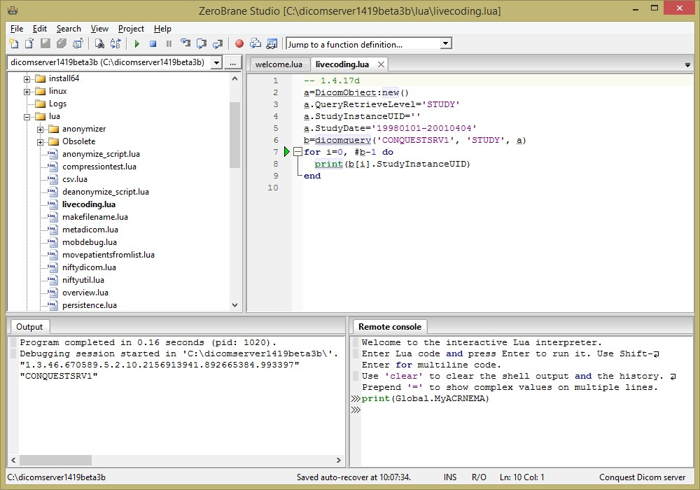

In the Lua script, all normal Lua functionality is present (the examples delivered with ZeroBraneStudio are a good starting point to learn Lua), and the following variables and classes are defined:

Filename Name of dropped file (if any)

command_line command from importconverter e.g.,
“process series by t.lua command”

returnfile If set from lua server command; file contents are returned to client

Global Server status (counters) and configuration
e.g.:
Global.StartTime
Global.BaseDir

Association Information of current connection
Association.Calling
Association.Called
Association.Thread
Association.ConnectedIP

Command Received command by server
Command.AffectedSOPClassUID
Command.AffectedSOPInstanceUID
Command.CommandField
Command.MessageID
Command.MessageIDBeingRespondedTo
Command.DataSetType
Command.MoveDestination
Command.TransferSyntaxUID
Command.MoveOriginatorApplicationEntityTitle
Command.MoveOriginatorMessageID
Command:Write(filename) write dicom object
Command:Dump(filename) write dicom object header as text file
It is possible to add modify the Command and/or add private Conquest tags to
modify e.g. move behavior. See e.g. ConquestMaxSlices, ConquestScript,
ConquestSplit. Integer results such as MessageID are returned as strings.

Data Data object of current DICOM command (DicomObject)

DicomObject DICOM Object (e.g., image)
DicomObject:new() returns empty DicomObject
DicomObject:new(json_string) convert json to DicomObject
DicomObject:newarray() returns empty DicomArray
DicomObject:free () frees DicomObject or DicomArray
Data.Storagestring e.g. MAG0 for importconverters
DicomObject:Script(code) run conquest style script
DicomObject:GetPixel(x, y, fr) get pixel returns 1..N values
DicomObject:SetPixel(x, y, fr, values) set pixel
DicomObject:GetRow(y, frame) get row returning array
DicomObject:SetRow(y, frame, table) set row of pixels
DicomObject:GetColumn(x, fr) get column returns array
DicomObject:SetColumn(x, fr, table) set column of pixels
DicomObject:GetImage(frame) get image as binary string
DicomObject:SetImage(frame, string) set 2D image in dicom object
DicomObject:SetImage(frame,string,scale) set 2D float image object
DicomObject:Read(filename: string) read dicom object
DicomObject:Write(filename: string) write dicom object
DicomObject:Dump(filename: string) write header as text file
DicomObject:GetVR(grp, elmnt, asstring) get vr as byte sequence returns DicomArray/table/string
DicomObject:SetVR(grp, elmnt, value) set vr from DicomArray/table of bytes/binary/json string
DicomObject:AddImage() Enter image into DICOM server
DicomObject:Copy() Returns copy of object
DicomObject:Copy(json_string) Combine object with json
DicomObject:Compress(string) Returns compressed copy object
DicomObject:Serialize() Returns object in Lua syntax
DicomObject:Serialize(true) Returns object in JSON syntax
DicomObject:Serialize(true,true) Returns in JSON with pixeldata
DicomObject:Serialize(true,true,true) Returns in DicomWEB JSON syntax
DicomObject:Reset() Removes all contents
Data.PatientID Any VR is accessible

DicomArray Dicom sequence = array of DICOM objects
DicomObject:newarray() create
DicomArray:free() free
DicomArray:Add(dicomobject) add dicomobject to array
DicomArray:Delete(0) Delete numbered entry
DicomArray:Serialize() Returns object in Lua syntax
DicomArray:Serialize(true) Returns object in JSON syntax
DicomArray[0] elements 0..#-1 are DicomObject

Utility functions

newdicomobject() returns DicomObject
deletedicomobject(DicomObject) free DicomObject
newdicomarray() returns DicomArray

print(...) print arguments to console
debuglog(...) print if debug logging enabled
gpps(section, key, default) Reads DICOM.INI
crc(string) Calculates crc of string
md5(string) Calculates MD5 of strinf
tickcount() Return time in ms
dictionary(group, element) return dictionary name
dictionary(name) returns dict group, element
get_sqldef(database, field: integer) Reads DICOM.SQL returns (group, element, FieldName, Length, SQLType, DicomType
system(program: string) run program in the background
checkaccess(item, IP: string)
Checks IP against allowed and denied in dicom.ini
rshift(value, N) Shift integer value right
lshift(value, N) Shift integer value left
band(a, b) And integer values
bxor(a, b) XOR integer values
bnot(a) NOT integer value
listoldestpatients(max:integer, device:string, sort:string)
Find oldest patients e.g. to move/delete, sort on database field; returns list of patID's
destroy() Special for server events
reject() See e.g. script('destroy')
retry()
genuid() Returns new UID
tempfile(extension: string) Returns temp file name
get_amap(entry: int) Reads item from acrnema.map returns AE, IP, port, compression
dbquery(database, fields, query) Executes SQL query on database returns table of records from 1 with table of fields from 1
return nil if query fails; {} if query result empty
dicomquery(AE, level, query: DicomObject) returns sequence counting from 0
dicomquery2(AE, level, query: DicomObject) (old) returns sequence from 0
dicommove(AE, dest, query: DicomObject, patroot:number, extra:DicomObject) move data from DICOM server to DICOM server, extra tags can change the outgoing images
dicomget(AE:string, level:string, query) get object array from server
dicomread(query) same from local server
dicomdelete( query: DicomObject) delete data from DICOM server
dicomstore(ae:string; DicomObject/DicomArray) send data to any DICOM server
dicomecho(ae:string; extra:DicomObject) echo server, reads raw response
dicomprint(Object/Array,AE,format,callback) print object(array) to server
heapinfo() returns string allocations
sql(statement: string) execute SQL statement
changeuid(olduid[, proposeduid) Consistently modify UID, returns mapped UID changeuid('') clears UID cache
changeuid(olduid, proposeduid, stage, [type]) Pass '' for proposedUID as none
changeuidback(newuid: string) For a modified UID, returns original if exists, returns (string or nil)\
addimage(image: userdata) Enter image into server
sleep(N: integer) Sleep for N ms
mkdir(path: string) Make directory (recursive)
ConvertBinaryData(format:string, data:string|table)
convert table to binary string or vice-versa; format e.g. f8; 1000*f8; 1000*u4, 100*s100

HTML(text: string, …) web server only: output HTML
CGI(key, default) web server only: read url entry
CGI() web server only: rd post buffer

servercommand(command: string, mode:string) Sends conquest server command, e.g. 'display_status:' or 'get_param:MyACRNema' (string)
mode can 'cgibinary', 'cgihtml' or <filename to upload and >filename to download, 'binary' without procesing.
The following ways allow returning data fom server to script:
lua:return expression – limited to 512 characters
lua:Data:SetVR(0x9999,0x0401,longstring)
lua:local s=tempfile('txt') local f=io.open(s, "wb") f:write(r) returnfile=s f:close();
servercommand('luastart:statement') starts a new thread

These functions work on variable Data

script(script_code: string) Sends conquest style script to server, e.g. 'forward to AE'. Special functions are: script('retry') for RejectedImageWorkListConverter0 and RejectedImageConverter0; will re-attempt to store the object after the script is done, script('defer') for ExportConverter: will cause later retry, and script('destroy') for query/store or move: will cancel operation; script('destroy2') will do the same silently

getpixel(x: int, y: int, frame: int) returns pixel values
setpixel(x: int, y: int, frame: int, pixel: int, …) set pixel values
getrow(y: int, frame: int) get row of pixels as arraysetrow(y: int, frame: int, table) set row of pixels
getcolumn(x: int, frame: int) get column of pixels as array
setcolumn(x: int, frame: int, a: table) set column of pixels
getimage(frame: int) get image as binary string
setimage(frame: int, a: string) set entire image
setimage(frame: int, a: string, scale:float) set short image from floats
getvr(group, element, asstring) get VR as DicomArray/byte array/binary string from dicom object returns (DicomArray/table/string of VR values)
setvr(group, element, a) set VR sequence or binary
readdicom(filename) read Data dicom object
writedicom(filename) write Data dicom object
writeheader(filename) write Data header as text file
resetdicom() clear all Data contents

Note that calls to the Conquest script language, e.g. script() and Data:Script() can do forward calls e.g.

Data:Script('forward to AE').

These calls by default share a single channel (19.0) so it is best to restrict your script with just one of these calls, so that the forward code can optimise transfers.

