“Driven By The Cold” – Practicing Test Driven Development with ColdFusion
“Testing is not the same thing as having tests.” - Kent Beck, Test Driven Development by Example

Table of Contents
- Introduction
  - Fear is not an option, bitch!
  - Terminology
- The Twitter Client
  - Requirements
- TDD In Action
  - Where to start?
  - Shweet!
- Summary
- References

Introduction
Test Driven Development (TDD) is the disciplined practice of writing unit tests prior to writing the actual production code. This practice can lead to clean, well-designed software that is agile and can be adapted quickly to rapidly changing requirements. Additionally, having tests for your code gives you a platform for immediate feedback on the state of your software as well as communicate your intentions to team members.
In this 2-part series, we will demonstrate how to apply TDD to ColdFusion application development. We will show you how you can leverage the MXUnit tool-set to build unit tests and automated test suites that give you, the developer, that prompt assessment about your code and facilitates collaboration in a team environment.

Fear is not an option!
Pressure to deliver can be the demise of software quality. And fear prevents you from trying something new, possibly faltering along the way, but ultimately succeeding. Take a leap of faith and try unit testing and TDD; we promise you will learn something new and valuable!
The first part of this series is aimed at the experienced ColdFusion developer interested in learning more about unit testing and TDD, or for the veteran test driven developer wanting a refresher.
A note on Unit Testing and TDD : Writing a unit test is an activity of TDD. You can write unit tests anytime! TDD requires the developer to write unit tests, however, you can still write unit tests without practicing TDD. Deciding when to write tests is the decision of the developer. It's been our experience that the one of the most beneficial things you can do for your development is to write tests for your, regardless of when you write them. We wouldn't have spent hours upon hours building a freely available test framework and Eclipse plugin for ColdFusion developers if we didn't believe this ourselves. Not only are we the tool builders, we are some of its busiest users!

Terminology
- Unit Test – Code that when run, exercises and tests your production code at an atomic level.
- Production Code – The code that gets executed when the application is run. This is typically what your customer is paying for.
- Test Case – A specific test that executes some production code and checks its correctness.
- Test Suite – A collection of test cases that may be run together
- Assertions – Functions that test the state of an object; e.g. assertEquals(epected value, actual value), assertTrue(boolean expression);
- Red-Green-Refactor – The TDD mantra. Red indicates a failing test; Green is a passing test; and Refactoring is the process of altering the code's implementation.

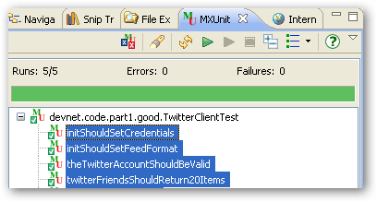
Figure 1- Note the pretty Green bar. Green is good.

TDD In Action : Show me the money!
This following example is intended to demonstrate some TDD basics, and in Part 2 [LINK] we will show you some advanced unit testing techniques that will answer some of the inevitable questions that arise shortly after getting started.

The Twitter Client
Twitter (http://twitter.com) is a popular micro-blogging social networking tool that allows its users to stay in touch with people they “follow”.
This widget will read Twitter and make content available for some UI to display. The contents may consist of either a Twitter user's most recent “tweets” or the most recent tweets of the people the user is following. The Twitter API is REST-based [LINK] and is open to anyone who has a Twitter account. To run the example widget and associated tests, you will need to set up an account at Twitter and “follow” a few people. For more information on the Twitter API please see http://apiwiki.twitter.com/REST+API+Documentation.

You should also be able to just read these articles and accompanying source code without running the examples, to learn the principals of unit testing and TDD.

Where do you start?
At this point, resist the urge to simply bang out code that will read the Twitter feed and send serialized JSON to an Ajax client. Remember, this is an exercise in TDD.
One technique is to articulate your understanding of the requirements in the form of a test list. The process is to list the tests you feel will cover your requirements. This is an agile approach to specification, too, and when implemented as tests, provides some excellent documentation to your code in addition to testing your code! After you write the test list, write the tests (which will initially fail) one by one, followed by the production code such that the tests will pass.
For our purposes, work with the following tests:
- Twitter should be alive (a ping test)
- The Twitter account should be valid (a verify credentials test)
- The Twitter “friend's” feed should return 20 items (feed test)
- The Twitter Client should set login credentials and feed format when created (init tests) TBD

We know from the Twitter API that there is a “test” method that returns 'ok' if successful. A first run at the “should be alive” test may look like this:
<cfcomponent extends="mxunit.framework.TestCase">
<cffunction name="twitterShouldBeAlive">
<cfset var twitter = createObject("component","TwitterClient")>
<cfset var expected = 'ok'>
<cfset var actual = twitter.ping()>
<cfset assertEquals(expected, actual)>
</cffunction>

</cfcomponent>

This test is telling us that we expect the ping method on the Twitter component to return the string 'ok' and nothing else.
What happens when you run this test in MXUnit? It will fail with the message “Could not find the component or interface TwitterClient.”
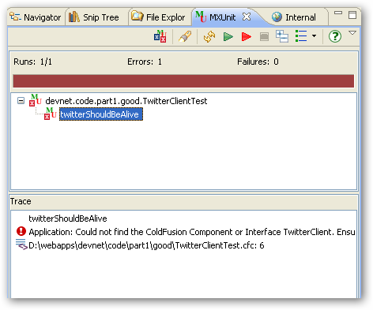
Figure 2- Red portion of Red, Green, Refactor

Believe it or not, this is good! This is the Red part of the Red, Green, Refactor rhythm. This is telling you what to code you need to write. So, go for it. We'll wait [imagine game show jingle here].

<cfcomponent name=”TwitterClient”>

<cfset variables.instance = StructNew()>
<cfset variables.twitterUrl = "http://www.twitter.com">

<cffunction name="ping" hint="runs the twitter api test command.">
<cfhttp url="#twitterUrl#/help/test.json" method="get">
<cfreturn deserializeJSON(cfhttp.FileContent)>
</cffunction>

</cfcomponent>

We know from the Twitter API that the http response body should return a simple string, 'ok'. You need to deserialize the JSON object in order to get at the http response body. This code works fine, but you would probably want to throw an exception if there’s a problem with Twitter, instead of leaving it all up to the client. So, refactor the code and leave the test as is – the test is still valid!
<cffunction name="ping" hint="Runs the twitter api test command.">
<cfset var response = 'not ok' />
<cfhttp url="#twitterUrl#/help/test.json" method="get">
<cfset response = deserializeJSON(cfhttp.FileContent)>
<cfif response is not 'ok'>
<cfthrow type="TwitterPingFailure"
message="Twitter might be down"
detail="Twitter says #cfhttp.FileContent#">
</cfif>
<cfreturn response>
</cffunction>

When you run the twitterShouldBeAlive test again, you will still see a pretty Green bar. You should begin to see how running a test repeatedly against changing production code is a good thing.

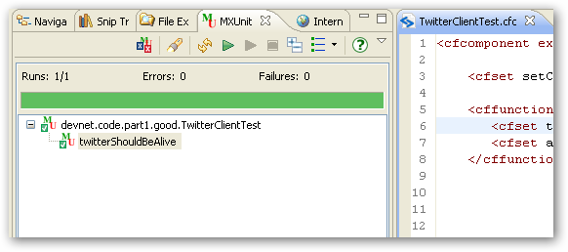
Figure 3- Green is happiness.

That’s the first item on our test list. Take a look at the second item on our test list: The Twitter account should be valid (a verify credentials test)

Again, write the test first. It should look something like:
<cffunction name="theTwitterAccountShouldBeValid">
<cfset twitter = createObject("component","TwitterClient")>
<cfset actual = twitter.verifyCredentials(uname,pwd) />
<cfset assertTrue(actual)>
</cffunction>

Note that in the source code [LINK] there is a utility function for reading credentials in from a text file. You could code your credentials as a variable, too. They’re not published here for obvious reasons.
When you run this you’ll again be in the Red. Feel the rhythm. Be one with The Test.
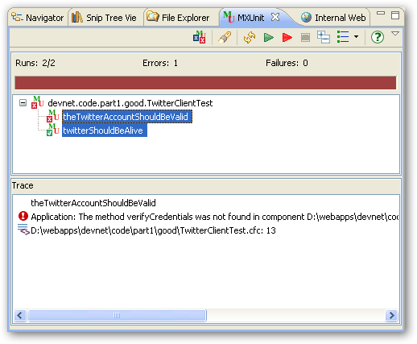
Figure 4 - Red again

You know what to do now, right? Yep. Write the verifyCredentials production code. Don’t worry too much about how you’re implementing it. It’s going to change. But that’s OK because we now have a test that we can use to make sure it's doing what we want.

<cffunction name="verifyCredentials" hint="Tests that the credentials are valid.">
<cfargument name="uname" type="string">
<cfargument name="pwd" type="string">
<cfset var response = {} >
<cfhttp url="#twitterUrl#/account/verify_credentials.json" method="get"
username="#arguments.uname#"
password="#arguments.pwd#">
<cfset response = deserializeJSON(cfhttp.FileContent)>
<cfif not structKeyExists(response,'id')>
<cfthrow type="TwitterAuthenticationFailure"
message="Could not log into Twitter."
detail="Tried user:#arguments.uname# pwd:#arguments.pwd#">
</cfif>
<cfreturn true />
</cffunction>

Run the test again:
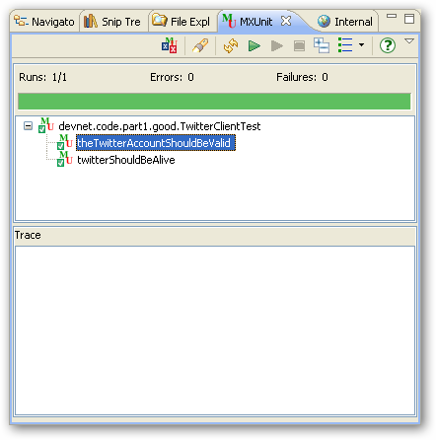
Figure 5 - Ohm ...

OK - Now for a bit of TDD Kung-Fu. We know that good credentials work; how can we test for bad credentials? Is there something we can do with the TwitterAuthenticationFailure exception maybe? Hmmm ... Add this next item to your test list: Invalid Credentials Should Throw TwitterAuthenticationFailure. Copy and Paste into a new test (remove the spaces, of course):
<cffunction name="invalidCredentialsShouldThrowTwitterAuthenticationFailure">
<cfset twitter = createObject("component","TwitterClient")>
<cftry>
<cfset twitter.verifyCredentials('Kwai Chang Caine','Grasshopper') />
<cfset fail('Should not get here.') />
<cfcatch type="TwitterAuthenticationFailure"></cfcatch>
</cftry>
</cffunction>
Here we are testing that an exception is thrown and this is also nicely articulated in the test name. Why the fail() method? The fail() method is there for 2 reasons: (1) if for some reason the TwitterAuthenticationFailure is not thrown, we will automatically fail the test, (2) this does a good job at showing our intent with the code and the test.

Summary
Note that the size of the methods is small and their intent is focused on a single task. This not only makes it easier to test, but makes your code cleaner, easier to read, and easier to maintain.
Having a suite of test allows you to run many tests very quickly and frequently.
The tests serve as great documentation, illustrating specific intent with your code. Some developers go even as far as to omit comments in their code in favor of tests.
We've demonstrated the practice of TDD with respect to a simple and small application. If applications were all this simple, all of use would be testing all the time. But the reality is that software is hard and hard to test. In Part 2 of this series, we'll show you how to address some hard-to-test issues that always rear their head when building software.

[PLACE SOMEWHERE ELSE AS PER ADOBE TEMPLATE]

Requirements
In order to make the most of this article, you need the following software and files:

ColdFusion 8
- Try
- Buy

MXUnit Framework and Eclipse Plugin
Download: http://mxunit.org
Detailed installation instructions: http://mxunit.org/doc/index.cfm

Sample files:
Download the sample files <insert Adobe download URL> (ZIP, xxK)

Prerequisite knowledge
Working knowledge of ColdFusion Components
Minimal understanding of MXUnit unit testing and helpful
Using CFEclipse Helpful.

About the authors
Marc Esher has been developing ColdFusion and Java applications since 2000. He currently works in the financial industry building custom print-on-demand software. He is a co-project-owner for MXUnit and has contributed the Eclipse plugin along with several framework features. He has an abiding passion for team building, mentoring, and process improvement. Marc lives in Pennsylvania with his wife and children.

Bill Shelton has been building web software since the time CGI and Perl were considered really cool and has been using ColdFusion and Java for over 10 years. Bill is the blurred visionary for the MXUnit framework and part-time software quality evangelist. He lives in Northern Virginia with his wifes and kids, and works for the U.S. Federal Government.

Marc and Bill blog occasionally at http://blog.mxunit.org and can be followed on Twitter: Bill Shelton @virtix. Marc Esher @marcesher

References
Test Driven Development by Example - [TODO]
Test Driven - [TODO]
Refactoring - [TODO]
xUnit Test Patterns -s [TODO]

