Coldfusion unit testing test driven development mxunit testability design oo components cfc coverage

"Driven By The Cold" – Practicing Test Driven Development with ColdFusion
"Testing is not the same thing as having tests." - Kent Beck, Test Driven Development by Example
Bill Shelton and Marc Esher
http://mxunit.org

Table of contents
Introduction
No Fear!
TDD In Action: Show me the money!
Summary
Where to go from here

Introduction
Test Driven Development (TDD) is the disciplined practice of writing unit tests prior to writing the actual production code. This practice can lead to clean, well-designed software that is agile and can be adapted quickly to rapidly changing requirements. Additionally, having tests for your code gives you a platform for immediate feedback on the state of your software and communicates your intentions to team members. Essentially, the process is simple, yet, like anything done well, it takes time to learn and practice. You write tests for your code, quickly write the code to make the tests pass, then refactor the code to make it do what it should. Changes to code are done in small increments, referred to as baby steps. While developing you will be frequently running your unit tests. This gives you that immediate feedback.
In this 2-part series, we will demonstrate how to apply TDD and unit testing techniques to ColdFusion application development. We will show you how you can leverage the MXUnit toolset to build unit tests and automated test suites that give you, the developer, that almost instantaneous assessment about your code and facilitates collaboration in a team environment.

Requirements
In order to make the most of this article, you need the following software and files:

ColdFusion 8
- Try
- Buy

MXUnit Framework and Eclipse Plugin
Download: http://mxunit.org
Detailed installation instructions: http://mxunit.org/doc/index.cfm
Sample files:
Download the sample files <insert Adobe download URL> (ZIP, xxK)
Prerequisite knowledge
Working knowledge of ColdFusion Components
Minimal understanding of MXUnit and unit testing and helpful
Using CFEclipse helpful.

About the authors
Bill Shelton is the blurred visionary for the MXUnit framework and part-time software quality evangelist. He has been building web software since the time CGI and Perl were considered really cool and has been using ColdFusion, Java, and other languages for over 10 years. Bill lives in Northern Virginia with his wifes and kids, and works for the U.S. Federal Government.
Marc Esher has been developing ColdFusion and Java applications since 2000. He currently works in the financial industry building custom print-on-demand software. He is a co-project-owner for MXUnit and has contributed the Eclipse plugin along with several framework features. He has an abiding passion for team building, mentoring, and process improvement. Marc lives in Pennsylvania with his wife and children.
Marc and Bill blog occasionally at http://blog.mxunit.org and can be followed on Twitter: Bill Shelton @virtix. Marc Esher @marcesher
***Begin New Page

No Fear!
Excessive pressure to deliver can be the demise of software quality, and fear also prevents you from trying something new, possibly faltering along the way, but ultimately succeeding. Take a leap of faith and try unit testing and TDD; we promise you will learn something new and valuable!
A Note on Unit Testing and TDD : Writing unit tests is an activity of TDD. However, you can write unit tests anytime! TDD requires the developer to write unit tests; but, you can still write unit tests without practicing TDD. Deciding when to write tests is the decision of the developer. It's been our experience that the one of the most beneficial things you can do for your development is to write unit tests for your code, as you develop your code. We wouldn't have spent hours upon hours building a freely available test framework and Eclipse plug-in for ColdFusion if we didn't strongly believe this ourselves. Not only are we the tool builders, we are some of its most demanding users!

Terminology
Unit Test – Code that when run, exercises and tests your production code at an atomic level.
Production Code – The code that gets executed when the application is run or testing. This is typically what your customer is paying for.
Test Case – A specific test that executes some production code and checks its state or behavior.
Test Suite – A collection of test cases that can be run together
Assertions – Functions that test the state of an object; e.g. assertEquals(expected value, actual value), assertTrue(boolean expression);
Red-Green-Refactor – The TDD mantra. Red indicates a failing test; Green is a passing test; and Refactoring is the process of altering the code's implementation.
Baby Steps – Small incremental changes to your code and unit tests.

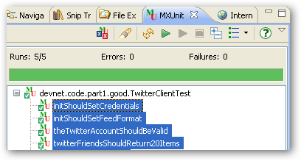
Figure 1- Note the pretty Green bar. Green is good.
***Begin New Page

TDD In Action : Show me the money!
The following example is intended to demonstrate some TDD basics, and in Part 2 [LINK] we will show you some advanced unit testing techniques that will answer some of the inevitable questions that arise shortly after getting started.

The Twitter Client
Twitter (http://twitter.com) is a popular micro-blogging and social networking tool that allows its users to stay in touch with people they “follow”, by posting and reading 140 character “tweets”, or entries.

Functional Requirements
This component will read Twitter and make the data available in ColdFusion.
The data will consist of the 20 most recent “tweets” of the people the user is following.

The Twitter API is REST-based and is open to anyone who has a Twitter account. Our production code will be using http to retrieve the data from Twitter. To run the example and associated tests, you will need to set up an account at Twitter and “follow” a few people. (You should also be able to simply read these articles and accompanying source code[LINK], without running the examples, to learn the principals of unit testing and TDD.)
For more information on the Twitter API please see http://apiwiki.twitter.com/REST+API+Documentation.

Where do you start?
At this point, resist the urge to simply bang out code that will read the Twitter feed and send JSON to an Ajax client. Remember, this is an exercise in TDD. Breathe in. Breathe out. Focus.
One technique to articulate your understanding of the requirements is to write a test list. In natural language, write the tests you feel will cover your requirements on paper or sticky-notes or a To Do list. This is an agile approach to specification, too, and when ultimately implemented as unit tests, provides some excellent documentation in addition to testing your code. After you write the test list, one by one write the unit tests (which will initially fail), followed by the production code such that the tests will pass.
For our purposes, start with the following tests (you will add more later – remember baby steps):
- Twitter should be alive (a ping test)
- The Twitter account should be valid (a verify credentials test)
- The Twitter Friends timeline should return 20 items (feed test)

We know from the Twitter API that there is a “test” url that returns 'ok' if successful – http://twitter.com/help/test.json. A first run at the “should be alive” test may look like this:
<cffunction name="twitterShouldBeAlive">
<cfset var twitter = createObject("component","TwitterClient")>
<cfset var expected = 'ok'>
<cfset var actual = twitter.ping() >
<cfset assertEquals(expected,actual)>
</cffunction>

This test is telling us that we expect the ping method on the TwitterClient component to return the string 'ok' and nothing else.
To run this and the other tests, make sure you have MXUnit installed and then point your browser to http://localhost/[TBD]/TwitterClientTest.cfc?method=runtestremote. For these examples, we will be illustrating test results using the MXUnit Eclipse Plugin.
What happens when you run this test in MXUnit? It will fail with the message “Could not find the component or interface TwitterClient.”
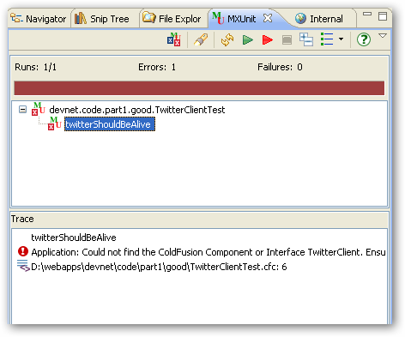
Figure 2- Red portion of Red, Green, Refactor

Believe it or not, this is good! This is the Red part of the Red, Green, Refactor rhythm mentioned earlier. This is telling you what to code you need to write. So, go for it ... [imagine game show jingle here] …

<cffunction name="ping" hint="Runs the twitter api test command.">
<cfhttp url="http://www.twitter.com/help/test.json" method="get">
<cfset response = deserializeJSON(cfhttp.FileContent)>
<cfreturn response>
</cffunction>

We know from the Twitter API that the http response body should contain a simple string, 'ok'. You need to deserialize the JSON object to escape the double-quoted string in the http response body. Now, run the test:
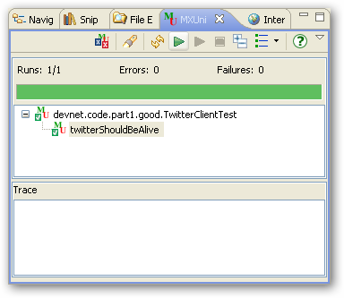
Figure 3 – Feel the Power of Green!

This code works fine, but you would probably want to throw an exception if there’s a problem with Twitter, instead of leaving it all up to the client. So, refactor the code and leave the test as is – the test is still valid!
<cffunction name="ping" hint="Runs the twitter api test command.">
<cfset var response = 'not ok' />
<cfhttp url="http://www.twitter.com/help/test.json" method="get">
<cfset response = deserializeJSON(cfhttp.FileContent)>
<cfif response is not 'ok'>
<cfthrow type="TwitterPingFailure"
message="Twitter might be down"
detail="Twitter says #cfhttp.FileContent#">
</cfif>
<cfreturn response>
</cffunction>
When you run the twitterShouldBeAlive test again, you will still see that pretty Green bar. Can you see how having a test allows you to refactor your production code quickly?

That’s the first item on our test list. Take a look at the second item: The Twitter account should be valid (a verify credentials test)

Again, write the test first. It should look something like:
<cffunction name="theTwitterAccountShouldBeValid">
<cfset var twitter = createObject("component","TwitterClient"). >
<cfset var actual = twitter.verifyCredentials(uname,pwd) />
<cfset assertTrue(actual)>
</cffunction>

Note that in the TwitterClientTest.cfc in the source code [LINK] there is a setCredentials() utility function for reading credentials in from a text file. You could code your credentials as a variable, too. They’re not published here for obvious reasons.

When you run this you’ll again be in the Red. Feel the rhythm. Be one with The Test.
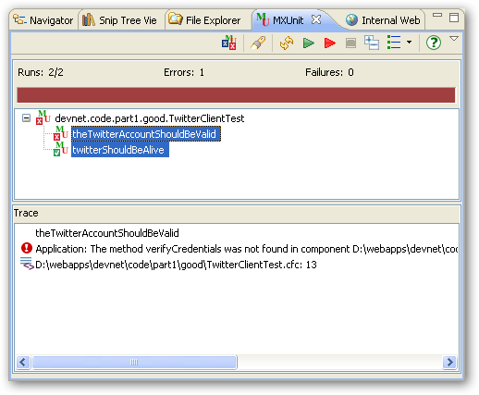
Figure 4 - Red again
You know what to do now, right? Write the verifyCredentials production code. Don’t worry too much about how you’re implementing it. It’s going to change. But that’s OK because we now have a test that we can use to make sure it's doing what we want. Baby steps.
<cffunction name="verifyCredentials" hint="Tests that credentials are valid.">
<cfargument name="uname" type="string">
<cfargument name="pwd" type="string">
<cfreturn true />
</cffunction>

When you run your test, you will quickly be in the Green. But wait! The code doesn't really do anything, it just returns true. Red, Green, Refactor. You've implemented the interface, but now, refactor it so that it does what you want it to do, all the while trying to keep your tests Green.

<cffunction name="verifyCredentials" hint="Tests that credentials are valid.">
<cfargument name="uname" type="string">
<cfargument name="pwd" type="string">
<cfset var response = {} >
<cfhttp url="http://www.twitter.com/account/verify_credentials.json"
method="get"
username="#arguments.uname#"
password="#arguments.pwd#">
<cfset response = deserializeJSON(cfhttp.FileContent)>
<cfif not structKeyExists(response,'id')>
<cfthrow type="TwitterAuthenticationFailure"
message="Could not log into Twitter."
detail="Tried user:#arguments.uname# pwd:#arguments.pwd#" />
</cfif>
<cfreturn true />
</cffunction>
Run the test again:
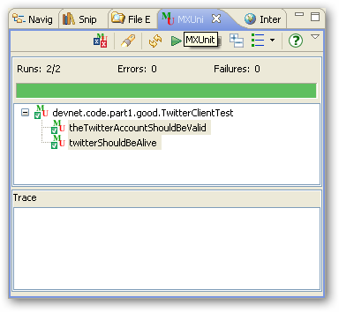
Figure 5 - Ohm ...
Now for a bit of TDD Kung-Fu: we know that good credentials work; how can we test for bad credentials? Is there something we can do with the TwitterAuthenticationFailure exception maybe? Add this next item to your test list: Invalid Credentials Should Throw TwitterAuthenticationFailure. Copy and Paste into a new test (remove the spaces, of course):
<cffunction name="invalidCredentialsShouldThrowTwitterAuthenticationFailure">
<cfset var twitter = createObject("component","TwitterClient") />
<cftry>
<cfset twitter.verifyCredentials('Kwai Chang Caine','Grasshopper') />
<cfset fail('Should not get here.') />
<cfcatch type="TwitterAuthenticationFailure"></cfcatch>
</cftry>
</cffunction>
Here we are testing that an exception is thrown by our production code when we pass in invalid credentials. This is also nicely articulated by the test's name. Why the fail() method? The fail() method is there for 2 reasons: (1) if for some reason the TwitterAuthenticationFailure is not thrown, we want to fail the test, and (2) this does a good job at showing our intent with the code and the test.
Load and run your tests again. You will see this:
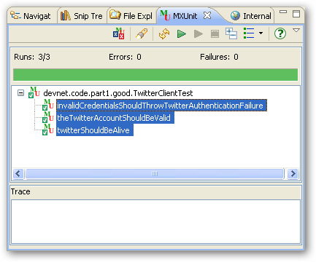
Figure 6 - Added test for expected exception

Next on the list is the The Twitter “friend's” feed should return 20 items (feed test). You know the steps. Write the test and watch it fail (Red), write the production code and run the test again (Green), and change the production code as needed (Refactor).

<cffunction name="twitterFriendsTimelineShouldReturn20Items">
<cfset var twitter = createObject("component","TwitterClient") />
<cfset var results = twitter.friendsTimeline(variables.uname,variables.pw)>
<cfset debug(results)>
<cfset assertEquals(20, arrayLen(results), "Something other than 20 items were returned.") />
</cffunction>
The test is telling us now to add a friendsTimeline method to our TwitterClient and that it needs to accept username and password parameters.

<cffunction name="friendsTimeline" hint="returns the user's friends timeline">
<cfargument name="uname" type="string">
<cfargument name="pwd" type="string">
<cfset var response = {} >
<cfhttp url="http://www.twitter.com/statuses/friends_timeline.json"
method="get"
username="#arguments.username#"
password="#arguments.password#">
<cfset response = deserializeJSON(cfhttp.FileContent)>
<cfreturn response>
</cffunction>

When you run this test you will feel the joy of The Green:
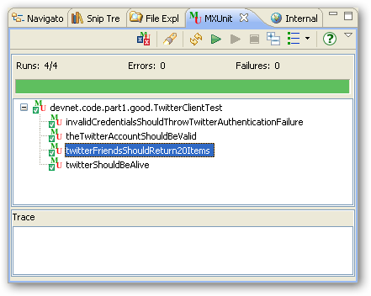
Figure 7- twitterFriendsShouldReturn20Items

Refactoring the TwitterClient
There are some obvious problems with the TwitterClient. There’s some code duplication that can be changed. There’s also the problem with repeatedly passing around user credentials. It would probably be better to set the user's credentials when the TwitterClient instance is created, that is, in init(). So, add some tests to make sure init() does what it’s supposed to do: init Should set credentials.

<cffunction name="initShouldSetCredentials">
<cfset var twitter = createObject("component","TwitterClient")>
<cfset twitter.init('Master Po', 'gimme my walking stick, bug boy')>
<cfset assertEquals('Master Po', twitter.getUserName(), 'Username not set')>
<cfset assertEquals('gimme my walking stick', twitter.getPassword(), 'Password not set') >
</cffunction>
When you run this, again you’ll be in the Red. So, listen to the test; it’s telling you exactly what you need to write:
<cffunction name="init" hint="Initializes TwitterClient">
<cfargument name="uname" type="string">
<cfargument name="pwd" type="string">
<cfset this.userName = arguments.uname >
<cfset this.password = arguments.pwd >
<cfreturn this >
</cffunction>
In addition, you will need to write getters and setters - accessor methods - to return the username and password.
Now, for each test, one by one:
- Change ths test so that the credentials are set in init(); e.g.,
<cfset var twitter = createObject("component","TwitterClient").init(uname,pw)>
- Remove any credentials from the method calls in TwitterClientTest; e.g.,
<cfset twitter.verifyCredentials() />
- Run the test, which will be Red (fail)
- Refactor the TwitterClient to remove the credentials as parameters and use getUserName() and getPassword() instead.
<cffunction name="friendsTimeline" hint="returns the authenticated user's friends timeline">
<cfset var response = {} >
<cfhttp url="http://www.twitter.com/statuses/friends_timeline.json"
method="get"
username="#getUserName()#"
password="#getPassword()#">
<cfset response = deserializeJSON(cfhttp.FileContent)>
<cfreturn response>
</cffunction>
Run the tests again. You’ll be Green (pass)

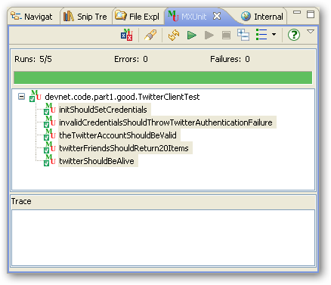
Figure 8- Refactored and still Green

There’s still plenty of room for refactoring and making the code even cleaner. Here are some ideas that are also listed in the source code under the “better” directory:
- Leverage MXUnit's setUp() method to initialize the TwitterClient and remove the createObject statement from each test. This will reduce the amount of code to read.
- Reduce code duplication in TwitterClient by creating instance data for the twitter url and twitter outputformat (JSON or XML)

What's cool is that you now have a number of tests that (1) you can run anytime you need to make changes to the TwitterClient, and (2) your team (and you, too, many days from now) can look at the tests and get a clear picture of what your intentions were at the time this was written.

Summary
One thing you may have noticed is that the tests may be slow. This is because of the dependency upon your network and upon Twitter itself. This is a common challenge when writing unit tests and there are also common solutions; solutions that will make your tests run fast and ensure that your application does what it’s supposed to do.
Note that the size of the methods is small and their intent is focused on a single task. This not only makes it easier to test, but makes your code cleaner, easier to read, and easier to maintain.
Having a suite of tests allows you to run many tests very quickly and frequently. The tests serve as great documentation, illustrating specific intent with your code. Some developers go even as far as to omit comments in their code in favor of tests.
We've demonstrated the practice of TDD with respect to a simple and small application. If applications were all this simple, all of use would be testing all the time. But the reality is that good software is hard to write and hard to test. Also, adopting TDD at an organizational level is yet another challenge onto itself. There are many challenges and some good solutions.

***Final section (mandatory)

Where to go from here
You may very well have tons of questions. This is a good thing. Proceed to Part 2 [LINK] for some more real-world approaches to some of the tough questions. If you haven’t already done so, download and install MXUnit and join the MXUnit Google Group.

Test and be Happy!

References
- Beck, Kent A. (2002). Test Driven Development: By Example. Addison-Wesley Longman,.
- Koskela, Lasse (2007). Test Driven: TDD and Acceptance TDD for Java Developers. Manning Publications.
- Meszaros, Gerard (2007). xUnit Test Patterns: Refactoring Test Code. Addison-Wesley.
- Fowler, Martin; Beck, Kent; Brant, John; Opdyke; William; Roberts, Don (1999). Refactoring: Improving the Design of Existing Code. Addison-Wesley
- Feathers, Michael (2008).The Flawed Theory Behind Unit Testing . 06-12-2008. http://michaelfeathers.typepad.com/michael_feathers_blog/2008/06/the-flawed-theo.html
- Myer, Bertrand (2004). Test or spec? Test and spec? Test from spec!. 09-2004. http://www.eiffel.com/general/column/2004/september.html
- Levinson, Mark (2009). Making TDD Stick: Problems and Solutions for Adopters. 01-05-2009. http://www.infoq.com/articles/levison-TDD-adoption-strategy;jsessionid=7BBC461D5E5AD36721A71C33FC929B93
- Bellware, Scott (2009). Good Design is Easily-Learned. 01-12-2009. http://blog.scottbellware.com/2009/01/good-design-is-easily-learned.html

