|  |  |  |  |  |
| --- | --- | --- | --- | --- |
| |  | | --- | |  | |  | |  | |  | |
| Luci  Human seeker robot in hostile environments |
| PROJECT SPRINT #1. DATE: 14th April 2021  Martí Caixal i Joniquet Ricard Lopez Olivares Hernán Capilla Urbano Marc Garrofé Urrutia |

Table of Contents

Project description 1

Electronic components 1

Scheme 1

Extra components and 3D pieces 1

Foreseen risks and contingency plan 2

Luci

Human seeker robot in hostile environments

# Project description

*This robot’s aim is to seek people whose situation is not favorable in hostile environments. It searchs, avoids obstacles, detects humans in environments where people can’t afford to get in (such as gas, smoke, or buildings on fire) and notifies the emergency units.*

*“Luci keeps you safe, from environments where you won’t be safe.”*

# Electronic components

This is the list of the used components:

* *Raspberry Pi 3 B+*
* *Gravity: Gas sensor*
* *Ultrasound HC-SR04 distance sensor*
* *Arduino UNO Rev.3*
* *Motor Kit: DAGU 140rpm*
* *9V battery cable*
* *MLX90640 Thermal Camera Breakout*
* *Webcam C160*
* *Temperature/Humidity sensor*
* *Power Bank 5000*
* *L93B Quad Push*

# Hardware Scheme

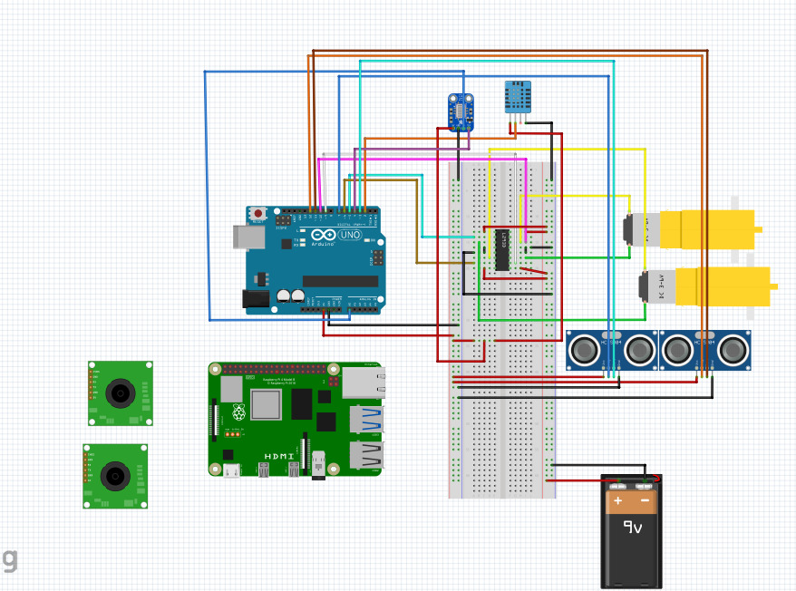

# Software Architecture

# Amazing contributions

*Mixing Compting Vision + Robotics with the purpose of analyzing normal images and thermic images to get the results.*

*Adaptive robot to different environments such as gas, fire, smoke, etc.*

*Not only detects but notifies.*

*Not only notifies but it also indicates the path that has followed the robot plus the obstacles that have found on its way.*

*HERE_CLEARLY_JUSTIFY_THE_MARK_THAT_YOUR_PROJECTE_DESERVES_IN_CASE_OF_FULFILLING_ALL_THE_OBJECTIVES*

# Extra components and 3D pieces

* *Design 3 pieces*Tenim primerament la base del robot. Aquesta presenta la part per ficar els motors I les rodes, així com tots els elements com Arduino o Raspberry.
* Aixi la podem veure buida: *Diagrama, Dibujo de ingeniería

  Descripción generada automáticamente*
* La idea darrere de aquest forat rectangular al final (que no es definitiu) es la d’instal·lar tota la electrònica I d’aquesta forma poder connectar l’arduino al ordinador pel cable, així com les bateries sense haver de treure-ho. El forat actualment es molt gran, un cop tinguem tota la electrònica es vol intentar fer a ‘mida’ perquè nomes hi càpiga els cables corresponents.

Seguidament, tenim la part de davant. Aquesta, s’ha imprimir a part ja que la idea es que tot això pugui ser imprès en la impressora 3D però a part d’això, presenta els seus beneficis.

Primerament, es on anirà tots els sensors i les càmeres del robot. Tenir-ho per separat en un mòdul ens permet que la seva instal·lació o customizació del mòdul sigui efectiva sense modificar tot el robot en si. Un cop tots els sensors estiguin ficats, els seus cables aniran cap enrere on estarà tota la computació.

S’ha intentat distribuir totes les coses perquè el robot tingui un pes uniforme al voltant de tota la estructura, I que sigui lo mes baix possible d’aquesta forma pot entrar en més llocs.

Finalment, tenim la tapa, que permet tancar tot el Sistema en una estructura homogènia I perquè no, bonica, sense tota la electrònica visible i a la vegada protegida.

La idea general de tot era fer-lo un robot versàtil I modular, per a poder tractor problemes de forma individual i que també càpigues tot en la base de impressió de una impressora 3D

# Foreseen risks and contingency plan

|  |  |  |  |  |
| --- | --- | --- | --- | --- |
| **Risk #** | **Description** | **Probability** (High/Medium/Low) | **Impact** (High/Medium/Low**)** | **Contingency plan** |
| 1 | Camera not stable | Médium | Low | Stabilize the image sequence although the the FOV would be reduced |
| 2 | Faulty thermal camera | Low | Medium | Refund it and ask for a new camera if possible. Otherwise we would just use the default pi camera for computer vision |
| 3 | Cannot merge both images (normal and thermal camera) | Medium | Medium | Images would be needed to be treated separately. The predictions would likely be worse. |
| 4 | Wheels don’t move smoothly | Medium | Low | The robots would just not move smoothly. If it too much, some smoothing could be created by adding a chicken rubber around the wheels. |
| 5 | Not enough CPU/GPU power | Medium | Medium | Instead of getting the desired 20fps, we would have a lower fps and probably would not be able to use it in real time. |
| 6 | Not enough torque from the motors to move the robot | Low | High | More powerful motors would be required. Another option could be using extra gears to increase torque, but the speed would be decreased. |
| 7 | Don’t know how to connect Arduino and Raspbery pi together | High | Low | We would first try to do it on a PC with a simulator following some tutorials. Once we get to understand it, we would try to do it again now with the physical components. |
| 8 | 3D printed parts are not good or do not fit together with one another or the other electrical components | High | low | If the error is low, we could just file down the edges. Otherwise, some new parts would be to be printed. |

References

This project has been inspired by the following Internet projects:

URL Link 1: <https://www.eltiempo.com/tecnosfera/novedades-tecnologia/firebot-el-robot-que-ayuda-a-prevenir-incendios-forestales-103122>

URL Link 2: <https://github.com/gritmind/image-processing-for-fire-detection>

URL Link 3: <https://makersportal.com/blog/2020/6/8/high-resolution-thermal-camera-with-raspberry-pi-and-mlx90640>