Interview

1Q) What is the size of int,float,char,double with respect to 16-bit,32-bit,64-bit processor?

Ans)If an OS is using 16-bit microprocessor architecture then int is of 2 bytes while in a 64-bit microprocessor, the compiler can decide to have int of size 8 bytes. Compiler and system dependent. If the system is 64 bit then generally the integer happens to be of 32 bit if the compiler supports 32 bit.

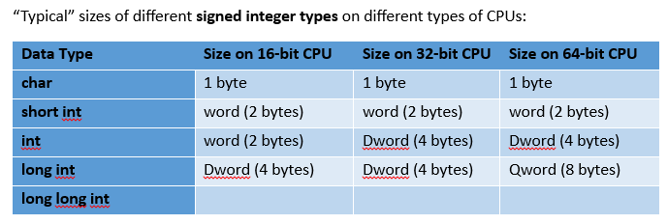

program of size
#include<stdio.h>int main() {
int intType;
float floatType;
double doubleType;
char charType;

// sizeof evaluates the size of a variable
printf("Size of int: %zu bytes\n", sizeof(intType));
printf("Size of float: %zu bytes\n", sizeof(floatType));
printf("Size of double: %zu bytes\n", sizeof(doubleType));
printf("Size of char: %zu byte\n", sizeof(charType));

return 0;
}

2Q) What is the difference between pre-increment and post-increment? which is the best
performer.
Ans)In the C/C++ programming language, there exists a operator that is used to increase the value of a variable by 1. The operator is denoted by the ++ symbol. When we increase the value of a variable before assigning it to another variable then it is known as Pre-Increment. When the value of a variable is incremented after assigning it to a variable, it is known as Post-Increment.
So, we can increment the value of a variable in the following two ways -
- Pre-Increment
- Post-Increment

Properties of the Increment Operator
Following are the main properties of the preincrement and postincrement in C -
- It increases the value of a variable by 1.
- It can only be used with variables.
- It is represented by a double plus ++ symbol.

Pre-Increment in C
As the name suggests, the pre-increment operator alters the value of the variable before using it in any expression. Therefore, we can say that the pre-increment operator increases the value of the variable first and then use it in the expression.
int main(){
// Declare a variable (say a) and assign 5 to it.
int a = 5;
int c = 1;
int d = 2;
int e = 5;
++d; //pre increment
c++;//post increment
e--;

// Now use pre-increment on 'a' and assign it to 'b'.
int b = ++a;

// Print 'a' and 'b'
printf("a = %d\nb = %d\n", a, b);
printf("c =%d\n",c);
printf("d = %d\n",d);
printf("e = %d\n",e);
return 0;

}

3Q) What is the difference between do-while loop and while loop?
Ans) Here is a list of the differences present between while and do-while loop in C, C++, Java.
Parameters | while | do-while
Checking of Condition | It first needs to check the condition, and only then can we execute the statement(s). | The execution of statement(s) occurs at least once. After that, the checking of the condition occurs.
Semicolon | while(condition)  No semicolon is present at the end of the while loop. | while(condition);  A semicolon is present at the end of the do-while loop.
Requirement of Brackets | We don’t require any brackets if there is only a single statement. | We would always require brackets in this case.
Initialization of Variables | We always need to initialize a variable in a condition before the execution of this loop. | The initialization of the variable may occur within or before the execution of the loop.
Controlling | The while loop is an entry-controlled type of loop. | The do-while loop is an exit-controlled type of loop.

while loop
- #include <stdio.h>
- #include <conio.h>
- Void main ()
- {
- int i;
- clrscr();
- i = 1;
- while (i<=10)
- {
- print ("hello");
- i = i + 1;
- }
- getch();
- }
do while

- #include <stdio.h>
- #include <conio.h>
- Void main ()
- {
- int i;
- clrscr();
- i = 1;
- do
- {
- printf("hello");
- i = i + 1;
- }
- while(i<=10);
- getch();
- }

