TCP-connection for real-time simulation
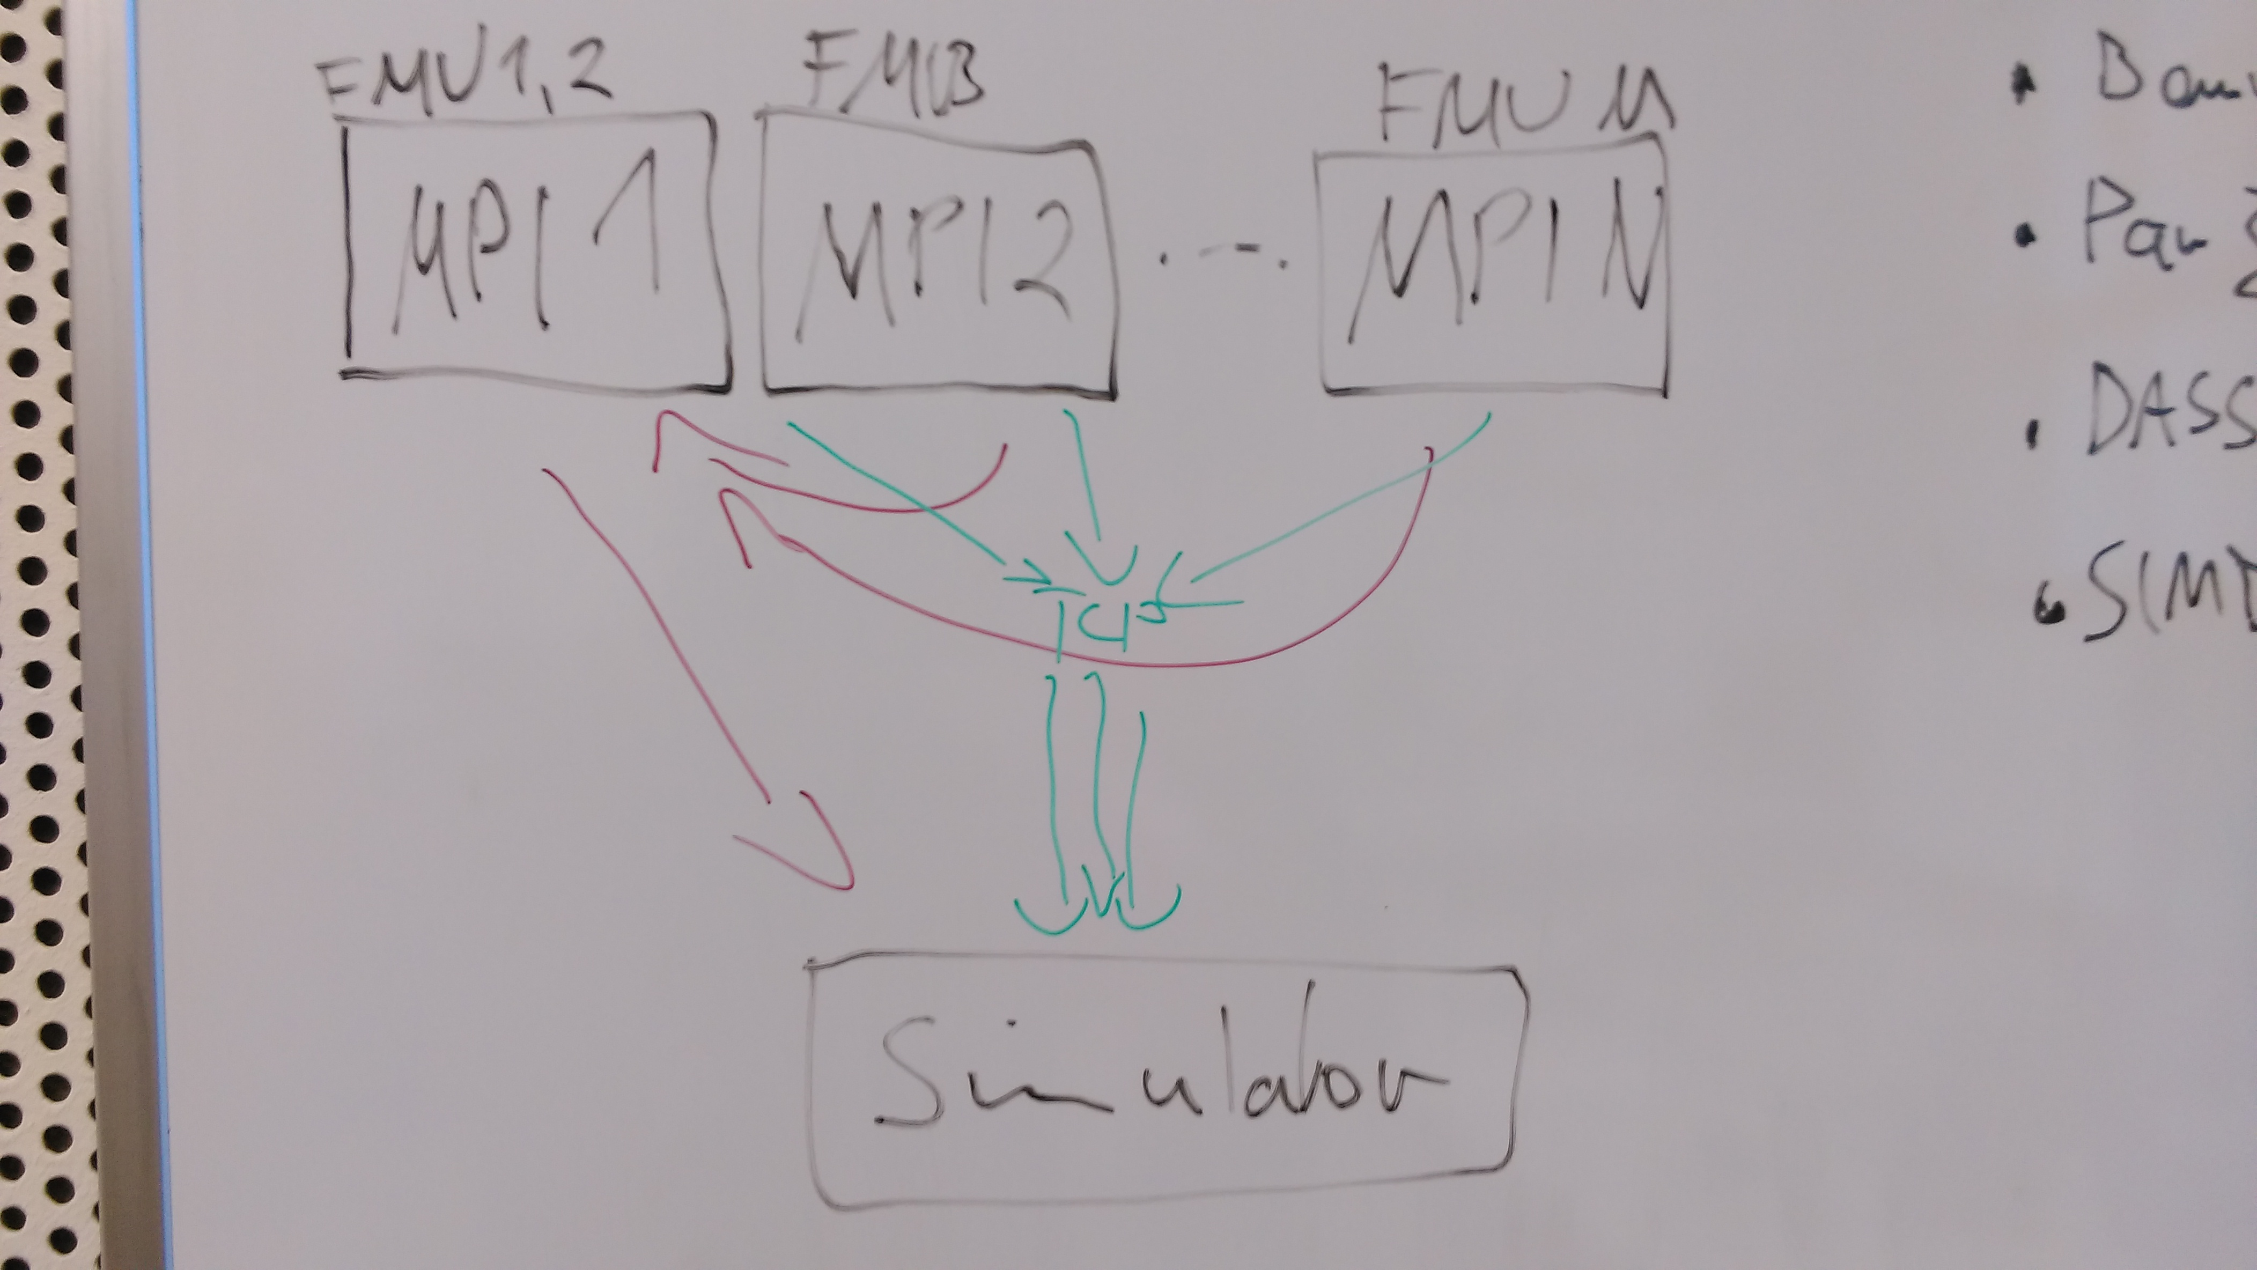

Two possibilities:
- (green) every MPI-rank has its own TCP-connector (multiple TCP)
- (red) One MPI-rank collects data and send them (one TCP)

One TCP:
Aspects:
- Idea: Less needed handshakes (one per data transmission), simulator don't has to open several ports (just one) or has to distinct from whom the data came
- MPI-rank 0 collects data from ranks 1 – n-1
- Transmits the data
- Recvs the input data coming from simulator
- Sends relevant input data to MPI ranks
- Implementation in FMI-Master:
- Using MPI-Writer to collect output data from FMUs
- Implement a real-time simulation (OpenMP and MPI version) with scheme:

list<solver> L;
frame = 0;
while(run)
simulateFrame(L); //simulate till writeOutput than block
// MPI/OpenMp-worker
if(checkRecvsTCP(lastFrame + 1 )
++lastFrameM;
inputs = newInputs;
run = newRun;
end if
sendTCP(frame++,getOutputs());
(inFrame,newInputs,newRun) = recvTCP();
if(frame – lastFrame > delay)
wait(inFrame);
speadInputs(inputs);
end while
- MPI-Writer (getOutputs) only prints normal output times no time events (not needed for real-time simulation)
- Possible optimization: blocked Worker can clean up DataHistory

