NEIGHBOURS / TETANGGA

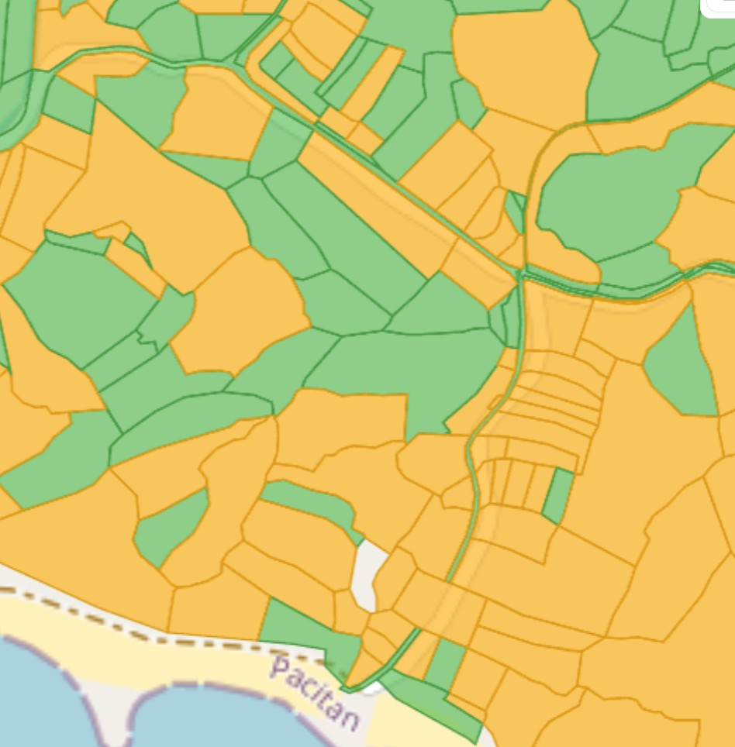 Bhumi ATR BN
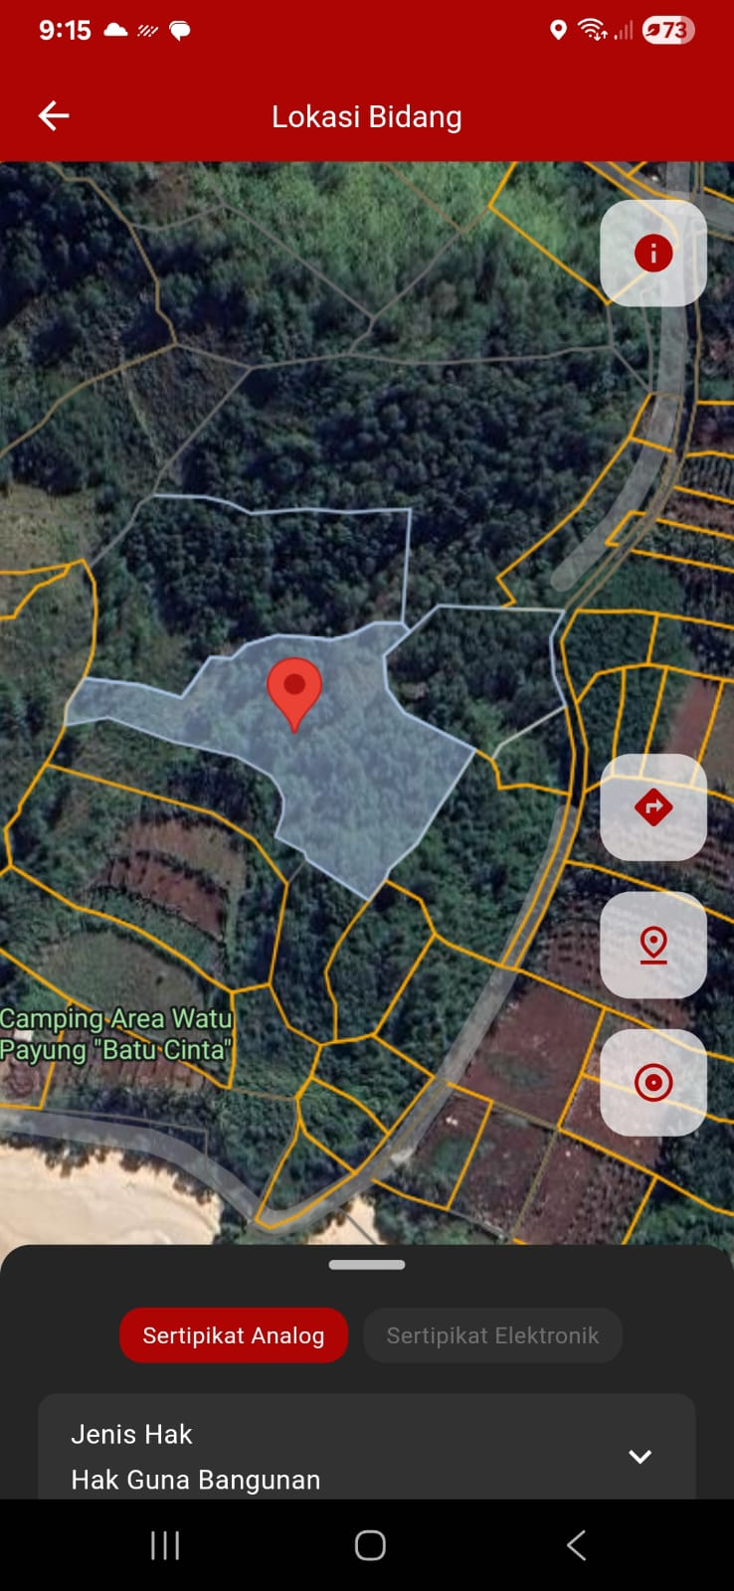 SENTUH TANAHKU
CERTIFICATES

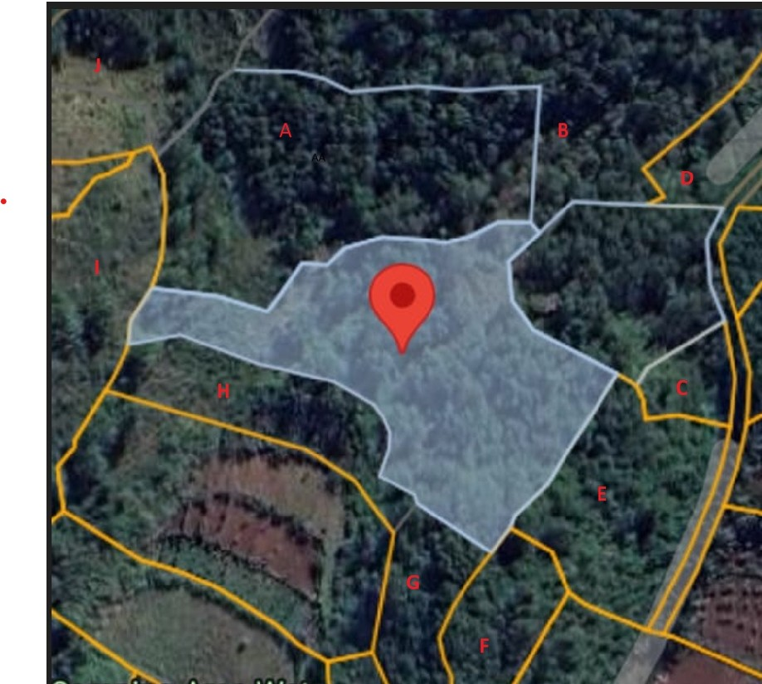

CERTIFICATE | OWNER NAME | OWNER NOMOR HP | NIB | TYPE HAK | LUAS
A | KKB |  |  | HGB | 4040
B – Watu Karung | Rully Wijayanti |  | 02233 | Kosong | 7204
C - Jlubang | Misman | 085336778239 | 01650 | Milik | 446
D - Jlubang | Yadi |  | 01657 | Milik | 1060
E - Jlubang | Sunarto |  | 00390 | Milik | 2000
F - Jlubang | Dwisumarwati |  | NIBEL: 000074671 | Milik | 972
G Jlubang | Usop Mulyono |  |  | No info | No info
H | Sukadi |  | 02264 | Kosong | 1357
I | Ayi Indriati |  | NIBEL: 000062174 | Milik | 4742
J | Suwarno Cs |  | 02248 | Kosong | 2590

