Statistics Cheat Sheet

Mr. Roth , Mar 2004
1. Fundamentals
- Population – Everybody to be analysed
- Parameter - # summarizing Pop
- Sample – Subset of Pop we collect data on
- Statistics - # summarizing Sample
- Quantitative Variables – a number
- Discrete – countable (# cars in family)
- Continuous – Measurements – always # between
- Qualitative
- Nominal – just a name
- Ordinal – Order matters (low, mid, high)
Choosing a Sample
- Sample Frame – list of pop we choose sample from
- Biased – sampling differs from pop characteristics.
- Volunteer Sample – any of below three types may end up as volunteer if people choose to respond.
Sample Designs
- Judgement Samp: Choose what we think represents
- Convenience Sample – easily accessed people
- Probability Samp: Elements selected by Prob
- Simple random sample – every element = chance
- Systematic sample – almost random but we choose by method
- Census – data on every everyone/thing in pop
Stratified Sampling
Divide pop into subpop based upon characteristics
- Proportional: in proportion to total pop
- Stratified Random: select random within substrata
- Cluster: Selection within representative clusters
Collect the Data
- Experiment: Control the environment
- Observation:
2. Single Variable Data - Distributions
- Graphing Categorical: Pie & bar chart)
- Histogram (classes, count within each class)
- – shape, center, spread. Symmetric, skewed right, skewed left
- Stemplots
0 | 11222 |  | 0 | 112233
1 | 011333 |  | 0 | 56677
2 | etc |  | 1
- Mean: 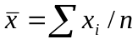
- Median: M: If odd – center, if even - mean of 2
- Boxplot:
Min | Q1 | M | Q3 | Max

- Variance: 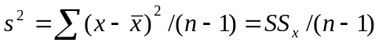,
- p78: standard deviation, s = √s²
- 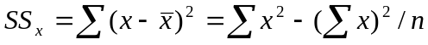
- Density curve – relative proportion within classes – area under curve = 1
- Normal Distribution: 68, 95, 99.7 % within 1, 2, 3 std deviations.
- p98: z-score 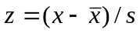 or 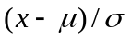
- Standard Normal: N(0,1) when N(μ,σ)
3. Bivariate - Scatterplots & Correlation
- Explanatory – independent variable
- Response – dependent variable
- Scatterplot: form, direction, strength, outliers
- – form is linear negative, …
- – to add categorical use different color/symbol
- p147: Linear Correlation- direction & strength of linear relationship
- Pearsons Coeff: {-1 ≤ r ≤ 1} 1 is perfectly linear + slope, -1 is perfectly linear – slope.
- 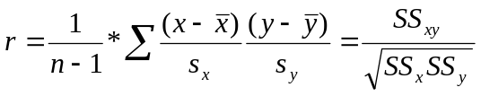,
- r = z_{x}z_{y} / (n - 1),
- 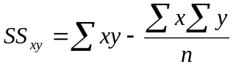
4. Regression
- least squares – sum of squares of vertical error minimized
- p154: y = b₀ + b₁x, or 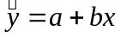,
- (same as y = mx + b)
- 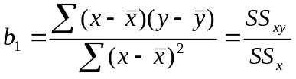 = r (s_{y} / s_{x})
- Then solving knowing lines thru centroid (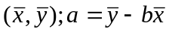
- 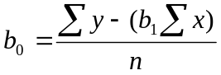
- r^2 is proportion of variation described by linear relationship
- residual = y - = observed – predicted.
- Outliers: in y direction -> large residuals, in x direction -> often influential to least squares line.
- Extrapolation – predict beyond domain studied
- Lurking variable
- Association doesn't imply causation
5. Data – Sampling
- Population: entire group
- Sample: part of population we examine
- Observation: measures but does not influence response
- Experiment: treatments controlled & responses observed
- Confounded variables (explanatory or lurking) when effects on response variable cannot be distinguished
- Sampling types: Voluntary response – biased to opinionated, Convenience – easiest
- Bias: systematically favors outcomes
- Simple Random Sample (SRS): every set of n individuals has equal chance of being chosen
- Probability sample: chosen by known probability
- Stratified random: SRS within strata divisions
- Response bias – lying/behavioral influence
6. Experiments
- Subjects: individuals in experiment
- Factors: explanatory variables in experiment
- Treatment: combination of specific values for each factor
- Placebo: treatment to nullify confounding factors
- Double-blind: treatments unknown to subjects & individual investigators
- Control Group: control effects of lurking variables
- Completely Randomized design: subjects allocated randomly among treatments
- Randomized comparative experiments: similar groups – nontreatment influences operate equally
- Experimental design: control effects of lurking variables, randomize assignments, use enough subjects to reduce chance
- Statistical signifi: observations rare by chance
- Block design: randomization within a block of individuals with similarity (men vs women)
7. Probability & odds
- 2 definitions:
- 1) Experimental: Observed likelihood of a given outcome within an experiment
- 2) Theoretical: Relative frequency/proportion of a given event given all possible outcomes (Sample Space)
- Event: outcome of random phenomenon
- n(S) – number of points in sample space
- n(A) – number of points that belong to A
- p 183: Empirical: P'(A) = n(A)/n = #observed/ #attempted.
- p 185: Law of large numbers – Exp -> Theoret.
- p. 194: Theoretical P(A) = n(A)/n(S) , favorable/possible
- 0 ≤ P(A) ≤ 1, ∑ (all outcomes) P(A) = 1
- p. 189: S = Sample space, n(S) - # sample points. Represented as listing {(, ), …}, tree diagram, or grid
- p. 197 Complementary Events P(A) + P() = 1
- p200: Mutually exclusive events: both can't happen at the same time
- p203. Addition Rule: P(A or B) = P(A) + P(B) – P(A and B) [which = 0 if exclusive]
- p207: Independent Events: Occurrence (or not) of A does not impact P(B) & visa versa.
- Conditional Probability: P(A|B) – Probability of A given that B has occurred. P(B|A) – Probability of B given that A has occurred.
- Independent Events iff P(A|B) = P(A) and P(B|A) = P(B)
- Special Multiplication. Rule: P(A and B) = P(A)*P(B)
- General mult. Rule: P(A and B) = P(A)*P(B|A) = P(B)*P(A|B)
- Odds / Permutations
- Order important vs not (Prob of picking four numbers)
- Permutations: nPr, n!/(n – r)! , number of ways to pick r item(s) from n items if order is important : Note: with repetitions p alike and q alike = n!/p!q!.
- Combinations: nCr, n!/((n – r)!r!) , number of ways to pick r item(s) from n items if order is NOT important
- Replacement vs not (AAKKKQQJJJJ10) (a) Pick an A, replace, then pick a K. (b) Pick a K, keep it, pick another.
- Fair odds - If odds are 1/1000 and 1000 payout. May take 3000 plays to win, may win after 200.
8. Probability Distribution
- Refresh on Numb heads from tossing 3 coins. Do grid {HHH,….TTT} then #Heads vs frequency chart{(0,1), (1,3), (2,3), (4,1)} – Note Pascals triangle
- Random variable – circle #Heads on graph above. "Assumes unique numerical value for each outcome in sample space of probability experiment".
- Discrete – countable number
- Continuous – Infinite possible values.
- Probability Distribution: Add next to coins frequency chart a P(x) with 1/8, 3/8, 3/8, 1/8 values
- Probability Function: Obey two properties of prob. (0 ≤ P(A) ≤ 1, ∑ (all outcomes) P(A) = 1.
- Parameter: Unknown # describing population
- Statistic: # computed from sample data
 | Sample | Population
Mean |  | μ - mu
Variance | s² | σ²
Standard deviation | s | σ - sigma
- Base: 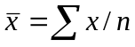, 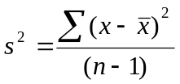
 | Frequency Dist | Probability Distribution
Mean | 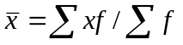 | 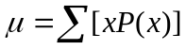
Var | 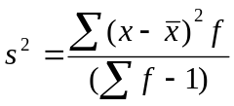 | 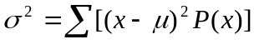
Std Dv | s = √s² | 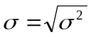
- Probability acting as an 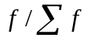 . Lose the -1
9. Sampling Distribution
- By law of large #'s, as n -> population, 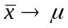
- Given as mean of SRS of size n, from pop with μ and σ. Mean of sampling distribution of is μ and standard deviation is 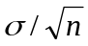
- If individual observations have normal distribution N(μ,σ) – then of n has N(μ,)
- Central Limit Theorem: Given SRS of b from a population with μ and σ. When n is large, the sample mean is approx normal.
10. Binomial Distribution
- Binomial Experiment. Emphasize Bi – two possible outcomes (success,failure). n repeated identical trials that have complementary P(success) + P(failure) = 1. binomial is count of successful trials where 0≤x≤n
- p : probability of success of each observation
- Binomial Coefficient: nCk = n!/(n – k)!k!
- Binomial Prob: P(x = k) = 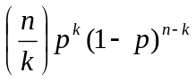
- Binomal μ = np
- Binomal 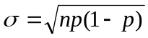
11. Confidence Intervals
- Statistical Inference: methods for inferring data about population from a sample
- If is unbiased, use to estimate μ
- Confidence Interval: Estimate+/- error margin
- Confidence Level C: probability interval captures true parameter value in repeated samples
- Given SRS of n & normal population, C confidence interval for μ is: 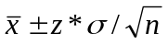
- Sample size for desired margin of error – set +/- value above & solve for n.
12. Tests of significance
- Assess evidence supporting a claim about popu.
- Idea – outcome that would rarely happen if claim were true evidences claim is not true
- Ho – Null hypothesis: test designed to assess evidence against Ho. Usually statement of no effect
- Ha – alternative hypothesis about population parameter to null
- Two sided: Ho: μ = 0, Ha: μ ≠ 0
- P-value: probability, assuming Ho is true, that test statistic would be as or more extreme (smaller P-value is > evidence against Ho)
- z = 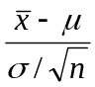
- Significance level α : if α = .05, then happens no more than 5% of time. "Results were significant (P < .01 )"
- Level α 2-sided test rejects Ho: μ = μ_{o} when u_{o} falls outside a level 1 – α confidence int.
- Complicating factors: not complete SRS from population, multistage & many factor designs, outliers, non-normal distribution, σ unknown.
- Under coverage and nonresponse often more serious than the random sampling error accounted for by confidence interval
- Type I error: reject Ho when it's true – α gives probability of this error
- Type II error: accept Ho when Ha is true
- Power is 1 – probability of Type II error

