强基班

匿名
MATLAB实验

注：斜体加粗的为代码

1.

A=[1,2,3,4;4,3,2,1;2,3,4,1;3,2,4,1];
B=[1+4j,2+3j,3+2j,4+1j;4+1j,3+2j,2+3j,1+4j;2+3j,3+2j,4+1j,1+4j;3+2j,2+3j,4+1j,1+4j];

A =
[1, 2, 3, 4, 0, 0]
[4, 3, 2, 1, 0, 0]
[2, 3, 4, 1, 0, 0]
[3, 2, 4, 1, 0, 0]
[0, 0, 0, 0, 0, 5]

2.

A=magic(8);
B=A(2:2:end,:)

A =
64 2 3 61 60 6 7 57
9 55 54 12 13 51 50 16
17 47 46 20 21 43 42 24
40 26 27 37 36 30 31 33
32 34 35 29 28 38 39 25
41 23 22 44 45 19 18 48
49 15 14 52 53 11 10 56
8 58 59 5 4 62 63 1
B =
9 55 54 12 13 51 50 16
40 26 27 37 36 30 31 33
41 23 22 44 45 19 18 48
8 58 59 5 4 62 63 1

3.

syms sums;syms k;
sums=symsum(2^k,k,0,63)

18446744073709551615

4.

subplot(211);
t=-1:0.00001:1;
y=sin(1./t);
plot(t,y)

subplot(212);
t=-pi:0.00001:pi;
y=sin(tan(t))-tan(sin(t));
plot(t,y)

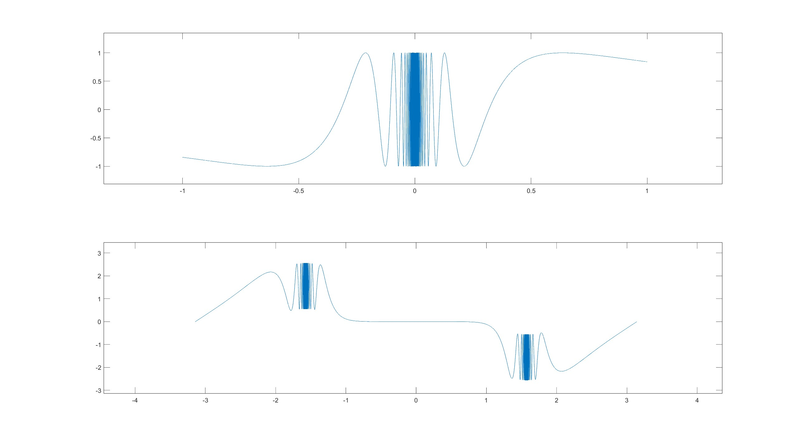

5.

[x,y]=meshgrid(-9:1:9,-9:1:9);
z=1./sqrt((1.-x).^2+y.^2)+1./sqrt((1.+x).^2+y.^2);
subplot(221),surfc(x,y,z),shading flat,view(0,90)
subplot(222),surfc(x,y,z),shading flat,view(-90,0)
subplot(223),surfc(x,y,z),shading flat,view(0,0)
subplot(224),surfc(x,y,z),shading flat

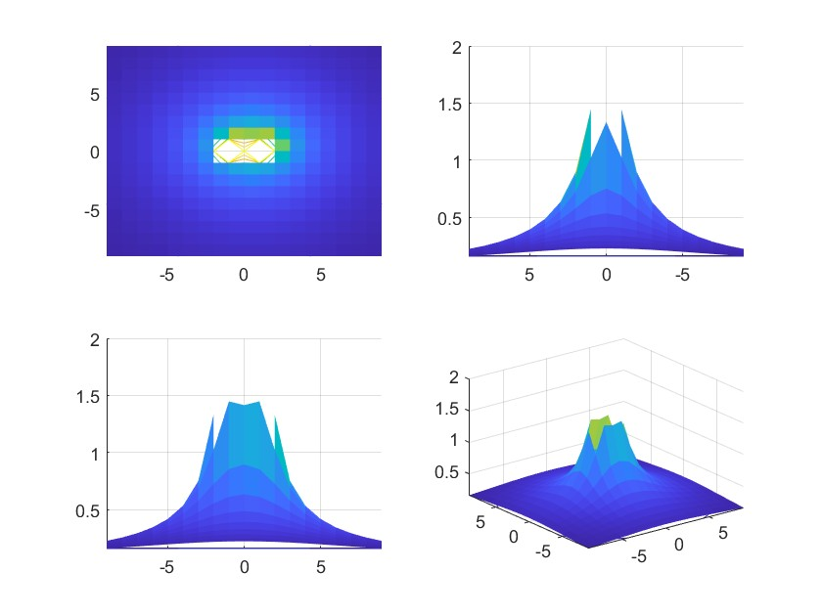

6.

syms x;
f=(3^x+9^x)^(1/x);
L=limit(f,inf)

syms x;syms y;
f(x,y)=x*y/(sqrt(x*y+1)-1);
L=limit(limit(f,x,0),y,0)

syms x;syms y;
f(x,y)=(1-cos(x^2+y^2))/((x^2+y^2)*exp(x^2+y^2));
L=limit(limit(f,x,0),y,0)

L =9
L =2
L =0

7.

‘paradiff.m’
function result=paradiff(y,x,t,n)
if mod(n,1)~=0,error('n should be positive integer,please correct.')
else,g1=diff(x,t);result=diff(y,t)/g1;
for i=2:n,result=diff(result,t)/g1;end
end

命令行：
syms t;
x=log(cos(t));
y=cos(t)-t*sin(t);
f1(t)=simplify(paradiff(y,x,t,1))
f2(t)=simplify(paradiff(y,x,t,2));simplify(f2(sym(pi)/3))

ans =(7*pi*3^(1/2))/54 + 5/6

8.

syms t;syms x;syms y;syms fx2;syms fxy;syms fy2;
f(x,y)=int(exp(-t^2),t,0,x*y);
fx2=diff(diff(f,x),x);
fy2=diff(diff(f,y),y);
fxy=diff(diff(f,x),y);
A=simplify(x/y*fx2-2*fxy+fy2);
disp(A);

-2*exp(-x^2*y^2)*(x^3*y - x^2*y^2 + 1)

9.

syms k;
f(k)=1/((2*k)^2-1);
LIM_f=symsum(f,k,1,inf);
disp(LIM_f);

syms k;syms n;
f(n,k)=1/(n^2+k*sym(pi));
LIM=limit(n*symsum(f,k,1,n),inf);
disp(LIM);

1/2
1

10.
syms t;syms a;
x(t)=a*(cos(t)+t*sin(t));
y(t)=a*(sin(t)-t*cos(t));
x1(t)=diff(x,t);
y1(t)=diff(y,t);
I=simplify(int((x^2+y^2)*sqrt(x1^2+y1^2),t,0,2*sym(pi)));
disp(I);

syms t;syms x;syms y;
syms c positive;syms b positive;syms a positive;
x(t)=c/a*cos(t);
y(t)=c/b*sin(t);
x1(t)=diff(x,t);
y1(t)=diff(y,t);
I=simplify(int((y*x^3+exp(y))*x1+(x*y^3+x*exp(y)-2*y)*y1,t,0,sym(pi)));
disp(I);

2*pi^2*(2*pi^2 + 1)*(a^2)^(3/2)
-(2*c*(15*b^4 - 2*c^4))/(15*a*b^4)
11.

syms a b c d e;
p=[a,b,c,d,e];
A=vander(p);
a=simplify(det(A));
disp(a);

(a - b)*(a - c)*(a - d)*(b - c)*(a - e)*(b - d)*(b - e)*(c - d)*(c - e)*(d - e)

12.

A=[-2 0.5 -0.5 0.5;0 -1.5 0.5 -0.5;2 0.5 -4.5 0.5;2 1 -2 -2];
[T,J]=jordan(sym(A)),J1=inv(T)*A*T
%变换矩阵是T

T =
[ 0, 1/2, 1/2, -1/4]
[ 0, 0, 1/2, 1]
[1/4, 1/2, 1/2, -1/4]
[1/4, 1/2, 1, -1/4]
J =
[-4, 0, 0, 0]
[ 0, -2, 1, 0]
[ 0, 0, -2, 1]
[ 0, 0, 0, -2]
J1 =
[-4, 0, 0, 0]
[ 0, -2, 1, 0]
[ 0, 0, -2, 1]
[ 0, 0, 0, -2]
13.

A=[3 -6 -4 0 5;1 4 2 -2 4;-6 3 -6 7 3;-13 10 0 -11 0;0 4 0 3 4];
B=[3 -2 1;-2 -9 2;-2 -1 9];
C=[-2 1 -1;4 1 2;5 -6 1;6 -4 -4;-6 6 -3];
X=sylvester(A,B,C),norm(A*X+X*B-(-1)*C)

A=[3 -6 -4 0 5;1 4 2 -2 4;-6 3 -6 7 3;-13 10 0 -11 0;0 4 0 3 4];
B=[3 -2 1;-2 -9 2;-2 -1 9];
C=-1*[-2 1 -1;4 1 2;5 -6 1;6 -4 -4;-6 6 -3];
syms nr nc;
[nr,nc]=size(C);
A0=kron(eye(nc),sym(A))+kron(sym(B).',eye(nr));
x0=-A0\C(:);
X=reshape(x0,nr,nc),norm(A*X+X*B-(-1)*C)

X =
4.0569 14.5128 -1.5653
-0.0356 -25.0743 2.7408
-9.4886 -25.9323 4.4177
-2.6969 -21.6450 2.8851
-7.7229 -31.9100 3.7634
ans =
27.8085
X =
[ 434641749950/107136516451, 4664546747350/321409549353, -503105815912/321409549353]
[ -3809507498/107136516451, -8059112319373/321409549353, 880921527508/321409549353]
[-1016580400173/107136516451, -8334897743767/321409549353, 1419901706449/321409549353]
[ -288938859984/107136516451, -6956912657222/321409549353, 927293592476/321409549353]
[ -827401644798/107136516451, -10256166034813/321409549353, 1209595497577/321409549353]
ans =
0
14.

A=[-4.5 0 0.5 -1.5;-0.5 -4 0.5 -0.5;1.5 1 -2.5 1.5;0 -1 -1 -3];
syms t;
ans1=expm(sym(A)*t)
ans2=funm(sym(A)*t,@sin)
ans3=simplify(expm(sym(A)*t)*funm(A^2*expm(sym(A)*t)*t,@sin))

ans1 =
[exp(-3*t)/2 + exp(-5*t)/2 - (t*exp(-3*t))/2 + (t^2*exp(-3*t))/2, exp(-5*t)/2 - exp(-3*t)/2 + t*exp(-3*t), (t*exp(-3*t))/2 + (t^2*exp(-3*t))/2, exp(-5*t)/2 - exp(-3*t)/2 - (t*exp(-3*t))/2 + (t^2*exp(-3*t))/2]
[ exp(-5*t)/2 - exp(-3*t)/2 + (t*exp(-3*t))/2, exp(-3*t)/2 + exp(-5*t)/2, (t*exp(-3*t))/2, exp(-5*t)/2 - exp(-3*t)/2 + (t*exp(-3*t))/2]
[ exp(-3*t)/2 - exp(-5*t)/2 + (t*exp(-3*t))/2, exp(-3*t)/2 - exp(-5*t)/2, exp(-3*t) + (t*exp(-3*t))/2, exp(-3*t)/2 - exp(-5*t)/2 + (t*exp(-3*t))/2]
[ -(t^2*exp(-3*t))/2, -t*exp(-3*t), -(t*exp(-3*t)*(t + 2))/2, -(exp(-3*t)*(t^2 - 2))/2]
ans2 =
[(t^2*sin(3*t))/2 - sin(5*t)/2 - (t*cos(3*t))/2 - sin(3*t)/2, sin(3*t)/2 - sin(5*t)/2 + t*cos(3*t), t^2*(sin(3*t)/2 + cos(3*t)/t) - sin(3*t)/2 - (t*(cos(3*t) - sin(3*t)/t))/2, t^2*(sin(3*t)/2 + sin(3*t)/t^2) - sin(5*t)/2 - (t*cos(3*t))/2 - sin(3*t)/2]
[ sin(3*t)/2 - sin(5*t)/2 + (t*cos(3*t))/2, - sin(3*t)/2 - sin(5*t)/2, sin(3*t)/2 + (t*(cos(3*t) - sin(3*t)/t))/2, sin(3*t)/2 - sin(5*t)/2 + (t*cos(3*t))/2]
[ sin(5*t)/2 - sin(3*t)/2 + (t*cos(3*t))/2, sin(5*t)/2 - sin(3*t)/2, (t*(cos(3*t) - sin(3*t)/t))/2 - sin(3*t)/2, sin(5*t)/2 - sin(3*t)/2 + (t*cos(3*t))/2]
[ -(t^2*sin(3*t))/2, -t*cos(3*t), -t^2*(sin(3*t)/2 + cos(3*t)/t), -t^2*(sin(3*t)/2 + sin(3*t)/t^2)]
ans3 =
[(exp(-3*t)*sin(9*t*exp(-3*t)))/2 + (exp(-5*t)*sin(25*t*exp(-5*t)))/2 + 4*t*exp(-6*t)*cos(9*t*exp(-3*t)) - (t*exp(-3*t)*sin(9*t*exp(-3*t)))/2 - (33*t^2*exp(-6*t)*cos(9*t*exp(-3*t)))/2 + (27*t^3*exp(-6*t)*cos(9*t*exp(-3*t)))/2 + (t^2*exp(-3*t)*sin(9*t*exp(-3*t)))/2 - 18*t^2*exp(-9*t)*sin(9*t*exp(-3*t)) + 54*t^3*exp(-9*t)*sin(9*t*exp(-3*t)) - (81*t^4*exp(-9*t)*sin(9*t*exp(-3*t)))/2, (exp(-5*t)*sin(25*t*exp(-5*t)))/2 - (exp(-3*t)*sin(9*t*exp(-3*t)))/2 - 6*t*exp(-6*t)*cos(9*t*exp(-3*t)) + t*exp(-3*t)*sin(9*t*exp(-3*t)) + 9*t^2*exp(-6*t)*cos(9*t*exp(-3*t)), (t*exp(-3*t)*sin(9*t*exp(-3*t)))/2 - 2*t*exp(-6*t)*cos(9*t*exp(-3*t)) - (15*t^2*exp(-6*t)*cos(9*t*exp(-3*t)))/2 + (27*t^3*exp(-6*t)*cos(9*t*exp(-3*t)))/2 + (t^2*exp(-3*t)*sin(9*t*exp(-3*t)))/2 - 18*t^2*exp(-9*t)*sin(9*t*exp(-3*t)) + 54*t^3*exp(-9*t)*sin(9*t*exp(-3*t)) - (81*t^4*exp(-9*t)*sin(9*t*exp(-3*t)))/2, (exp(-5*t)*sin(25*t*exp(-5*t)))/2 - (exp(-3*t)*sin(9*t*exp(-3*t)))/2 + 4*t*exp(-6*t)*cos(9*t*exp(-3*t)) - (t*exp(-3*t)*sin(9*t*exp(-3*t)))/2 - (33*t^2*exp(-6*t)*cos(9*t*exp(-3*t)))/2 + (27*t^3*exp(-6*t)*cos(9*t*exp(-3*t)))/2 + (t^2*exp(-3*t)*sin(9*t*exp(-3*t)))/2 - 18*t^2*exp(-9*t)*sin(9*t*exp(-3*t)) + 54*t^3*exp(-9*t)*sin(9*t*exp(-3*t)) - (81*t^4*exp(-9*t)*sin(9*t*exp(-3*t)))/2]
[ (exp(-5*t)*sin(25*t*exp(-5*t)))/2 - (exp(-3*t)*sin(9*t*exp(-3*t)))/2 - 3*t*exp(-6*t)*cos(9*t*exp(-3*t)) + (t*exp(-3*t)*sin(9*t*exp(-3*t)))/2 + (9*t^2*exp(-6*t)*cos(9*t*exp(-3*t)))/2, (exp(-3*t)*sin(9*t*exp(-3*t)))/2 + (exp(-5*t)*sin(25*t*exp(-5*t)))/2, (t*exp(-6*t)*(exp(3*t)*sin(9*t*exp(-3*t)) - 6*cos(9*t*exp(-3*t)) + 9*t*cos(9*t*exp(-3*t))))/2, (exp(-5*t)*sin(25*t*exp(-5*t)))/2 - (exp(-3*t)*sin(9*t*exp(-3*t)))/2 - 3*t*exp(-6*t)*cos(9*t*exp(-3*t)) + (t*exp(-3*t)*sin(9*t*exp(-3*t)))/2 + (9*t^2*exp(-6*t)*cos(9*t*exp(-3*t)))/2]
[ (exp(-3*t)*sin(9*t*exp(-3*t)))/2 - (exp(-5*t)*sin(25*t*exp(-5*t)))/2 - 3*t*exp(-6*t)*cos(9*t*exp(-3*t)) + (t*exp(-3*t)*sin(9*t*exp(-3*t)))/2 + (9*t^2*exp(-6*t)*cos(9*t*exp(-3*t)))/2, (exp(-3*t)*sin(9*t*exp(-3*t)))/2 - (exp(-5*t)*sin(25*t*exp(-5*t)))/2, exp(-3*t)*sin(9*t*exp(-3*t)) - 3*t*exp(-6*t)*cos(9*t*exp(-3*t)) + (t*exp(-3*t)*sin(9*t*exp(-3*t)))/2 + (9*t^2*exp(-6*t)*cos(9*t*exp(-3*t)))/2, (exp(-3*t)*sin(9*t*exp(-3*t)))/2 - (exp(-5*t)*sin(25*t*exp(-5*t)))/2 - 3*t*exp(-6*t)*cos(9*t*exp(-3*t)) + (t*exp(-3*t)*sin(9*t*exp(-3*t)))/2 + (9*t^2*exp(-6*t)*cos(9*t*exp(-3*t)))/2]
[ -(t*exp(-9*t)*(2*exp(3*t)*cos(9*t*exp(-3*t)) - 36*t*sin(9*t*exp(-3*t)) + 108*t^2*sin(9*t*exp(-3*t)) - 81*t^3*sin(9*t*exp(-3*t)) - 24*t*exp(3*t)*cos(9*t*exp(-3*t)) + t*exp(6*t)*sin(9*t*exp(-3*t)) + 27*t^2*exp(3*t)*cos(9*t*exp(-3*t))))/2, -t*exp(-6*t)*(exp(3*t)*sin(9*t*exp(-3*t)) - 6*cos(9*t*exp(-3*t)) + 9*t*cos(9*t*exp(-3*t))), 5*t*exp(-6*t)*cos(9*t*exp(-3*t)) - t*exp(-3*t)*sin(9*t*exp(-3*t)) + 3*t^2*exp(-6*t)*cos(9*t*exp(-3*t)) - (27*t^3*exp(-6*t)*cos(9*t*exp(-3*t)))/2 - (t^2*exp(-3*t)*sin(9*t*exp(-3*t)))/2 + 18*t^2*exp(-9*t)*sin(9*t*exp(-3*t)) - 54*t^3*exp(-9*t)*sin(9*t*exp(-3*t)) + (81*t^4*exp(-9*t)*sin(9*t*exp(-3*t)))/2, exp(-3*t)*sin(9*t*exp(-3*t)) - t*exp(-6*t)*cos(9*t*exp(-3*t)) + 12*t^2*exp(-6*t)*cos(9*t*exp(-3*t)) - (27*t^3*exp(-6*t)*cos(9*t*exp(-3*t)))/2 - (t^2*exp(-3*t)*sin(9*t*exp(-3*t)))/2 + 18*t^2*exp(-9*t)*sin(9*t*exp(-3*t)) - 54*t^3*exp(-9*t)*sin(9*t*exp(-3*t)) + (81*t^4*exp(-9*t)*sin(9*t*exp(-3*t)))/2]

15.

syms a t;
f(t)=sin(a*t)/t;
F=simplify(laplace(f(t)))

syms a t;
f(t)=t^5*sin(a*t);
F=simplify(laplace(f(t)))

syms a t;
f(t)=t^8*cos(a*t);
F=simplify(laplace(f(t)))

F =atan(a/s)
F =(240*a*s*(3*a^4 - 10*a^2*s^2 + 3*s^4))/(a^2 + s^2)^6
F =(40320*s*(9*a^8 - 84*a^6*s^2 + 126*a^4*s^4 - 36*a^2*s^6 + s^8))/(a^2 + s^2)^9

16.

syms a b s;
F=1/(sqrt(s^2)*(s^2-a^2)*(s+b));
f(t)=ilaplace(F)

syms a b s t;
F(s)=(s-a)^(1/2)-(s-b)^(1/2);
f(t)=simplify(ilaplace(F,s,t))

syms a b s t;
F(s)=log((s-a)/(s-b));
f(t)=simplify(ilaplace(F,s,t))

f(t) =-ilaplace(1/((b + s)*(a^2 - s^2)*(s^2)^(1/2)), s, t)
f(t) =ilaplace((s - a)^(1/2), s, t) - ilaplace((s - b)^(1/2), s, t)
f(t) =-(exp(a*t) - exp(b*t))/t17.

17.
syms x t;
f=x^2*(3*pi-2*abs(x));
F=fourier(f,x,t)
f1=ifourier(F,t,x)

syms t w;
f=t^2*(t-2*pi)^2;
F=fourier(f,t,w)
f1=ifourier(F,w,t)

F =- 24/t^4 - 6*pi^2*dirac(2, t)
f1 =(6*x^2*pi^2 - 4*pi*x^3*sign(x))/(2*pi)
F =- 8*dirac(2, w)*pi^3 + dirac(3, w)*pi^2*8i + 2*dirac(4, w)*pi
f1 =(8*pi^3*t^2 - 8*pi^2*t^3 + 2*pi*t^4)/(2*pi)
不能得到。

18.

syms k a T z;
f(T)=cos(k*a*T);
F(z)=ztrans(f,T,z)
f1(T)=iztrans(F,z,T)
t=(-10):1:10;
f(t)-f1(t)

syms k a T z;
f(T)=(k*T)^2*exp(-a*k*T);
F(z)=ztrans(f,T,z)
f1(T)=iztrans(F,z,T)
t=(-10):1:10;
f(t)-f1(t)

syms k a T z;
f(T)=(k*a*T-1+exp(-a*k*T));
F(z)=ztrans(f,T,z)
f1(T)=iztrans(F,z,T)
t=(-10):1:10;
f(t)-f1(t)
F(z) =(z*(z - cos(a*k)))/(z^2 - 2*cos(a*k)*z + 1)
f1(T) =cos(T*a*k)
ans =[0, 0, 0, 0, 0, 0, 0, 0, 0, 0, 0, 0, 0, 0, 0, 0, 0, 0, 0, 0, 0]
F(z) =(k^2*z*exp(a*k)*(z*exp(a*k) + 1))/(z*exp(a*k) - 1)^3
f1(T) =3*k^2*(exp(-a*k)^T*(T - 1) + kroneckerDelta(T, 0)) - 2*k^2*(kroneckerDelta(T, 0) - exp(-a*k)^T*nchoosek(T - 1, 2)) + k^2*(exp(-a*k)^T - kroneckerDelta(T, 0))
ans =[0, 0, 0, 0, 0, 0, 0, 0, 0, 0, 0, 0, 0, 0, 0, 0, 0, 0, 0, 0, 0]
F(z) =z/(z - exp(-a*k)) - z/(z - 1) + (a*k*z)/(z - 1)^2
f1(T) =exp(-a*k)*(exp(a*k)*exp(-a*k)^T - exp(a*k)*kroneckerDelta(T, 0)) - (kroneckerDelta(T, 0) - 1)*(a*k - 1) + a*k*(T + kroneckerDelta(T, 0) - 1)
ans =[0, 0, 0, 0, 0, 0, 0, 0, 0, 0, 0, 0, 0, 0, 0, 0, 0, 0, 0, 0, 0]

19.

syms x;
f(x)=exp(-(x+1)^2+pi/2)*sin(5*x+2);
%y=-5:0.05:5;
%plot(y,f(y))
x0=solve(f)
f(x0)
f1=inline('exp(-(x1+1).^2+pi/2).*sin(5*x1+2)','x1');
fsolve(f1,-2.9)
fsolve(f1,-2.3)
fsolve(f1,-1.65)
fsolve(f1,-1.05)
fsolve(f1,0.25)
fsolve(f1,0.8)

syms x y;
eqn=(x.^2+y.^2+x.*y).*exp(-x.^2-y.^2-x.*y)==0;
y1=solve(eqn,y)
e=simplify(subs((x.^2+y.^2+x.*y).*exp(-x.^2-y.^2-x.*y),y,y1))
x0 =
-2/5
ans =
0

方程已解。

fsolve 已完成，因为按照函数容差的值衡量，
函数值向量接近于零，并且按照梯度的值衡量，
问题似乎为正则问题。

<停止条件详细信息>
ans =
-2.9133

方程已解。

fsolve 已完成，因为按照函数容差的值衡量，
函数值向量接近于零，并且按照梯度的值衡量，
问题似乎为正则问题。

<停止条件详细信息>
ans =
-2.2850

方程已解。

fsolve 已完成，因为按照函数容差的值衡量，
函数值向量接近于零，并且按照梯度的值衡量，
问题似乎为正则问题。

<停止条件详细信息>
ans =
-1.6566

方程已解。

fsolve 已完成，因为按照函数容差的值衡量，
函数值向量接近于零，并且按照梯度的值衡量，
问题似乎为正则问题。

<停止条件详细信息>
ans =
-1.0283

方程已解。

fsolve 已完成，因为按照函数容差的值衡量，
函数值向量接近于零，并且按照梯度的值衡量，
问题似乎为正则问题。

<停止条件详细信息>
ans =
0.2283

方程已解。

fsolve 已完成，因为按照函数容差的值衡量，
函数值向量接近于零，并且按照梯度的值衡量，
问题似乎为正则问题。

<停止条件详细信息>
ans =
0.8566

y1 =
- x/2 - (3^(1/2)*x*1i)/2
- x/2 + (3^(1/2)*x*1i)/2
e =
0
0

20.

syms x c c1;
f(c)=int((exp(x)-c*x)^2,x,0,1);
%diff(f,c)
eqn=diff(f,c)==0;
c1=solve(eqn,c)
c2=-10:0.1:15;
plot(c2,f(c2))

c1 =3

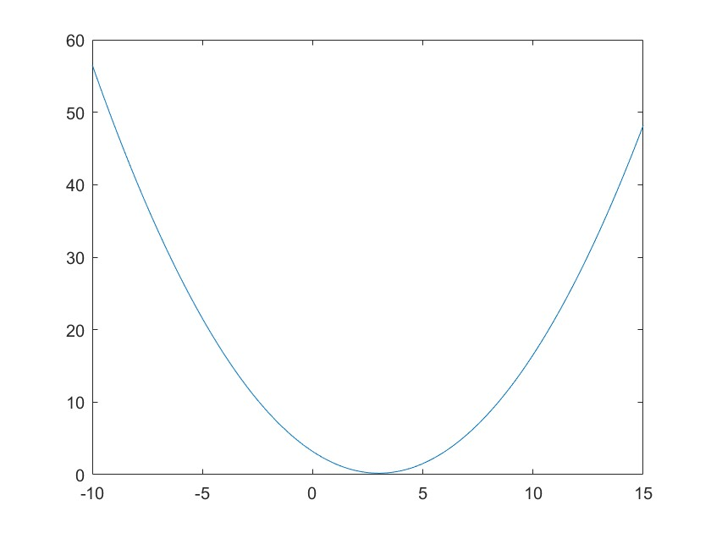
21.

‘opt_con1.m’
function[c,ceq]=opt_con1(x)
c=[x(1)*x(2)-x(1)-x(2)+1.5,-x(1)*x(2)-10,x(1)+x(2)];
ceq=[];

f=@(x)exp(x(1))*(4*x(1)^2+2*x(2)^2+4*x(1)*x(2)+2*x(2)+1);
ff=optimset;
ff.TolFun=eps;ff.TolX=eps;ff.TolCon=eps;
x0=[0;0];xm=[-10;-10];xM=[10;10];
A=[];B=[];Aeq=[];Beq=[];
[x,f_opt,flag,d]=fmincon(f,x0,A,B,Aeq,Beq,xm,xM,@opt_con1,ff)

可能存在局部最小值。满足约束。

fmincon 已停止，因为当前步长小于
步长容差值并且在约束容差值范围内满足约束。

<停止条件详细信息>
x =
1.1825
-1.7398
f_opt =
3.0608
flag =
2
d =
包含以下字段的 struct:

iterations: 23
funcCount: 124
constrviolation: 0
stepsize: 2.5300e-16
algorithm: 'interior-point'
firstorderopt: 2.6076e-07
cgiterations: 34
message: '可能存在局部最小值。满足约束。↵↵fmincon 已停止，因为当前步长小于↵步长容差值并且在约束容差值范围内满足约束。↵↵<停止条件详细信息>↵↵优化已停止，因为 x 的所有元素的相对变化↵小于 options.StepTolerance = 2.220446e-16，↵并且相对最大约束违反值 0.000000e+00 小于 options.ConstraintTolerance = 2.220446e-16。'
bestfeasible: [1×1 struct]

22.

f=[-592;-381;-273;-55;-48;-37;-23];
intcon=1:7;
A=[3534,2356,1767,589,528,451,304];
b=119567;
Aeq=[];
beq=[];
lb=zeros(7,1);
ub=[Inf;Inf;Inf;Inf;Inf;Inf;Inf];
x=intlinprog(f,intcon,A,b,Aeq,beq,lb,ub)

Running HiGHS 1.6.0: Copyright (c) 2023 HiGHS under MIT licence terms
Presolving model
1 rows, 7 cols, 7 nonzeros
1 rows, 7 cols, 7 nonzeros
Objective function is integral with scale 1

Solving MIP model with:
1 rows
7 cols (0 binary, 7 integer, 0 implied int., 0 continuous)
7 nonzeros

Nodes | B&B Tree | Objective Bounds | Dynamic Constraints | Work
Proc. InQueue | Leaves Expl. | BestBound BestSol Gap | Cuts InLp Confl. | LpIters Time

0 0 0 0.00% -97734 inf inf 0 0 0 0 0.0s
S 0 0 0 0.00% -97734 -19917 390.71% 0 0 0 0 0.0s
0 0 0 0.00% -20012.25 -19917 0.48% 0 0 2 2 0.0s

Solving report
Status Optimal
Primal bound -19979
Dual bound -19979
Gap 0% (tolerance: 0.01%)
Solution status feasible
-19979 (objective)
0 (bound viol.)
1.06581410364e-14 (int. viol.)
0 (row viol.)
Timing 0.01 (total)
0.00 (presolve)
0.00 (postsolve)
Nodes 1
LP iterations 4 (total)
0 (strong br.)
2 (separation)
0 (heuristics)

找到最优解。

Intlinprog 在根节点处停止，因为
目标值在最优值的间隙容差范围内，options.AbsoluteGapTolerance = 1e-06。intcon
变量是容差范围内的整数，options.ConstraintTolerance = 1e-06。

x =
32.0000
2.0000
1.0000
0
0
0
0

23.

syms x y(x) C1 C2;
u=x*x*exp(-5*x);
y1=diff(y);
y2=diff(y,2);
y0=dsolve(y2-(2-1/x)*y1+(1-1/x)*y==u);
y0(x)=simplify(y0)
C1s=solve(y0(1)==pi,C1);
C2s=solve(subs(y0(pi),C1,C1s)==1,C2);
y0(x)=simplify(subs(y0(x),[C1,C2],[C1s,C2s]))
%simplify(y0(1)),simplify(y0(pi))

y0(x) =
(exp(-5*x)*(30*x - 6*ei(-6*x)*exp(6*x) + 36*x^2 + 1296*C1*exp(6*x) + 1296*C2*exp(6*x)*log(x) + 11))/1296
y0(x) =
(exp(-5*x)*(30*x - 6*ei(-6*x)*exp(6*x) + 36*x^2 + 1296*exp(6*x)*exp(-1)*(pi + (exp(-5)*(6*ei(-6)*exp(6) - 77))/1296) - (exp(6*x)*log(x)*(11*exp(-6*pi) - 1296*exp(-pi) + 6*ei(-6) - 77*exp(-6) - 6*ei(-6*pi) + 1296*pi*exp(-1) + 36*pi^2*exp(-6*pi) + 30*pi*exp(-6*pi)))/log(pi) + 11))/1296

24.

syms t x(t);
x1=diff(x);x2=diff(x,2);
eqn=x2+2*t*x1+t*t*x==t+1;
x0=dsolve(eqn,t)

syms x y(x);
y1(x)=diff(y);
eqn=y1(x)+2*x*y(x)==x*exp(-x^2);
y0=dsolve(eqn)

x0 =exp(-(t*(t - 2))/2)*(exp(t^2/2 - t)/2 + (2^(1/2)*pi^(1/2)*erfi(2^(1/2)*(t/2 - 1/2))*exp(-1/2))/2) + C1*exp(-(t*(t - 2))/2) + C2*exp(-(t*(t + 2))/2) - (exp(-(t*(t + 2))/2)*exp(t^2/2 + t))/2

y0 =C1*exp(-x^2) + (x^2*exp(-x^2))/2

25.

[t,x]=ode45(@(t,x)rossler_eqn(t,x,0.2,0.2,5.7),[0,100],[0;0;0]);
subplot(121),plot3(x(:,1),x(:,2),x(:,3));grid %加入网格
%分别对应[x,y,z],diff([x,y,z]),diff([x,y,z],2)
[t,x]=ode45(@(t,x)rossler_eqn(t,x,0.2,0.5,10),[0,100],[0;0;0]);
subplot(122),plot3(x(:,1),x(:,2),x(:,3));grid

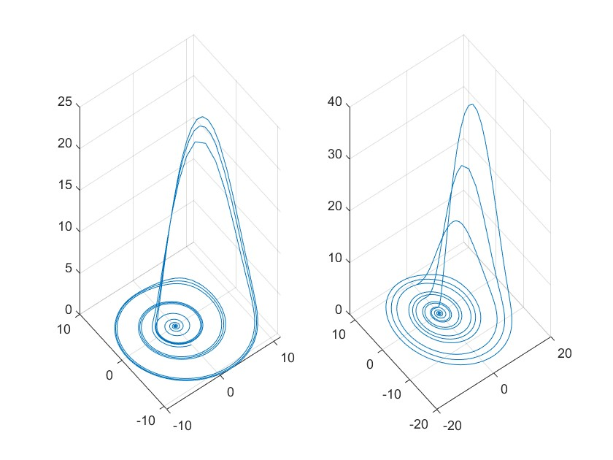

26.

[t1,x1]=ode45(@(t,x)practice_eqn_1(t,x),[1,0],[2;4;-2;7;6]);
[t2,x2]=ode45(@(t,x)practice_eqn_1(t,x),[1,3],[2;4;-2;7;6]);
t=[t1(end:-1:1);t2];x=[x1(end:-1:1,:);x2];
subplot(131),plot(t,x),grid,legend('x','x1','y','y1','y2');xlabel('t'),ylabel('x'),
subplot(132),plot(x(:,1),x(:,3)),grid,xlabel('x'),ylabel('x1')
subplot(133),plot3(x(:,1),x(:,2),x(:,3)),grid,xlabel('x'),ylabel('x1'),zlabel('y')

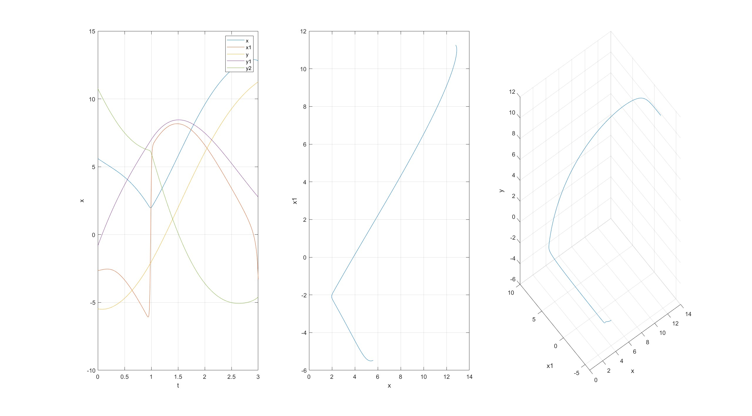

27.

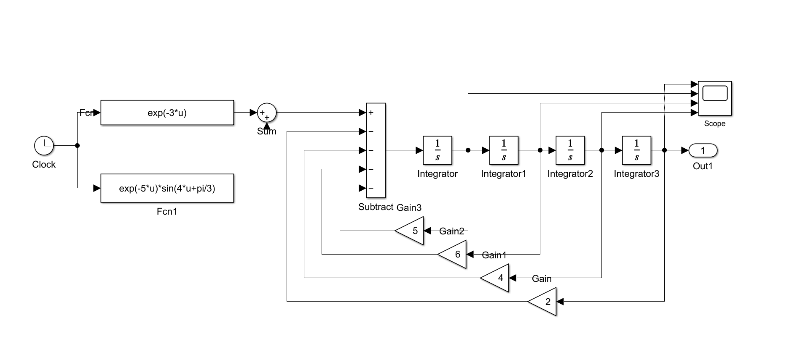
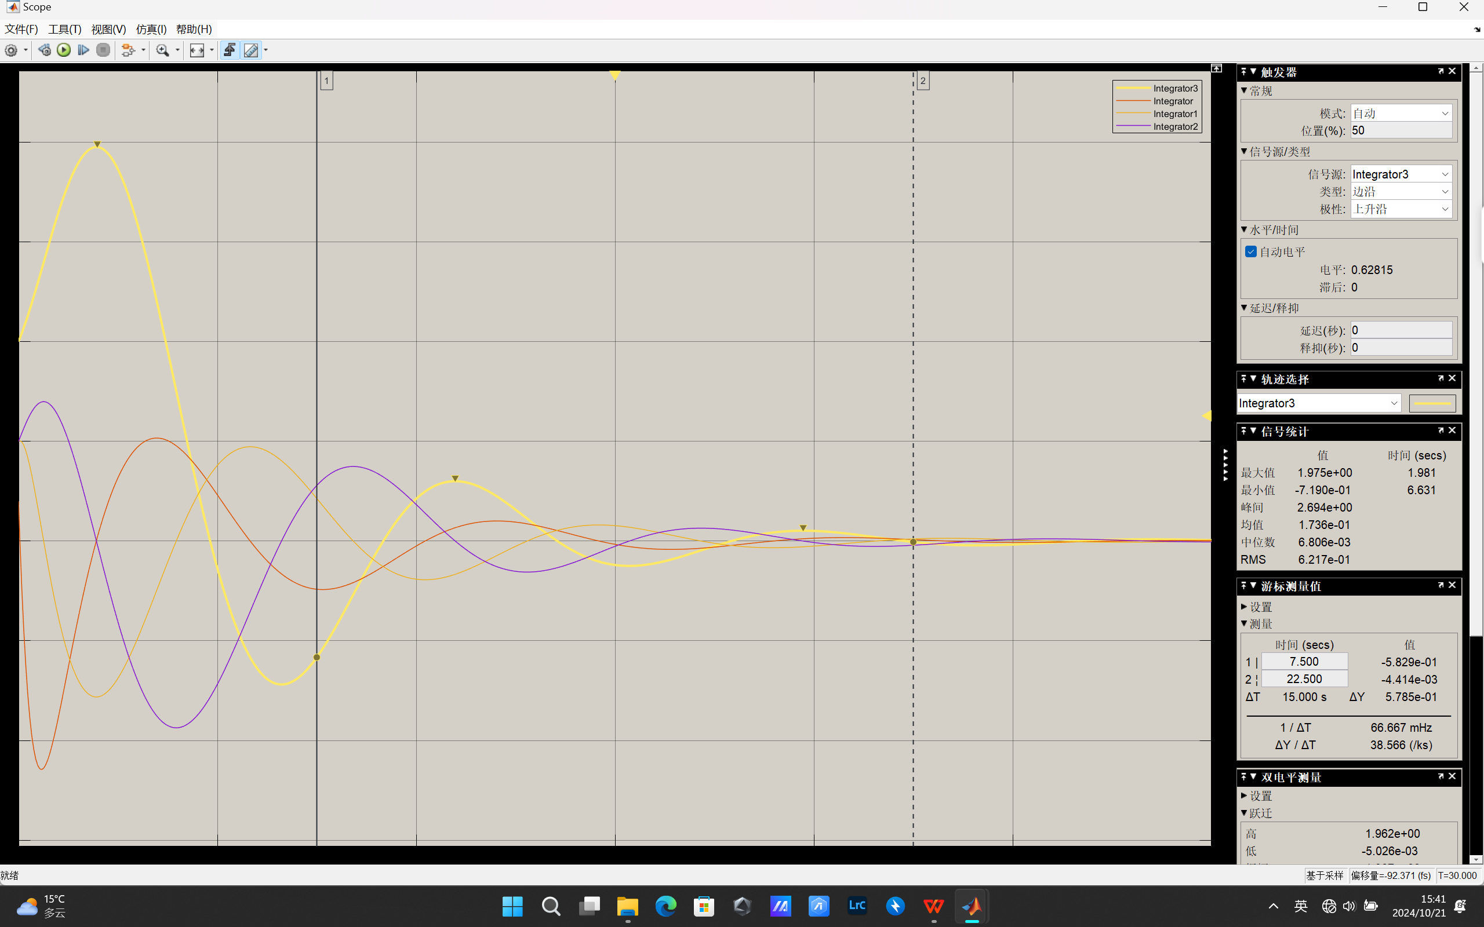
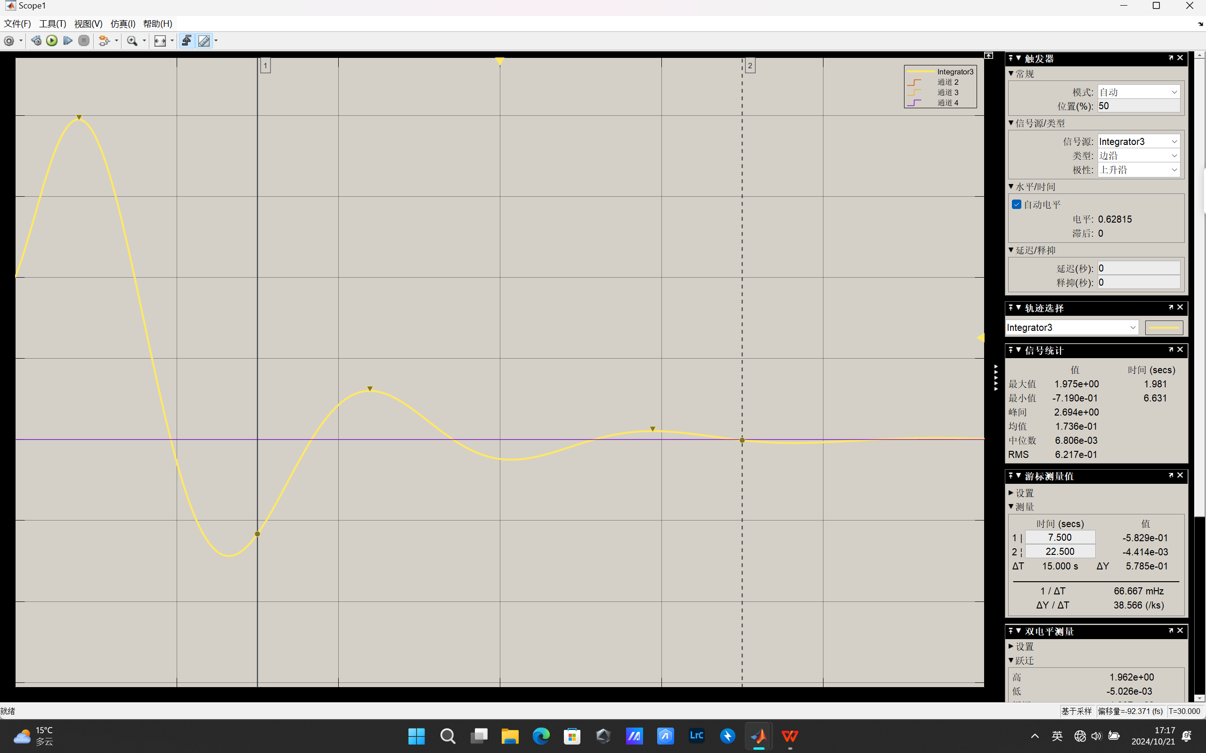

28.

t=0:0.2:2;
y=t.^2.*exp(-5*t).*sin(t);
subplot(221);plot(t,y),hold on;plot(t,y,'o'),hold on;grid
tq=0:0.01:2;
yq_lin=interp1(t,y,tq,"linear");
subplot(222);plot(t,y,'o',tq,yq_lin,'b--o')
yq_mak=interp1(t,y,tq,"makima");
subplot(223);plot(t,y,'o',tq,yq_mak,'b--o'),
yq_nea=interp1(t,y,tq,"nearest");
subplot(224);plot(t,y,'o',tq,yq_nea,'b--o')
figure;
t1=0:0.0001:2;
y1=t1.^2.*exp(-5*t1).*sin(t1);
plot(t1,y1)
