题目1:
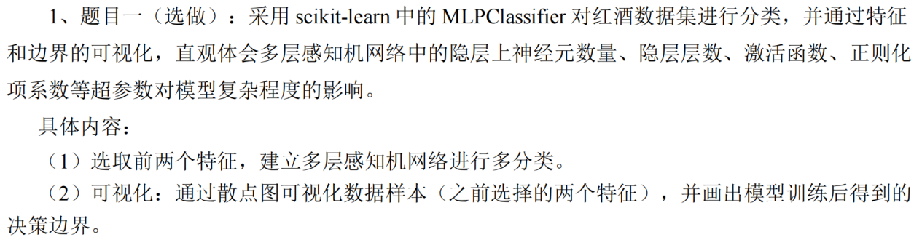

代码：
import numpy as np
import matplotlib.pyplot as plt
from sklearn.datasets import load_wine
from sklearn.neural_network import MLPClassifier
from sklearn.preprocessing import StandardScaler
from sklearn.model_selection import train_test_split
from sklearn.metrics import classification_report

# 加载数据集
wine = load_wine()
X = wine.data[:, :2] # 只取前两个特征
y = wine.target

# 分割数据集
X_train, X_test, y_train, y_test = train_test_split(X, y, test_size=0.2, random_state=42)

# 正确标准化：只使用训练数据计算参数
scaler = StandardScaler()
X_train_scaled = scaler.fit_transform(X_train)
X_test_scaled = scaler.transform(X_test)

# 设置默认参数
mlp = MLPClassifier(
hidden_layer_sizes=(10,), # 单隐层，10个神经元
activation='relu', # ReLU激活函数
alpha=0.0001, # L2正则化系数
max_iter=1000,
random_state=42
)
mlp.fit(X_train_scaled, y_train)

# 预测并输出分类报告
y_pred = mlp.predict(X_test_scaled)
print("Classification Report:")
print(classification_report(y_test, y_pred))

# 创建网格点用于决策边界可视化
h = 0.02 # 网格步长
all_data_scaled = scaler.transform(X) # 整个数据集标准化
x_min, x_max = all_data_scaled[:, 0].min() - 0.5, all_data_scaled[:, 0].max() + 0.5
y_min, y_max = all_data_scaled[:, 1].min() - 0.5, all_data_scaled[:, 1].max() + 0.5
xx, yy = np.meshgrid(np.arange(x_min, x_max, h), np.arange(y_min, y_max, h))
grid_points = np.c_[xx.ravel(), yy.ravel()]

# 预测网格点的类别
Z = mlp.predict(grid_points)
Z = Z.reshape(xx.shape)

# 创建绘图
plt.figure(figsize=(10, 8))

# 绘制决策边界
plt.contourf(xx, yy, Z, alpha=0.8)

# 绘制训练数据点
scatter = plt.scatter(X_train_scaled[:, 0], X_train_scaled[:, 1], c=y_train,
edgecolors='k', s=50, label='Train Data')

# 绘制测试数据点
plt.scatter(X_test_scaled[:, 0], X_test_scaled[:, 1], c=y_test,
marker='s', edgecolors='k', s=50, alpha=0.7, label='Test Data')

# 设置图表属性
plt.title(f"MLPClassifier\nHidden Layers: {mlp.hidden_layer_sizes} | Activation: {mlp.activation} | Alpha: {mlp.alpha}")
plt.xlabel("Standardized " + wine.feature_names[0])
plt.ylabel("Standardized " + wine.feature_names[1])
plt.legend(loc='best')
plt.colorbar(scatter, ticks=[0,1,2]).set_ticklabels(wine.target_names)

plt.tight_layout()
plt.savefig("题目1.png")
plt.show()

结果：
Classification Report:
precision recall f1-score support

0 0.92 0.79 0.85 14
1 0.93 0.93 0.93 14
2 0.60 0.75 0.67 8

accuracy 0.83 36
macro avg 0.82 0.82 0.81 36
weighted avg 0.85 0.83 0.84 36

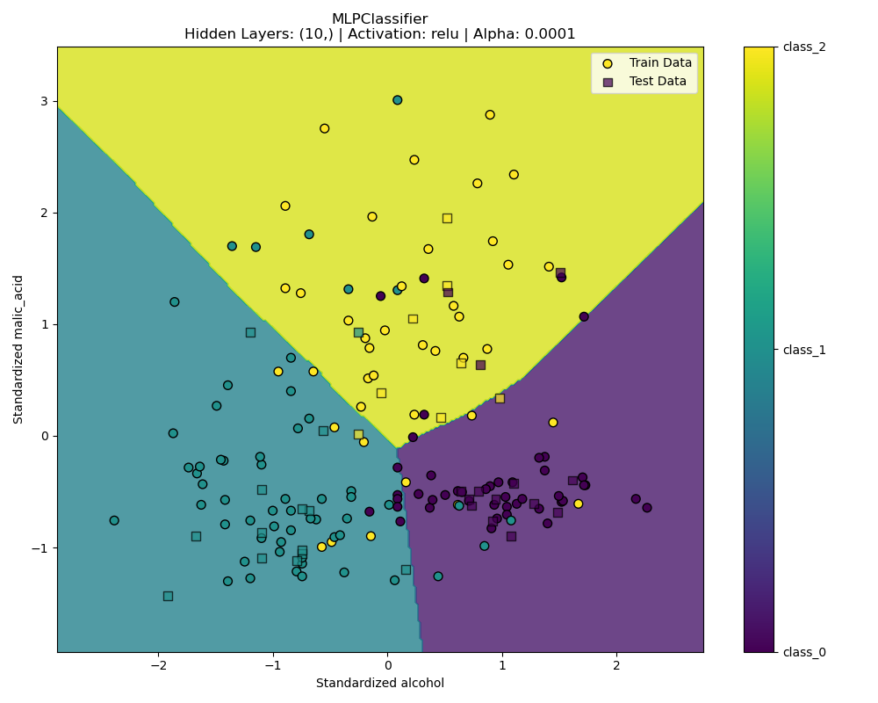
讨论1+3：

代码：
import numpy as np
import matplotlib.pyplot as plt
from sklearn.datasets import load_wine
from sklearn.neural_network import MLPClassifier
from sklearn.preprocessing import StandardScaler
from sklearn.model_selection import train_test_split
from sklearn.metrics import classification_report, accuracy_score
from matplotlib.colors import ListedColormap
import time

# Load dataset
wine = load_wine()
X = wine.data[:, :2] # Use first two features
y = wine.target

# Split dataset
X_train, X_test, y_train, y_test = train_test_split(X, y, test_size=0.2, random_state=42)

# Standardize
scaler = StandardScaler()
X_train_scaled = scaler.fit_transform(X_train)
X_test_scaled = scaler.transform(X_test)

# Accuracy vs number of neurons
plt.figure(figsize=(10, 6))
neuron_counts = np.arange(10, 110, 10) # Neurons from 10 to 100
train_accuracies = []
test_accuracies = []
training_times = []

for n in neuron_counts:
# Record start time
start_time = time.time()

# Set model parameters
mlp = MLPClassifier(
hidden_layer_sizes=(n,), # Single hidden layer
activation='relu', # ReLU activation
alpha=0.001, # L2 regularization
max_iter=2000,
random_state=42
)
mlp.fit(X_train_scaled, y_train)

# Record training time
elapsed_time = time.time() - start_time
training_times.append(elapsed_time)

# Record accuracy
train_acc = mlp.score(X_train_scaled, y_train)
test_acc = mlp.score(X_test_scaled, y_test)
train_accuracies.append(train_acc)
test_accuracies.append(test_acc)
print(f"Neurons = {n:<3d} | Time: {elapsed_time:.4f}s | Train Acc: {train_acc:.4f} | Test Acc: {test_acc:.4f}")

# Plot accuracy changes
plt.plot(neuron_counts, train_accuracies, 'bo-', label='Training Accuracy')
plt.plot(neuron_counts, test_accuracies, 'ro-', label='Test Accuracy')
plt.title('MLP Accuracy vs Number of Neurons')
plt.xlabel('Number of Neurons in Hidden Layer')
plt.ylabel('Accuracy')
plt.xticks(neuron_counts)
plt.grid(True, linestyle='--', alpha=0.5)
plt.legend()
plt.tight_layout()
plt.savefig('accuracy_curve.png')
plt.show()

# Plot training time changes
plt.figure(figsize=(10, 6))
plt.plot(neuron_counts, training_times, 'go-')
plt.title('Training Time vs Number of Neurons')
plt.xlabel('Number of Neurons in Hidden Layer')
plt.ylabel('Training Time (seconds)')
plt.xticks(neuron_counts)
plt.grid(True, linestyle='--', alpha=0.5)
plt.tight_layout()
plt.savefig('training_time_curve.png')
plt.show()

# Create 3x3 grid of decision boundaries
fig, axes = plt.subplots(3, 3, figsize=(15, 15))
neuron_counts = np.arange(10, 100, 10) # Neurons from 20 to 100, step 10

# Define colormaps
cmap_light = ListedColormap(['#FFAAAA', '#AAFFAA', '#AAAAFF'])
cmap_bold = ListedColormap(['#FF0000', '#00FF00', '#0000FF'])

# Create meshgrid for decision boundaries
h = 0.02 # Step size
x_min, x_max = X_train_scaled[:, 0].min() - 0.5, X_train_scaled[:, 0].max() + 0.5
y_min, y_max = X_train_scaled[:, 1].min() - 0.5, X_train_scaled[:, 1].max() + 0.5
xx, yy = np.meshgrid(np.arange(x_min, x_max, h), np.arange(y_min, y_max, h))

for i, ax in enumerate(axes.flat):
n_neurons = neuron_counts[i]

# Record start time
start_time = time.time()

# Create and train model
mlp = MLPClassifier(
hidden_layer_sizes=(n_neurons,),
activation='relu',
alpha=0.0001,
max_iter=2000,
random_state=42
)
mlp.fit(X_train_scaled, y_train)

# Record training time
elapsed_time = time.time() - start_time

# Calculate test accuracy
test_acc = mlp.score(X_test_scaled, y_test)

# Predict meshgrid points
Z = mlp.predict(np.c_[xx.ravel(), yy.ravel()])
Z = Z.reshape(xx.shape)

# Plot decision boundary
ax.pcolormesh(xx, yy, Z, cmap=cmap_light, shading='auto')

# Plot training data points
ax.scatter(X_train_scaled[:, 0], X_train_scaled[:, 1], c=y_train,
cmap=cmap_bold, edgecolor='k', s=30)

# Set subplot title with training time
ax.set_title(f'Neurons: {n_neurons}\nTest Acc: {test_acc:.4f}\nTime: {elapsed_time:.4f}s')
ax.set_xlabel("Standardized " + wine.feature_names[0])
ax.set_ylabel("Standardized " + wine.feature_names[1])
ax.set_xlim(xx.min(), xx.max())
ax.set_ylim(yy.min(), yy.max())

plt.tight_layout()
plt.savefig('discussion1.png')
plt.show()
讨论3关键修改：
# Set model parameters
mlp = MLPClassifier(
hidden_layer_sizes=(n,), # Single hidden layer
activation='tanh',
alpha=0.001, # L2 regularization
max_iter=2000,
random_state=42
)
mlp.fit(X_train_scaled, y_train)

结果：
讨论1：
Neurons = 10 | Time: 0.1103s | Train Acc: 0.7606 | Test Acc: 0.8333
Neurons = 20 | Time: 0.1031s | Train Acc: 0.8310 | Test Acc: 0.8056
Neurons = 30 | Time: 0.1046s | Train Acc: 0.8169 | Test Acc: 0.8333
Neurons = 40 | Time: 0.1175s | Train Acc: 0.8239 | Test Acc: 0.8333
Neurons = 50 | Time: 0.1348s | Train Acc: 0.8239 | Test Acc: 0.8611
Neurons = 60 | Time: 0.1489s | Train Acc: 0.8239 | Test Acc: 0.8056
Neurons = 70 | Time: 0.1508s | Train Acc: 0.8239 | Test Acc: 0.8333
Neurons = 80 | Time: 0.2477s | Train Acc: 0.8169 | Test Acc: 0.8333
Neurons = 90 | Time: 0.2204s | Train Acc: 0.8239 | Test Acc: 0.8611
Neurons = 100 | Time: 0.3360s | Train Acc: 0.8521 | Test Acc: 0.8889

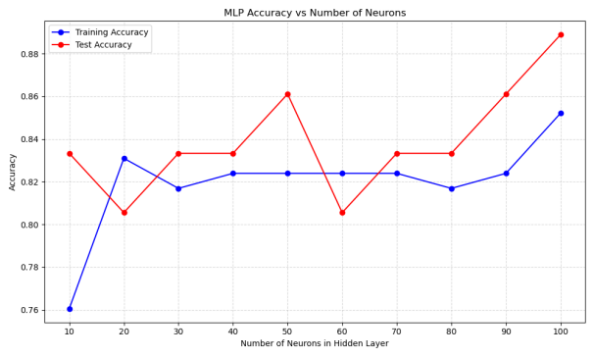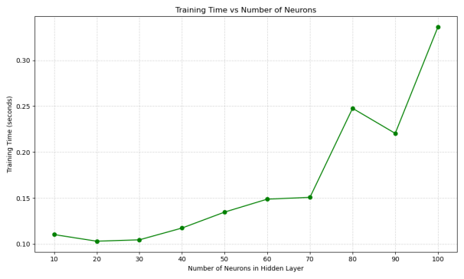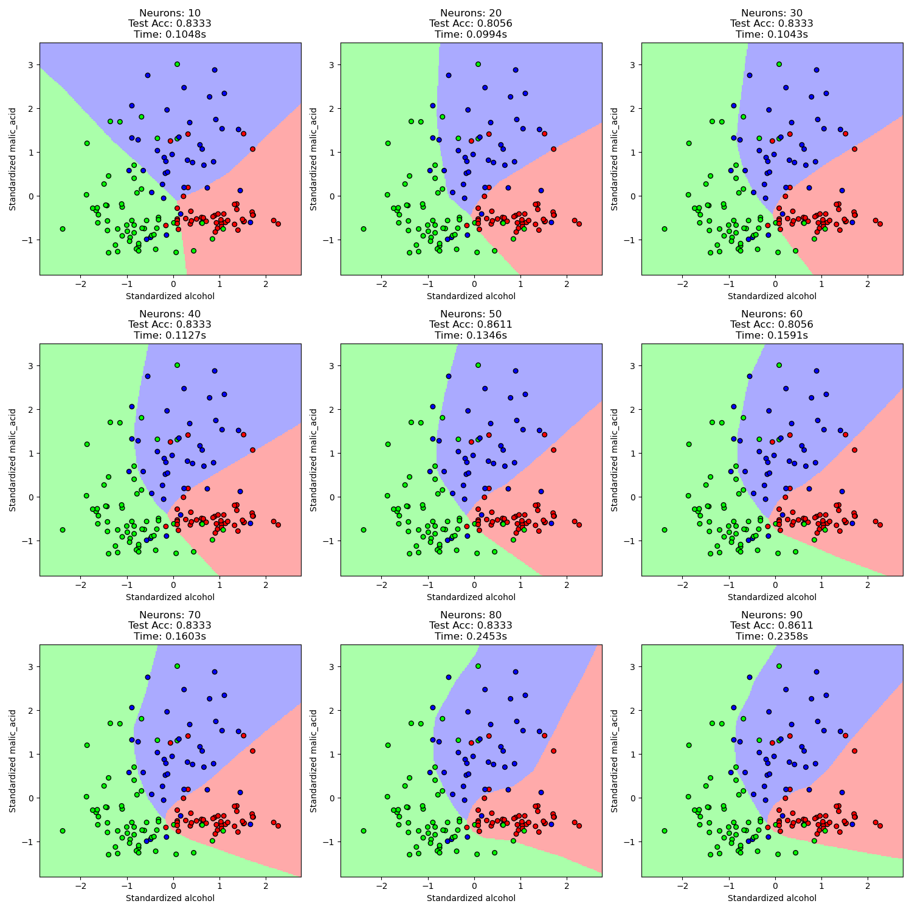

讨论3：
Neurons = 10 | Time: 0.1042s | Train Acc: 0.8099 | Test Acc: 0.7778
Neurons = 20 | Time: 0.0812s | Train Acc: 0.8169 | Test Acc: 0.8056
Neurons = 30 | Time: 0.0686s | Train Acc: 0.8099 | Test Acc: 0.7778
Neurons = 40 | Time: 0.0786s | Train Acc: 0.8169 | Test Acc: 0.8056
Neurons = 50 | Time: 0.0766s | Train Acc: 0.8099 | Test Acc: 0.7778
Neurons = 60 | Time: 0.0669s | Train Acc: 0.8028 | Test Acc: 0.7778
Neurons = 70 | Time: 0.0843s | Train Acc: 0.8028 | Test Acc: 0.8056
Neurons = 80 | Time: 0.0512s | Train Acc: 0.8028 | Test Acc: 0.8056
Neurons = 90 | Time: 0.0543s | Train Acc: 0.7958 | Test Acc: 0.7778
Neurons = 100 | Time: 0.0585s | Train Acc: 0.7958 | Test Acc: 0.8056
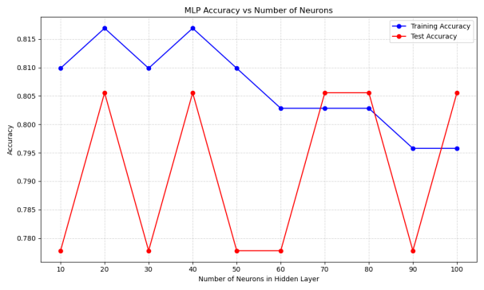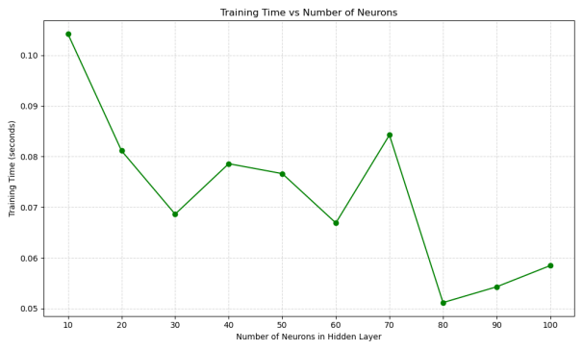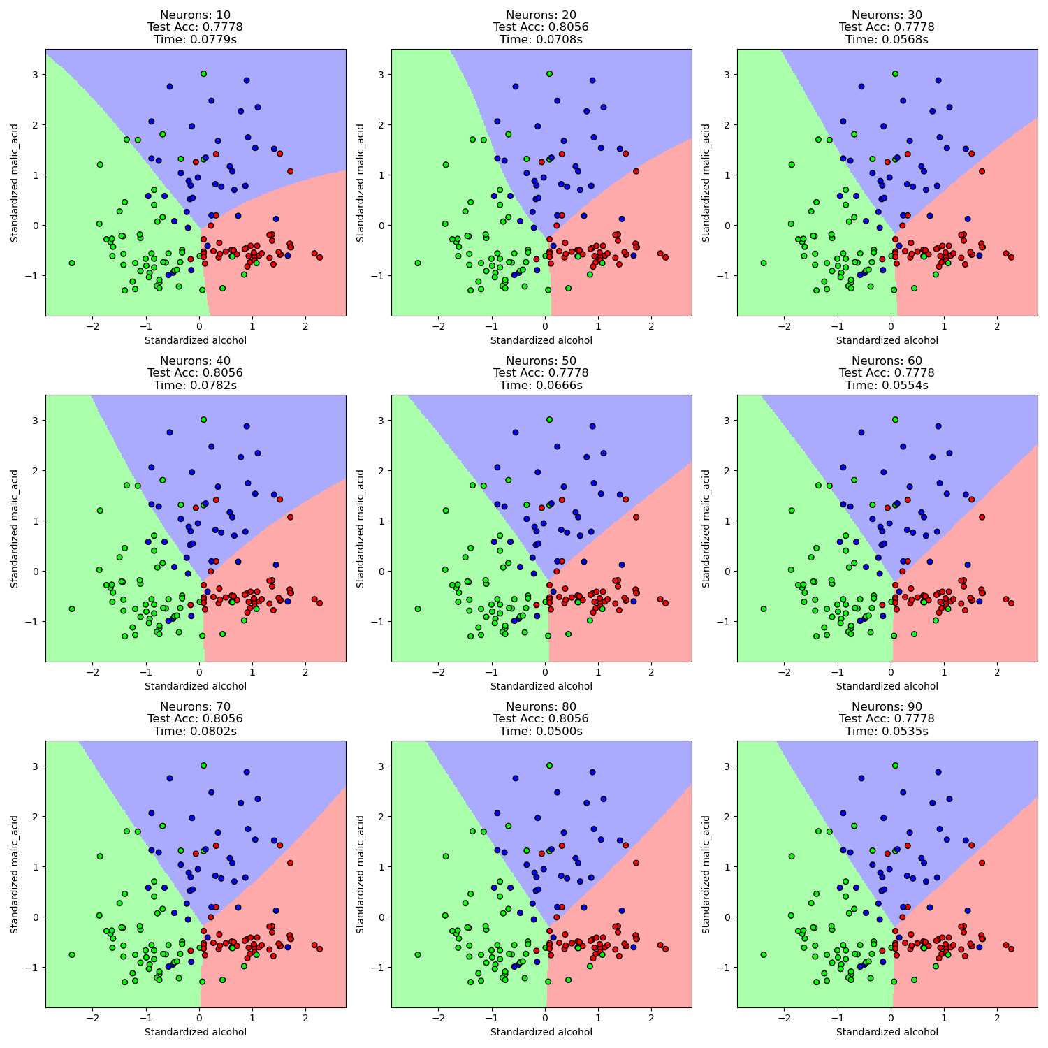
讨论2+4：

代码：
import numpy as np
import matplotlib.pyplot as plt
from sklearn.datasets import load_wine
from sklearn.neural_network import MLPClassifier
from sklearn.preprocessing import StandardScaler
from sklearn.model_selection import train_test_split
from sklearn.metrics import classification_report, accuracy_score
from matplotlib.colors import ListedColormap
import time
import warnings

# Filter convergence warnings
warnings.filterwarnings("ignore", category=UserWarning)

# Load dataset
wine = load_wine()
X = wine.data[:, :2] # Use first two features
y = wine.target

# Split dataset
X_train, X_test, y_train, y_test = train_test_split(X, y, test_size=0.2, random_state=42)

# Standardize
scaler = StandardScaler()
X_train_scaled = scaler.fit_transform(X_train)
X_test_scaled = scaler.transform(X_test)

# Accuracy vs number of layers
plt.figure(figsize=(10, 6))
layer_counts = np.arange(1, 10, 1) # Layers from 1 to 9
train_accuracies = []
test_accuracies = []
iter_used = []
training_times = [] # Added to store training times

for n in layer_counts:
# Record start time
start_time = time.time()

# Set model parameters with increased iterations
mlp = MLPClassifier(
hidden_layer_sizes=(10,) * n, # n hidden layers, each with 10 neurons
activation='relu', # ReLU activation
alpha=0.0001, # L2 regularization
max_iter=5000,
random_state=42,
n_iter_no_change=50
)
mlp.fit(X_train_scaled, y_train)

# Record training time
elapsed_time = time.time() - start_time
training_times.append(elapsed_time) # Store elapsed time

# Record number of iterations actually used
n_iters = mlp.n_iter_
iter_used.append(n_iters)

# Record accuracy
train_acc = mlp.score(X_train_scaled, y_train)
test_acc = mlp.score(X_test_scaled, y_test)
train_accuracies.append(train_acc)
test_accuracies.append(test_acc)
# Added training time to print statement
print(
f"Layers = {n} | Time: {elapsed_time:.4f}s | Train Acc: {train_acc:.4f} | Test Acc: {test_acc:.4f} | Iters: {n_iters}")

# Plot accuracy changes
plt.plot(layer_counts, train_accuracies, 'bo-', label='Training Accuracy')
plt.plot(layer_counts, test_accuracies, 'ro-', label='Test Accuracy')
plt.title('MLP Accuracy vs Number of Layers')
plt.xlabel('Number of Hidden Layers')
plt.ylabel('Accuracy')
plt.xticks(layer_counts)
plt.grid(True, linestyle='--', alpha=0.5)
plt.legend()
plt.tight_layout()
plt.savefig('accuracy_curve.png')
plt.show()

# Plot training time changes (added new plot)
plt.figure(figsize=(10, 6))
plt.plot(layer_counts, training_times, 'go-')
plt.title('Training Time vs Number of Layers')
plt.xlabel('Number of Hidden Layers')
plt.ylabel('Training Time (seconds)')
plt.xticks(layer_counts)
plt.grid(True, linestyle='--', alpha=0.5)
plt.tight_layout()
plt.savefig('training_time_curve.png')
plt.show()

# Create 3x3 grid of decision boundaries
fig, axes = plt.subplots(3, 3, figsize=(15, 15))
layer_counts = np.arange(1, 10, 1) # Layers from 1 to 9

# Define colormaps
cmap_light = ListedColormap(['#FFAAAA', '#AAFFAA', '#AAAAFF'])
cmap_bold = ListedColormap(['#FF0000', '#00FF00', '#0000FF'])

# Create meshgrid for decision boundaries
h = 0.02 # Step size
x_min, x_max = X_train_scaled[:, 0].min() - 0.5, X_train_scaled[:, 0].max() + 0.5
y_min, y_max = X_train_scaled[:, 1].min() - 0.5, X_train_scaled[:, 1].max() + 0.5
xx, yy = np.meshgrid(np.arange(x_min, x_max, h), np.arange(y_min, y_max, h))

for i, ax in enumerate(axes.flat):
n_layers = layer_counts[i]

# Record start time for decision boundary training
start_time = time.time()

# Create and train model with increased iterations
mlp = MLPClassifier(
hidden_layer_sizes=(10,) * n_layers, # n_layers hidden layers
activation='relu',
alpha=0.0001,
max_iter=5000,
random_state=42,
n_iter_no_change=50
)
mlp.fit(X_train_scaled, y_train)

# Record training time
elapsed_time = time.time() - start_time

# Calculate test accuracy
test_acc = mlp.score(X_test_scaled, y_test)

# Predict meshgrid points
Z = mlp.predict(np.c_[xx.ravel(), yy.ravel()])
Z = Z.reshape(xx.shape)

# Plot decision boundary
ax.pcolormesh(xx, yy, Z, cmap=cmap_light, shading='auto')

# Plot training data points
ax.scatter(X_train_scaled[:, 0], X_train_scaled[:, 1], c=y_train,
cmap=cmap_bold, edgecolor='k', s=30)

# Added training time to subplot title
ax.set_title(f'Layers: {n_layers}\nTest Acc: {test_acc:.4f}\nTime: {elapsed_time:.4f}s')
ax.set_xlabel("Standardized " + wine.feature_names[0])
ax.set_ylabel("Standardized " + wine.feature_names[1])
ax.set_xlim(xx.min(), xx.max())
ax.set_ylim(yy.min(), yy.max())

plt.tight_layout()
plt.savefig('decision_boundaries.png')
plt.show()

# Plot iterations used per layer
plt.figure(figsize=(10, 5))
plt.bar(layer_counts, iter_used)
plt.title('Iterations Required for Convergence')
plt.xlabel('Number of Hidden Layers')
plt.ylabel('Iterations Used')
plt.xticks(layer_counts)
plt.grid(axis='y', linestyle='--', alpha=0.5)
plt.tight_layout()
plt.savefig('convergence_iterations.png')
plt.show()

结果：
讨论2：
Layers = 1 | Time: 0.1140s | Train Acc: 0.7676 | Test Acc: 0.8333 | Iters: 650
Layers = 2 | Time: 0.1933s | Train Acc: 0.8380 | Test Acc: 0.8333 | Iters: 799
Layers = 3 | Time: 0.9916s | Train Acc: 0.9577 | Test Acc: 0.8056 | Iters: 3433
Layers = 4 | Time: 1.3030s | Train Acc: 0.9859 | Test Acc: 0.8333 | Iters: 3469
Layers = 5 | Time: 1.3154s | Train Acc: 0.9930 | Test Acc: 0.8333 | Iters: 3087
Layers = 6 | Time: 1.9307s | Train Acc: 1.0000 | Test Acc: 0.8611 | Iters: 3989
Layers = 7 | Time: 2.3512s | Train Acc: 0.9930 | Test Acc: 0.8333 | Iters: 4331
Layers = 8 | Time: 1.2171s | Train Acc: 0.9930 | Test Acc: 0.8333 | Iters: 1974
Layers = 9 | Time: 1.5761s | Train Acc: 0.9507 | Test Acc: 0.8889 | Iters: 2237
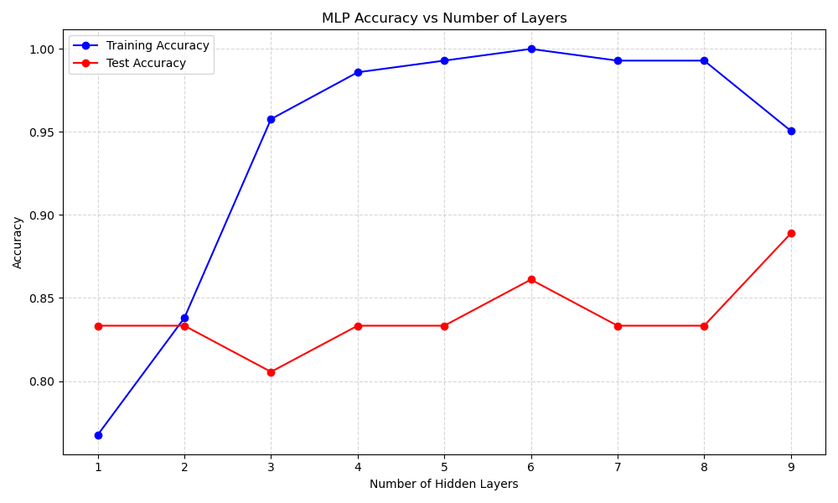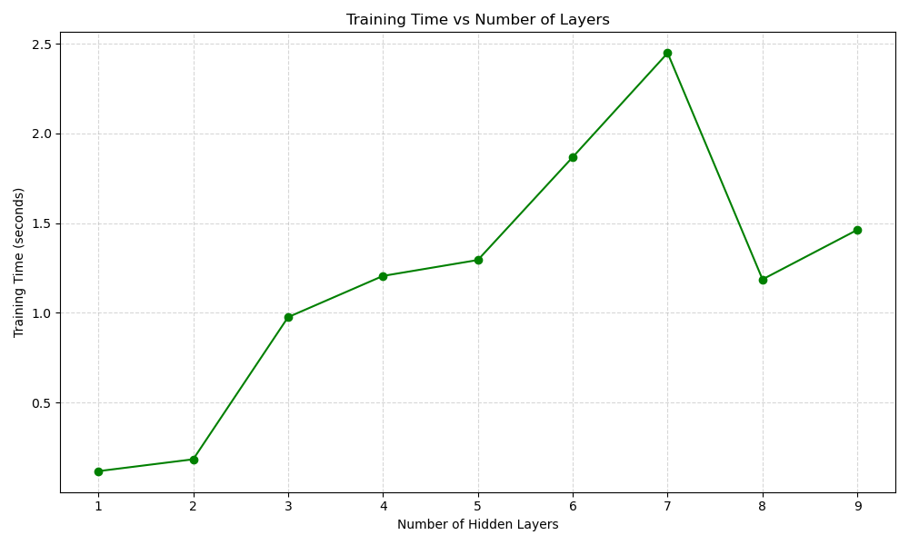
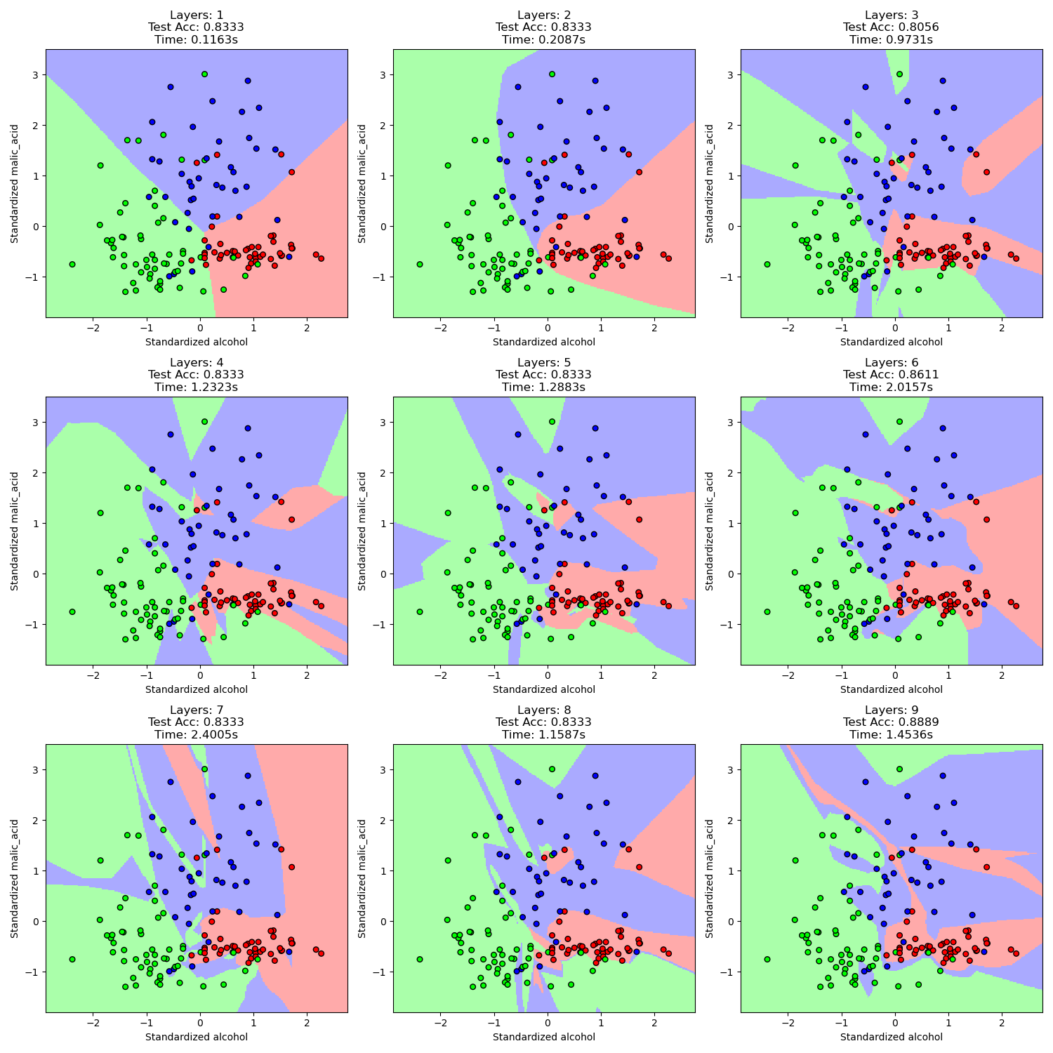
讨论4：
α=0.001
Layers = 1 | Time: 0.1205s | Train Acc: 0.7676 | Test Acc: 0.8333 | Iters: 650
Layers = 2 | Time: 0.1885s | Train Acc: 0.8310 | Test Acc: 0.8333 | Iters: 801
Layers = 3 | Time: 0.8778s | Train Acc: 0.9577 | Test Acc: 0.8056 | Iters: 2969
Layers = 4 | Time: 1.7317s | Train Acc: 0.9789 | Test Acc: 0.8611 | Iters: 4952
Layers = 5 | Time: 1.2956s | Train Acc: 0.9930 | Test Acc: 0.8611 | Iters: 3028
Layers = 6 | Time: 2.0354s | Train Acc: 1.0000 | Test Acc: 0.8056 | Iters: 4090
Layers = 7 | Time: 2.1082s | Train Acc: 0.9930 | Test Acc: 0.8611 | Iters: 3879
Layers = 8 | Time: 1.3044s | Train Acc: 0.9930 | Test Acc: 0.8611 | Iters: 2199
Layers = 9 | Time: 1.1231s | Train Acc: 0.9859 | Test Acc: 0.8333 | Iters: 1605

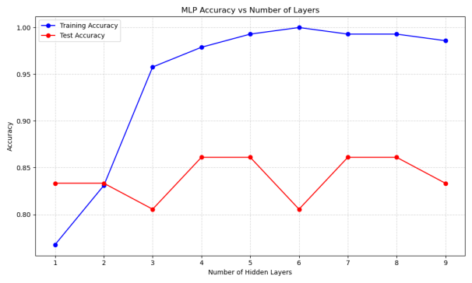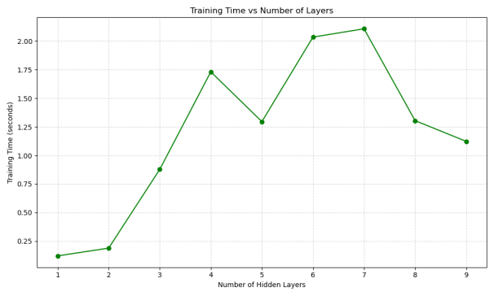
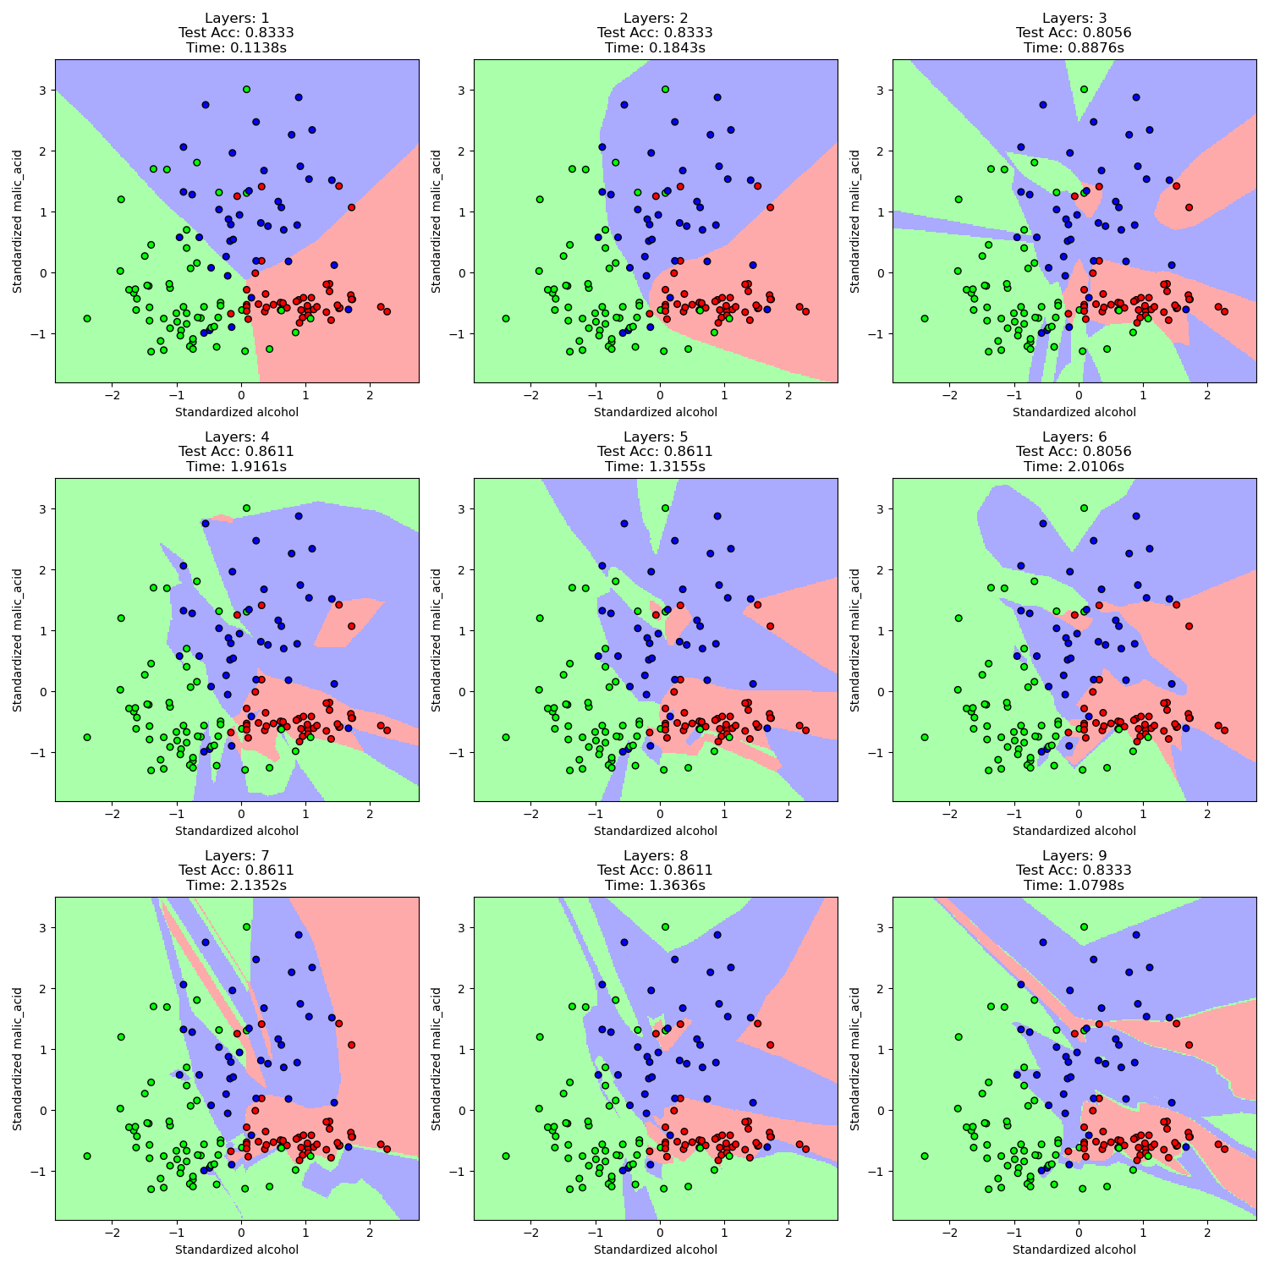
α=0.01
Layers = 1 | Time: 0.1140s | Train Acc: 0.7676 | Test Acc: 0.8333 | Iters: 650
Layers = 2 | Time: 0.1891s | Train Acc: 0.8310 | Test Acc: 0.8333 | Iters: 803
Layers = 3 | Time: 0.9759s | Train Acc: 0.9507 | Test Acc: 0.8056 | Iters: 3141
Layers = 4 | Time: 1.5649s | Train Acc: 0.9789 | Test Acc: 0.8333 | Iters: 4344
Layers = 5 | Time: 1.2983s | Train Acc: 1.0000 | Test Acc: 0.8333 | Iters: 2859
Layers = 6 | Time: 1.4718s | Train Acc: 0.9718 | Test Acc: 0.8056 | Iters: 2917
Layers = 7 | Time: 2.1059s | Train Acc: 1.0000 | Test Acc: 0.7778 | Iters: 3770
Layers = 8 | Time: 1.2624s | Train Acc: 0.9859 | Test Acc: 0.8333 | Iters: 2070
Layers = 9 | Time: 2.1304s | Train Acc: 0.9648 | Test Acc: 0.7778 | Iters: 3108
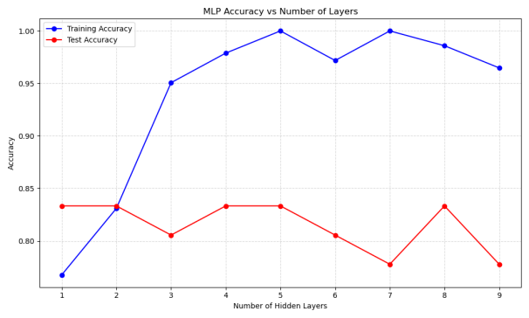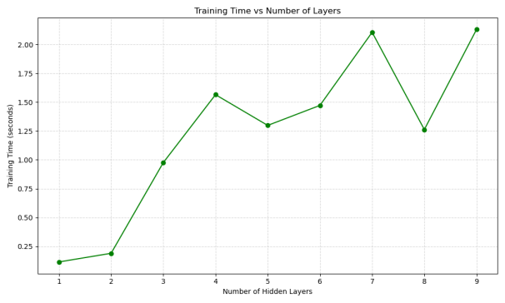
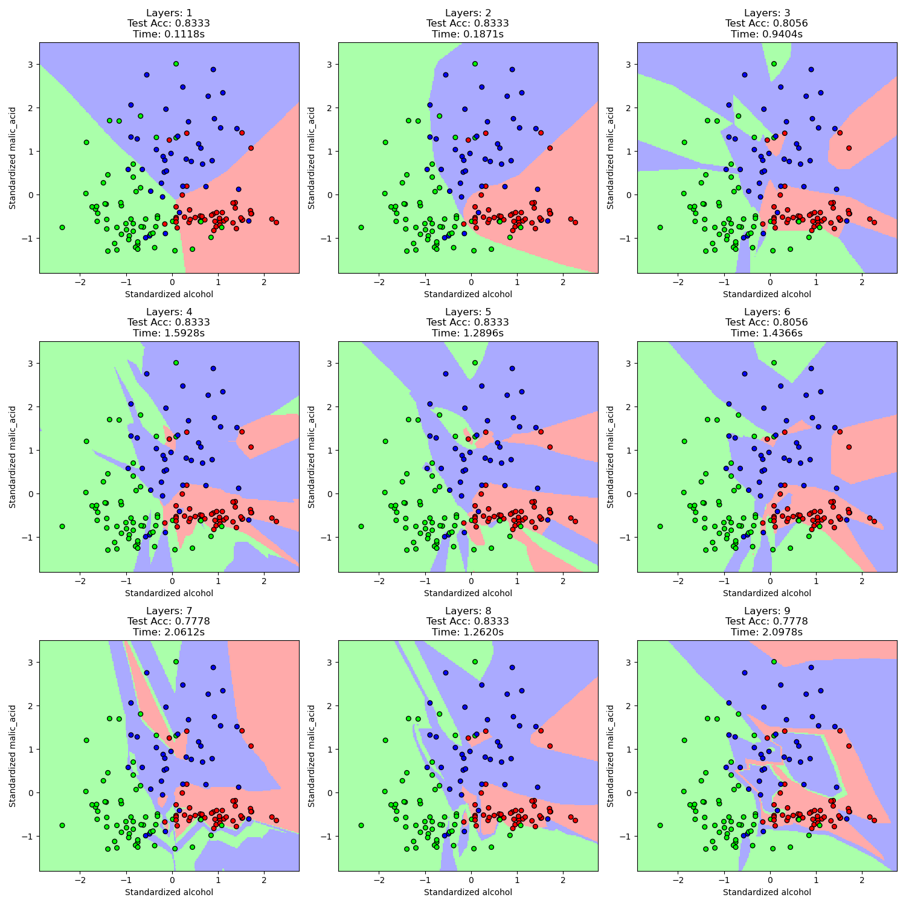
α=0.1
Layers = 1 | Time: 0.1124s | Train Acc: 0.7676 | Test Acc: 0.8333 | Iters: 645
Layers = 2 | Time: 0.1689s | Train Acc: 0.8310 | Test Acc: 0.8333 | Iters: 772
Layers = 3 | Time: 0.7291s | Train Acc: 0.9296 | Test Acc: 0.8611 | Iters: 2470
Layers = 4 | Time: 1.2461s | Train Acc: 0.9930 | Test Acc: 0.8333 | Iters: 3704
Layers = 5 | Time: 1.3579s | Train Acc: 0.9648 | Test Acc: 0.8611 | Iters: 3169
Layers = 6 | Time: 1.3254s | Train Acc: 1.0000 | Test Acc: 0.8611 | Iters: 2726
Layers = 7 | Time: 1.8630s | Train Acc: 0.9648 | Test Acc: 0.8333 | Iters: 3490
Layers = 8 | Time: 1.5951s | Train Acc: 0.9930 | Test Acc: 0.8056 | Iters: 2560
Layers = 9 | Time: 1.5807s | Train Acc: 0.9789 | Test Acc: 0.8889 | Iters: 2411
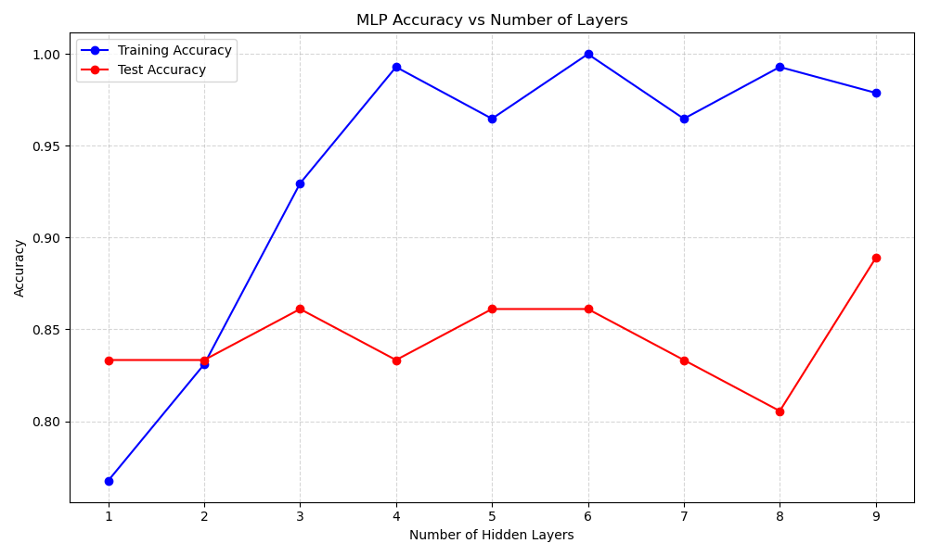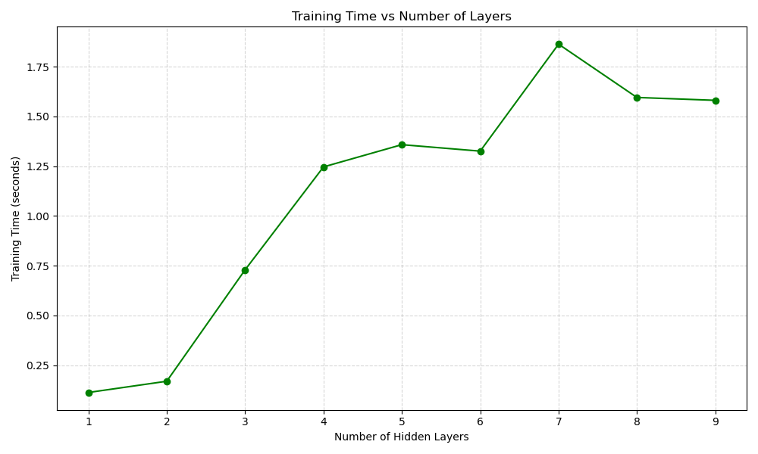
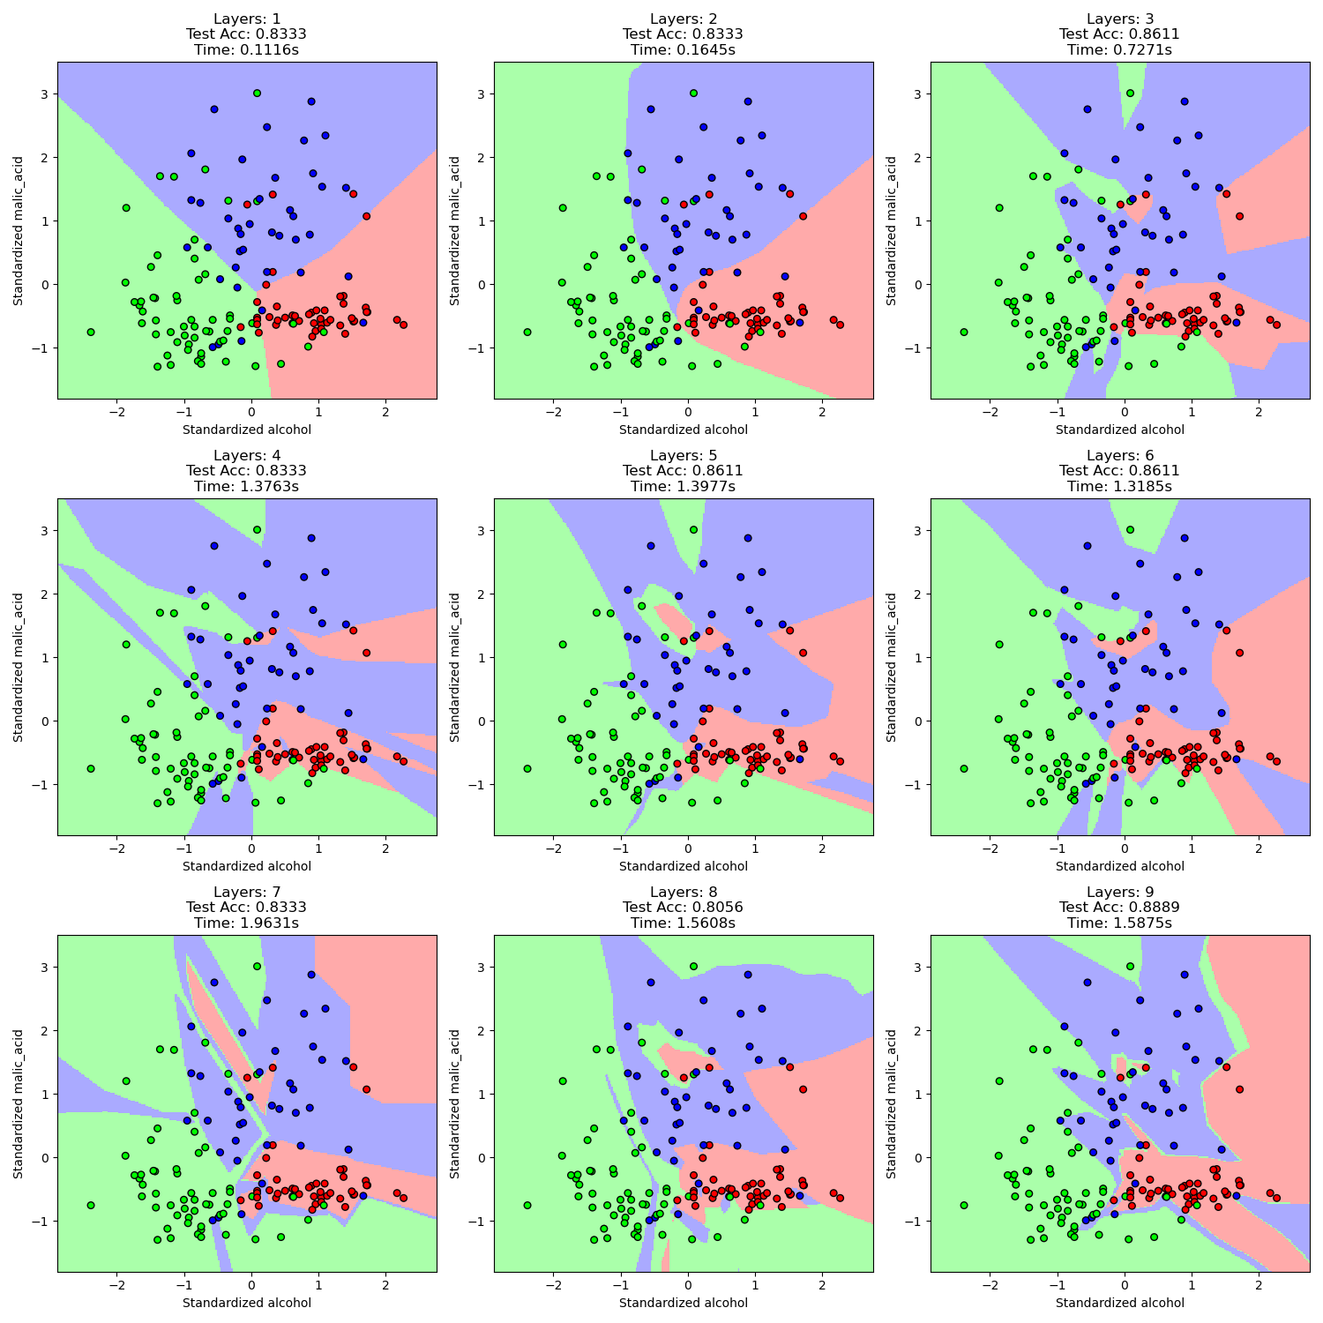
α=1
Layers = 1 | Time: 0.1420s | Train Acc: 0.8099 | Test Acc: 0.8056 | Iters: 781
Layers = 2 | Time: 0.1502s | Train Acc: 0.8239 | Test Acc: 0.8333 | Iters: 688
Layers = 3 | Time: 0.1847s | Train Acc: 0.8310 | Test Acc: 0.8611 | Iters: 638
Layers = 4 | Time: 0.2299s | Train Acc: 0.8310 | Test Acc: 0.8611 | Iters: 653
Layers = 5 | Time: 0.8004s | Train Acc: 0.8944 | Test Acc: 0.8889 | Iters: 1911
Layers = 6 | Time: 0.9765s | Train Acc: 0.9085 | Test Acc: 0.8611 | Iters: 1981
Layers = 7 | Time: 1.0590s | Train Acc: 0.8803 | Test Acc: 0.8611 | Iters: 1888
Layers = 8 | Time: 0.7962s | Train Acc: 0.8873 | Test Acc: 0.8333 | Iters: 1278
Layers = 9 | Time: 1.1569s | Train Acc: 0.8944 | Test Acc: 0.8611 | Iters: 1732
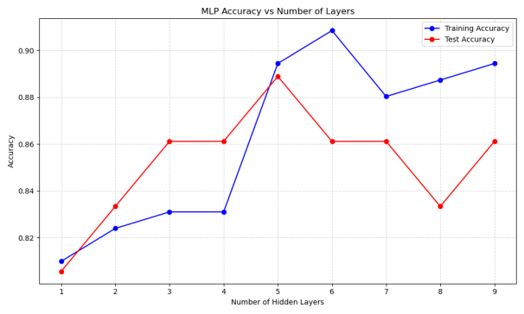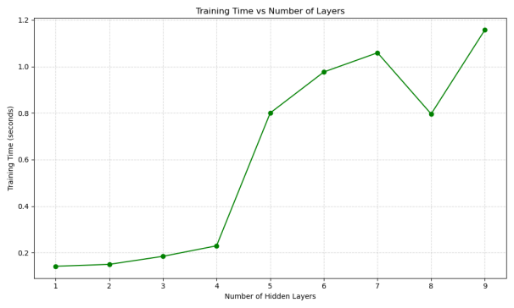
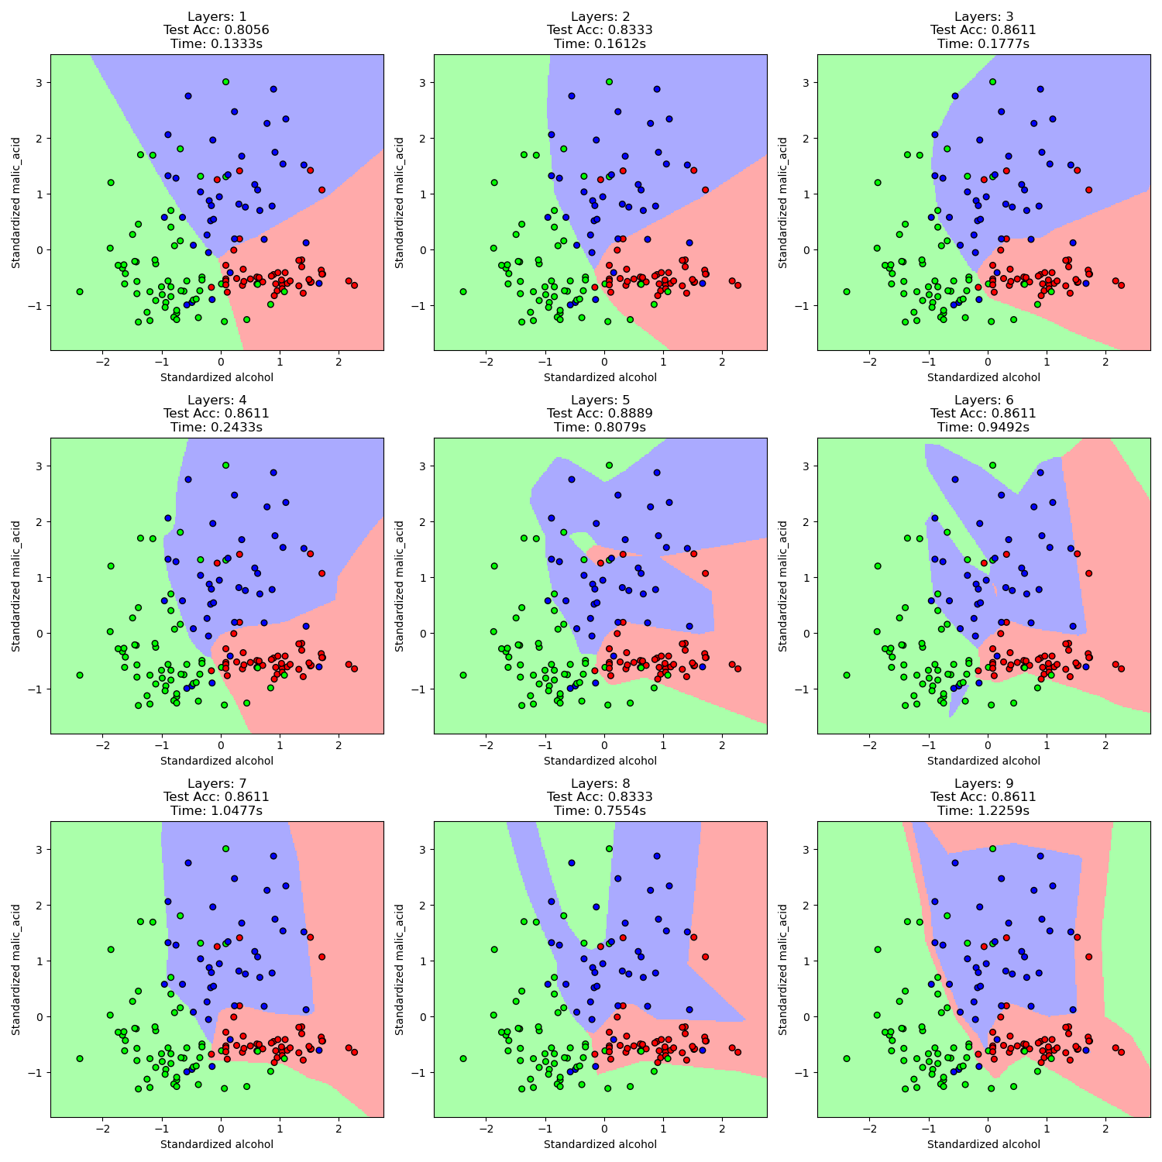
总结：
综合上述讨论，隐层上神经元数量越多、隐层层数越多、激活函数选择Relu、正则化项系数越小,模型复杂程度越大。

题目2：
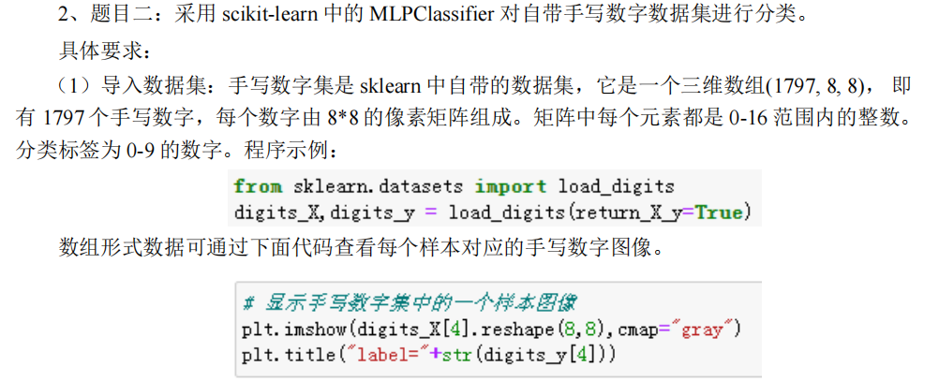
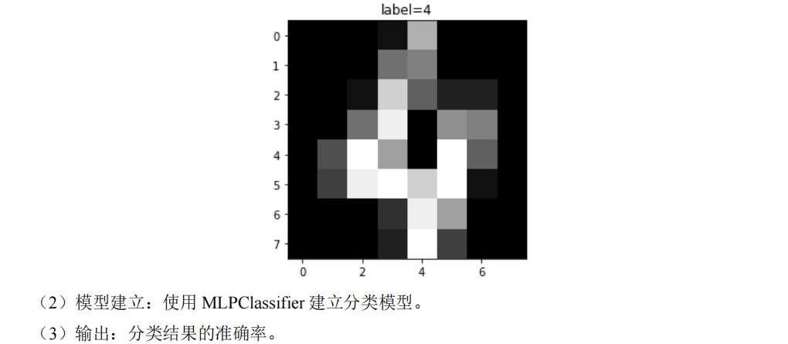
代码：
import numpy as np
import matplotlib.pyplot as plt
from sklearn.datasets import load_digits
from sklearn.model_selection import train_test_split
from sklearn.neural_network import MLPClassifier
from sklearn.metrics import accuracy_score
from sklearn.preprocessing import StandardScaler
from sklearn.pipeline import make_pipeline
from sklearn.model_selection import GridSearchCV

# 加载数据集
digits = load_digits()
digits_X, digits_y = digits.data, digits.target

# 划分训练集和测试集
X_train, X_test, y_train, y_test = train_test_split(digits_X, digits_y, test_size=0.2, random_state=42)

# 创建数据预处理和模型优化管道
pipeline = make_pipeline(
StandardScaler(),
MLPClassifier(random_state=42, early_stopping=True)
)

# 设置超参数网格进行调优
param_grid = {
'mlpclassifier__hidden_layer_sizes': [(128,), (256,), (128, 64)],
'mlpclassifier__activation': ['relu', 'tanh'],
'mlpclassifier__solver': ['adam', 'sgd'],
'mlpclassifier__alpha': [0.0001, 0.001, 0.01],
'mlpclassifier__learning_rate_init': [0.001, 0.01, 0.1],
'mlpclassifier__max_iter': [500, 1000]
}

# 使用网格搜索和交叉验证优化模型
grid = GridSearchCV(pipeline, param_grid, cv=5, scoring='accuracy', n_jobs=-1, verbose=1)
grid.fit(X_train, y_train)

# 最佳模型及其参数
best_model = grid.best_estimator_
best_params = grid.best_params_
print(f"Best Parameters: {best_params}")

# 评估最佳模型
y_pred = best_model.predict(X_test)
accuracy = accuracy_score(y_test, y_pred)
print(f"Classification Accuracy: {accuracy:.4f}")

# 可视化预测结果
plt.figure(figsize=(14, 10))
correct_count = 0
samples_to_show = 16

for i in range(samples_to_show):
plt.subplot(4, 4, i + 1)
actual = y_test[i]
predicted = y_pred[i]

plt.imshow(X_test[i].reshape(8, 8), cmap="gray")
plt.title(f"Actual: {actual}\nPred: {predicted}", fontsize=10)
plt.axis('off')

if actual == predicted:
correct_count += 1

plt.tight_layout()
plt.suptitle(f'MLP Classifier Results (Accuracy: {accuracy:.4f}, Sample Correct: {correct_count}/{samples_to_show})',
fontsize=14, y=1.02)
plt.savefig('讨论5.png')
plt.show()

结果：
Classification Accuracy: 0.2639
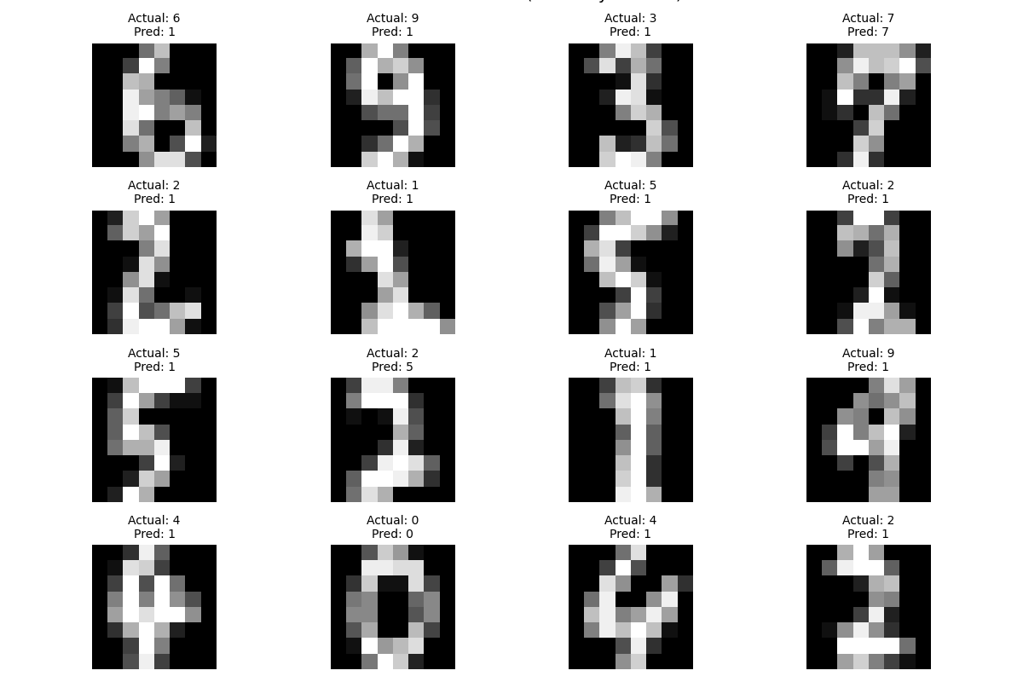

讨论5：
代码：
import numpy as np
import matplotlib.pyplot as plt
from sklearn.datasets import load_digits
from sklearn.model_selection import train_test_split
from sklearn.neural_network import MLPClassifier
from sklearn.metrics import accuracy_score
from sklearn.preprocessing import StandardScaler
from sklearn.pipeline import make_pipeline
from sklearn.model_selection import GridSearchCV

# 加载数据集
digits = load_digits()
digits_X, digits_y = digits.data, digits.target

# 划分训练集和测试集
X_train, X_test, y_train, y_test = train_test_split(digits_X, digits_y, test_size=0.2, random_state=42)

# 创建数据预处理和模型优化管道
pipeline = make_pipeline(
StandardScaler(),
MLPClassifier(random_state=42, early_stopping=True)
)

# 设置超参数网格进行调优
param_grid = {
'mlpclassifier__hidden_layer_sizes': [(128,), (256,), (128, 64)],
'mlpclassifier__activation': ['relu', 'tanh'],
'mlpclassifier__solver': ['adam', 'sgd'],
'mlpclassifier__alpha': [0.0001, 0.001, 0.01],
'mlpclassifier__learning_rate_init': [0.001, 0.01, 0.1],
'mlpclassifier__max_iter': [500, 1000]
}

# 使用网格搜索和交叉验证优化模型
grid = GridSearchCV(pipeline, param_grid, cv=5, scoring='accuracy', n_jobs=-1, verbose=1)
grid.fit(X_train, y_train)

# 最佳模型及其参数
best_model = grid.best_estimator_
best_params = grid.best_params_
print(f"Best Parameters: {best_params}")

# 评估最佳模型
y_pred = best_model.predict(X_test)
accuracy = accuracy_score(y_test, y_pred)
print(f"Classification Accuracy: {accuracy:.4f}")

# 可视化预测结果
plt.figure(figsize=(14, 10))
correct_count = 0
samples_to_show = 16

for i in range(samples_to_show):
plt.subplot(4, 4, i + 1)
actual = y_test[i]
predicted = y_pred[i]

plt.imshow(X_test[i].reshape(8, 8), cmap="gray")
plt.title(f"Actual: {actual}\nPred: {predicted}", fontsize=10)
plt.axis('off')

if actual == predicted:
correct_count += 1

plt.tight_layout()
plt.suptitle(f'MLP Classifier Results (Accuracy: {accuracy:.4f}, Sample Correct: {correct_count}/{samples_to_show})',
fontsize=14, y=1.02)
plt.savefig('讨论5.png')
plt.show()

结果：
Fitting 5 folds for each of 216 candidates, totalling 1080 fits
Best Parameters: {'mlpclassifier__activation': 'relu', 'mlpclassifier__alpha': 0.0001, 'mlpclassifier__hidden_layer_sizes': (256,), 'mlpclassifier__learning_rate_init': 0.01, 'mlpclassifier__max_iter': 500, 'mlpclassifier__solver': 'adam'}

Classification Accuracy: 0.9722

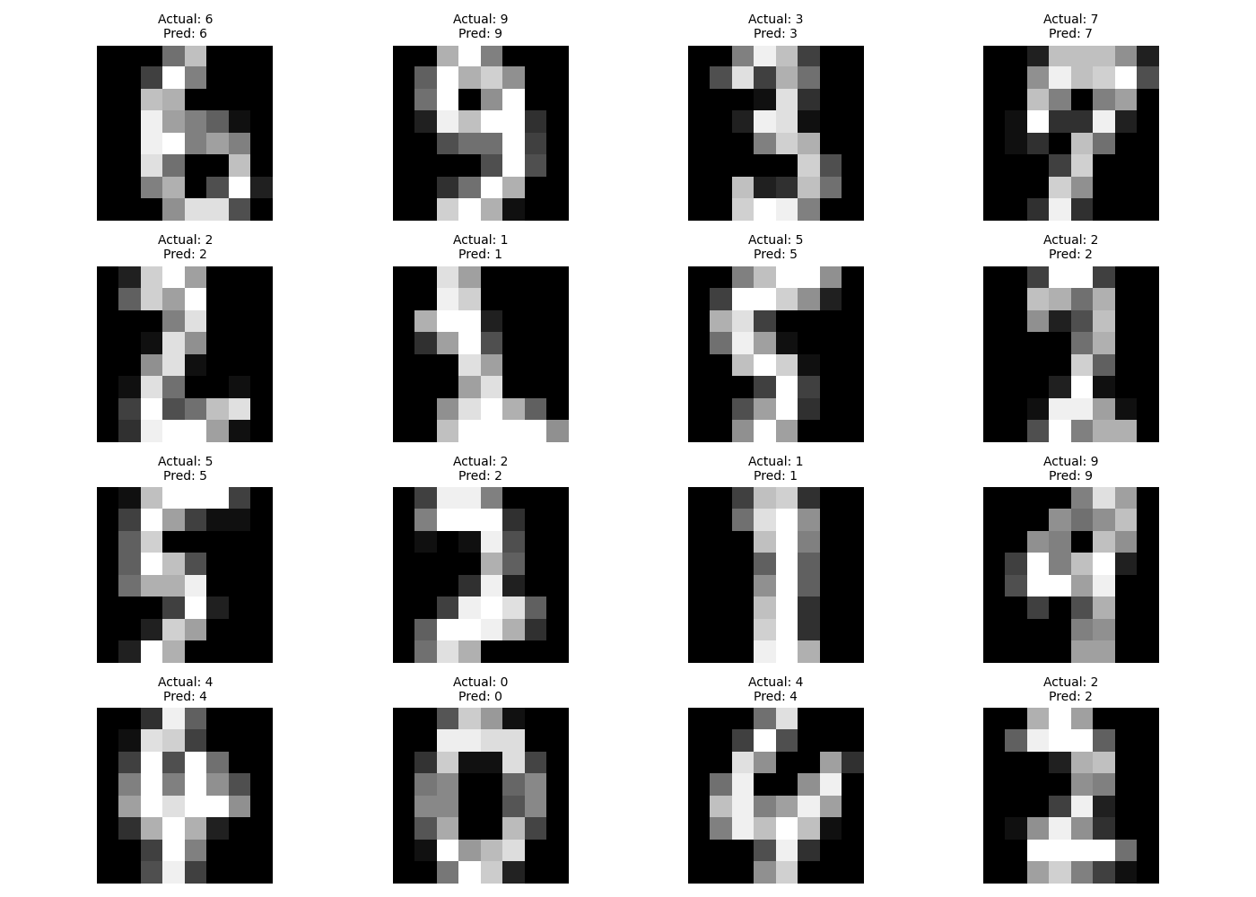
显著提高了泛化能力。
题目3：
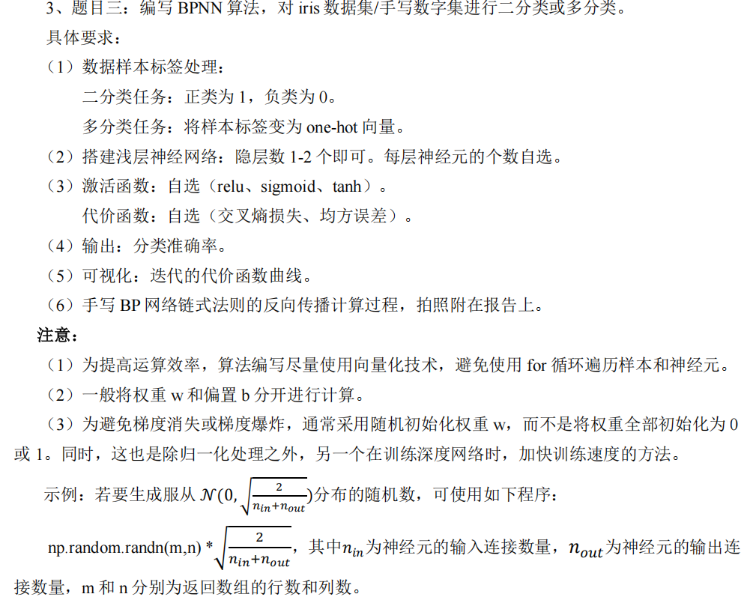
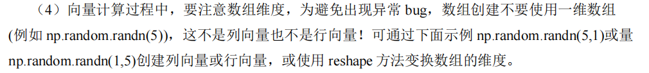

代码：
import numpy as np
import matplotlib.pyplot as plt
from sklearn.datasets import load_digits
from sklearn.model_selection import train_test_split
from sklearn.preprocessing import OneHotEncoder
from sklearn.metrics import accuracy_score

# 加载数据集
digits = load_digits()
X, y = digits.data, digits.target

# 预处理：归一化
X = X / 16.0

# 划分训练集和测试集
X_train, X_test, y_train, y_test = train_test_split(
X, y, test_size=0.2, random_state=42
)

# One-hot 编码
encoder = OneHotEncoder()
y_train_oh = encoder.fit_transform(y_train.reshape(-1, 1)).toarray()
y_test_oh = encoder.transform(y_test.reshape(-1, 1)).toarray()

# 网络参数
input_size = 64
hidden_size = 256
output_size = 10
learning_rate = 0.01
max_iter = 2000

# 参数初始化 (He初始化)
def initialize_parameters(input_dim, hidden_dim, output_dim):
np.random.seed(42)
W1 = np.random.randn(input_dim, hidden_dim) * np.sqrt(2 / (input_dim + hidden_dim))
b1 = np.zeros((1, hidden_dim))
W2 = np.random.randn(hidden_dim, output_dim) * np.sqrt(2 / (hidden_dim + output_dim))
b2 = np.zeros((1, output_dim))
return W1, b1, W2, b2

# 激活函数和其导数
def relu(x):
return np.maximum(0, x)

def relu_derivative(x):
return (x > 0).astype(float)

def softmax(x):
exp_x = np.exp(x - np.max(x, axis=1, keepdims=True))
return exp_x / np.sum(exp_x, axis=1, keepdims=True)

# 前向传播
def forward_propagation(X, W1, b1, W2, b2):
# 确保输入是二维数组
if X.ndim == 1:
X = X.reshape(1, -1)
Z1 = np.dot(X, W1) + b1
A1 = relu(Z1)
Z2 = np.dot(A1, W2) + b2
A2 = softmax(Z2)
return Z1, A1, Z2, A2

# 计算交叉熵损失
def compute_loss(y_oh, predictions):
m = y_oh.shape[0]
log_predictions = np.log(np.clip(predictions, 1e-12, None))
loss = -np.sum(y_oh * log_predictions) / m
return loss

# 反向传播
def backward_propagation(X, y_oh, Z1, A1, W2, A2):
m = X.shape[0]
dZ2 = A2 - y_oh
dW2 = np.dot(A1.T, dZ2) / m
db2 = np.sum(dZ2, axis=0, keepdims=True) / m
dA1 = np.dot(dZ2, W2.T)
dZ1 = dA1 * relu_derivative(Z1)
dW1 = np.dot(X.T, dZ1) / m
db1 = np.sum(dZ1, axis=0, keepdims=True) / m
return dW1, db1, dW2, db2

# 更新参数
def update_parameters(W1, b1, W2, b2, dW1, db1, dW2, db2, learning_rate):
W1 = W1 - learning_rate * dW1
b1 = b1 - learning_rate * db1
W2 = W2 - learning_rate * dW2
b2 = b2 - learning_rate * db2
return W1, b1, W2, b2

# 计算准确率 - 修复维度问题
def compute_accuracy(y_true, predictions):
# 确保预测结果是二维数组
if predictions.ndim == 1:
predictions = predictions.reshape(1, -1)
y_pred = np.argmax(predictions, axis=1)
return accuracy_score(y_true, y_pred)

# 初始化参数
W1, b1, W2, b2 = initialize_parameters(input_size, hidden_size, output_size)

# 存储损失和准确率
loss_history = []
train_acc_history = []
test_acc_history = []
iter_points = []

# 训练循环
for i in range(max_iter):
# 前向传播
Z1, A1, Z2, A2 = forward_propagation(X_train, W1, b1, W2, b2)

# 计算损失
loss = compute_loss(y_train_oh, A2)
loss_history.append(loss)

# 反向传播和更新
dW1, db1, dW2, db2 = backward_propagation(X_train, y_train_oh, Z1, A1, W2, A2)
W1, b1, W2, b2 = update_parameters(W1, b1, W2, b2, dW1, db1, dW2, db2, learning_rate)

# 定期计算准确率
if i % 10 == 0:
# 训练集准确率
_, _, _, train_pred = forward_propagation(X_train, W1, b1, W2, b2)
train_acc = compute_accuracy(y_train, train_pred)
train_acc_history.append(train_acc)

# 测试集准确率
_, _, _, test_pred = forward_propagation(X_test, W1, b1, W2, b2)
test_acc = compute_accuracy(y_test, test_pred)
test_acc_history.append(test_acc)
iter_points.append(i)

# 每50次迭代打印进度
if i % 50 == 0:
print(f"Iteration {i}: Loss = {loss:.4f}, Train Acc = {train_acc:.4f}, Test Acc = {test_acc:.4f}")

# 最终评估
_, _, _, test_pred_all = forward_propagation(X_test, W1, b1, W2, b2)
test_pred_all = test_pred_all.reshape(-1, output_size) # 确保二维
test_pred_labels = np.argmax(test_pred_all, axis=1)
final_accuracy = compute_accuracy(y_test, test_pred_all)
print(f"Final Test Accuracy: {final_accuracy:.4f}")

# 可视化训练过程
plt.figure(figsize=(15, 5))

# 损失曲线
plt.subplot(1, 2, 1)
plt.plot(range(max_iter), loss_history)
plt.xlabel('Iteration')
plt.ylabel('Cross-Entropy Loss')
plt.title('Training Loss Curve')
plt.grid(True)

# 准确率曲线
plt.subplot(1, 2, 2)
plt.plot(iter_points, train_acc_history, label='Train Accuracy')
plt.plot(iter_points, test_acc_history, label='Test Accuracy')
plt.xlabel('Iteration')
plt.ylabel('Accuracy')
plt.legend()
plt.title('Accuracy During Training')
plt.grid(True)
plt.tight_layout()
plt.savefig('training_curve.png')
plt.show()

# 可视化测试预测结果对比
plt.figure(figsize=(14, 10))
correct_count = 0
samples_to_show = min(16, len(X_test)) # 确保不超过测试样本数

for i in range(samples_to_show):
plt.subplot(4, 4, i + 1)
actual = y_test[i]
predicted = test_pred_labels[i]

# 获取原始图像（未归一化）
plt.imshow(X_test[i].reshape(8, 8) * 16, cmap='gray') # 恢复原始像素值

# 设置颜色：正确预测为绿色，错误为红色
color = 'green' if actual == predicted else 'red'
plt.title(f"Actual: {actual}\nPred: {predicted}", color=color, fontsize=10)
plt.axis('off')

if actual == predicted:
correct_count += 1

plt.tight_layout()
plt.suptitle(
f'BPNN Classifier Results (Accuracy: {final_accuracy:.4f}, Sample Correct: {correct_count}/{samples_to_show})',
fontsize=14, y=1.02)
plt.savefig('prediction_results.png')
plt.show()

# 创建混淆矩阵
from sklearn.metrics import confusion_matrix, ConfusionMatrixDisplay

cm = confusion_matrix(y_test, test_pred_labels)
disp = ConfusionMatrixDisplay(confusion_matrix=cm, display_labels=range(10))
disp.plot(cmap='Blues')
plt.title('Confusion Matrix')
plt.savefig('confusion_matrix.png')
plt.show()

结果：
Iteration 0: Loss = 2.3681, Train Acc = 0.1134, Test Acc = 0.1028
Iteration 50: Loss = 2.1237, Train Acc = 0.3890, Test Acc = 0.3722
Iteration 100: Loss = 1.9514, Train Acc = 0.6715, Test Acc = 0.6889
Iteration 150: Loss = 1.7956, Train Acc = 0.7606, Test Acc = 0.7750
Iteration 200: Loss = 1.6494, Train Acc = 0.7982, Test Acc = 0.8167
Iteration 250: Loss = 1.5120, Train Acc = 0.8205, Test Acc = 0.8472
Iteration 300: Loss = 1.3840, Train Acc = 0.8365, Test Acc = 0.8611
Iteration 350: Loss = 1.2664, Train Acc = 0.8594, Test Acc = 0.8639
Iteration 400: Loss = 1.1597, Train Acc = 0.8789, Test Acc = 0.8806
Iteration 450: Loss = 1.0640, Train Acc = 0.8914, Test Acc = 0.8889
Iteration 500: Loss = 0.9789, Train Acc = 0.8998, Test Acc = 0.8972
Iteration 550: Loss = 0.9037, Train Acc = 0.9061, Test Acc = 0.9083
Iteration 600: Loss = 0.8374, Train Acc = 0.9095, Test Acc = 0.9083
Iteration 650: Loss = 0.7791, Train Acc = 0.9137, Test Acc = 0.9083
Iteration 700: Loss = 0.7277, Train Acc = 0.9172, Test Acc = 0.9056
Iteration 750: Loss = 0.6823, Train Acc = 0.9207, Test Acc = 0.9083
Iteration 800: Loss = 0.6421, Train Acc = 0.9214, Test Acc = 0.9083
Iteration 850: Loss = 0.6064, Train Acc = 0.9235, Test Acc = 0.9167
Iteration 900: Loss = 0.5744, Train Acc = 0.9255, Test Acc = 0.9139
Iteration 950: Loss = 0.5458, Train Acc = 0.9276, Test Acc = 0.9167
Iteration 1000: Loss = 0.5201, Train Acc = 0.9304, Test Acc = 0.9194
Iteration 1050: Loss = 0.4968, Train Acc = 0.9304, Test Acc = 0.9194
Iteration 1100: Loss = 0.4757, Train Acc = 0.9339, Test Acc = 0.9222
Iteration 1150: Loss = 0.4565, Train Acc = 0.9360, Test Acc = 0.9222
Iteration 1200: Loss = 0.4390, Train Acc = 0.9374, Test Acc = 0.9222
Iteration 1250: Loss = 0.4229, Train Acc = 0.9388, Test Acc = 0.9222
Iteration 1300: Loss = 0.4081, Train Acc = 0.9402, Test Acc = 0.9222
Iteration 1350: Loss = 0.3944, Train Acc = 0.9402, Test Acc = 0.9222
Iteration 1400: Loss = 0.3818, Train Acc = 0.9402, Test Acc = 0.9222
Iteration 1450: Loss = 0.3700, Train Acc = 0.9415, Test Acc = 0.9250
Iteration 1500: Loss = 0.3591, Train Acc = 0.9443, Test Acc = 0.9250
Iteration 1550: Loss = 0.3489, Train Acc = 0.9450, Test Acc = 0.9278
Iteration 1600: Loss = 0.3394, Train Acc = 0.9457, Test Acc = 0.9278
Iteration 1650: Loss = 0.3305, Train Acc = 0.9471, Test Acc = 0.9278
Iteration 1700: Loss = 0.3222, Train Acc = 0.9478, Test Acc = 0.9278
Iteration 1750: Loss = 0.3143, Train Acc = 0.9485, Test Acc = 0.9306
Iteration 1800: Loss = 0.3069, Train Acc = 0.9492, Test Acc = 0.9333
Iteration 1850: Loss = 0.2999, Train Acc = 0.9499, Test Acc = 0.9333
Iteration 1900: Loss = 0.2933, Train Acc = 0.9499, Test Acc = 0.9361
Iteration 1950: Loss = 0.2870, Train Acc = 0.9506, Test Acc = 0.9361
Final Test Accuracy: 0.9361
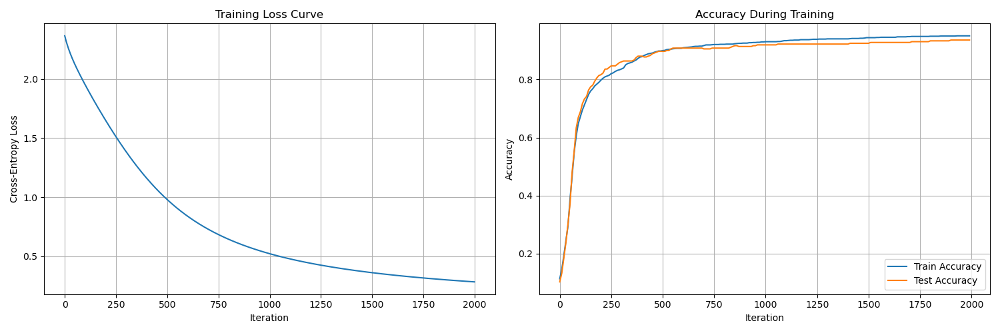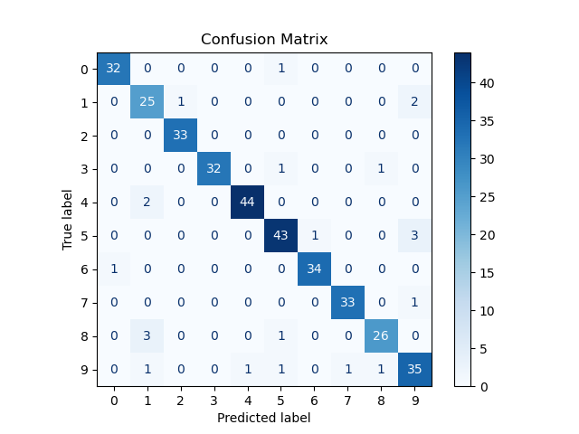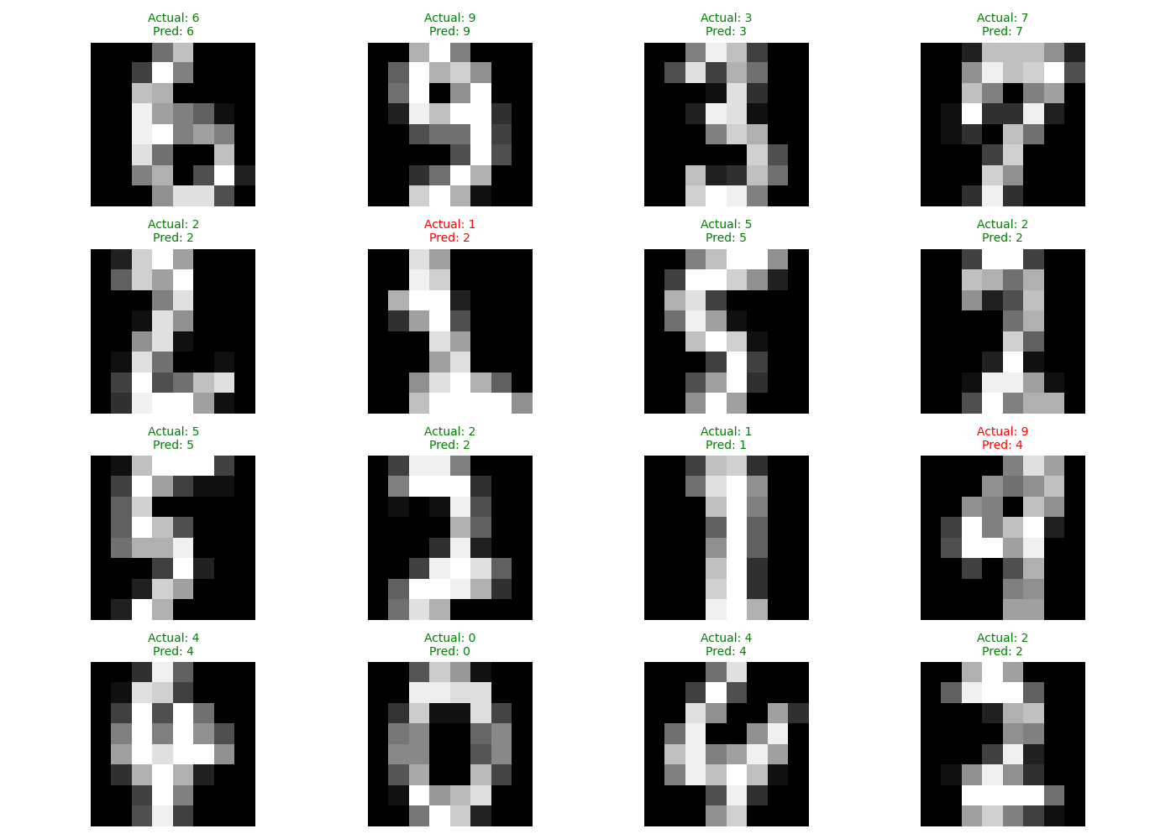
手写 BP 网络链式法则的反向传播：
