GA1

%%%%%%%%%%%%%%%%%%%%标准遗传算法求函数极值%%%%%%%%%%%%%%%%%%%
% 目标函数：max f(x) = x + 10*sin(5*x) + 7*cos(4*x), x∈[0,10]
%%%%%%%%%%%%%%%%%%%%%%%%初始化参数%%%%%%%%%%%%%%%%%%%%%%%%%%
clear all; close all; clc;

NP = 50; % 种群数量
L = 20; % 二进制编码长度
Pc = 0.8; % 交叉率
Pm = 0.1; % 变异率
G = 100; % 最大遗传代数
Xs = 10; % 自变量上限
Xx = 0; % 自变量下限

f = randi([0,1], NP, L); % 随机初始种群

% 目标函数（适应度函数）
func1 = @(x) x + 10*sin(5*x) + 7*cos(4*x);

trace = zeros(1, G); % 记录每代最优适应度

for k = 1:G
% 解码：二进制 → 十进制实数
x = zeros(NP, 1);
for i = 1:NP
U = f(i, :);
m = 0;
for j = 1:L
m = m + U(j) * 2^(j-1);
end
x(i) = Xx + m * (Xs - Xx) / (2^L - 1);
Fit(i) = func1(x(i));
end

% 记录最优个体
[maxFit, idx] = max(Fit);
fBest = f(idx, :);
trace(k) = maxFit;

% 适应度归一化（用于轮盘赌）
minFit = min(Fit);
Fit_norm = (Fit - minFit) / (maxFit - minFit);

% 轮盘赌选择
sum_Fit = sum(Fit_norm);
fitvalue = Fit_norm / sum_Fit;
fitvalue = cumsum(fitvalue);
ms = sort(rand(NP, 1));
fiti = 1;
newi = 1;
nf = zeros(NP, L);
while newi <= NP
if ms(newi) < fitvalue(fiti)
nf(newi, :) = f(fiti, :);
newi = newi + 1;
else
fiti = fiti + 1;
end
end

% 单点交叉（实际代码中用了随机掩码，这里按原文逻辑）
for i = 1:2:NP
if rand < Pc
% 随机生成一个与染色体长度相同的0/1掩码，1的位置交换基因
q = randi([0,1], 1, L);
for j = 1:L
if q(j) == 1
temp = nf(i+1, j);
nf(i+1, j) = nf(i, j);
nf(i, j) = temp;
end
end
end
end

% 位变异
for i = 1:NP
for j = 1:L
if rand < Pm
nf(i, j) = ~nf(i, j);
end
end
end

% 精英保留：用历史最优个体替换新种群中第一个个体
nf(1, :) = fBest;
f = nf;
end

% 输出最优解
xBest = Xx + sum(fBest .* 2.^(0:L-1)) * (Xs - Xx) / (2^L - 1);
fprintf('最优解 x = %.6f, 目标函数值 = %.6f\n', xBest, func1(xBest));

% 绘制进化曲线
figure;
plot(trace);
xlabel('迭代次数');
ylabel('目标函数值');
title('适应度进化曲线');

最优解 x = 7.856777, 目标函数值 = 24.855363

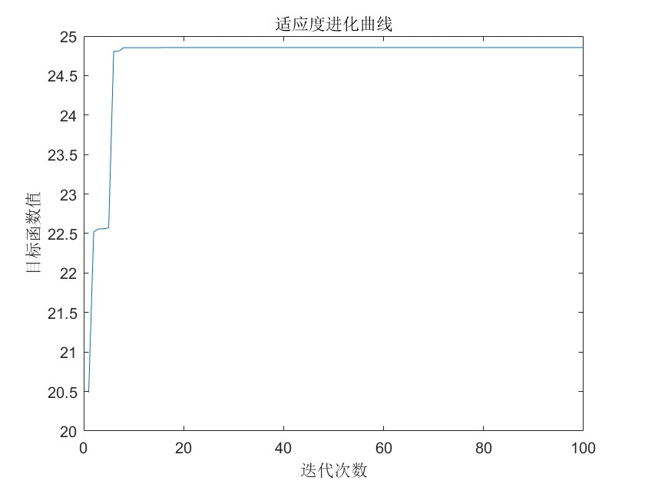

%%%%%%%%%%%%%%%%%%%% 参数影响分析：种群大小、迭代次数、交叉率、变异率 %%%%%%%%%%%%%%%%%%%%
% 目标函数：max f(x) = x + 10*sin(5*x) + 7*cos(4*x), x∈[0,10]
clear all; close all; clc;

% 基准参数
NP0 = 50; L = 20; Pc0 = 0.8; Pm0 = 0.1; G0 = 100;
Xs = 10; Xx = 0;
func1 = @(x) x + 10*sin(5*x) + 7*cos(4*x);

% 定义运行函数（输入参数，返回每代最优适应度轨迹）
function trace = runGA(NP, L, Pc, Pm, G, Xs, Xx, func1)
f = randi([0,1], NP, L);
trace = zeros(1, G);
for k = 1:G
x = zeros(NP,1);
for i = 1:NP
U = f(i,:);
m = sum(U .* 2.^(0:L-1));
x(i) = Xx + m * (Xs-Xx) / (2^L-1);
Fit(i) = func1(x(i));
end
[maxFit, idx] = max(Fit);
fBest = f(idx,:);
trace(k) = maxFit;
minFit = min(Fit);
if maxFit == minFit
Fit_norm = ones(NP,1)/NP;
else
Fit_norm = (Fit - minFit) / (maxFit - minFit);
end
% 轮盘赌
fitvalue = cumsum(Fit_norm / sum(Fit_norm));
ms = sort(rand(NP,1));
newi = 1; fiti = 1; nf = zeros(NP,L);
while newi <= NP
if ms(newi) < fitvalue(fiti)
nf(newi,:) = f(fiti,:);
newi = newi+1;
else
fiti = fiti+1;
if fiti > NP, fiti = NP; nf(newi,:) = f(randi(NP),:); newi = newi+1; end
end
end
% 交叉
for i = 1:2:NP
if rand < Pc
cp = randi([1, L-1]);
temp = nf(i, cp+1:end);
nf(i, cp+1:end) = nf(i+1, cp+1:end);
nf(i+1, cp+1:end) = temp;
end
end
% 变异
for i = 1:NP
for j = 1:L
if rand < Pm
nf(i,j) = ~nf(i,j);
end
end
end
nf(1,:) = fBest;
f = nf;
end
end

% 1. 种群大小影响
figure;
NP_vals = [20, 50, 100];
colors = {'r','g','b'};
for i = 1:length(NP_vals)
trace = runGA(NP_vals(i), L, Pc0, Pm0, G0, Xs, Xx, func1);
plot(trace, 'Color', colors{i}, 'LineWidth', 1.5); hold on;
end
legend('NP=20','NP=50','NP=100');
xlabel('迭代次数'); ylabel('最优适应度'); title('种群大小对收敛的影响');
grid on;

% 2. 交叉率影响
figure;
Pc_vals = [0.6, 0.8, 1.0];
for i = 1:length(Pc_vals)
trace = runGA(NP0, L, Pc_vals(i), Pm0, G0, Xs, Xx, func1);
plot(trace, 'Color', colors{i}, 'LineWidth', 1.5); hold on;
end
legend('Pc=0.6','Pc=0.8','Pc=1.0');
xlabel('迭代次数'); ylabel('最优适应度'); title('交叉率对收敛的影响');
grid on;

% 3. 变异率影响
figure;
Pm_vals = [0.05, 0.1, 0.2];
for i = 1:length(Pm_vals)
trace = runGA(NP0, L, Pc0, Pm_vals(i), G0, Xs, Xx, func1);
plot(trace, 'Color', colors{i}, 'LineWidth', 1.5); hold on;
end
legend('Pm=0.05','Pm=0.1','Pm=0.2');
xlabel('迭代次数'); ylabel('最优适应度'); title('变异率对收敛的影响');
grid on;

% 4. 迭代次数影响（直接比较不同G下的最终适应度）
G_vals = [50, 100, 200];
final_fit = zeros(1, length(G_vals));
for i = 1:length(G_vals)
trace = runGA(NP0, L, Pc0, Pm0, G_vals(i), Xs, Xx, func1);
final_fit(i) = trace(end);
end
fprintf('不同迭代次数下的最终适应度：\n');
for i = 1:length(G_vals)
fprintf('G=%d : %.6f\n', G_vals(i), final_fit(i));
end

不同迭代次数下的最终适应度：
G=50 : 24.855360
G=100 : 24.855363
G=200 : 24.855363
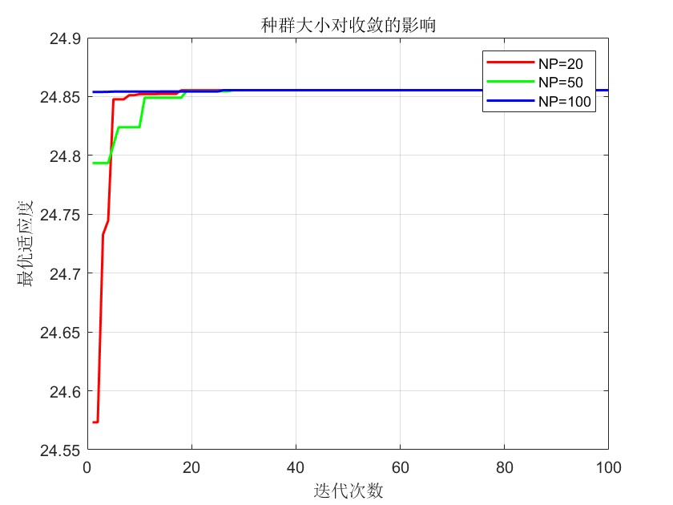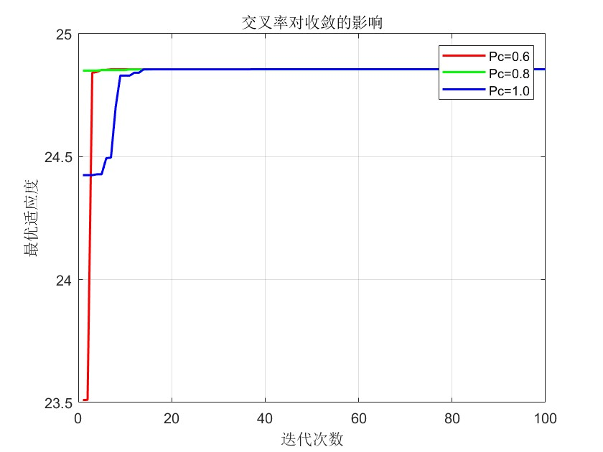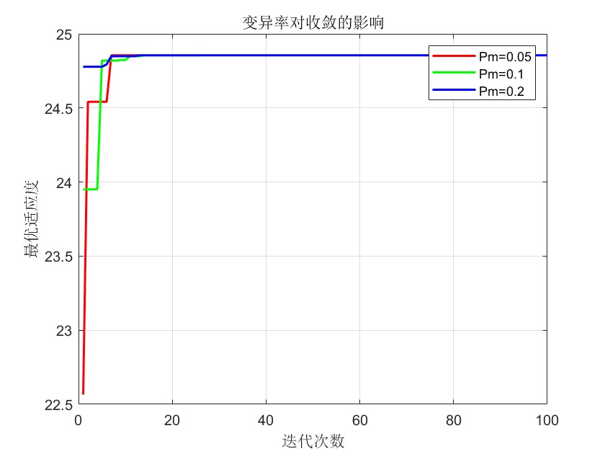

GA2

%%%%%%%%%%%%%%%%%%%%实编码遗传算法求函数极小值%%%%%%%%%%%%%%%%%%%
% 目标函数：min f(x) = sum(x_i^2), i=1..10, x_i∈[-20,20]
%%%%%%%%%%%%%%%%%%%%%%%%初始化参数%%%%%%%%%%%%%%%%%%%%%%%%%%
clear all; close all; clc;

D = 10; % 变量维数
NP = 100; % 种群规模
Xs = 20; % 上限
Xx = -20; % 下限
G = 1000; % 最大遗传代数
Pc = 0.8; % 交叉概率
Pm = 0.1; % 变异概率

% 随机初始化种群（每列为一个个体）
f = rand(D, NP) * (Xs - Xx) + Xx;

% 适应度函数
func2 = @(x) sum(x.^2);

% 计算初始种群适应度并排序
FIT = zeros(1, NP);
for np = 1:NP
FIT(np) = func2(f(:, np));
end
[SortFIT, Index] = sort(FIT);
Sortf = f(:, Index);

trace = zeros(1, G);

for gen = 1:G
Emper = Sortf(:, 1); % 君主（最优个体）
NoPoint = round(D * Pc); % 每次交叉的基因点数
PoPoint = randi([1, D], NoPoint, NP/2); % 随机选择交叉位置

nf = Sortf; % 子代暂存
for i = 1:NP/2
nf(:, 2*i-1) = Emper;
nf(:, 2*i) = Sortf(:, 2*i);
for k = 1:NoPoint
nf(PoPoint(k,i), 2*i-1) = nf(PoPoint(k,i), 2*i);
nf(PoPoint(k,i), 2*i) = Emper(PoPoint(k,i));
end
end

% 变异：每个基因位以概率 Pm 重新随机生成
for m = 1:NP
for n = 1:D
if rand < Pm
nf(n, m) = rand * (Xs - Xx) + Xx;
end
end
end

% 计算子代适应度
NFIT = zeros(1, NP);
for np = 1:NP
NFIT(np) = func2(nf(:, np));
end
[NSortFIT, Index] = sort(NFIT);
NSortf = nf(:, Index);

% 合并父代和子代，取前 NP 个最优个体
f1 = [Sortf, NSortf];
FIT1 = [SortFIT, NSortFIT];
[SortFIT1, Index] = sort(FIT1);
Sortf1 = f1(:, Index);
SortFIT = SortFIT1(1:NP);
Sortf = Sortf1(:, 1:NP);

trace(gen) = SortFIT(1); % 记录每代最优适应度
end

Bestf = Sortf(:, 1);
fprintf('最优解 x = [');
fprintf('%.4f ', Bestf);
fprintf('], 目标函数值 = %.6f\n', SortFIT(1));

figure;
plot(trace);
xlabel('迭代次数');
ylabel('目标函数值');
title('适应度进化曲线');

最优解 x = [-0.0046 -0.0037 0.0108 -0.0000 0.0003 0.0001 -0.0009 -0.0216 0.0052 0.0003 ], 目标函数值 = 0.000646

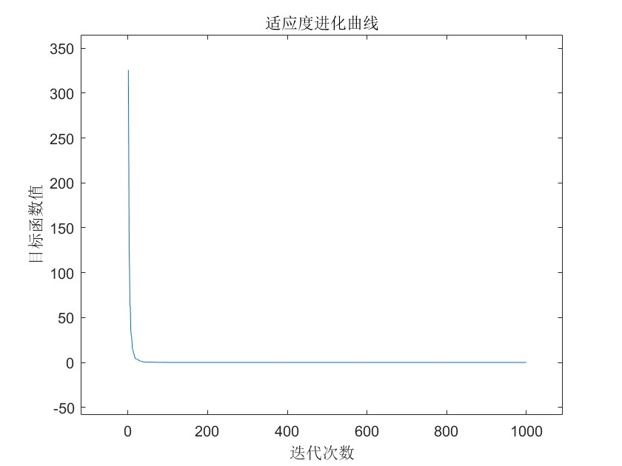

%%%%%%%%%%%%%%%%%%%% 分析不同选择、交叉、变异组合对性能的影响 %%%%%%%%%%%%%%%%%%%%
% 目标函数：min f(x) = sum(x_i^2), i=1..10, x_i∈[-20,20]
clear all; close all; clc;

D = 10; NP = 100; Xs = 20; Xx = -20; G = 500; % 固定其他参数
func2 = @(x) sum(x.^2);

% 定义三种不同操作组合
% 组合1：轮盘赌选择 + 君主交叉 + 均匀变异
% 组合2：锦标赛选择 + 算术交叉 + 非均匀变异
% 组合3：随机选择 + 模拟二进制交叉 + 高斯变异

function trace = runGA_comb(comb, D, NP, Xs, Xx, G, func2)
f = rand(D, NP) * (Xs - Xx) + Xx;
FIT = zeros(1,NP);
for np=1:NP, FIT(np)=func2(f(:,np)); end
[SortFIT, Index] = sort(FIT);
Sortf = f(:, Index);
trace = zeros(1,G);
for gen=1:G
switch comb
case 1 % 轮盘赌 + 君主交叉 + 均匀变异
% 适应度归一化
maxFit = max(SortFIT); minFit = min(SortFIT);
if maxFit == minFit
fit = ones(1,NP)/NP;
else
fit = (maxFit - SortFIT) / (maxFit - minFit);
end
% 轮盘赌选择
cumfit = cumsum(fit/sum(fit));
new_idx = zeros(1,NP);
for i=1:NP
new_idx(i) = find(rand < cumfit, 1);
end
nf = Sortf(:, new_idx);
% 君主交叉（与最优个体交叉）
Emper = Sortf(:,1);
Pc = 0.8;
NoPoint = round(D*Pc);
PoPoint = randi([1,D], NoPoint, NP);
for i=1:NP
if rand < Pc
for k=1:NoPoint
temp = nf(PoPoint(k,i),i);
nf(PoPoint(k,i),i) = Emper(PoPoint(k,i));
Emper(PoPoint(k,i)) = temp;
end
end
end
% 均匀变异
Pm = 0.1;
for i=1:NP
for j=1:D
if rand < Pm
nf(j,i) = rand * (Xs-Xx) + Xx;
end
end
end
case 2 % 锦标赛选择 + 算术交叉 + 非均匀变异
% 锦标赛选择（tournament size=3）
new_idx = zeros(1,NP);
for i=1:NP
idx = randi(NP, 1, 3);
[~, best] = min(SortFIT(idx));
new_idx(i) = idx(best);
end
nf = Sortf(:, new_idx);
% 算术交叉
Pc = 0.8;
for i=1:2:NP
if rand < Pc
alpha = rand;
nf(:,i) = alpha * nf(:,i) + (1-alpha) * nf(:,i+1);
nf(:,i+1) = alpha * nf(:,i+1) + (1-alpha) * nf(:,i);
end
end
% 非均匀变异（随代数递减）
Pm = 0.1;
b = 2;
for i=1:NP
for j=1:D
if rand < Pm
r = rand;
if r < 0.5
nf(j,i) = nf(j,i) + (Xs - nf(j,i)) * (1 - r^( (1-gen/G)^b ));
else
nf(j,i) = nf(j,i) - (nf(j,i) - Xx) * (1 - r^( (1-gen/G)^b ));
end
end
end
end
case 3 % 随机选择 + 模拟二进制交叉 + 高斯变异
% 随机选择（均匀）
new_idx = randperm(NP);
nf = Sortf(:, new_idx);
% 模拟二进制交叉 (SBX)
Pc = 0.8;
eta_c = 20;
for i=1:2:NP
if rand < Pc
u = rand;
if u <= 0.5
beta = (2*u)^(1/(eta_c+1));
else
beta = (1/(2*(1-u)))^(1/(eta_c+1));
end
child1 = 0.5*((1+beta)*nf(:,i) + (1-beta)*nf(:,i+1));
child2 = 0.5*((1-beta)*nf(:,i) + (1+beta)*nf(:,i+1));
nf(:,i) = child1; nf(:,i+1) = child2;
end
end
% 高斯变异
Pm = 0.1;
sigma = 0.1 * (Xs - Xx);
for i=1:NP
for j=1:D
if rand < Pm
nf(j,i) = nf(j,i) + sigma * randn;
nf(j,i) = max(Xx, min(Xs, nf(j,i)));
end
end
end
end
% 评价子代
NFIT = zeros(1,NP);
for np=1:NP, NFIT(np)=func2(nf(:,np)); end
[NSortFIT, Index] = sort(NFIT);
NSortf = nf(:, Index);
% 精英保留（合并父代子代，取最优NP个）
f1 = [Sortf, NSortf];
FIT1 = [SortFIT, NSortFIT];
[SortFIT1, Index] = sort(FIT1);
Sortf1 = f1(:, Index);
SortFIT = SortFIT1(1:NP);
Sortf = Sortf1(:, 1:NP);
trace(gen) = SortFIT(1);
end
end

% 运行三种组合
figure;
comb_names = {'轮盘赌+君主交叉+均匀变异','锦标赛+算术交叉+非均匀变异','随机+SBX+高斯变异'};
colors = {'r','g','b'};
for comb = 1:3
trace = runGA_comb(comb, D, NP, Xs, Xx, G, func2);
plot(trace, 'Color', colors{comb}, 'LineWidth', 1.5); hold on;
end
legend(comb_names);
xlabel('迭代次数'); ylabel('最优适应度'); title('不同操作组合对收敛的影响');
grid on;

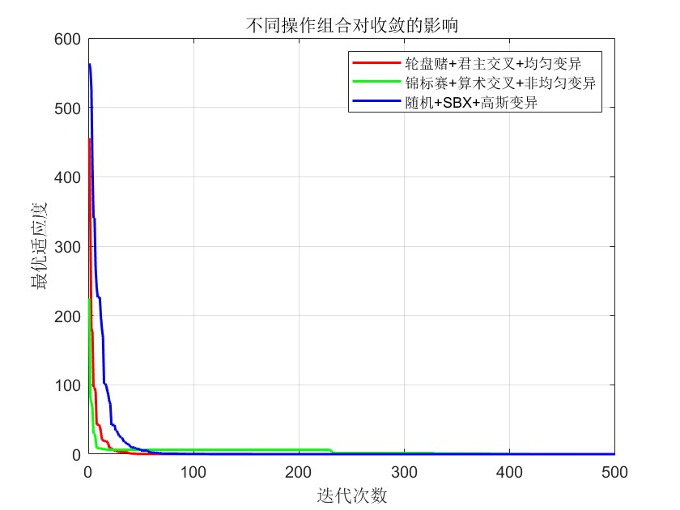

GA3

%%%%%%%%%%%%%%%%%%%%遗传算法解决TSP问题（修正版）%%%%%%%%%%%%%%%%%%%%%%%
clear all; close all; clc;

% 31个省会城市坐标
C = [1304 2312; 3639 1315; 4177 2244; 3712 1399; 3488 1535; 3326 1556;
3238 1229; 4196 1044; 4312 790; 4386 570; 3007 1970; 2562 1756;
2788 1491; 2381 1676; 1332 695; 3715 1678; 3918 2179; 4061 2370;
3780 2212; 3676 2578; 4029 2838; 4263 2931; 3429 1908; 3507 2376;
3394 2643; 3439 3201; 2935 3240; 3140 3550; 2545 2357; 2778 2826;
2370 2975];
N = size(C, 1);

% 距离矩阵
D = zeros(N, N);
for i = 1:N
for j = 1:N
D(i,j) = sqrt((C(i,1)-C(j,1))^2 + (C(i,2)-C(j,2))^2);
end
end

% 参数
NP = 200; % 种群规模
G = 1000; % 迭代次数
Pc = 0.8; % 交叉概率
Pm = 0.1; % 变异概率

% 随机生成初始种群（每行一个合法排列）
f = zeros(NP, N);
for i = 1:NP
f(i,:) = randperm(N);
end

% 记录全局最优
R = f(1,:);
minlen = inf;
Rlength = zeros(1, G);

% ================== 定义合法排列检查函数 ==================
function flag = isPermutation(x, N)
flag = isequal(sort(x), 1:N);
end

% ================== 主循环 ==================
for gen = 1:G
% 计算路径长度
len = zeros(NP, 1);
for i = 1:NP
len(i) = D(f(i,N), f(i,1));
for j = 1:N-1
len(i) = len(i) + D(f(i,j), f(i,j+1));
end
end

% 更新全局最优（仅当个体合法时）
[curr_min, idx] = min(len);
if curr_min < minlen && isPermutation(f(idx,:), N)
minlen = curr_min;
R = f(idx, :);
end
Rlength(gen) = minlen;

% 适应度归一化
maxlen = max(len);
minlen_curr = min(len);
if maxlen == minlen_curr
fit = ones(NP, 1) / NP;
else
fit = (maxlen - len) / (maxlen - minlen_curr);
end

% 轮盘赌选择
sum_fit = sum(fit);
if sum_fit == 0
nf = f(randperm(NP), :);
else
fitvalue = cumsum(fit / sum_fit);
ms = sort(rand(NP, 1));
newi = 1;
fiti = 1;
nf = zeros(NP, N);
while newi <= NP
if ms(newi) < fitvalue(fiti)
nf(newi, :) = f(fiti, :);
newi = newi + 1;
else
fiti = fiti + 1;
if fiti > NP
fiti = NP;
nf(newi, :) = f(randi(NP), :);
newi = newi + 1;
end
end
end
end

% ================== 顺序交叉（OX） ==================
for i = 1:2:NP
if rand < Pc
p1 = randi([1, N-1]);
p2 = randi([p1+1, N]);
parent1 = nf(i, :);
parent2 = nf(i+1, :);
% 子代1：中间段来自parent1，其余按parent2顺序填充
child1 = zeros(1, N);
child1(p1:p2) = parent1(p1:p2);
remain = parent2(~ismember(parent2, child1));
idx_remain = 1;
for j = 1:N
if j < p1 || j > p2
child1(j) = remain(idx_remain);
idx_remain = idx_remain + 1;
end
end
% 子代2：中间段来自parent2，其余按parent1顺序填充
child2 = zeros(1, N);
child2(p1:p2) = parent2(p1:p2);
remain = parent1(~ismember(parent1, child2));
idx_remain = 1;
for j = 1:N
if j < p1 || j > p2
child2(j) = remain(idx_remain);
idx_remain = idx_remain + 1;
end
end
nf(i, :) = child1;
nf(i+1, :) = child2;
end
end

% ================== 交换变异 ==================
for i = 1:NP
if rand < Pm
pos = randperm(N, 2);
temp = nf(i, pos(1));
nf(i, pos(1)) = nf(i, pos(2));
nf(i, pos(2)) = temp;
end
end

% 精英保留（确保个体合法）
if isPermutation(R, N)
nf(1, :) = R;
else
% 如果全局最优非法，重新生成一个合法个体
nf(1, :) = randperm(N);
end
f = nf;
end

% ================== 输出最优路径 ==================
fprintf('最优路径顺序（城市编号）：\n');
disp(R);
fprintf('最短路径长度：%.4f\n', minlen);

% ================== 绘制带箭头的路径图 ==================
figure;
plot(C(:,1), C(:,2), 'ko', 'MarkerFaceColor', 'k', 'MarkerSize', 8);
hold on;

% 绘制线段和箭头
for i = 1:N-1
x1 = C(R(i),1); y1 = C(R(i),2);
x2 = C(R(i+1),1); y2 = C(R(i+1),2);
plot([x1 x2], [y1 y2], 'b-', 'LineWidth', 1.5);
% 在每条线段的中点附近添加箭头
midX = (x1 + x2)/2;
midY = (y1 + y2)/2;
% 计算方向角
angle = atan2(y2 - y1, x2 - x1);
% 箭头长度
arrowLen = 8;
% 箭头两个侧翼点
ang1 = angle + pi/6;
ang2 = angle - pi/6;
dx1 = arrowLen * cos(ang1);
dy1 = arrowLen * sin(ang1);
dx2 = arrowLen * cos(ang2);
dy2 = arrowLen * sin(ang2);
% 绘制箭头（用线段）
quiver(midX, midY, (x2-x1)/10, (y2-y1)/10, 0, 'Color', 'r', 'MaxHeadSize', 0.5);
end
% 闭合路径（最后一段回到起点）
x1 = C(R(N),1); y1 = C(R(N),2);
x2 = C(R(1),1); y2 = C(R(1),2);
plot([x1 x2], [y1 y2], 'b-', 'LineWidth', 1.5);
midX = (x1 + x2)/2;
midY = (y1 + y2)/2;
angle = atan2(y2 - y1, x2 - x1);
quiver(midX, midY, (x2-x1)/10, (y2-y1)/10, 0, 'Color', 'r', 'MaxHeadSize', 0.5);

% 标记起点
plot(C(R(1),1), C(R(1),2), 'gp', 'MarkerSize', 12, 'MarkerFaceColor', 'g');
title(['优化最短距离：', num2str(minlen)]);
xlabel('X坐标'); ylabel('Y坐标');
axis equal;
grid on;

% 绘制进化曲线
figure;
plot(Rlength);
xlabel('迭代次数');
ylabel('最短路径长度');
title('适应度进化曲线');

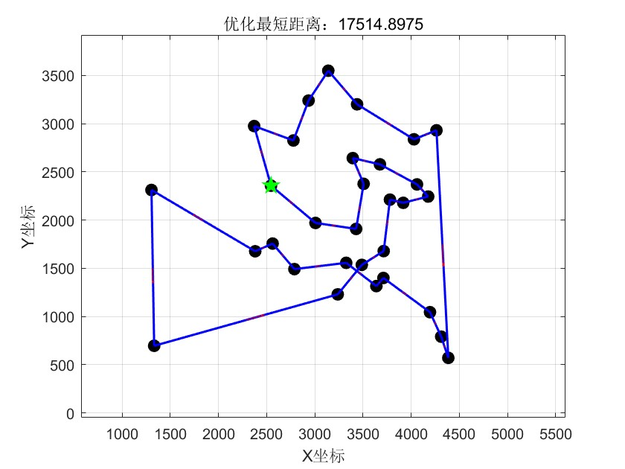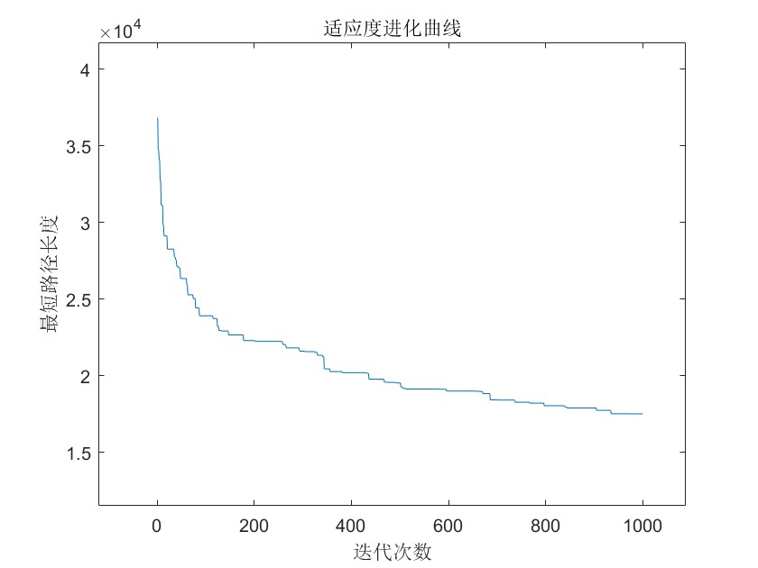

%%%%%%%%%%%%%%%%%%%% 分析不同交叉算子：PMX、OX、CX %%%%%%%%%%%%%%%%%%%%
clear all; close all; clc;

% 城市坐标（与之前相同）
C = [1304 2312; 3639 1315; 4177 2244; 3712 1399; 3488 1535; 3326 1556;
3238 1229; 4196 1044; 4312 790; 4386 570; 3007 1970; 2562 1756;
2788 1491; 2381 1676; 1332 695; 3715 1678; 3918 2179; 4061 2370;
3780 2212; 3676 2578; 4029 2838; 4263 2931; 3429 1908; 3507 2376;
3394 2643; 3439 3201; 2935 3240; 3140 3550; 2545 2357; 2778 2826;
2370 2975];
N = size(C,1);
D = zeros(N,N);
for i=1:N, for j=1:N, D(i,j)=sqrt((C(i,1)-C(j,1))^2+(C(i,2)-C(j,2))^2); end; end

% 参数
NP = 200; G = 500; Pc = 0.8; Pm = 0.1;

% 定义交叉算子函数（输入两个父代，输出两个子代）
function [child1, child2] = OX(parent1, parent2)
N = length(parent1);
p1 = randi([1,N-1]); p2 = randi([p1+1,N]);
child1 = zeros(1,N); child2 = zeros(1,N);
child1(p1:p2) = parent1(p1:p2);
remain = parent2(~ismember(parent2, child1));
idx=1;
for j=1:N
if j<p1 || j>p2
child1(j) = remain(idx); idx=idx+1;
end
end
child2(p1:p2) = parent2(p1:p2);
remain = parent1(~ismember(parent1, child2));
idx=1;
for j=1:N
if j<p1 || j>p2
child2(j) = remain(idx); idx=idx+1;
end
end
end

function [child1, child2] = PMX(parent1, parent2)
N = length(parent1);
p1 = randi([1,N-1]); p2 = randi([p1+1,N]);
child1 = parent1; child2 = parent2;
for i=p1:p2
% 交换片段内的基因
val1 = parent1(i); val2 = parent2(i);
idx1 = find(child1 == val2); idx2 = find(child2 == val1);
child1([i, idx1]) = child1([idx1, i]);
child2([i, idx2]) = child2([idx2, i]);
end
end

function [child1, child2] = CX(parent1, parent2)
N = length(parent1);
child1 = zeros(1,N); child2 = zeros(1,N);
% 使用循环交叉
visited = false(1,N);
cycle = 1;
while ~all(visited)
% 开始一个新循环
start = find(~visited,1);
i = start;
while ~visited(i)
visited(i) = true;
child1(i) = parent1(i);
child2(i) = parent2(i);
i = find(parent2 == parent1(i));
end
% 交替
if mod(cycle,2)==0
% 交换子代1和子代2的当前循环部分
idx = find(visited & (child1~=0));
temp = child1(idx); child1(idx)=child2(idx); child2(idx)=temp;
end
cycle = cycle+1;
end
end

% 主循环（封装）
function trace = runTSP_withCrossover(crossType, NP, G, Pc, Pm, D, N)
f = zeros(NP,N);
for i=1:NP, f(i,:)=randperm(N); end
R = f(1,:); minlen = inf; trace = zeros(1,G);
for gen=1:G
len = zeros(NP,1);
for i=1:NP
len(i) = D(f(i,N), f(i,1));
for j=1:N-1, len(i)=len(i)+D(f(i,j), f(i,j+1)); end
end
[curr_min, idx] = min(len);
if curr_min < minlen, minlen = curr_min; R = f(idx,:); end
trace(gen) = minlen;
maxlen = max(len); minlen_curr = min(len);
if maxlen == minlen_curr
fit = ones(NP,1)/NP;
else
fit = (maxlen - len) / (maxlen - minlen_curr);
end
% 选择
cumfit = cumsum(fit/sum(fit));
new_idx = zeros(NP,1);
for i=1:NP, new_idx(i) = find(rand < cumfit,1); end
nf = f(new_idx,:);
% 交叉
for i=1:2:NP
if rand < Pc
switch crossType
case 'OX'
[c1,c2] = OX(nf(i,:), nf(i+1,:));
case 'PMX'
[c1,c2] = PMX(nf(i,:), nf(i+1,:));
case 'CX'
[c1,c2] = CX(nf(i,:), nf(i+1,:));
end
nf(i,:)=c1; nf(i+1,:)=c2;
end
end
% 变异
for i=1:NP
if rand < Pm
pos = randperm(N,2);
nf(i,pos) = nf(i,fliplr(pos));
end
end
nf(1,:) = R;
f = nf;
end
end

% 运行三种交叉算子
figure;
crossNames = {'OX','PMX','CX'};
colors = {'r','g','b'};
for i=1:3
trace = runTSP_withCrossover(crossNames{i}, NP, G, Pc, Pm, D, N);
plot(trace, 'Color', colors{i}, 'LineWidth', 1.5); hold on;
end
legend(crossNames);
xlabel('迭代次数'); ylabel('最短路径长度'); title('不同交叉算子对TSP求解的影响');
grid on;

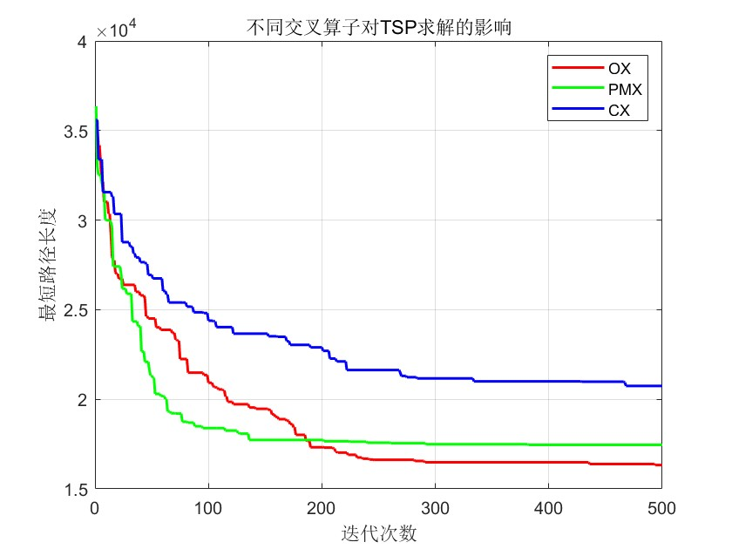

GA4

%%%%%%%%%%%%%%%%%%%%遗传算法解决0-1背包问题%%%%%%%%%%%%%%%%%%%
% 物品数量10，背包容量300，体积和价值已给定
clear all; close all; clc;

NP = 50; % 种群规模
L = 10; % 染色体长度（物品个数）
Pc = 0.8; % 交叉率
Pm = 0.05; % 变异率
G = 100; % 最大遗传代数
V = 300; % 背包容量

C = [95, 75, 23, 73, 50, 22, 6, 57, 89, 98]; % 物品体积
W = [89, 59, 19, 43, 100, 72, 44, 16, 7, 64]; % 物品价值
afa = 2; % 惩罚系数

% 适应度函数（带惩罚）
func4 = @(f) sum(f.*W) - afa * max(0, sum(f.*C) - V);

% 随机初始种群
f = randi([0,1], NP, L);

trace = zeros(1, G);

for k = 1:G
% 计算适应度
Fit = zeros(NP, 1);
for i = 1:NP
Fit(i) = func4(f(i,:));
end
[maxFit, idx] = max(Fit);
fBest = f(idx, :); % 历代最优个体
trace(k) = maxFit;

% 适应度归一化（用于轮盘赌）
minFit = min(Fit);
Fit_norm = (Fit - minFit) / (maxFit - minFit);

% 轮盘赌选择
sum_Fit = sum(Fit_norm);
fitvalue = Fit_norm / sum_Fit;
fitvalue = cumsum(fitvalue);
ms = sort(rand(NP, 1));
fiti = 1;
newi = 1;
nf = zeros(NP, L);
while newi <= NP
if ms(newi) < fitvalue(fiti)
nf(newi, :) = f(fiti, :);
newi = newi + 1;
else
fiti = fiti + 1;
end
end

% 单点交叉
for i = 1:2:NP
if rand < Pc
% 随机选择交叉点
cp = randi([1, L-1]);
nf(i, cp+1:end) = nf(i+1, cp+1:end);
nf(i+1, cp+1:end) = nf(i, cp+1:end); % 注意：这里修正了原代码的逻辑错误
end
end

% 位变异
for i = 1:NP
for j = 1:L
if rand < Pm
nf(i, j) = ~nf(i, j);
end
end
end

% 精英保留
nf(1, :) = fBest;
f = nf;
end

% 输出最优解
fprintf('最优解（选择物品）：');
fprintf('%d ', fBest);
fprintf('\n总价值：%.2f\n', func4(fBest));
fprintf('总体积：%d\n', sum(fBest .* C));

% 绘制进化曲线
figure;
plot(trace);
xlabel('迭代次数');
ylabel('适应度值');
title('适应度进化曲线');

最优解（选择物品）：1 0 1 0 1 1 1 0 0 1
- 物品编号 1、3、5、6、7、10 被选中（1 表示选，0 表示不选）。
总价值：388.00
总体积：294

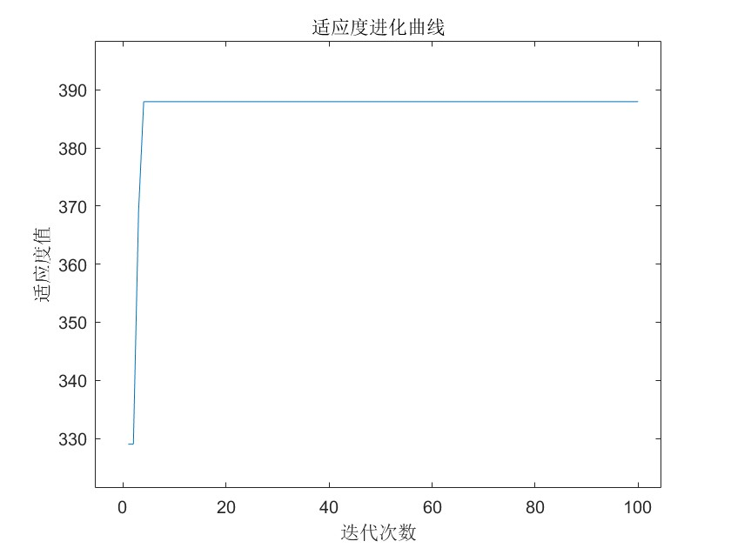

%%%%%%%%%%%%%%%%%%%% 分析不同惩罚函数对背包问题求解的影响 %%%%%%%%%%%%%%%%%%%%
clear all; close all; clc;

NP = 50; L = 10; Pc = 0.8; Pm = 0.05; G = 100; V = 300;
C = [95,75,23,73,50,22,6,57,89,98];
W = [89,59,19,43,100,72,44,16,7,64];

% 定义三种惩罚函数
% 1. 线性惩罚：fit = value - α * max(0, volume - V)
% 2. 平方惩罚：fit = value - α * (max(0, volume - V))^2
% 3. 指数惩罚：fit = value * exp(-α * max(0, volume - V))
alpha = 2; % 惩罚系数

function trace = runKnapsack(penaltyType, NP, L, Pc, Pm, G, V, C, W, alpha)
switch penaltyType
case 'linear'
func = @(f) sum(f.*W) - alpha * max(0, sum(f.*C) - V);
case 'square'
func = @(f) sum(f.*W) - alpha * (max(0, sum(f.*C) - V))^2;
case 'exp'
func = @(f) sum(f.*W) * exp(-alpha * max(0, sum(f.*C) - V));
end
f = randi([0,1], NP, L);
trace = zeros(1,G);
for k=1:G
Fit = zeros(NP,1);
for i=1:NP, Fit(i)=func(f(i,:)); end
[maxFit, idx] = max(Fit);
fBest = f(idx,:);
trace(k) = maxFit;
minFit = min(Fit);
if maxFit == minFit
Fit_norm = ones(NP,1)/NP;
else
Fit_norm = (Fit - minFit)/(maxFit - minFit);
end
% 轮盘赌
cumfit = cumsum(Fit_norm / sum(Fit_norm));
ms = sort(rand(NP,1));
newi=1; fiti=1; nf=zeros(NP,L);
while newi<=NP
if ms(newi) < cumfit(fiti)
nf(newi,:)=f(fiti,:);
newi=newi+1;
else
fiti=fiti+1;
if fiti>NP, fiti=NP; nf(newi,:)=f(randi(NP),:); newi=newi+1; end
end
end
% 单点交叉
for i=1:2:NP
if rand<Pc
cp = randi([1,L-1]);
temp = nf(i, cp+1:end);
nf(i, cp+1:end) = nf(i+1, cp+1:end);
nf(i+1, cp+1:end) = temp;
end
end
% 变异
for i=1:NP
for j=1:L
if rand<Pm, nf(i,j)=~nf(i,j); end
end
end
nf(1,:)=fBest;
f=nf;
end
end

% 运行三种惩罚函数
figure;
penaltyNames = {'linear','square','exp'};
colors = {'r','g','b'};
for i=1:3
trace = runKnapsack(penaltyNames{i}, NP, L, Pc, Pm, G, V, C, W, alpha);
plot(trace, 'Color', colors{i}, 'LineWidth', 1.5); hold on;
end
legend('线性惩罚','平方惩罚','指数惩罚');
xlabel('迭代次数'); ylabel('适应度值'); title('不同惩罚函数对背包问题的影响');
grid on;

% 输出最终最优值
for i=1:3
trace = runKnapsack(penaltyNames{i}, NP, L, Pc, Pm, G, V, C, W, alpha);
fprintf('%s惩罚最终适应度: %.2f\n', penaltyNames{i}, trace(end));
end

linear惩罚最终适应度: 388.00
square惩罚最终适应度: 388.00
exp惩罚最终适应度: 388.00

