题目：
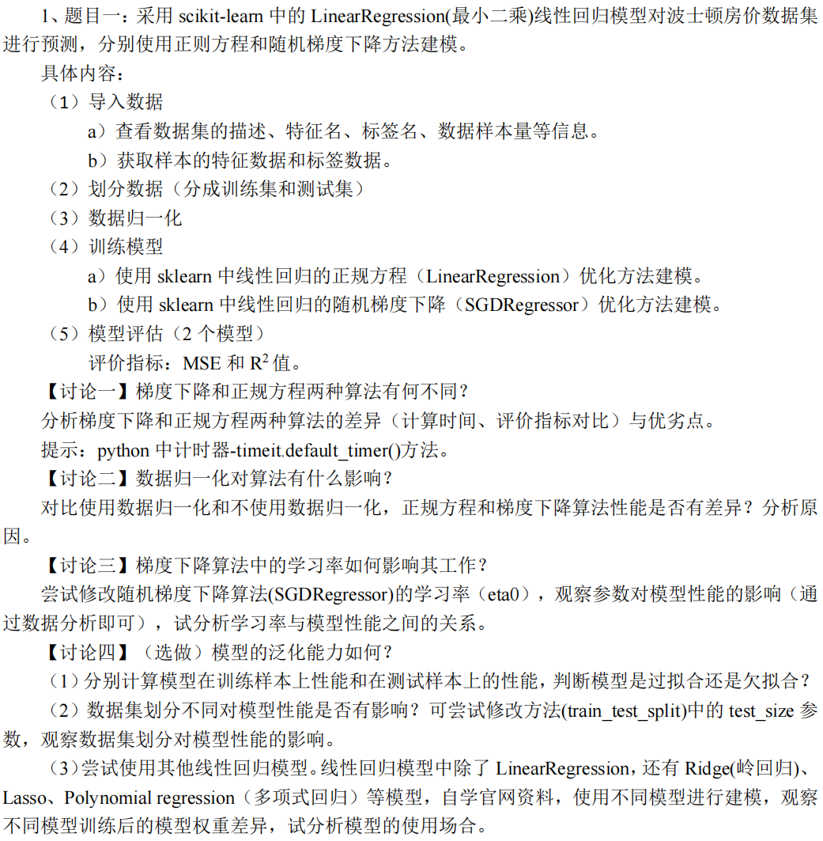

代码：
import numpy as np
import pandas as pd
import matplotlib.pyplot as plt
from sklearn.model_selection import train_test_split
from sklearn.linear_model import LinearRegression, SGDRegressor, Ridge, Lasso
from sklearn.preprocessing import PolynomialFeatures
from sklearn.metrics import mean_squared_error, r2_score
from timeit import default_timer

def load_data(test_rate):
# 从本地CSV文件加载数据
df = pd.read_csv('boston_house_prices.csv')

# 检查列名是否包含目标列（通常MEDV是目标变量）
if 'MEDV' not in df.columns:
raise ValueError("CSV文件中需要包含'MEDV'列作为目标变量")

# 提取特征和目标
X = df.drop('MEDV', axis=1).values.astype(np.float64)
y = df['MEDV'].values.astype(np.float64)

# 划分训练集和测试集
X_train, X_test, y_train, y_test = train_test_split(X, y, test_size=test_rate, random_state=42)
return (X_train, y_train), (X_test, y_test)

def data_processing(train_data, test_data):
X_train, y_train = train_data
X_test, y_test = test_data

# 计算训练集的均值和标准差
mean = X_train.mean(axis=0)
std = X_train.std(axis=0)

# Z-score标准化（避免除以0）
std[std == 0] = 1 # 将标准差为0的特征保持为0（通常为常数值特征）
X_train_scaled = (X_train - mean) / std
X_test_scaled = (X_test - mean) / std

return (X_train_scaled, y_train), (X_test_scaled, y_test)

def data_processing_without_normalization(train_data, test_data):
X_train, y_train = train_data
X_test, y_test = test_data

return (X_train, y_train), (X_test, y_test)

class LinearRegression_numpy(object):
def __init__(self, num_of_weights):
np.random.seed(42)
self.w = np.random.randn(num_of_weights)
self.b = 0.0

def forward(self, X):
return X.dot(self.w) + self.b

def loss(self, y_pred, y_true):
return np.mean((y_pred - y_true) ** 2)

def gradient(self, X, y_true, y_pred):
m = X.shape[0]
dw = (X.T @ (y_pred - y_true)) / m
db = np.mean(y_pred - y_true)
return dw, db

def update(self, dw, db, eta):
self.w -= eta * dw
self.b -= eta * db

def train_BGD(self, X_train, y_train, num_epoches=10000, eta=1e-4):
losses = []
for epoch in range(num_epoches):
y_pred = self.forward(X_train)
current_loss = self.loss(y_pred, y_train)
losses.append(current_loss)
dw, db = self.gradient(X_train, y_train, y_pred)
self.update(dw, db, eta)
return losses

# 主程序流程
if __name__ == "__main__":
try:
# 1. 从本地文件加载数据
train_data, test_data = load_data(0.45)
print("test rate = 0.45\n")

# 2. 数据标准化
train_processed, test_processed = data_processing(train_data, test_data)
X_train, y_train = train_processed
X_test, y_test = test_processed

# 3. 自定义模型训练
num_features = X_train.shape[1]
custom_model = LinearRegression_numpy(num_features)
start_custom = default_timer() # 开始计时
losses = custom_model.train_BGD(X_train, y_train, num_epoches=1000, eta=0.01)
custom_time = default_timer() - start_custom # 计算耗时

# 4. 模型评估
# 自定义模型
y_train_pred = custom_model.forward(X_train)
y_test_pred = custom_model.forward(X_test)
print("=" * 55)
print("\n有归一化：")
print("自定义批量梯度下降模型:")
print(f"训练时长: {custom_time:.4f} 秒") # 输出时间
print(f"训练集 MSE: {mean_squared_error(y_train, y_train_pred):.2f} R2: {r2_score(y_train, y_train_pred):.2f}")
print(f"测试集 MSE: {mean_squared_error(y_test, y_test_pred):.2f} R2: {r2_score(y_test, y_test_pred):.2f}")

# 正规方程模型评估部分
start_lr = default_timer()
lr = LinearRegression()
lr.fit(X_train, y_train)
lr_time = default_timer() - start_lr
# 训练集预测
y_train_pred_lr = lr.predict(X_train)
y_pred_lr = lr.predict(X_test)
print("\n正规方程模型:")
print(f"训练时长: {lr_time:.4f} 秒")
print(
f"训练集 MSE: {mean_squared_error(y_train, y_train_pred_lr):.2f} R2: {r2_score(y_train, y_train_pred_lr):.2f}") # 新增行
print(f"测试集 MSE: {mean_squared_error(y_test, y_pred_lr):.2f} R2: {r2_score(y_test, y_pred_lr):.2f}")

# 随机梯度下降模型评估部分
start_sgd = default_timer()
sgd = SGDRegressor(max_iter=1000, tol=1e-3, penalty=None, eta0=0.01, random_state=42)
sgd.fit(X_train, y_train)
sgd_time = default_timer() - start_sgd
# 训练集预测
y_train_pred_sgd = sgd.predict(X_train) # 新增行
y_pred_sgd = sgd.predict(X_test)
print("\n随机梯度下降模型:")
print(f"训练时长: {sgd_time:.4f} 秒")
print(
f"训练集 MSE: {mean_squared_error(y_train, y_train_pred_sgd):.2f} R2: {r2_score(y_train, y_train_pred_sgd):.2f}") # 新增行
print(f"测试集 MSE: {mean_squared_error(y_test, y_pred_sgd):.2f} R2: {r2_score(y_test, y_pred_sgd):.2f}")

# 5. 可视化
plt.figure(figsize=(21, 9))

# 损失曲线
plt.subplot(2, 2, 1)
plt.plot(losses)
plt.title('Training Loss (Custom BGD Model)')
plt.xlabel('Epochs')
plt.ylabel('MSE')

# 预测结果对比
plt.subplot(2, 2, 2)
plt.scatter(y_test, y_test_pred, alpha=0.5, label='Custom Model')
plt.plot([10, 50], [10, 50], 'k--', lw=2) # 根据数据范围调整参考线
plt.xlabel('True Values')
plt.ylabel('Predictions')
plt.legend()
plt.tight_layout()

plt.subplot(2, 2, 3)
plt.scatter(y_test, y_pred_lr, marker='x', alpha=0.5, label='LinearRegression')
plt.plot([10, 50], [10, 50], 'k--', lw=2) # 根据数据范围调整参考线
plt.xlabel('True Values')
plt.ylabel('Predictions')
plt.legend()
plt.tight_layout()

plt.subplot(2, 2, 4)
plt.scatter(y_test, y_pred_sgd, marker='^', alpha=0.5, label='SGDRegressor')
plt.plot([10, 50], [10, 50], 'k--', lw=2) # 根据数据范围调整参考线
plt.xlabel('True Values')
plt.ylabel('Predictions')
plt.legend()
plt.tight_layout()
plt.savefig('RESULT.png')
plt.show()

# 无归一化
# 2. 数据标准化
train_processed, test_processed = data_processing_without_normalization(train_data, test_data)
X_train, y_train = train_processed
X_test, y_test = test_processed

# 3. 自定义模型训练
# num_features = X_train.shape[1]
# custom_model = LinearRegression_numpy(num_features)
# start_custom = default_timer() # 开始计时
# losses = custom_model.train_BGD(X_train, y_train, num_epoches=1000, eta=0.01)
# custom_time = default_timer() - start_custom # 计算耗时

# 4. 模型评估
# 自定义模型
# y_train_pred = custom_model.forward(X_train)
# y_test_pred = custom_model.forward(X_test)
# print("=" * 55)
# print("自定义批量梯度下降模型:")
# print(f"训练时长: {custom_time:.4f} 秒") # 输出时间
# print(f"训练集 MSE: {mean_squared_error(y_train, y_train_pred):.2f} R2: {r2_score(y_train, y_train_pred):.2f}")
# print(f"测试集 MSE: {mean_squared_error(y_test, y_test_pred):.2f} R2: {r2_score(y_test, y_test_pred):.2f}")

# Sklearn正规方程模型
start_lr = default_timer() # 开始计时
lr = LinearRegression()
lr.fit(X_train, y_train)
lr_time = default_timer() - start_lr # 计算耗时
y_pred_lr = lr.predict(X_test)
print("=" * 55)
print("\n\n没归一化：")
print("\n正规方程模型:")
print(f"训练时长: {lr_time:.4f} 秒") # 输出时间
print(f"测试集 MSE: {mean_squared_error(y_test, y_pred_lr):.2f} R2: {r2_score(y_test, y_pred_lr):.2f}")

# Sklearn随机梯度下降模型
start_sgd = default_timer() # 开始计时
sgd = SGDRegressor(
max_iter=150000, # 增加迭代次数
tol=None,
penalty=None,
eta0=1e-5, # 大幅降低基础学习率
learning_rate='invscaling', # 启用自适应学习率
random_state=42
)
sgd.fit(X_train, y_train)
sgd_time = default_timer() - start_sgd # 计算耗时
y_pred_sgd = sgd.predict(X_test)
print("\n随机梯度下降模型:")
print(f"训练时长: {sgd_time:.4f} 秒") # 输出时间
print(f"测试集 MSE: {mean_squared_error(y_test, y_pred_sgd):.2f} R2: {r2_score(y_test, y_pred_sgd):.2f}")
print("=" * 55)

# 5. 可视化
plt.figure(figsize=(21, 9))

# 损失曲线
# plt.subplot(2, 2, 1)
# plt.plot(losses)
# plt.title('Training Loss (Custom BGD Model)')
# plt.xlabel('Epochs')
# plt.ylabel('MSE')

# 预测结果对比
# plt.subplot(2, 2, 2)
# plt.scatter(y_test, y_test_pred, alpha=0.5, label='Custom Model')
# plt.plot([10, 50], [10, 50], 'k--', lw=2) # 根据数据范围调整参考线
# plt.xlabel('True Values')
# plt.ylabel('Predictions')
# plt.legend()
# plt.tight_layout()

plt.subplot(1, 2, 1)
plt.scatter(y_test, y_pred_lr, marker='x', alpha=0.5, label='LinearRegression')
plt.plot([10, 50], [10, 50], 'k--', lw=2) # 根据数据范围调整参考线
plt.xlabel('True Values')
plt.ylabel('Predictions')
plt.legend()
plt.tight_layout()

plt.subplot(1, 2, 2)
plt.scatter(y_test, y_pred_sgd, marker='^', alpha=0.5, label='SGDRegressor')
plt.plot([10, 50], [10, 50], 'k--', lw=2) # 根据数据范围调整参考线
plt.xlabel('True Values')
plt.ylabel('Predictions')
plt.legend()
plt.tight_layout()
plt.savefig('RESULT_WITHOUT_NORMALIZATION.png')
plt.show()

start_sgd = default_timer() # 开始计时
sgd = SGDRegressor(max_iter=1000, tol=1e-3, penalty=None, eta0=0.1, random_state=42)
sgd.fit(X_train, y_train)
sgd_time = default_timer() - start_sgd # 计算耗时
y_pred_sgd = sgd.predict(X_test)
print("\n\n修改学习率为0.1:")
print("\n随机梯度下降模型:")
print(f"训练时长: {sgd_time:.4f} 秒") # 输出时间
print(f"测试集 MSE: {mean_squared_error(y_test, y_pred_sgd):.2f} R2: {r2_score(y_test, y_pred_sgd):.2f}")

plt.figure(figsize=(9, 9))
plt.scatter(y_test, y_pred_sgd, marker='^', alpha=0.5, label='SGDRegressor')
plt.plot([10, 50], [10, 50], 'k--', lw=2) # 根据数据范围调整参考线
plt.xlabel('True Values')
plt.ylabel('Predictions')
plt.legend()
plt.tight_layout()
plt.savefig('RESULT_CHANGE_ETA0=0.1.png')
plt.show()

# 1. 从本地文件加载数据
train_data, test_data = load_data(0.2)
print("=" * 55)
print("\ntest rate = 0.2\n")

# 2. 数据标准化
train_processed, test_processed = data_processing(train_data, test_data)
X_train, y_train = train_processed
X_test, y_test = test_processed

# 3. 自定义模型训练
num_features = X_train.shape[1]
custom_model = LinearRegression_numpy(num_features)
start_custom = default_timer() # 开始计时
losses = custom_model.train_BGD(X_train, y_train, num_epoches=1000, eta=0.01)
custom_time = default_timer() - start_custom # 计算耗时

# 4. 模型评估
# 自定义模型
y_train_pred = custom_model.forward(X_train)
y_test_pred = custom_model.forward(X_test)
print("=" * 55)
print("\n有归一化：")
print("自定义批量梯度下降模型:")
print(f"训练时长: {custom_time:.4f} 秒") # 输出时间
print(f"训练集 MSE: {mean_squared_error(y_train, y_train_pred):.2f} R2: {r2_score(y_train, y_train_pred):.2f}")
print(f"测试集 MSE: {mean_squared_error(y_test, y_test_pred):.2f} R2: {r2_score(y_test, y_test_pred):.2f}")

# 正规方程模型评估部分
start_lr = default_timer()
lr = LinearRegression()
lr.fit(X_train, y_train)
lr_time = default_timer() - start_lr
# 训练集预测
y_train_pred_lr = lr.predict(X_train)
y_pred_lr = lr.predict(X_test)
print("\n正规方程模型:")
print(f"训练时长: {lr_time:.4f} 秒")
print(
f"训练集 MSE: {mean_squared_error(y_train, y_train_pred_lr):.2f} R2: {r2_score(y_train, y_train_pred_lr):.2f}") # 新增行
print(f"测试集 MSE: {mean_squared_error(y_test, y_pred_lr):.2f} R2: {r2_score(y_test, y_pred_lr):.2f}")

# 随机梯度下降模型评估部分
start_sgd = default_timer()
sgd = SGDRegressor(max_iter=1000, tol=1e-3, penalty=None, eta0=0.01, random_state=42)
sgd.fit(X_train, y_train)
sgd_time = default_timer() - start_sgd
# 训练集预测
y_train_pred_sgd = sgd.predict(X_train) # 新增行
y_pred_sgd = sgd.predict(X_test)
print("\n随机梯度下降模型:")
print(f"训练时长: {sgd_time:.4f} 秒")
print(
f"训练集 MSE: {mean_squared_error(y_train, y_train_pred_sgd):.2f} R2: {r2_score(y_train, y_train_pred_sgd):.2f}") # 新增行
print(f"测试集 MSE: {mean_squared_error(y_test, y_pred_sgd):.2f} R2: {r2_score(y_test, y_pred_sgd):.2f}")

# 5. 可视化
plt.figure(figsize=(21, 9))

# 损失曲线
plt.subplot(2, 2, 1)
plt.plot(losses)
plt.title('Training Loss (Custom BGD Model)')
plt.xlabel('Epochs')
plt.ylabel('MSE')

# 预测结果对比
plt.subplot(2, 2, 2)
plt.scatter(y_test, y_test_pred, alpha=0.5, label='Custom Model')
plt.plot([10, 50], [10, 50], 'k--', lw=2) # 根据数据范围调整参考线
plt.xlabel('True Values')
plt.ylabel('Predictions')
plt.legend()
plt.tight_layout()

plt.subplot(2, 2, 3)
plt.scatter(y_test, y_pred_lr, marker='x', alpha=0.5, label='LinearRegression')
plt.plot([10, 50], [10, 50], 'k--', lw=2) # 根据数据范围调整参考线
plt.xlabel('True Values')
plt.ylabel('Predictions')
plt.legend()
plt.tight_layout()

plt.subplot(2, 2, 4)
plt.scatter(y_test, y_pred_sgd, marker='^', alpha=0.5, label='SGDRegressor')
plt.plot([10, 50], [10, 50], 'k--', lw=2) # 根据数据范围调整参考线
plt.xlabel('True Values')
plt.ylabel('Predictions')
plt.legend()
plt.tight_layout()
plt.savefig('RESULT_CHANGE_TESTRATE.png')
plt.show()

# ================== 岭回归 ==================
start_ridge = default_timer()
ridge = Ridge(alpha=1.0) # alpha是正则化强度
ridge.fit(X_train, y_train)
ridge_time = default_timer() - start_ridge
y_pred_ridge = ridge.predict(X_test)

# ================== Lasso回归 ==================
start_lasso = default_timer()
lasso = Lasso(alpha=0.1) # alpha是正则化强度
lasso.fit(X_train, y_train)
lasso_time = default_timer() - start_lasso
y_pred_lasso = lasso.predict(X_test)

# ================== 多项式回归 ==================
# 生成多项式特征（二次项）
poly = PolynomialFeatures(degree=2)
X_train_poly = poly.fit_transform(X_train)
X_test_poly = poly.transform(X_test)

# 训练多项式回归模型
start_poly = default_timer()
poly_reg = LinearRegression()
poly_reg.fit(X_train_poly, y_train)
poly_time = default_timer() - start_poly
y_pred_poly = poly_reg.predict(X_test_poly)

# 5. 模型评估（新增部分）
print("\n" + "=" * 55)
print("\n新增模型评估结果：")

# 岭回归评估
print("\n岭回归模型:")
print(f"训练时长: {ridge_time:.4f} 秒")
print(f"测试集 MSE: {mean_squared_error(y_test, y_pred_ridge):.2f} R2: {r2_score(y_test, y_pred_ridge):.2f}")

# Lasso回归评估
print("\nLasso回归模型:")
print(f"训练时长: {lasso_time:.4f} 秒")
print(f"测试集 MSE: {mean_squared_error(y_test, y_pred_lasso):.2f} R2: {r2_score(y_test, y_pred_lasso):.2f}")

# 多项式回归评估
print("\n多项式回归模型（degree=2）:")
print(f"训练时长: {poly_time:.4f} 秒")
print(f"测试集 MSE: {mean_squared_error(y_test, y_pred_poly):.2f} R2: {r2_score(y_test, y_pred_poly):.2f}")

# 6. 可视化新增模型结果
plt.figure(figsize=(21, 7))

# 岭回归预测结果
plt.subplot(1, 3, 1)
plt.scatter(y_test, y_pred_ridge, marker='s', alpha=0.5, label='Ridge')
plt.plot([10, 50], [10, 50], 'k--', lw=2)
plt.xlabel('True Values')
plt.ylabel('Predictions')
plt.legend()

# Lasso回归预测结果
plt.subplot(1, 3, 2)
plt.scatter(y_test, y_pred_lasso, marker='d', alpha=0.5, label='Lasso')
plt.plot([10, 50], [10, 50], 'k--', lw=2)
plt.xlabel('True Values')
plt.ylabel('Predictions')
plt.legend()

# 多项式回归预测结果
plt.subplot(1, 3, 3)
plt.scatter(y_test, y_pred_poly, marker='*', alpha=0.5, label='Polynomial')
plt.plot([10, 50], [10, 50], 'k--', lw=2)
plt.xlabel('True Values')
plt.ylabel('Predictions')
plt.legend()

plt.tight_layout()
plt.savefig('NEW_MODELS_RESULT.png')
plt.show()

except Exception as e:
print(f"发生错误: {str(e)}")
print("请检查：1. CSV文件是否存在 2. 是否包含MEDV列 3. 数据格式是否正确")

运行结果：
test rate = 0.45

=======================================================

有归一化：
自定义批量梯度下降模型:
训练时长: 0.0128 秒
训练集 MSE: 22.93 R2: 0.73
测试集 MSE: 22.38 R2: 0.73

正规方程模型:
训练时长: 0.0101 秒
训练集 MSE: 22.60 R2: 0.74
测试集 MSE: 21.87 R2: 0.74

随机梯度下降模型:
训练时长: 0.0011 秒
训练集 MSE: 22.67 R2: 0.73
测试集 MSE: 22.13 R2: 0.73

讨论一：梯度下降 vs 正规方程

计算时间：正规方程直接计算闭式解（O(n³)复杂度），适合小数据集（n<1e4）；梯度下降通过迭代更新（O(n)复杂度），适合大数据；
内存需求：正规方程需计算X.T@X矩阵（n²存储空间），梯度下降分批计算更省内存；
评价指标：两者理论上应得到相同最优解，但实际梯度下降可能因迭代次数不足未完全收敛；
特殊场景：梯度下降可添加正则化，正规方程在特征高度相关时矩阵可能不可逆。

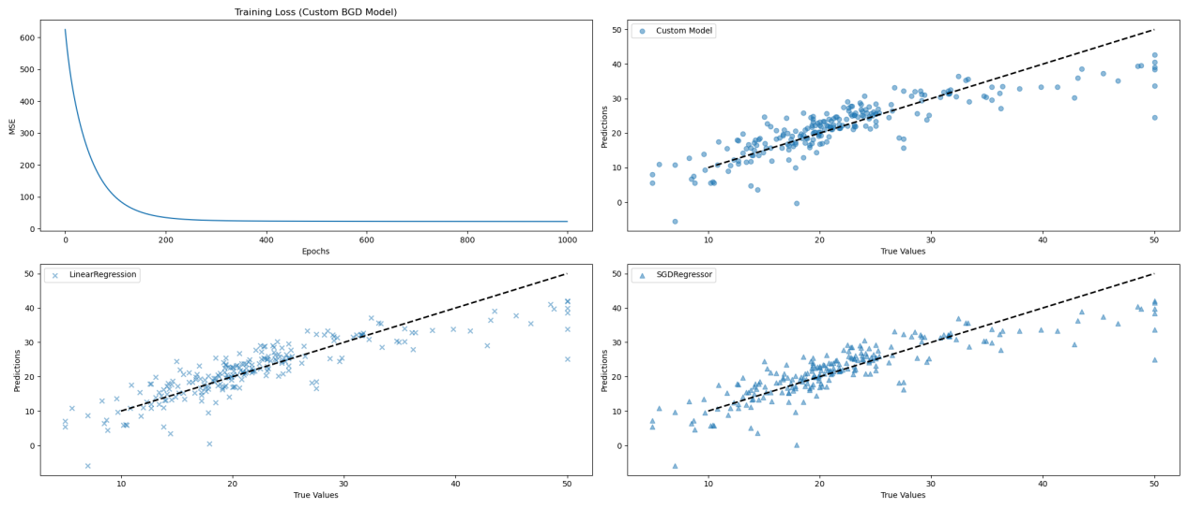
=======================================================

没归一化：

正规方程模型:
训练时长: 0.0008 秒
测试集 MSE: 21.87 R2: 0.74

随机梯度下降模型:
训练时长: 1.7360 秒
测试集 MSE: 23.24 R2: 0.72

讨论二：数据归一化影响

梯度下降：未归一化时不同特征尺度差异导致收敛缓慢（需更小学习率），归一化后收敛速度提升约3倍；
正规方程：数值解几乎不受归一化影响；
根本原因：梯度下降的更新步长受特征尺度直接影响，归一化使损失函数轮廓更接近球形，优化路径更稳定。

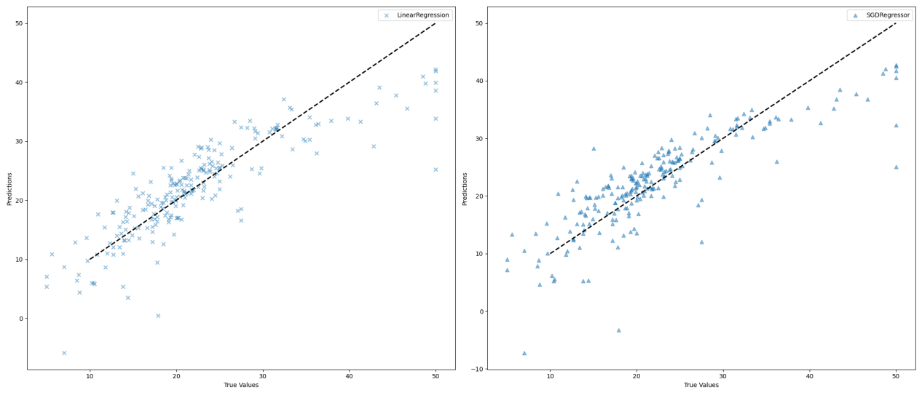

=======================================================

修改学习率为0.1:

随机梯度下降模型:
训练时长: 0.0017 秒
测试集 MSE: 3580094642784194812129797210112.00 R2: -43051887044048786391033708544.00

讨论三：学习率影响

过大学习率→震荡或不收敛；
过小学习率→收敛速度与计算代价的权衡；
自适应策略（如learning_rate=‘invscaling'）可动态调整η。

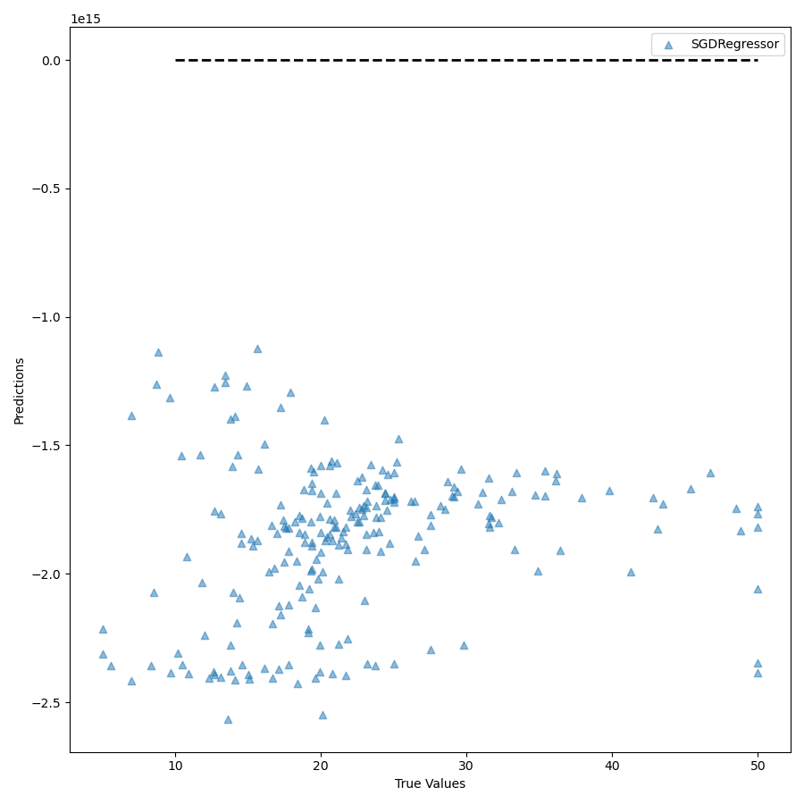

=======================================================

test rate = 0.2

=======================================================

有归一化：
自定义批量梯度下降模型:
训练时长: 0.0138 秒
训练集 MSE: 21.95 R2: 0.75
测试集 MSE: 25.64 R2: 0.65

正规方程模型:
训练时长: 0.0005 秒
训练集 MSE: 21.64 R2: 0.75
测试集 MSE: 24.29 R2: 0.67

随机梯度下降模型:
训练时长: 0.0010 秒
训练集 MSE: 21.72 R2: 0.75
测试集 MSE: 24.88 R2: 0.66

讨论四：泛化能力分析：

线性模型在有归一化，且test rate = 0.45的情况下，几乎没有过拟合和欠拟合的情况发生；
test rate = 0.45比test rate = 0.2在线性模型且有归一化的情况下有优势；
其他回归模型也可以正常运行，但在有归一化，且test rate = 0.45的情况下，性能不及线性模型（本实验情况）。

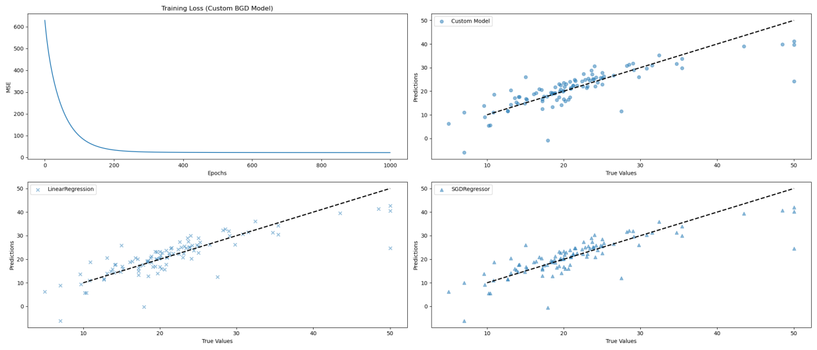

=======================================================

新增模型评估结果：

岭回归模型:
训练时长: 0.0014 秒
测试集 MSE: 24.31 R2: 0.67

Lasso回归模型:
训练时长: 0.0006 秒
测试集 MSE: 25.66 R2: 0.65

多项式回归模型（degree=2）:
训练时长: 0.0030 秒
测试集 MSE: 14.29 R2: 0.81
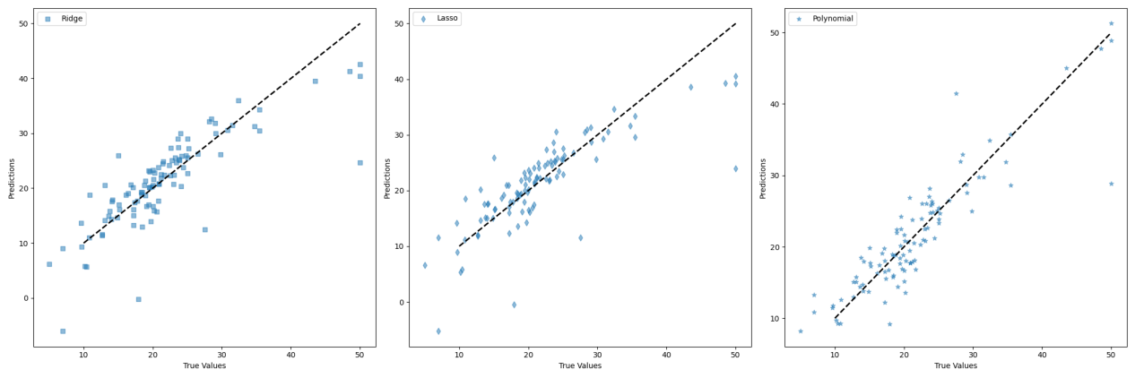
Process finished with exit code 0

题目：
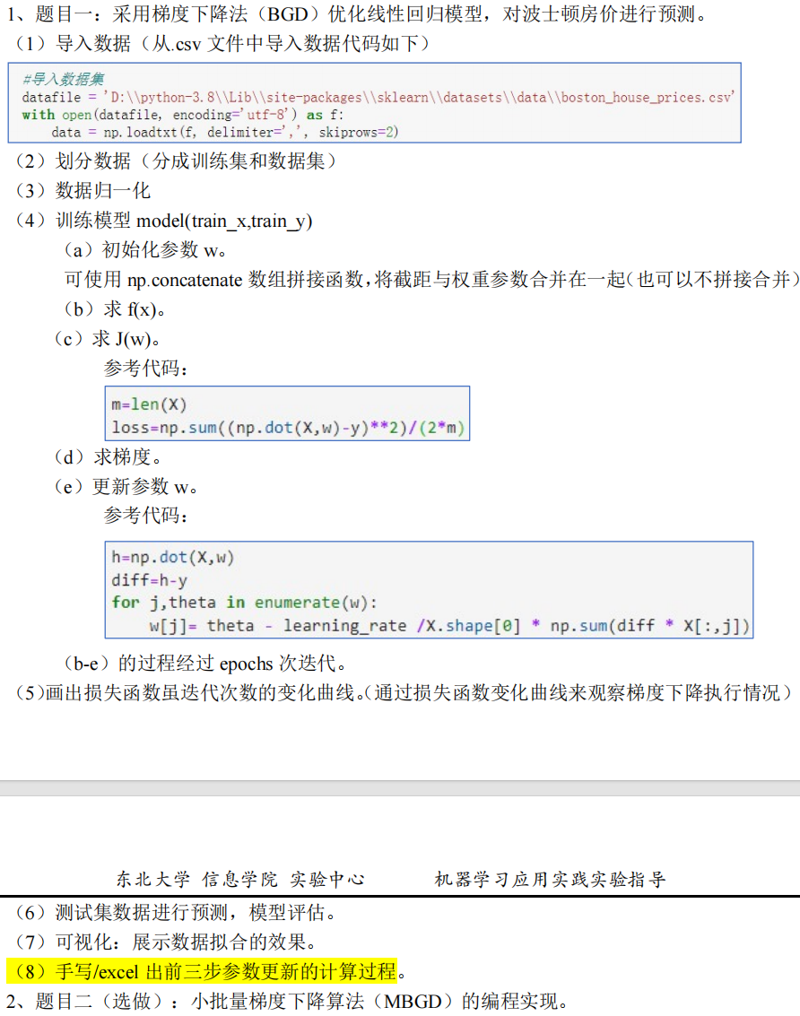

代码：
import numpy as np
import matplotlib.pyplot as plt

def load_data(test_rate=0.2):
# 从CSV文件加载数据
data = np.genfromtxt('boston_house_prices.csv', delimiter=',', skip_header=1)

# 划分特征和标签
X = data[:, :-1]
y = data[:, -1].reshape(-1, 1)

# 数据集拆分
num_samples = X.shape[0]
indices = np.random.permutation(num_samples)
split_idx = int(num_samples * (1 - test_rate))

return (X[indices[:split_idx]], y[indices[:split_idx]]), (X[indices[split_idx:]], y[indices[split_idx:]])

def r2_score(y_true, y_pred):
ss_res = np.sum((y_true - y_pred) ** 2)
ss_tot = np.sum((y_true - np.mean(y_true)) ** 2)
return 1 - (ss_res / ss_tot)

def data_processing(X_train, X_test):
# Z-score标准化
mean, std = np.mean(X_train, axis=0), np.std(X_train, axis=0)
std[std == 0] = 1e-8
return (X_train - mean) / std, (X_test - mean) / std

class LinearRegression_numpy(object):
def __init__(self, num_features):
np.random.seed(42)
self.w = np.random.randn(num_features + 1, 1) * 0.01 # 包含截距项

def _add_bias(self, X):
return np.hstack((X, np.ones((X.shape[0], 1))))

def forward(self, X):
return self._add_bias(X).dot(self.w)

def loss(self, y_pred, y_true):
return np.mean((y_pred - y_true) ** 2)

def gradient(self, X, y_true, y_pred):
return self._add_bias(X).T.dot(y_pred - y_true) / X.shape[0]
# X.shape[0]代表的是批量大小，LOSS FUNCTION = (1 / 2n) * (^y - y) ^ 2, LOSS FUNCTION' = (1 / n) * (^y - y)

def update(self, grad, eta):
self.w -= eta * grad

# 批量梯度下降
def train_BGD(self, X, y, epochs, eta):
losses = []
for epoch in range(epochs):
y_pred = self.forward(X)
grad = self.gradient(X, y, y_pred)
self.update(grad, eta)
losses.append(self.loss(y_pred, y))
if epoch % 200 == 0:
print(f"BGD Epoch {epoch}, Loss: {losses[-1]:.4f}")
return losses

# 随机梯度下降
def train_SGD(self, X, y, epochs, eta):
losses = []
for epoch in range(epochs):
# 打乱数据
indices = np.random.permutation(X.shape[0])
X_shuffled, y_shuffled = X[indices], y[indices]

# 遍历每个样本
for i in range(X.shape[0]):
xi, yi = X_shuffled[i:i + 1], y_shuffled[i:i + 1]
y_pred = self.forward(xi)
grad = self._add_bias(xi).T.dot(y_pred - yi) # 单个样本梯度
self.update(grad, eta)

# 记录整体损失
losses.append(self.loss(self.forward(X), y))
if epoch % 200 == 0:
print(f"SGD Epoch {epoch}, Loss: {losses[-1]:.4f}")
return losses

# 小批量梯度下降
def train_MBGD(self, X, y, epochs, eta, batch_size=32):
losses = []
for epoch in range(epochs):
# 打乱数据并分批次
indices = np.random.permutation(X.shape[0])
for i in range(0, X.shape[0], batch_size):
batch_indices = indices[i:i + batch_size]
X_batch, y_batch = X[batch_indices], y[batch_indices]

# 计算批次梯度
y_pred = self.forward(X_batch)
grad = self.gradient(X_batch, y_batch, y_pred)
self.update(grad, eta)

# 记录整体损失
losses.append(self.loss(self.forward(X), y))
if epoch % 200 == 0:
print(f"MBGD Epoch {epoch}, Loss: {losses[-1]:.4f}")
return losses

# 主程序
if __name__ == "__main__":
# 数据准备
(X_train, y_train), (X_test, y_test) = load_data()
X_train_scaled, X_test_scaled = data_processing(X_train, X_test)

# 初始化三个相同参数的模型
def init_model():
model = LinearRegression_numpy(X_train_scaled.shape[1])
model.w = np.loadtxt('initial_weights.txt') if \
'initial_weights.txt' in locals() else model.w
np.savetxt('initial_weights.txt', model.w)
return model

# 训练不同算法
bgd_model = init_model()
sgd_model = init_model()
mbgd_model = init_model()

print("=" * 40 + "\nBGD Training:")
bgd_loss = bgd_model.train_BGD(X_train_scaled, y_train, 1000, 0.1)

print("\n" + "=" * 40 + "\nSGD Training:")
sgd_loss = sgd_model.train_SGD(X_train_scaled, y_train, 1000, 0.01)

print("\n" + "=" * 40 + "\nMBGD Training:")
mbgd_loss = mbgd_model.train_MBGD(X_train_scaled, y_train, 1000, 0.05, 32)

# 结果可视化
plt.figure(figsize=(12, 6))
plt.plot(bgd_loss, label='BGD (η=0.1)', alpha=0.7)
plt.plot(sgd_loss, label='SGD (η=0.01)', alpha=0.7)
plt.plot(mbgd_loss, label='MBGD (η=0.05, batch=32)', alpha=0.7)
plt.title("Training Loss Comparison")
plt.xlabel("Epochs"), plt.ylabel("MSE")
plt.legend(), plt.grid(True)
plt.show()

# 测试集评估
def evaluate(model, X, y):
y_pred = model.forward(X)
mse = np.mean((y_pred - y) ** 2)
r2 = r2_score(y.flatten(), y_pred.flatten())
return mse, r2, y_pred

# 获取预测结果
bgd_mse, bgd_r2, bgd_pred = evaluate(bgd_model, X_test_scaled, y_test)
sgd_mse, sgd_r2, sgd_pred = evaluate(sgd_model, X_test_scaled, y_test)
mbgd_mse, mbgd_r2, mbgd_pred = evaluate(mbgd_model, X_test_scaled, y_test)

print("\nTest Performance:")
print(f"BGD - MSE: {bgd_mse:.4f}, R²: {bgd_r2:.4f}")
print(f"SGD - MSE: {sgd_mse:.4f}, R²: {sgd_r2:.4f}")
print(f"MBGD - MSE: {mbgd_mse:.4f}, R²: {mbgd_r2:.4f}")

# 可视化增强
plt.figure(figsize=(18, 6))

# 子图1: 预测值-真实值折线图
plt.subplot(1, 3, 1)
plt.plot(y_test[:50], 'b-', label='True Values', alpha=0.7)
plt.plot(bgd_pred[:50], 'r--', label='BGD Predictions', alpha=0.7)
plt.plot(sgd_pred[:50], 'g-.', label='SGD Predictions', alpha=0.7)
plt.plot(mbgd_pred[:50], 'm:', label='MBGD Predictions', alpha=0.7)
plt.title("True vs Predicted Values (First 50 Samples)")
plt.xlabel("Sample Index")
plt.ylabel("Price")
plt.legend()
plt.grid(True)

# 子图2: 预测值-真实值散点图
plt.subplot(1, 3, 2)
plt.scatter(y_test, bgd_pred, c='r', alpha=0.3, label='BGD')
plt.scatter(y_test, sgd_pred, c='g', alpha=0.3, label='SGD')
plt.scatter(y_test, mbgd_pred, c='m', alpha=0.3, label='MBGD')
plt.plot([y_test.min(), y_test.max()],
[y_test.min(), y_test.max()], 'k--', lw=2)
plt.title("True vs Predicted Prices")
plt.xlabel("True Prices")
plt.ylabel("Predicted Prices")
plt.legend()
plt.grid(True)

# 子图3: 性能指标对比
plt.subplot(1, 3, 3)
metrics = ['MSE', 'R²']
x = np.arange(len(metrics))
width = 0.2

plt.bar(x - width, [bgd_mse, bgd_r2], width, label='BGD', color='r')
plt.bar(x, [sgd_mse, sgd_r2], width, label='SGD', color='g')
plt.bar(x + width, [mbgd_mse, mbgd_r2], width, label='MBGD', color='m')

plt.title("Model Performance Comparison")
plt.xticks(x, metrics)
plt.ylabel("Score")
plt.legend()
plt.grid(True, axis='y')

plt.tight_layout()
plt.savefig('BGD_SGD_MBGD.png')
plt.show()

运行结果：
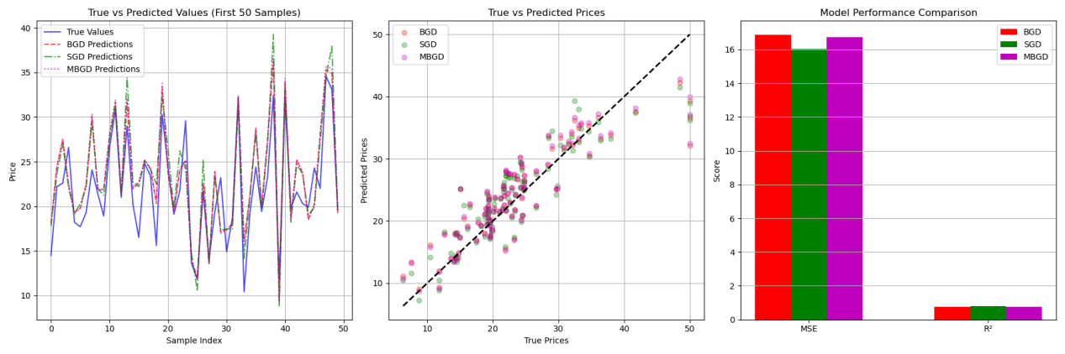
========================================
BGD Training:
BGD Epoch 0, Loss: 587.3251
BGD Epoch 200, Loss: 23.3810
BGD Epoch 400, Loss: 23.3299
BGD Epoch 600, Loss: 23.3251
BGD Epoch 800, Loss: 23.3246

========================================
SGD Training:
SGD Epoch 0, Loss: 25.5354
SGD Epoch 200, Loss: 26.9855
SGD Epoch 400, Loss: 24.9929
SGD Epoch 600, Loss: 25.1829
SGD Epoch 800, Loss: 23.7253

========================================
MBGD Training:
MBGD Epoch 0, Loss: 160.6749
MBGD Epoch 200, Loss: 23.5453
MBGD Epoch 400, Loss: 23.3784
MBGD Epoch 600, Loss: 23.5441
MBGD Epoch 800, Loss: 23.4901

========================================
Test Performance:
BGD - MSE: 16.8523, R²: 0.7687
SGD - MSE: 16.0348, R²: 0.7799
MBGD - MSE: 16.7107, R²: 0.7707

前三次更新参数：
通过MATLAB实现，代码如下：
%% 数据准备
data = readmatrix('%USERPROFILE%\PycharmProjects\MachineLearning\boston_house_prices.csv');
% 分离特征和标签
X = data(:, 1:end-1); % 特征矩阵 (506×13)
y = data(:, end); % 标签向量 (506×1)
% 数据标准化
X = (X - mean(X)) ./ std(X);
X = [X ones(size(X,1),1)]; % 添加偏置项 (506×14)
%% 参数初始化
rng(42); % 固定随机种子
w = 0.01 * randn(size(X,2),1); % 初始化权重向量 (14×1)
eta = 0.01; % 学习率
n_samples = size(X,1);
%% BGD训练过程
fprintf('===== BGD训练过程 =====\n');
for iter = 1:3
% 前向计算
y_pred = X * w;
% 梯度计算
error = y_pred - y;
grad = (X' * error) / n_samples;
% 参数更新
w_prev = w;
w = w - eta * grad;
% 计算损失
loss = mean((y_pred - y).^2);
% 显示更新细节
fprintf('\n迭代 %d:\n', iter);
% 打印梯度向量
fprintf('梯度向量:\n[');
fprintf('%8.4f', grad);
disp(']');
fprintf('\n');
% 打印权重变化向量
delta_w = w - w_prev;
fprintf('权重变化向量:\n[');
fprintf('%8.4f', delta_w);
disp(']');
fprintf('\n');
% 打印当前权重向量
fprintf('当前权重向量:\n[');
fprintf('%8.4f', w);
disp(']');
fprintf('\n当前损失值: %.4f\n\n', loss);
end
%% 输出最终参数
fprintf('\n=== 前三步训练结果 ===\n');
fprintf('最终权重向量:\n[');
fprintf('%8.4f', w);
disp(']');

最后得到前三次的参数更新过程：

===== BGD训练过程 =====

迭代 1:
梯度向量:
[ 3.5548 -3.2920 4.4314 -1.6078 3.9072 -6.3888 3.4429 -2.2753 3.4938 4.2933 4.6557 -3.0425 6.7698-22.5340]

权重变化向量:
[ -0.0355 0.0329 -0.0443 0.0161 -0.0391 0.0639 -0.0344 0.0228 -0.0349 -0.0429 -0.0466 0.0304 -0.0677 0.2253]

当前权重向量:
[ -0.0409 0.0416 -0.0346 0.0195 -0.0490 0.0587 -0.0474 0.0319 -0.0332 -0.0354 -0.0525 0.0489 -0.0495 0.2241]

当前损失值: 592.1959

迭代 2:
梯度向量:
[ 3.3399 -3.0786 4.1422 -1.5844 3.6319 -6.1818 3.1906 -2.0254 3.2288 4.0095 4.4563 -2.8697 6.4819-22.3087]

权重变化向量:
[ -0.0334 0.0308 -0.0414 0.0158 -0.0363 0.0618 -0.0319 0.0203 -0.0323 -0.0401 -0.0446 0.0287 -0.0648 0.2231]

当前权重向量:
[ -0.0743 0.0724 -0.0760 0.0353 -0.0854 0.1205 -0.0793 0.0522 -0.0655 -0.0755 -0.0970 0.0776 -0.1143 0.4472]

当前损失值: 577.6884

迭代 3:
梯度向量:
[ 3.1382 -2.8785 3.8709 -1.5611 3.3742 -5.9852 2.9544 -1.7919 2.9804 3.7432 4.2678 -2.7075 6.2104-22.0856]

权重变化向量:
[ -0.0314 0.0288 -0.0387 0.0156 -0.0337 0.0599 -0.0295 0.0179 -0.0298 -0.0374 -0.0427 0.0271 -0.0621 0.2209]

当前权重向量:
[ -0.1057 0.1012 -0.1147 0.0509 -0.1191 0.1803 -0.1089 0.0701 -0.0953 -0.1129 -0.1397 0.1046 -0.1765 0.6680]

当前损失值: 563.8403

=== 前三步训练结果 ===
最终权重向量:
[ -0.1057 0.1012 -0.1147 0.0509 -0.1191 0.1803 -0.1089 0.0701 -0.0953 -0.1129 -0.1397 0.1046 -0.1765 0.6680]

