题目一：
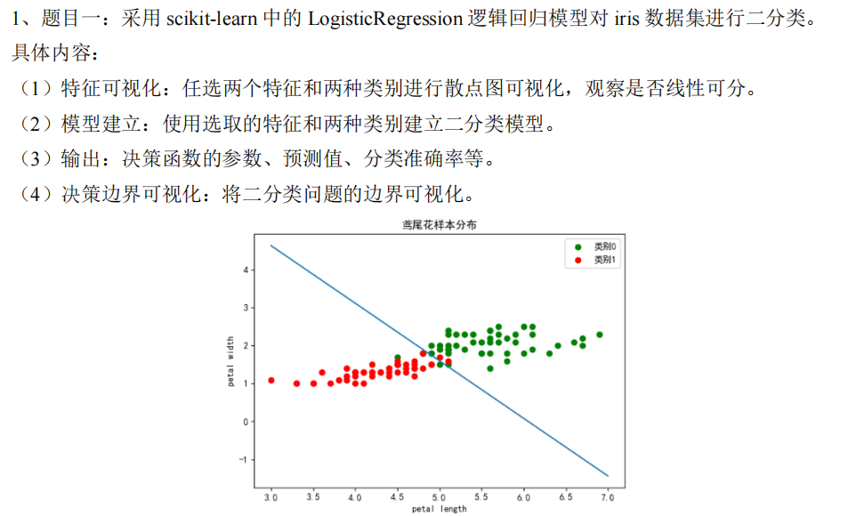

代码：
import numpy as np
import matplotlib.pyplot as plt
from sklearn import datasets
from sklearn.linear_model import LogisticRegression
from sklearn.metrics import accuracy_score

# 加载数据集
iris = datasets.load_iris()
X = iris.data[:, :2] # 选取前两个特征（萼片长度和宽度）
y = iris.target

# 筛选两种类别（Setosa和Versicolor）
X = X[y < 2]
y = y[y < 2]

# (1) 特征可视化
plt.figure(figsize=(8, 6))
plt.scatter(X[y == 0][:, 0], X[y == 0][:, 1], color='blue', label='Setosa')
plt.scatter(X[y == 1][:, 0], X[y == 1][:, 1], color='red', label='Versicolor')
plt.xlabel('Sepal length')
plt.ylabel('Sepal width')
plt.title('Feature Visualization')
plt.legend()
plt.show()

# (2) 建立模型
model = LogisticRegression(solver='liblinear')
model.fit(X, y)

# (3) 输出结果
print("决策函数参数：")
print("权重系数:", model.coef_[0])
print("截距项:", model.intercept_[0])
y_pred = model.predict(X)
print("\n预测值:", y_pred)
print("分类准确率: {:.2f}%".format(accuracy_score(y, y_pred)*100))

# (4) 决策边界可视化
x_min, x_max = X[:, 0].min() - 0.5, X[:, 0].max() + 0.5
y_min, y_max = X[:, 1].min() - 0.5, X[:, 1].max() + 0.5 # 确定网格（画布）多大

xx, yy = np.meshgrid(np.arange(x_min, x_max, 0.01),
np.arange(y_min, y_max, 0.01)) # 在x/y范围内以0.01为步长生成等间距点

Z = model.predict(np.c_[xx.ravel(), yy.ravel()]) # 每个坐标点都预测一次，来画出决策边界
Z = Z.reshape(xx.shape)

plt.figure(figsize=(8, 6))
plt.contourf(xx, yy, Z, alpha=0.4, cmap='coolwarm')
# contourf：填充等高线函数，根据 Z 的值（类别）在网格上绘制不同颜色的区域，表示决策边界。
plt.scatter(X[:, 0], X[:, 1], c=y, edgecolors='k', cmap='coolwarm')
plt.xlabel('Sepal length')
plt.ylabel('Sepal width')
plt.title('Decision Boundary')
plt.savefig('题目1.png')
plt.show()

结果：
决策函数参数：
权重系数: [ 2.21226733 -3.68263774]
截距项: -0.5858401100371663

预测值: [0 0 0 0 0 0 0 0 0 0 0 0 0 0 0 0 0 0 0 0 0 0 0 0 0 0 0 0 0 0 0 0 0 0 0 0 0 0 0 0 0 1（出错） 0 0 0 0 0 0 0 0
1 1 1 1 1 1 1 1 1 1 1 1 1 1 1 1 1 1 1 1 1 1 1 1 1 1 1 1 1 1 1 1 1 1 1 1 1 1 1 1 1 1 1 1 1 1 1 1 1 1]
分类准确率: 99.00%
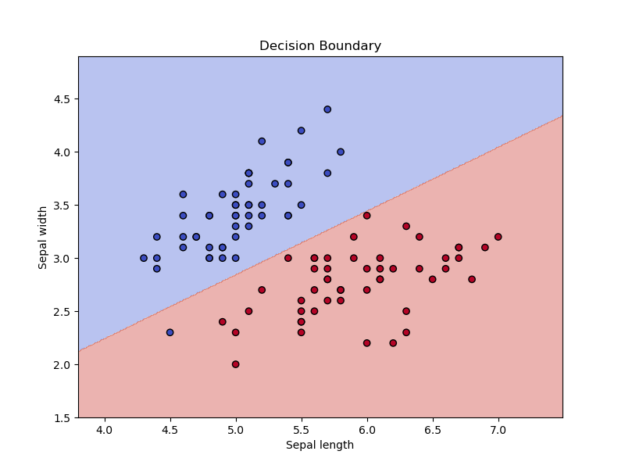

题目二：
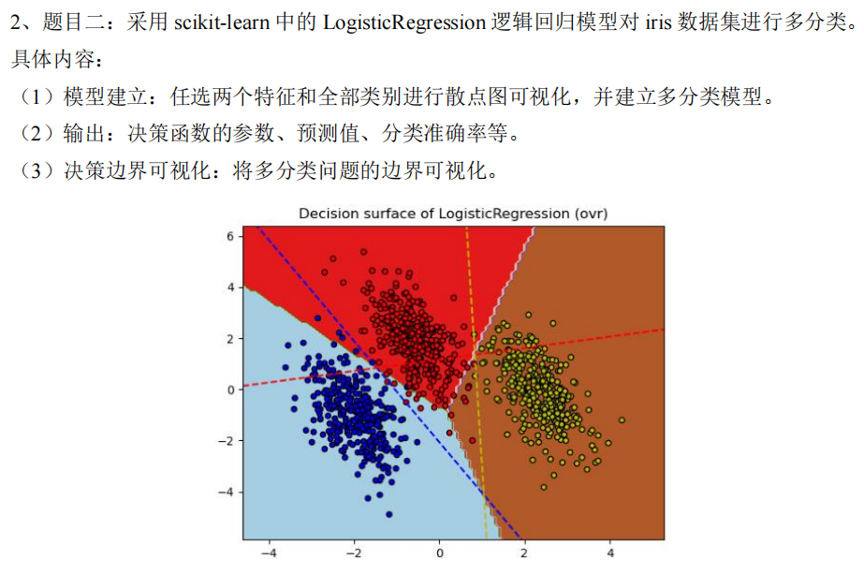
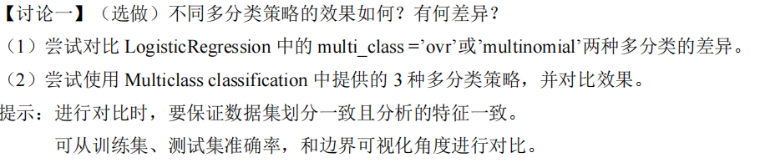

代码：
import numpy as np
import matplotlib.pyplot as plt
from sklearn import datasets
from sklearn.linear_model import LogisticRegression
from sklearn.model_selection import train_test_split
from sklearn.metrics import accuracy_score
from sklearn.multiclass import OneVsRestClassifier, OneVsOneClassifier

# 加载数据集并选择两个特征
iris = datasets.load_iris()
X = iris.data[:, [0, 1]] # 选取花萼长度和花萼宽度两个特征
y = iris.target

# 划分训练集和测试集
X_train, X_test, y_train, y_test = train_test_split(X, y, test_size=0.2, random_state=42)

# 定义三种多分类策略模型
models = {
'OvR (One-vs-Rest)': LogisticRegression(multi_class='ovr', solver='liblinear'),
'Multinomial (Softmax)': LogisticRegression(multi_class='multinomial', solver='lbfgs', max_iter=1000),
'OvO (One-vs-One)': OneVsOneClassifier(LogisticRegression(solver='liblinear'))
}

# 训练模型并输出结果
for name, model in models.items():
model.fit(X_train, y_train)
y_pred = model.predict(X_test)
print(f"{name}:")
print(f"测试集准确率: {accuracy_score(y_test, y_pred):.5f}\n")

# 原始数据可视化
plt.figure(figsize=(6, 4))
for i, color in zip([0, 1, 2], ['r', 'g', 'b']):
plt.scatter(X[y == i, 0], X[y == i, 1], c=color, label=iris.target_names[i], edgecolors='k')
plt.xlabel(iris.feature_names[0])
plt.ylabel(iris.feature_names[2])
plt.title("Original Data Distribution")
plt.legend()
plt.savefig("题目2_1.png")
plt.show()

# 决策边界可视化
x_min, x_max = X[:, 0].min() - 1, X[:, 0].max() + 1
y_min, y_max = X[:, 1].min() - 1, X[:, 1].max() + 1
xx, yy = np.meshgrid(np.arange(x_min, x_max, 0.02), np.arange(y_min, y_max, 0.02))

plt.figure(figsize=(21, 6))
for i, (name, model) in enumerate(models.items(), 1): # 遍历模型并绘制子图
plt.subplot(1, 3, i)
Z = model.predict(np.c_[xx.ravel(), yy.ravel()]).reshape(xx.shape)
plt.contourf(xx, yy, Z, alpha=0.8, cmap=plt.cm.RdYlBu)
plt.scatter(X_train[:, 0], X_train[:, 1], c=y_train, edgecolors='k', cmap=plt.cm.RdYlBu)
plt.xlabel(iris.feature_names[0])
plt.ylabel(iris.feature_names[2])
plt.title(f"{name}\nTrain Acc: {accuracy_score(y_train, model.predict(X_train)):.4f}")
plt.tight_layout()
plt.savefig("题目2_2.png")
plt.show()

结果：
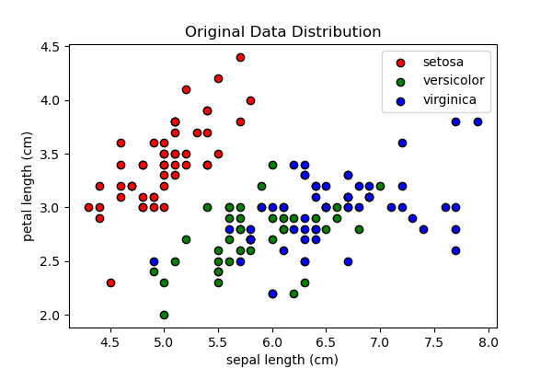
这两个特征线性不可分
OvR (One-vs-Rest):
测试集准确率: 0.83333

Multinomial (Softmax):
测试集准确率: 0.90000
本实验里效果最好

OvO (One-vs-One):
测试集准确率: 0.86667

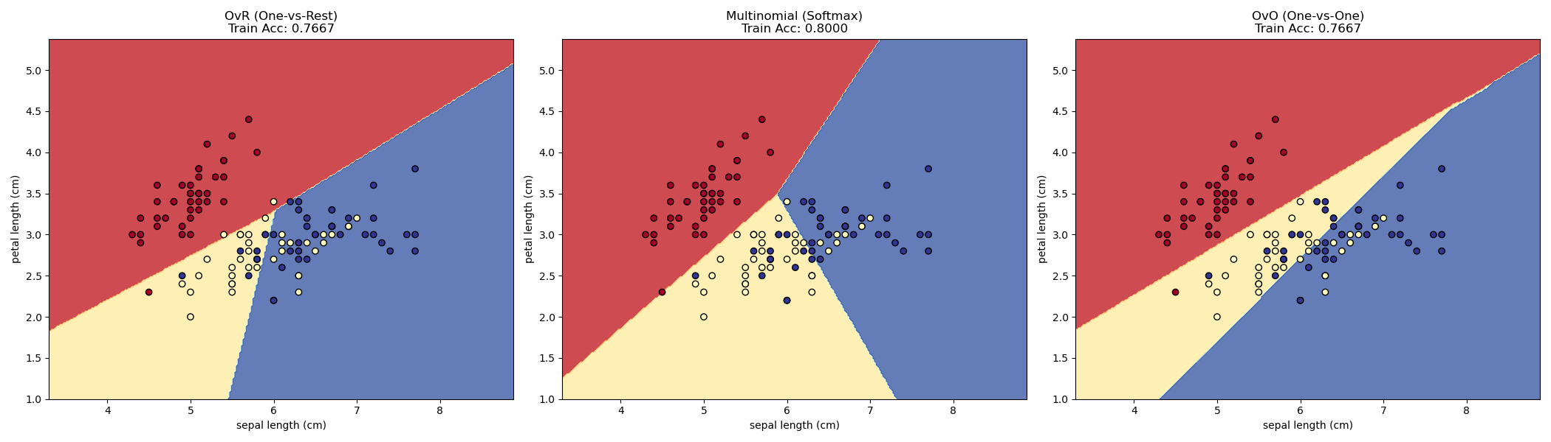
题目三：
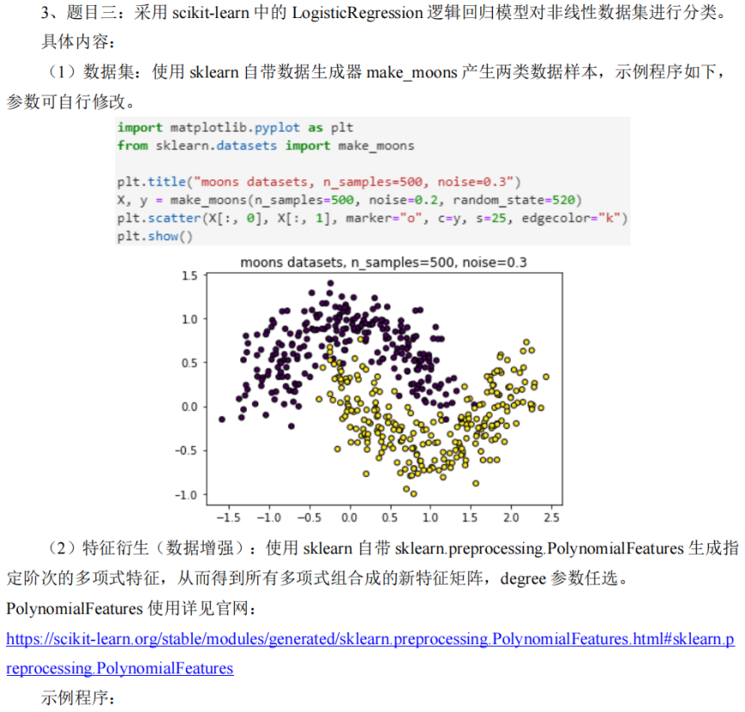
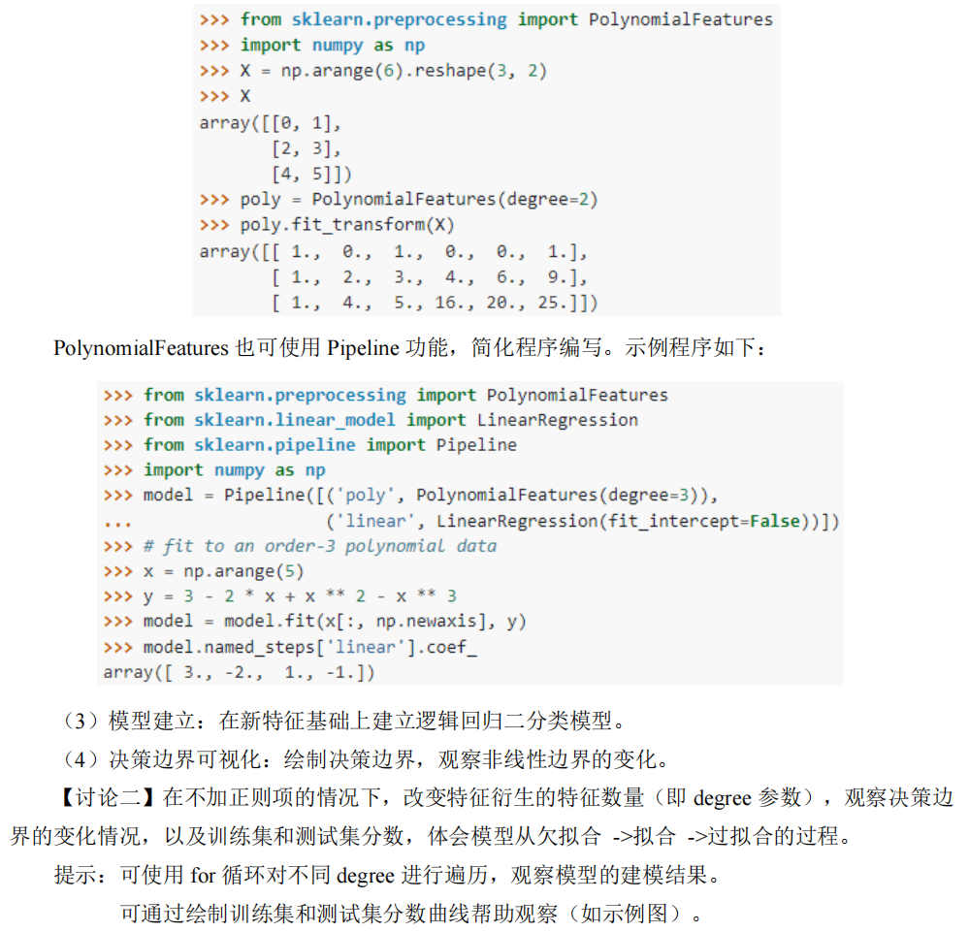
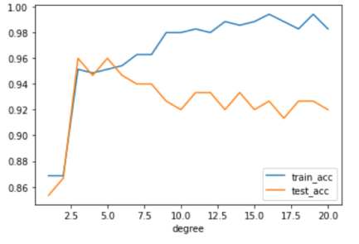
代码：
import numpy as np
import matplotlib.pyplot as plt
from matplotlib.colors import ListedColormap
from sklearn.datasets import make_moons
from sklearn.model_selection import train_test_split
from sklearn.preprocessing import PolynomialFeatures
from sklearn.linear_model import LogisticRegression
from sklearn.metrics import accuracy_score
from sklearn.preprocessing import StandardScaler

# 创建高对比度颜色映射
high_contrast = ListedColormap(['#FF4444', '#4444FF']) # 饱和红 vs 饱和蓝

# 生成数据
X, y = make_moons(n_samples=500, noise=0.21, random_state=520)
X_train, X_test, y_train, y_test = train_test_split(X, y, test_size=0.3, random_state=520)

# 创建3x3子图画布
plt.figure(figsize=(20, 15))
degrees = [1, 2, 3, 4, 5, 8, 10, 15, 20]

for i, degree in enumerate(degrees, 1):
ax = plt.subplot(3, 3, i)

# 特征工程
poly = PolynomialFeatures(degree=degree)
X_train_poly = poly.fit_transform(X_train)
X_test_poly = poly.transform(X_test)

# 模型训练
model = LogisticRegression(penalty=None, solver='lbfgs', max_iter=5000)
model.fit(X_train_poly, y_train)

# 计算精度
train_acc = accuracy_score(y_train, model.predict(X_train_poly))
test_acc = accuracy_score(y_test, model.predict(X_test_poly))

# 生成网格
x_min, x_max = X[:, 0].min() - 0.5, X[:, 0].max() + 0.5
y_min, y_max = X[:, 1].min() - 0.5, X[:, 1].max() + 0.5
xx, yy = np.meshgrid(np.linspace(x_min, x_max, 1000),
np.linspace(y_min, y_max, 1000))

# 预测决策边界
Z = model.predict(poly.transform(np.c_[xx.ravel(), yy.ravel()]))
Z = Z.reshape(xx.shape)

# 可视化设置
ax.contourf(xx, yy, Z, alpha=0.3, cmap=high_contrast)
# 训练集使用实心圆，测试集使用黑色边框的三角形
ax.scatter(X_train[:, 0], X_train[:, 1], c=y_train,
cmap=high_contrast, edgecolor='black', linewidth=0.6,
s=40, label='Train', zorder=2)
ax.scatter(X_test[:, 0], X_test[:, 1], c=y_test,
cmap=high_contrast, edgecolor='yellow', linewidth=1,
s=60, marker='^', label='Test', zorder=3)

ax.set_title(f'Degree {degree}\nTrain: {train_acc:.3f} Test: {test_acc:.3f}')
ax.legend(loc='upper right')

plt.tight_layout()
plt.savefig("题目3_1.png")
plt.show()

# 创建精度变化曲线
plt.figure(figsize=(12, 6))
train_scores = []
test_scores = []

for degree in degrees:
poly = PolynomialFeatures(degree=degree)
scaler = StandardScaler()
X_train_poly = scaler.fit_transform(poly.fit_transform(X_train))
X_test_poly = scaler.fit_transform(poly.transform(X_test))

model = LogisticRegression(penalty=None, solver='lbfgs', max_iter=5000)
model.fit(X_train_poly, y_train)

train_scores.append(accuracy_score(y_train, model.predict(X_train_poly)))
test_scores.append(accuracy_score(y_test, model.predict(X_test_poly)))

plt.plot(degrees, train_scores, 's-', color='#FF4444', label='Train Accuracy') # 使用饱和红色
plt.plot(degrees, test_scores, 'o-', color='#4444FF', label='Test Accuracy') # 使用饱和蓝色
plt.xticks(degrees, rotation=45)
plt.xlabel('Polynomial Degree')
plt.ylabel('Accuracy')
plt.title('Model Performance vs Polynomial Degree')
plt.legend()
plt.grid(True, alpha=0.3)
plt.tight_layout()
plt.savefig("题目3_2.png")
plt.show()

结果：
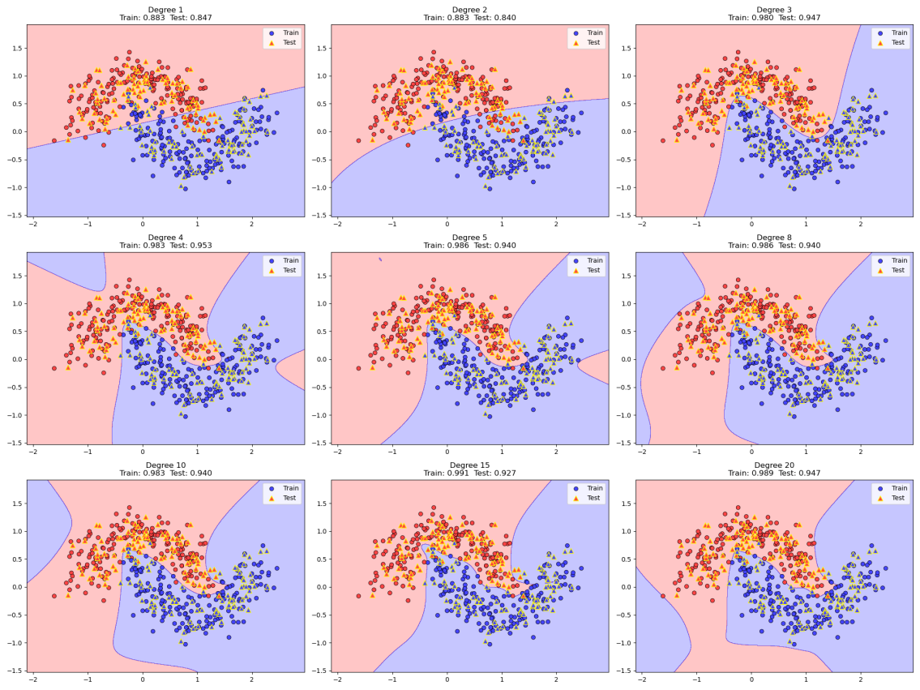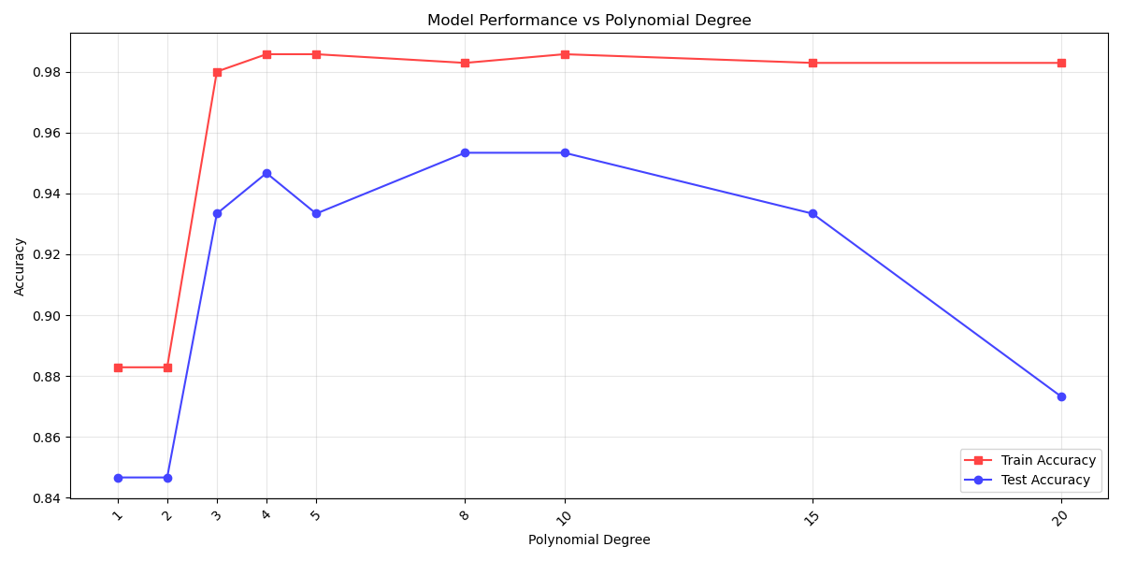
从左到右非常明显的从欠拟合到过拟合
讨论3/4：
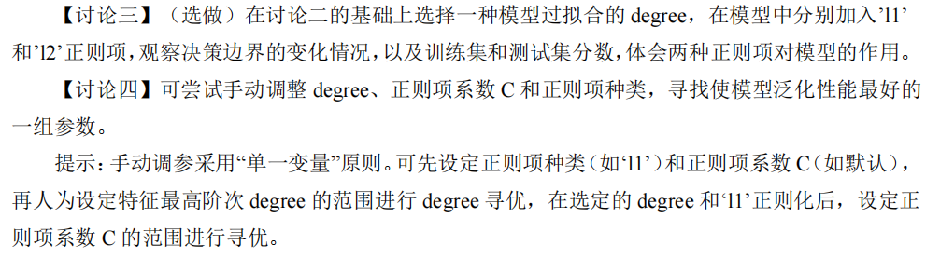

代码：
import numpy as np
import matplotlib.pyplot as plt
from matplotlib.colors import ListedColormap
from sklearn.datasets import make_moons
from sklearn.model_selection import train_test_split
from sklearn.preprocessing import PolynomialFeatures
from sklearn.linear_model import LogisticRegression
from sklearn.metrics import accuracy_score, confusion_matrix
from sklearn.preprocessing import StandardScaler

# 创建高对比度颜色映射
high_contrast = ListedColormap(['#FF4444', '#4444FF'])

# 生成数据
X, y = make_moons(n_samples=500, noise=0.2, random_state=520)
X_train, X_test, y_train, y_test = train_test_split(X, y, test_size=0.3, random_state=520)

# %% 讨论三：正则化对比（添加混淆矩阵）
plt.figure(figsize=(18, 10))
degrees = [20]
penalties = [None, 'l1', 'l2']

for i, penalty in enumerate(penalties, 1):
# 决策边界子图
ax1 = plt.subplot(2, 3, i)
degree = degrees[0]

poly = PolynomialFeatures(degree=degree)
scaler = StandardScaler()
X_train_poly = poly.fit_transform(X_train)
X_test_poly = poly.transform(X_test)

solver = 'lbfgs' if penalty in [None, 'l2'] else 'liblinear'
model = LogisticRegression(penalty=penalty, C=0.1, solver=solver,
max_iter=50000, random_state=520)
model.fit(X_train_poly, y_train)

y_pred_test = model.predict(X_test_poly)
y_pred_train = model.predict(X_train_poly)
train_acc = accuracy_score(y_train, y_pred_train)
test_acc = accuracy_score(y_test, y_pred_test)

x_min, x_max = X[:, 0].min() - 0.5, X[:, 0].max() + 0.5
y_min, y_max = X[:, 1].min() - 0.5, X[:, 1].max() + 0.5
xx, yy = np.meshgrid(np.linspace(x_min, x_max, 100),
np.linspace(y_min, y_max, 100))

Z = model.predict(poly.transform(np.c_[xx.ravel(), yy.ravel()]))
Z = Z.reshape(xx.shape)

ax1.contourf(xx, yy, Z, alpha=0.3, cmap=high_contrast)
ax1.scatter(X_train[:, 0], X_train[:, 1], c=y_train, cmap=high_contrast,
edgecolor='black', s=30, label='Train')
ax1.scatter(X_test[:, 0], X_test[:, 1], c=y_test, cmap=high_contrast,
edgecolor='yellow', marker='^', s=50, label='Test')
title = f'Degree {degree} | '
title += 'No Reg' if penalty is None else f'{penalty.upper()} Reg'
ax1.set_title(f"{title}\nTrain: {train_acc:.3f} Test: {test_acc:.3f}")
ax1.legend()

# 混淆矩阵子图
ax2 = plt.subplot(2, 3, i + 3)
cm = confusion_matrix(y_test, y_pred_test)
ax2.matshow(cm, cmap='Blues', alpha=0.7)
for (x, y), value in np.ndenumerate(cm):
ax2.text(x, y, f"{value}", ha="center", va="center", fontsize=12)
ax2.set_xlabel('Predicted', fontsize=10)
ax2.set_ylabel('Actual', fontsize=10)
ax2.set_xticks([0, 1])
ax2.set_yticks([0, 1])
ax2.set_xticklabels(['0', '1'])
ax2.set_yticklabels(['0', '1'])
ax2.set_title(f'Test Confusion Matrix (Acc={test_acc:.3f})', pad=15)

plt.tight_layout()
plt.savefig("讨论3.png")
plt.show()

# %% 讨论四：参数优化（保持原样）
# 第一阶段：固定正则项为l2，优化degree
plt.figure(figsize=(12, 6))
degrees_range = range(1, 21)
best_score = 0
best_degree = 1

for penalty in ['l2']:
train_scores = []
test_scores = []

for degree in degrees_range:
poly = PolynomialFeatures(degree=degree)
X_train_poly = poly.fit_transform(X_train)
X_test_poly = poly.transform(X_test)

model = LogisticRegression(penalty=penalty, C=1.0, solver='lbfgs',
max_iter=5000, random_state=520)
model.fit(X_train_poly, y_train)

train_acc = accuracy_score(y_train, model.predict(X_train_poly))
test_acc = accuracy_score(y_test, model.predict(X_test_poly))
train_scores.append(train_acc)
test_scores.append(test_acc)

if test_acc > best_score:
best_score = test_acc
best_degree = degree

plt.plot(degrees_range, test_scores, 'o-',
label=f'{penalty.upper()} Regularization')

plt.xticks(degrees_range)
plt.xlabel('Polynomial Degree')
plt.ylabel('Test Accuracy')
plt.title('Degree Optimization (C=1.0)')
plt.legend()
plt.grid(True, alpha=0.3)
plt.tight_layout()
plt.savefig("讨论4_degree.png")
plt.show()

# 第二阶段：优化正则化强度C
plt.figure(figsize=(12, 6))
C_values = np.logspace(-3, 2, 21)
best_C = None
best_score = -np.inf

for penalty in ['l2']:
train_scores = []
test_scores = []

for C in C_values:
poly = PolynomialFeatures(degree=best_degree)
X_train_poly = poly.fit_transform(X_train)
X_test_poly = poly.transform(X_test)

model = LogisticRegression(penalty=penalty, C=C, solver='lbfgs',
max_iter=5000, random_state=520)
model.fit(X_train_poly, y_train)

train_acc = accuracy_score(y_train, model.predict(X_train_poly))
test_acc = accuracy_score(y_test, model.predict(X_test_poly))
train_scores.append(train_acc)
test_scores.append(test_acc)

if test_acc > best_score:
best_score = test_acc
best_C = C

plt.semilogx(C_values, test_scores, 'o-',
label=f'Degree {best_degree} ({penalty.upper()})')

plt.xticks(C_values, [f"{x:.2f}" if x < 1 else f"{int(x)}" for x in C_values])
plt.xlabel('Regularization Strength (C)')
plt.ylabel('Test Accuracy')
plt.title('Regularization Optimization')
plt.legend()
plt.grid(True, alpha=0.3)
plt.tight_layout()
plt.savefig("讨论4_C.png")
plt.show()

print(f"Best Parameters: degree={best_degree}, C={best_C:.2f}, penalty=l2")
结果：
讨论三：
None和l2使用的求解器是lbfgs，l1使用的求解器时liblinear（lbfgs不支持l1正则化），所以有一定偏差
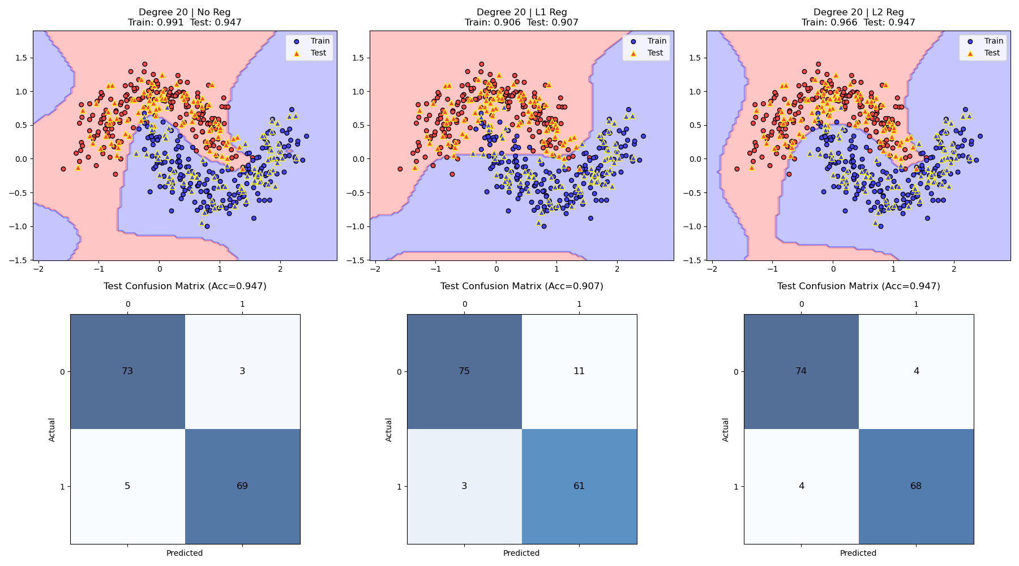

讨论四：
Best Parameters: degree=6, C=0.56, penalty=l2
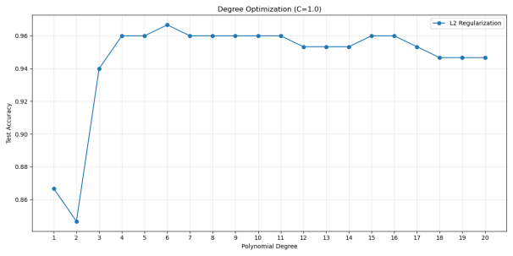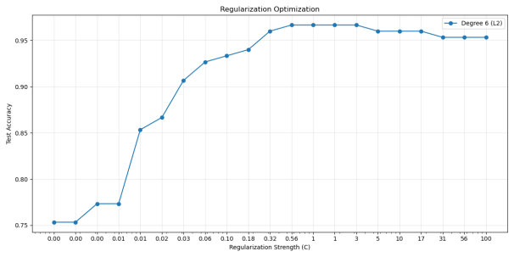

题目四：


代码：
import numpy as np
from sklearn.datasets import load_iris
import matplotlib.pyplot as plt

# 加载数据并筛选类别和特征
iris = load_iris()
X = iris.data[(iris.target == 0) | (iris.target == 1)][:, [0, 2]] # 选Setosa和Versicolor，特征0和2
y = iris.target[(iris.target == 0) | (iris.target == 1)]
y = y.reshape(-1, 1)

# 添加偏置项并标准化特征
X = np.hstack((X, np.ones((X.shape[0], 1))))
X[:, :2] = (X[:, :2] - np.mean(X[:, :2], axis=0)) / np.std(X[:, :2], axis=0)

# 初始化参数
w = np.zeros((3, 1))
learning_rate = 0.1
epochs = 1000

# 定义sigmoid函数
def sigmoid(z):
return 1 / (1 + np.exp(-z))

# 训练逻辑回归
for _ in range(epochs):
z = np.dot(X, w)
h = sigmoid(z)
gradient = np.dot(X.T, (h - y)) / len(y)
w -= learning_rate * gradient

# 预测和评估
prob = sigmoid(np.dot(X, w))
pred = (prob > 0.5).astype(int)
accuracy = np.mean(pred == y)

# 输出结果
print("决策函数参数:", w.flatten())
print("预测标签:", pred.flatten())
print("分类准确率:", accuracy)

# 可视化
plt.figure(figsize=(10, 6))
plt.scatter(X[y[:,0]==0, 0], X[y[:,0]==0, 1], c='b', label='Setosa')
plt.scatter(X[y[:,0]==1, 0], X[y[:,0]==1, 1], c='g', label='Versicolor')

# 绘制决策边界
x_min, x_max = X[:, 0].min()-1, X[:, 0].max()+1
y_min = (- (w[0] * x_min + w[2]) ) / w[1]
y_max = (- (w[0] * x_max + w[2]) ) / w[1]
plt.plot([x_min, x_max], [y_min, y_max], 'r--')

plt.xlabel('Sepal Length (standardized)')
plt.ylabel('Petal Length (standardized)')
plt.legend()
plt.title('Logistic Regression Decision Boundary')
plt.savefig("题目4.png")
plt.show()

结果：
决策函数参数: [0.97659023 4.34888168 0.68327845]
预测标签: [0 0 0 0 0 0 0 0 0 0 0 0 0 0 0 0 0 0 0 0 0 0 0 0 0 0 0 0 0 0 0 0 0 0 0 0 0 0 0 0 0 0 0 0 0 0 0 0 0 0
1 1 1 1 1 1 1 1 1 1 1 1 1 1 1 1 1 1 1 1 1 1 1 1 1 1 1 1 1 1 1 1 1 1 1 1 1 1 1 1 1 1 1 1 1 1 1 1 1 1]
分类准确率: 1.0

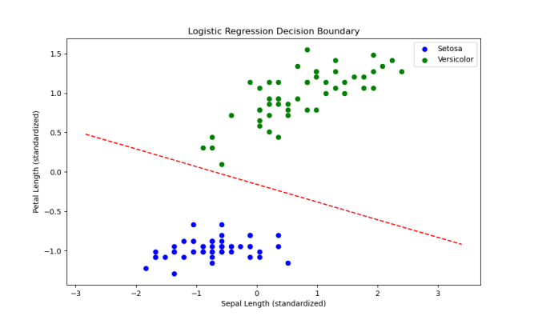
题目五：
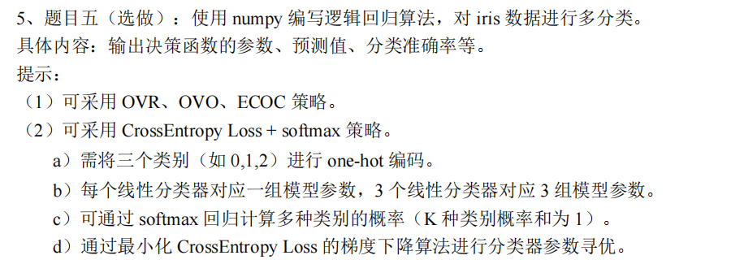

代码：
import numpy as np
import matplotlib.pyplot as plt
import seaborn as sns
from sklearn.datasets import load_iris
from sklearn.model_selection import train_test_split
from sklearn.preprocessing import StandardScaler
from sklearn.metrics import classification_report, confusion_matrix

# 加载数据
iris = load_iris()
X, y = iris.data, iris.target

# 划分训练集和测试集
X_train, X_test, y_train, y_test = train_test_split(X, y, test_size=0.2, random_state=42)

# 标准化数据
scaler = StandardScaler()
X_train = scaler.fit_transform(X_train)
X_test = scaler.transform(X_test)

# One-hot编码
def one_hot(y, k):
return np.eye(k)[y]

y_train_onehot = one_hot(y_train, 3)
y_test_onehot = one_hot(y_test, 3)

# 模型参数
n_features = X_train.shape[1]
n_classes = 3
W = np.zeros((n_features, n_classes))
b = np.zeros(n_classes)
learning_rate = 0.01
epochs = 1000

# Softmax函数
def softmax(z):
exp = np.exp(z - np.max(z, axis=1, keepdims=True))
return exp / np.sum(exp, axis=1, keepdims=True)

# 交叉熵损失
def cross_entropy(probs, y):
return -np.mean(y * np.log(probs + 1e-8))

# 训练过程
for epoch in range(epochs):
# 前向传播
logits = X_train.dot(W) + b
probs = softmax(logits)
loss = cross_entropy(probs, y_train_onehot)
# 误差反向传播
error = probs - y_train_onehot
dW = (X_train.T.dot(error)) / len(X_train)
db = np.mean(error, axis=0)
# 参数更新
W -= learning_rate * dW
b -= learning_rate * db
if epoch % 250 == 0:
print(f"Epoch {epoch}, Loss: {loss:.4f}")

# 预测函数
def predict(X):
logits = X.dot(W) + b
probs = softmax(logits)
return np.argmax(probs, axis=1)

# 评估模型
y_pred = predict(X_test)
accuracy = np.mean(y_pred == y_test)

# 可视化设置
plt.rcParams['font.size'] = 12
sns.set_style("whitegrid")

# 1. 混淆矩阵
cm = confusion_matrix(y_test, y_pred)
plt.figure(figsize=(8, 6))
sns.heatmap(cm, annot=True, fmt="d", cmap="Blues",
xticklabels=iris.target_names,
yticklabels=iris.target_names)
plt.xlabel("Predicted Label")
plt.ylabel("True Label")
plt.title("Confusion Matrix")
plt.tight_layout()
plt.savefig('题目5_1.png')
plt.show()

# 2. 分类报告
print("\nClassification Report:")
print(classification_report(y_test, y_pred, target_names=iris.target_names))

# 3. 决策边界可视化（使用PCA降维）
from sklearn.decomposition import PCA

# 降维到2D
pca = PCA(n_components=2)
X_pca = pca.fit_transform(scaler.transform(X))

# 在降维数据上重新训练模型
X_train_pca, X_test_pca, y_train_pca, y_test_pca = train_test_split(
X_pca, y, test_size=0.2, random_state=42)

# 重新训练模型参数
W_pca = np.zeros((2, 3))
b_pca = np.zeros(3)
for epoch in range(1000):
logits = X_train_pca.dot(W_pca) + b_pca
probs = softmax(logits)
error = probs - one_hot(y_train_pca, 3)
W_pca -= learning_rate * (X_train_pca.T.dot(error) / len(X_train_pca))
b_pca -= learning_rate * np.mean(error, axis=0)

# 生成网格数据
x_min, x_max = X_pca[:, 0].min() - 1, X_pca[:, 0].max() + 1
y_min, y_max = X_pca[:, 1].min() - 1, X_pca[:, 1].max() + 1
xx, yy = np.meshgrid(np.arange(x_min, x_max, 0.02),
np.arange(y_min, y_max, 0.02))

# 预测网格点
Z = predict(pca.inverse_transform(np.c_[xx.ravel(), yy.ravel()]))
Z = Z.reshape(xx.shape)

# 绘制决策边界
plt.figure(figsize=(10, 6))
plt.contourf(xx, yy, Z, alpha=0.8, cmap=plt.cm.Paired)
scatter = plt.scatter(X_pca[:, 0], X_pca[:, 1], c=y,
edgecolor='black', s=50, cmap=plt.cm.Paired)
plt.xlabel('PCA Component 1')
plt.ylabel('PCA Component 2')
plt.title("Decision Boundaries (PCA Projection)")
plt.legend(handles=scatter.legend_elements()[0],
labels=iris.target_names.tolist())
plt.colorbar(scatter, boundaries=np.arange(4)-0.5).set_ticks(np.arange(3))
plt.savefig('题目5_2.png')
plt.show()

# 输出模型参数和准确率
print("\nDecision function parameters:")
print("Weights:\n", W)
print("Bias:", b)
print("\nClassification accuracy: {:.2f}%".format(accuracy * 100))

结果：
Classification Report:
precision recall f1-score support

setosa 1.00 1.00 1.00 10
versicolor 1.00 0.89 0.94 9
virginica 0.92 1.00 0.96 11

accuracy 0.97 30
macro avg 0.97 0.96 0.97 30
weighted avg 0.97 0.97 0.97 30

Decision function parameters:
Weights:
[[-0.56429005 0.14255275 0.4217373 ]
[ 0.65882701 -0.59934182 -0.05948519]
[-0.85948687 0.12501013 0.73447675]
[-0.80544139 -0.11515537 0.92059676]]
Bias: [-0.23377331 0.47556263 -0.24178932]

Classification accuracy: 96.67%

