题目1
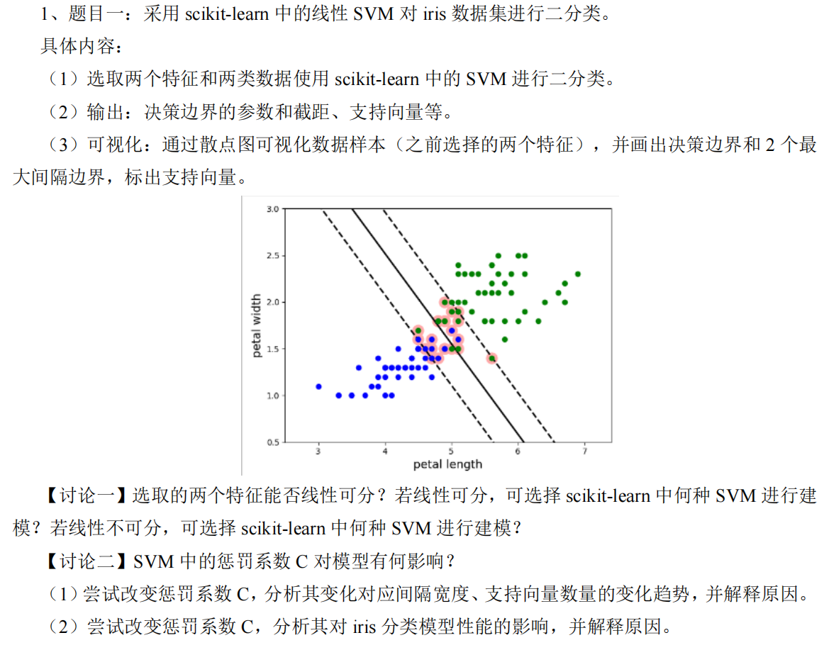

代码：
import numpy as np
import matplotlib.pyplot as plt
from sklearn import datasets
from sklearn.svm import SVC
from sklearn.metrics import accuracy_score
from sklearn.preprocessing import StandardScaler
from sklearn.model_selection import train_test_split
import pandas as pd
import os
import warnings

# 创建保存图片的目录
if not os.path.exists('images_1'):
os.makedirs('images_1')

# 加载Iris数据集
iris = datasets.load_iris()
X = iris.data[:, :2] # 只使用前两个特征
y = iris.target

# 创建线性可分和线性不可分问题的子集
# 线性可分：Setosa (0) vs Versicolor (1)
X_lin_sep = X[(y == 0) | (y == 1)]
y_lin_sep = y[(y == 0) | (y == 1)]

# 线性不可分：Versicolor (1) vs Virginica (2)
X_non_lin_sep = X[(y == 1) | (y == 2)]
y_non_lin_sep = y[(y == 1) | (y == 2)]
y_non_lin_sep = np.where(y_non_lin_sep == 1, 0, 1) # 重新标记为0和1

# 标准化数据
scaler_lin = StandardScaler()
X_lin_sep_scaled = scaler_lin.fit_transform(X_lin_sep)

scaler_non_lin = StandardScaler()
X_non_lin_sep_scaled = scaler_non_lin.fit_transform(X_non_lin_sep)

# 定义可视化函数
def plot_svm_boundary(model, X, y, title, filename):
plt.figure()
plt.scatter(X[:, 0], X[:, 1], c=y, cmap=plt.cm.Paired, edgecolors='k')

# 绘制决策边界
ax = plt.gca()
xlim = ax.get_xlim()
ylim = ax.get_ylim()

# 创建网格来评估模型
xx = np.linspace(xlim[0], xlim[1], 30)
yy = np.linspace(ylim[0], ylim[1], 30)
YY, XX = np.meshgrid(yy, xx)
xy = np.vstack([XX.ravel(), YY.ravel()]).T
Z = model.decision_function(xy).reshape(XX.shape)

# 绘制决策边界和间隔边界
ax.contour(XX, YY, Z, colors='k', levels=[-1, 0, 1], alpha=0.5,
linestyles=['--', '-', '--'])

# 标记支持向量
ax.scatter(model.support_vectors_[:, 0], model.support_vectors_[:, 1],
s=100, linewidth=1, facecolors='none', edgecolors='k')

plt.xlabel(iris.feature_names[0])
plt.ylabel(iris.feature_names[1])
plt.title(title)
plt.savefig(filename)
plt.close()

# 线性可分问题
print("线性可分问题(Setosa vs Versicolor):")
# 使用更大的容差和迭代次数防止收敛警告
svc_lin_sep = SVC(kernel='linear', C=100, tol=1e-5, max_iter=50000)
svc_lin_sep.fit(X_lin_sep_scaled, y_lin_sep)

# 输出模型参数
print("决策边界参数 (w):", svc_lin_sep.coef_[0])
print("截距 (b):", svc_lin_sep.intercept_[0])
print("支持向量数量:", len(svc_lin_sep.support_vectors_))
print("支持向量坐标:\n", svc_lin_sep.support_vectors_)

# 可视化线性可分问题
plot_svm_boundary(svc_lin_sep, X_lin_sep_scaled, y_lin_sep,
"SVM for Linearly Separable Case (Standardized)",
"images_1/题目1_1.png")

# 线性不可分问题
print("\n线性不可分问题(Versicolor vs Virginica):")
# 设置适当的C值避免数值问题
svc_non_lin_sep = SVC(kernel='linear', C=0.5, tol=1e-5, max_iter=50000)
svc_non_lin_sep.fit(X_non_lin_sep_scaled, y_non_lin_sep)

# 输出模型参数
print("决策边界参数 (w):", svc_non_lin_sep.coef_[0])
print("截距 (b):", svc_non_lin_sep.intercept_[0])
print("支持向量数量:", len(svc_non_lin_sep.support_vectors_))
print("支持向量坐标:\n", svc_non_lin_sep.support_vectors_)

# 可视化线性不可分问题
plot_svm_boundary(svc_non_lin_sep, X_non_lin_sep_scaled, y_non_lin_sep,
"SVM for Non-linearly Separable Case (Standardized)",
"images_1/题目1_2.png")

# 改变惩罚系数C的试验
def svm_c_experiment(X, y, scaler, problem_name, prefix):
# 使用更合理的C值范围，避免极端值
C_values = [0.001, 0.01, 0.1, 0.5, 1, 5, 10]
results = {
'C': [],
'Margin_Width': [],
'Num_Support_Vectors': [],
'Train_Accuracy': [],
'Test_Accuracy': []
}

# 划分训练集和测试集
X_train, X_test, y_train, y_test = train_test_split(
X, y, test_size=0.3, random_state=42
)

# 标准化数据
X_train = scaler.fit_transform(X_train)
X_test = scaler.transform(X_test)

# 不同C值实验
for C_val in C_values:
# 使用更大的迭代次数和更小的容差
model = SVC(kernel='linear', C=C_val, tol=1e-6, max_iter=100000)
with warnings.catch_warnings():
warnings.simplefilter("ignore")
model.fit(X_train, y_train)

# 计算间隔宽度: 2 / ||w||
w_norm = np.sum(model.coef_ ** 2)
margin_width = 2.0 / np.sqrt(w_norm) if w_norm > 1e-10 else float('inf')

# 计算预测精度
y_train_pred = model.predict(X_train)
y_test_pred = model.predict(X_test)
train_acc = accuracy_score(y_train, y_train_pred)
test_acc = accuracy_score(y_test, y_test_pred)

# 存储结果
results['C'].append(C_val)
results['Margin_Width'].append(margin_width)
results['Num_Support_Vectors'].append(len(model.support_vectors_))
results['Train_Accuracy'].append(train_acc)
results['Test_Accuracy'].append(test_acc)

# 创建DataFrame并打印结果
df = pd.DataFrame(results)
print(f"\n{problem_name} 实验结果表:")
print(df)

# 可视化结果
plt.figure(figsize=(15, 10))

plt.subplot(3, 1, 1)
plt.semilogx(results['C'], results['Margin_Width'], 'o-')
plt.xlabel('C (log scale)')
plt.ylabel('Margin Width')
plt.title(f'{problem_name}: Margin Width vs C')
plt.grid(True, which="both", ls="-")

plt.subplot(3, 1, 2)
plt.semilogx(results['C'], results['Num_Support_Vectors'], 'o-')
plt.xlabel('C (log scale)')
plt.ylabel('Number of Support Vectors')
plt.title(f'{problem_name}: Support Vectors vs C')
plt.grid(True, which="both", ls="-")

plt.subplot(3, 1, 3)
plt.semilogx(results['C'], results['Train_Accuracy'], 'o-', label='Train Accuracy')
plt.semilogx(results['C'], results['Test_Accuracy'], 'o-', label='Test Accuracy')
plt.xlabel('C (log scale)')
plt.ylabel('Accuracy')
plt.title(f'{problem_name}: Model Accuracy vs C')
plt.legend()
plt.grid(True, which="both", ls="-")

plt.tight_layout()
plt.savefig(f"images_1/题目1_{prefix}.png")
plt.close()

return df

# 进行线性可分问题的C值实验
print("\n线性可分问题的C值实验:")
df_lin = svm_c_experiment(X_lin_sep, y_lin_sep, scaler_lin,
"Linearly Separable Problem", "3")

# 进行线性不可分问题的C值实验
print("\n线性不可分问题的C值实验:")
df_non_lin = svm_c_experiment(X_non_lin_sep, y_non_lin_sep, scaler_non_lin,
"Non-linearly Separable Problem", "4")

结果：

线性可分问题(Setosa vs Versicolor):
选择了较大的C值（100），更加接近硬间隔SVM，或者从结果上说就是硬分隔决策边界参数 (w): [ 4.03253145 -2.50705808]
截距 (b): 0.927371895398489
支持向量数量: 4
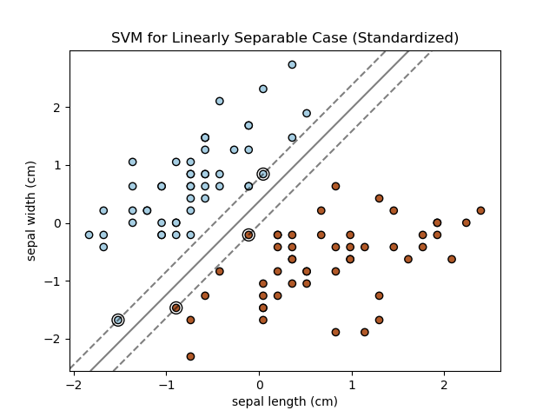

线性不可分问题(Versicolor vs Virginica):
选择了较小的C值（0.5），更加接近软间隔SVM，或者从结果上说就是软分隔决策边界参数 (w): [1.05521561 0.26486874]
截距 (b): -0.043200108662679086
支持向量数量: 69
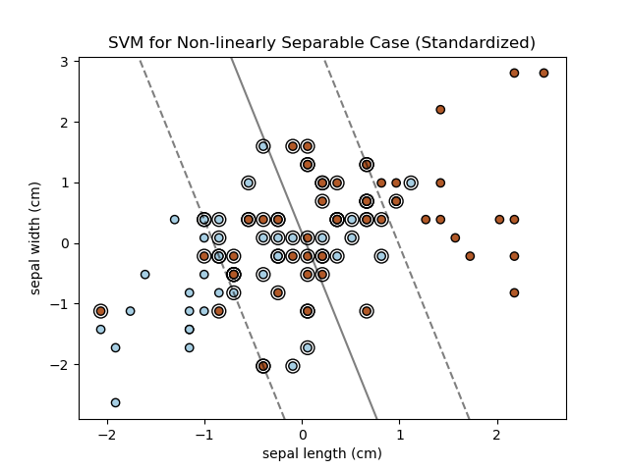

线性可分问题的C值实验:

Linearly Separable Problem 实验结果表:
C Margin_Width Num_Support_Vectors Train_Accuracy Test_Accuracy
0 0.001 32.727424 66 0.528571 0.433333
1 0.010 3.339979 66 0.985714 1.000000
2 0.100 1.625449 25 0.985714 1.000000
3 0.500 1.065099 12 0.985714 1.000000
4 1.000 0.820421 10 0.985714 1.000000
5 5.000 0.536617 4 1.000000 1.000000
6 10.000 0.412818 4 1.000000 1.000000
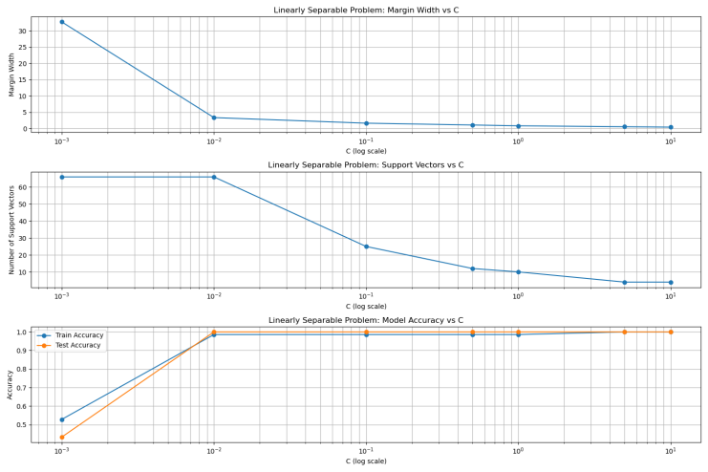
C 参数控制对误分类的惩罚强度：小 C 值倾向于最大化分类边界的间隔（Margin），但可能允许更多误分类（欠拟合）；大 C 值倾向于最小化误分类，但会缩小间隔。

线性不可分问题的C值实验:

Non-linearly Separable Problem 实验结果表:
C Margin_Width Num_Support_Vectors Train_Accuracy Test_Accuracy
0 0.001 70.456928 66 0.528571 0.433333
1 0.010 7.045693 66 0.571429 0.566667
2 0.100 2.271124 56 0.757143 0.633333
3 0.500 1.772921 50 0.771429 0.700000
4 1.000 1.519647 48 0.757143 0.700000
5 5.000 1.519644 47 0.742857 0.700000
6 10.000 1.519643 48 0.728571 0.700000
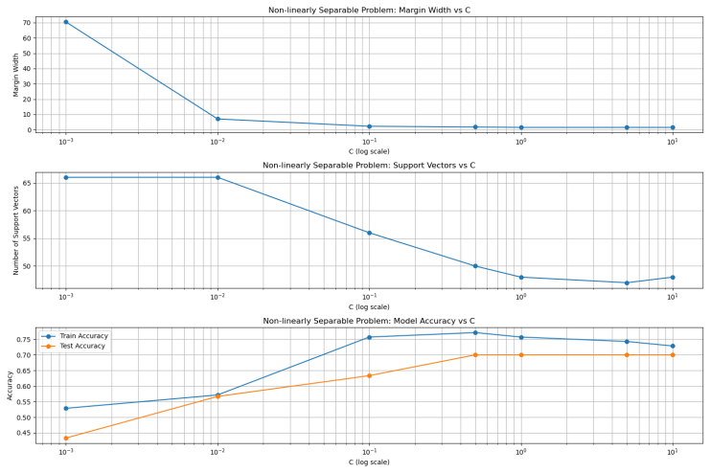
随着C值增大，间隔宽度显著减小。当C从0.001增至10.000时，间隔宽度从70.456急剧缩小至1.519。当C ≥ 1.000时，间隔宽度趋于稳定（约1.519），不再显著变化。（可能原因：模型复杂度达到上限。）
低C（0.001）时测试准确率最低（43.33%），因间隔过大导致欠拟合。当C增至0.500时，测试准确率达峰值（70%），相比低C提升26.67%。C ≥ 0.500后，测试准确率稳定在70%，不再提升（即使C增至10.000）。实验显示C=0.500时取得最佳泛化能力（测试准确率70%），进一步增大C不会提升效果。
C=0.500时训练准确率最高（77.14%）。当C>0.500（如增至10.000），训练准确率从77.14%降至72.86%，但测试准确率不变。表明过大的C值导致模型对训练数据的噪声过拟合，泛化能力不再提升。

对于线性不可分问题，改用RBF作为核函数：
关键代码修改：
# 线性不可分问题 - 使用RBF核函数
print("\n线性不可分问题(Versicolor vs Virginica) with RBF kernel:") # 设置RBF核函数和适当的超参数 svc_non_lin_sep = SVC(kernel='rbf', gamma='auto', C=1.0, tol=1e-5, max_iter=50000) svc_non_lin_sep.fit(X_non_lin_sep_scaled, y_non_lin_sep)

结果：
线性不可分问题(Versicolor vs Virginica) with RBF kernel:
使用核函数: rbf
支持向量数量: 73

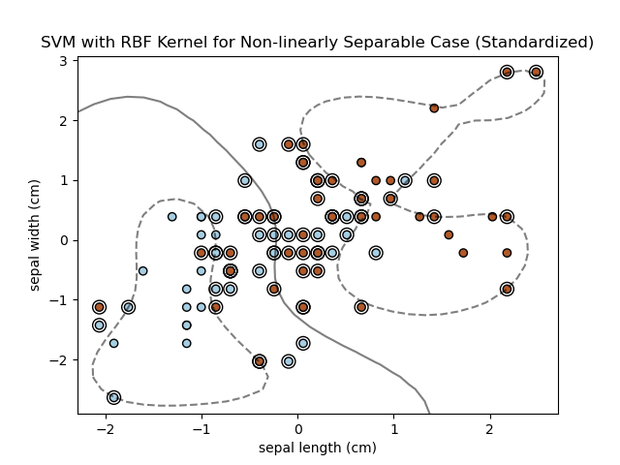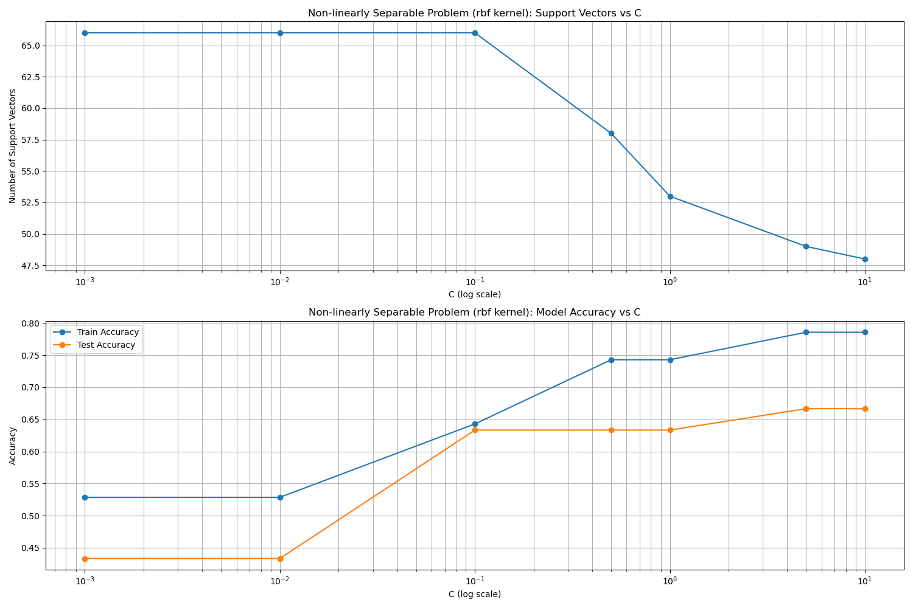

线性不可分问题的C值实验 with RBF kernel:

Non-linearly Separable Problem (rbf kernel) 实验结果表:
C Margin_Width Num_Support_Vectors Train_Accuracy Test_Accuracy
0 0.001 -1 66 0.528571 0.433333
1 0.010 -1 66 0.528571 0.433333
2 0.100 -1 66 0.642857 0.633333
3 0.500 -1 58 0.742857 0.633333
4 1.000 -1 53 0.742857 0.633333
5 5.000 -1 49 0.785714 0.666667
6 10.000 -1 48 0.785714 0.666667

与线性核函数比更容易过拟合，
在C值较大时训练准确率更高，测试准确率有所不及，本实验里性能没有显著提升。
题目2
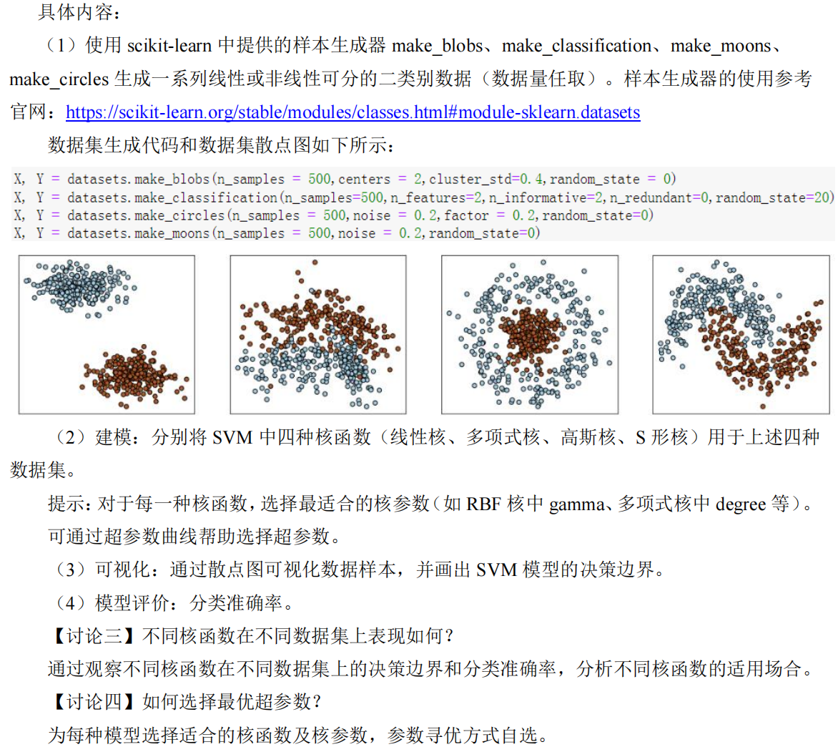

代码：
import numpy as np
import matplotlib.pyplot as plt
from matplotlib.colors import ListedColormap
from sklearn import datasets
from sklearn.svm import SVC
from sklearn.model_selection import train_test_split, GridSearchCV, StratifiedKFold
from sklearn.metrics import accuracy_score
from skopt import BayesSearchCV
from skopt.space import Real, Categorical, Integer

# Create directory for images
import os

os.makedirs('images_2', exist_ok=True)

# Generate datasets
datasets_info = [
{'func': datasets.make_blobs, 'args': {'n_samples': 500, 'centers': 2,
'cluster_std': 0.4, 'random_state': 0}, 'name': 'Blobs'},
{'func': datasets.make_classification, 'args': {'n_samples': 500, 'n_features': 2,
'n_informative': 2, 'n_redundant': 0,
'random_state': 20}, 'name': 'Classification'},
{'func': datasets.make_circles, 'args': {'n_samples': 500, 'noise': 0.2,
'factor': 0.2, 'random_state': 0}, 'name': 'Circles'},
{'func': datasets.make_moons, 'args': {'n_samples': 500, 'noise': 0.2,
'random_state': 0}, 'name': 'Moons'}
]

# Prepare kernels with hyperparameter search spaces
kernels = [
{'name': 'Linear', 'type': 'linear',
'grid': {'C': [0.01, 0.1, 1, 10, 100]},
'bayes': {'C': Real(0.01, 100, prior='log-uniform')}},

{'name': 'Polynomial', 'type': 'poly',
'grid': {'C': [0.1, 1, 10], 'gamma': ['scale', 'auto'], 'degree': [2, 3, 4]},
'bayes': {'C': Real(0.1, 100, prior='log-uniform'),
'gamma': Categorical(['scale', 'auto']),
'degree': Integer(2, 4)}},

{'name': 'RBF', 'type': 'rbf',
'grid': {'C': [0.1, 1, 10, 100], 'gamma': [0.01, 0.1, 1, 10]},
'bayes': {'C': Real(0.1, 100, prior='log-uniform'),
'gamma': Real(0.01, 10, prior='log-uniform')}},

{'name': 'Sigmoid', 'type': 'sigmoid',
'grid': {'C': [0.1, 1, 10], 'gamma': [0.01, 0.1, 1], 'coef0': [-1, 0, 1]},
'bayes': {'C': Real(0.1, 10, prior='log-uniform'),
'gamma': Real(0.01, 1, prior='log-uniform'),
'coef0': Integer(-1, 1)}}
]

# Optimizer settings
cv = StratifiedKFold(n_splits=5, shuffle=True, random_state=42)
plot_idx = 0

# Function to plot decision boundaries
def plot_decision_boundary(ax, model, X, y, title):
cm_bright = ListedColormap(['#FF0000', '#0000FF'])
x_min, x_max = X[:, 0].min() - 0.3, X[:, 0].max() + 0.3
y_min, y_max = X[:, 1].min() - 0.3, X[:, 1].max() + 0.3
xx, yy = np.meshgrid(np.linspace(x_min, x_max, 200),
np.linspace(y_min, y_max, 200))

Z = model.predict(np.c_[xx.ravel(), yy.ravel()])
Z = Z.reshape(xx.shape)

ax.contourf(xx, yy, Z, alpha=0.4, cmap=plt.cm.coolwarm)
ax.scatter(X[:, 0], X[:, 1], c=y, cmap=cm_bright, edgecolors='k', alpha=0.9)
ax.set_title(title, fontsize=9)
ax.set_xticks([])
ax.set_yticks([])

# Main processing loop
for data_idx, data_info in enumerate(datasets_info):
# Generate dataset
X, y = data_info['func'](**data_info['args'])
X_train, X_test, y_train, y_test = train_test_split(
X, y, test_size=0.2, random_state=42, stratify=y
)

# Run optimization methods
for method in ['grid', 'bayes']:
fig, axs = plt.subplots(2, 2, figsize=(10, 8))
fig.suptitle(f"{data_info['name']} Dataset - {method.capitalize()} Search",
fontsize=14, fontweight='bold')

for kernel_idx, kernel in enumerate(kernels):
# Create classifier
clf = SVC(kernel=kernel['type'], random_state=42)

# Hyperparameter optimization
if method == 'grid':
optimizer = GridSearchCV(
estimator=clf,
param_grid=kernel['grid'],
cv=cv,
scoring='accuracy',
n_jobs=-1
)
optimizer.fit(X_train, y_train)
else:
optimizer = BayesSearchCV(
estimator=clf,
search_spaces=kernel['bayes'],
cv=cv,
scoring='accuracy',
n_jobs=-1,
n_iter=30,
random_state=42
)
optimizer.fit(X_train, y_train)

# Best model
best_model = optimizer.best_estimator_
y_pred = best_model.predict(X_test)
accuracy = accuracy_score(y_test, y_pred)

# Print best parameters in purple
print(f"\033[95mDataset: {data_info['name']}, Kernel: {kernel['name']}, Method: {method.upper()}")
print(f"Accuracy: {accuracy:.4f}")
print(f"Best params: {optimizer.best_params_}\033[0m")

# Plot results
row = kernel_idx // 2
col = kernel_idx % 2
plot_decision_boundary(
axs[row, col],
best_model,
X_train,
y_train,
f"{kernel['name']} Kernel (Acc: {accuracy:.3f})"
)

# Save figure
plt.tight_layout(rect=[0, 0, 1, 0.96])
plt.savefig(f'images_2/题目2_{plot_idx}.png', dpi=300, bbox_inches='tight')
plot_idx += 1
plt.close()

结果：
GridSearchCV方法：
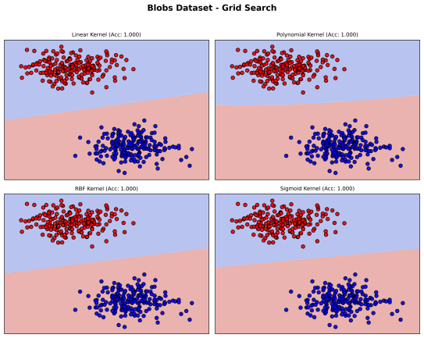
Dataset: Blobs, Kernel: Linear, Method: GRID
Accuracy: 1.0000
Best params: {'C': 0.01}

Dataset:Blobs, Kernel: Polynomial, Method: GRID
Accuracy: 1.0000
Best params: {'C': 0.1, 'degree': 2, 'gamma': 'scale'}

Dataset: Blobs, Kernel: RBF, Method: GRID
Accuracy: 1.0000
Best params: {'C': 0.1, 'gamma': 0.01}

Dataset: Blobs, Kernel: Sigmoid, Method: GRID
Accuracy: 1.0000
Best params: {'C': 0.1, 'coef0': -1, 'gamma': 0.01}

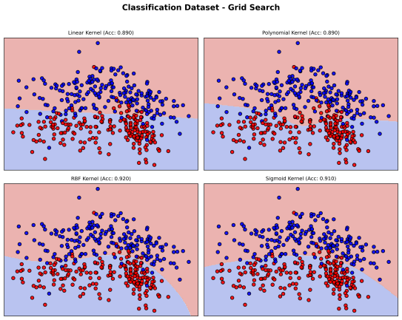
Dataset: Classification, Kernel: Linear, Method: GRID
Accuracy: 0.8900
Best params: {'C': 0.1}

Dataset: Classification, Kernel: Polynomial, Method: GRID
Accuracy: 0.8900
Best params: {'C': 0.1, 'degree': 3, 'gamma': 'scale'}

Dataset: Classification, Kernel: RBF, Method: GRID
Accuracy: 0.9200
Best params: {'C': 10, 'gamma': 0.1}

Dataset: Classification, Kernel: Sigmoid, Method: GRID
Accuracy: 0.9100
Best params: {'C': 10, 'coef0': -1, 'gamma': 0.1}
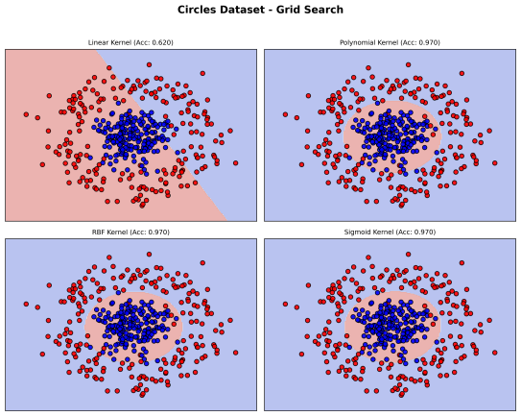
Dataset: Circles, Kernel: Linear, Method: GRID
Accuracy: 0.6200
Best params: {'C': 0.01}

Dataset: Circles, Kernel: Polynomial, Method: GRID
Accuracy: 0.9700
Best params: {'C': 0.1, 'degree': 2, 'gamma': 'scale'}

Dataset: Circles, Kernel: RBF, Method: GRID
Accuracy: 0.9700
Best params: {'C': 10, 'gamma': 0.1}

Dataset: Circles, Kernel: Sigmoid, Method: GRID
Accuracy: 0.9700
Best params: {'C': 1, 'coef0': -1, 'gamma': 1}

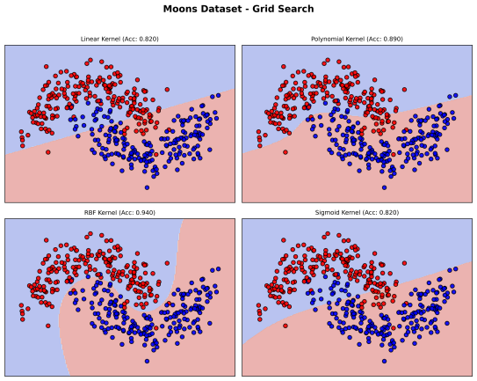
Dataset: Moons, Kernel: Linear, Method: GRID
Accuracy: 0.8200
Best params: {'C': 1}

Dataset: Moons, Kernel: Polynomial, Method: GRID
Accuracy: 0.8900
Best params: {'C': 10, 'degree': 3, 'gamma': 'scale'}

Dataset: Moons, Kernel: RBF, Method: GRID
Accuracy: 0.9400
Best params: {'C': 10, 'gamma': 1}

Dataset: Moons, Kernel: Sigmoid, Method: GRID
Accuracy: 0.8200
Best params: {'C': 10, 'coef0': -1, 'gamma': 0.1}

贝叶斯优化方法：
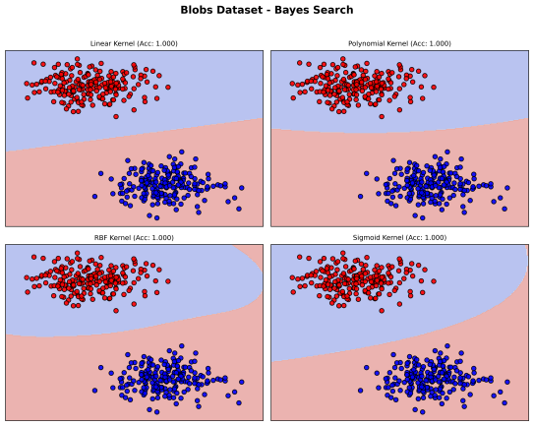
Dataset: Blobs, Kernel: Linear, Method: BAYES
Accuracy: 1.0000
Best params: OrderedDict([('C', 0.4369339947510315)])

Dataset:Blobs,Kernel: Polynomial, Method: BAYES
Accuracy: 1.0000
Best params: OrderedDict([('C', 1.6994636371262763), ('degree', 3), ('gamma', 'auto')])

Dataset: Blobs, Kernel: RBF, Method: BAYES
Accuracy: 1.0000
Best params: OrderedDict([('C', 1.6994636371262763), ('gamma', 1.5246748254295628)])

Dataset: Blobs, Kernel: Sigmoid, Method: BAYES
Accuracy: 1.0000
Best params: OrderedDict([('C', 4.7290805470559185), ('coef0', 1), ('gamma', 0.04044084484117812)])

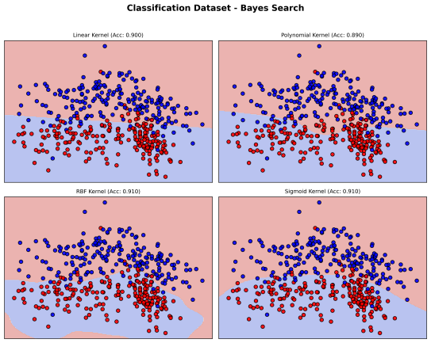
Dataset: Classification, Kernel: Linear, Method: BAYES
Accuracy: 0.9000
Best params: OrderedDict([('C', 0.4369339947510315)])

Dataset: Classification, Kernel: Polynomial, Method: BAYES
Accuracy: 0.8900
Best params: OrderedDict([('C', 0.1), ('degree', 3), ('gamma', 'scale')])

Dataset: Classification, Kernel: RBF, Method: BAYES
Accuracy: 0.9100
Best params: OrderedDict([('C', 0.8035999687014224), ('gamma', 3.7588898205796824)])
Dataset: Classification, Kernel: Sigmoid, Method: BAYES
Accuracy: 0.9100
Best params: OrderedDict([('C', 4.2149456283335), ('coef0', -1), ('gamma', 0.1570703295827246)])

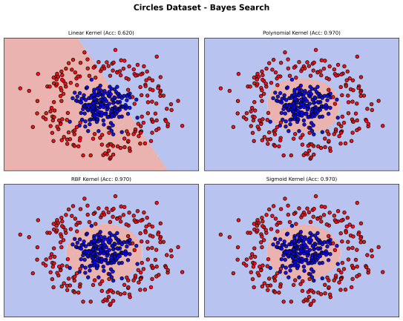
Dataset: Circles, Kernel: Linear, Method: BAYES
Accuracy: 0.6200
Best params: OrderedDict([('C', 0.16582286961638348)])

Dataset: Circles, Kernel: Polynomial, Method: BAYES
Accuracy: 0.9700
Best params: OrderedDict([('C', 4.267850550142993), ('degree', 4), ('gamma', 'scale')])

Dataset: Circles, Kernel: RBF, Method: BAYES
Accuracy: 0.9700
Best params: OrderedDict([('C', 88.08332735252795), ('gamma', 0.025221077443845892)])

Dataset: Circles, Kernel: Sigmoid, Method: BAYES
Accuracy: 0.9700
Best params: OrderedDict([('C', 4.666633068366001), ('coef0', -1), ('gamma', 1.0)])

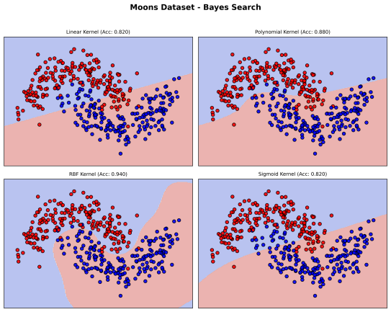
Dataset: Moons, Kernel: Linear, Method: BAYES
Accuracy: 0.8200
Best params: OrderedDict([('C', 1.491462267977867)])

Dataset: Moons, Kernel: Polynomial, Method: BAYES
Accuracy: 0.8800
Best params: OrderedDict([('C', 73.52481813242629), ('degree', 3), ('gamma', 'auto')])

Dataset: Moons, Kernel: RBF, Method: BAYES
Accuracy: 0.9400
Best params: OrderedDict([('C', 1.0235727816099582), ('gamma', 3.71408489359063)])

Dataset: Moons, Kernel: Sigmoid, Method: BAYES
Accuracy: 0.8200
Best params: OrderedDict([('C', 10.0), ('coef0', -1), ('gamma', 0.10624239165471892)])

【讨论三】不同核函数在不同数据集上的表现分析
线性可分数据 (Blobs)：所有核函数均达到100%准确率，说明线性核已足够处理简单数据。
中等复杂数据 (Classification)：RBF核表现最优（92%），因其能灵活拟合中等非线性边界。线性核表现最差（89%）。
高度非线性数据 (Circles/Moons)：线性核完全失效（Circles: 62%, Moons: 82%），因其无法拟合环形/弯月形边界。RBF核和多项式核表现卓越​​（Circles: 97%, Moons: 94%），尤其多项式核在Circles中通过degree=2完美匹配环形结构。Sigmoid核表现不稳定：在Circles上优秀（97%），但在Moons上与线性核相当（82%），对参数敏感。

【讨论四】最优超参数选择策略​​
核函数默认选择RBF核：在4个数据集中3次达到最优/次优（Classification、Circles、Moons）。
参数寻优方式对比：网格搜索：全局最优，参数覆盖全面、计算开销大、适合参数少或计算资源充足情况；贝叶斯优化：自适应探索方向、适合参数多或计算资源受限情况。
​​选择的参数范围：
C（惩罚系数）：影响所有核函数，优先优化（范围[0.01, 100]）
γ（RBF/多项式核）：核心参数，范围[0.001, 10]
degree（多项式核）：从2开始尝试，不超过5
coef0（Sigmoid核）：试探[-1, 1]范围

题目3
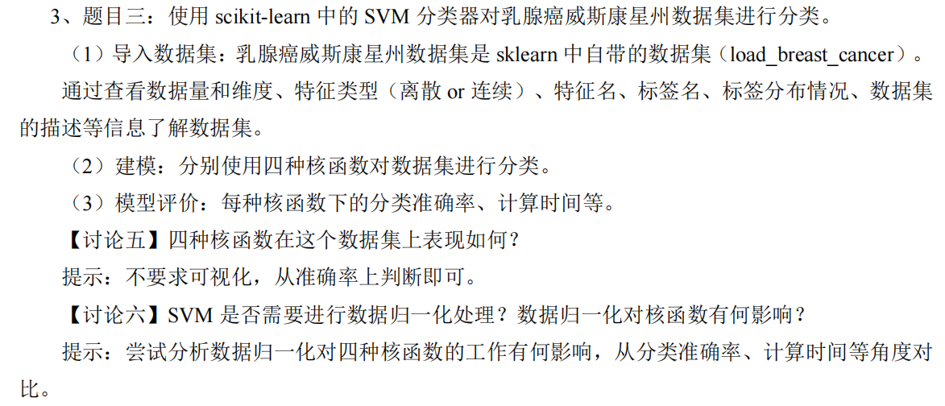

代码：
import numpy as np
import pandas as pd
import matplotlib.pyplot as plt
from sklearn.datasets import load_breast_cancer
from sklearn.model_selection import train_test_split
from sklearn.svm import SVC
from sklearn.preprocessing import StandardScaler
from sklearn.metrics import accuracy_score
import time
import os

# Create directory for images
os.makedirs("images_3", exist_ok=True)

# Load dataset
cancer = load_breast_cancer()
X, y = cancer.data, cancer.target
feature_names = cancer.feature_names
target_names = cancer.target_names

# (1) Explore dataset
print(f"Number of samples: {X.shape[0]}")
print(f"Number of features: {X.shape[1]}")
print("\nFeature names:")
for i, name in enumerate(feature_names):
print(f"{i + 1}. {name}")
print(f"\nTarget names: {target_names}")
print(f"Label distribution: \n{pd.Series(y).value_counts()}")
print("\nDataset description:")
print(cancer.DESCR)

# Prepare data for modeling
X_train, X_test, y_train, y_test = train_test_split(X, y, test_size=0.3, random_state=42)

# Initialize kernels and results storage
kernels = ['linear', 'poly', 'rbf', 'sigmoid']
results_raw = {'accuracy': [], 'time': []}
results_scaled = {'accuracy': [], 'time': []}

# Without normalization
print("\nWithout normalization:")
for kernel in kernels:
start_time = time.time()
clf = SVC(kernel=kernel, random_state=42)
clf.fit(X_train, y_train)
y_pred = clf.predict(X_test)
acc = accuracy_score(y_test, y_pred)
elapsed_time = time.time() - start_time

results_raw['accuracy'].append(acc)
results_raw['time'].append(elapsed_time)

print(f"{kernel} kernel - Accuracy: {acc:.4f}, Time: {elapsed_time:.4f}s")

# With normalization
scaler = StandardScaler()
X_train_scaled = scaler.fit_transform(X_train)
X_test_scaled = scaler.transform(X_test)

print("\nWith normalization:")
for kernel in kernels:
start_time = time.time()
clf = SVC(kernel=kernel, random_state=42)
clf.fit(X_train_scaled, y_train)
y_pred = clf.predict(X_test_scaled)
acc = accuracy_score(y_test, y_pred)
elapsed_time = time.time() - start_time

results_scaled['accuracy'].append(acc)
results_scaled['time'].append(elapsed_time)

print(f"{kernel} kernel - Accuracy: {acc:.4f}, Time: {elapsed_time:.4f}s")

# Visualization
plt.figure(figsize=(15, 10))

# Accuracy comparison
plt.subplot(2, 2, 1)
x_axis = np.arange(len(kernels))
width = 0.3
plt.bar(x_axis - width / 2, results_raw['accuracy'], width, label='Raw Data', color='royalblue')
plt.bar(x_axis + width / 2, results_scaled['accuracy'], width, label='Scaled Data', color='lightcoral')
plt.ylabel('Accuracy')
plt.title('Accuracy Comparison')
plt.xticks(x_axis, kernels)
plt.ylim(0, 1.05) # Adjusted to show full 0-1 range
plt.legend()
for i in range(len(kernels)):
plt.text(i - width / 2, results_raw['accuracy'][i] + 0.01, f'{results_raw["accuracy"][i]:.4f}', ha='center')
plt.text(i + width / 2, results_scaled['accuracy'][i] + 0.01, f'{results_scaled["accuracy"][i]:.4f}', ha='center')

# Time comparison
plt.subplot(2, 2, 2)
plt.bar(x_axis - width / 2, results_raw['time'], width, label='Raw Data', color='royalblue')
plt.bar(x_axis + width / 2, results_scaled['time'], width, label='Scaled Data', color='lightcoral')
plt.ylabel('Time (seconds)')
plt.title('Training Time Comparison')
plt.xticks(x_axis, kernels)
plt.legend()
for i in range(len(kernels)):
plt.text(i - width / 2, results_raw['time'][i] + 0.01, f'{results_raw["time"][i]:.4f}s', ha='center')
plt.text(i + width / 2, results_scaled['time'][i] + 0.01, f'{results_scaled["time"][i]:.4f}s', ha='center')

# Raw data results
plt.subplot(2, 2, 3)
plt.bar(kernels, results_raw['accuracy'], color=['royalblue', 'forestgreen', 'gold', 'tomato'])
plt.ylabel('Accuracy')
plt.title('Raw Data: Accuracy per Kernel')
plt.ylim(0, 1.05) # Adjusted to show full 0-1 range
for i, acc in enumerate(results_raw['accuracy']):
plt.text(i, acc + 0.01, f'{acc:.4f}', ha='center')

# Scaled data results
plt.subplot(2, 2, 4)
plt.bar(kernels, results_scaled['accuracy'], color=['royalblue', 'forestgreen', 'gold', 'tomato'])
plt.ylabel('Accuracy')
plt.title('Scaled Data: Accuracy per Kernel')
plt.ylim(0, 1.05) # Adjusted to show full 0-1 range
for i, acc in enumerate(results_scaled['accuracy']):
plt.text(i, acc + 0.01, f'{acc:.4f}', ha='center')

plt.tight_layout()
plt.savefig('images_3/题目3_1.png')
plt.close()

# Create performance metrics table
fig, ax = plt.subplots(figsize=(10, 4))
ax.axis('off')
cell_text = [
[f'{results_raw["accuracy"][i]:.4f}' for i in range(4)],
[f'{results_scaled["accuracy"][i]:.4f}' for i in range(4)],
[f'{results_raw["time"][i]:.4f}s' for i in range(4)],
[f'{results_scaled["time"][i]:.4f}s' for i in range(4)]
]
columns = kernels
rows = ['Raw Accuracy', 'Scaled Accuracy', 'Raw Time', 'Scaled Time']
table = ax.table(cellText=cell_text, rowLabels=rows, colLabels=columns, loc='center', cellLoc='center')
table.scale(1, 2)
table.auto_set_font_size(False)
table.set_fontsize(10)
plt.title('SVM Performance Metrics', pad=20)
plt.savefig('images_3/题目3_2.png')
plt.close()

结果：
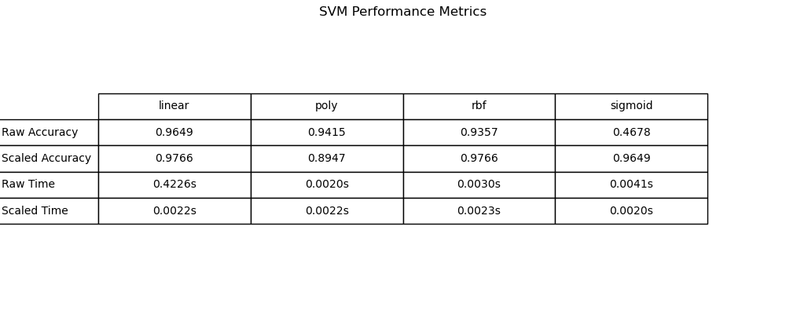


With normalization:
linear kernel - Accuracy: 0.9766, Time: 0.0022s
poly kernel - Accuracy: 0.8947, Time: 0.0022s
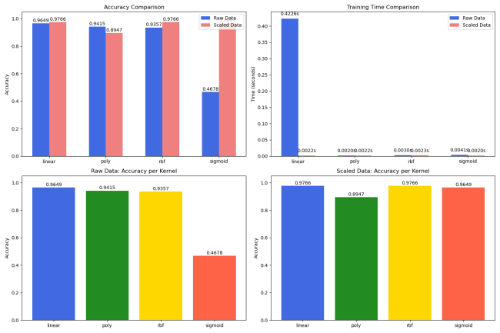
rbf kernel - Accuracy: 0.9766, Time: 0.0023s
sigmoid kernel - Accuracy: 0.9649, Time: 0.0020s

Without normalization:
linear kernel - Accuracy: 0.9649, Time: 0.4226s
poly kernel - Accuracy: 0.9415, Time: 0.0020s
rbf kernel - Accuracy: 0.9357, Time: 0.0030s
sigmoid kernel - Accuracy: 0.4678, Time: 0.0041s

【讨论五】四种核函数在这个数据集上表现如何？
在该数据集上，linear 核和 rbf 核（尤其归一化后）表现最佳，而 poly 核表现最差，sigmoid 核需谨慎使用归一化。​​

【讨论六】 SVM 是否需要进行数据归一化处理？数据归一化对核函数有何影响？
归一化能提升准确率（尤其对基于距离的核如 rbf 和 sigmoid）、减少计算时间（尤其对 linear 核），并防止模型不稳定（如 sigmoid 核的崩溃）。因此，在大多数情况下，应该使用归一化。
归一化不是对所有核都有益（例如，poly 核的准确率可能下降），但鉴于其对关键核函数（linear、rbf、sigmoid）的正面作用，整体利大于弊。

题目4：
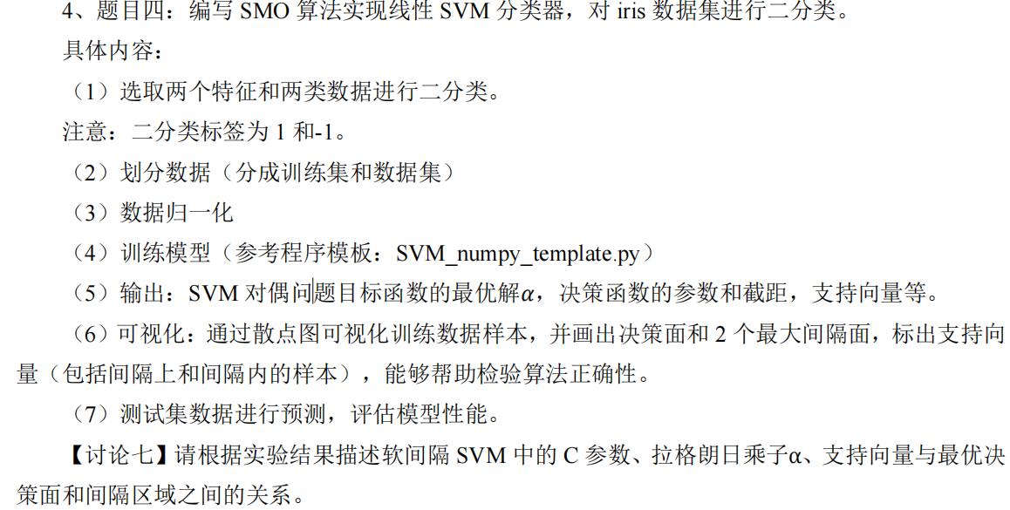

代码：
import random
import matplotlib.pyplot as plt
import numpy as np
import os
from sklearn.datasets import load_iris
from sklearn.model_selection import train_test_split
from sklearn.preprocessing import StandardScaler
from sklearn.metrics import accuracy_score

class Supper_Vector_Machine:
def __init__(self, dataset, target, C, toler, iter_max):
# 初始化SVM参数
self.X = dataset # 数据集
self.y = target # 目标值
self.C = C # 惩罚系数
self.toler = toler # 容忍度
self.iter_max = iter_max # 最大迭代次数
self.n_samples, self.n_features = self.X.shape # 样本数和特征数
self.alpha = np.zeros(self.n_samples) # 拉格朗日乘子
self.b = 0 # 偏置项
self.w = np.zeros(self.n_features) # 权重向量
self.E = np.zeros(self.n_samples) # 误差缓存
self.K = np.zeros((self.n_samples, self.n_samples)) # 核矩阵

# 预先计算核矩阵
for i in range(self.n_samples):
for j in range(self.n_samples):
self.K[i, j] = self.Kernel(i, j)

def Fx(self, i):
# 计算第i个样本的预测值
return np.sum(self.alpha * self.y * self.K[:, i]) + self.b

def Kernel(self, i, j):
# 线性核函数
return np.dot(self.X[i], self.X[j])

def random_j(self, i):
# 随机选择不同于i的j
j = i
while j == i:
j = random.randint(0, self.n_samples - 1)
return j

def get_L_H(self, i, j):
# 计算alpha_j的上下界
if self.y[i] != self.y[j]:
L = max(0, self.alpha[j] - self.alpha[i])
H = min(self.C, self.C + self.alpha[j] - self.alpha[i])
else:
L = max(0, self.alpha[i] + self.alpha[j] - self.C)
H = min(self.C, self.alpha[i] + self.alpha[j])
return L, H

def filter(self, alpha_j, L, H):
# 修剪alpha_j使其在[L,H]区间内
if alpha_j < L:
return L
elif alpha_j > H:
return H
else:
return alpha_j

def SMO(self):
# 序列最小优化算法
iter_count = 0
while iter_count < self.iter_max:
change_count = 0
for i in range(self.n_samples):
Fi = self.Fx(i)
self.E[i] = Fi - self.y[i]

# 检查是否违反KKT条件
if ((self.y[i] * self.E[i] < -self.toler) and (self.alpha[i] < self.C)) or \
((self.y[i] * self.E[i] > self.toler) and (self.alpha[i] > 0)):
j = self.random_j(i)
Fj = self.Fx(j)
self.E[j] = Fj - self.y[j]

# 计算alpha_j的边界
L, H = self.get_L_H(i, j)
if L == H:
continue

# 计算eta
eta = 2 * self.K[i, j] - self.K[i, i] - self.K[j, j]
if eta >= 0:
continue

# 更新alpha_j
alpha_j_old = self.alpha[j]
self.alpha[j] = self.alpha[j] - (self.y[j] * (self.E[i] - self.E[j])) / eta
self.alpha[j] = self.filter(self.alpha[j], L, H)

# 如果变化太小则跳过
if abs(self.alpha[j] - alpha_j_old) < self.toler:
continue

# 更新alpha_i
alpha_i_old = self.alpha[i]
self.alpha[i] = self.alpha[i] + self.y[i] * self.y[j] * (alpha_j_old - self.alpha[j])

# 计算b1和b2
b1 = self.b - self.E[i] - self.y[i] * (self.alpha[i] - alpha_i_old) * self.K[i, i] \
- self.y[j] * (self.alpha[j] - alpha_j_old) * self.K[i, j]
b2 = self.b - self.E[j] - self.y[i] * (self.alpha[i] - alpha_i_old) * self.K[i, j] \
- self.y[j] * (self.alpha[j] - alpha_j_old) * self.K[j, j]

# 更新偏置项b
if 0 < self.alpha[i] < self.C:
self.b = b1
elif 0 < self.alpha[j] < self.C:
self.b = b2
else:
self.b = (b1 + b2) / 2

# 更新误差缓存
self.E[i] = self.Fx(i) - self.y[i]
self.E[j] = self.Fx(j) - self.y[j]

change_count += 1

# 检查是否收敛
if change_count == 0:
iter_count += 1
else:
iter_count = 0

# 计算权重向量w
self.w = np.dot((self.alpha * self.y), self.X)

def predict(self, dataset):
# 预测新数据
y_pred = np.zeros(len(dataset))
for i in range(len(dataset)):
s = np.sign(np.dot(self.w, dataset[i]) + self.b)
y_pred[i] = s
return y_pred

def score(self, y_true, y_pred):
# 计算准确率
return accuracy_score(y_true, y_pred)

if __name__ == '__main__':
# 创建保存图像的目录
if not os.path.exists('images_4'):
os.makedirs('images_4')

# 加载鸢尾花数据集
iris = load_iris()
X = iris.data[:, :2] # 只使用前两个特征
y = iris.target

# 二分类问题：只保留类别0和1
X = X[(y == 0) | (y == 1)]
y = y[(y == 0) | (y == 1)]
y = np.where(y == 0, -1, 1) # 将类别0转换为-1，类别1保持不变

# 划分训练集和测试集
X_train, X_test, y_train, y_test = train_test_split(X, y, test_size=0.2, random_state=42)

# 标准化特征
scaler = StandardScaler()
X_train = scaler.fit_transform(X_train)
X_test = scaler.transform(X_test)

# 训练SVM模型
svm = Supper_Vector_Machine(X_train, y_train, C=1.0, toler=0.01, iter_max=10)
svm.SMO()

# 获取支持向量
support_vectors_idx = (svm.alpha > 0)
support_vectors = X_train[support_vectors_idx]

# 打印模型参数
print(f"最优alpha值:\n{svm.alpha}")
print(f"决策函数参数(w): {svm.w}")
print(f"偏置项(b): {svm.b}")
print(f"支持向量数量: {len(support_vectors)}")

# 可视化结果
plt.figure(figsize=(12, 8))

# 绘制训练数据点
plt.scatter(X_train[y_train == 1][:, 0], X_train[y_train == 1][:, 1], c='r', marker='o', label='类别 1')
plt.scatter(X_train[y_train == -1][:, 0], X_train[y_train == -1][:, 1], c='b', marker='x', label='类别 -1')

# 绘制支持向量
plt.scatter(support_vectors[:, 0], support_vectors[:, 1],
s=100, facecolors='none', edgecolors='k', label='支持向量')

# 创建网格用于绘制决策边界
x_min, x_max = X_train[:, 0].min() - 1, X_train[:, 0].max() + 1
y_min, y_max = X_train[:, 1].min() - 1, X_train[:, 1].max() + 1
xx, yy = np.meshgrid(np.linspace(x_min, x_max, 500),
np.linspace(y_min, y_max, 500))

# 计算网格点的预测值
Z = np.dot(np.c_[xx.ravel(), yy.ravel()], svm.w) + svm.b
Z = Z.reshape(xx.shape)

# 绘制决策边界和间隔
plt.contour(xx, yy, Z, levels=[0], linewidths=2, colors='g') # 决策边界
plt.contour(xx, yy, Z, levels=[-1, 1], linewidths=1, colors='k', linestyles='dashed') # 间隔边界

# 为图例添加决策边界和间隔的线条
decision_line = plt.Line2D([], [], color='g', linewidth=2, label='决策边界')
margin_line = plt.Line2D([], [], color='k', linestyle='dashed', linewidth=1, label='间隔边界')

plt.xlabel('花萼长度(标准化)')
plt.ylabel('花萼宽度(标准化)')
plt.title('鸢尾花数据集上的SVM分类')

# 合并所有图例句柄
handles, labels = plt.gca().get_legend_handles_labels()
handles.extend([decision_line, margin_line])
plt.legend(handles=handles)

# 保存图像
plt.savefig('images_4/题目4_1.png', dpi=300, bbox_inches='tight')
plt.close()

# 预测并评估模型
y_pred = svm.predict(X_test)
accuracy = svm.score(y_test, y_pred)
print(f"测试集准确率: {accuracy:.4f}")

结果：
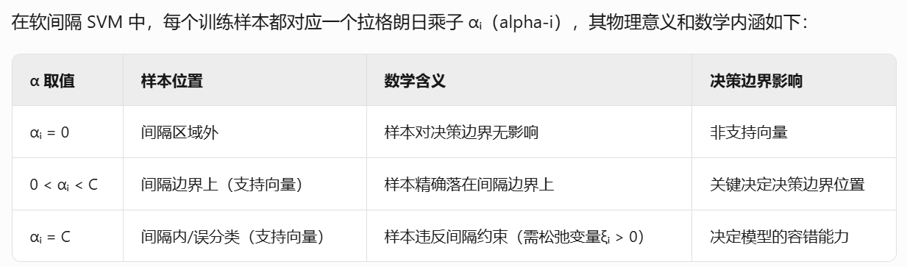
C = 0.01：
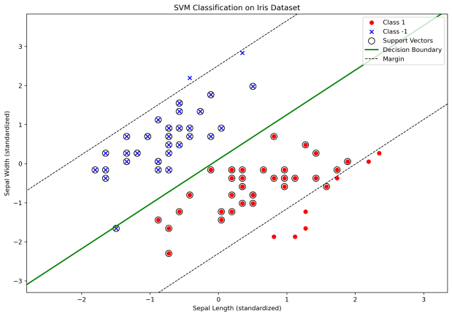
Optimal alpha values:
[0.01 0.01 0.01 0.01 0.01 0. 0.01 0.01 0.01 0. 0.01 0.01 0.01 0.01
0.01 0.01 0.01 0.01 0.01 0.01 0.01 0.01 0.01 0.01 0.01 0.01 0.01 0.01
0. 0.01 0.01 0.01 0.01 0.01 0.01 0.01 0.01 0.01 0.01 0.01 0.01 0.01
0.01 0.01 0. 0.01 0.01 0. 0.01 0.01 0.01 0.01 0. 0.01 0.01 0.01
0.01 0. 0.01 0.01 0.01 0.01 0.01 0.01 0.01 0. 0.01 0.01 0.01 0.
0.01 0.01 0.01 0.01 0.01 0.01 0.01 0.01 0.01 0.01]
Decision function parameters (w): [ 0.47482459 -0.41544268]
Bias term (b): 0.044843443285344196
Support vectors count: 71
Test Accuracy: 1.0000

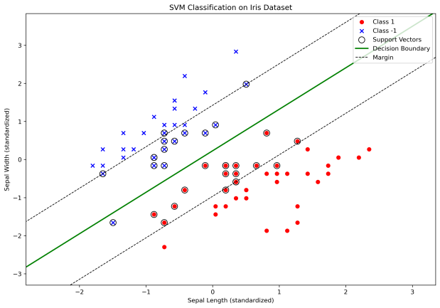
C = 0.1：
Optimal alpha values:
[0.0018396 0.1 0.00128361 0. 0. 0.
0. 0.1 0.1 0. 0. 0.
0.1 0.09675854 0.1 0. 0.1 0.
0.1 0. 0.0990802 0.1 0.00101464 0.1
0. 0. 0. 0.1 0. 0.
0. 0. 0. 0. 0.1 0.
0. 0.1 0.1 0. 0.0018396 0.05636944
0. 0. 0. 0. 0. 0.
0.1 0. 0. 0.1 0. 0.
0.1 0.1 0. 0. 0.0009198 0.1
0. 0.1 0. 0. 0.1 0.
0. 0. 0.1 0. 0.0009198 0.
0. 0. 0.1 0. 0. 0.03847213
0. 0. ]
Decision function parameters (w): [ 0.911472 -0.83640473]
Bias term (b): 0.1918382028983373
Support vectors count: 32
Test Accuracy: 1.0000
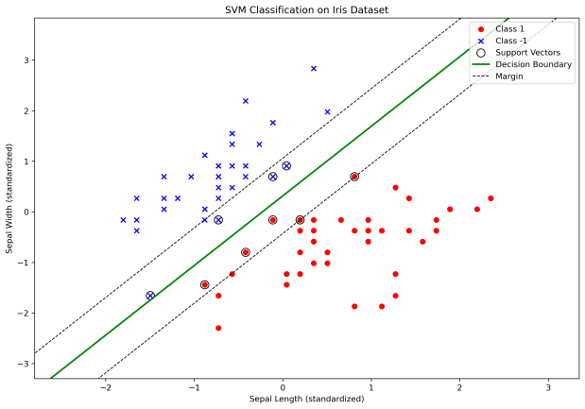
C = 1：
Optimal alpha values:
[0. 0.32269327 0. 0. 0. 0.
0. 0. 0. 0. 0. 0.
0.74106056 0. 0. 0. 0.23589326 0.
0. 0. 0. 0. 0. 0.
0. 0. 0. 1. 0. 0.
0. 0. 0. 0. 0. 0.
0. 0. 1. 0. 0. 0.
0. 0. 0. 0. 0. 0.
0. 0. 0. 1. 0. 0.
0. 0.70659852 0. 0. 0. 1.
0. 1. 0. 0. 0. 0.
0. 0. 0. 0. 0. 0.
0. 0. 1. 0. 0. 0.
0. 0. ]
Decision function parameters (w): [ 1.8496228 -1.34311135]
Bias term (b): 0.4224426592491229
Support vectors count: 10
Test Accuracy: 1.0000

C = 10：

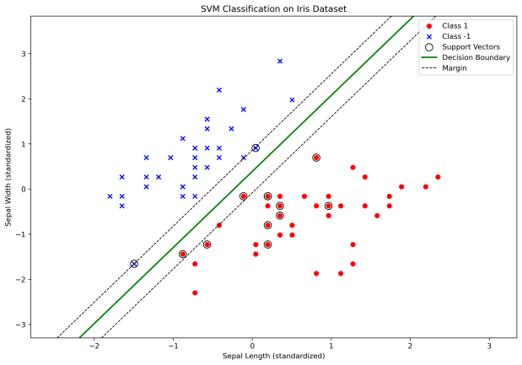
Optimal alpha values:
[2.22044605e-16 6.66133815e-16 0.00000000e+00 0.00000000e+00
2.22044605e-16 0.00000000e+00 0.00000000e+00 2.22044605e-16
0.00000000e+00 0.00000000e+00 0.00000000e+00 0.00000000e+00
4.44089210e-16 0.00000000e+00 0.00000000e+00 0.00000000e+00
4.44089210e-16 0.00000000e+00 0.00000000e+00 0.00000000e+00
0.00000000e+00 0.00000000e+00 0.00000000e+00 0.00000000e+00
0.00000000e+00 0.00000000e+00 0.00000000e+00 0.00000000e+00
0.00000000e+00 0.00000000e+00 0.00000000e+00 0.00000000e+00
0.00000000e+00 0.00000000e+00 0.00000000e+00 0.00000000e+00
0.00000000e+00 0.00000000e+00 5.69148561e+00 0.00000000e+00
0.00000000e+00 0.00000000e+00 0.00000000e+00 0.00000000e+00
0.00000000e+00 0.00000000e+00 0.00000000e+00 0.00000000e+00
0.00000000e+00 0.00000000e+00 0.00000000e+00 4.21303869e+00
0.00000000e+00 0.00000000e+00 2.22044605e-16 1.81641698e+00
0.00000000e+00 0.00000000e+00 2.22044605e-16 0.00000000e+00
2.22044605e-16 8.09828289e+00 0.00000000e+00 0.00000000e+00
0.00000000e+00 0.00000000e+00 0.00000000e+00 0.00000000e+00
0.00000000e+00 0.00000000e+00 0.00000000e+00 0.00000000e+00
0.00000000e+00 0.00000000e+00 0.00000000e+00 0.00000000e+00
0.00000000e+00 0.00000000e+00 0.00000000e+00 0.00000000e+00]
Decision function parameters (w): [ 3.5584199 -2.1113879]
Bias term (b): 0.8227971457884619
Support vectors count: 13
Test Accuracy: 1.0000

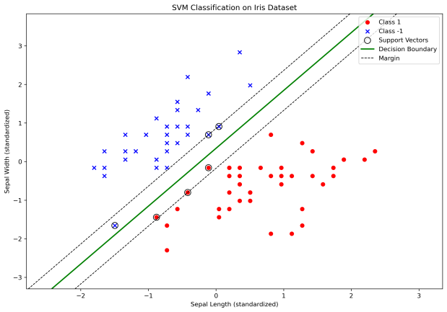
C = 100：
Optimal alpha values:
[0. 0. 0. 0. 0. 0.
0. 0. 0. 0. 0. 0.
0. 0. 0. 0. 0. 0.
0. 0. 0. 0. 0. 0.
0. 0. 0. 0. 0. 0.
0. 0. 0. 0. 0. 0.
0. 0. 0.05291952 0. 0. 0.
0. 0. 0. 0. 0. 0.
0. 0. 0. 2.56743701 0. 0.
0. 0.26076718 0. 0. 0. 1.45913921
0. 6.10152359 0. 0. 0. 0.
0. 0. 0. 0. 0. 0.
0. 0. 5.19794326 0. 0. 0.
0. 0. ]
Decision function parameters (w): [ 2.89603086 -1.93096476]
Bias term (b): 0.6650965214767091
Support vectors count: 6
Test Accuracy: 1.0000
在软间隔SVM中，参数C控制分类器的严格程度：
C越小（如0.01），允许更多训练误差，拉格朗日乘子α普遍较小（接近0或C），支持向量数量多，决策边界较平滑，间隔较宽但可能欠拟合。
C越大（如100），惩罚误分类更严厉，α中非零值更多（接近C），支持向量减少且多为边界或误分类点，决策边界更复杂，间隔变窄但可能过拟合。

SMO算法：

