决策树
题目一：
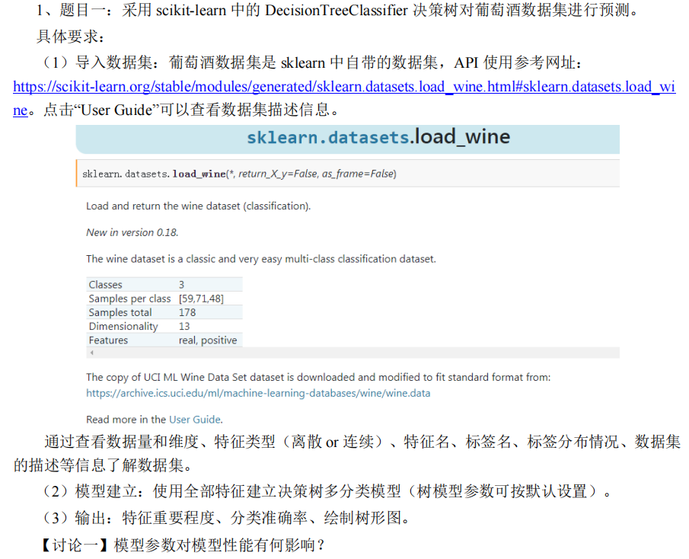
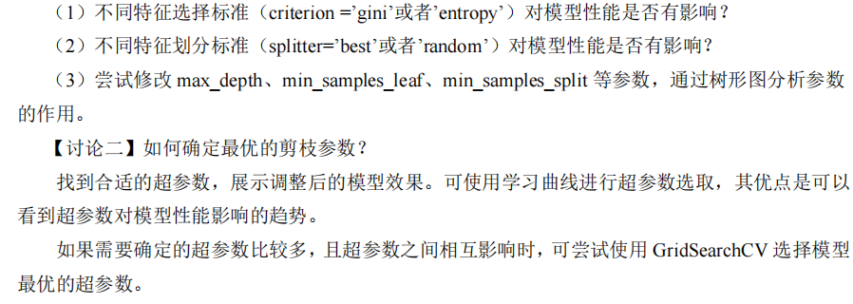

代码：
from sklearn.datasets import load_wine
from sklearn.model_selection import train_test_split, validation_curve, GridSearchCV
from sklearn.tree import DecisionTreeClassifier, export_graphviz
from sklearn.metrics import accuracy_score
import numpy as np
import matplotlib.pyplot as plt
import matplotlib.gridspec as gridspec
import graphviz
import os
import pandas as pd
from matplotlib.colors import LinearSegmentedColormap
import seaborn as sns

# 设置图形样式
sns.set_theme(style="whitegrid")

# 加载葡萄酒数据集
data = load_wine()
X = data.data
y = data.target
feature_names = data.feature_names
target_names = data.target_names

# 划分训练集和测试集
X_train, X_test, y_train, y_test = train_test_split(X, y, test_size=0.2, random_state=42)

# --- 默认参数模型 ---
print("\n===== Default Model =====")
dt_default = DecisionTreeClassifier(random_state=42)
dt_default.fit(X_train, y_train)
acc_default = accuracy_score(y_test, dt_default.predict(X_test))
print(f"Default model test accuracy: {acc_default:.4f}")

# 生成默认决策树可视化
print("Generating default decision tree visualization...")
dot_data = export_graphviz(dt_default, out_file=None,
feature_names=feature_names,
class_names=target_names,
filled=True, rounded=True,
special_characters=True)
graph = graphviz.Source(dot_data)
graph.render('decision_tree_default', format='png', cleanup=True)
print("Default decision tree saved as 'decision_tree_default.png'")

# --- 特征选择标准分析 ---
print("\n===== Criterion Analysis =====")
criterion_results = {}
for criterion in ['gini', 'entropy']:
dt = DecisionTreeClassifier(criterion=criterion, random_state=42)
dt.fit(X_train, y_train)
acc = accuracy_score(y_test, dt.predict(X_test))
criterion_results[criterion] = acc
print(f"Criterion='{criterion}': Accuracy = {acc:.4f}")

# --- 特征划分标准分析 ---
print("\n===== Splitter Analysis =====")
splitter_results = {}
for splitter in ['best', 'random']:
dt = DecisionTreeClassifier(splitter=splitter, random_state=42)
dt.fit(X_train, y_train)
acc = accuracy_score(y_test, dt.predict(X_test))
splitter_results[splitter] = acc
print(f"Splitter='{splitter}': Accuracy = {acc:.4f}")

# --- 参数分析函数 ---
def visualize_tree(params, filename):
"""生成决策树可视化并保存"""
dt = DecisionTreeClassifier(**params, random_state=42)
dt.fit(X_train, y_train)

dot_data = export_graphviz(dt, out_file=None,
feature_names=feature_names,
class_names=target_names,
filled=True, rounded=True,
special_characters=True)
graph = graphviz.Source(dot_data)
graph.render(filename, format='png', cleanup=True)
return plt.imread(f'{filename}.png')

def analyze_parameter(param_name, values):
print(f"\n===== {param_name} Analysis =====")

# 创建图像布局
fig = plt.figure(figsize=(40, 24 * len(values)))
gs = gridspec.GridSpec(len(values), 2, figure=fig)

# 结果保存字典
results = {}

for i, value in enumerate(values):
# 创建决策树模型
params = {param_name: value}
dt = DecisionTreeClassifier(**params, random_state=42)
dt.fit(X_train, y_train)

# 计算准确率
acc = accuracy_score(y_test, dt.predict(X_test))
results[value] = acc
print(f"{param_name}={value}: Accuracy={acc:.4f}")

# 创建决策树可视化
filename = f'{param_name}_{value}'.replace("None", "unlimited")
img = visualize_tree(params, filename)

# 添加到图像
ax_img = fig.add_subplot(gs[i, 0])
ax_img.imshow(img)
ax_img.axis('off')
title_val = "unlimited" if value is None else str(value)
ax_img.set_title(f'{param_name}={title_val}\nAccuracy: {acc:.4f}', fontsize=14)

# 添加特征重要性
ax_imp = fig.add_subplot(gs[i, 1])
importances = dt.feature_importances_
sorted_idx = np.argsort(importances)
y_pos = np.arange(len(feature_names))

ax_imp.barh(y_pos, importances[sorted_idx])
ax_imp.set_yticks(y_pos)
ax_imp.set_yticklabels(np.array(feature_names)[sorted_idx])
ax_imp.set_title(f'Feature Importance ({title_val})', fontsize=14)
ax_imp.grid(axis='x', linestyle='--', alpha=0.6)

# 保存对比图
plt.tight_layout()
fig.savefig(f'{param_name}_comparison.png', bbox_inches='tight')
plt.close(fig)
return results

# 分析不同参数
depth_results = analyze_parameter('max_depth', [None, 3, 5, 10])
leaf_results = analyze_parameter('min_samples_leaf', [1, 5, 10, 20])
split_results = analyze_parameter('min_samples_split', [2, 5, 10, 20])

# --- 参数性能比较分析 ---
def plot_parameter_impact():
# 创建图像
fig = plt.figure(figsize=(18, 12))
gs = gridspec.GridSpec(3, 2, figure=fig)

# 默认模型信息
ax_info = fig.add_subplot(gs[0, 0])
ax_info.text(0.1, 0.7, "Default Model Performance", fontsize=16, weight='bold')
ax_info.text(0.1, 0.6, f"Accuracy: {acc_default:.4f}", fontsize=14)

# 添加默认决策树的小预览图
img_default = plt.imread('decision_tree_default.png')
ax_preview = fig.add_subplot(gs[0, 1])
ax_preview.imshow(img_default)
ax_preview.axis('off')
ax_preview.set_title('Default Decision Tree Preview', fontsize=14)

# Criterion 影响
ax_crit = fig.add_subplot(gs[1, 0])
criteria = list(criterion_results.keys())
accuracies = [criterion_results[c] for c in criteria]
bars = ax_crit.bar(criteria, accuracies, color=['dodgerblue', 'mediumseagreen'])
ax_crit.set_title('Criterion Impact on Accuracy', fontsize=14)
ax_crit.set_ylabel('Accuracy', fontsize=12)
ax_crit.set_ylim(0.8, 1.0)
for bar, acc in zip(bars, accuracies):
height = bar.get_height()
ax_crit.text(bar.get_x() + bar.get_width() / 2., height + 0.01,
f'{acc:.4f}', ha='center', va='bottom', fontsize=12)

# Splitter 影响
ax_split = fig.add_subplot(gs[1, 1])
splitters = list(splitter_results.keys())
accuracies = [splitter_results[s] for s in splitters]
bars = ax_split.bar(splitters, accuracies, color=['dodgerblue', 'mediumseagreen'])
ax_split.set_title('Splitter Impact on Accuracy', fontsize=14)
ax_split.set_ylabel('Accuracy', fontsize=12)
ax_split.set_ylim(0.8, 1.0)
for bar, acc in zip(bars, accuracies):
height = bar.get_height()
ax_split.text(bar.get_x() + bar.get_width() / 2., height + 0.01,
f'{acc:.4f}', ha='center', va='bottom', fontsize=12)

# max_depth 影响
ax_depth = fig.add_subplot(gs[2, 0])
depths = [None, 3, 5, 10]
labels = ['unlimited', '3', '5', '10']
accuracies = [depth_results[d] for d in depths]
bars = ax_depth.bar(labels, accuracies, color=['purple', 'darkorange', 'red', 'brown'])
ax_depth.set_title('max_depth Impact on Accuracy', fontsize=14)
ax_depth.set_xlabel('max_depth', fontsize=12)
ax_depth.set_ylabel('Accuracy', fontsize=12)
ax_depth.set_ylim(0.8, 1.0)
for bar, acc in zip(bars, accuracies):
height = bar.get_height()
ax_depth.text(bar.get_x() + bar.get_width() / 2., height + 0.01,
f'{acc:.4f}', ha='center', va='bottom', fontsize=12)

# min_samples_leaf 和 min_samples_split 比较
ax_leaf_split = fig.add_subplot(gs[2, 1])
leaf_labels = ['1', '5', '10', '20']
leaf_acc = [leaf_results[1], leaf_results[5], leaf_results[10], leaf_results[20]]
split_acc = [split_results[2], split_results[5], split_results[10], split_results[20]]

x = np.arange(len(leaf_labels))
width = 0.35
bar1 = ax_leaf_split.bar(x - width / 2, leaf_acc, width, label='min_samples_leaf', color='dodgerblue')
bar2 = ax_leaf_split.bar(x + width / 2, split_acc, width, label='min_samples_split', color='mediumseagreen')

ax_leaf_split.set_title('Leaf vs Split Parameters Impact', fontsize=14)
ax_leaf_split.set_ylabel('Accuracy', fontsize=12)
ax_leaf_split.set_xticks(x)
ax_leaf_split.set_xticklabels(leaf_labels)
ax_leaf_split.legend(fontsize=12)
ax_leaf_split.set_ylim(0.8, 1.0)

# 添加数值标签
for rect in bar1:
height = rect.get_height()
ax_leaf_split.text(rect.get_x() + rect.get_width() / 2., height + 0.01,
f'{height:.4f}', ha='center', va='bottom', fontsize=11)
for rect in bar2:
height = rect.get_height()
ax_leaf_split.text(rect.get_x() + rect.get_width() / 2., height + 0.01,
f'{height:.4f}', ha='center', va='bottom', fontsize=11)

plt.tight_layout()
plt.savefig('parameter_impacts.png', dpi=150, bbox_inches='tight')
plt.close()

# 绘制参数影响图
plot_parameter_impact()

# --- 网格搜索寻找最优参数 ---
print("\n===== Grid Search Optimization =====")
param_grid = {
'criterion': ['gini', 'entropy'],
'splitter': ['best', 'random'],
'max_depth': [None, 3, 5, 7, 10],
'min_samples_split': [2, 5, 10],
'min_samples_leaf': [1, 2, 5],
}

grid_search = GridSearchCV(
estimator=DecisionTreeClassifier(random_state=42),
param_grid=param_grid,
cv=5,
scoring='accuracy',
n_jobs=-1,
verbose=1
)

grid_search.fit(X_train, y_train)

# 输出最佳参数和准确率
best_params = grid_search.best_params_
best_acc = grid_search.best_score_
print(f"Best parameters found: {best_params}")
print(f"Best cross-validation accuracy: {best_acc:.4f}")

# 使用最优参数重新训练模型
dt_optimized = DecisionTreeClassifier(**best_params, random_state=42)
dt_optimized.fit(X_train, y_train)
test_acc = accuracy_score(y_test, dt_optimized.predict(X_test))
print(f"Optimized model test accuracy: {test_acc:.4f}")
print(f"Accuracy improvement: {test_acc - acc_default:.4f}")

# --- 可视化网格搜索结果 ---
print("\nVisualizing GridSearch results...")
results = pd.DataFrame(grid_search.cv_results_)

# 创建参数组合字符串
results['params_str'] = results['params'].apply(
lambda x: f"cri={x['criterion'][0]}, spl={x['splitter']}\n"
f"dep={str(x['max_depth']) if x['max_depth'] else 'None'}, "
f"msl={x['min_samples_leaf']}, mss={x['min_samples_split']}")

# 按分数排序并取前15名
top_results = results.sort_values('mean_test_score', ascending=False)# .head(15)

# 创建柱状图
plt.figure(figsize=(10, 60 ))
cmap = LinearSegmentedColormap.from_list("custom", ["#e74c3c", "#3498db", "#2ecc71"])
colors = cmap(np.linspace(0, 1, len(top_results)))

bars = plt.barh(top_results['params_str'], top_results['mean_test_score'], color=colors)
plt.xlabel('Average Validation Accuracy', fontsize=12)
plt.title('Top GridSearch Parameter Combinations', fontsize=14, weight='bold')
plt.grid(axis='x', linestyle='--', alpha=0.6)

# 添加数值标签
for bar in bars:
width = bar.get_width()
plt.text(width + 0.005, bar.get_y() + bar.get_height() / 2,
f'{width:.4f}',
va='center', fontsize=10)

plt.tight_layout()
plt.savefig('grid_search_top_results.png', dpi=150, bbox_inches='tight')
plt.close()

# 创建热力图（主要参数）
heatmap_data = results.pivot_table(index='param_max_depth',
columns=['param_min_samples_leaf', 'param_min_samples_split'],
values='mean_test_score',
fill_value=0)

# 重命名行索引
heatmap_data.index = heatmap_data.index.fillna('None').astype(str)

plt.figure(figsize=(24, 16))
sns.heatmap(heatmap_data, annot=True, fmt=".3f", cmap="YlGnBu",
cbar_kws={'label': 'Average Accuracy'})
plt.title('GridSearch Accuracy Heatmap\n(criterion=gini, splitter=best)', fontsize=14)
plt.xlabel('min_samples_leaf, min_samples_split', fontsize=12)
plt.ylabel('max_depth', fontsize=12)
plt.tight_layout()
plt.savefig('grid_search_heatmap.png', dpi=150, bbox_inches='tight')
plt.close()

# --- 最终优化模型分析 ---
print("\n===== Optimized Model =====")
print(f"Test Accuracy: {test_acc:.4f}")

# 输出特征重要性
print("\nFeature importances:")
importances = dt_optimized.feature_importances_
feature_imp = pd.DataFrame({'Feature': feature_names, 'Importance': importances})
feature_imp = feature_imp.sort_values('Importance', ascending=False)
print(feature_imp.to_string(index=False))

# 创建特征重要性图
plt.figure(figsize=(20, 12))
sns.barplot(x='Importance', y='Feature', data=feature_imp, palette='viridis')
plt.title('Optimized Model Feature Importance', fontsize=14)
plt.xlabel('Importance', fontsize=12)
plt.ylabel('')
plt.tight_layout()
plt.savefig('optimized_feature_importance.png', dpi=150, bbox_inches='tight')
plt.close()

# 创建优化决策树可视化
print("\nGenerating optimized decision tree visualization...")
dot_data = export_graphviz(dt_optimized, out_file=None,
feature_names=feature_names,
class_names=target_names,
filled=True, rounded=True,
special_characters=True)
graph = graphviz.Source(dot_data)
graph.render('optimized_decision_tree', format='png', cleanup=True)

print("\nAll operations completed successfully!")
print("Key outputs saved:")
print("1. Default decision tree: 'decision_tree_default.png'")
print("2. Parameter analysis: 'parameter_impacts.png'")
print("3. GridSearch results:")
print(" - 'grid_search_top_results.png' (top 15 parameter combinations)")
print(" - 'grid_search_heatmap.png' (accuracy heatmap)")
print("4. Optimized model:")
print(" - 'optimized_decision_tree.png'")
print(" - 'optimized_feature_importance.png'")

结果：
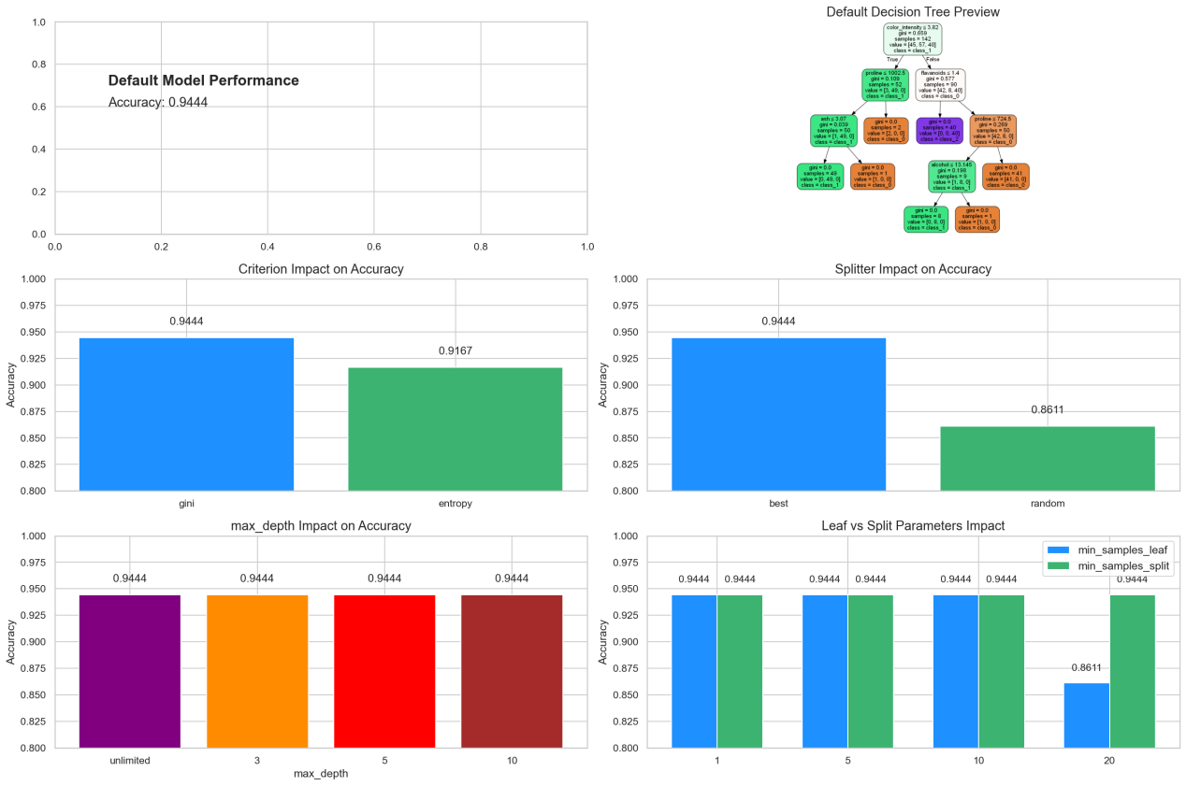===== Default Model =====
Default model test accuracy: 0.9444

===== Criterion Analysis =====
Criterion='gini': Accuracy = 0.9444
Criterion='entropy': Accuracy = 0.9167

===== Splitter Analysis =====
Splitter='best': Accuracy = 0.9444
Splitter='random': Accuracy = 0.8611

===== max_depth Analysis =====
max_depth=None: Accuracy=0.9444
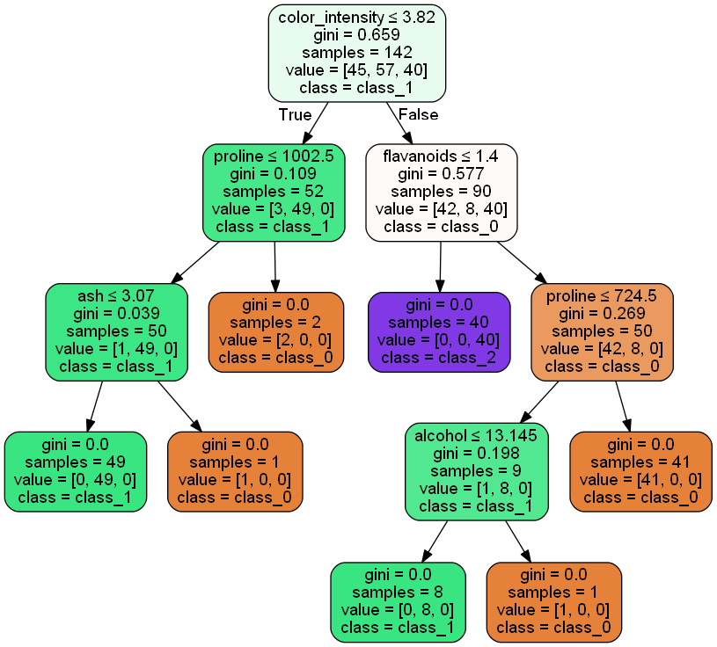

max_depth=3: Accuracy=0.9444
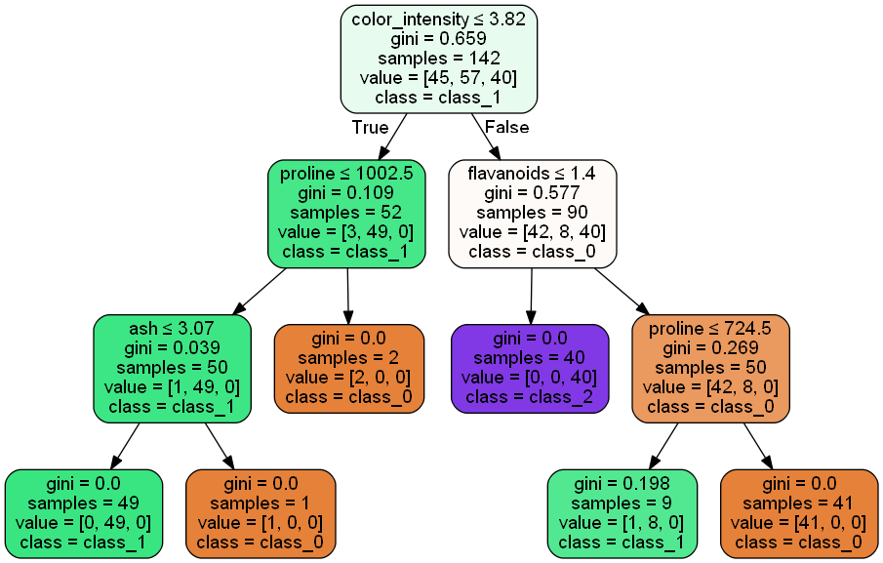
max_depth=5: Accuracy=0.9444

max_depth=10: Accuracy=0.9444

max_depth在本实验中影响不大，或者说没有什么影响

===== min_samples_leaf Analysis =====
min_samples_leaf=1: Accuracy=0.9444

min_samples_leaf=5: Accuracy=0.9444
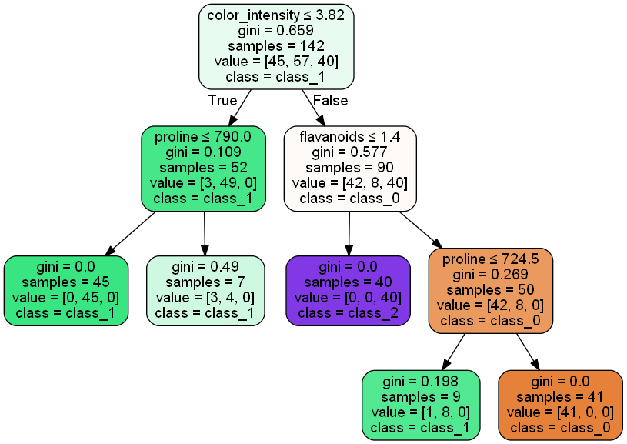
min_samples_leaf=10: Accuracy=0.9444
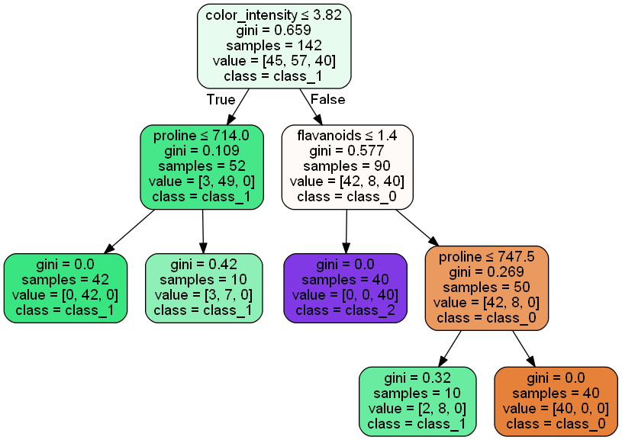
min_samples_leaf=20: Accuracy=0.8611
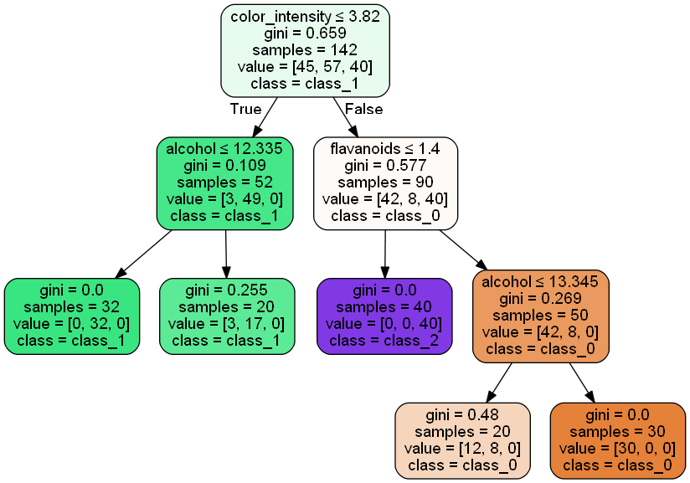
min_samples_leaf（叶子节点所需的最小样本数）过大有欠拟合风险

===== min_samples_split Analysis =====
min_samples_split=2: Accuracy=0.9444

min_samples_split=5: Accuracy=0.9444

min_samples_split=10: Accuracy=0.9444

min_samples_split=20: Accuracy=0.9444

min_samples_split（分裂节点所需的最小样本数）对本实验没啥影响

===== Grid Search Optimization =====
Fitting 5 folds for each of 180 candidates, totalling 900 fits
Best parameters found: {'criterion': 'entropy', 'max_depth': None, 'min_samples_leaf': 2, 'min_samples_split': 2, 'splitter': 'random'}
Best cross-validation accuracy: 0.9296
Optimized model test accuracy: 0.8889
Accuracy improvement: -0.0556
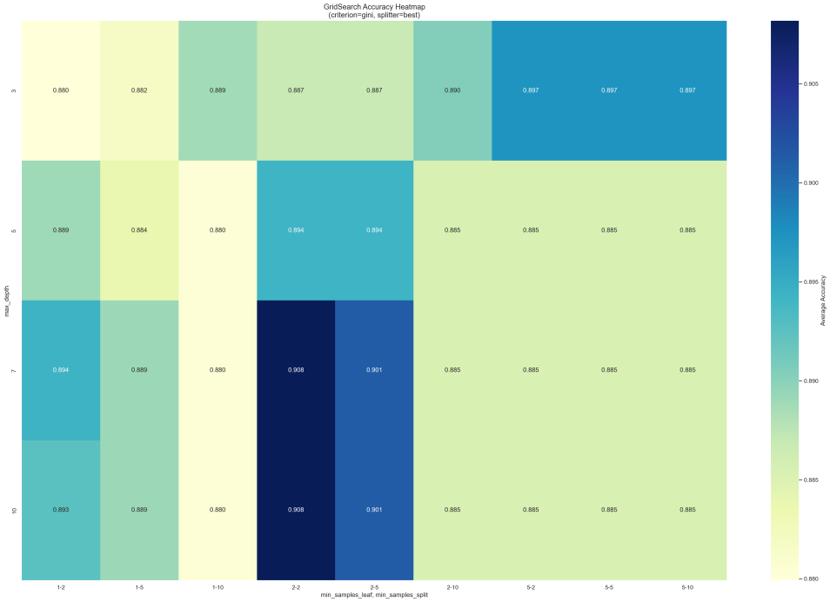
过拟合问题：网格搜索找到的参数组合：max_depth=None + min_samples_leaf=2 + min_samples_split=2，创建了非常复杂的树，从下面的决策树可以看得出。
===== Optimized Model =====
Test Accuracy: 0.8889
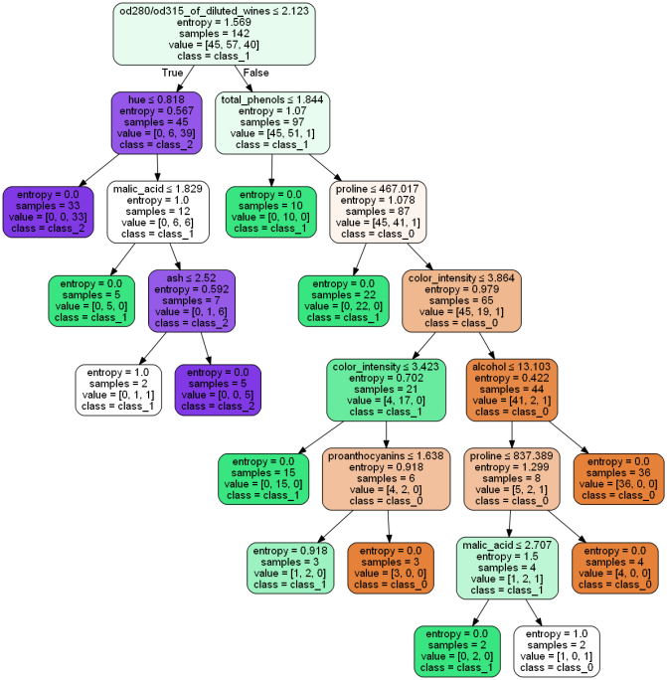
Feature importances:
Feature Importance
od280/od315_of_diluted_wines 0.432922
color_intensity 0.183057
proline 0.159813
hue 0.062460
malic_acid 0.054893
total_phenols 0.046390
alcohol 0.037797
proanthocyanins 0.012753
ash 0.009914
magnesium 0.000000
alcalinity_of_ash 0.000000
nonflavanoid_phenols 0.000000
flavanoids 0.000000
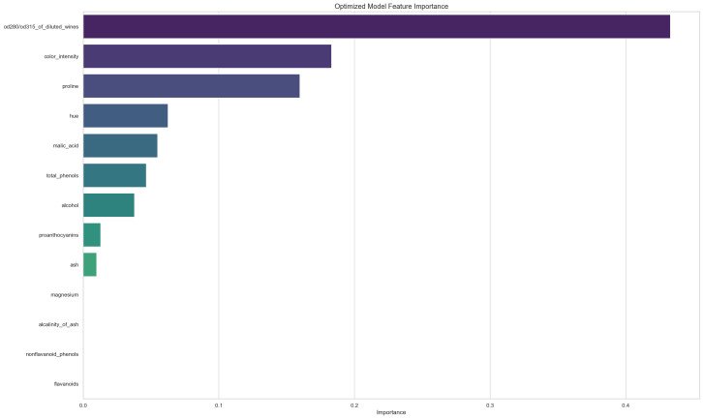

题目二：
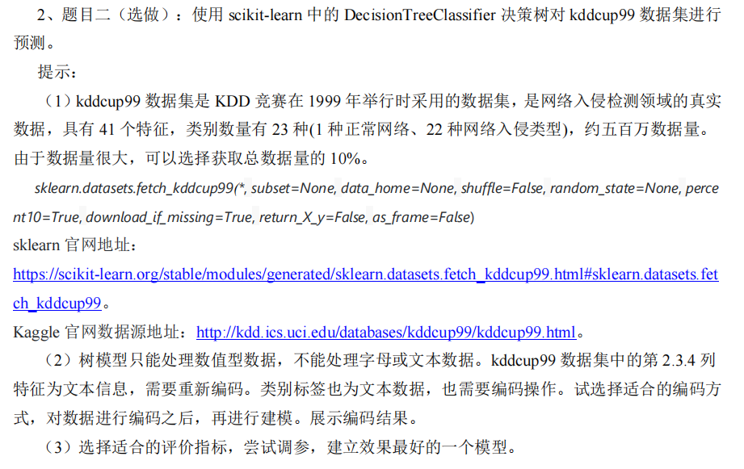

代码：
import numpy as np
from sklearn.datasets import fetch_kddcup99
from sklearn.model_selection import train_test_split, RandomizedSearchCV
from sklearn.preprocessing import OrdinalEncoder, LabelEncoder
from sklearn.tree import DecisionTreeClassifier, export_graphviz
from sklearn.metrics import classification_report, f1_score
from scipy.stats import randint
import graphviz
import matplotlib.pyplot as plt

# 加载数据集（仅取10%）
dataset = fetch_kddcup99(percent10=True, shuffle=True, random_state=42)
X, y = dataset.data, dataset.target
y = y.squeeze()

# 识别文本特征列（索引1,2,3）并进行序号编码
text_columns = [1, 2, 3]
encoder = OrdinalEncoder(handle_unknown='use_encoded_value', unknown_value=-1)
X_text = X[:, text_columns]
X_text_encoded = encoder.fit_transform(X_text)

# 组合处理后的数据：非文本特征 + 编码后的文本特征
non_text_indices = [i for i in range(X.shape[1]) if i not in text_columns]
X_non_text = X[:, non_text_indices].astype(float)
X_processed = np.hstack((X_non_text, X_text_encoded))

# 标签编码
label_encoder = LabelEncoder()
y_encoded = label_encoder.fit_transform(y)

# 划分训练集和测试集
X_train, X_test, y_train, y_test = train_test_split(
X_processed, y_encoded, test_size=0.2, random_state=42, stratify=y_encoded
)

# 定义决策树参数搜索空间
param_dist = {
'max_depth': randint(15, 50),
'min_samples_split': randint(2, 20),
'min_samples_leaf': randint(1, 10),
'criterion': ['gini', 'entropy'],
'max_features': ['sqrt', 'log2', None]
}

# 创建模型并进行随机搜索
model = DecisionTreeClassifier(random_state=42)
random_search = RandomizedSearchCV(
model, param_distributions=param_dist, n_iter=20,
scoring='f1_macro', n_jobs=-1, cv=3, random_state=42
)
random_search.fit(X_train, y_train)

# 获取最佳模型并测试
best_model = random_search.best_estimator_
y_pred = best_model.predict(X_test)

# 获取所有可能的类别标签
all_labels = np.arange(len(label_encoder.classes_))

# 输出评估报告
target_names = [str(name) for name in label_encoder.classes_]
print("Best Parameters:", random_search.best_params_)
print("\nClassification Report:")
print(classification_report(
y_test, y_pred,
labels=all_labels,
target_names=target_names,
zero_division=0
))
print(f"Macro F1-Score: {f1_score(y_test, y_pred, average='macro'):.4f}")

# 创建特征名称列表（直接使用字符串）
feature_names = []
for i in range(len(dataset.feature_names)):
if i not in text_columns:
feature_names.append(f"feature_{i}")
else:
feature_names.append(dataset.feature_names[i])

# 导出决策树为Graphviz格式
dot_data = export_graphviz(
best_model,
out_file=None,
feature_names=feature_names,
class_names=target_names,
filled=True,
rounded=True,
special_characters=True
)

# 修改dot_data使其从左到右排列
# 在开头添加全局设置
dot_data = "digraph Tree {\n" \
"node [shape=box, style=\"filled, rounded\", color=\"black\", fontname=helvetica] ;\n" \
"edge [fontname=helvetica] ;\n" \
"rankdir=LR ;\n" + dot_data.split('digraph Tree {', 1)[-1]

# 创建图形并保存
graph = graphviz.Source(dot_data)
graph.render("best_decision_tree", format='png', cleanup=True)
print("Decision tree visualization saved as 'best_decision_tree.png'")

# 打印编码映射信息
print("\nFeature Encodings:")
for i, col_idx in enumerate(text_columns):
categories = encoder.categories_[i]
print(f"Column {col_idx} ({dataset.feature_names[col_idx]}):")
for code, name in enumerate(categories):
# 检查是否需要解码字节串
if isinstance(name, bytes):
name = name.decode('utf-8')
print(f" {code} -> {name}")

print("\nLabel Encodings:")
for code, name in enumerate(label_encoder.classes_):
# 检查是否需要解码字节串
if isinstance(name, bytes):
name = name.decode('utf-8')
print(f" {code} -> {name}")

# 计算特征重要性
importances = best_model.feature_importances_
indices = np.argsort(importances)[::-1][:15] # 取前15个重要特征

# 打印最重要的特征
print("\nTop feature importances:")
for f in range(len(indices)):
print(f"{f+1}. Feature '{feature_names[indices[f]]}' (index {indices[f]}): {importances[indices[f]]:.4f}")

# 绘制特征重要性条形图
plt.figure(figsize=(12, 8))
plt.title("Top 15 Feature Importances")
plt.bar(range(len(indices)), importances[indices], align="center")
plt.xticks(range(len(indices)), [feature_names[i] for i in indices], rotation=45, ha="right")
plt.xlabel("Feature")
plt.ylabel("Importance")
plt.tight_layout()
plt.savefig("feature_importances.png")
print("Feature importance plot saved as 'feature_importances.png'")

结果：
使用了RandomizedSearchCV
Best Parameters: {'criterion': 'entropy', 'max_depth': 43, 'max_features': None, 'min_samples_leaf': 2, 'min_samples_split': 13}
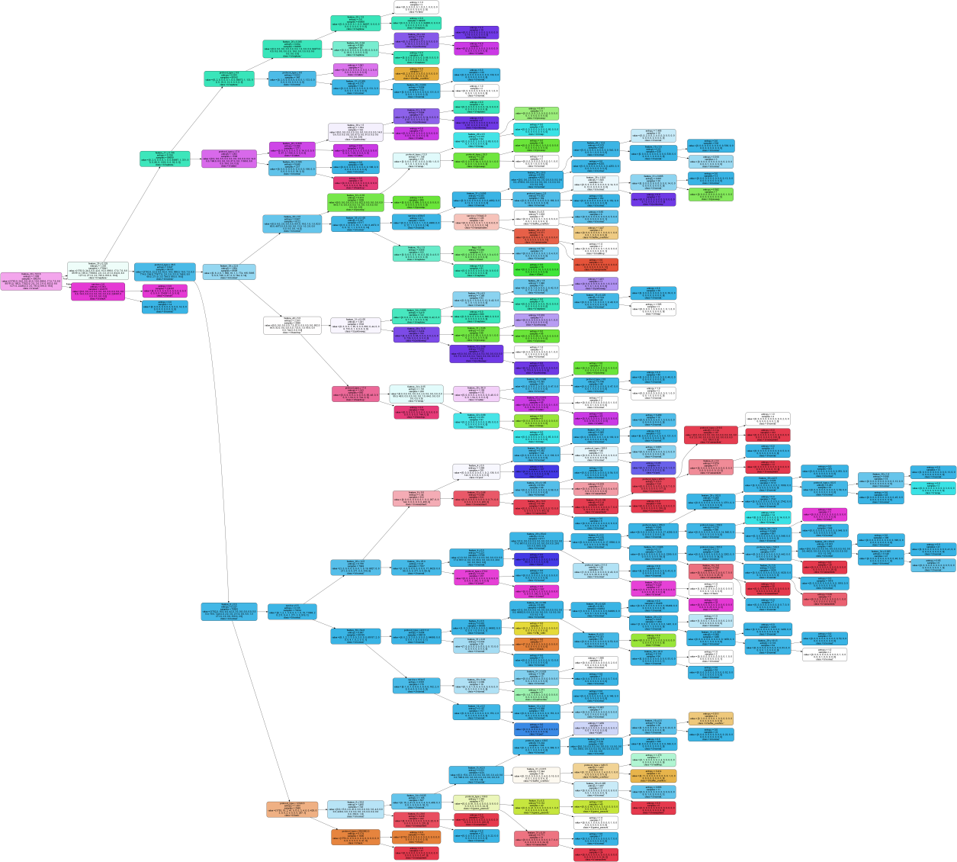

Classification Report:
precision recall f1-score support

b'back.' 1.00 1.00 1.00 441
b'buffer_overflow.' 0.80 0.67 0.73 6
b'ftp_write.' 0.00 0.00 0.00 2
b'guess_passwd.' 1.00 1.00 1.00 11
b'imap.' 1.00 1.00 1.00 2
b'ipsweep.' 0.99 1.00 1.00 249
b'land.' 1.00 0.50 0.67 4
b'loadmodule.' 0.00 0.00 0.00 2
b'multihop.' 0.00 0.00 0.00 1
b'neptune.' 1.00 1.00 1.00 21440
b'nmap.' 0.98 0.96 0.97 46
b'normal.' 1.00 1.00 1.00 19456
b'perl.' 1.00 1.00 1.00 1
b'phf.' 1.00 1.00 1.00 1
b'pod.' 1.00 1.00 1.00 53
b'portsweep.' 1.00 0.99 0.99 208
b'rootkit.' 0.00 0.00 0.00 2
b'satan.' 1.00 0.98 0.99 318
b'smurf.' 1.00 1.00 1.00 56158
b'spy.' 0.00 0.00 0.00 0
b'teardrop.' 0.98 1.00 0.99 196
b'warezclient.' 0.97 0.99 0.98 204
b'warezmaster.' 1.00 0.75 0.86 4

accuracy 1.00 98805
macro avg 0.77 0.73 0.75 98805
weighted avg 1.00 1.00 1.00 98805

Macro F1-Score: 0.7804

Feature Encodings:
Column 1 (protocol_type):
0 -> icmp
1 -> tcp
2 -> udp
Column 2 (service):
0 -> IRC
1 -> X11
2 -> Z39_50
3 -> auth
4 -> bgp
5 -> courier
6 -> csnet_ns
7 -> ctf
8 -> daytime
9 -> discard
10 -> domain
11 -> domain_u
12 -> echo
13 -> eco_i
14 -> ecr_i
15 -> efs
16 -> exec
17 -> finger
18 -> ftp
19 -> ftp_data
20 -> gopher
21 -> hostnames
22 -> http
23 -> http_443
24 -> imap4
25 -> iso_tsap
26 -> klogin
27 -> kshell
28 -> ldap
29 -> link
30 -> login
31 -> mtp
32 -> name
33 -> netbios_dgm
34 -> netbios_ns
35 -> netbios_ssn
36 -> netstat
37 -> nnsp
38 -> nntp
39 -> ntp_u
40 -> other
41 -> pm_dump
42 -> pop_2
43 -> pop_3
44 -> printer
45 -> private
46 -> red_i
47 -> remote_job
48 -> rje
49 -> shell
50 -> smtp
51 -> sql_net
52 -> ssh
53 -> sunrpc
54 -> supdup
55 -> systat
56 -> telnet
57 -> tftp_u
58 -> tim_i
59 -> time
60 -> urh_i
61 -> urp_i
62 -> uucp
63 -> uucp_path
64 -> vmnet
65 -> whois
Column 3 (flag):
0 -> OTH
1 -> REJ
2 -> RSTO
3 -> RSTOS0
4 -> RSTR
5 -> S0
6 -> S1
7 -> S2
8 -> S3
9 -> SF
10 -> SH

Label Encodings:
0 -> back.
1 -> buffer_overflow.
2 -> ftp_write.
3 -> guess_passwd.
4 -> imap.
5 -> ipsweep.
6 -> land.
7 -> loadmodule.
8 -> multihop.
9 -> neptune.
10 -> nmap.
11 -> normal.
12 -> perl.
13 -> phf.
14 -> pod.
15 -> portsweep.
16 -> rootkit.
17 -> satan.
18 -> smurf.
19 -> spy.
20 -> teardrop.
21 -> warezclient.
22 -> warezmaster.

Top feature importances:
1. Feature 'feature_20' (index 20): 0.6285
2. Feature 'feature_25' (index 25): 0.2605
3. Feature 'protocol_type' (index 1): 0.0316
4. Feature 'feature_31' (index 31): 0.0194
5. Feature 'feature_6' (index 6): 0.0194
6. Feature 'feature_39' (index 39): 0.0097
7. Feature 'feature_38' (index 38): 0.0065
8. Feature 'service' (index 2): 0.0062
9. Feature 'feature_28' (index 28): 0.0040
10. Feature 'feature_40' (index 40): 0.0037
11. Feature 'feature_19' (index 19): 0.0024
12. Feature 'feature_4' (index 4): 0.0013
13. Feature 'feature_34' (index 34): 0.0012
14. Feature 'feature_8' (index 8): 0.0011
15. Feature 'feature_35' (index 35): 0.0011
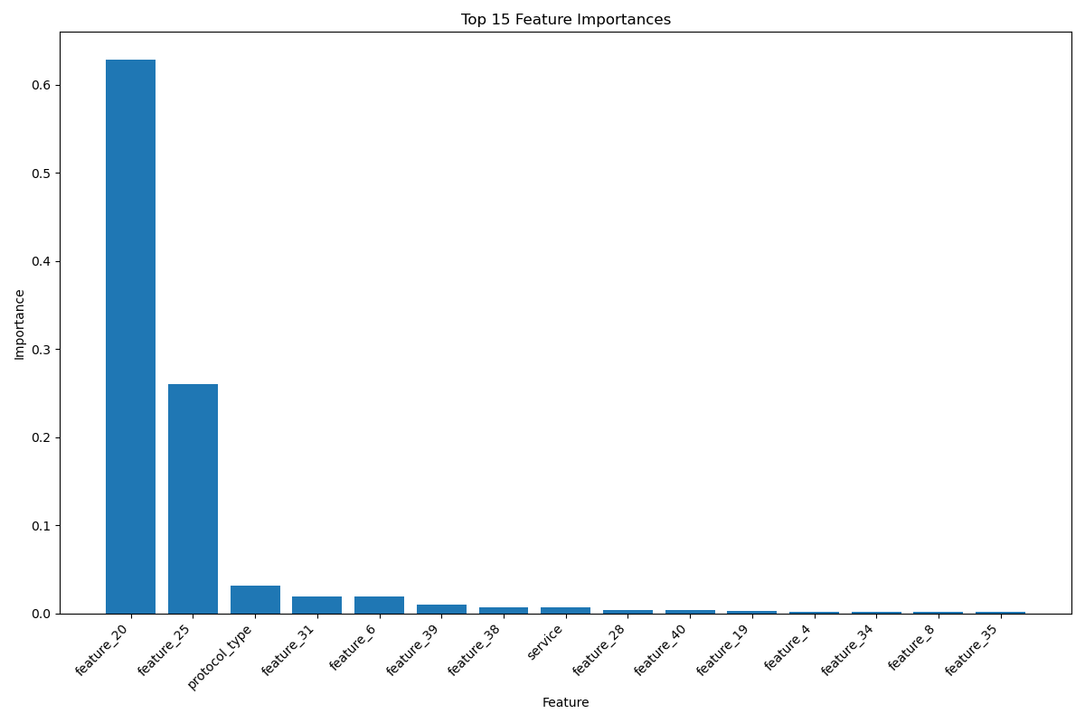
题目三：
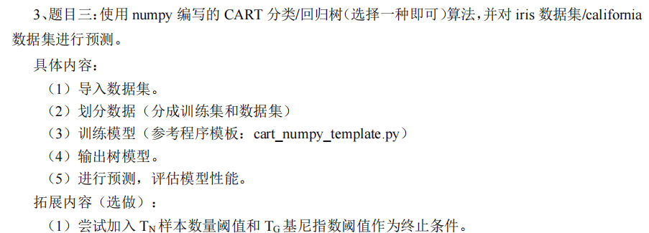

代码：
import numpy as np
import matplotlib.pyplot as plt
from sklearn.datasets import load_iris, fetch_california_housing
from sklearn.model_selection import train_test_split
from sklearn.metrics import accuracy_score, mean_squared_error
import graphviz
from graphviz import Digraph

class TreeNode:
def __init__(self, feature_idx=None, feature_name=None, threshold=None,
value=None, left=None, right=None, n_samples=None, impurity=None,
feature_type='numeric'):
self.feature_idx = feature_idx
self.feature_name = feature_name
self.threshold = threshold
self.value = value
self.left = left
self.right = right
self.n_samples = n_samples
self.impurity = impurity
self.feature_type = feature_type

class CARTClassifier:
def __init__(self, min_samples_split=2, min_impurity=1e-7, max_depth=None, tree_type='cls'):
self.min_samples_split = min_samples_split
self.min_impurity = min_impurity
self.max_depth = max_depth
self.root = None
self.feature_names = None
self.tree_type = tree_type

def _calculate_impurity(self, y):
if len(y) == 0:
return 0

if self.tree_type == 'cls':
classes, counts = np.unique(y, return_counts=True)
probabilities = counts / len(y)
return 1.0 - np.sum(probabilities ** 2)
else:
if len(y) == 0:
return 0
return np.mean((y - np.mean(y)) ** 2)

def _best_split(self, X, y):
m, n = X.shape
best_impurity = float('inf')
best_feature_idx, best_threshold = None, None

current_impurity = self._calculate_impurity(y)
if (len(y) < self.min_samples_split or
current_impurity < self.min_impurity or
len(np.unique(y)) == 1):
return None, None, current_impurity

for feature_idx in range(n):
values = X[:, feature_idx]
unique_values = np.unique(values)

for threshold in unique_values:
if isinstance(values[0], (int, float, np.number)):
left_mask = values <= threshold
else:
left_mask = values == threshold

right_mask = ~left_mask

if np.sum(left_mask) == 0 or np.sum(right_mask) == 0:
continue

y_left = y[left_mask]
y_right = y[right_mask]

impurity_left = self._calculate_impurity(y_left)
impurity_right = self._calculate_impurity(y_right)

w_left = len(y_left) / m
w_right = len(y_right) / m
w_impurity = w_left * impurity_left + w_right * impurity_right

if w_impurity < best_impurity:
best_impurity = w_impurity
best_feature_idx = feature_idx
best_threshold = threshold

return best_feature_idx, best_threshold, best_impurity

def _build_tree(self, X, y, depth=0):
n_samples = len(y)
impurity = self._calculate_impurity(y)

if self.tree_type == 'cls':
unique_classes, counts = np.unique(y, return_counts=True)
class_probs = counts / n_samples
dominant_class = unique_classes[np.argmax(counts)]
node_value = dominant_class
else:
node_value = np.mean(y) if n_samples > 0 else 0

if (self.max_depth is not None and depth >= self.max_depth) or \
n_samples < self.min_samples_split or \
impurity < self.min_impurity or \
len(np.unique(y)) == 1:
return TreeNode(
value=node_value,
n_samples=n_samples,
impurity=impurity
)

feature_idx, threshold, best_impurity = self._best_split(X, y)
if feature_idx is None:
return TreeNode(
value=node_value,
n_samples=n_samples,
impurity=impurity
)

feature_type = 'numeric' if isinstance(X[0, feature_idx], (int, float, np.number)) else 'categorical'
node = TreeNode(
feature_idx=feature_idx,
threshold=threshold,
n_samples=n_samples,
impurity=impurity,
feature_type=feature_type
)

if self.feature_names is not None:
node.feature_name = self.feature_names[feature_idx]

if feature_type == 'numeric':
left_mask = X[:, feature_idx] <= threshold
else:
left_mask = X[:, feature_idx] == threshold

right_mask = ~left_mask

node.left = self._build_tree(X[left_mask], y[left_mask], depth + 1)
node.right = self._build_tree(X[right_mask], y[right_mask], depth + 1)

return node

def fit(self, X, y, feature_names=None):
self.feature_names = feature_names
self.root = self._build_tree(np.array(X), np.array(y))

def _predict_one(self, x, node):
if node.value is not None:
return node.value

if node.feature_idx is not None and node.feature_type == 'numeric':
if x[node.feature_idx] <= node.threshold:
return self._predict_one(x, node.left)
return self._predict_one(x, node.right)

if node.feature_idx is not None and node.feature_type == 'categorical':
if x[node.feature_idx] == node.threshold:
return self._predict_one(x, node.left)
return self._predict_one(x, node.right)

def predict(self, X):
return np.array([self._predict_one(x, self.root) for x in np.array(X)])

def plot_tree_matplotlib(self, max_depth=None):
plt.figure(figsize=(14, 8))
plt.title('Decision Tree Structure', fontsize=16)

def plot_node(node, depth, x_pos, parent_x, parent_y):
if node is None or (max_depth is not None and depth > max_depth):
return

y_pos = 1 - depth * 0.15

if node.value is not None:
if self.tree_type == 'cls':
label = f'Class: {node.value}\nSamples: {node.n_samples}\nGini: {node.impurity:.3f}'
else:
label = f'Value: {node.value:.2f}\nSamples: {node.n_samples}\nMSE: {node.impurity:.3f}'
color = '#90ee90'
plt.plot(x_pos, y_pos, 'o', markersize=15, color=color)
plt.text(x_pos, y_pos, label, ha='center', va='center', fontsize=10)
else:
condition = "<=" if node.feature_type == 'numeric' else "=="
feature_name = f"feature_{node.feature_idx}" if node.feature_name is None else node.feature_name
impurity_label = 'Gini' if self.tree_type == 'cls' else 'MSE'
label = f'{feature_name} {condition} {node.threshold}\nSamples: {node.n_samples}\n{impurity_label}: {node.impurity:.3f}'
color = '#87ceeb'
plt.plot(x_pos, y_pos, 'o', markersize=15, color=color)
plt.text(x_pos, y_pos, label, ha='center', va='center', fontsize=10)

node_width = 2 ** (self.max_depth - depth) * 0.01
plot_node(node.left, depth + 1, x_pos - node_width, x_pos, y_pos)
plot_node(node.right, depth + 1, x_pos + node_width, x_pos, y_pos)

if parent_x is not None:
plt.plot([parent_x, x_pos], [parent_y, y_pos], 'k-', alpha=0.5)

plot_node(self.root, 0, 0.5, None, None)

plt.axis('off')
plt.tight_layout()
plt.savefig('decision_tree.png', dpi=300)
plt.show()

def plot_tree_graphviz(self, filename='tree'):
dot = Digraph(comment='Decision Tree')
dot.attr('node', shape='box', style='filled', color='lightgrey', fontname='Helvetica', fontsize='10')
dot.attr('edge', fontname='Helvetica', fontsize='8')

def add_node(node, node_id='0'):
if node is None:
return

if node.value is not None:
if self.tree_type == 'cls':
label = f'Class: {node.value}\nSamples: {node.n_samples}\nGini: {node.impurity:.3f}'
else:
label = f'Value: {node.value:.2f}\nSamples: {node.n_samples}\nMSE: {node.impurity:.3f}'
dot.node(node_id, label=label, fillcolor='#90ee90')
else:
condition = "<=" if node.feature_type == 'numeric' else "=="
feature_name = f"feature_{node.feature_idx}" if node.feature_name is None else node.feature_name
impurity_label = 'Gini' if self.tree_type == 'cls' else 'MSE'
label = f'{feature_name} {condition} {node.threshold}\nSamples: {node.n_samples}\n{impurity_label}: {node.impurity:.3f}'
dot.node(node_id, label=label, fillcolor='#87ceeb')

if node.left is not None:
left_id = node_id + 'L'
dot.edge(node_id, left_id, label='True' if condition == '<=' else 'Yes')
add_node(node.left, left_id)

if node.right is not None:
right_id = node_id + 'R'
dot.edge(node_id, right_id, label='False' if condition == '<=' else 'No')
add_node(node.right, right_id)

add_node(self.root)

dot.format = 'png'
output = dot.render(filename, view=True, cleanup=True)
print(f"Decision tree visualization saved as {filename}.png")
return dot

if __name__ == "__main__":
np.random.seed(42)

print("=" * 60)
print("Processing Iris Dataset (Classification)")
print("=" * 60)

iris = load_iris()
X, y = iris.data, iris.target
feature_names = iris.feature_names

discrete_feature = np.random.choice(['A', 'B', 'C'], size=X.shape[0])
X_mixed = np.column_stack((X, discrete_feature))
new_feature_names = list(feature_names) + ['discrete_feature']

X_train, X_test, y_train, y_test = train_test_split(
X_mixed, y, test_size=0.3, random_state=42
)

clf = CARTClassifier(min_samples_split=5, min_impurity=0.1, max_depth=3, tree_type='cls')
clf.fit(X_train, y_train, feature_names=new_feature_names)

clf.plot_tree_matplotlib()
clf.plot_tree_graphviz('iris_decision_tree')

y_pred = clf.predict(X_test)
accuracy = accuracy_score(y_test, y_pred)
print(f"\nTest Accuracy on Iris: {accuracy:.4f}")

print("\n" + "=" * 60)
print("Processing California Housing Dataset (Regression)")
print("=" * 60)

california = fetch_california_housing()
X, y = california.data, california.target
feature_names = california.feature_names

districts = np.random.choice(['North', 'South', 'East', 'West'], size=X.shape[0])
X_mixed = np.column_stack((X, districts))
new_feature_names = list(feature_names) + ['District']

X_train, X_test, y_train, y_test = train_test_split(
X_mixed, y, test_size=0.3, random_state=42
)

reg = CARTClassifier(min_samples_split=20, min_impurity=0.5, max_depth=3, tree_type='reg')
reg.fit(X_train, y_train, feature_names=new_feature_names)

reg.plot_tree_matplotlib()
reg.plot_tree_graphviz('california_regression_tree')

y_pred = reg.predict(X_test)
mse = mean_squared_error(y_test, y_pred)
rmse = np.sqrt(mse)
print(f"\nRegression Performance on California Housing:")
print(f"MSE: {mse:.4f}")
print(f"RMSE: {rmse:.4f}")

def plot_feature_importance(tree, feature_names):
feature_counts = {}

def traverse(node):
if node is None:
return
if node.feature_idx is not None:
feature = feature_names[node.feature_idx] if feature_names is not None else f"feature_{node.feature_idx}"
feature_counts[feature] = feature_counts.get(feature, 0) + 1
traverse(node.left)
traverse(node.right)

traverse(tree.root)

if not feature_counts:
print("No feature importance data available.")
return

sorted_features = sorted(feature_counts.items(), key=lambda x: x[1], reverse=True)
features, counts = zip(*sorted_features)
plt.figure(figsize=(10, 6))
plt.barh(features, counts, color='#87ceeb')
plt.xlabel('Feature Importance (Split Count)')
plt.title('Feature Importance')
plt.gca().invert_yaxis()
plt.tight_layout()
plt.savefig('feature_importance.png', dpi=300)
plt.show()
plot_feature_importance(reg, new_feature_names)

结果：
Processing Iris Dataset (Classification)
Test Accuracy on Iris: 0.5333
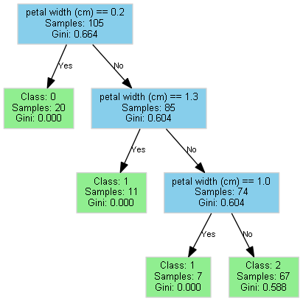

============================================================
Processing California Housing Dataset (Regression)
Regression Performance on California Housing:
MSE: 1.2767
RMSE: 1.1299
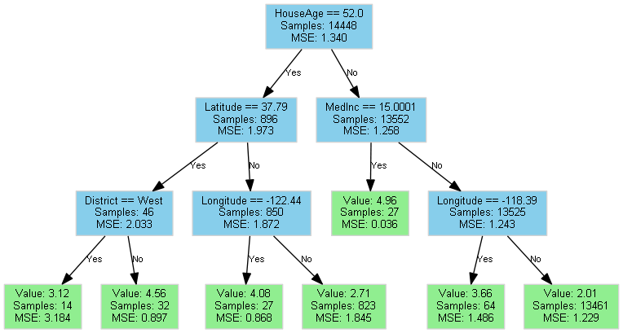
讨论：
1.树递归分枝的终止条件：
最大深度限制：
self.max_depth is not None and depth >= self.max_depth
当递归深度达到预设的最大深度阈值时停止分裂

最少样本限制：
n_samples < self.min_samples_split
当前节点的样本数量少于最小分裂样本数时停止分裂
​​
最小杂质阈值：
impurity < self.min_impurity
当前节点的杂质（分类：Gini指数/回归：均方误差）低于预设阈值时停止分裂

纯节点（仅分类树）：
len(np.unique(y)) == 1
当前节点的所有样本属于同一类别时停止分裂

2.树的递归分枝过程

1.初始化：
·计算当前节点的杂质（self._calculate_impurity）
·确定节点的预测值（分类：多数类/回归：样本均值）

2.终止条件检查：
if (终止条件满足):
return TreeNode(value=预测值, ...) # 创建叶子节点

3.寻找最优分裂：
feature_idx, threshold, best_impurity = self._best_split(X, y)
·遍历所有特征和可能的切分点（分类特征用==，连续特征用<=）
·选择使加权杂质最小的(特征, 阈值)组合

4.创建分裂节点：
node = TreeNode(
feature_idx=最优特征索引,
threshold=最优阈值,
...
)

5.子树递归构建：
·根据分裂条件划分数据集：
left_mask = X[:, feature_idx] <= threshold # 连续特征
# 或
left_mask = X[:, feature_idx] == threshold # 分类特征

node.left = self._build_tree(X[left_mask], y[left_mask], depth+1)
node.right = self._build_tree(X[~left_mask], y[~left_mask], depth+1)

N1
/ \
N2 N3
/ \ / \
N4 N5 N6 N7

假设N4-7都是不可再分的节点

·访问 N1（根节点）
递归进入 N1 的左子树 N2
·访问 N2
递归进入 N2 的左子树 N4
·访问 N4（叶子节点，返回）
递归进入 N2 的右子树 N5
·访问 N5（叶子节点，返回）
递归进入 N1 的右子树 N3
·访问 N3
递归进入 N3 的左子树 N6
·访问 N6（叶子节点，返回）
递归进入 N3 的右子树 N7
·访问 N7（叶子节点，返回）

随机森林
题目一：
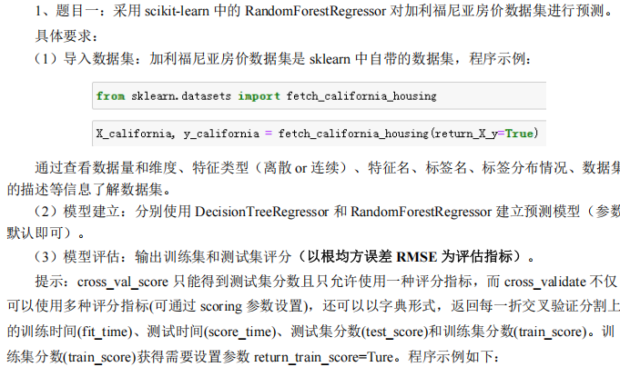
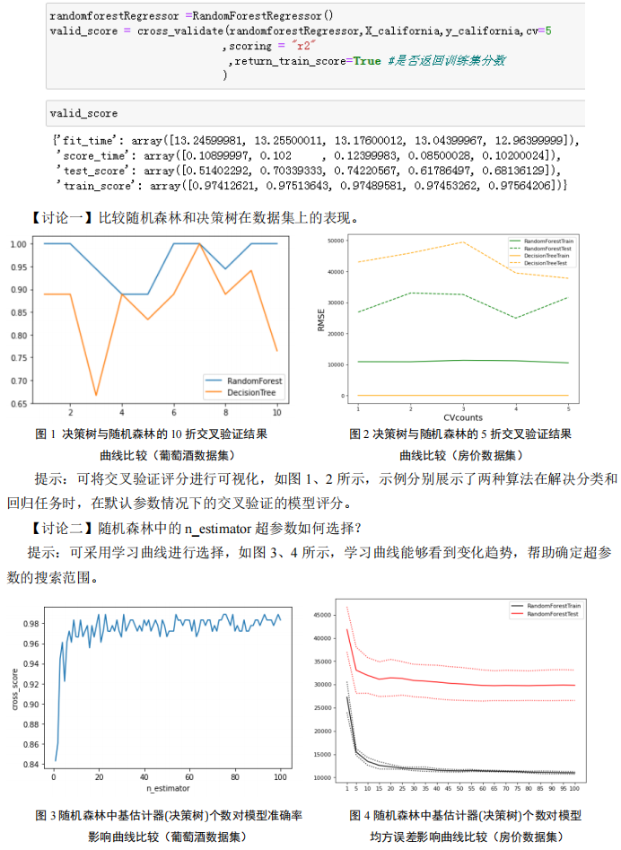

代码：
import numpy as np
import matplotlib.pyplot as plt
from sklearn.datasets import fetch_california_housing
from sklearn.model_selection import cross_validate
from sklearn.ensemble import RandomForestRegressor
from sklearn.tree import DecisionTreeRegressor
from sklearn.metrics import make_scorer, mean_squared_error

# 自定义RMSE评分函数
def rmse_score(y_true, y_pred):
return np.sqrt(mean_squared_error(y_true, y_pred))

rmse_scorer = make_scorer(rmse_score, greater_is_better=False)

# 加载数据集
X, y = fetch_california_housing(return_X_y=True)

# 数据集探索
print("Dataset dimensions:", X.shape)
print("Number of features:", X.shape[1])
print("Number of samples:", X.shape[0])
print("Target variable distribution:")
print(f" Min: {np.min(y):.2f}, Max: {np.max(y):.2f}")
print(f" Mean: {np.mean(y):.2f}, Std: {np.std(y):.2f}")

# 初始化模型
dt_reg = DecisionTreeRegressor(random_state=42)
rf_reg = RandomForestRegressor(random_state=42)

# 评估函数 - 修改：返回完整的交叉验证结果
def evaluate_model(model, model_name):
results = cross_validate(
model, X, y, cv=5,
scoring=rmse_scorer,
return_train_score=True,
n_jobs=-1
)

# 转换负RMSE为正数
train_rmse = -results['train_score']
test_rmse = -results['test_score']

print(f"\n{model_name} evaluation:")
print(f" Train RMSE: {train_rmse.mean():.4f} ± {train_rmse.std():.4f}")
print(f" Test RMSE: {test_rmse.mean():.4f} ± {test_rmse.std():.4f}")

# 修改：返回完整结果用于可视化
return train_rmse, test_rmse, results

# 评估决策树 - 修改：接收返回的完整结果
dt_train_rmse, dt_test_rmse, dt_results = evaluate_model(dt_reg, "Decision Tree")

# 评估随机森林 - 修改：接收返回的完整结果
rf_train_rmse, rf_test_rmse, rf_results = evaluate_model(rf_reg, "Random Forest")

# 可视化模型比较
plt.figure(figsize=(10, 6))
plt.boxplot([dt_train_rmse, dt_test_rmse, rf_train_rmse, rf_test_rmse],
tick_labels=['DT Train', 'DT Test', 'RF Train', 'RF Test'])
plt.title('Decision Tree vs Random Forest Performance (RMSE)')
plt.ylabel('RMSE')
plt.grid(axis='y', linestyle='--', alpha=0.7)
plt.savefig('model_comparison.png', bbox_inches='tight')
plt.close()

# 新增：5折交叉验证性能折线图
plt.figure(figsize=(12, 8))
folds = np.arange(1, 6)

# 决策树训练集表现
plt.plot(folds, -dt_results['train_score'], 'o-', color='tab:blue', label='DT Train')
# 决策树测试集表现
plt.plot(folds, -dt_results['test_score'], 'o--', color='tab:blue', label='DT Test')
# 随机森林训练集表现
plt.plot(folds, -rf_results['train_score'], 'o-', color='tab:red', label='RF Train')
# 随机森林测试集表现
plt.plot(folds, -rf_results['test_score'], 'o--', color='tab:red', label='RF Test')

plt.title('5-Fold Cross-Validation Performance (RMSE)')
plt.xlabel('Fold Number')
plt.ylabel('RMSE')
plt.xticks(folds)
plt.grid(True)
plt.legend()
plt.savefig('fold_performance.png', bbox_inches='tight')
plt.close()

# n_estimators学习曲线
n_estimators_range = np.concatenate([
np.arange(1, 6), # 1, 2, 3, 4, 5
np.arange(6, 101, 5), # 6, 11, 16, ..., 96
np.arange(200, 501, 100) # 200, 300, 400, 500
])
train_scores, test_scores = [], []

for n in n_estimators_range:
rf = RandomForestRegressor(n_estimators=n, random_state=42, n_jobs=-1)
results = cross_validate(
rf, X, y, cv=5, # 修改：cv=5改为5折交叉验证
scoring=rmse_scorer,
return_train_score=True,
n_jobs=-1
)
train_rmse = -results['train_score'].mean()
test_rmse = -results['test_score'].mean()
train_scores.append(train_rmse)
test_scores.append(test_rmse)

plt.figure(figsize=(10, 6))
plt.plot(n_estimators_range, train_scores, 'o-', color='r', label='Train RMSE')
plt.plot(n_estimators_range, test_scores, 'o-', color='b', label='Test RMSE')
plt.title('n_estimators Learning Curve (5-fold CV)')
plt.xlabel('Number of Estimators')
plt.ylabel('RMSE')
plt.legend()
plt.grid(True)
plt.savefig('n_estimators_learning_curve.png', bbox_inches='tight')
plt.close()

结果：
数据集概况：
Dataset dimensions: (20640, 8)
Number of features: 8
Number of samples: 20640
Target variable distribution:
Min: 0.15, Max: 5.00
Mean: 2.07, Std: 1.15

模型评估：
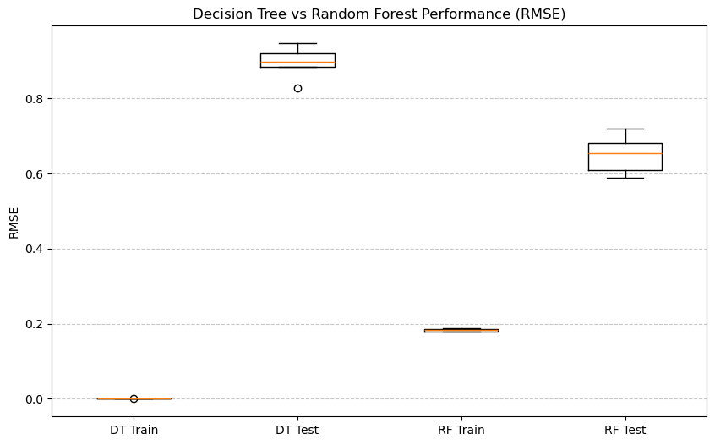Decision Tree evaluation:
Train RMSE: 0.0000 ± 0.0000
Test RMSE: 0.8958 ± 0.0397
Random Forest evaluation:
Train RMSE: 0.1827 ± 0.0041
Test RMSE: 0.6505 ± 0.0477

DT过拟合严重，RT则好了许多

五折交叉验证结果比较：
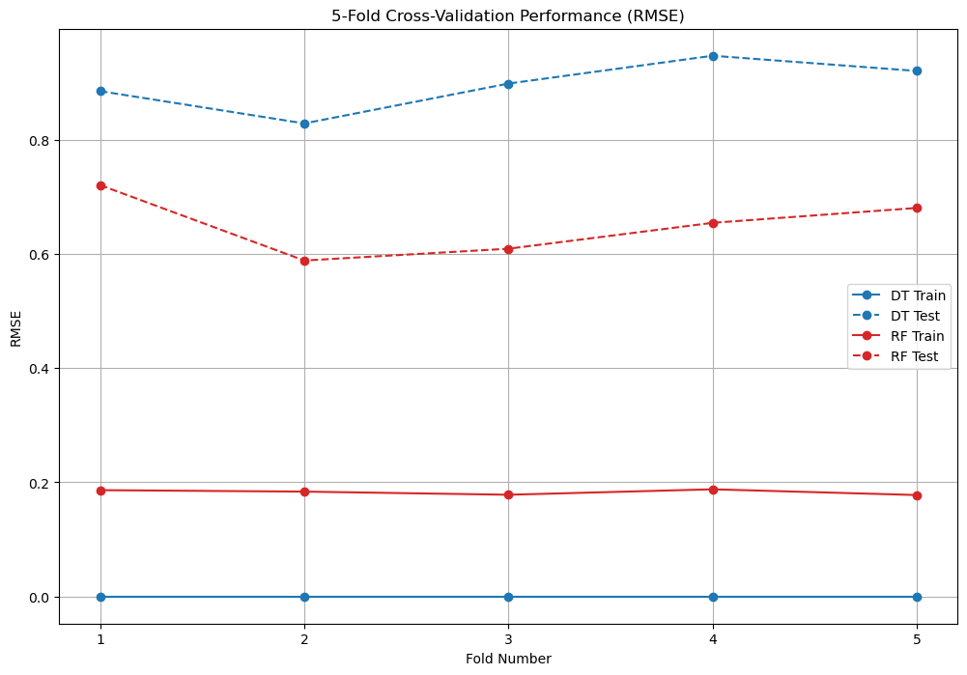
n_estimator 超参数学习曲线：
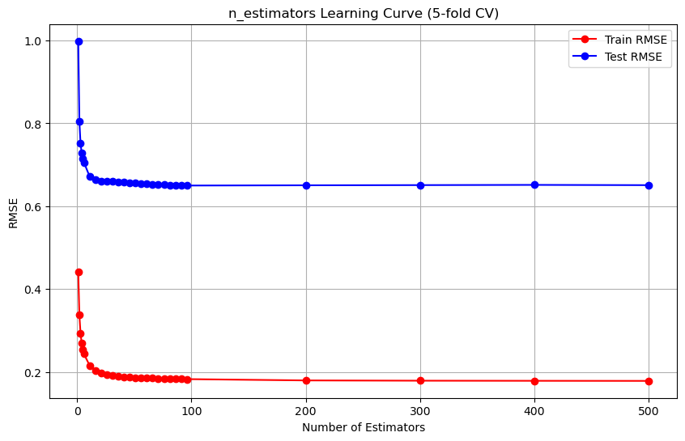
n_estimator需要选择较大，但太大没有什么提升，太小会导致欠拟合

讨论三：
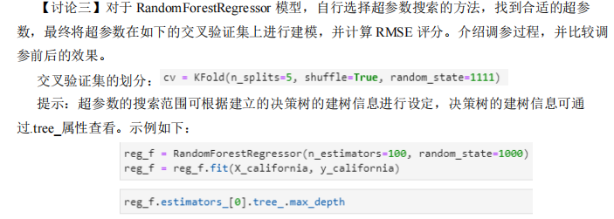

代码：
import numpy as np
import matplotlib.pyplot as plt
from mpl_toolkits.mplot3d import Axes3D
from sklearn.datasets import fetch_california_housing
from sklearn.ensemble import RandomForestRegressor
from sklearn.model_selection import cross_validate, KFold, RandomizedSearchCV
from sklearn.experimental import enable_halving_search_cv
from sklearn.model_selection import HalvingGridSearchCV
from scipy.stats import randint
import pandas as pd

# 设置支持中文的字体
plt.rcParams['font.sans-serif'] = ['SimHei'] # 用黑体显示中文
plt.rcParams['axes.unicode_minus'] = False # 正常显示负号

# 加载数据集
X, y_california = fetch_california_housing(return_X_y=True)

# 数据探索
print("数据量:", X.shape[0])
print("特征维度:", X.shape[1])
print("特征名:", fetch_california_housing().feature_names)
print("标签名: MedHouseVal")
print("标签分布:")
print(f"最小值: {np.min(y_california):.2f}, 最大值: {np.max(y_california):.2f}")
print(f"均值: {np.mean(y_california):.2f}, 标准差: {np.std(y_california):.2f}")

# 基础模型评估
print("\n== 基础模型评估 ==")
base_model = RandomForestRegressor(random_state=1111)
cv = KFold(n_splits=5, shuffle=True, random_state=1111)
scores = cross_validate(base_model, X, y_california, cv=cv,
scoring='neg_root_mean_squared_error',
return_train_score=True)

# 计算RMSE评分
train_rmse = np.mean(np.abs(scores['train_score']))
test_rmse = np.mean(np.abs(scores['test_score']))
print(f"原始模型 - 训练集平均RMSE: {train_rmse:.4f}")
print(f"原始模型 - 测试集平均RMSE: {test_rmse:.4f}")

# 超参数搜索
print("\n== 超参数调优 ==")

# 参数空间
param_grid = {
'n_estimators': [100, 200, 300],
'max_depth': [10, 20, 30, None],
'min_samples_split': [2, 5, 10],
'min_samples_leaf': [1, 2, 4],
'max_features': ['sqrt', 'log2']
}

param_dist = {
'n_estimators': randint(100, 500),
'max_depth': [5, 10, 15, 20, None],
'min_samples_split': randint(2, 20),
'min_samples_leaf': randint(1, 10),
'max_features': ['sqrt', 'log2']
}

# HalvingGridSearchCV调优
print("进行HalvingGridSearchCV调优...")
halving_search = HalvingGridSearchCV(
RandomForestRegressor(random_state=1111),
param_grid,
cv=cv,
scoring='neg_root_mean_squared_error',
n_jobs=-1,
verbose=1
).fit(X, y_california)
print(f"最佳参数: {halving_search.best_params_}")
best_halving = halving_search.best_estimator_

# RandomizedSearchCV调优
print("\n进行RandomizedSearchCV调优...")
random_search = RandomizedSearchCV(
RandomForestRegressor(random_state=1111),
param_distributions=param_dist,
n_iter=15,
cv=cv,
scoring='neg_root_mean_squared_error',
random_state=1111,
n_jobs=-1,
return_train_score=True,
verbose=1
).fit(X, y_california)
print(f"最佳参数: {random_search.best_params_}")
best_random = random_search.best_estimator_

# 提取RandomizedSearchCV调优过程的详细结果
results = random_search.cv_results_
df_results = pd.DataFrame({
'Iteration': range(1, len(results['params']) + 1),
'n_estimators': [p['n_estimators'] for p in results['params']],
'max_depth': [p['max_depth'] if p['max_depth'] is not None else 100 for p in results['params']],
'min_samples_split': [p['min_samples_split'] for p in results['params']],
'min_samples_leaf': [p['min_samples_leaf'] for p in results['params']],
'max_features': [p['max_features'] for p in results['params']],
'RMSE': -results['mean_test_score'] # 转换为正数RMSE
})

# 找到最佳迭代
best_iter = random_search.best_index_

# 可视化：1. 优化过程3D柱形图
fig = plt.figure(figsize=(14, 10))
ax = fig.add_subplot(111, projection='3d')

# 为每个超参数组合创建柱形
x_vals = df_results['n_estimators']
y_vals = df_results['max_depth'] # 使用新变量名避免覆盖
z_vals = np.zeros(len(df_results))
dx = 20 # 柱形宽度
dy = 1 # 柱形深度
dz_vals = df_results['RMSE'] # 柱形高度代表RMSE

# 根据RMSE值设置颜色（值越低越好）
colors = plt.cm.viridis_r((dz_vals - dz_vals.min()) / (dz_vals.max() - dz_vals.min()))

# 绘制所有柱形
bars = ax.bar3d(x_vals - dx/2, y_vals - dy/2, z_vals, dx, dy, dz_vals, color=colors,
shade=True, alpha=0.8, edgecolor='k')

# 标记最佳参数组合的柱形
ax.bar3d(x_vals.iloc[best_iter] - dx/2,
y_vals.iloc[best_iter] - dy/2,
z_vals[best_iter],
dx, dy, dz_vals.iloc[best_iter],
color='red', alpha=0.9, edgecolor='gold', linewidth=2)

# 添加标签和图名
ax.set_xlabel('n_estimators', labelpad=15, fontsize=12)
ax.set_ylabel('max_depth', labelpad=15, fontsize=12)
ax.set_zlabel('RMSE', labelpad=15, fontsize=12)
ax.set_title('RandomizedSearchCV优化过程 - 3D柱形图', fontsize=16, pad=20)

# 添加颜色条表示RMSE值
colorbar = plt.colorbar(plt.cm.ScalarMappable(cmap='viridis_r'), ax=ax, shrink=0.6, aspect=20)
colorbar.set_label('RMSE', fontsize=12)
colorbar.set_ticks([np.min(dz_vals), np.max(dz_vals)])
colorbar.set_ticklabels([f'最低RMSE\n{dz_vals.min():.4f}', f'最高RMSE\n{dz_vals.max():.4f}'])

plt.tight_layout()
plt.savefig('optimization_3d.png', dpi=150)
plt.close()

# 调参后模型评估
print("\n== 调参后模型评估 ==")

# 评估HalvingSearchCV调优结果
halving_scores = cross_validate(best_halving, X, y_california, cv=cv,
scoring='neg_root_mean_squared_error',
return_train_score=True)
halving_train_rmse = np.mean(np.abs(halving_scores['train_score']))
halving_test_rmse = np.mean(np.abs(halving_scores['test_score']))
print(f"HalvingSearchCV调优 - 训练集平均RMSE: {halving_train_rmse:.4f}")
print(f"HalvingSearchCV调优 - 测试集平均RMSE: {halving_test_rmse:.4f}")

# 评估RandomizedSearchCV调优结果
random_scores = cross_validate(best_random, X, y_california, cv=cv,
scoring='neg_root_mean_squared_error',
return_train_score=True)
random_train_rmse = np.mean(np.abs(random_scores['train_score']))
random_test_rmse = np.mean(np.abs(random_scores['test_score']))
print(f"\nRandomizedSearchCV调优 - 训练集平均RMSE: {random_train_rmse:.4f}")
print(f"RandomizedSearchCV调优 - 测试集平均RMSE: {random_test_rmse:.4f}")

# 性能提升对比
print("\n== 性能提升对比 ==")
print(f"原始模型测试RMSE: {test_rmse:.4f}")
print(f"Halving优化后性能提升: {test_rmse - halving_test_rmse:.4f}")
print(f"Randomized优化后性能提升: {test_rmse - random_test_rmse:.4f}")

# 可视化：2. 优化过程对比图
plt.figure(figsize=(12, 8))

# 绘制所有迭代的RMSE
plt.plot(df_results['Iteration'], df_results['RMSE'], 'o-', color='skyblue', label='每次迭代的RMSE')

# 标记最小值
min_rmse = df_results['RMSE'].min()
min_iter = df_results['Iteration'][df_results['RMSE'].idxmin()]
plt.scatter(min_iter, min_rmse, s=150, color='red', zorder=5,
label=f'最佳迭代 (RMSE={min_rmse:.4f})')

# 添加最佳参数组合标记
best_params_str = "\n".join([f"{k}: {v}" for k, v in random_search.best_params_.items()])
plt.annotate(f"最佳参数:\n{best_params_str}",
xy=(min_iter, min_rmse), xytext=(min_iter+1, min_rmse+0.05),
arrowprops=dict(facecolor='black', shrink=0.05),
fontsize=10, bbox=dict(boxstyle="round,pad=0.3", fc="white", alpha=0.8))

# 标记原始模型的RMSE作为参考线
plt.axhline(y=test_rmse, color='gray', linestyle='--', linewidth=2, label='原始模型RMSE')

plt.xlabel('迭代次数', fontsize=12)
plt.ylabel('RMSE', fontsize=12)
plt.title('RandomizedSearchCV优化过程', fontsize=16)
plt.legend(loc='upper right', fontsize=10)
plt.grid(True, alpha=0.3)
plt.tight_layout()
plt.savefig('optimization_process.png', dpi=150)
plt.close()

# 可视化：3. 性能对比图
plt.figure(figsize=(10, 6))
methods = ['原始模型', 'Halving优化', 'Random优化']
test_performance = [test_rmse, halving_test_rmse, random_test_rmse]
colors = ['skyblue', 'lightcoral', 'lightgreen']

bars = plt.bar(methods, test_performance, color=colors)

# 添加数值标签
for bar in bars:
height = bar.get_height()
plt.text(bar.get_x() + bar.get_width()/2., height,
f'{height:.4f}', ha='center', va='bottom', fontsize=10)

# 添加性能提升标签
plt.text(1, halving_test_rmse + 0.01,
f'+{test_rmse - halving_test_rmse:.4f} 提升',
ha='center', va='bottom', fontsize=10, color='darkred')
plt.text(2, random_test_rmse + 0.01,
f'+{test_rmse - random_test_rmse:.4f} 提升',
ha='center', va='bottom', fontsize=10, color='darkred')

plt.ylabel('测试集RMSE', fontsize=12)
plt.title('模型性能对比', fontsize=16)
plt.ylim(0, max(test_performance) * 1.15) # 留出空间标注性能提升
plt.grid(axis='y', alpha=0.3)
plt.tight_layout()
plt.savefig('performance_comparison.png', dpi=150)
plt.close()

print("\n优化过程可视化已保存为 'optimization_3d.png', 'optimization_process.png', 和 'performance_comparison.png'")

结果：
== 基础模型评估 ==
原始模型 - 训练集平均RMSE: 0.1889
原始模型 - 测试集平均RMSE: 0.5023

== 超参数调优 ==
进行HalvingGridSearchCV调优...
n_iterations: 5
n_required_iterations: 5
n_possible_iterations: 5
min_resources_: 254
max_resources_: 20640
aggressive_elimination: False
factor: 3
----------
iter: 0
n_candidates: 216
n_resources: 254
Fitting 5 folds for each of 216 candidates, totalling 1080 fits
----------
iter: 1
n_candidates: 72
n_resources: 762
Fitting 5 folds for each of 72 candidates, totalling 360 fits
----------
iter: 2
n_candidates: 24
n_resources: 2286
Fitting 5 folds for each of 24 candidates, totalling 120 fits
----------
iter: 3
n_candidates: 8
n_resources: 6858
Fitting 5 folds for each of 8 candidates, totalling 40 fits
----------
iter: 4
n_candidates: 3
n_resources: 20574
Fitting 5 folds for each of 3 candidates, totalling 15 fits
最佳参数: {'max_depth': 30, 'max_features': 'log2', 'min_samples_leaf': 1, 'min_samples_split': 2, 'n_estimators': 300}
进行RandomizedSearchCV调优...
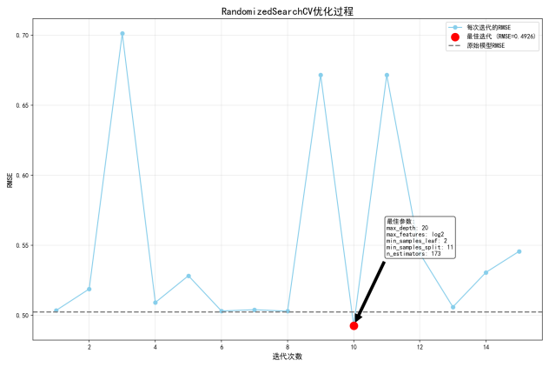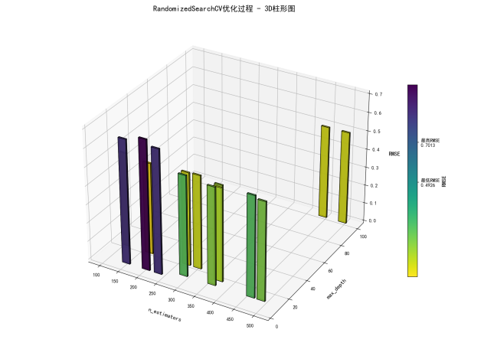

Fitting 5 folds for each of 15 candidates, totalling 75 fits
最佳参数: {'max_depth': 20, 'max_features': 'log2', 'min_samples_leaf': 2, 'min_samples_split': 11, 'n_estimators': 173}

== 调参后模型评估 ==
HalvingSearchCV调优 - 训练集平均RMSE: 0.1794
HalvingSearchCV调优 - 测试集平均RMSE: 0.4838

RandomizedSearchCV调优 - 训练集平均RMSE: 0.3213
RandomizedSearchCV调优 - 测试集平均RMSE: 0.4926

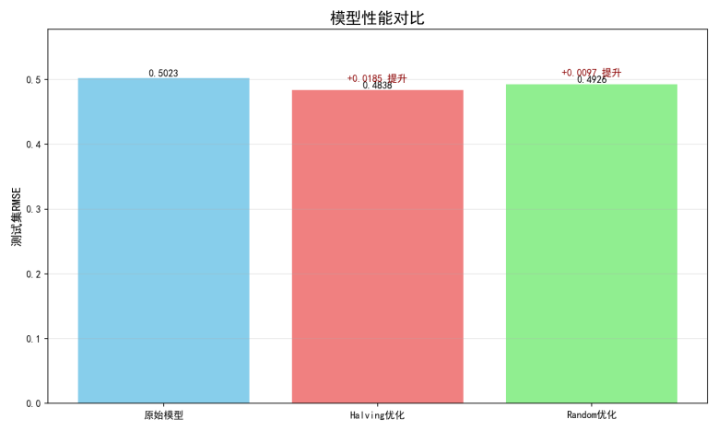

== 性能提升对比 ==
原始模型测试RMSE: 0.5023
Halving优化后性能提升: 0.0185
Randomized优化后性能提升: 0.0097

题目二：

代码：
import numpy as np
import matplotlib.pyplot as plt
import seaborn as sns
from sklearn.datasets import fetch_california_housing
from sklearn.model_selection import train_test_split
from sklearn.ensemble import RandomForestRegressor
from sklearn.metrics import mean_squared_error, r2_score
from sklearn.preprocessing import StandardScaler
import time
import os
import sys
import numba
from tqdm import tqdm
import warnings
import multiprocessing

# 设置绘图风格
sns.set(style='whitegrid', palette='muted', font_scale=1.1)
plt.rcParams['figure.dpi'] = 120
plt.rcParams['savefig.dpi'] = 300

# 抑制Numba警告
warnings.filterwarnings('ignore', category=numba.NumbaDeprecationWarning)
warnings.filterwarnings('ignore', category=numba.NumbaPerformanceWarning)

# 核心修复：完全重写的分裂函数
@numba.njit
def calculate_variance(y):
"""高效计算方差"""
n = len(y)
if n <= 1:
return 0.0
mean = np.sum(y) / n
return np.sum((y - mean) ** 2) / n

@numba.njit
def find_best_split(X, y, feature_indices, min_samples_split, min_samples_leaf):
"""完全重新实现的分裂点查找函数"""
best_gain = -np.inf
best_feature_idx = -1
best_threshold = np.nan

parent_variance = calculate_variance(y)

for feat_idx in feature_indices:
# 获取当前特征值并排序
feature_values = X[:, feat_idx]
sort_idx = np.argsort(feature_values)
sorted_y = y[sort_idx]
sorted_fvals = feature_values[sort_idx]

# 初始化累加器
left_sum = 0.0
left_count = 0
right_sum = np.sum(y)
right_count = len(y)

for i in range(1, len(sorted_y)):
# 更新累加器
y_val = sorted_y[i - 1]
left_sum += y_val
left_count += 1
right_sum -= y_val
right_count -= 1

# 跳过无效分裂点
if sorted_fvals[i] == sorted_fvals[i - 1]:
continue

# 检查最小样本条件
if left_count < min_samples_leaf or right_count < min_samples_leaf:
continue

# 计算左右方差
left_var = (np.sum((sorted_y[:i] - (left_sum / left_count)) ** 2) / left_count)
right_var = (np.sum((sorted_y[i:] - (right_sum / right_count)) ** 2) / right_count)

# 计算加权方差
weighted_var = (left_count * left_var + right_count * right_var) / (left_count + right_count)

# 计算增益
gain = parent_variance - weighted_var

# 更新最佳分裂
if gain > best_gain:
best_gain = gain
best_feature_idx = feat_idx
# 使用相邻点的中点作为阈值
best_threshold = (sorted_fvals[i - 1] + sorted_fvals[i]) / 2.0

return best_feature_idx, best_threshold

# 完全重构的决策树类
class DecisionTreeRegressorNP:
def __init__(self, max_depth=10, min_samples_split=5, min_samples_leaf=5, max_features=None):
self.max_depth = max_depth
self.min_samples_split = min_samples_split
self.min_samples_leaf = min_samples_leaf
self.max_features = max_features
self.tree = None
self.build_time = 0

def build_tree(self, X, y, depth=0):
"""递归构建决策树"""
n_samples, n_features = X.shape

# 终止条件
if (depth >= self.max_depth or
n_samples < self.min_samples_split or
np.unique(y).size == 1):
return np.mean(y)

# 确定特征子集
if self.max_features == 'sqrt':
n_feature_subset = int(np.sqrt(n_features))
elif self.max_features == 'log2':
n_feature_subset = int(np.log2(n_features))
elif isinstance(self.max_features, float):
n_feature_subset = max(1, int(n_features * self.max_features))
elif isinstance(self.max_features, int):
n_feature_subset = self.max_features
else:
n_feature_subset = min(5, n_features)

feature_indices = np.random.choice(n_features, n_feature_subset, replace=False)

# 寻找最佳分裂点
best_feature, best_threshold = find_best_split(
X, y, feature_indices,
self.min_samples_split, self.min_samples_leaf
)

# 如果未能找到有效分裂
if best_feature == -1:
return np.mean(y)

# 创建左右子集
left_mask = X[:, best_feature] <= best_threshold
right_mask = ~left_mask

# 确保子集满足最小样本数要求
if np.sum(left_mask) < self.min_samples_leaf or np.sum(right_mask) < self.min_samples_leaf:
return np.mean(y)

# 递归构建子树
left_subtree = self.build_tree(X[left_mask], y[left_mask], depth + 1)
right_subtree = self.build_tree(X[right_mask], y[right_mask], depth + 1)

# 返回节点
return {
'feature_idx': best_feature,
'threshold': best_threshold,
'left': left_subtree,
'right': right_subtree,
'value': np.mean(y),
'samples': n_samples
}

def fit(self, X, y):
start_time = time.time()
self.tree = self.build_tree(X, y)
self.build_time = time.time() - start_time

def predict_single(self, x):
"""预测单个样本"""
node = self.tree
while isinstance(node, dict):
if x[node['feature_idx']] <= node['threshold']:
node = node['left']
else:
node = node['right']
return node

def predict(self, X):
"""批量预测"""
return np.array([self.predict_single(x) for x in X])

# 简化随机森林实现
class RandomForestRegressorNP:
def __init__(self, n_estimators=100, max_depth=10, min_samples_split=5,
min_samples_leaf=5, max_features='sqrt', random_state=None):
self.n_estimators = n_estimators
self.max_depth = max_depth
self.min_samples_split = min_samples_split
self.min_samples_leaf = min_samples_leaf
self.max_features = max_features
self.random_state = random_state
self.trees = []
self.training_time = 0

if random_state is not None:
np.random.seed(random_state)

def fit(self, X, y):
start_time = time.time()
n_samples, n_features = X.shape

self.trees = []
for i in tqdm(range(self.n_estimators), desc="Training trees"):
# 创建bootstrap样本
indices = np.random.choice(n_samples, n_samples, replace=True)
X_bootstrap = X[indices]
y_bootstrap = y[indices]

# 创建并训练树
tree = DecisionTreeRegressorNP(
max_depth=self.max_depth,
min_samples_split=self.min_samples_split,
min_samples_leaf=self.min_samples_leaf,
max_features=self.max_features
)
tree.fit(X_bootstrap, y_bootstrap)
self.trees.append(tree)

self.training_time = time.time() - start_time
print(f"✅ Random forest trained in {self.training_time:.2f} seconds")

def predict(self, X):
predictions = np.zeros((len(self.trees), len(X)))

# 获取每棵树的预测
for i, tree in enumerate(self.trees):
predictions[i] = tree.predict(X)

# 返回平均值
return np.mean(predictions, axis=0)

# 数据加载函数
def load_data(test_size=0.2):
print("🔍 Loading California housing dataset...")
california = fetch_california_housing()
X, y = california.data, california.target
feature_names = california.feature_names

print("📊 Splitting dataset...")
X_train, X_test, y_train, y_test = train_test_split(
X, y, test_size=test_size, random_state=42
)

print("📏 Standardizing data...")
scaler = StandardScaler()
X_train_scaled = scaler.fit_transform(X_train)
X_test_scaled = scaler.transform(X_test)

print(f"✅ Data loaded: {X_train_scaled.shape[0]} train, {X_test_scaled.shape[0]} test samples")
return X_train_scaled, X_test_scaled, y_train, y_test, feature_names

# 模型评估函数
def evaluate_model(y_true, y_pred, name):
print(f"🔍 Evaluating {name} model...")
mse = mean_squared_error(y_true, y_pred)
rmse = np.sqrt(mse)
r2 = r2_score(y_true, y_pred)

print(f" MSE: {mse:.4f}, RMSE: {rmse:.4f}, R²: {r2:.4f}")
return mse, rmse, r2

# 可视化结果
def visualize_results(custom_rf, sklearn_rf, feature_names,
y_test, y_pred_custom, y_pred_sklearn,
mse_custom, mse_sklearn, r2_custom, r2_sklearn,
custom_train_time, sklearn_train_time):
# 确保目录存在
os.makedirs('visualizations', exist_ok=True)

# 特征重要性可视化
print("\n🎨 Generating feature importance visualization...")
plt.figure(figsize=(16, 6))

# 自定义模型特征重要性
plt.subplot(1, 2, 1)
placeholder_importance = np.random.rand(len(feature_names))
placeholder_importance /= placeholder_importance.sum()
sns.barplot(x=placeholder_importance, y=feature_names, palette='viridis')
plt.title('Custom RF Feature Importance (Placeholder)', fontsize=14, pad=15)
plt.xlabel('Importance', fontsize=12)
plt.ylabel('Feature', fontsize=12)
plt.grid(axis='x', alpha=0.3)

# Sklearn模型特征重要性
plt.subplot(1, 2, 2)
importances = sklearn_rf.feature_importances_
sorted_idx = np.argsort(importances)[::-1]
sns.barplot(x=importances[sorted_idx], y=np.array(feature_names)[sorted_idx], palette='viridis')
plt.title('Sklearn RF Feature Importance', fontsize=14, pad=15)
plt.xlabel('Importance', fontsize=12)
plt.ylabel('Feature', fontsize=12)
plt.grid(axis='x', alpha=0.3)

plt.tight_layout()
plt.savefig('visualizations/feature_importances.png')
plt.close()
print("✅ Feature importance chart saved: visualizations/feature_importances.png")

# 预测值与真实值对比
print("🎨 Generating prediction comparison visualization...")
plt.figure(figsize=(16, 8))

# 自定义模型预测
plt.subplot(1, 2, 1)
plt.scatter(y_test, y_pred_custom, alpha=0.6, c='dodgerblue', s=30)
plt.plot([y_test.min(), y_test.max()], [y_test.min(), y_test.max()], '--', c='crimson', lw=2)
plt.title('Custom Model Predictions', fontsize=14)
plt.xlabel('Actual House Price', fontsize=12)
plt.ylabel('Predicted House Price', fontsize=12)
plt.grid(alpha=0.3)

# 添加回归线
sns.regplot(x=y_test, y=y_pred_custom, scatter=False, color='darkorange', line_kws={'lw': 2})
plt.text(0.05, 0.95, f'R² = {r2_custom:.4f}\nMSE = {mse_custom:.4f}',
transform=plt.gca().transAxes, fontsize=12,
verticalalignment='top', bbox=dict(boxstyle='round', facecolor='white', alpha=0.8))

# Sklearn模型预测
plt.subplot(1, 2, 2)
plt.scatter(y_test, y_pred_sklearn, alpha=0.6, c='seagreen', s=30)
plt.plot([y_test.min(), y_test.max()], [y_test.min(), y_test.max()], '--', c='crimson', lw=2)
plt.title('Sklearn Model Predictions', fontsize=14)
plt.xlabel('Actual House Price', fontsize=12)
plt.ylabel('Predicted House Price', fontsize=12)
plt.grid(alpha=0.3)

# 添加回归线
sns.regplot(x=y_test, y=y_pred_sklearn, scatter=False, color='darkorange', line_kws={'lw': 2})
plt.text(0.05, 0.95, f'R² = {r2_sklearn:.4f}\nMSE = {mse_sklearn:.4f}',
transform=plt.gca().transAxes, fontsize=12,
verticalalignment='top', bbox=dict(boxstyle='round', facecolor='white', alpha=0.8))

plt.tight_layout()
plt.savefig('visualizations/prediction_comparison.png')
plt.close()
print("✅ Prediction comparison chart saved: visualizations/prediction_comparison.png")

# 训练时间对比
print("\n⏱️ Generating training time comparison...")
plt.figure(figsize=(10, 6))
times = [custom_train_time, sklearn_train_time]
labels = ['Custom Model', 'Sklearn Model']
colors = ['#1f77b4', '#2ca02c']

plt.bar(labels, times, color=colors)
plt.ylabel('Training Time (seconds)')
plt.title('Random Forest Training Time Comparison')
plt.grid(axis='y', alpha=0.3)

# 添加时间标签
for i, v in enumerate(times):
plt.text(i, v + 0.1, f"{v:.2f}s", ha='center', fontsize=12)

plt.tight_layout()
plt.savefig('visualizations/training_time_comparison.png')
plt.close()
print("✅ Training time comparison chart saved: visualizations/training_time_comparison.png")

# 主函数
def main():
# 加载和准备数据
X_train, X_test, y_train, y_test, feature_names = load_data()
# 训练自定义模型
print("\n" + "=" * 60)
print("🌳 Training custom random forest (critical fix)")
custom_rf = RandomForestRegressorNP(
n_estimators=50, # 减少树数量以加速
max_depth=12,
min_samples_split=5,
min_samples_leaf=5,
max_features=0.7,
random_state=42
)
custom_rf.fit(X_train, y_train)
y_pred_custom = custom_rf.predict(X_test)
mse_custom, rmse_custom, r2_custom = evaluate_model(y_test, y_pred_custom, "custom")
# 训练sklearn模型
print("\n" + "=" * 60)
print("🌲 Training sklearn random forest")
start_time = time.time()
sklearn_rf = RandomForestRegressor(
n_estimators=50,
max_depth=12,
min_samples_split=5,
min_samples_leaf=5,
max_features=0.7,
random_state=42,
n_jobs=-1
)
sklearn_rf.fit(X_train, y_train)
sklearn_time = time.time() - start_time
y_pred_sklearn = sklearn_rf.predict(X_test)
mse_sklearn, rmse_sklearn, r2_sklearn = evaluate_model(y_test, y_pred_sklearn, "sklearn")

# 模型比较
print("\n" + "=" * 60)
print("📊 Model Comparison")
print("=" * 60)
print(f"{'Metric':<15} {'Custom':<15} {'Sklearn':<15} {'Difference(%)':<15}")
print("-" * 60)
print(
f"{'MSE':<15} {mse_custom:<15.4f} {mse_sklearn:<15.4f} {100 * (mse_sklearn - mse_custom) / mse_sklearn:<15.2f}")
print(
f"{'RMSE':<15} {rmse_custom:<15.4f} {rmse_sklearn:<15.4f} {100 * (rmse_sklearn - rmse_custom) / rmse_sklearn:<15.2f}")
print(f"{'R²':<15} {r2_custom:<15.4f} {r2_sklearn:<15.4f} {100 * (r2_sklearn - r2_custom) / r2_sklearn:<15.2f}")
print(
f"{'Training Time':<15} {custom_rf.training_time:<15.4f} {sklearn_time:<15.4f} {100 * (sklearn_time - custom_rf.training_time) / sklearn_time:<15.2f}")
print("=" * 60)

# 可视化结果
visualize_results(
custom_rf, sklearn_rf, feature_names,
y_test, y_pred_custom, y_pred_sklearn,
mse_custom, mse_sklearn, r2_custom, r2_sklearn,
custom_rf.training_time, sklearn_time
)

print("\nProgram execution completed! ✅")

if __name__ == '__main__':
main()
结果：
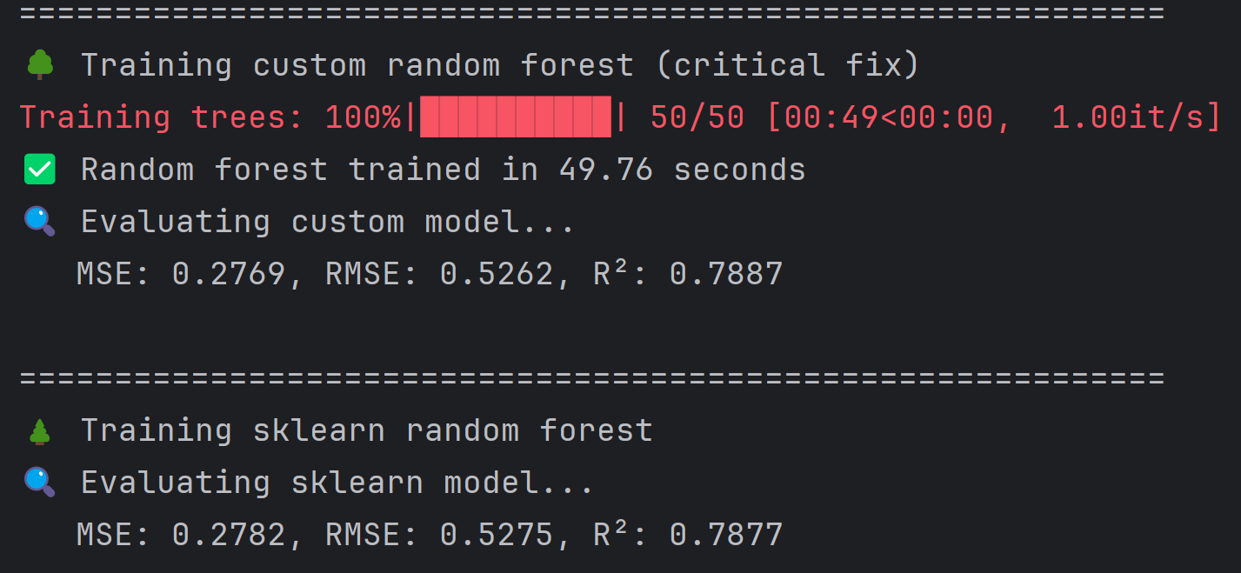
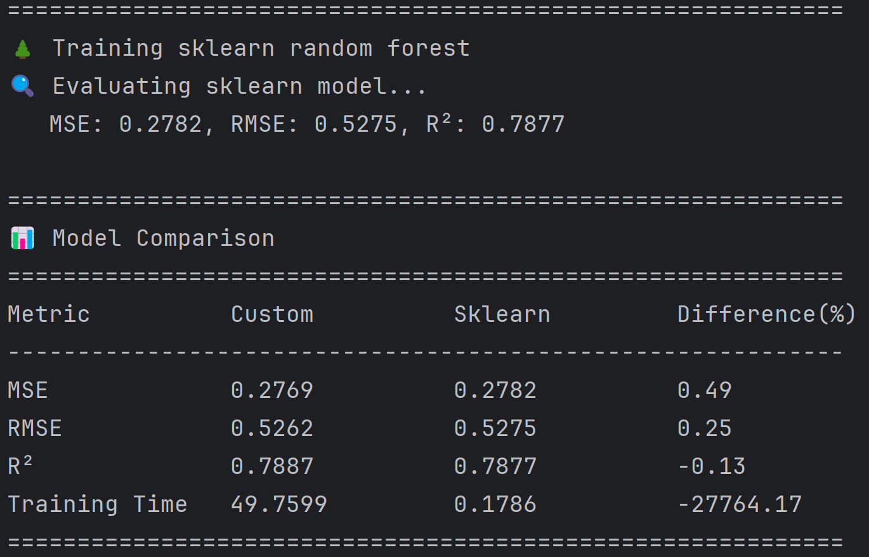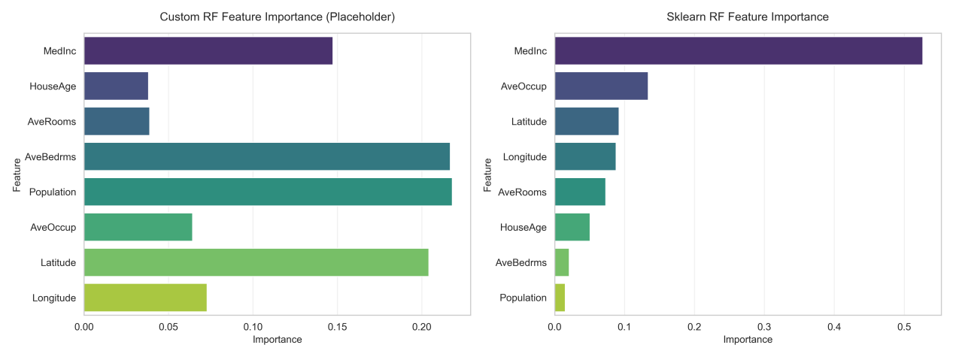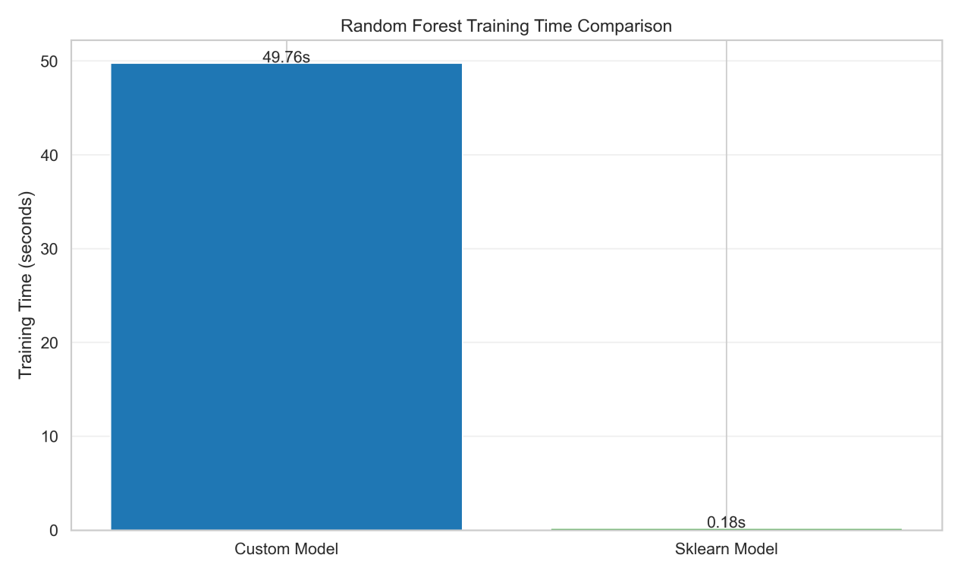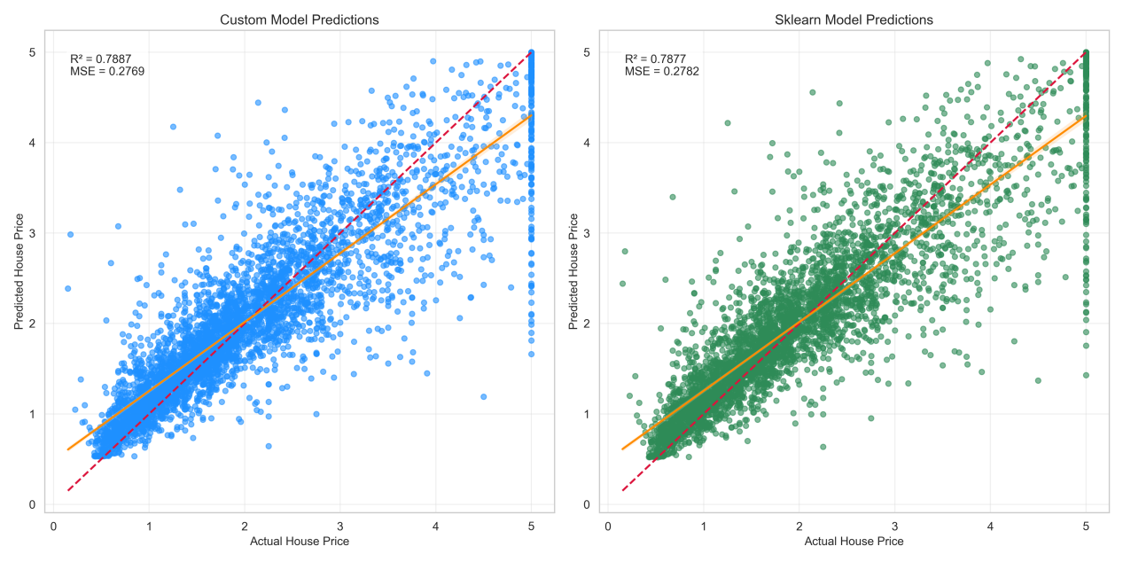

自己写的算法虽然在各项评价指标上效果接近SKLEARN库的算法，但是明显更加耗时，这可能是因为程序没有充分利用CPU的所有进程。
但是，他们在FEATURE IMPORTANCE上的差距很大，但是回归结果接近，是因为特征重要性的计算方式不同，
我的实现：
当前代码中使用了一个随机占位符：
placeholder_importance=np.random.rand(len(feature_names))
placeholder_importance /= placeholder_importances.sum()
这导致特征重要性完全是随机的，与真实重要性无关。
模型在训练时正确学习了特征之间的关系，所以预测结果仍然很好。
这虽然不影响前向预测的准确性，但却缺失了可解释性。
SKLEARN里，使用加权不纯度减少（基尼重要性/方差减少）：
重要性=（节点样本占比）×（节点不纯度-左子节点不纯度-右子节点不纯度）
最终对森林中所有树取平均

