题目1：


代码：
import numpy as np
import matplotlib.pyplot as plt
from sklearn.datasets import load_wine
from sklearn.ensemble import AdaBoostClassifier
from sklearn.model_selection import cross_validate, StratifiedKFold

# 加载葡萄酒数据集
wine = load_wine()
X, y = wine.data, wine.target

# 创建AdaBoost分类器
ada = AdaBoostClassifier(random_state=42)

# 5折交叉验证
cv = StratifiedKFold(n_splits=5, shuffle=True, random_state=42)
scores = cross_validate(ada, X, y, cv=cv,
return_train_score=True,
return_estimator=True,
scoring='accuracy')

# 计算损失（1 - 准确率）
train_loss = 1 - scores['train_score']
val_loss = 1 - scores['test_score']

# 输出模型评分
print(f"平均交叉验证得分: {np.mean(scores['test_score']):.4f}")
print(f"训练损失: {train_loss.round(4)}")
print(f"验证损失: {val_loss.round(4)}")
print(f"模型表现: {'良好' if np.mean(val_loss) < 0.2 else '一般'} (平均验证损失: {np.mean(val_loss):.4f})")

# 可视化损失曲线
plt.figure(figsize=(10, 6))
folds = range(1, 6)
plt.plot(folds, train_loss, 'o-', color='blue', label='Train Loss')
plt.plot(folds, val_loss, 's-', color='red', label='Validation Loss')
plt.title('AdaBoost 5-fold cross-validation loss')
plt.xlabel('Fold number')
plt.ylabel('Loss (1 - accuracy)')
plt.xticks(folds)
plt.legend()
plt.grid(True, alpha=0.3)
plt.tight_layout()
plt.savefig('1_adaboost_cv_loss.png', dpi=150)
plt.close()

结果：
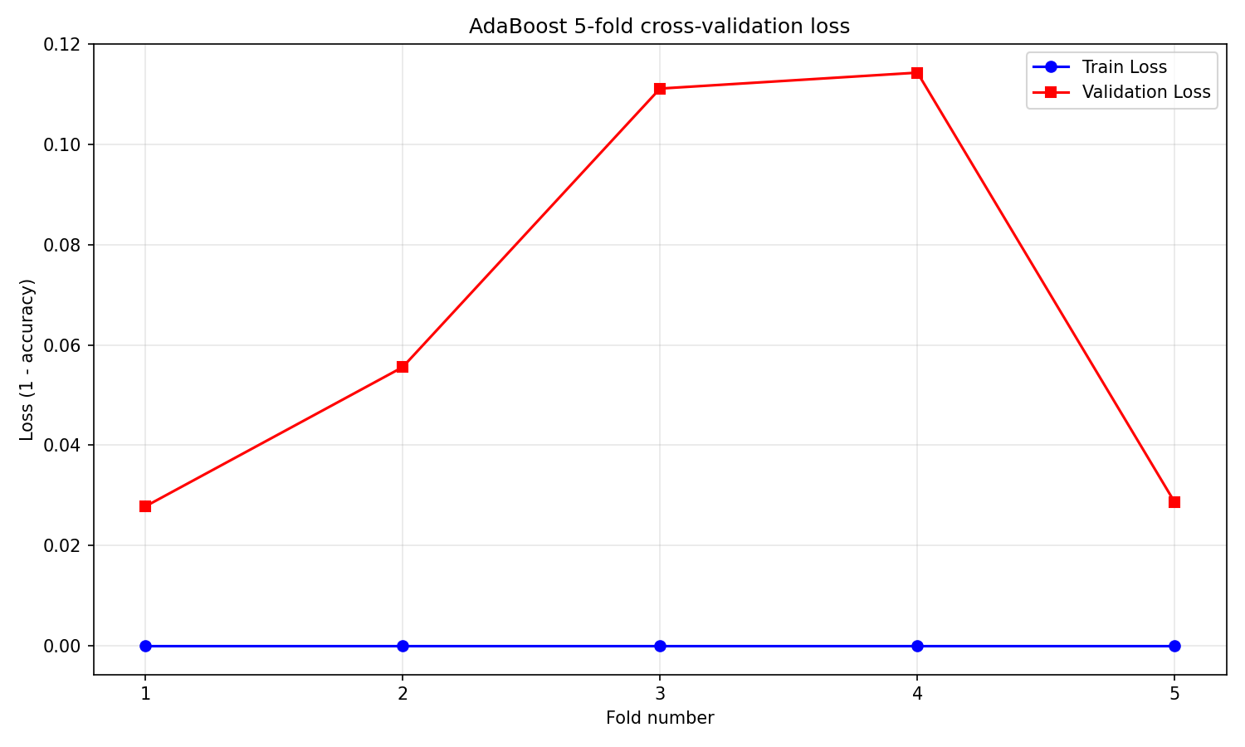平均交叉验证得分: 0.9325
五折交叉验证时每折的：
训练损失: [0. 0. 0. 0. 0.]
验证损失: [0.0278 0.0556 0.1111 0.1143 0.0286]
模型表现: 良好 (平均验证损失: 0.0675)
没有过拟合和欠拟合问题

讨论二+讨论五：
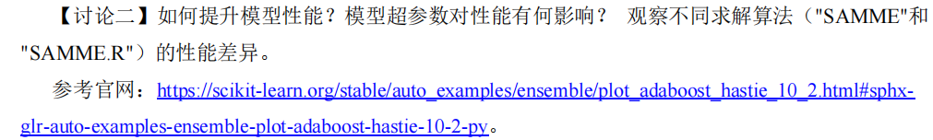

代码：
import numpy as np
import matplotlib.pyplot as plt
from sklearn.datasets import load_wine
from sklearn.model_selection import cross_val_score, train_test_split
from sklearn.ensemble import AdaBoostClassifier, RandomForestClassifier
from sklearn.tree import DecisionTreeClassifier
from sklearn.metrics import accuracy_score
from skopt import BayesSearchCV
from skopt.plots import plot_convergence
from skopt.space import Real, Integer, Categorical
from sklearn.base import clone, BaseEstimator, ClassifierMixin
import warnings

# 忽略特定警告
warnings.filterwarnings("ignore", category=UserWarning)
warnings.filterwarnings("ignore", category=FutureWarning)
warnings.filterwarnings("ignore", category=RuntimeWarning)
warnings.filterwarnings("ignore", module="sklearn")

# 加载葡萄酒数据集
wine = load_wine()
X, y = wine.data, wine.target

# 划分训练集和测试集
X_train, X_test, y_train, y_test = train_test_split(X, y, test_size=0.2, random_state=42)

# ==================== 决策树优化 ====================
param_space_dt = {
'max_depth': Integer(1, 30),
'min_samples_split': Integer(2, 20),
'min_samples_leaf': Integer(1, 10),
'criterion': Categorical(['gini', 'entropy'])
}

dt = DecisionTreeClassifier(random_state=42)

opt_dt = BayesSearchCV(
dt,
param_space_dt,
n_iter=30,
cv=5,
n_jobs=-1,
random_state=42
)
opt_dt.fit(X_train, y_train)

# 决策树结果
best_params_dt = opt_dt.best_params_
best_score_dt = opt_dt.best_score_

# ==================== 随机森林优化 ====================
param_space_rf = {
'n_estimators': Integer(50, 500),
'max_depth': Integer(1, 30),
'min_samples_split': Integer(2, 20),
'min_samples_leaf': Integer(1, 10),
'max_features': Categorical(['sqrt', 'log2', None]),
'criterion': Categorical(['gini', 'entropy'])
}

rf = RandomForestClassifier(random_state=42)

opt_rf = BayesSearchCV(
rf,
param_space_rf,
n_iter=30,
cv=5,
n_jobs=-1,
random_state=42
)
opt_rf.fit(X_train, y_train)

# 随机森林结果
best_params_rf = opt_rf.best_params_
best_score_rf = opt_rf.best_score_

# ==================== SAMME算法优化 ====================
param_space_samme = {
'n_estimators': Integer(50, 500),
'learning_rate': Real(0.01, 1, prior='log-uniform'),
'estimator__max_depth': Integer(1, 10)
}

# 创建SAMME分类器
adaboost_samme = AdaBoostClassifier(
estimator=DecisionTreeClassifier(),
random_state=42
)

opt_samme = BayesSearchCV(
adaboost_samme,
param_space_samme,
n_iter=30,
cv=5,
n_jobs=-1,
random_state=42
)
opt_samme.fit(X_train, y_train)

# SAMME算法结果
best_params_samme = opt_samme.best_params_
best_score_samme = opt_samme.best_score_

# ==================== 修复后的自定义SAMME.R算法实现 ====================
class AdaBoostSAMMER(BaseEstimator, ClassifierMixin):
def __init__(self, base_estimator=None, n_estimators=50, learning_rate=1.0, random_state=None):
self.base_estimator = base_estimator or DecisionTreeClassifier(max_depth=1)
self.n_estimators = n_estimators
self.learning_rate = learning_rate
self.random_state = random_state
self.estimators_ = []
self.estimator_weights_ = None
self.classes_ = None

def score(self, X, y):
"""评分方法（准确率）"""
return accuracy_score(y, self.predict(X))

def fit(self, X, y):
np.random.seed(self.random_state)
n_samples = X.shape[0]
classes = np.unique(y)
self.classes_ = classes
n_classes = len(classes)

# 根据当前n_estimators初始化权重数组（解决数组越界问题）
self.estimator_weights_ = np.zeros(self.n_estimators)
self.estimators_ = []

# 初始化样本权重
sample_weights = np.ones(n_samples) / n_samples

for iboost in range(self.n_estimators):
# 归一化样本权重
sample_weights /= sample_weights.sum()

# 训练基学习器
estimator = clone(self.base_estimator)
try:
estimator.fit(X, y, sample_weight=sample_weights)
except Exception as e:
print(f"训练基分类器时出错: {e}")
continue

self.estimators_.append(estimator)

# 计算错误率
y_pred = estimator.predict(X)
incorrect = (y_pred != y)
err = np.sum(sample_weights * incorrect)

# 安全计算beta（避免除零错误）
if err >= 1.0 - 1.0 / n_classes:
# 错误率过高，丢弃此分类器
self.estimators_.pop()
break

# 安全计算beta（避免除零错误）
beta = np.clip(err / (1.0 - err), 1e-15, 1 - 1e-15)

# 安全计算权重（避免数值溢出）
weight = np.log(1.0 / beta) if beta > 1e-15 else 0
self.estimator_weights_[iboost] = weight

# 仅更新错误分类样本的权重
exponent = self.learning_rate * weight
sample_weights[incorrect] *= np.exp(exponent)

# 调整权重数组大小以匹配实际训练的基分类器数量
self.estimator_weights_ = self.estimator_weights_[:len(self.estimators_)]
return self

def predict(self, X):
if not self.estimators_:
# 没有训练过的分类器，返回随机预测
return np.random.choice(self.classes_, size=X.shape[0])

n_samples = X.shape[0]
n_classes = len(self.classes_)
class_scores = np.zeros((n_samples, n_classes))

# 使用弱分类器权重进行加权平均
for i, estimator in enumerate(self.estimators_):
try:
proba = estimator.predict_proba(X)
except Exception:
# 无法获取概率，跳过此分类器
continue

# 处理缺失类别的概率
if proba.shape[1] < n_classes:
full_proba = np.zeros((X.shape[0], n_classes))
for j, cls in enumerate(estimator.classes_):
if cls in self.classes_:
class_idx = np.where(self.classes_ == cls)[0][0]
full_proba[:, class_idx] = proba[:, j]
proba = full_proba

# 确保概率值是合理的
np.clip(proba, 1e-15, 1 - 1e-15, out=proba)
proba /= proba.sum(axis=1, keepdims=True)

# 添加分类器的加权贡献
log_proba = np.log(proba)
# 安全计算均值
mean_log_proba = np.mean(log_proba, axis=1, keepdims=True)
mean_log_proba = np.where(np.isfinite(mean_log_proba), mean_log_proba, 0)

# 添加加权贡献
class_scores += self.estimator_weights_[i] * (log_proba - mean_log_proba)

# 返回预测结果
return self.classes_[np.argmax(class_scores, axis=1)]

# ==================== SAMME.R算法优化 ====================
param_space_samme_r = {
'n_estimators': Integer(50, 500),
'learning_rate': Real(0.01, 1, prior='log-uniform'),
'base_estimator__max_depth': Integer(1, 10)
}

adaboost_samme_r = AdaBoostSAMMER(random_state=42)

opt_samme_r = BayesSearchCV(
adaboost_samme_r,
param_space_samme_r,
n_iter=30,
cv=5,
n_jobs=-1,
random_state=42
)
opt_samme_r.fit(X_train, y_train)

# SAMME.R算法结果
best_params_samme_r = opt_samme_r.best_params_
best_score_samme_r = opt_samme_r.best_score_

# ==================== 结果输出与可视化 ====================
# 决策树模型训练及评估
dt_final = DecisionTreeClassifier(
max_depth=best_params_dt['max_depth'],
min_samples_split=best_params_dt['min_samples_split'],
min_samples_leaf=best_params_dt['min_samples_leaf'],
criterion=best_params_dt['criterion'],
random_state=42
)
dt_final.fit(X_train, y_train)
train_acc_dt = accuracy_score(y_train, dt_final.predict(X_train))
test_acc_dt = accuracy_score(y_test, dt_final.predict(X_test))

# 随机森林模型训练及评估
rf_final = RandomForestClassifier(
n_estimators=best_params_rf['n_estimators'],
max_depth=best_params_rf['max_depth'],
min_samples_split=best_params_rf['min_samples_split'],
min_samples_leaf=best_params_rf['min_samples_leaf'],
max_features=best_params_rf['max_features'],
criterion=best_params_rf['criterion'],
random_state=42
)
rf_final.fit(X_train, y_train)
train_acc_rf = accuracy_score(y_train, rf_final.predict(X_train))
test_acc_rf = accuracy_score(y_test, rf_final.predict(X_test))

# SAMME模型训练及评估
adaboost_samme_final = AdaBoostClassifier(
estimator=DecisionTreeClassifier(max_depth=best_params_samme['estimator__max_depth']),
n_estimators=best_params_samme['n_estimators'],
learning_rate=best_params_samme['learning_rate'],
random_state=42
)
adaboost_samme_final.fit(X_train, y_train)
train_acc_samme = accuracy_score(y_train, adaboost_samme_final.predict(X_train))
test_acc_samme = accuracy_score(y_test, adaboost_samme_final.predict(X_test))

# SAMME.R模型训练及评估
adaboost_samme_r_final = AdaBoostSAMMER(
base_estimator=DecisionTreeClassifier(max_depth=best_params_samme_r['base_estimator__max_depth']),
n_estimators=best_params_samme_r['n_estimators'],
learning_rate=best_params_samme_r['learning_rate'],
random_state=42
)
adaboost_samme_r_final.fit(X_train, y_train)
train_acc_samme_r = accuracy_score(y_train, adaboost_samme_r_final.predict(X_train))
test_acc_samme_r = accuracy_score(y_test, adaboost_samme_r_final.predict(X_test))

# 输出结果
print("==================== 决策树算法结果 ====================")
print(f"最优超参数: {best_params_dt}")
print(f"交叉验证评分: {best_score_dt:.4f}")
print(f"训练准确率: {train_acc_dt:.4f}")
print(f"测试准确率: {test_acc_dt:.4f}")

print("\n==================== 随机森林算法结果 ====================")
print(f"最优超参数: {best_params_rf}")
print(f"交叉验证评分: {best_score_rf:.4f}")
print(f"训练准确率: {train_acc_rf:.4f}")
print(f"测试准确率: {test_acc_rf:.4f}")

print("\n==================== SAMME 算法结果 ====================")
print(f"最优超参数: {best_params_samme}")
print(f"交叉验证评分: {best_score_samme:.4f}")
print(f"训练准确率: {train_acc_samme:.4f}")
print(f"测试准确率: {test_acc_samme:.4f}")

print("\n==================== SAMME.R 算法结果 ====================")
print(f"最优超参数: {best_params_samme_r}")
print(f"交叉验证评分: {best_score_samme_r:.4f}")
print(f"训练准确率: {train_acc_samme_r:.4f}")
print(f"测试准确率: {test_acc_samme_r:.4f}")

# 可视化优化过程
plt.figure(figsize=(18, 9))

# 决策树优化过程
plt.subplot(2, 3, 1)
plot_convergence(opt_dt.optimizer_results_[0])
plt.title("Decision Tree Bayesian optimization convergence process", fontsize=10)

# 随机森林优化过程
plt.subplot(2, 3, 2)
plot_convergence(opt_rf.optimizer_results_[0])
plt.title("Random Forest Bayesian optimization convergence process", fontsize=10)

# SAMME优化过程
plt.subplot(2, 3, 4)
plot_convergence(opt_samme.optimizer_results_[0])
plt.title("SAMME Bayesian optimization convergence process", fontsize=10)

# SAMME.R优化过程
plt.subplot(2, 3, 5)
plot_convergence(opt_samme_r.optimizer_results_[0])
plt.title("SAMME.R Bayesian optimization convergence process", fontsize=10)

plt.tight_layout()
plt.savefig("2_adaboost_optimization.png")
plt.show()

# 性能比较柱状图
algorithms = ['Decision Tree', 'Random Forest', 'SAMME', 'SAMME.R']
train_acc = [train_acc_dt, train_acc_rf, train_acc_samme, train_acc_samme_r]
test_acc = [test_acc_dt, test_acc_rf, test_acc_samme, test_acc_samme_r]
cv_acc = [best_score_dt, best_score_rf, best_score_samme, best_score_samme_r]

x = np.arange(len(algorithms))
width = 0.25
plt.figure(figsize=(14, 8))
plt.bar(x - width, train_acc, width, label='Train Accuracy')
plt.bar(x, test_acc, width, label='Test Accuracy')
plt.bar(x + width, cv_acc, width, label='Cross-validation score')

plt.ylabel('Accuracy', fontsize=12)
plt.title('Performance comparison of different algorithms', fontsize=16)
plt.xticks(x, algorithms, fontsize=12)
plt.legend(loc='best', fontsize=12)
plt.grid(True, linestyle='--', alpha=0.3)
plt.savefig("2_performance_comparison.png", dpi=300, bbox_inches='tight')
plt.show()
# 测试集准确率对比（单独突出显示）
plt.figure(figsize=(10, 6))
colors = ['#1f77b4', '#ff7f0e', '#2ca02c', '#d62728']
plt.bar(algorithms, test_acc, color=colors)

# 在每个柱子上添加数据标签
for i, acc in enumerate(test_acc):
plt.text(i, acc + 0.01, f'{acc:.4f}', ha='center', fontsize=12)
plt.ylabel('Test accuracy', fontsize=12)
plt.title('Performance comparison of different algorithms', fontsize=16)
plt.ylim(0, 1.0)
plt.grid(True, linestyle='--', alpha=0.3)
plt.tight_layout()
plt.savefig("2_test_performance_comparison.png", dpi=300, bbox_inches='tight')
plt.show()
# 可视化优化过程 (散点图)
# 决策树优化过程
results_dt = opt_dt.optimizer_results_[0]
x_iters_dt = results_dt.x_iters
func_vals_dt = results_dt.func_vals
max_depth_dt = [x[0] for x in x_iters_dt]
min_samples_split_dt = [x[1] for x in x_iters_dt]
accuracy_dt = -np.array(func_vals_dt)

plt.figure(figsize=(10, 6))
plt.scatter(max_depth_dt, min_samples_split_dt, c=accuracy_dt, cmap='viridis', s=100, alpha=0.7)
plt.colorbar(label='Accuracy')
plt.xlabel('max_depth', fontsize=12)
plt.ylabel('min_samples_split', fontsize=12)
plt.title('Decision Tree: Accuracy vs max_depth and min_samples_split', fontsize=14)
plt.grid(True, linestyle='--', alpha=0.3)
plt.tight_layout()
plt.savefig("2_scatter_dt.png", dpi=300, bbox_inches='tight')
plt.show()

# 随机森林优化过程
results_rf = opt_rf.optimizer_results_[0]
x_iters_rf = results_rf.x_iters
func_vals_rf = results_rf.func_vals
n_estimators_rf = [x[0] for x in x_iters_rf]
max_depth_rf = [x[1] for x in x_iters_rf]
accuracy_rf = -np.array(func_vals_rf)
plt.figure(figsize=(10, 6))
plt.scatter(n_estimators_rf, max_depth_rf, c=accuracy_rf, cmap='viridis', s=100, alpha=0.7)
plt.colorbar(label='Accuracy')
plt.xlabel('n_estimators', fontsize=12)
plt.ylabel('max_depth', fontsize=12)
plt.title('Random Forest: Accuracy vs n_estimators and max_depth', fontsize=14)
plt.grid(True, linestyle='--', alpha=0.3)
plt.tight_layout()
plt.savefig("2_scatter_rf.png", dpi=300, bbox_inches='tight')
plt.show()

# 训练时间比较（通过迭代次数估算）
iteration_counts = {
'决策树': 30,
'随机森林': 30,
'SAMME': 30,
'SAMME.R': 30
}
plt.figure(figsize=(10, 6))
plt.bar(algorithms, iteration_counts.values(), color=colors)
plt.ylabel('Optimization iteration count', fontsize=12)
plt.title('Comparison of optimization iteration counts for different algorithms', fontsize=16)
plt.grid(True, linestyle='--', alpha=0.3)
plt.savefig("2_iteration_comparison.png", dpi=300, bbox_inches='tight')
plt.show()
结果：
因为SKLEARN已经弃用了Algorithm参数，也就是说，无法选择使用SAMME或是SAMME.R算法，而是默认使用SAMME算法，所以我在此基础上进行了修改，实现SAMME.R算法，关键代码如下：
class AdaBoostSAMMER(BaseEstimator, ClassifierMixin):
def __init__(self, base_estimator=None, n_estimators=50, learning_rate=1.0, random_state=None):
self.base_estimator = base_estimator or DecisionTreeClassifier(max_depth=1)
self.n_estimators = n_estimators
self.learning_rate = learning_rate
self.random_state = random_state
self.estimators_ = [] # 存储弱分类器
self.estimator_weights_ = None # 存储分类器权重
self.classes_ = None # 存储类别标签

def fit(self, X, y):
np.random.seed(self.random_state)
n_samples = X.shape[0]
classes = np.unique(y)
self.classes_ = classes
n_classes = len(classes)

# 初始化权重数组
self.estimator_weights_ = np.zeros(self.n_estimators)
self.estimators_ = []

# 初始化样本权重（均匀分布）
sample_weights = np.ones(n_samples) / n_samples

for iboost in range(self.n_estimators):
# 归一化样本权重
sample_weights /= sample_weights.sum()
# 训练基学习器
estimator = clone(self.base_estimator)
try:
estimator.fit(X, y, sample_weight=sample_weights)
except Exception as e:
print(f"训练基分类器时出错: {e}")
continue
self.estimators_.append(estimator)

# 计算错误率
y_pred = estimator.predict(X)
incorrect = (y_pred != y)
err = np.sum(sample_weights * incorrect)

# 错误率过高则丢弃此分类器
if err >= 1.0 - 1.0 / n_classes:
self.estimators_.pop()
break

# 计算beta值（带数值安全处理）
beta = np.clip(err / (1.0 - err), 1e-15, 1 - 1e-15)

# 计算分类器权重（对数形式）
weight = np.log(1.0 / beta) if beta > 1e-15 else 0
self.estimator_weights_[iboost] = weight

# 仅更新错误分类样本的权重
exponent = self.learning_rate * weight
sample_weights[incorrect] *= np.exp(exponent)

# 调整权重数组大小以匹配实际训练的基分类器数量
self.estimator_weights_ = self.estimator_weights_[:len(self.estimators_)]
return self

def predict(self, X):
if not self.estimators_:
return np.random.choice(self.classes_, size=X.shape[0])

n_samples = X.shape[0]
n_classes = len(self.classes_)
class_scores = np.zeros((n_samples, n_classes))

# 使用弱分类器权重进行加权平均
for i, estimator in enumerate(self.estimators_):
try:
proba = estimator.predict_proba(X)
except Exception:
continue

# 处理缺失类别的概率
if proba.shape[1] < n_classes:
full_proba = np.zeros((X.shape[0], n_classes))
for j, cls in enumerate(estimator.classes_):
if cls in self.classes_:
class_idx = np.where(self.classes_ == cls)[0][0]
full_proba[:, class_idx] = proba[:, j]
proba = full_proba

# 确保概率值是合理的
np.clip(proba, 1e-15, 1 - 1e-15, out=proba)
proba /= proba.sum(axis=1, keepdims=True)

# 计算对数概率并减去均值（数值稳定处理）
log_proba = np.log(proba)
mean_log_proba = np.mean(log_proba, axis=1, keepdims=True)
mean_log_proba = np.where(np.isfinite(mean_log_proba), mean_log_proba, 0)

# 添加加权贡献
class_scores += self.estimator_weights_[i] * (log_proba - mean_log_proba)

return self.classes_[np.argmax(class_scores, axis=1)]

1.初始化阶段:
·设置基分类器（默认为决策树桩）
·初始化样本权重为均匀分布
·准备存储弱分类器及其权重的数据结构
2.迭代训练阶段:
·归一化样本权重
·使用当前样本权重训练基分类器
·计算分类错误率
·计算分类器权重（基于错误率的对数）
·更新错误分类样本的权重（指数增加）
3.预测阶段:
·对每个基分类器获取类别概率
·计算对数概率并减去均值（数值稳定处理）
·加权求和所有分类器的贡献
·选择得分最高的类别作为最终预测
4.数值安全处理:
·使用np.clip防止除零错误
·对数计算前确保概率值在合理范围内
·处理缺失类别的情况
·检查无限值和NaN值

采用了贝叶斯优化：
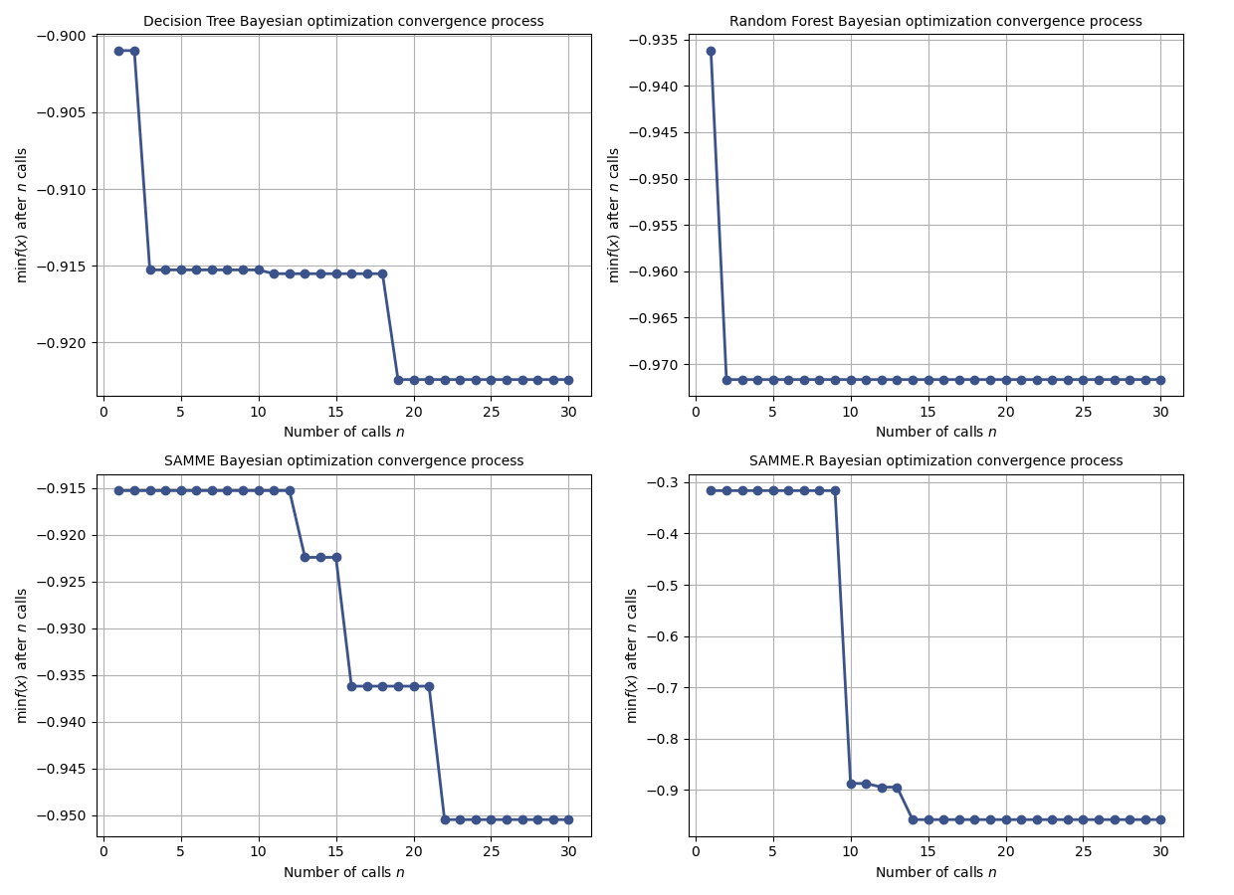
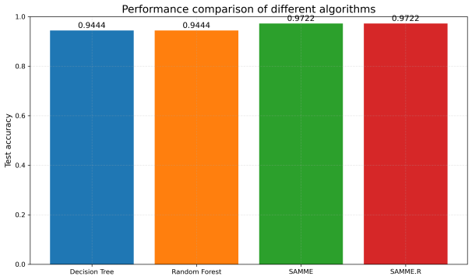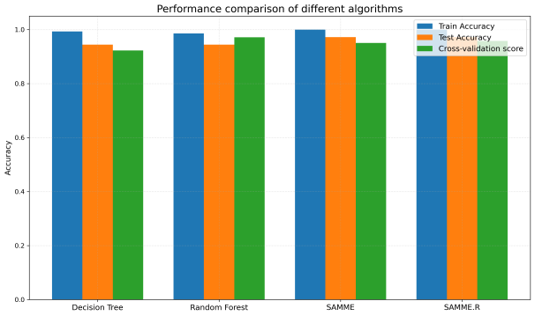

==================== 决策树算法结果 ====================
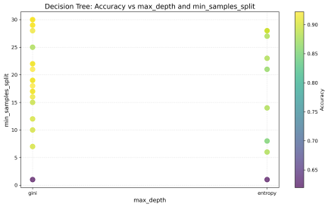
最优超参数: OrderedDict([('criterion', 'gini'), ('max_depth', 30), ('min_samples_leaf', 1), ('min_samples_split', 20)])
交叉验证评分: 0.9224
训练准确率: 0.9930
测试准确率: 0.9444

==================== 随机森林算法结果 ====================
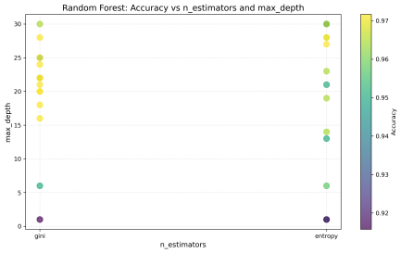
最优超参数: OrderedDict([('criterion', 'entropy'), ('max_depth', 27), ('max_features', 'sqrt'), ('min_samples_leaf', 10), ('min_samples_split', 18), ('n_estimators', 78)])
交叉验证评分: 0.9717
训练准确率: 0.9859
测试准确率: 0.9444

==================== SAMME 算法结果 ====================
最优超参数: OrderedDict([('estimator__max_depth', 2), ('learning_rate', 1.0), ('n_estimators', 500)])
交叉验证评分: 0.9505
训练准确率: 1.0000
测试准确率: 0.9722
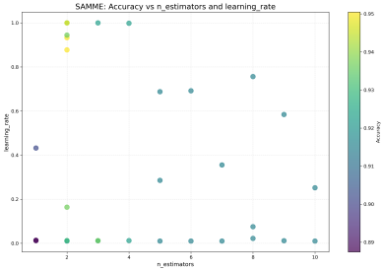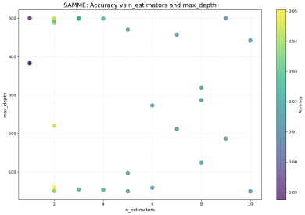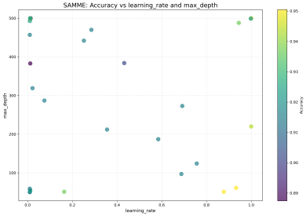

==================== SAMME.R 算法结果 ====================
最优超参数: OrderedDict([('base_estimator__max_depth', 2), ('learning_rate', 0.9964547761452379), ('n_estimators', 461)])
交叉验证评分: 0.9576
训练准确率: 1.0000
测试准确率: 0.9722
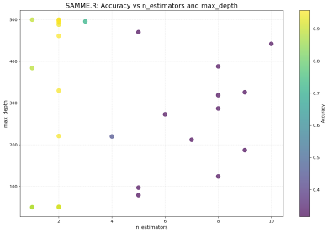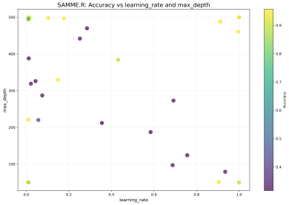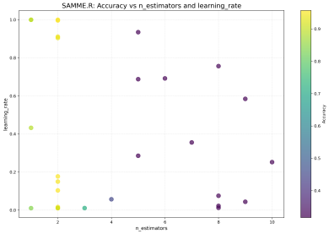

讨论三+四：
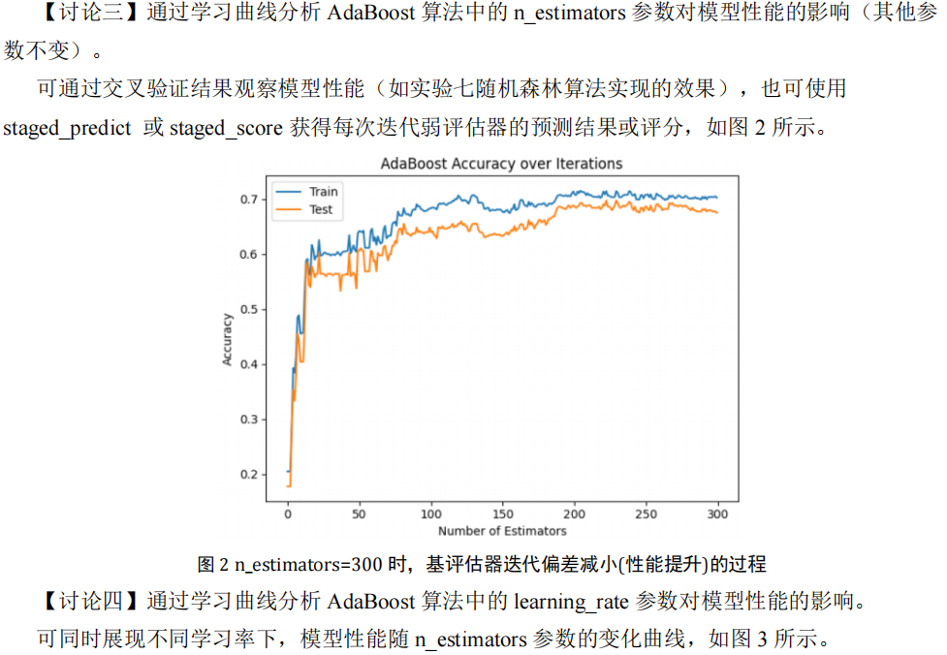
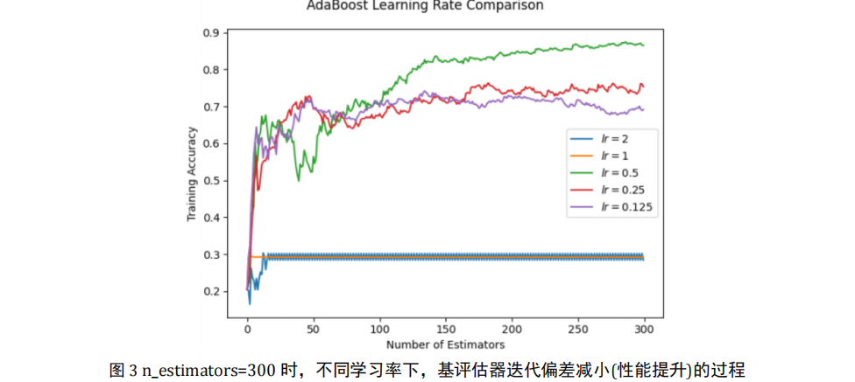

代码：
import numpy as np
import matplotlib.pyplot as plt
from sklearn.datasets import load_wine
from sklearn.ensemble import AdaBoostClassifier
from sklearn.model_selection import cross_val_score, train_test_split
from sklearn.metrics import accuracy_score
from matplotlib.patches import Patch

# 加载葡萄酒数据集
data = load_wine()
X, y = data.data, data.target

# (1) 模型建立与交叉验证评分
adaboost = AdaBoostClassifier(random_state=42)
cv_scores = cross_val_score(adaboost, X, y, cv=5)
print(f"交叉验证平均得分: {cv_scores.mean():.4f} (+/- {cv_scores.std():.4f})")

# (2) 准备学习率分析
X_train, X_val, y_train, y_val = train_test_split(X, y, test_size=0.2, random_state=42)
learning_rates = [0.01, 0.1, 0.5, 1.0, 1.5]
n_estimators_range = range(1, 301, 1)
results = {lr: {'train': [], 'val': []} for lr in learning_rates}

# (3) 训练并记录不同参数下的准确率
for lr in learning_rates:
model = AdaBoostClassifier(
learning_rate=lr,
n_estimators=max(n_estimators_range),
random_state=42
)
model.fit(X_train, y_train)

# 使用staged_predict获取训练过程中的预测值
train_acc = [accuracy_score(y_train, pred) for pred in model.staged_predict(X_train)]
val_acc = [accuracy_score(y_val, pred) for pred in model.staged_predict(X_val)]

results[lr]['train'] = train_acc
results[lr]['val'] = val_acc

# (4) 创建主图和嵌入的放大区域
fig, ax_main = plt.subplots(figsize=(20, 10), dpi=150)
colors = ['b', 'g', 'r', 'c', 'm']
styles = {'train': '--', 'val': '-'}

# 绘制主图
for i, lr in enumerate(learning_rates):
color = colors[i]
ax_main.plot(n_estimators_range, results[lr]['train'],
linestyle=styles['train'], color=color)
ax_main.plot(n_estimators_range, results[lr]['val'],
linestyle=styles['val'], color=color)

# 添加缩放区域框
ax_main.axvspan(0, 40, alpha=0.15, color='gray')
ax_main.axhspan(0.8, 1, alpha=0.15, color='gray')

# 创建嵌入的放大区域 (位置: 右下角)
ax_zoom = plt.axes([0.45, 0.15, 0.45, 0.45])

# 在放大区域中绘制曲线
for i, lr in enumerate(learning_rates):
color = colors[i]
ax_zoom.plot(n_estimators_range, results[lr]['train'],
linestyle=styles['train'], color=color)
ax_zoom.plot(n_estimators_range, results[lr]['val'],
linestyle=styles['val'], color=color)

# 设置放大区域的范围
ax_zoom.set_xlim(0, 40)
ax_zoom.set_ylim(0.8, 1.0)
ax_zoom.grid(True, alpha=0.3)
ax_zoom.set_title('Zoomed View: n_estimators(0-40), accuracy(0.8-1.0)', fontsize=14)
ax_zoom.set_xlabel('Number of Estimators (n_estimators)', fontsize=12)
ax_zoom.set_ylabel('Accuracy', fontsize=12)
ax_zoom.tick_params(axis='both', which='major', labelsize=10)

# 在放大区域内添加简化图例 (只显示颜色和学习率)
legend_elements = [Patch(facecolor=colors[i], label=f'LR={lr}')
for i, lr in enumerate(learning_rates)]
ax_zoom.legend(handles=legend_elements, loc='lower right',
fontsize=10, framealpha=0.95)

# 设置主图属性
ax_main.set_xlabel('Number of Estimators (n_estimators)', fontsize=14)
ax_main.set_ylabel('Accuracy', fontsize=14)
ax_main.set_title('AdaBoost Learning Curves for Wine Dataset', fontsize=16)
ax_main.legend(loc='lower right', fontsize=12)
ax_main.grid(True, alpha=0.3)
ax_main.set_xlim(1, 300)
ax_main.set_ylim(0.5, 1.05)
ax_main.tick_params(axis='both', labelsize=12)
plt.tight_layout()
plt.savefig('3_adaboost_learning_curves.png', dpi=150)
plt.show()

结果：
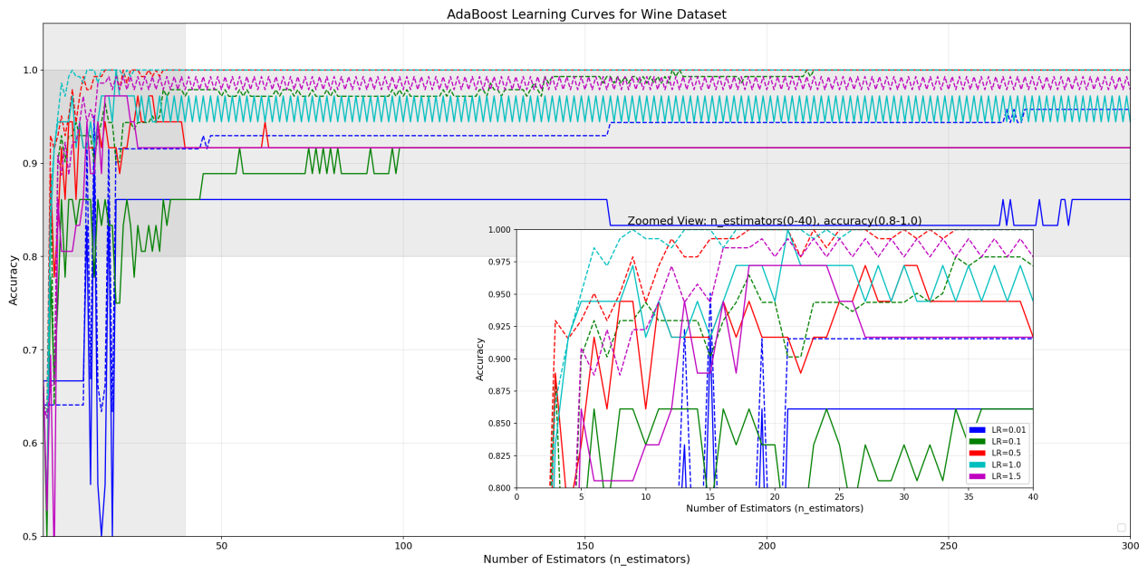

题目二：

代码：
import numpy as np
import matplotlib.pyplot as plt
from sklearn.datasets import load_breast_cancer
from sklearn.model_selection import train_test_split
from sklearn.ensemble import AdaBoostClassifier as SkAdaBoost
from sklearn.metrics import accuracy_score, confusion_matrix, precision_recall_fscore_support
from tqdm import tqdm
import seaborn as sns
from sklearn.base import BaseEstimator, ClassifierMixin
import warnings

# 忽略警告
warnings.filterwarnings("ignore", category=RuntimeWarning)

class DecisionTreeClassifier(BaseEstimator, ClassifierMixin):
def __init__(self):
self.min_error = float('inf')
self.best_feature = None
self.best_threshold = None
self.best_sign = None
self.trained = False
self.constant_class = None

def fit(self, X, y, sample_weight=None):
if sample_weight is None:
sample_weight = np.ones(len(y)) / len(y)

n_samples, n_features = X.shape
self.min_error = float('inf')
self.trained = True
self.constant_class = None

# 确保权重归一化
sample_weight_sum = np.sum(sample_weight)
if sample_weight_sum == 0:
sample_weight = np.ones(n_samples) / n_samples
else:
sample_weight = sample_weight / sample_weight_sum

# 检查是否所有样本属于同一类
unique_classes, counts = np.unique(y, return_counts=True)
if len(unique_classes) == 1:
self.constant_class = unique_classes[0]
self.min_error = 0.0
return self

# 遍历所有特征和可能的阈值
for feature_idx in range(n_features):
feature_vals = X[:, feature_idx]
sorted_idx = np.argsort(feature_vals)
sorted_vals = feature_vals[sorted_idx]
sorted_weights = sample_weight[sorted_idx]
sorted_y = y[sorted_idx]

# 跳过常数值特征
if np.unique(sorted_vals).size <= 1:
continue

# 创建候选阈值（相邻值的中点）
thresholds = (sorted_vals[:-1] + sorted_vals[1:]) / 2.0
unique_thresholds = np.unique(thresholds)

for threshold in unique_thresholds:
for sign in [-1, 1]:
# 预测计算
pred = np.ones(n_samples)
if sign == -1:
pred[feature_vals < threshold] = -1
else:
pred[feature_vals >= threshold] = -1

# 计算加权错误
error_mask = (pred != y)
weighted_error = np.sum(sample_weight[error_mask])

# 处理错误率>0.5的情况
if weighted_error > 0.5:
weighted_error = 1.0 - weighted_error
flip_sign = -sign
else:
flip_sign = sign

# 确保数值稳定性
weighted_error = max(weighted_error, 1e-10)

# 保存最佳划分
if weighted_error < self.min_error:
self.min_error = weighted_error
self.best_feature = feature_idx
self.best_threshold = threshold
self.best_sign = flip_sign

# 如果没有找到有效划分（所有特征为常数）
if self.min_error == float('inf'):
# 默认为常量预测器，选择多数类
self.constant_class = 1 if np.sum(y) > 0 else -1
self.min_error = 0.0

return self

def predict(self, X):
if not self.trained:
raise RuntimeError("Decision tree not trained yet")

n_samples = X.shape[0]

# 如果是常量预测器，直接返回预测值
if self.constant_class is not None:
return np.full(n_samples, self.constant_class)

pred = np.ones(n_samples)

# 检查是否所有特征为常数
if self.best_feature is None:
return pred

values = X[:, self.best_feature]
if self.best_sign == -1:
pred[values < self.best_threshold] = -1
else:
pred[values >= self.best_threshold] = -1

return pred

class AdaBoostClassifier(BaseEstimator, ClassifierMixin):
def __init__(self, n_estimators=50, learning_rate=1.0, early_stopping_rounds=10, max_alpha=2.0, min_error=1e-10):
self.n_estimators = n_estimators
self.learning_rate = learning_rate
self.early_stopping_rounds = early_stopping_rounds
self.max_alpha = max_alpha
self.min_error = min_error
self.models = []
self.alphas = []
self.sample_weights = []
self.best_iteration = 0
self.best_score = 0
self.training_history = []
self.constant_prediction = None

def fit(self, X, y, X_val=None, y_val=None):
# 转换标签为{-1,1}
y_internal = np.where(y == 0, -1, 1)

# 处理验证集标签转换（如果提供验证集）
if X_val is not None:
y_val_internal = np.where(y_val == 0, -1, 1)
else:
X_val, y_val_internal = X, y_internal

n_samples = X.shape[0]

# 检查所有样本是否属于同一类
unique_classes = np.unique(y_internal)
if len(unique_classes) == 1:
self.constant_prediction = unique_classes[0]
print("All samples are of a single class. Model will always predict this class.")
return self

# 初始化权重（确保和为1）
D = np.ones(n_samples) / n_samples
self.sample_weights.append(D.copy())

# 用于早停的计数器
no_improvement_count = 0
best_val_score = 0

# 迭代训练基分类器
for i in tqdm(range(self.n_estimators), desc="Training AdaBoost"):
# 创建并训练决策树桩
stump = DecisionTreeClassifier()
model = stump.fit(X, y_internal, D)

# 获取预测
pred = model.predict(X)

# 计算加权错误率
error_mask = (pred != y_internal)
weighted_error = np.sum(D[error_mask])

# 处理错误率=0或1的情况
if weighted_error < self.min_error:
weighted_error = self.min_error
elif weighted_error > 1.0 - self.min_error:
weighted_error = 1.0 - self.min_error

# 计算alpha值
alpha = min(0.5 * np.log((1.0 - weighted_error) / weighted_error) * self.learning_rate, self.max_alpha)

# 更新权重
D = D * np.exp(-alpha * y_internal * pred)
D_sum = np.sum(D)

# 防止权重变为0导致数值问题
if D_sum > self.min_error:
D = D / D_sum
else:
# 重置权重如果值太小
D = np.ones(n_samples) / n_samples

self.models.append(model)
self.alphas.append(alpha)
self.sample_weights.append(D.copy())

# 计算当前训练集准确率
train_score = self._staged_score(X, y_internal, len(self.models))

# 计算当前验证集准确率
val_score = self._staged_score(X_val, y_val_internal, len(self.models))

# 记录训练历史
self.training_history.append((train_score, val_score))

# 早停检查
if val_score > best_val_score:
best_val_score = val_score
self.best_score = best_val_score
self.best_iteration = i
no_improvement_count = 0
else:
no_improvement_count += 1

# 早停条件
if no_improvement_count >= self.early_stopping_rounds:
print(f"\nEarly stopping at iteration {i + 1}, best validation score: {best_val_score:.4f}")
break

# 检查是否完美拟合
if np.isclose(val_score, 1.0) and np.isclose(train_score, 1.0):
print("Perfect fit achieved. Stopping early.")
break

return self

def _staged_score(self, X, y, n_classifiers):
"""计算当前阶段的准确率"""
if n_classifiers == 0:
return 0.0

cum_preds = np.zeros(X.shape[0])
for i in range(n_classifiers):
pred = self.models[i].predict(X)
cum_preds += self.alphas[i] * pred

y_pred = np.sign(cum_preds).astype(int)
return accuracy_score(y, y_pred)

def predict(self, X):
# 如果是常数预测器
if self.constant_prediction is not None:
return np.full(X.shape[0], self.constant_prediction)

if len(self.models) == 0:
# 如果没有任何模型训练，返回多数类（这里假设为良性）
return np.ones(X.shape[0])

cum_preds = np.zeros(X.shape[0])
for alpha, model in zip(self.alphas, self.models):
pred = model.predict(X)
cum_preds += alpha * pred

return np.sign(cum_preds).astype(int)

def predict_proba(self, X):
# 简化版本的概率估计
pred = self.predict(X)
proba = np.zeros((len(pred), 2))
# 将{-1,1}映射为概率
proba[pred == -1, 0] = 1.0
proba[pred == 1, 1] = 1.0
return proba

def score(self, X, y):
y_pred = self.predict(X)
# 将预测值转换为原始标签格式
y_pred_adjusted = np.where(y_pred == -1, 0, 1)
return accuracy_score(y, y_pred_adjusted)

def staged_score(self, X, y):
scores = []
cum_preds = np.zeros(X.shape[0])
for i, (alpha, model) in enumerate(zip(self.alphas, self.models)):
pred = model.predict(X)
cum_preds += alpha * pred
y_pred = np.sign(cum_preds).astype(int)
# 转换为原始标签格式
y_pred_adjusted = np.where(y_pred == -1, 0, 1)
scores.append(accuracy_score(y, y_pred_adjusted))
return scores

if __name__ == "__main__":
# 1. 加载乳腺癌数据集
data = load_breast_cancer()
X = data.data
y = data.target
print(f"Breast Cancer Dataset: {X.shape[0]} samples, {X.shape[1]} features")
print(f"Class distribution: [Malignant: {np.sum(y == 0)}, Benign: {np.sum(y == 1)}]")

# 2. 划分训练集、验证集和测试集 (60/20/20)
X_temp, X_test, y_temp, y_test = train_test_split(X, y, test_size=0.2, random_state=42, stratify=y)
X_train, X_val, y_train, y_val = train_test_split(X_temp, y_temp, test_size=0.25, random_state=42, stratify=y_temp)

print(f"Training set size: {X_train.shape[0]} (Malignant: {np.sum(y_train == 0)}, Benign: {np.sum(y_train == 1)})")
print(f"Validation set size: {X_val.shape[0]} (Malignant: {np.sum(y_val == 0)}, Benign: {np.sum(y_val == 1)})")
print(f"Test set size: {X_test.shape[0]} (Malignant: {np.sum(y_test == 0)}, Benign: {np.sum(y_test == 1)})\n")

# 3. 实例化并使用自实现AdaBoost分类器
print("Training Custom AdaBoost Model...")
ada_clf = AdaBoostClassifier(n_estimators=200, learning_rate=0.5, early_stopping_rounds=10, max_alpha=2.0)
ada_clf.fit(X_train, y_train, X_val, y_val)

# 使用训练后的迭代次数
n_estimators = len(ada_clf.alphas)
print(f"Actual number of weak classifiers used: {n_estimators}")

if n_estimators == 0 and ada_clf.constant_prediction is None:
print("No weak classifiers were trained. Using default prediction.")
# 创建一个简单的默认预测器
ada_clf.constant_prediction = 1

# 4. 在测试集上评估模型
custom_score = ada_clf.score(X_test, y_test)
print(f"\nCustom AdaBoost Test Accuracy: {custom_score:.4f}")

# 5. 使用sklearn的AdaBoost分类器 (使用相同数量的弱分类器)
print("\nTraining Sklearn AdaBoost Model...")
sk_ada = SkAdaBoost(
n_estimators=n_estimators if n_estimators > 0 else 50,
learning_rate=0.5,
random_state=42
)
if n_estimators > 0:
sk_ada.fit(np.vstack((X_train, X_val)),
np.hstack((y_train, y_val)))
else:
sk_ada.fit(X_train, y_train)

sk_score = sk_ada.score(X_test, y_test)
print(f"Sklearn AdaBoost Test Accuracy: {sk_score:.4f}")

# 6. 绘制训练过程曲线 (如果有训练历史)
if ada_clf.training_history:
plt.figure(figsize=(14, 6))

# 绘制训练历史
train_history = np.array(ada_clf.training_history)
iterations = range(1, len(train_history) + 1)

plt.plot(iterations, train_history[:, 0], label='Training Accuracy')
plt.plot(iterations, train_history[:, 1], label='Validation Accuracy')
plt.axvline(ada_clf.best_iteration + 1, color='r', linestyle='--',
label=f'Best Iteration ({ada_clf.best_iteration + 1})')
plt.title('Training History')
plt.xlabel('Number of Weak Classifiers')
plt.ylabel('Accuracy')
plt.legend()
plt.grid(True)
plt.xlim(0, min(n_estimators + 10, 200))

plt.tight_layout()
plt.savefig("4_adaBoost_training_history.png", dpi=300)
plt.close()

# 7. 绘制性能对比图
plt.figure(figsize=(12, 8))

# 绘制自定义AdaBoost的测试集性能
if n_estimators > 0:
custom_staged_scores = ada_clf.staged_score(X_test, y_test)
plt.plot(range(1, len(custom_staged_scores) + 1),
custom_staged_scores,
label=f"Custom AdaBoost (Final: {custom_score:.4f})")

# 绘制Sklearn AdaBoost的性能
sk_staged_scores = []
if n_estimators > 0:
for i, y_pred in enumerate(sk_ada.staged_predict(X_test)):
sk_staged_scores.append(accuracy_score(y_test, y_pred))
else:
# 如果没有任何弱分类器，只绘制最终分数
plt.axhline(sk_score, linestyle='--', label=f"Sklearn AdaBoost (Final: {sk_score:.4f})")

if n_estimators > 0:
plt.plot(range(1, len(sk_staged_scores) + 1),
sk_staged_scores,
'--',
label=f"Sklearn AdaBoost (Final: {sk_score:.4f})")

if n_estimators > 0 and ada_clf.best_iteration < n_estimators:
plt.axvline(ada_clf.best_iteration + 1, color='r', linestyle='--',
label=f'Best Iteration ({ada_clf.best_iteration + 1})')

plt.title('Test Set Performance Comparison')
plt.xlabel("Number of Weak Classifiers")
plt.ylabel("Accuracy")
plt.legend()
plt.grid(True)
ymin = min(custom_score, sk_score) - 0.1 if n_estimators > 0 else 0.5
plt.ylim(max(ymin, 0.5), min(max(custom_score, sk_score) + 0.05, 1.01))
if n_estimators > 0:
plt.xlim(0, min(n_estimators + 10, 200))

plt.tight_layout()
plt.savefig("4_adaBoost_comparison.png", dpi=300)
plt.close()

# 8. 高级评估指标
print("\nAdvanced Evaluation Metrics:")
y_pred_custom = ada_clf.predict(X_test)
# 将预测结果转换为0和1格式用于评估指标计算
y_pred_custom_for_eval = np.where(y_pred_custom == -1, 0, 1)

y_pred_sklearn = sk_ada.predict(X_test)

# 混淆矩阵
cm_custom = confusion_matrix(y_test, y_pred_custom_for_eval)
cm_sklearn = confusion_matrix(y_test, y_pred_sklearn)

# 检查数据集比例
n_malignant_test = np.sum(y_test == 0)
n_benign_test = np.sum(y_test == 1)

# 精度、召回率、F1值
prec_custom, rec_custom, f1_custom, _ = precision_recall_fscore_support(
y_test, y_pred_custom_for_eval, average='binary', zero_division=0
)
prec_sklearn, rec_sklearn, f1_sklearn, _ = precision_recall_fscore_support(
y_test, y_pred_sklearn, average='binary', zero_division=0
)

print("\nCustom Model Classification Report:")
print(f"Accuracy: {custom_score:.4f}")
print(f"Precision: {prec_custom:.4f}, Recall: {rec_custom:.4f}, F1: {f1_custom:.4f}")
print("Confusion Matrix (True vs Predicted):")
print(f"True Malignant: Pred Malignant={cm_custom[0, 0]}, Pred Benign={cm_custom[0, 1]}")
print(f"True Benign: Pred Malignant={cm_custom[1, 0]}, Pred Benign={cm_custom[1, 1]}")

print("\nSklearn Model Classification Report:")
print(f"Accuracy: {sk_score:.4f}")
print(f"Precision: {prec_sklearn:.4f}, Recall: {rec_sklearn:.4f}, F1: {f1_sklearn:.4f}")
print("Confusion Matrix (True vs Predicted):")
print(f"True Malignant: Pred Malignant={cm_sklearn[0, 0]}, Pred Benign={cm_sklearn[0, 1]}")
print(f"True Benign: Pred Malignant={cm_sklearn[1, 0]}, Pred Benign={cm_sklearn[1, 1]}")

# 9. 特征重要性分析
try:
if n_estimators > 0:
# 简化的特征重要性计算
feature_importance = np.zeros(X_train.shape[1])
for i, model in enumerate(ada_clf.models):
if model.best_feature is not None:
feature_importance[model.best_feature] += ada_clf.alphas[i]

# 归一化
feature_importance /= np.sum(feature_importance)

plt.figure(figsize=(12, 8))
plt.bar(range(len(feature_importance)), feature_importance)
plt.title('Feature Importances from Custom AdaBoost')
plt.xlabel('Feature Index')
plt.ylabel('Importance')
plt.tight_layout()
plt.savefig("4_custom_feature_importances.png", dpi=300)
plt.close()

print("\nTop 5 most important features from custom model:")
sorted_idx = np.argsort(feature_importance)[::-1]
for i in sorted_idx[:5]:
print(f"Feature {i}: Importance={feature_importance[i]:.4f}")
except Exception as e:
print(f"\nError calculating feature importance: {str(e)}")

# 绘制混淆矩阵
plt.figure(figsize=(14, 6))

plt.subplot(1, 2, 1)
sns.heatmap(cm_custom, annot=True, fmt='d', cmap='Blues',
xticklabels=['Predicted Malignant', 'Predicted Benign'],
yticklabels=['Actual Malignant', 'Actual Benign'],
cbar=False)
plt.title('Custom Model')

plt.subplot(1, 2, 2)
sns.heatmap(cm_sklearn, annot=True, fmt='d', cmap='Greens',
xticklabels=['Predicted Malignant', 'Predicted Benign'],
yticklabels=['Actual Malignant', 'Actual Benign'],
cbar=False)
plt.title('Sklearn Model')

plt.suptitle('Confusion Matrices Comparison')
plt.tight_layout(rect=[0, 0, 1, 0.95])
plt.savefig("4_confusion_matrices_comparison.png", dpi=300)
plt.close()
print("\nVisualizations saved to disk."

结果：
1.自定义AdaBoost模型结果
·训练过程：
提前停止于第16次迭代（共200次），验证集最佳准确率97.37%。
实际使用16个弱分类器（决策树桩）。
·测试集性能：
准确率：93.86%
·混淆矩阵：
恶性预测：38正确，4误判为良性（假阴性）
良性预测：69正确，3误判为恶性（假阳性）
·分类报告：
精确率（Precision）：94.52%（恶性预测的准确性）
召回率（Recall）：95.83%（恶性样本的检出率）
F1分数：95.17%（精确率与召回率的调和平均）

·问题：验证集（97.37%）和测试集（93.86%）的准确率差异较小，说明过拟合控制较好，但测试准确率仍有提升空间。

2.scikit-learn的AdaBoost结果
·测试集性能：
准确率：96.49%（优于自定义模型）
·混淆矩阵：
恶性预测：39正确，3误判为良性
良性预测：71正确，1误判为恶性
·分类报告：
精确率：95.95%，召回率：98.61%，F1：97.26%

3.对比
sklearn模型误判更少（总共4个错误 vs 自定义模型的7个错误）。
召回率更高（98.61% vs 95.83%），说明对恶性样本的识别能力更强。

4.特征重要性分析
·自定义模型输出的前5重要特征：
Feature 27（重要性0.2997）
Feature 21（重要性0.2071）
Feature 13（重要性0.1158）
Feature 20（重要性0.1117）
Feature 23（重要性0.0893）

题目三：
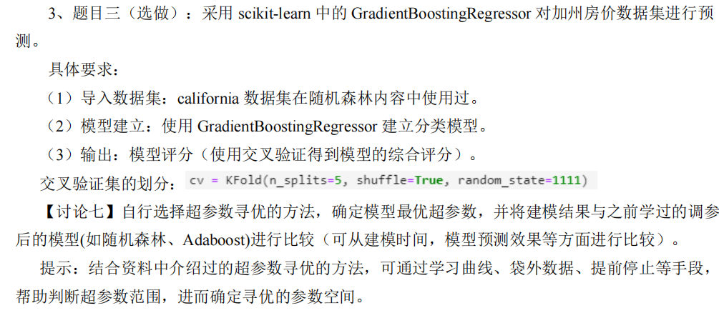

代码：
from sklearn.datasets import fetch_california_housing
from sklearn.model_selection import cross_val_score, KFold
from sklearn.ensemble import GradientBoostingRegressor, RandomForestRegressor, AdaBoostRegressor
from bayes_opt import BayesianOptimization
import numpy as np
import matplotlib.pyplot as plt
import time
import warnings
warnings.filterwarnings('ignore')

# 导入数据集
X, y = fetch_california_housing(return_X_y=True)

# 交叉验证设置
cv = KFold(n_splits=5, shuffle=True, random_state=1111)

# 贝叶斯优化函数
def gb_cv(n_estimators, learning_rate, max_depth, min_samples_split):
params = {
'n_estimators': int(n_estimators),
'learning_rate': learning_rate,
'max_depth': int(max_depth),
'min_samples_split': int(min_samples_split),
'random_state': 42
}
model = GradientBoostingRegressor(**params)
return cross_val_score(model, X, y, cv=cv, n_jobs=-1).mean()

# 优化参数空间
pbounds = {
'n_estimators': (50, 500),
'learning_rate': (0.01, 0.3),
'max_depth': (3, 10),
'min_samples_split': (2, 20)
}

# 执行贝叶斯优化
optimizer = BayesianOptimization(
f=gb_cv,
pbounds=pbounds,
random_state=42
)
optimizer.maximize(init_points=5, n_iter=25)

# 获取最优参数
best_params = optimizer.max['params']
for param in ['n_estimators', 'max_depth', 'min_samples_split']:
best_params[param] = int(best_params[param])

# 使用最优参数的GB模型
start_gb = time.time()
gb_best = GradientBoostingRegressor(**best_params, random_state=42)
gb_scores = cross_val_score(gb_best, X, y, cv=cv, n_jobs=-1)
gb_time = time.time() - start_gb
gb_score_mean = np.mean(gb_scores)

# 比较模型
models = {
'GB (Bayes Opt)': GradientBoostingRegressor(**best_params, random_state=42),
'Random Forest': RandomForestRegressor(n_estimators=200, max_depth=10, random_state=42, n_jobs=-1),
'AdaBoost': AdaBoostRegressor(n_estimators=200, learning_rate=0.1, random_state=42)
}

scores = []
times = []

for name, model in models.items():
start = time.time()
scores.append(cross_val_score(model, X, y, cv=cv, n_jobs=-1).mean())
times.append(time.time() - start)

# 提取优化过程中的参数历史
iterations = range(1, len(optimizer.res)+1)
n_estimators_hist = [res['params']['n_estimators'] for res in optimizer.res]
learning_rate_hist = [res['params']['learning_rate'] for res in optimizer.res]
max_depth_hist = [res['params']['max_depth'] for res in optimizer.res]
min_samples_split_hist = [res['params']['min_samples_split'] for res in optimizer.res]
target_hist = [res['target'] for res in optimizer.res]

# 结果可视化 - 使用新的布局
plt.figure(figsize=(18, 15))

# 1. 目标函数优化过程 (左上)
plt.subplot(3, 2, 1)
plt.plot(iterations, target_hist, 'b-o')
plt.title('Bayesian Optimization Convergence', fontsize=14)
plt.xlabel('Iteration', fontsize=12)
plt.ylabel('CV Score (R²)', fontsize=12)
plt.grid(True, alpha=0.3)

# 2. 模型比较 - 评分 (右上)
plt.subplot(3, 2, 2)
bars = plt.bar(models.keys(), scores, color=['steelblue', 'sandybrown', 'mediumseagreen'])
plt.title('Model Comparison (CV Score)', fontsize=14)
plt.ylabel('R² Score', fontsize=12)
plt.ylim(min(scores)-0.05, max(scores)+0.05)
for bar in bars:
height = bar.get_height()
plt.text(bar.get_x() + bar.get_width()/2., height,
f'{height:.4f}', ha='center', va='bottom', fontsize=12)

# 3. n_estimators参数变化 (中左)
plt.subplot(3, 2, 3)
plt.plot(iterations, n_estimators_hist, 'r-o')
plt.title('n_estimators Parameter Evolution', fontsize=14)
plt.xlabel('Iteration', fontsize=12)
plt.ylabel('n_estimators Value', fontsize=12)
plt.axhline(y=best_params['n_estimators'], color='gray', linestyle='--', alpha=0.7)
plt.text(1, best_params['n_estimators']+10, f'Final: {best_params["n_estimators"]}', fontsize=12)
plt.grid(True, alpha=0.3)

# 4. learning_rate参数变化 (中右)
plt.subplot(3, 2, 4)
plt.plot(iterations, learning_rate_hist, 'g-o')
plt.title('learning_rate Parameter Evolution', fontsize=14)
plt.xlabel('Iteration', fontsize=12)
plt.ylabel('learning_rate Value', fontsize=12)
plt.axhline(y=best_params['learning_rate'], color='gray', linestyle='--', alpha=0.7)
plt.text(1, best_params['learning_rate']+0.01, f'Final: {best_params["learning_rate"]:.4f}', fontsize=12)
plt.grid(True, alpha=0.3)

# 5. 其他参数变化 - max_depth和min_samples_split (下左)
plt.subplot(3, 2, 5)
plt.plot(iterations, max_depth_hist, 'b-o', label='max_depth')
plt.plot(iterations, min_samples_split_hist, 'm-o', label='min_samples_split')
plt.title('Other Hyperparameter Evolution', fontsize=14)
plt.xlabel('Iteration', fontsize=12)
plt.ylabel('Parameter Value', fontsize=12)
plt.axhline(y=best_params['max_depth'], color='b', linestyle='--', alpha=0.7)
plt.text(1, best_params['max_depth']+0.1, f'Final: {best_params["max_depth"]}', color='b', fontsize=12)
plt.axhline(y=best_params['min_samples_split'], color='m', linestyle='--', alpha=0.7)
plt.text(1, best_params['min_samples_split']-0.2, f'Final: {best_params["min_samples_split"]}', color='m', fontsize=12)
plt.legend()
plt.grid(True, alpha=0.3)
# 6. 模型比较 - 训练时间 (下右)
plt.subplot(3, 2, 6)
bars_time = plt.bar(models.keys(), times, color=['steelblue', 'sandybrown', 'mediumseagreen'])
plt.title('Model Training Time Comparison', fontsize=14)
plt.ylabel('Time (seconds)', fontsize=12)
for bar in bars_time:
height = bar.get_height()
plt.text(bar.get_x() + bar.get_width()/2., height,
f'{height:.2f}s', ha='center', va='bottom', fontsize=12)

plt.tight_layout(pad=3.0)
plt.savefig('model_comparison.png', dpi=150, bbox_inches='tight')
# 输出最优超参数和比较结果
print("最优超参数组合:")
for k, v in best_params.items():
print(f"{k}: {v}")

print("\n模型评分比较 (5折交叉验证平均):")
for name, score in zip(models.keys(), scores):
print(f"{name}: {score:.4f}")

print("\n训练时间比较 (秒):")
for name, t in zip(models.keys(), times):
print(f"{name}: {t:.2f}s")
结果：
